Prototype
For the e-Store system

Table of contents

1. Home 3
2. Login 4
3. Register 5
4. View search result 6
5. View product catalog 7
6. View cart details 8
7. Option to check out as guest 9
8. Provide shipping and payment details 10
9. Confirmation page 12
10. View order status 14

Home

This page is the home page which provides links to various other activities like login, view order status, view cart, help and search facility provided by the system.

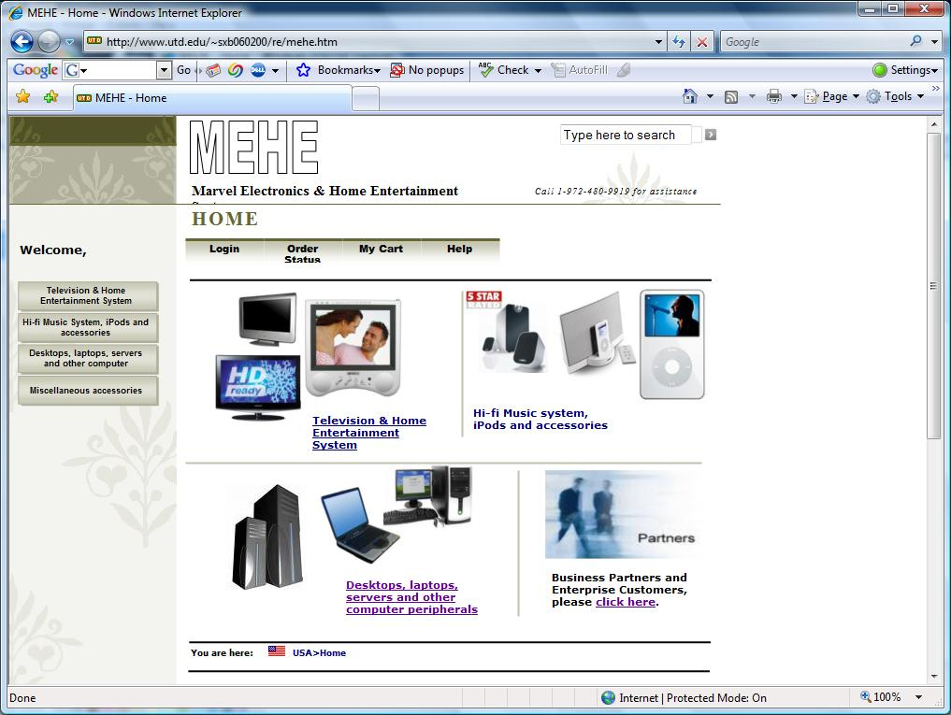

Login

This page is displayed on clicking the log in button on the home page. User can log in to the system in the log in page.

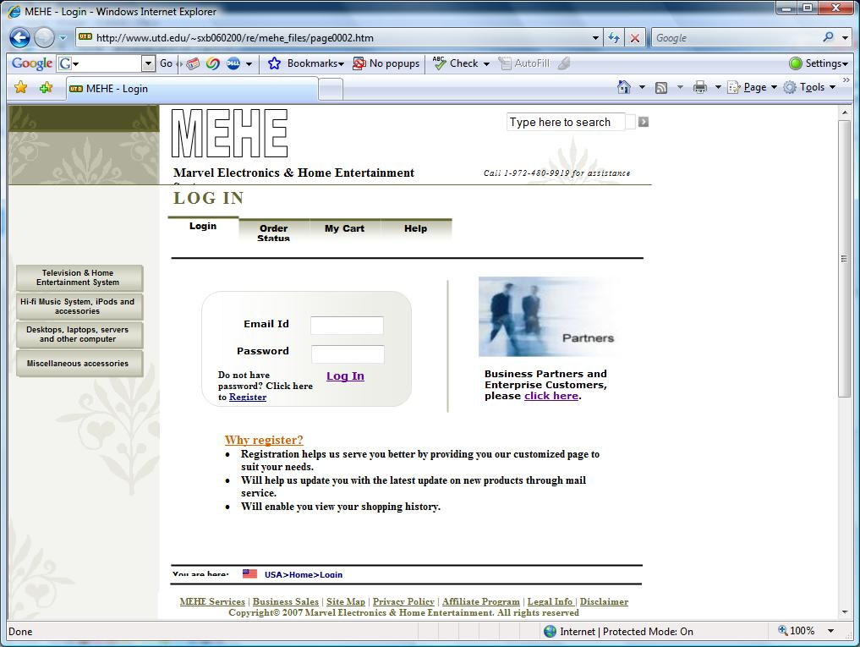

Register

On clicking the register link in the log in page, user is provided with the registration page, where the user can provide his/her information to register as a customer with the company.

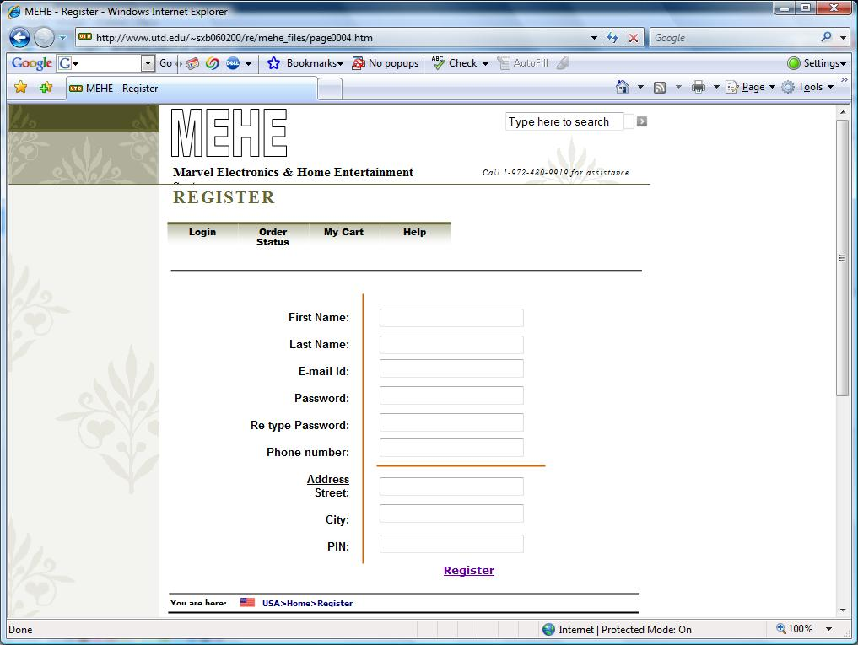

View search result

The following page displays the list of items. The page can be displayed either by searching for a particular item or by clicking on the link to the left of the home page for viewing a list of desired items.

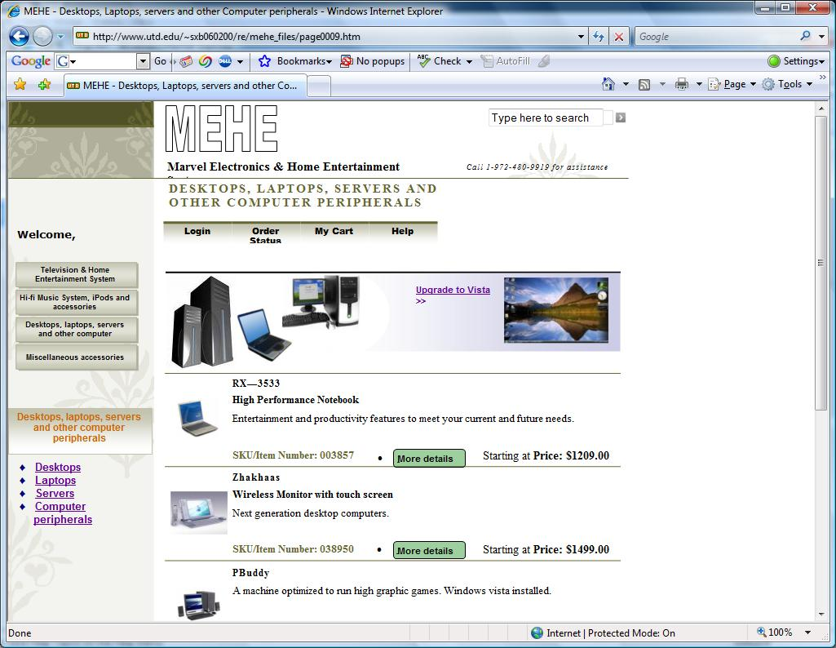

View product catalog

The product catalog page shows all the information for a particular product. It provides a link for configuring the product. This page is displayed by clicking on the more details link in the view search results page.

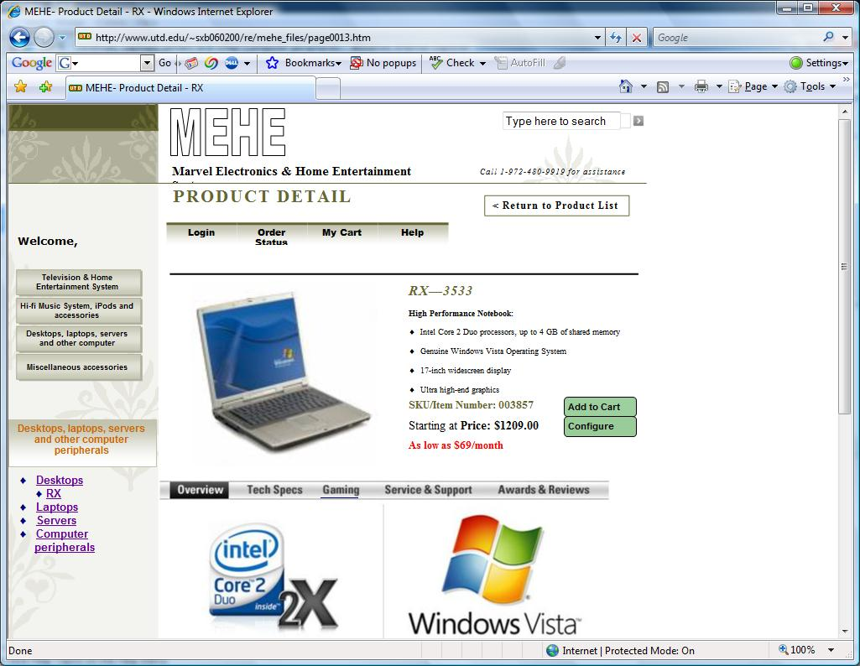

View cart details

The view cart details page is displayed by clicking on the my cart link on the top of the home page or when a new item is added to the cart. The page displays the items contained in the cart.

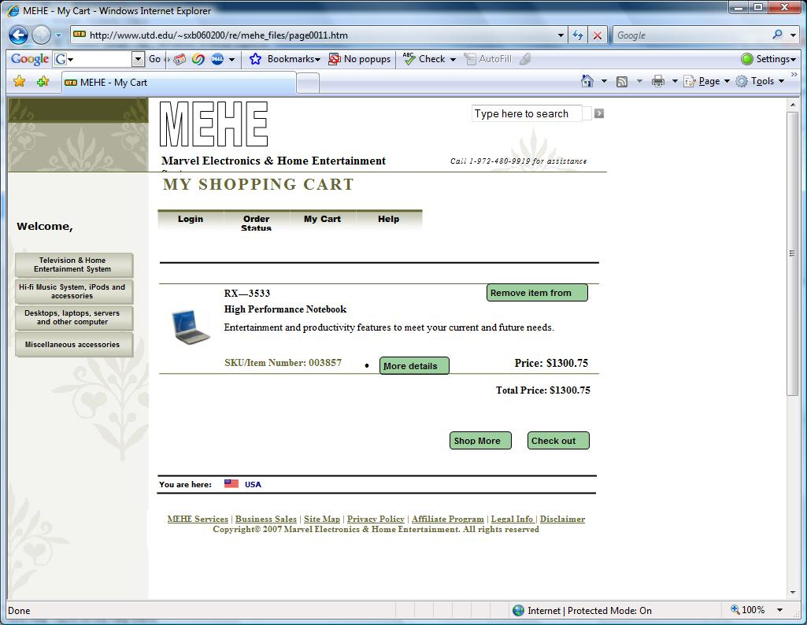

Option to check out as guest

The system provides an option for the user to check out as guest after the purchase is made, thus giving user the flexibility not to register with the company.

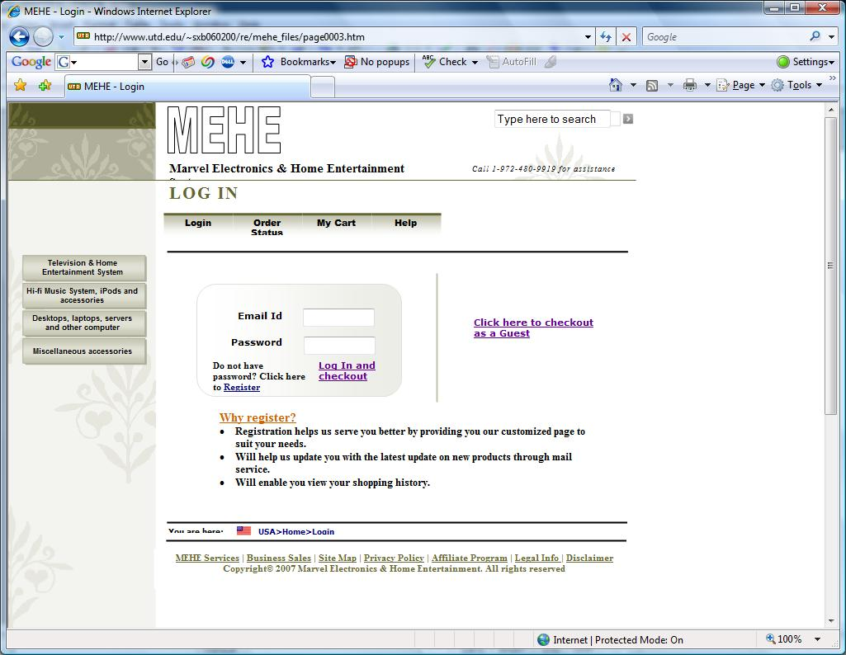

Provide shipping and payment details

The user has to provide his shipping, billing and payment information in this page. The page is displayed when the user checks out.

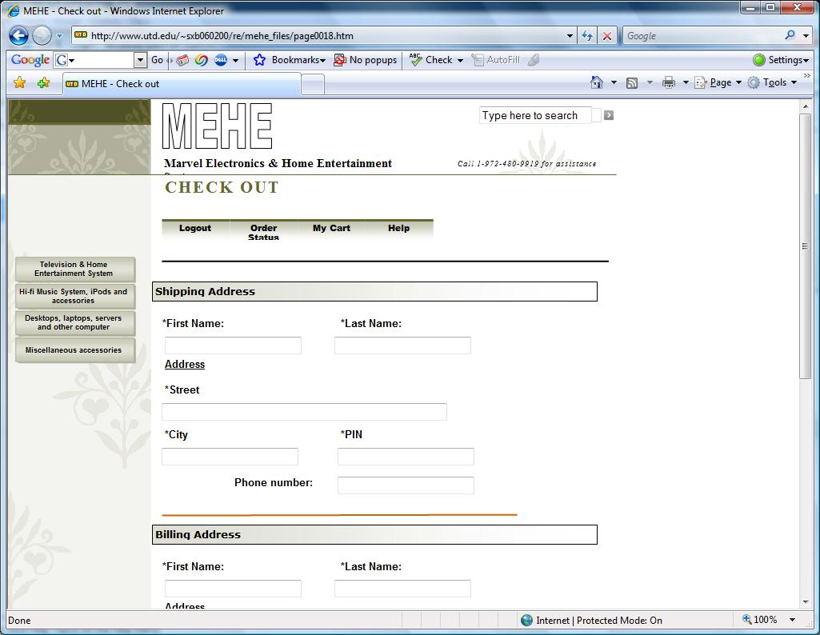

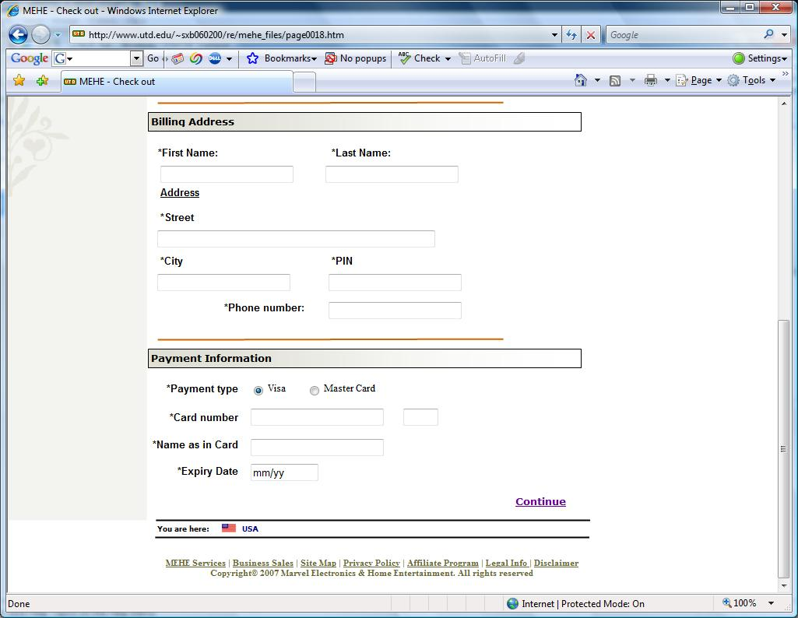

Confirmation page

The customer is presented with the confirmation page, before the transaction is committed. The system provides a unique transaction/order id which can be used later for tracking.

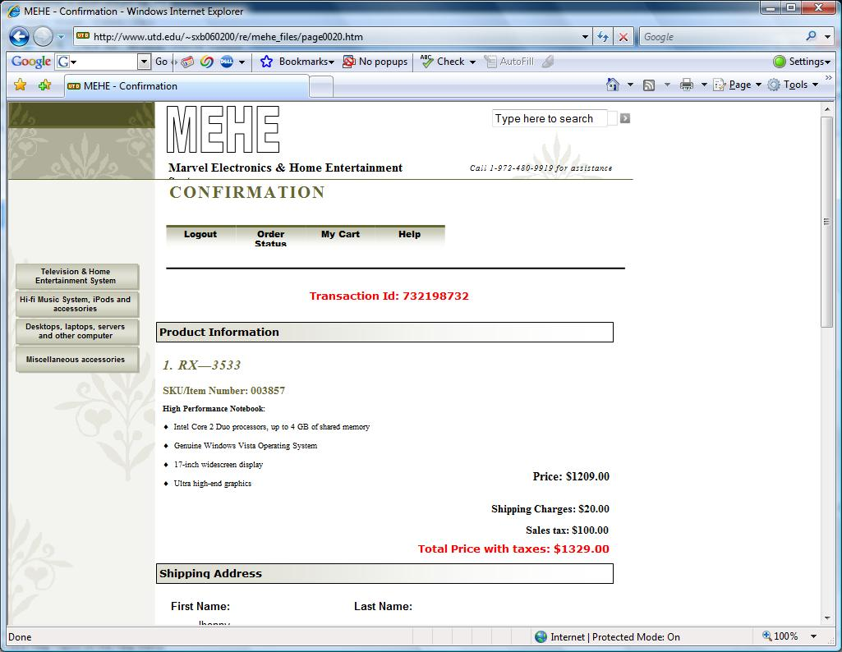

User is given an option to change his details by clicking the back button in the confirmation page.

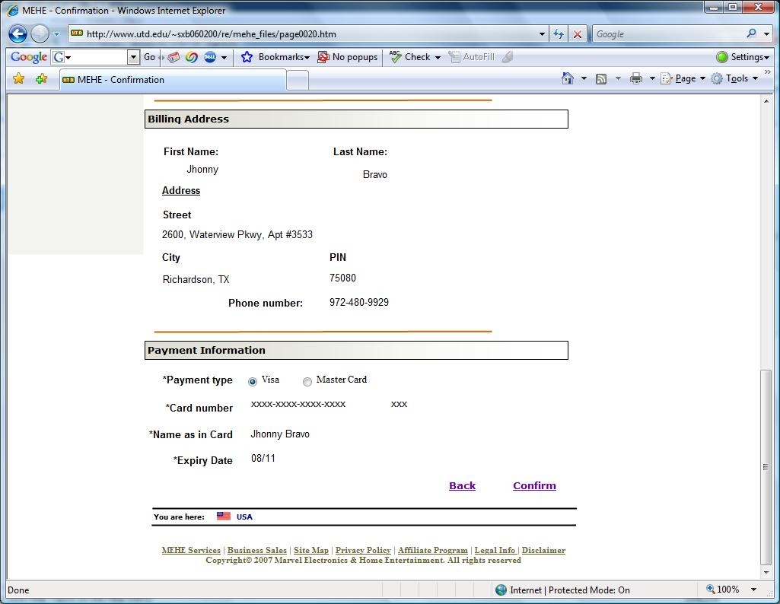

View order status

The customer can view the status of his order at any time by clicking the order status button on the top of the home page. The user provides the transaction/order number.

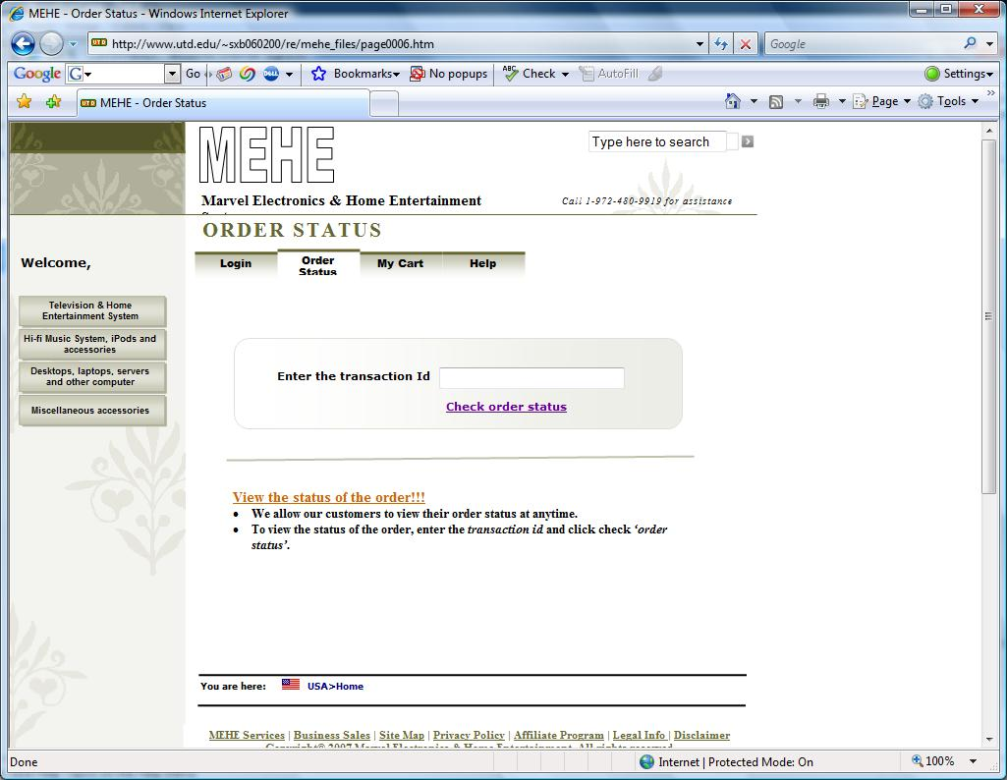

Upon giving the transaction id, the system will display the status of the customer’s order.



