Synergy Distributed Meeting Scheduler System
Project Phase II

System Requirements Specification
Version 1.4

Team: HIGH-FLIERS
Team URL: http://www.utdallas.edu/~rxt058000/welcome.html

Name | UTD Email | SID
Puneet Simha Team Leader | pxk068000@utdallas.edu | 11134514
Deepthi Durgempudi | dxd072000@utdallas.edu | 11163460
Mahitha Devalapalle | mxd065000@utdallas.edu | 11141826
Sindhura Vallabhaneni | sxv069100@utdallas.edu | 11157441
Ragavika Tarigopula | rxt058000@utdallas.edu | 11116375
Nithya Bondalapati | nxb056000@utdallas.edu | 11107632
Siddharth Dhall | sxd068000@utdallas.edu | 11141981

Dr. Lawrence Chung
CS 6361 – Advanced Requirements Engineering
University of Texas at Dallas
Fall 2008

Revision History

Date | Version | Description | Author
10/01/08 | <1.0> | SRS 1.0 | High-fliers
10/23/08 | <1.1> | SRS 1.1 | High-fliers
11/13/08 | <1.2> | SRS 1.2 | Sindhu, Ragavika
11/17/08 | <1.3> | SRS 1.3 | Sindhu, Ragavika
12/01/08 | <1.4> | SRS 1.4 | Ragavika, Nithya

Table of Contents

1. Introduction 3
1.1 Purpose 3
1.2 Scope 4
1.3 Definitions, acronyms and abbreviations 4
1.4 References 4
1.5 Overview 5
2. Overall Description 5
2.1 Product Perspective 5
2.2 Product Features 5
2.3 Assumptions and Dependencies 6
3. Specific Requirements 7
3.1 External Interface Requirements 7
3.1.1 User Interfaces 7
3.1.2 Software Interfaces 8
3.2 Functional Requirements 8
User Classes 8
Use case diagram 9
System Sequence Diagram 11
3.2.1 Initiate Meeting 11
3.2.2 Respond to a Meeting Invite 12
3.2.3 Update a Meeting Request 12
3.2.4 Administrator Functions 13
3.2.5 Update Calendar 13
3.2.6 Conflict Resolution 13
3.2.7 Meeting Reminder 14
3.2.8 Monitor Meetings 14
3.3 Non-Functional Requirements 14
3.3.1 Performance requirements 14
3.3.2 Software System Attributes 15
3.4 Other Requirements 19
3.4.1 Online Access 19

Introduction

Purpose

The purpose of this document is to present the functional and non functional requirements of the Synergy Distributed Meeting Scheduler (SDMS). Synergy Soft, Inc. is looking to develop a software system to solve the problem of manually arranging and keeping track of meetings. For this, they have gathered some initial requirements from potential customers. Based on its past experience, however, the company is also well aware that getting the right requirements the first time will be the barometer to successfully completing the entire development effort, reducing production time, and to keeping up its well-established reputation and ultimately to satisfying their workforce and customers. Due to this criticality, Synergy Soft, Inc. has sought the services of High-Fliers to deliver a detailed requirements description which captures real customers’ needs/wants as precisely, concisely and conceptually as possible.

Scope

The SDMS system shall assist its users in scheduling and rescheduling meetings, prioritizing meetings, adding people to meetings. It shall also allow users to define the times in which they will not be available to attend a meeting, and their preferred meeting times. SDMS shall allow the meeting attendees to reserve resources like over-head projectors, laptops, markers, etc. It shall also provide the functionality to cancel meetings. The software should be adaptable to any application, such as scheduling courses, flights, room assignments at hospitals and hotels, and much more. More specific functionalities within the scope of this project will be discussed in the Requirements [4 & 6] sections.

Definitions, acronyms and abbreviations

- SDMS: Synergy Distributed Meeting Scheduler
- Date range: The time interval in which the meeting initiator schedules the meeting.
- Exclusion set: A set of dates on which the potential meeting attendees cannot attend the meeting.
- Preference set: A set of dates on which they would prefer the meeting to take place.
- Potential meeting attendees: The set of people that the meeting initiator invites for the meeting.
- Meeting initiator: The person who initiates the meeting.
- Date conflicts: A date conflict occurs when the proposed meeting date does not belong to the stated date range, or it belongs to the exclusion set.
- Virtual meetings: Meetings in a virtual place, e.g.; teleconferencing.
- SRS: Software Requirements Specifications

References
- Initial Requirements document by Synergy Soft, Inc.
- Software Requirements Specifications template- www.processimpact.com/process_assets/srs_template.doc

Overview
The SRS document has been divided into three sections:
1. Section 1 (current section) provided an overview of the entire SRS document along with the product scope and the purpose of this document.
2. Section 2 describes the factors that will have a bearing on the product being produced. This product will be based on the SRS. It includes product perspective, product features and assumptions and dependencies.
3. Section 3 describes specific requirements. They include external interface requirements, Functional Requirements, Non-Functional Requirements and Other Requirements.

Overall Description

Product Perspective
Synergy Soft, Inc. has been using a simple Microsoft Excel spreadsheet for scheduling meetings and keeping track of attendees. Since the company has grown over time, this method has become highly inefficient. To solve this problem, they have decided to use an effective software system that would enable them to schedule meetings and provide other related services like reserving meeting locations, inviting people, rescheduling meetings etc. After gathering the initial documents, they have approached the high-fliers to deliver a detailed requirements document. This software system (SDMS) shall serve as a solution to Synergy Soft, Inc.’s problem of inefficient meeting scheduling methods.

Product Features
SDMS shall primarily serve as a meeting scheduler system. This section outlines the major functionalities that the SDMS shall support. All the functionalities shall be described in the Requirements [4 & 6] section of the SRS document in greater detail. A summary of the most prominent functionalities are as follows-
- Schedule a meeting under the constraints expressed by potential participants
- Re-plan a meeting to support changing user constraints
- Support conflict resolution
- Reserve meeting location and resources
- Manage all interactions among participants required during organization of the meeting
- Handle several meeting requests in parallel
- Must have a repository for available locations, size they can accommodate, and equipment they offer.

Assumptions and Dependencies
The following assumptions and dependencies have been made for the system to function effectively:
- The system will always be connected to the intranet or internet and the mail servers will be functioning 24/7.
- The user is educated about the product and the various data stored in the system.
- The system will specify and validate resources at a location only if the details of the location are already stored in the system.
- The system will specify email address of attendees only if the details of the attendees are already stored in the system.
- The system cannot prevent a user to select a wrong location if it satisfies the requirements as specified by the user.
- System can be integrated to other applications only if they have a similar protocol.
- The system can be maintained and the control features in the system can be maintained by an administrator. Other users would not have these privileges.
- The application allows having only one session at one point of time.
- User is locked if the user provides incorrect password for more than three times. The user id can be locked only by the administrator.
- External constraints shall be considered after a meeting date and location have been proposed. For example, if a high priority meeting needs to be accommodated, a lower priority meeting may be changed or cancelled.

Specific Requirements

External Interface Requirements

User Interfaces
The user interfaces will be plain HTML pages. The user interfaces identified up to phase 2 include:

Administrator Pages

Home Page
This screen is the Welcome Page for both the Normal users and the Administrator.

Administrator’s welcome page
This is the Administrator Functions Page where he has options to View the existing User profiles, Register a New User and Edit/Delete User Accounts.

View Existing User Profiles
This page allows the Administrator to view the profiles of existing users.

Edit/Delete User account
This page allows the Administrator to make changes to the existing User Profiles and even delete a User Account.

Register a New User
This page allows the Administrator to add a new User Account.

User Pages

Home Page
This is the Welcome Page for the User which displays the Invitations Sent, the Initiated Meetings and the Confirmed Meetings.

Login Page
This page allows the user to login to the SDMS by providing his login name and password.

New User Registration
This page allows the User to register his profile on the SDMS.

Inbox
This page displays the Accepted Meeting Invitations.

Initiate Meeting
This page allows the User to initiate a new meeting by providing the essential details like the names of attendees, the date, the equipment necessary etc.

Update Calendar
This page allows the User to update his calendar in order to choose his preference and exclusion date sets.

Minutes of Meeting
This page allows the User to upload a new Minutes of Meeting document and also view the uploaded Minutes of Meetings documents.

Software Interfaces

Windows Address Book
The SDMS will be interfaced to the windows address book to automatically take the contact details of the user to send emails.

Email System
The SDMS will be interfaced to an Email system, which can be used to send email notifications to the meeting participants.

Database
A database system will be used to store all the user information and meeting information.

Logging System
A logging system will be used to log all the user transactions.

Search Engine
To provide a keyword based search for the user to search for any information in our system.

Functional Requirements
This section deals with the System functional and non-functional requirements identified from the preliminary definition of the SDMS provided by Synergy Soft Inc. These requirements describe the domain and the stakeholders in relation to the process of scheduling a meeting.

User Classes
Users are classified into 2 types for the purpose of defining the requirements for SDMS. The first kind consists of the people who initiate the meetings. The second kind consists of people who actually attend the meetings. The SDMS system shall support access by both user classes.

Use case diagram
A business use case diagram consists of business use cases and business actor associated with those use cases a business use case is a sequence of actions business performs that yield an observable result of value to a particular business actor. In our SDMS system we have identified initiators and participants to the business actors and administrator to be business worker our SDMS system is mainly usable by the meeting initiators and the meeting participants. So, they are the business actors in the business use diagram shown below:
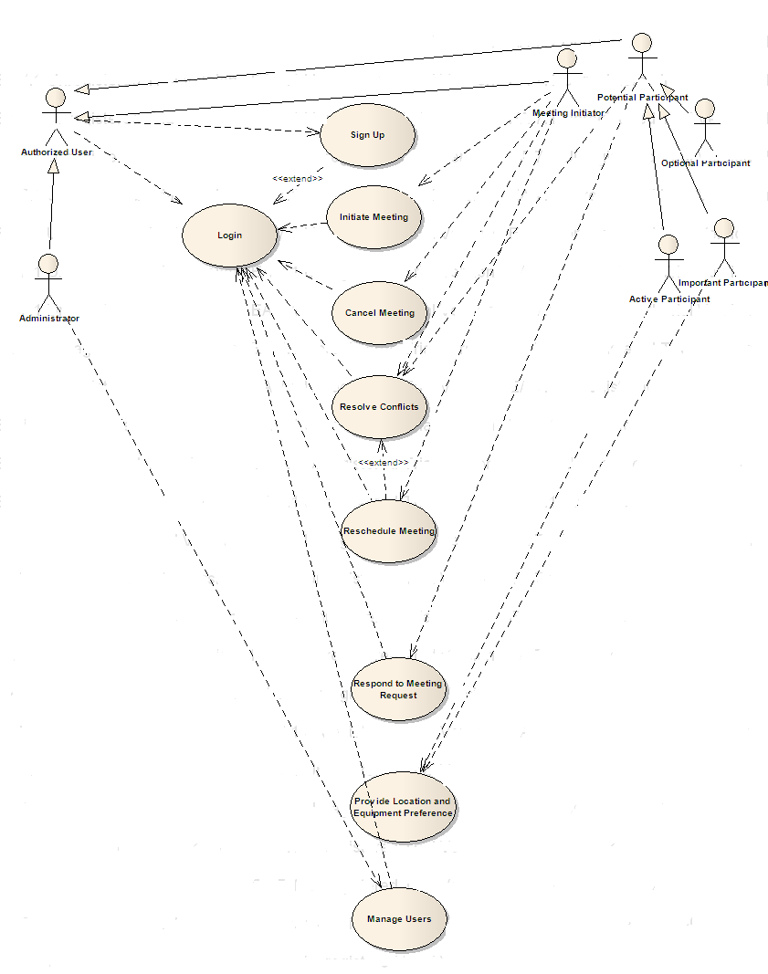
SDMS SYSTEM

System Sequence Diagram

Sequence diagrams are the most popular UML artifact for dynamic modeling, which focuses on identifying the behavior within your system. It shows the sequence of interactions among objects. Below is the sequence diagram showing the interactions occurring within our SDMS system.
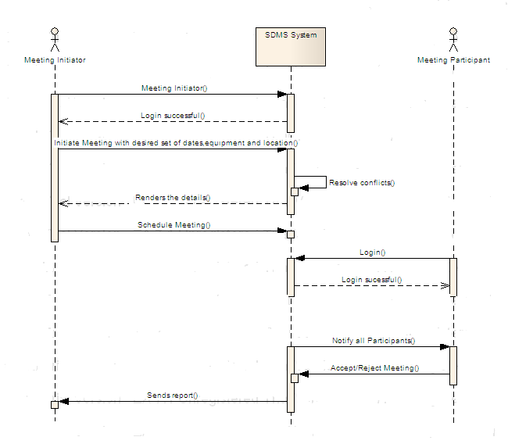
Fig-2: Sequence Diagram

Initiate Meeting

SDMS shall allow the meeting initiator to initiate a meeting under constraints expressed by the participants and with the specified requirements.

SDMS shall allow the meeting initiator to select the participants for his meeting

SDMS shall allow the meeting initiator to categorize the participants as important, active or optional

SDMS shall allow the meeting initiator to select a date range within which the meeting will be scheduled.

SDMS shall allow the meeting initiator to select a meeting location from the list of available locations based on meeting date and resources required.

SDMS shall allow the meeting initiator to request resources like projectors, DVD players...etc for the meeting.

SDMS shall get the inclusion set and exclusion set of dates from the participants calendars

After getting the preferred dates from all participants, the SDMS shall choose a preferred date which is convenient to all.

SDMS shall allow the meeting initiator to confirm the meeting date before finalizing the meeting date.

SDMS shall send meeting invitations to all the participants after the meeting date is confirmed.

SDMS shall re-plan a meeting to support changing external constraints

SDMS shall allow the meeting initiator to schedule multiple meetings at the same time.

Respond to a Meeting Invite

SDMS shall allow the potential participant to respond to a meeting request from the initiator without comments

SDMS shall allow a participant to add comments along with their acceptance to let the initiator know if they can only make a partial attendance to the meeting (Added Requirement)

SDMS shall allow only important participants to suggest their location preferences while accepting a meeting request.

SDMS shall allow only active participants to request additional resources while accepting a meeting request.

SDMS shall allow a meeting initiator to view the list of meetings initiated by him.

SDMS shall allow an authorized user to view all the meeting requests received by him

SDMS shall allow a participant to view the list of confirmed meetings.

SDMS shall allow a potential attendee to reject a meeting invite if he is not interested to attend the meeting

Update a Meeting Request

SDMS shall send an update to all the participants whenever there is any change in the meeting request.

SDMS shall allow the meeting initiator to change the location of the meeting based on the preference requests from the important participants

SDMS shall allow the meeting initiator to reschedule a meeting in the event of irresolvable conflicts.

SDMS shall allow the meeting initiator to add more participants at any time before the meeting.

SDMS shall allow the meeting initiator to remove existing participants at any time before the meeting.

SDMS shall allow the meeting initiator to add more equipment resources to the meeting, based on requests from the active participants.

SDMS shall be capable of cancelling a meeting by itself (based on a pre-defined criteria) or by allowing the meeting initiator to cancel it.

Administrator Functions

SDMS shall allow the administrator to accept a user’s request to sign up into the system.

SDMS shall allow the administrator to unlock the user accounts which have been locked due to more than three attempts of incorrect password.

SDMS shall allow the administrator to disable a user’s account which is temporarily not in use.

SDMS shall allow the administrator to enable (activate) a user’s account when it is needed again.

SDMS shall allow the administrator to delete the user accounts which are no longer in use.

SDMS shall allow the administrator to view all the contacts

SDMS shall allow the administrator to edit the user accounts which are no longer in use.

Update Calendar
A user should be able to update his calendar with exclusion set and preference set.

Conflict Resolution
A conflict resolution technique shall be used by the SDMS to resolve date conflicts.

Date Conflict
- If there is a date conflict with an important participant, the system cancels the meeting and asks the initiator to re-plan the meeting.
- If there is a date with an active participant, the system will inform the initiator about it. The initiator can decide on whether changing the important participant or re-schedule the meeting.
- If there is a date conflict with an optional participant, the system automatically withdraws him from the meeting.

Meeting Reminder
The system shall send meeting remainders to all the accepted meeting attendees 30 minutes before the meeting.

Monitor Meetings
SDMS shall allow the potential attendees of the meeting to upload a summary of the meeting or any concerning documents of the meeting.

Address Book
SDMS shall allow all the users to see address details of the other users.

Non-Functional Requirements

Performance requirements

The system should not take more than 30 seconds to either schedule a meeting/send the request back to the initiator.

The system should work in a network environment with multiple users.

Software System Attributes

Accurately Monitor Meetings

SDMS shall accurately monitor a meeting, especially when it is held in a virtual place.

Dynamic and Flexible Meeting Re-planning

SDMS shall allow dynamic and flexible re-planning of a meeting.

Accommodate Decentralized Requests

SDMS shall accommodate decentralized requests i.e., allow any authorized user to request a meeting independent of their location.

Time Required to Schedule a meeting

SDMS shall ensure that the elapsed time between the submission of a meeting request and the determination of the corresponding date/location should be minimal.

Quick Conflict Resolution
To achieve quick conflict resolution, it is required to have the following:
- Categorize the participants into Important, Active and Optional.
- Take preference sets and exclusion sets from the participants
- System decides on the preferred meeting date in most of the situations

Date Conflict
- If there is a date conflict with an important participant, the system cancels the meeting and asks the initiator to re-plan the meeting.
- If there is a date with an active participant, the system will inform the initiator about it. The initiator can decide on whether changing the important participant or re-schedule the meeting.
- If there is a date conflict with an optional participant, the system automatically withdraws him from the meeting.

Minimal Number of Negotiations

The system shall take minimal number of negotiations with the meeting initiator or participants to schedule the meeting.
Minimal Number of negotiations is achieved by having three things together:
- Take the start date and end date from the meeting initiator
- Take the preference set and exclusion set from the meeting participants calendars
- System automatically gives the preferred date for the meeting.
- If a date conflict occurs for an important participant, that meeting will be cancelled or a new round of negotiations are required.
- If a date conflict occurs with an optional participant, the participant will be automatically withdrawn from the meeting by the system.
- If a date conflict occurs with an active participant the meeting initiator is given a chance to decide on whether to change the active participant or start a new round of negotiations.

Reliability

The system must be 99% operational 99% of the calendar time. No bugs may remain in the executable code after delivery. To achieve this, the product must be thoroughly tested so as to ensure a failure free, reliable product.
The diagram below shows the cloud diagram for the NFR – Reliability.
Reliability for SDMS includes Integrity, availability and accuracy. RDBMS and Efficiency strongly make integrity where as consistency also contributes to integrity. But using an RDBMS strongly decreases performance.

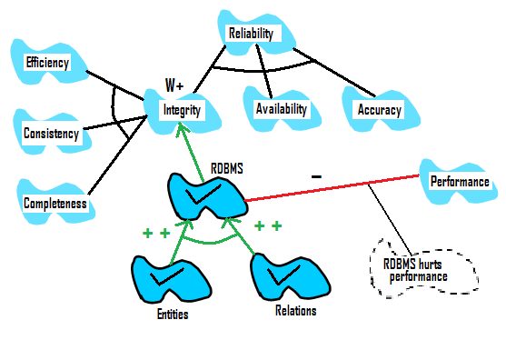

Availability
The system shall be available 24X7 to schedule meetings.

Security
To perform any transaction in the proposed system, the user should have the required authorization. Authorization settings will form the integral part of the system. Security for the SDMS includes integrity, confidentiality and availability. The confidentiality includes authentication of a user is verified by a user name and password.
The following features address security requirements of the system
        - Login to the system
An authorized user can log in to the SDMS system.
        - Sign Up for an account
A new user can create a new account and become an authorized user.
        - Logout of the system
A user can log out from the system.
        - Change password
An authorized user can change his/her password whenever desired.
        - Lock user account
A user account is locked by the system if a user tries to log in with an incorrect password for more than three times.

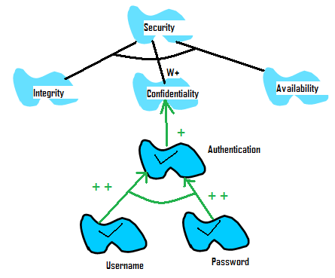

Maintainability
SDMS shall be maintainable. Customer support shall be provided. The system should be modularized. Each module should have minimum level of interdependence with other modules, thus making the process of locating and fixing errors easier.
Maintainability is provided by either testability, understandability, modifiability and evolvability.
Understandability further depends on consistency. Modifiability further depends on structured-ness and Extendibility. This is further provided by evolvability and object oriented-ness. Object oriented-ness is provided by objects.

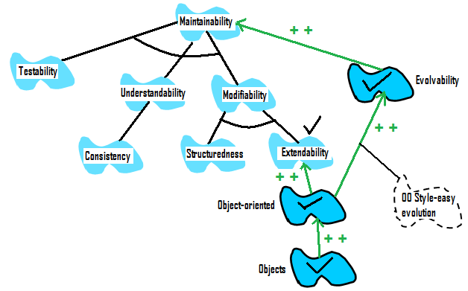

Portability
The system shall be able to work on different platform like Windows, Linux and UNIX. This can be achieved by using a portable programming language like .NET to implement it.

Other Requirements

Online Access
SDMS will be launched as a web application, and can be accessed by any authorized user at any time from any location with access to the internet.

