Synergy Distributed Meeting Scheduler System
Project Phase II

Supplementary Specification
Version 1.1

Team: HIGH-FLIERS
Team URL: http://www.utdallas.edu/~rxt058000/welcome.html

Name | UTD Email | SID
Puneet Simha Team Leader | pxk068000@utdallas.edu | 11134514
Deepthi Durgempudi | dxd072000@utdallas.edu | 11163460
Mahitha Devalapalle | mxd065000@utdallas.edu | 11141826
Sindhura Vallabhaneni | sxv069100@utdallas.edu | 11157441
Ragavika Tarigopula | rxt058000@utdallas.edu | 11116375
Nithya Bondalapati | nxb056000@utdallas.edu | 11107632
Siddharth Dhall | sxd068000@utdallas.edu | 11141981

Dr. Lawrence Chung
CS 6361 – Advanced Requirements Engineering
University of Texas at Dallas
Fall 2008

Revision History

Date | Version | Description | Author
11/17/08 | <1.0> | Supplementary Specification 1.0 | Ragavika
12/01/08 | <1.1> | Supplementary Specification 1.1 | Ragavika

Table of Contents
1. Introduction 5
1.1 Purpose 5
1.2 Scope 5
1.3 References 5
1.4 Overview 5
2. Functionality 6
3. Non-Functional Requirements 6
3.1 Reliability 6
3.1.1 Integrity 6
3.1.2 Availability 6
3.1.3 Accuracy 6
3.2 Availability 7
3.3 Security 7
3.3.1 Integrity 7
3.3.2 Confidentiality 7
3.3.3 Availability 8
3.4 Maintainability 8
3.5 Portability 9
3.6 Usability 9
3.6.1 Operating System Compliance 9
3.6.2 Design for Ease-of-Use 10
3.6.3 Help 10
3.7 Performance 10
3.7.1 Simultaneous Users 10
3.7.2 Transaction Response Time 10
4. Design Constraints 10
4.1 Windows Address Book 10
4.2 Email System 10
4.3 Database 10
4.4 Logging System 10
4.5 Search Engine 11
5. Data Entities 11
5.1 Trainee Data Elements 11
6. Printed Documents 13

Introduction

Purpose
The purpose of this document is to define requirements of the Synergy Distributed Meeting Scheduler. This Supplementary Specification lists the requirements that are not readily captured in the use cases of the use-case model. The Supplementary Specifications and the use-case model together capture a complete set of requirements on the system. It provides a set of Non-functional requirements.

Scope
The SDMS system shall assist its users in scheduling and rescheduling meetings, prioritizing meetings, adding people to meetings. It shall also allow users to define the times in which they will not be available to attend a meeting, and their preferred meeting times. SDMS shall allow the meeting attendees to reserve resources like over-head projectors, laptops, markers, etc. It shall also provide the functionality to cancel meetings. More specific functionalities within the scope of this project will be discussed in the Requirements [3] sections.

References
- www.utdallas.edu/~chung/RE/syllabus.htm
- Course Registration System – Supplementary Specification
http://www.ts.mah.se/RUP/wyliecollegeexample/courseregistrationproject/artifacts/baselined/inception/supplspec_v0.htm

1.4 Overview
This section provides the overview of the remaining sections of the document. This document is divided into 6 sections. They include:
- Introduction: This section provides the introduction to the document. It contains purpose, scope, definitions and acronyms and references.
- Functionality: It provides an overview of the functionality of the SDMS system.
- Non-Functional Requirements: This section provides a detailed explanation of the Non-functional requirements for the SDMS system along with a few cloud diagrams.
- Design Constraints: This section provides the design constraints of the SDMS system. It discusses about the interfaces which work with the SDMS system.
- Data Entities: This section provides a list of training data for the fields in the SDMS pages.
- Printed Documents: This section provides a list of documents prepared along with this one.

Functionality

SDMS shall primarily serve as a meeting scheduler system. This section outlines the major functionalities that the SDMS shall support. All the functionalities shall be described in the Requirements [3] section of the SRS document in greater detail. A summary of the most prominent functionalities are as follows-
- Schedule a meeting under the constraints expressed by potential participants
- Re-plan a meeting to support changing user constraints
- Support conflict resolution
- Reserve meeting location and resources
- Manage all interactions among participants required during organization of the meeting
- Handle several meeting requests in parallel
- Must have a repository for available locations, size they can accommodate, and equipment they offer.

Non-Functional Requirements

Reliability
The system must be 99% operational 99% of the calendar time. No bugs may remain in the executable code after delivery. To achieve this, the product must be thoroughly tested so as to ensure a failure free, reliable product.
The diagram below shows the cloud diagram for the NFR – Reliability.
Reliability for SDMS includes:

Integrity
Integrity of the SDMS system includes efficiency, consistency, RDBMS and completeness.

Availability
The system should be available 24X7 for scheduling meeting.

Accuracy
The system should be able to calculate the best possible meeting date.
RDBMS and Efficiency strongly make integrity where as consistency also contributes to integrity. But using an RDBMS strongly decreases performance.

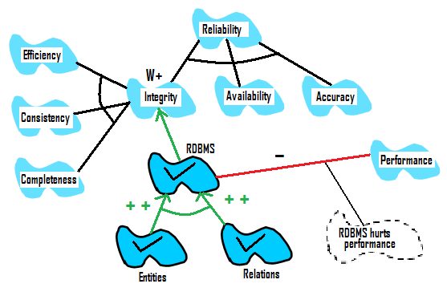

Availability
The system shall be available 24X7 to schedule meetings.

Security
To perform any transaction in the proposed system, the user should have the required authorization. Authorization settings will form the integral part of the system. Security for the SDMS includes:

Integrity
It means ensuring data is "whole" or complete the condition in which data are identically maintained during any operation (such as transfer, storage or retrieval), the preservation of data for their intended use, or, relative to specified operations.
Often such integrity is ensured by use of a number referred to as a Message Integrity Code (MIC) or Message Authentication Code (MAC).

Confidentiality
The confidentiality includes authentication of a user.

Authentication
The authentication of a user is verified by user name and password.

Availability
The system should be available 24X7 for scheduling meetings.

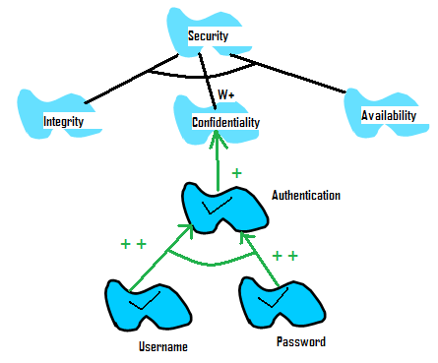

Maintainability
SDMS shall be maintainable. Customer support shall be provided. The system should be modularized. Each module should have minimum level of interdependence with other modules, thus making the process of locating and fixing errors easier. SDMS shall be maintainable. Customer support shall be provided. The system should be modularized. Each module should have minimum level of interdependence with other modules, thus making the process of locating and fixing errors easier.
Maintainability is provided by either testability, understandability, modifiability and evolvability.
Understandability further depends on consistency. Modifiability further depends on structured-ness and Extendibility. This is further provided by evolvability and object oriented-ness. Object oriented-ness is provided by objects.

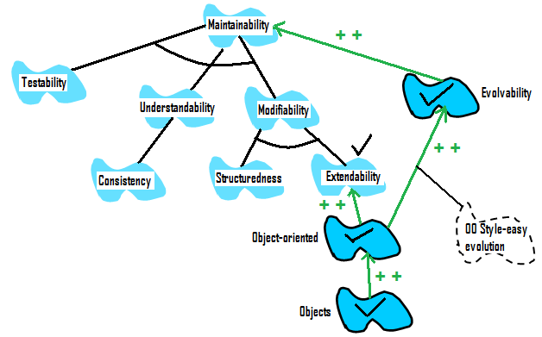

Portability
The system shall be able to work on different platform like Windows, Linux and UNIX. This can be achieved by using a portable programming language like .NET to implement it.

Usability
This section lists all of those requirements that relate to, or affect, the usability of the system.

Operating System Compliance
The desktop user interface shall be Windows, Linux and UNIX compliant

Design for Ease-of-Use
The user interface of the SDMS shall be designed for ease-of-use and shall be appropriate for a computer-literate user community with no additional training on the System.

Help
Each feature of the C-Registration System shall have built-in help for the user. Help shall include step by step instructions on using the System and definitions for terms and acronyms.

Performance
The performance characteristics of the system are outlined in this section.

Simultaneous Users
The system shall support up to 200 simultaneous users against the central database at any given time.

Transaction Response Time
The system must be able to complete first iteration of scheduling a meeting should be completed in not more than 20 seconds.

Design Constraints

Windows Address Book
The SDMS will be interfaced to the windows address book to automatically take the contact details of the user to send emails.

Email System
The SDMS will be interfaced to an Email system, which can be used to send email notifications to the meeting participants.

Database
A database system will be used to store all the user information and meeting information.

Logging System
A logging system will be used to log all the user transactions.

Search Engine
To provide a keyword based search for the user to search for any information in our system.

Data Entities

Trainee Data Elements
User Interface | Field | Description | Mandatory
Login Page | User Name | A login user name of the user which he chooses at the time of registration | Y
Login Page | Password | A login password of the user which he chooses at the time of registration | Y
Inbox | Accept | A meeting participant can click this button, if he wants to accept the meeting request | N
Inbox | Reject | A meeting participant can click this button, if he is not willing to attend the meeting | N
Inbox | Accept With Comments | A meeting participant can click this button and add comments (location and equipment preferences, partial attendance ...) | N
Initiate Meeting | Meeting Name | Name of the meeting which is selected by the initiator | Y
Initiate Meeting | Type of Meeting | A meeting type can be Emergency, Team or Lunch | Y
Initiate Meeting | Start Date | Start date for the meeting. The date after which the meeting is to be scheduled | Y
Initiate Meeting | End Date | End date for the meeting. The date before which the meeting is to be scheduled. | Y
Initiate Meeting | Location | This is a drop down list which shows the available locations for the meeting to be held. | Y
Initiate Meeting | Select Participants | The initiator can select the participants for the meeting | Y
Initiate Meeting | Participant Type | The initiator can assign roles to the participants  and click add after each participant is selected and assigned a role | Y
Update Calendar | Exclusion Set | The participants can update their calendar whenever they want. Usually they do it in the beginning of week. Here they can add the dates in which they are not available for any meetings | Y
Update Calendar | Preference Set | They can add the dates in which they are available for any meeting | Y
New User Registration | First Name | User’s First Name | Y
New User Registration | Middle Name | User’s Middle Name | N
New User Registration | Last Name | User’s Last Name | Y
New User Registration | Designation | This describes the user’s designation in the organization | Y
New User Registration | Description | The user can provide any description about his information | N
New User Registration | Email Address | The user’s email address where the system needs to forward the meeting updates | Y
New User Registration | User Name | The user can select a user name for his SDMS account | Y
New User Registration | Password | The user can select a password for his SDMS account | Y
New User Registration | Confirm Password | The user needs to reenter his password to confirm it | Y
Admin Accept User Registration | Add | Whenever a user fills in the registration for SDMS, the admin gets a request to add or decline | Y

Printed Documents
The following documents are prepared in the SDMS phase 2:
- Vision Document 1.1
- Stakeholder Request Document 1.0
- Supplementary Specification 1.0
- Software Requirements Specification 1.3
- Deliverable 1.1

