Synergy Distributed Meeting Scheduler System
Project Phase II

Vision Document
Version 1.2

Team: HIGH-FLIERS
Team URL: http://www.utdallas.edu/~rxt058000/welcome.html

Name | UTD Email | SID
Puneet Simha Team Leader | pxk068000@utdallas.edu | 11134514
Deepthi Durgempudi | dxd072000@utdallas.edu | 11163460
Mahitha Devalapalle | mxd065000@utdallas.edu | 11141826
Sindhura Vallabhaneni | sxv069100@utdallas.edu | 11157441
Ragavika Tarigopula | rxt058000@utdallas.edu | 11116375
Nithya Bondalapati | nxb056000@utdallas.edu | 11107632
Siddharth Dhall | sxd068000@utdallas.edu | 11141981

Dr. Lawrence Chung
CS 6361 – Advanced Requirements Engineering
University of Texas at Dallas
Fall 2008

Revision History

Date | Version | Description | Author
11/13/08 | <1.0> | Vision Document 1.0 | Ragavika, Nithya, Sindhuri
11/17/08 | <1.1> | Vision Document 1.1 | Ragavika, Nithya
12/01/08 | <1.2> | Vision Document 1.2 | Ragavika, Nithya

Table of Contents
1 Introduction 5
1.1 Purpose 5
1.2 Scope 5
1.3 Definitions, Acronyms, and Abbreviations 5
1.4 References 6
2 Positioning 6
2.1 Business Opportunity 6
2.2 Problem Statement 7
2.3 Product Position Statement 9
3 Stakeholder and User Descriptions 9
3.1 Market Demographics 9
3.2 Stakeholder Summary 10
3.3 User Summary 10
3.4 User Environment 15
3.5 Stakeholder/User Profiles 16
3.5.1 Meeting Scheduler/Initiator 16
3.5.2 Meeting Participant 16
3.5.3 Administrator 17
3.6 Key Stakeholder or User Needs 17
4 Product Overview 19
4.1 Product Perspective 19
4.2 Summary of Capabilities 20
4.3 Assumptions and Dependencies 21
4.4 Cost and Pricing 21
4.5 Licensing and Installation 21
5 Product Features 21
6 Constraint 25
6.1 Maintainability 25
6.2 Reliability 25
6.3 Security 26
6.4 Minimal Number of Negotiations 27
6.5 Quick Conflict Resolution 28
To achieve quick conflict resolution, it is required to have the following: 28

Introduction
Synergy Soft, Inc. has been using a simple Microsoft Excel spreadsheet for scheduling meetings and keeping track of attendees. Since the company has grown over time, this method has become highly inefficient. To solve this problem, they have decided to use an effective software system that would enable them to schedule meetings and provide other related services like reserving meeting locations, inviting people, rescheduling meetings etc. After gathering the initial documents, they have approached the high-fliers to deliver a detailed requirements document. This software system (SDMS) shall serve as a solution to Synergy Soft, Inc.’s problem of inefficient meeting scheduling methods.

Purpose
The purpose of this document is to collect, analyze and define high level requirements, user wants and needs and system features for a proposed Synergy Distributed Meeting Scheduler, which is a software system to schedule meetings effectively. The system shall focus on the capabilities needed by the stakeholders and target users (Meeting Participants and Initiators).
The details of how the system fulfils these needs can be found in the supplementary specification.

Scope
This initial version (Version 1.0) of the SDMS Vision document shall primarily focus on the high level user needs, as well as general requirements and features. In addition, information pertaining to user wants and needs, for use in determining future system requirements and features, are also included.
The SDMS is an software system which allows the user to schedule meetings with less number of interaction between the meeting initiator and the meeting participants. The system takes care of selecting a preferred date for the meeting depending on the participant’s calendars.

Definitions, Acronyms, and Abbreviations
SDMS | Synergy Distributed Meeting Scheduler
Meeting Initiator | A person that initiates meeting scheduling and makes final choice of meeting date and location
Potential Participant | A person who will attend the meeting
Important Participant | A participant who is necessary to the purpose of the meeting
Active Participant | A participant who will play a major role in the meeting and is responsible for specifying equipment requirements; is identified by the meeting initiator
Meeting Proposal | An invitation to a meeting including the meeting topic, date range, and duration that is sent to a list of Confirmed and Unconfirmed participants
Date Range | a time interval established by the meeting initiator during which he would like the meeting to occur
Exclusion set | Date ranges when attendees cannot attend meeting
Preference set | Date range when attendees can attend meeting
Date Conflicts | Occurs when no meeting date within preference set , excluding exclusion set can be found.
Virtual Meeting | Meetings in a virtual place e.g.: teleconferencing
Optional Participant | A participant who is optional to attend the meeting

References
- Home Appliance Control System Vision by Lawrence Chung, Kendra Cooper and Sam Courtney

Positioning

Business Opportunity
The business can improve their process of scheduling meeting from using a simple Microsoft Spread Sheet to an effective SDMS. By having an SDMS the company does not have to spend hours in negotiating with the participants about the meetings. This can leave more room for other tasks of the organization. The processes or products can achieve a new level of innovation each time they are worked on, thus promoting a less expensive and better quality product. This will in effect translate to better quality product and customer satisfaction which in effect opens up more business opportunity.

Problem Statement

The problem of | Inefficient and time consuming process of scheduling meetings manually
affects | Company work force
the impact of which is | Loss of productive time which in-turn affects the company’s productivity.
a successful solution would be | A flexible and efficient system to schedule meetings in a less time consuming manner.

Problem Fish Bone Diagram

Difficulty in monitoring meetings
Difficult to schedule a meeting whenever we want (anytime-24/7)
Difficulty in scheduling meetings if attendees cannot be physically present during the meeting
Hard to reflect changing participants’ constraints
Unauthorized users may access the meeting information
Difficulty in keeping track of the meeting location and meeting date
Large number of negotiations
Time consuming process of selecting a meeting date that is convenient to all the attendees
People are facing many difficulties while Scheduling meetings manually

This fish bone diagram shows that the major problem as people facing many difficulties while scheduling meetings manually. People are facing such difficulty because of the following reasons:
- Time consuming process of selecting a meeting date that is convenient to all the attendees
- Large number of negotiations
- Difficulty in keeping track of the meeting location and meeting date
- Unauthorized users may access the meeting information
- Difficulty in monitoring meetings
- Difficult to schedule a meeting whenever we want (anytime-24/7)
- Difficulty in scheduling meetings if attendees cannot be physically present during the meeting
- Hard to reflect changing participants’ constraints

Solution Fish Bone Diagram

Difficulty in scheduling meetings if attendees cannot be physically present during the meeting

Difficulty in monitoring meetings

Hard to reflect changing participants’ constraints

Time consuming process of selecting a meeting date that is convenient to all the attendees

Unauthorized users may access the meeting information

Difficulty in keeping track of the meeting location and meeting date

Large number of negotiations

Solution:
SYNERGY DISTRIBUTED MEETING SCHEDULER SYSTEM (SDMS)
People are facing many difficulties while Scheduling meetings manually

The solution fish bone diagram shows that the SDMS solves the following problems:
- People are facing many difficulties while Scheduling meetings manually
- Large number of negotiations
- Time consuming process of selecting a meeting date that is convenient to all the attendees
- Hard to reflect changing participants’ constraints
- Difficulty in monitoring meetings
- Difficulty in scheduling meetings if attendees cannot be physically present during the meeting
- Unauthorized users may access the meeting information
- Difficulty in keeping track of the meeting location and meeting date

Product Position Statement

For | A company’s workforce
Who | Needs a quick and efficient way to schedule meeting without spending much time in resolving conflicts
SDMS | Is an software system to schedule meetings
That | Provides its users an effective way to schedule and manage meetings in less time consuming manner
Unlike | The current process of scheduling meetings manually through a Microsoft Spread sheet.
Our Product | Includes features such as conflict resolution, tracking meeting requests, choose location and equipment, less number of negotiations, place to upload meeting documents.

Stakeholder and User Descriptions

Market Demographics
Today, most company workers spend the majority of their time in resolving conflicts while scheduling meetings, negotiating with the meeting participants and rescheduling them again. Synergy Soft Inc with the help of its SDMS, is dedicated to providing the flexible, effective and less time consuming way to schedule meetings. This decreases the time spent on scheduling meetings and this time can be productively used for other tasks.
With the rapid demand for a flexible and time effective meeting scheduler, Synergy Soft Inc can use its generic solution to capture the market which is need for such a meeting scheduler system.

Stakeholder Summary

Table: Non-User Stake Holders
Name | Description | Responsibilities
Requirements Engineer | This is a stakeholder that works  with to gather user’s needs/requests and translates them correctly into requirements to be used for  design. | He is responsible to analyze the requirements and prepare the Use case diagrams. He is also responsible to identify possible issues and come up with a solution after interacting with the business. He is also responsible to refine requirements.
Team Leader | Leads and coordinates the team | He is responsible to lead and coordinate the team and review each deliverable and contribute feedback to the team. He is also responsible to conduct team meetings whenever necessary.
Designer | This is a stakeholder works on preparing the system  design. | He is responsible to create UML diagrams necessary for the development which address FRs and SIGs which address NFRs
Prototype Developer | This is a stakeholder primarily works on the system  Development. | He is responsible to develop the system from the design given by the designer.

User Summary
Name | Description | Responsibilities
Meeting Scheduler/Initiator | A person who initiates meetings | He is responsible to Initiate a particular meeting by selecting participants, meeting location, preferred start and end date and time period.
Participant | A person who participates in the meetings | There are 3 types of participants for the SDMS – Important, Active and Optional. Important participants – Very important for a meeting and the meeting will be cancelled if they cannot attend the meeting. Active – They address the meetings. Optional – All the other participants are optional
Administrator | A person who manages users of the system | He accepts the users request for registering into the system by reviewing their credibility, unlock user accounts and delete user accounts.

Business Use Case Diagram

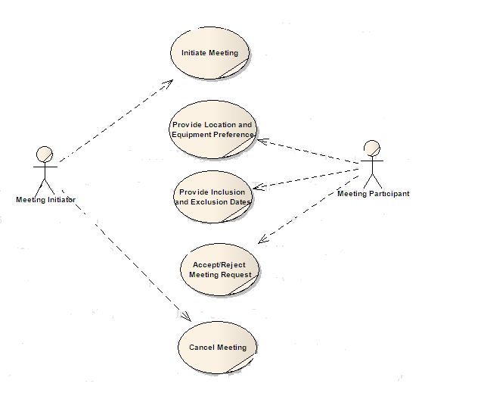

This business use case diagram shows the business actors and the use cases. It depicts the high level business functions in relation to the following actors:
Meeting Initiator:
A meeting initiator can sign up, login, initiate a meeting, resolve conflicts, reschedule meeting, cancel meeting and select location, equipment and date.
Participant:
A meeting participant can sign up, login, accept meeting request, select location, equipment and date.
The business functions for scheduling meetings are initiate meeting, cancel meeting, accept/reject meeting, providing inclusion and exclusion dates and any location and equipment preferences.

i* Diagram:
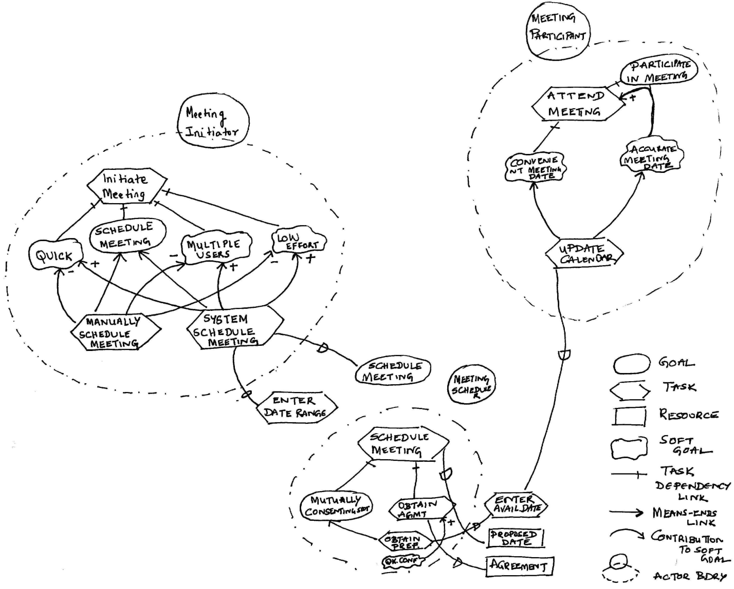
The above i* diagram shows the major stakeholders of the SDMS – Meeting Initator and Meeting Participant and how they interact with the system and its functions.
Business Class Diagram
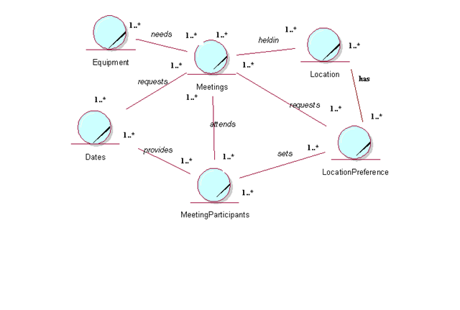
This diagram shows the business entities and the relationships between them along with the multiplicities between them.

Business Sequence Diagram
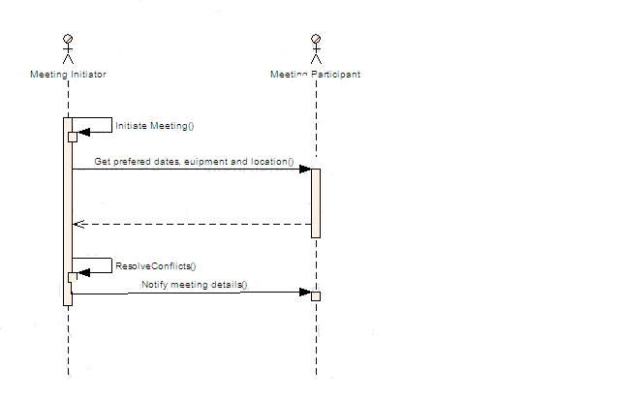

This diagram shows the business sequence diagram which depicts the interaction between a meeting initiator and meeting participant.

User Environment
An SDMS is a very light weight system which doesn’t need any special requirements to get installed on the user environment. It can be installed on any computer. Security measures will be in place to prevent unauthorized access to the system.

Stakeholder/User Profiles

Meeting Scheduler/Initiator

Description | A person who initiates/schedules meetings
Type | Primary User
Responsibilities | He is responsible to Initiate a particular meeting by selecting participants, meeting location, preferred start and end date and time period.
Success Criteria | Ability to schedule meeting on a preferred date, in a preferred location and with all the required participants with less number of negotiations
Involvement | We will have sample meeting schedulers to help evaluate our design to guide to our vision.
Deliverables | None
Comments/Issues | None

Meeting Participant

Description | A person who participates in the meetings
Type | Primary User
Responsibilities | There are 3 types of participants for the SDMS – Important, Active and Optional. Important participants – Very important for a meeting and the meeting will be cancelled if they cannot attend the meeting. Active – They address the meetings. Optional – All the other participants are optional
Success Criteria | Ability to accept a meeting request
Involvement | We will have sample meeting participants to help evaluate our design to guide to our vision.
Deliverables | None
Comments/Issues | None

Administrator

Description | A person who manages users of the system
Type | Primary User
Responsibilities | He accepts the users request for registering into the system by reviewing their credibility, unlock user accounts and delete user accounts.
Success Criteria | Ability to manage users – accept user requests by verifying their credibility, unlock users and delete users
Involvement | We will have sample administrators to help evaluate our design to guide to our vision.
Deliverables | None
Comments/Issues | None

Key Stakeholder or User Needs
Need | Priority | Concerns | Proposed Solutions
Need to schedule meetings easily | High | Ability to schedule and manage meetings easily through an online system | Develop SDMS
Less Number of Negotiations | High | Management of the negotiations going to and from the meeting initiator to the meeting participant | The system takes the start date and end date from the meeting initiator and takes the exclusion set and preference set of each participant and it gets the best available date. If an optional candidate cannot make it to the meeting, it withdraws the participant automatically. If an important participants cannot make it, the meeting will be cancelled and if an active participant cannot make to the meeting, the initiator is then contacted to take the decision
Take less time to resolve conflicts | High | Management of conflicts to avoid more number of negotiations | The system takes the preferred set and exclusion set from the participants calendar
Need to schedule virtual meetings | Medium | Ability to schedule virtual meeting to allow people to attend meetings through teleconferencing | Allow meeting location to be on a particular phone line or through video conferencing
Scheduling meetings concurrently | Medium | Ability to schedule more than one meeting concurrently | The system should be able to take more than one meeting initiator forms.
Monitor Meetings | Medium | Ability for others to monitor the meetings | Provide videoconferencing to allow other people to monitor the meetings
Upload meeting documents | Low | Ability to upload the meeting documents for further references | Provide a section in SDMS where the meeting participants can upload their documents
Select Meeting Location | High | Management of the meeting rooms | Provide a section in the meeting initiate form to allow the initiator to select a location from the available list and then the important participant gets a request to accept or give a preferred meeting location
Select Preferred Date for Meeting | High | Ability to select a meeting date which is convenient for most of the participants | Provide a section in the meeting initiate form to select the start date and end date and the system takes the exclusion set and preference set of each participant and it gets the best available date.
Select Meeting Equipment | High | Management of the available meeting equipments. | Provide a section in the meeting initiate form allowing the meeting initiator to select a meeting equipment. An active participant can also request for any equipment when he gets the request of the meeting
Secured Access | High | Management of private user and meeting information | Provide a login for each user and verify their credentials
Usability | Medium | Ability to provide  intuitive navigation the complete system | Provide easy interface to the users to be able to go through the system without any training.

Product Overview
This section contains an overview of the proposed Synergy Distributed Meeting Scheduler System, including information such as a product perspective, product assumptions and dependencies, etc.

Product Perspective

Synergy Soft, Inc. has been using a simple Microsoft Excel spreadsheet for scheduling meetings and keeping track of attendees. Since the company has grown over time, this method has become highly inefficient. To solve this problem, they have decided to use an effective software system that would enable them to schedule meetings and provide other related services like reserving meeting locations, inviting people, rescheduling meetings etc. After gathering the initial documents, they have approached the high-fliers to deliver a detailed requirements document. This software system (SDMS) shall serve as a solution to Synergy Soft, Inc.’s problem of inefficient meeting scheduling methods.

The Synergy Distributed Meeting Scheduler System is independent and totally self-contained as of now. But as a further enhancement it may be interfaced with the company’s address book.

Summary of Capabilities
Customer Benefit | Supporting Features
Organize meetings i.e., to determine, for each meeting request, a meeting date and location so that most of the intended participants will effectively participate | The system proposes a meeting date which belongs to the date range stated by the meeting initiator. It will not belong to the exclusion date set of any participant and will belong to the preferred date sets of the participants. It shall also allow the initiator to select the meeting location.
Monitor meetings, especially when they are held in a distributed manner | TBD
Plan Meetings under the constraints expressed by participants | The meeting date proposed by the system will not belong to the exclusion date set of any participant and will belong to the preferred date sets of the participants.
Re-Plan a meeting to support the changing user constraints | The system allows the participants to modify their exclusion sets, preference sets; it allows the meeting initiator to extend the date range; Cancellation of the meeting is also allowed if it is inevitable.
Support Conflict Resolution  (according to the resolution policies stated by the client) | 1. The system allows the Meeting Initiator to change the Date Range.  2. The system allows the Meeting Initiator to notify the participants to change their preference and exclusion sets so as to accommodate the proposed meeting date.
Manage all the interactions among participants required during  the organization of the meeting, | The system notifies the participants of the proposed meeting date; allows them to accept/reject the meeting invitations; notifies them if the meeting date is changed or if the meeting is cancelled.

Assumptions and Dependencies

Cost and Pricing
TBD

Licensing and Installation
This product will be sold to the customer on a license-basis. Installation of this product shall be performed by the customer with minimal support from the company.

Product Features

The following features address security requirements of the system
- Login to the system
An authorized user can log in to the SDMS system.
- Sign Up for an account
A new user can create a new account and become an authorized user.
- Logout of the system
A user can log out from the system.
- Change password
An authorized user can change his/her password whenever desired.
- Lock user account
A user account is locked by the system if a user tries to log in with an incorrect password for more than three times.
The following features relate to the process of initiating a meeting
- Select participants for a meeting
A Meeting Initiator can select participants for his meeting.
- Multiple meeting scheduling
A meeting initiator can schedule multiple meetings at the same time.
- Set participant category
Participant can be categorized as important, active or optional.
- Select “Date range” for meeting
A meeting Initiator should be able to select a Date Range within which the meeting will be scheduled.
- Select “Location” for the meeting
A meeting location can be selected from the list of available locations based on meeting date and resources.
- Select “Resources” for the meeting
Resources like projectors, DVD players, etc. can be requested for the meeting.
- Get Preferred Dates of all participants
Within the date range, a set of dates that are convenient for all participants can be obtained by the system.
- Confirm a specific meeting date from the “Date Range”
After getting preferred dates from all potential attendees, choose one preferred date that is convenient to all.
- Send invites to participants
After confirming all meeting details, invitations can be sent to potential attendees as updates to their SDMS accounts.
- Re-plan a meeting
A meeting Initiator can re-plan a meeting to support changing external constraints.

The following features relate to the process of responding to a meeting invite

- Accept a meeting invite (without comments)
Potential attendees can accept a meeting invitation unconditionally.
- Accept a meeting invite (with comments)
Potential attendees can write comments along with their acceptance to let the initiator know if they cannot stay for the entire duration of the meeting or if they need a location change or require additional resources.
- Request additional resources for the meeting
Active participants can request additional resources while accepting the meeting invitation.
- Suggest preferred location
Important participants can suggest their location preferences while accepting a meeting.
- Reject a meeting invite
Potential attendees can reject a meeting invite.

The following features relate to the process of updating a meeting request

- Change meeting Location
Based on the preference requests from important participants, the meeting initiator can change the location of the meeting.
- Change meeting Date
The meeting can be re-scheduled by the initiator in the event of irresolvable conflicts.
- Add meeting Details (agenda)
More details can be added to a meeting description.
- Add new participants or remove existing participants
At any time before the meeting, the initiator can add more potential attendees to the meeting or remove the existing participants.
- Add resources to the meeting
Based on the equipment requests from active participants, the meeting initiator can add equipment to the meeting.
- Notify participants about any changes
Emails will be dispatched to the participants whenever the initiator makes any changes to a meeting.
- Upload meeting minutes
All potential attendees can upload a summary of the meeting or any concerning documents.

The following features are other miscellaneous features supported by SDMS
- Email meeting reminders
Email reminders shall be sent to all the “accepted” meeting attendees 30 minutes before the meeting.
- Notify initiators about location contentions
When two or more meetings are contending for the same location, the initiators of those meetings are notified.
- Update Calendar
Users can update their calendars with exclusion sets and preference sets.

Product features supporting Conflict Resolution
A conflict resolution technique shall be used by the SDMS to resolve date conflicts.

Date Conflict
- If there is a date conflict with an important participant, the system cancels the meeting and asks the initiator to re-plan the meeting.
- If there is a date conflict with an active participant, the system will inform the initiator about it. The initiator can decide on whether changing the active participant or re-schedule the meeting.
- If there is a date conflict with an optional participant, the system automatically withdraws him from the meeting.

The following are the features available for an administrative role
- Accept the request for a New User account
When a new user creates an account in SDMS the administrator receives a request and he activates the account before the user can start using his account.
- Unlock user accounts
User accounts that have been locked by the system due to more than three attempts of incorrect password, can be unlocked by the administrator upon user request.
- Disable User Accounts
User accounts which are temporarily not in use can be disabled by the administrator.
- Enable User Accounts
User accounts that have been disabled can be enabled by the administrator when they are needed.
- Delete user account
User accounts which are no longer in use can be deleted by the administrator.

Other features:

- Online Access
SDMS will be launched as a web application, and can be accessed by any authorized user at any time from any location with access to the internet.

Constraint

Maintainability

Maintainability is provided by either testability, understandability, modifiability and evolvability.
Understandability further depends on consistency. Modifiability further depends on structured-ness and Extendibility. This is further provided by evolvability and object oriented-ness. Object oriented-ness is provided by objects.

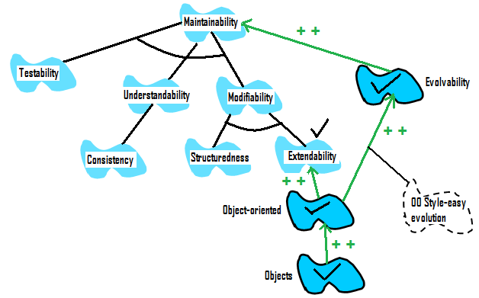

Reliability
Reliability for SDMS includes Integrity, availability and accuracy. RDBMS and Efficiency strongly make integrity where as consistency also contributes to integrity. But using an RDBMS strongly decreases performance.

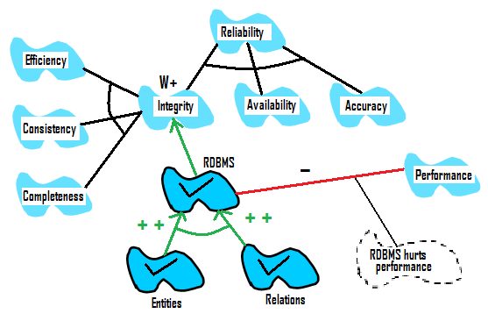

Security
Security for the SDMS includes integrity, confidentiality and availability. The confidentiality includes authentication of a user is verified by a user name and password.
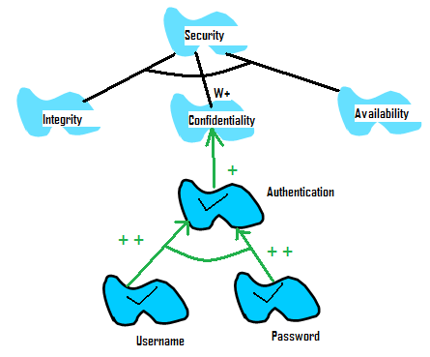

Minimal Number of Negotiations

Minimal Number of negotiations is achieved by having three things together:
- Take the start date and end date from the meeting initiator
- Take the preference set and exclusion set from the meeting participants calendars
- System automatically gives the preferred date for the meeting.
- If a date conflict occurs for an important participant, that meeting will be cancelled or a new round of negotiations are required.
- If a date conflict occurs with an optional participant, the participant will be automatically withdrawn from the meeting by the system.
- If a date conflict occurs with an active participant the meeting initiator is given a chance to decide on whether to change the active participant or start a new round of negotiations.

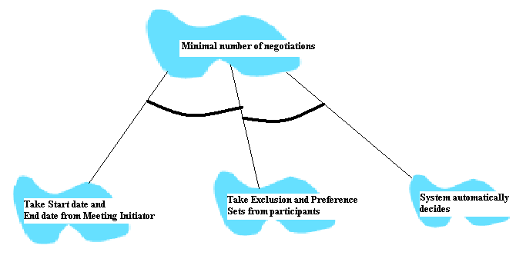

Quick Conflict Resolution

To achieve quick conflict resolution, it is required to have the following:
- Categorize the participants into Important, Active and Optional.
- Take preference sets and exclusion sets from the participants
- System decides on the preferred meeting date in most of the situations

