Team Blitzkrieg
Distributed Meeting Scheduler

Final Phase II

Software Requirements Specification
Version 1.23

Team Blitzkrieg
Team Website: http://utdallas.edu/~srw051000/SE6361_Blitzkreig/
Student Name | Student Id | Email address
Aditya Dhamankar | acd081000 | acd081000@utdallas.edu
Ajay Narasimmamoorthy | axn084020 | axn084020@utdallas.edu
Bryan Parker | blp090020 | blp090020@utdallas.edu
Jassem Shakil | jxs082200 | jxs082200@utdallas.edu
Jeevan Kumar | jxg096020 | jxg096020@utdallas.edu
Muhammad Abdullah | mxa088100 | mxa088100@utdallas.edu
Preeti Ganeshmohan | pxg076000 | pxg076000@utdallas.edu
Sean Wilson | srw051000 | srw051000@utdallas.edu
Vinay SAMPATHKumar | vks061000 | vks061000@utdallas.edu
MEGHANA SATPUTE | mns086000 | mns086000@utdallas.edu

Submitted to:
Dr. Lawrence Chung
Associate Professor,
Department of Computer Science,
The University of Texas at Dallas

Revision History

Version | Date | Description | Editor
1.1 | 09/15/2009 | Added Domain Issues | Sean ,Bryan
1.2 | 09/17/2009 | Added Functional & Nonfunctional Issues | Preeti, Vinay, Jassesm, Muhammad
1.3 | 09/21/2009 | Added Domain Improved Understanding | Sean, Bryan
1.4 | 09/23/2009 | Added Project Overview (Ref. from previous slides) | Sean, Jeevan
1.5 | 09/24/2009 | Added Functional Improved Understanding | Preeti, Vinay
1.6 | 09/27/2009 | Added Nonfunctional Improved Understanding | Jassem, Muhammad
1.7 | 09/30/2009 | Finished integrating the document. | Sean , Bryan
1.8 | 10/01/2009 | Updated the Prototype Section | Ajay, Aditya
1.9 | 10/03/2009 | Added Additional Requirements | Bryan
1.10 | 10/13/2009 | Added meeting history | Sean, Vinay
1.11 | 10/14/2009 | Added Traceability Matrix between system and Domain | Bryan, Sean
1.12 | 10/16/2009 | Added user manual | Ajay, Aditya
1.13 | 10/18/2009 | Added Traceability between prototype and system | Sean
1.14 | 10/20/2009 | Added WRS Template(Goals and problems) | Jeevan,Sean,Meghana
1.15 | 10/21/2009 | Integrated the document | Jeevan
1.16 | 10/22/2009 | Added UML, Final reviewing and editing | Meghana
1.17 | 10/22/2009 | Final Reviewing | Sean
1.18 | 11/01/2009 | Added New Requirements, Outlook Features | Vinay, Meghana
1.19 | 11/04/2009 | Added new Traceability | Vinay, Preeti
1.20 | 11/05/2009 | Semi-Formal Notation | Jeevan, Aditya, Ajay
1.21 | 11/09/2009 | Final Reviewing | Vinay
1.22 | 11/11/2009 | Added UML diagrams, references and reviewed | Meghana
1.23 | 11/25/2009 | Updated Requirements Table, Improved Understanding & Traceability Matrices | Sean
1.23 | 11/26/2009 | Updated Improved Understanding & Added Phase I vs Phase II Traceability Table. | Sean

Table of Contents
1. Introduction 7
1.1 Project Scope 7
1.1.1 Intended Users 8
1.1.2 Stakeholders 8
1.2 Project Deliverables 8
1.3 Project Responsibilities 9
1.4 Process Model 10
1.5 Requirements 11
1.5.1 Domain Requirements 11
1.5.2. Functional Requirements 12
1.5.3. Nonfunctional Requirements 12
2. Issues with Preliminary Definition 13
2.1 Issues with the Domain, Stakeholders Functional and Non-Functional Objectives 13
2.1.1 ISSUE STATEMENT: [DR1] 13
2.1.2 ISSUE STATEMENT: [DR2] 14
2.1.3 ISSUE STATEMENT: [DR3, DR4] 15
2.1.4 ISSUE STATEMENT: [DR5] 15
2.1.5 ISSUE STATEMENT: [DR6] 16
2.1.6 ISSUE STATEMENT: [DR7] 16
2.1.7 ISSUE STATEMENT: [DR8] 17
2.1.8 ISSUE STATEMENT: [DR9, DR10] 17
2.1.9 ISSUE STATEMENT: [DR11] 18
2.1.10 ISSUE STATEMENT: [DR12] 18
2.1.11 ISSUE STATEMENT: [DR13] 19
2.1.12 ISSUE STATEMENT: [DR14] 19
2.1.13 ISSUE STATEMENT: [DR15] 20
2.1.14 ISSUE STATEMENT: [DR16] 20
2.1.15 ISSUE STATEMENT: [DR19] 21
2.1.16 ISSUE STATEMENT: [DR21] 21
2.1.17 ISSUE STATEMENT: [DR24] 22
2.1.18 ISSUE STATEMENT: [DR25] 22
2.1.19 ISSUE STATEMENT: [DR26] 23
2.2 Issues with Software System Requirements – Functional Requirements 24
2.2.1 ISSUE STATEMENT: [FR1] 24
2.2.2 ISSUE STATEMENT: [FR3] 25
2.2.3 ISSUE STATEMENT: [FR3] 26
2.2.4 ISSUE STATEMENT: [FR5] 26
2.2.5 ISSUE STATEMENT: [FR5] 27
2.2.6 ISSUE STATEMENT: [FR6] 27
2.2.7 ISSUE STATEMENT: [FR12, FR13] 28
2.2.8 ISSUE STATEMENT: [FR15] 28
2.2.9 ISSUE STATEMENT: [FR18] 29
2.2.10 ISSUE STATEMENT: [FR19] 29
2.2.11 ISSUE STATEMENT: [FR21] 30
2.2.12 ISSUE STATEMENT: [FR22] 31
2.2.13 ISSUE STATEMENT: [FR23] 32
2.2.14 ISSUE STATEMENT: [FR24] 33
2.2.15 ISSUE STATEMENT: [FR25] 34
2.2.16 ISSUE STATEMENT: [FR26] 35
2.2.17 ISSUE STATEMENT: [FR27] 36
2.3 Issues with Software System Requirements – Non-Functional Requirements 37
2.3.1 ISSUE STATEMENT: [NFR2] 37
2.3.2 ISSUE STATEMENT: [NFR3] 38
2.3.3 ISSUE STATEMENT: [NFR4] 38
2.3.4 ISSUE STATEMENT: [NFR5] 39
2.3.5 ISSUE STATEMENT: [NFR6] 39
2.3.6 ISSUE STATEMENT: [NFR7] 40
2.3.7 ISSUE STATEMENT: [NFR8] 40
2.3.8 ISSUE STATEMENT: [NFR9] 41
2.3.9 ISSUE STATEMENT: [NFR10] 42
2.3.10 ISSUE STATEMENT: [NFR11] 42
2.3.11 ISSUE STATEMENT: [NFR12] 43
2.3.12 ISSUE STATEMENT: [NFR13] 43
2.3.13 ISSUE STATEMENT: [NFR14] 44
2.3.14 ISSUE STATEMENT: [NFR18] 44
3. WRS ( World, Requirement, Specification) 46
1. Problem 46
2.Goal 46
3.1 Improved Understanding for the Domain, Stakeholders Functional and Non-Functional Objectives 47
3.2 Improved Understanding for Software System Requirement: Functional Requirement 48
3.3 Improved Understanding for Software System Requirement: Non-Functional Requirement 51
USABILITY: 54
4. Preliminary Prototype and User Manual 56
4.1. Prototype 56
1. Register Page 56
2. Login Page 57
3. User Profile 58
4. Home Page 59
5. Schedule New Meeting 60
6. New Incoming Meeting Request – Active Participant 61
7. New Incoming Meeting Request – Important Participant 62
8. New Incoming Meeting Request – Regular Participant 63
9. Conflict Resolution 64
4.2. User Manual 65
1. Login page 65
2. Home page 65
3. Schedule New Meeting page 65
4. Finalize Meeting Page: 66
5. User Profile Page: 66
6.Result Page: 66
5 .Traceability Matrix & Table 67
5.1 Domain vs System 67
5.2 Prototype Features 68
5.3 System Vs Prototype 69
5.4 Functional vs Nonfunctional 70
5.5 Phase I vs PhaseII 70
6. Product Specification Models 72
6.1 Use Case Description:– 73
6.2 Use Case Diagram :- 74
6.3 Class Diagram :- 75
Fig. 6.3 Class Diagram 75
7. Our Project – Why Better? 76
8. References 77
9. Definitions, Acronyms and Abbreviations 78
10. Glossary 78

1. Introduction
The introduction will provide entry level details to the reader, for this project. It will provide a brief overview of the project, the deliverables applicable to this project together with phases and deadlines, the reference material and finally the terminologies and concepts associated with the project. ^{[1] [2]}

1.1 Project Scope
The project Distributed Meeting Scheduler automates the process of scheduling meetings. It is a type of resource allocation and collaboration system. The main function of this project is to schedule meetings based on the availability of resources and constraints put forward by the resources. There are primarily two actors in the system:
- Meeting Initiator
Responsible for initiating a meeting and defining an interval within which a meeting can be held.
- Potential Meeting Attendees
These people will be attending a meeting and will provide availability timings and non-availability timings to the system. Some meeting attendees can be further classified into three categories:
- Important Participants: ^{[3]}
Meeting attendees who may specify their preferred meeting locations
- Active Participants: ^{[3]}
Meeting attendees who may be providing special equipment requirements for the meeting like projector, internet connection etc.
- Regular Participants:
Meeting attendees who specify their preferred and exclusion sets only

The system functions in the following manner:
- The meeting initiator initiates a meeting along with the time interval within which the meeting can take place
- The meeting attendees provide their availability and non-availability information along with their preferred meeting location
- The system then finds a feasible meeting time along with an available preferred meeting room for the meeting keeping in consideration the constraints and availability data provided by various actors of the system
- If there are any conflicts, the system supports conflict resolution using the conflict policy provided by the client
- The system also supports changing user constraints before the date and location of the meeting is finalized

1.1.1 Intended Users
  - TeraSoft
The system will be designed specifically for TeraSoft as per the requirements
posted by TeraSoft.
  - Organizations with IT Infrastructure
Any organization with IT infrastructure can use Distributed Meeting Scheduler
for scheduling intra-organization meetings.

1.1.2 Stakeholders
The following are the stakeholders in this project.
- TeraSoft ^{[3]}
The organization which has requested services of Team Blitzkreig for requirements engineering and development of Distributed Meeting Scheduler
- Team Blitzkrieg
Team, responsible to carry out the aforementioned activities
- Professor Lawrence Chung
Co-ordinated with Terasoft on behalf of Team Blitzkrieg to gather customer’s requirements

1.2 Project Deliverables
The project is divided into two phases with each phase having two sub-phases. The following is the project deliverable chart for interim phase I along with deadlines:

 | S No. | Deliverable | Deadline
Phase 1 | 1 | Software Project Management Plan | September 3rd, 2009
Phase 1 | 2 | Software Requirements Specification | September 18th, 2009
Phase 1 | 3 | Prototype (Mock-up) | September 24th, 2009
Phase 1 | 4 | User Manual | September 27th, 2009
Phase 1 | 5 | Presentation | September 29th, 2009
Phase 1 | 6 | Revised Software Project Management Plan | October 17th, 2009
Phase 1 | 7 | Revised Presentation | October 19th, 2009
Phase 1 | 8 | Revised Software Requirements Specification | October 21st, 2009

1.3 Project Responsibilities
Phase 1
  Deliverable | Developers | Reviewers | Team Lead(s)
  Software Project Management Plan | Jassem  Muhammad | Aditya  Ajay  Bryan  Jeevan  Preeti  Sean | Vinay
  Requirements Specifications | Bryan  Jassem  Jeevan  Muhammad  Preeti  Sean  Vinay | Aditya  Ajay  MEGHANA | Aditya
  Prototype | Aditya  Ajay  Muhammad | Bryan  Jassem  Jeevan  Sean  Vinay | Preeti
  User Manual | Ajay | Aditya  Bryan  Jassem  Muhammad  Preeti  Sean  Vinay | Jeevan
  Presentation | BRYAN  Jassem  Preeti  Vinay | Aditya  Bryan  Jeevan  Muhammad  Sean | Ajay

1.4 Process Model
Distributed Meeting Scheduler will be completed by Team Blitzkrieg in two phases. In the first phase, the activities of Systems Engineering and Requirements Analysis will be performed by the team. The second phase will incorporate activities of Software Architecture and Design, Implementation and Testing.
In order to cater the changing requirements, Evolutionary Spiral Model will be used for software development.

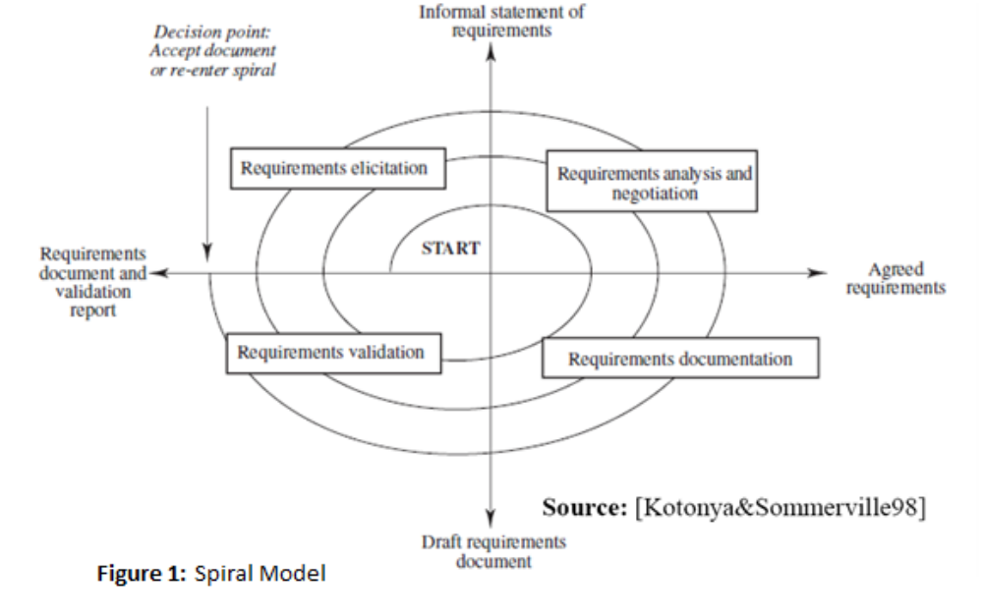The team will produce each deliverable by:
- Analyzing and discussing requirements in team meetings
- Constructing deliverables
- Reviewing deliverables for amendments before submission
While carrying out Requirements Analysis, model proposed by Ross will be used to answer the three most important questions:
1. Why the system is needed?
2. What system features will serve and satisfy this context?
- How the system is to be constructed?

1.5 Requirements

1.5.1 Domain Requirements
DR1 | In the application domain, meetings are typically arranged in the following manner.
DR2 | A meeting initiator will ask all potential meeting attendees for the following information based on their personal agenda:
DR3 | a set of dates on which they cannot attend the meeting (hereafter, referred to as exclusion set); and
DR4 | a set of dates on which they would prefer the meeting to take place (hereafter referred to as preference set);
DR5 | A meeting date shall be defined perhaps by a combination of calendar date, time period and time zone.
DR6 | The exclusion and preference sets should be contained in some time interval prescribed by the meeting initiator (hereafter referred to as date range).
DR7 | The initiator could also ask, in a friendly manner, active participants to provide any special equipment requirements on the meeting location (e.g., overhead projector, workstation, network connection, telephone, etc.).
DR8 | She may also ask important participants to state preferences about the meeting location.
DR9 | The proposed meeting date should belong to the stated date range and to none of the exclusion sets;
DR10 | furthermore it should ideally belong to as many preference sets as possible.
DR11 | The proposal should be made as early as possible.
DR12 | A date conflict occurs when no such date can be found.
DR13 | A conflict is strong when no date can be found within the date range and outside all exclusion sets;
DR14 | A conflict is weak when dates can be found within the date range and outside all exclusion sets, but no date can be found at the intersection of all preference sets.
DR15 | A conflict can be resolved by the initiator extends the date range; and
DR15 | A conflict can be resolved by some participants remove some dates from their exclusion set; and
DR15 | A conflict can be resolved by some participants withdrawing from the meeting; and
DR15 | A conflict can be resolved by some participants adding some new dates to their preference set.
DR16 | Each conflict resolution should be done as quickly as possible and with no more interactions than is really needed.
DR17 | It shall meet the equipment requirements
DR18 | A meeting room must be available at the selected meeting date.
DR19 | furthermore it [the meeting room] should ideally belong to one of the locations preferred by as many important participants as possible.
DR20 | It is absolutely necessary, however, to allow each meeting to take place in a virtual place, e.g., through teleconferencing using laptop computers.
DR21 | The number of negotiations shall be kept minimal, but a new round of negotiation may be required when no such room can be found.
DR22 | The meeting initiator can be one of the participants or some representative (e.g., a secretary).
DR23 | The meeting initiator can cancel or reschedule a meeting.
DR24 | All participants can fully, partially or not attend a meeting.
DR25 | The meeting can be scheduled to be one-time or recurring.
DR26 | Meeting locations should be convenient

1.5.2. Functional Requirements
FR1 | The purpose of DMS is to support the organization of meetings – that is, to determine, for each meeting request, a meeting date and location so that most of the intended participants will effectively participate.
FR2 | SDMS shall assist users in the following activities:
FR3 | Monitor meetings, especially when they are held in a distributed manner;
FR4 | Plan meetings under the constraints expressed by participants (see domain theory);
FR5 | Re-plan a meeting to support the changing user constraints, for instance:
FR6 | to modify the exclusion set, preference set and/or preferred location before a meeting date/location is proposed; and
FR7 | to take some external constraints into account after a date and location have been proposed - e.g., due to the need to accommodate a more important meeting. - here, the original meeting date or location may then need to be changed; sometimes the meeting may even be cancelled.
FR8 | In all cases some bound on re-planning should be set up.
FR9 | Support conflict resolution according to resolution policies stated by the client;
FR10 | Manage all the interactions among participants required during the organization of the meeting, for instance:
FR11 | to support the negotiation and conflict resolution processes;
FR12 | to make participants aware of what's going on during the planning process;
FR13 | to keep participants informed about schedules and their changes; and
FR14 | The meeting scheduler system must in general handle several meeting requests in parallel.
FR15 | Meeting requests can be competing when they overlap in time or space. Concurrency must thus be managed.
FR16 | The meeting initiator indicates a deadline to include preferences and exclusion sets.
FR17 | If a conflict exists, after the preference and exclusion set deadline is set and reached, additional time is given to resolve the conflicts, otherwise the meeting date is finalized.
FR18 | Some meetings are scheduled and organized at the same time where partial attendance can be allowed
FR19 | Each of the different type of user should have different access privileges
FR20 | A secure login username and password is required for each of the user to access the system
FR21 | A participant should only be able to see the meeting information that he/she initiated or is part of
FR22 | A participant should only be able to search the meeting information that he/she initiated or is part of
FR23 | The meeting initiator should be able to invite another person even after sending the original meeting request.
FR24 | The system should automatically decline conflicting meeting requests for each user
FR25 | The meeting coordinator can Create reminders for a meeting as far in advance as he/she wants.
FR26 | Initiator can open another person's calendar, contacts, or tasks to see if that person is available for meeting.
FR27 | Any Participant should be able to cancel the meeting

1.5.3. Nonfunctional Requirements
NFR1 | In meeting the functional requirements, non-functional requirements should also be taken account. They include:
NFR2 | A meeting should be accurately monitored, especially when it is held in a virtual place. Here, nomadicity will then be important to consider;
NFR3 | Re-planning of a meeting should be done as dynamically and with as much flexibility as possible;
NFR4 | The amount of interaction among participants(e.g., number and length of messages, amount of negotiation required) should be kept minimal;
NFR5 | The intended system should considerably reduce the amount of overhead usually incurred in organizing meetings where potential attendees are distributed over many different places and  communicate with each other, for example, via Internet;
NFR6 | The system should reflect as closely as possible the way meetings are typically managed (see the domain theory above);
NFR7 | The meeting date and location should be as convenient as possible, and available as early as possible, to all (potential) participants;
NFR8 | The system should accommodate as much decentralized requests as possible; any authorized user should be able to request a meeting independently of her whereabouts;
NFR9 | Physical constraints should not be broken --- e.g., a person may not be at two different places at the same time; a meeting room may not be allocated to more than one meeting at the same time; etc.;
NFR10 | The system should provide an appropriate level of performance:
NFR10 | the elapsed time between the submission of a meeting request and the determination of the corresponding date/location should be minimal; or
NFR10 | a lower bound should be fixed between the time at which the meeting date is determined and the time at which the meeting is actually taking place;
NFR11 | The system should be usable by non-experts;
NFR12 | The system should be customizable to professional as well as private meetings - ...;
NFR13 | The system should be flexible enough to accommodate evolving data - e.g., the sets of concerned participants may be varying, the address at which a participant can be reached may be varying, etc.;
NFR14 | The system should be easily extensible to accommodate the following typical variations:
NFR14 | handling of explicit priorities among dates in preference sets;
NFR14 | variations in date formats, address formats, interface language, etc.; and
NFR14 | partial reuse in other contexts - e.g., to help establish course schedule.
NFR15 | More than 50 percent of active participants must attend the meeting.
NFR16 | The meeting initiator indicates a lower bound for a meeting date and location to be decided.
NFR17 | The response deadline for the decision of the meeting date and location should be less than the specified lower bound.
NFR18 | Information about meetings should be secure.

2. Issues with Preliminary Definition

2.1 Issues with the Domain, Stakeholders Functional and Non-Functional Objectives

2.1.1 ISSUE STATEMENT: [DR1]
“In the application domain, meetings are typically arranged in the following manner.”
Problem: (Type of Issue: ambiguity) The statement implies that there are multiply ways to arrange a meeting.
Option 1: Define several ways to arrange a meeting.
Option 2: Remove the word “typically.”
Option 3: Remove the entire statement.
Solution: Option 2
Rationale: If the word “typically” is removed, then the statement will imply that there is only one way that a meeting is arranged. This eliminates any ambiguity and saves time, compared to creating multiple variations of the same method. Removing the statement would cause confusing because there would be no overall summary of what is going to be described.
Reference: None

2.1.2 ISSUE STATEMENT: [DR2]
“A meeting initiator will ask all potential meeting attendees for the following information based on their personal agenda”
Problem: (Type of Issue: ambiguity) The statement does not give the definition of a “meeting initiator” and a definition for “potential meeting attendees.”
Option 1: Define the meeting initiator as a person who requests a meeting. Define the potential meeting attendees as people who have received a meeting invitation from the meeting initiator with a request to fill out the following information based on their personal agenda.
Option 2: Define the meeting initiator as someone who starts the meeting and the potential meeting attendees are the people who could possibly attend the meeting based on their agenda information.
Solution: Option 1
Rationale: A much more accurate description and definition of a meeting initiator and potential meeting attendees. This greatly reduces any ambiguous doubts about what roles the individuals have within the meeting scheduler system.
Reference: None

2.1.3 ISSUE STATEMENT: [DR3, DR4]
“a set of dates on which they cannot attend the meeting (hereafter, referred to as exclusion set) and a set of dates on which they would prefer the meeting to take place (hereafter referred to as the preference set)”
Problem: (Type of Issue: incompleteness) Does not completely state what information is included in the exclusion and preference sets.
Option 1: An exclusion and preference set contains a set of dates and times that correspond with those dates that they prefer (or do not prefer) the meeting to take place.
Option 2: An exclusion and preference set contains a set of dates and times that correspond with those dates within the date/time range that the meeting initiator has specified.
Solution: Option 2
Rationale: This option is more complete and specific compared to the first option. Time need to be included with the dates because not all potential meeting participants are available/ unavailable throughout the entire dates that they choose. Also, they have to choose the dates/times within the specified time/range, otherwise a potential participant might set a preference time at 1:00 a.m. in the morning.
Reference: None

2.1.4 ISSUE STATEMENT: [DR5]
“A meeting date shall be defined perhaps by a pair (calendar date, time period).”
Problem: (Type of Issue: incompleteness) There is not clear decision as what constitutes as a meeting date.
Option 1: Remove the word “perhaps” and define the meeting dates as a pair consisting of a calendar date and time.
Option 2: Remove the word “perhaps” and define the meeting dates as consisting of a calendar date, the day of the week, and time.
Solution: Option 2
Rationale: Removing the word “perhaps” gives the statement a concise decision, and defining the meeting date to also include the day of the week better clarifies when the meeting takes place.
Reference: None

2.1.5 ISSUE STATEMENT: [DR6]
“The exclusion and preference sets should be contained in some time interval prescribed by the meeting initiator (hereafter referred to as date range).”
Problem: (Type of Issue: unsoundness & ambiguity,) The statement sounds suggestive and time interval is not clearly defined.
Option 1: Remove “should be” and define the time interval as a start date and end date.
Option 2: Replace “should be” with “shall” and define the time interval as a start and end date/time with upper and lower bounds.
Solution: Option 2
Rationale: Removing “should be” makes the statement more concrete and a start/end time interval is required, not just the date, to prevent the selection of a time that a meeting would never occur ( For example: 3 a.m. in the morning)
Reference: None

2.1.6 ISSUE STATEMENT: [DR7]
“The initiator could also ask, in a friendly manner, active participants to provide any special equipment requirements on the meeting location (e.g., overhead projector, workstation, network connection, telephone, etc.).”
Problem: (Type of Issue: ambiguity) The statement does not clearly define an active participant and the phrase “could also ask, in a friendly manner” is subjective and suggestive, which creates ambiguity.
Option 1: Remove and replace the phrase “could also ask, in a friendly manner” with “asks” and define active participants as people who are going to speak or give a presentation in a meeting (such as give a presentation) who can request special equipment to be provided at the meeting location.
Option 2: Remove “could also ask, friendly manner” and define active participants as people who will provide special equipment to the meeting location.
Solution: Option 1
Rationale: Replacing the phrase makes the initiator obligated to contact active participants to inquire about special equipment needs. It also removes the interpretation that the active participants are the ones bringing the equipment.
Reference: None

2.1.7 ISSUE STATEMENT: [DR8]
“She may also ask important participants to state preferences about the meeting location.”
Problem: (Type of Issue: unsoundness & ambiguity) The statement specifies the initiator to be of a certain gender, important participants is not defined, and the possible meeting location preferences are broad.
Option 1: Define important participants as people who are deemed important by the initiator and are allowed to state a meeting location preference to be anywhere.
Option 2: Replace “she” with “initiator” and define important participants as people with a higher priority over other participants, whom can also be an active participant. They also have the option to state a preferred meeting location from a list of locations set by the meeting initiator.
Solution: Option 2
Rationale: Replacing “she” does not give the impression that the initiator can only be of a specific gender. The initiators role isn’t to decide which participants are considered important because an important participant has a pre-defined level of importance. Also, allowing the important participant to set a meeting preference to be anywhere would complicate the system and the final decision of the meeting location.
Reference: None

2.1.8 ISSUE STATEMENT: [DR9, DR10]
“The proposed meeting date should belong to the stated date range and to none of the exclusion sets; furthermore it should ideally belong to as many preference sets as possible.”
Problem: (Type of Issue: unsoundness) The statement is suggesting what “should be,” which leaves room open interpretations as to whether are not something should be done.
Option 1: Remove the two “should” words.
Option 2: Replace the two “should” words with “shall” and remove “ideally.”
Solution: Option 2
Rationale: Replacing the words with “shall” and removing “ideally” strongly emphases the constraints in which the system operates to determine a meeting date and time.
Reference: None

2.1.9 ISSUE STATEMENT: [DR11]
“The proposal should be made as early as possible.”
Problem: (Type of Issue: ambiguity) The statement does not clearly state what is “early.”
Option 1: Remove the statement.
Option 2: Define “early” with respect to the rate at which the potential meeting attendees respond with their preference/exclusion sets or the percentage of responses received from each type of potential attendee (active/important).
Solution: Option 2
Rationale: Replacing “should” with “must” elevates the priority that a feature needs to be implemented. If the statement was removed there is possibility that a proposal will take a long amount of time. Also, defining the meaning of “early” guarantees that a proposal will be reached within a certain amount of time.
Reference: None

2.1.10 ISSUE STATEMENT: [DR12]
“A date conflict occurs when no such date can be found.”
Problem: (Type of Issue: ambiguity) The statement does not give a time aspect to the date.
Option 1: Remove the statement.
Option 2: Change the word date to meeting date, which was defined as a calendar date and time period.
Solution: Option 2
Rationale: By clarifying that a date conflict occurs when no such meeting date can be found removes any ambiguity that could have arisen as a result of a user thinking it was referring to a date only.
Reference: None

2.1.11 ISSUE STATEMENT: [DR13]
“A conflict is strong when no date can be found within the date range and outside all exclusion sets;”
Problem: (Type of Issue: ambiguity) The statement does not give a time aspect to the date.
Option 1: Remove the statement.
Option 2: Change the word date to meeting date, which was defined as a calendar date and time period.
Solution: Option 2
Rationale: By clarifying that a date conflict occurs when no such meeting date can be found removes any ambiguity that could have arisen as a result of a user thinking it was referring to a date only.
Reference: None

2.1.12 ISSUE STATEMENT: [DR14]
“A conflict is weak when dates can be found within the date range and outside all exclusion sets, but no date can be found at the intersection of all preference sets.”
Problem: (Type of Issue: ambiguity) The statement does not give a time aspect to the date.
Option 1: Remove the statement.
Option 2: Change the word date to meeting date, which was defined as a calendar date and time period.
Solution: Option 2
Rationale: By clarifying that a date conflict occurs when no such meeting date can be found removes any ambiguity that could have arisen as a result of a user thinking it was referring to a date only.
Reference: None

2.1.13 ISSUE STATEMENT: [DR15]
“Conflicts can be resolved in several ways, including:”
Problem: (Type of Issue: ambiguity) This statement is insinuating that there may be additional ways (other than given) to resolve date conflicts.
Option 1: Remove the statement.
Option 2: Brainstorm about each and every possible way to resolve a date conflict.
Option 3: Assume that the stated points are the "only" ways to solve a date conflict in the case of the DMS. When resolving a date conflict, the system will default to one of these choices.
Solution: Option 3
Rationale: By specifying that these are the only ways to resolve a date conflict, it removes any ambiguity that existed before.
Reference: None

2.1.14 ISSUE STATEMENT: [DR16]
"Each conflict resolution should be done as quickly as possible and with no more interactions than is really needed."
Problem: (Type of Issue: ambiguity) This statement does not define what "quickly as possible" means, and the statement "no more interactions than is really needed" adds no value to this statement.
Option 1: Remove the statement.
Option 2: Define “quickly as possible” with respect to the rate at which the potential meeting attendees respond with their modified conflict resolution methods. Remove the statement "no more interactions than is really needed".
Solution: Option 2
Rationale: By defining the meaning of "quickly as possible", it guarantees that a resolution will be reached within a certain amount of time.
Reference: None

2.1.15 ISSUE STATEMENT: [DR19]
"Furthermore it should ideally belong to one of the locations preferred by as many important participants as possible."
Problem: (Type of Issue: ambiguity) The word ideally states a condition in which it is not required.
Option 1: Remove the statement.
Option 2: Remove ideally, and replace the statement "as many important participants as possible" with "the majority of important participants".
Option 3: Remove the ideally statement.
Solution: Option 2
Rationale: By removing ideally, you state a requirement that is more concrete.
Reference: None

2.1.16 ISSUE STATEMENT: [DR21]
"The number of negotiations should be kept minimal, but a new round of negotiation may be required when no such room can be found."
Problem: (Type of Issue: ambiguity) The statement sounds suggestive and minimal is not clearly defined.
Option 1: Remove the statement.
Option 2: Remove the should word.
Option 2: Replace should with shall and define minimal as the "maximum number of negotiations needed to resolve a conflict."
Solution: Option 3
Rationale: By removing should and specifying a more concrete value for minimal, the statement strongly emphasizes the constraints in which the system operates to resolve a conflict.
Reference: None

2.1.17 ISSUE STATEMENT: [DR24]
" All participants can fully, partially or not attend a meeting.”
Problem: (Type of Issue: ambiguity) The statement sounds suggestive and partial attendance is not clearly defined.
Option 1: Define partial attendance as the 50% or more participants attend the meeting.
Option 2: Define partial attendance as same participant can attend different meetings partially.
Option 2: Define partial attendance as same participant can attend different meetings partially but in non-overlapping manner.
Solution: Option 3
Rationale: Option 1 is already covered and allowing a participant to attend more than 1 meetings in non –overlapping manner seems more feasible as participant can not attend different meetings in same time interval. So for example if there are 2 meetings first is from 11 to 1 and second is from 11 to 2 then participant will be able to attend first meeting from 11 to 12 and second meeting from 12 to 1.
Reference: None
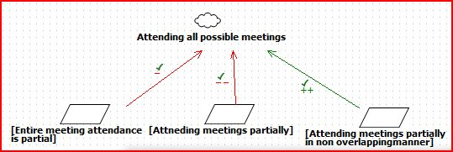

2.1.18 ISSUE STATEMENT: [DR25]
" The meeting can be scheduled to be one-time or recurring..”
Problem: (Type of Issue: ambiguity) Here the word “recurrence” does not explicitly say when the meeting can be recurrent. Also the statement sounds suggestive and a more defined approach needs to be taken.
Option 1: The meeting is recurrent every day at the time specified.
Option 2: The meeting is recurrent every week at the day and time specified.
Option 3: The meeting is recurrent every month at the date and time specified.
Option 4: The meeting is recurrent every year at the date and time specified.
Option 5: The meeting coordinator decides when the meeting should reoccur..
Solution: Option 5
Rationale: The meeting can be scheduled to be one-time or recurring. It means the initiator will be given an option if the meeting is one time or it will recur every day/week/ month/ year. If it is recurring then automatically requests will be sent for those meeting till the initiator cancels the meeting.
.Reference: None.
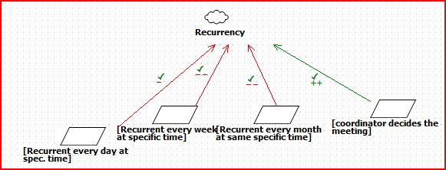

2.1.19 ISSUE STATEMENT: [DR26]
" Meeting locations should be convenient.”
Problem: (Type of Issue: ambiguity, redundant) Convenient can mean different things to different people. It is not clearly defined. It can mean near from participant’s home or near from participant’s office or from the preferred location participant has selected.
Option 1: All participants can give preferred location and the most preferred one is selected to be the meeting location.
Option 2: Only important participants can select their preferred location and the most preferred one by them is selected to be the meeting location.
Option 3: Ignore this requirement.
Solution: Option 3
Rationale: Option 2 is already covered. We can allow all participants to select preferred location (Option 1) but there can be a situation where location will be selected by regular participant’s preference and if 49% of them cancel the meeting then meeting will be still scheduled. Such a meeting might not be convenient to the important participants. Since Option 2 exists already, we will remove this requirement.
Reference: None.
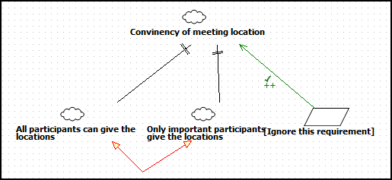

2.2 Issues with Software System Requirements – Functional Requirements

2.2.1 ISSUE STATEMENT: [FR1]

“The purpose of DMS is to support the organization of meetings – that is, to determine, for each meeting request, a meeting date and location so that most of the intended participants will effectively participate.”

Problem: Unclear on the following:
a. Who are the intended participants? Does it include both the important and active participants?
b. How many participants are required so that a meeting date and location could be decided?
Option 1:
a. All the important participants are treated as required. Active participants could be optionally present in the meeting.
b. All the important participants’ preferences need to be satisfied for the meeting to be held.

Option 2:
a. All the important and active participants are treated as required.
b. Important and active participant’s preferences to be satisfied for the meeting to be held.

Option 3:
a. All the important participants and active participants could be optionally present in the meeting.
b. More than a threshold (say 70%) of the important participant’s preferences on the date and location need to be satisfied. A meeting can be held when the total number of active and important participants needs to be more than thresholds say 50% and in that more than 70% of important participants participate.

Solution: Option 3

Rationale: This allows the meeting to be flexible if an important participant has other priorities. The thresholds are decided by the client.
Reference: None

2.2.2 ISSUE STATEMENT: [FR3]

“Monitor meetings, especially when they are held in a distributed Manner.”
Problem:
Does not describe what responsibilities does monitoring involve.

Option 1:
Responsible for initiating the meeting, fixing a meeting date after consensus with the participants and presiding over the meeting (making meeting notes).

Option 2:
Involves only fixing the meeting date.

Option 3:
Involves re-planning if meeting date is postponed/cancelled/preponed.

Option 4:
Includes arranging the meeting location and date after consensus from the participants and getting the resources for the meeting.

Solution: Option 4

Rationale: The participant who monitors the meetings is responsible for the meeting and aids in smooth conduction of the meeting.

Reference: None

2.2.3 ISSUE STATEMENT: [FR3]
“Monitor meetings, especially when they are held in a distributed Manner.”
Problem:
Does not describe who is supposed to monitor the meetings.
Option 1:
Active participant

Option 2: Important participant

Option 3: Meeting initiator

Solution: Option 3

Reason: The meeting initiator who monitors the meetings is responsible for the coordination and aids in smooth conduction of the meeting.

Reference: None

2.2.4 ISSUE STATEMENT: [FR5]
“Re-plan a meeting to support the changing user constraints.”
Problem: Does not mention who is responsible to re-plan the meeting

Option 1:
Any user who requests for a change becomes the meeting initiator and is responsible for the meeting. This user could be an important or an active participant.

Option 2:
Only the meeting initiator is allowed to make changes to the meeting when a participant requests for it.

Solution: Option 2

Rationale: Makes it organized and easy to track requests and changes.
Reference: None

2.2.5 ISSUE STATEMENT: [FR5]
“Re-plan a meeting to support the changing user constraints.”
Problem:
Does not list the whether the user is an important or active participant.
Option 1: Important or active participant can cause changes to the meeting.

Option 2:
Meeting is re-planned only if an important participant requests for it.

Option 3:
Meeting is re-planned only if an important participant request for it and the threshold of the number of important participants falls below 70%. If the absence of the important participant does not reduce below the threshold then the meeting cannot be changed.

Solution: Option 3

Rationale: Allows the meeting to be changed only when the majority of the important participants cannot attend the meeting. The threshold is decided by the client.

Reference: None

2.2.6 ISSUE STATEMENT: [FR6]
“To modify the exclusion set, preference set and/or preferred location before a meeting date/location is proposed.”
Problem:
When is the latest a meeting schedule can be changed?
Option 1:
Anytime before the meeting starts.

Option 2:
A defined period – like 10 min., 1 hours etc

Option 3:
This could be informed by the initiator in the meeting request email sent to all the participants. After the defined time the meeting details should not be changed.

Solution: Option 3

Rationale: Keeps the meeting organized by avoiding confusions and clashes.

Reference: None

2.2.7 ISSUE STATEMENT: [FR12, FR13]

“ ..to make participants aware of what's going on during the planning process;
.. to keep participants informed about schedules and their changes; ”
Problem:
Are all the participants (active, important and users who declined the meeting) informed about changes in the meeting.
Option 1:
Only the users who accepted the meeting are kept updated.

Option 2:
All the important participants who were sent the meeting request are updated. All the active participants who accepted the meeting request are updated.

Option 3:
Everybody who received the meeting request are updated (includes important, active participants and also participants who declined the meeting request.)

Solution: Option 3

Rationale: This allows users who declined a meeting due to different priority to have the option of attending a meeting if the time/location is changed.

Reference: None

2.2.8 ISSUE STATEMENT: [FR15]
“Meeting requests can be competing when they overlap in time or space.”
Problem: How are the ties broken?
Option 1: First come – first serve. Meetings that are booked first are prioritized first.

Option 2: Ties are broken by the meeting initiator who decides if the meeting needs to be cancelled/postponed/changed.

Solution: Option 2

Rationale: This allows a meeting to be cancelled if the meeting initiator decides to do so by looking at the priorities of the other meetings. In the absence of the meeting initiator, the decision is taken by an important participant. Ties are broken by taking votes from the important participants.

Reference: None

2.2.9 ISSUE STATEMENT: [FR18]
“Some meetings are scheduled and organized at the same time where partial attendance can be allowed.”

Problem: (Type of Issue: ambiguity) The statement sounds vague and partial attendance is not clearly defined. Also who schedules and organizes these meetings isn’t defined clearly
Option 1: Define partial attendance as continue with holding the meeting even if 50% or more participants attend the meeting.
Option 2: Define partial attendance as same participant can choose to attend or not attend different meetings partially as per his/her will.
Option 2: Define partial attendance as same participant can attend different meetings partially but in non-overlapping manner.
Solution: Option 3
Rationale: Option 1 is already covered and allowing a participant to attend more than 1 meeting in non –overlapping manner seems more feasible as participant cannot attend different meetings in same time interval. So for example if there are 2 meetings first is from 11 to 1 and second is from 11 to 2 then participant will be able to attend first meeting from 11 to 12 and second meeting from 12 to 1. This ensures his meeting schedule does not clash in time.
Reference: None

2.2.10 ISSUE STATEMENT: [FR19]
“Each of the different type of user should have different access privileges.”

Problem: (Type of Issue: ambiguity) The statement sounds vague and here “different” in terms of user types and access privileges are not listed which would make the requirement more clear. Also the statement sounds suggestive and a more defined approach needs to be taken.
Option 1: Define access privilege as any meeting participant shall be able to invite and include another participant to the meeting.
Option 2: Define access privilege as any meeting participant shall not be able to include another participant to the meeting. He/She can invite another person to the meeting only through the meeting coordinator.
Solution: Option 2.
Rationale: Option 2 makes sure that all users do not get access rights to add/delete the attendees of a particular meeting. Only the meeting coordinator shall have the sole authority to make the modifications..
Reference: None

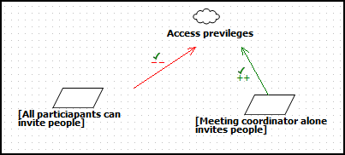

2.2.11 ISSUE STATEMENT: [FR21]
“A participant should only be able to see the meeting information that he/she initiated or is part of.”

Problem: (Type of Issue: ambiguity) The statement sounds vague and here “what” type of information a particular attendee can see which would make the requirement more clear. Also the statement sounds suggestive and a more defined stand needs to be taken
Option 1: The meeting attendee should be able to see any participants meeting information along with his/her own.
Option 2: The meeting attendee should be able to view only his/her own meeting information depending on their role as regular, important or active participant or meeting coordinator.
Solution: Option 2
Rationale: Security is ensured by concealing others participant’s information from a user so that data integrity and the privacy of the person is ensured. Also different roles have different access privileges. For example a regular participant must not be able to view or choose list of meeting rooms as only an important participant can choose from a list of meeting rooms. Similarly active participant shall not be allowed to create/modify or delete a meeting location or time which is the sole authority of the meeting coordinator. Only the meeting coordinator shall have the sole authority to view the calendar of the participant of the meeting to schedule effectively.
Reference: None

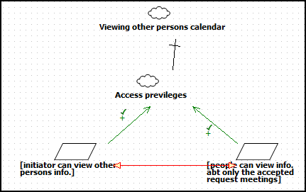

2.2.12 ISSUE STATEMENT: [FR22]
“A participant should only be able to search the meeting information that he/she initiated or is part of.”

Problem: (Type of Issue: ambiguity, redundancy) The statement sounds vague and here “what” type of information a particular attendee can search for which would make the requirement more clear. Also the statement sounds suggestive and a more defined stand needs to be taken. In addition this requirement is redundant as a similar requirement to view particular information is already defined
Option 1: The meeting attendee should be able to search for any participants meeting information along with his/her own.
Option 2: The meeting attendee should be able to search for only his/her own meeting information depending on their role as regular, important or active participant or meeting coordinator.
Solution: Option 2
Rationale: Security is ensured by concealing others participant’s information from a user so that data integrity and the privacy of the person is ensured. Also different roles have different access privileges. For example a regular participant must not be able to search for the list of meeting rooms as only an important participant can choose from a list of meeting rooms. Similarly active participant shall not be allowed to search for and modify/delete a meeting location or time which is the sole authority of the meeting coordinator. Only the meeting coordinator shall have the sole authority to search for and view the calendar of a participant of the meeting to schedule effectively.
Reference: None
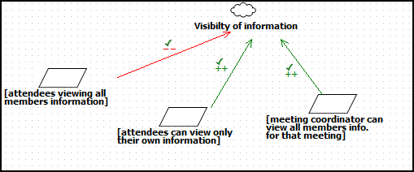

2.2.13 ISSUE STATEMENT: [FR23]
“The meeting initiator should be able to invite another person even after sending the original meeting request”

Problem: (Type of Issue: ambiguity) The statement sounds vague and here “why” the coordinator wants to include another person to the meeting is unclear. Also the statement sounds suggestive and a more defined stand needs to be taken.
Option 1: The meeting coordinator shall include another person as a participant according to his/her liking.
Option 2: The meeting coordinator shall include another person as a participant depending on their role as regular, important or active participant if an existing member suggests that person’s inclusion or if the coordinator feels that person has been missed out initially..
Solution: Option 2
Rationale: The flexibility to include a person to the meeting by the meeting coordinator even after the initial invite has been sent should be allowed by the system. Here a participant can request or suggest to the coordinator that another person be invited to the meeting and the coordinator sends the invite. The meeting coordinator can also include the person if he accidentally left him/her out during the initial invitation process.
Reference: Microsoft Office Outlook Meeting Scheduler features

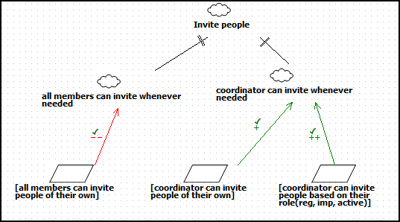

2.2.14 ISSUE STATEMENT: [FR24]
“The system should automatically decline conflicting meeting requests for each user.”
Problem:
The system has the ability to decline meeting requests for the user if there is a conflict in the meetings without notifying the user.
Option 1: The system cancels any conflicting meeting requests without notifying the user.
Option 2: The system notifies the user of the declined meeting request.
Option 3: The user is given the option of the decline the meeting request during a conflict. He has the ability to decline the earlier accepted meeting and can attend the new meeting. In addition, the user also has the capability to partially attend a meeting.
Solution: Option 3
Rationale: This gives the user the right to decide which meeting he/she would prefer to attend or partially attend.
Reference: Microsoft Office Outlook Meeting Scheduler features
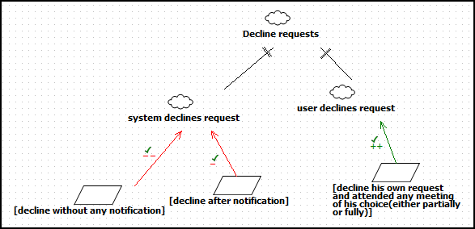

2.2.15 ISSUE STATEMENT: [FR25]
“The meeting coordinator can create reminders for a meeting as far in advance as he/she wants.”
Problem: Unclear on what information would the reminders contain. Also, how often are the meeting reminders sent before a meeting or if only 1 reminder is sent.
Option 1: The reminders sent contain only the meeting location and time.
Option 2: The reminders sent contain only the meeting location, meeting attendees and time.
Option 3: The reminders sent contain only the meeting location, meeting attendees, time and brief information about the meeting.
Option 4: The reminders sent contain only the meeting location, time and brief information about the meeting. The number of reminders sent is decided by the meeting coordinator to all participants who accepted the meeting.
Option 5: The reminders sent contain only the meeting location, time and brief information about the meeting. The number of reminders sent is decided by the meeting coordinator to important participants.
Option 6: The reminders sent contain only the meeting location, time and brief information about the meeting. The number of reminders sent is decided by the meeting coordinator to active participants.
Option 7: The reminders sent contain only the meeting location, time and brief information about the meeting. The number of reminders sent is decided by the meeting coordinator to regular participants.
Solution: Option 4
Rationale: Each user is reminded only relevant information about the meeting. The number of meeting reminders to be sent is controlled by the meeting coordinator depending on the size, importance of the meeting. Reminders are sent only to users who have accepted the meeting requests.
Reference: Microsoft Office Outlook Meeting Scheduler features
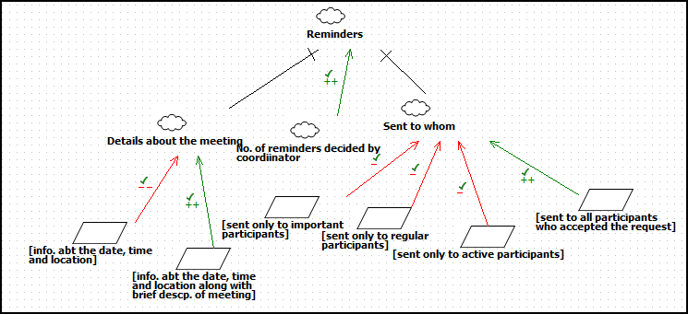

2.2.16 ISSUE STATEMENT: [FR26]
“Initiator can open another person's calendar, contacts, or tasks to see if that person is available for meeting.”

Problem:
(Type of Issue: Redundancy, conflicting) This requirement is redundant as the Initiator will come to know by preference and exclusion sets provided by participants. Also it is conflicting with requirements FR21 and FR22 which say “A participant should only be able to see/search the meeting information that he/she initiated or is part of”
Option 1: Allow Initiator to see another participant’s calendar.

Option 2: Remove the requirement.

Solution: Option 2

Rationale: This requirement is not needed as by exclusion sets and preferred sets provided by participants the Initiator will come to know their availability. It will lead to security issues so this requirement is removed

Reference: Microsoft Office Outlook Meeting Scheduler features

2.2.17 ISSUE STATEMENT: [FR27]
“Any participant should be able to cancel the meeting.”

Problem: (Type of Issue: conflicting) This requirement is conflicting with requirement DR23 which say “The meeting initiator can cancel or reschedule a meeting.”

Option 1: Allow all participants to cancel the meeting.

Option 2: Remove the requirement.

Solution: Option 2

Rationale: This requirement is removed as it was conflicting with DR23. Also if any of the participant can not attend the meeting then it is better to allow that participant to withdraw from meeting rather than canceling the meeting.

Reference: Microsoft Office Outlook Meeting Scheduler features

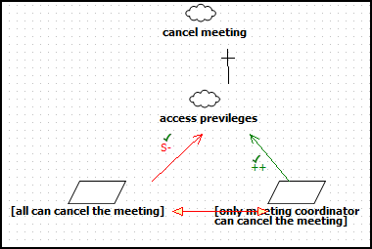

2.3 Issues with Software System Requirements – Non-Functional Requirements

2.3.1 ISSUE STATEMENT: [NFR2]
A meeting should be accurately monitored, especially when it is held in a virtual place. Here, nomadicity will then be important to consider;
Problem: (Type of Issue: Unsoundness, Incompleteness) The word “should” does not provide binding provision. The word “accurately” is not defined and cannot be measured. Also, the definition for “nomadicity” in context to the project is missing.
Option 1: Replace word “should” with “shall”. Remove word “accurately” and eliminate the entire sentence “Here, nomadicity will then be important to consider”.
Option 2: Replace word “should” with “shall”. The word “accurately” only provides emphasis on the functional requirement of selecting time/date within the time frame and not belonging to any of the exclusion set, and deciding on a voted and available location with requested resources. The entire sentence “Here, nomadicity will then be important to consider” is eliminated.
Option 3: Replace word “should” with “shall”. The word “accurately” refers to the availability of valid and updated information including exclusion and preferred sets, locations and resource requests. The word “nomadicity” refers to the availability of precise aforementioned information to the meeting initiator regardless of his/her geographic location.
Solution: Option 3
Rationale: Option 3 is better because it entails minimum change in the actual non-functional requirement while providing further explanation of the terms.
Reference: None

2.3.2 ISSUE STATEMENT: [NFR3]
Re-planning of a meeting should be done as dynamically and with as much flexibility as possible;
Problem: (Type of Issue: Ambiguity, Incompleteness) Who will re-plan the meeting is not specified. The word “should” does not provide binding provision. The words “dynamically” and “flexibility” are not defined and cannot be quantified and measured.
Option 1: Meeting initiator shall re-plan the meeting. The word “should” is replaced with “shall”. The word “dynamically” refers to the capability of system to make decisions on the basis of most updated information available including preferred and exclusion sets, locations and resource requests. The word “flexibility” refers to allowing the important and active participants to change their feedback whenever deemed necessary.
Option 2: The system shall re-plan the meeting in-case of a conflict. The word “should” is replaced with “shall”. The word “dynamically” refers to the capability of system to make decisions on the basis of most updated information available including preferred and exclusion sets, locations and resource requests. The word “flexibility” refers to allowing the important and active participants to change the date range and providing their exclusion and preferred sets from the new range.
Solution: Option 1
Rationale: Option 1 is better because it is a simple, logical and more feasible solution.
Reference: None

2.3.3 ISSUE STATEMENT: [NFR4]
The amount of interaction among participants(e.g., number and length of messages, amount of negotiation required) should be kept minimal;
Problem: (Type of Issue: Unsoundness, Ambiguity) The word “should” does not provide binding provision. The interaction takes place between the participants and the system and not among the participants directly. The provided examples are incomplete and ambiguous. The word “minimal” cannot be quantified.
Option 1: Replace word “should” with “shall”. The only allowed interactions between the system and active participants are to inquire and provide exclusion and preferred sets, and resource requirements. The only allowed interactions between the system and important participants are to inquire and provide exclusion and preferred sets, and preferred locations. The only allowed interactions between the system and regular participants are to inquire and provide exclusion and preferred sets. The only allowed interactions between the system and meeting initiator are meeting management operations and update on participants’ feedback.
Option 2: Replace word “should” with “shall”. All the interactions are broadcasted to all participants to burgeon common understanding, thus resulting in decreased number of future interactions.
Solution: Option 1
Rationale: Option 1 involves less exchange of messages which is suitable in most of the cases, where future interactions are not required at all.
Reference: None

2.3.4 ISSUE STATEMENT: [NFR5]
The intended system should considerably reduce the amount of overhead usually incurred in organizing meetings where potential attendees are distributed over many different places and communicate with each other, for example, via Internet;
Problem: (Type of Issue: Unsoundness, Ambiguity) The word “should” does not provide binding provision. The system under discussion is an electronic web-based system whose performance does not depend on the geographical distribution of the participants. An overhead is caused if the participants do not respond to the system which is also possible if the participants are not geographically distributed. The statement quotes Internet as an example which implies that other ways of communication are also allowed, which are however not mentioned.
Option 1: Replace word “should” with “shall”. Ignore the stated overhead completely. Internet, Email, Instant Messaging and SMS are the allowed methods of communication.
Option 2: Replace word “should” with “shall”. Ignore the stated overhead completely. Internet and Email are the allowed methods of communication.
Solution: Option 2
Rationale: Inclusion of other methods of communication will make the system more complex. Also, the availability of Internet/Web application and Email on portal devices warrants elimination from consideration for other methods of communication.
Reference: None

2.3.5 ISSUE STATEMENT: [NFR6]
The system should reflect as closely as possible the way meetings are typically managed (see the domain theory above);
Problem: (Type of Issue: Unsoundness, Ambiguity, Inconsistency) The word “should” does not provide binding provision. The phrase “as closely as possible” cannot be quantified. The word “typically” implies that a meeting can be managed in other ways as well.
Option 1: Replace word “should” with “shall”. “As closely as possible” implies exactly. “Typically” is ignored. Only one way of management of meeting is automated in the system.
Option 2: The use of word “should” is maintained in order to avoid binding provision for automating the exact management of meeting process. “Typically” is ignored. Only one way of management of meeting is automated in the system.
Solution: Option 1
Rationale: Option 1 is better because it does not allow any unforeseen/unpredictable behavior of the system during its life cycle.
Reference: None

2.3.6 ISSUE STATEMENT: [NFR7]
The meeting date and location should be as convenient as possible, and available as early as possible, to all (potential) participants;
Problem: (Type of Issue: Ambiguity, Incompleteness, Inconsistent) The definition for “convenient” is not provided. “As early as possible” is ambiguous and cannot be quantified. Only important and not every participant can provide preference for location.
Option 1: “Convenient” means the selected date/time and location for meeting should not entail need to change exclusion sets. “As early as possible” implies the selection of first available date and time from preference sets. “All potential participants” are further categorized as regular, important and active participants.
Option 2: “Convenient” means the selected date/time and location for meeting should fall in as many preferred sets and location preferences as possible. “As early as possible” implies the swift selection of date/time and location for meeting once the required sets are available. “All potential participants” are further categorized as regular, important and active participants.
Solution: Option 2
Rationale: Option 2 is better because it is logical and simpler to work with.
Reference: None

2.3.7 ISSUE STATEMENT: [NFR8]
“The system should accommodate as much decentralized requests as possible; any authorized user should be able to request a meeting independently of her whereabouts;”
Problem: (Type of Issue: Incompleteness, Unsoundness) The definition of a decentralized request has not been provided with respect to the system under consideration. Secondly, the word “as much” creates confusion as to how many number of decentralized requests a system shall allow. Also the word “authorized user” is vague. Lastly, the usage of word “her” is incorrect as the user can be a male or a female.
Option 1: The system shall allow the meeting initiator to specify as many distinct meeting requests as possible. By distinct we mean that the system shall not allow the meeting with same meeting information more than once
Option 2: The system shall allow every user to initiate as many meeting requests as possible.
Option 3: Meeting Initiator shall submit requests by using the web interface provided by the system.
Solution: Option 1 and 3
Rationale: The composition of option 1 and 3 is the best solution as the “meeting initiator” will be able to make as many meeting requests as possible. The system shall make sure that no two same meetings are entered. Also as the solution will be a web application, hence the whereabouts of the initiator are not of any concern.
Reference: None

2.3.8 ISSUE STATEMENT: [NFR9]
“Physical constraints should not be broken --- e.g., a person may not be at two different places at the same time; a meeting room may not be allocated to more than one meeting at the same time; etc.;”
Problem: (Type of Issue: incompleteness) The use of word “etc” creates an incompleteness in the aforementioned NFR. It indicates that there are many possible physical constraints in the system of which only two are specified.
Option 1: Due to the incompleteness the NFR is ignored.
Option 2: The system shall not 1) allow a person to attend more than one meetings at the same time 2) allocate a meeting room to more than one meetings at the same time
Solution: Option 2
Rationale: Option 2 is the best solution as the system shall cater to the compliance of aforementioned physical constraints. Furthermore in addition to these if a new physical constraint comes then it can be included too
Reference: None

2.3.9 ISSUE STATEMENT: [NFR10]
“The system should provide an appropriate level of performance:
- the elapsed time between the submission of a meeting request and the determination of the corresponding date/location should be minimal; or
- a lower bound should be fixed between the time at which the meeting date is determined and the time at which the meeting is actually taking place;”
Problem: (Type of Issue: incompleteness, ambiguity, unsoundness) The NFR provides the level of performance in the sense that the meeting date/time and location should be decided as early as possible. Is this the only performance measure? Secondly the first point in the NFR, the system does not quantify the word “minimal” secondly the minimal is more dependent on the meeting attendees.
Option 1: Ignore the first performance level and allow the meeting initiator to specify a lower bound, before which a meeting date/time and location shall be decided.
Option 2: The system shall decide on its own the lower bound within which the meeting date/time and location is decided. The system shall take into account the meeting date and the request initiation date
Solution: Option 1
Rationale: Option 1 is the best solution as it provides control to the meeting initiator to specify the time window within which all the decision has to be made by the system
Reference: None

2.3.10 ISSUE STATEMENT: [NFR11]
“The system should be usable by non-experts;”
Problem: (Type of Issue: incompleteness) The NFR does not define the term usable and the ways using which the usability requirements are matched. Furthermore, the users (termed as non-experts) are not defined. The requirement should have at least mentioned the worst type of user a system can interact with.
Option 1: Due to the incompleteness the NFR is ignored.
Option 2: The user interfaces shall be interactive enough for use by the non-expert users. This includes usage of proper input descriptors, indications on whether the input is optional or not, notification to the user in case he enters some invalid input.
Solution: Option 2
Rationale: Option 2 is the best solution as it caters to the usability requirements of the system and will help a non-expert in using out system easily.
Reference: None

2.3.11 ISSUE STATEMENT: [NFR12]
“The system should be customizable to professional as well as private meetings - ...;”
Problem: (Type of Issue: incompleteness) The NFR does not define the terms professional meetings and private meetings. Until and unless we know the meaning of these terms we cannot make a decision on what actually is the requirement
Option 1: There will be no distinction between a professional and a private meeting.
Option 2: The meeting initiator shall term a meeting as professional or private at the time of initiating a meeting. The system functionality will remain unaffected in both cases.
Solution: Option 2
Rationale: Option 2 is more appropriate solution as it allows some distinction between private and professional meetings. Furthermore if in future we get to know the distinction, we can easily implement the system functionality
Reference: None

2.3.12 ISSUE STATEMENT: [NFR13]
“The system should be flexible enough to accommodate evolving data - e.g., the sets of concerned participants may be varying, the address at which a participant can be reached may be varying, etc.;”
Problem: (Type of Issue: incompleteness) The use of word “etc” creates an incompleteness in the aforementioned NFR. It indicates that there are many possible ways to make the system flexible to accommodate changing data, of which only two are discussed. Furthermore, the level of flexibility is also not defined
Option 1: Ignore the NFR due to its incompleteness
Option 2: Remove the word “etc” from the NFR and allow the meeting initiator to 1) the meeting initiator shall add as many participants (active, important, active/important, and regular) as possible at any time before the final date/time and location decision of the meeting 2) the system shall allow the participants to provide a list of email address to which he wishes to be communicated and reached.
Solution: Option 2
Rationale: Option 2 is more appropriate solution as it implements a level of flexibility rather than having no flexibility at all
Reference: None

2.3.13 ISSUE STATEMENT: [NFR14]
“The system should be flexible enough to accommodate evolving data - e.g., the sets of concerned participants may be varying, the address at which a participant can be reached may be varying, etc.;”
Problem: (Type of Issue: incompleteness) The use of word “etc” creates an incompleteness in the aforementioned NFR. It indicates that there are many possible ways to make the system flexible to accommodate changing data, of which only two are discussed. Furthermore, the level of flexibility is also not defined
Option 1: Ignore the NFR due to its incompleteness
Option 2: Remove the word “etc” from the NFR and allow the meeting initiator to 1) the meeting initiator shall add as many participants (active, important, active/important, and regular) as possible at any time before the final date/time and location decision of the meeting 2) the system shall allow the participants to provide a list of email address to which he wishes to be communicated and reached.
Solution: Option 2
Rationale: Option 2 is more appropriate solution as it implements a level of flexibility rather than having no flexibility at all
Reference: None

2.3.14 ISSUE STATEMENT: [NFR18]
“Information about meetings should be secure.”
Problem: (Type of Issue: incompleteness) The requirement is incomplete as it does not specify what exactly expected by “secure” system and what information needs to be secure. i.e. the information about the participants or the meeting details.

Option 1: Define security as the access privileges for each type of user. Users shall be able to log into the system via a login screen with a user name and password. A participant should only be able to see and search the meeting information that he/she initiated or is part of.
Option 2: All participants will have same privileges.
Option 3: Meeting details will be kept secret.
Solution: Option 1
Rationale: Option 3 is out of the scope of our system. Option 2 seems inappropriate as all participants are not of equal importance and there is no point giving equipment request access to regular participants or access to cancel meeting by regular participants. So Option 1 is most suitable as it will allow different types of participants to do different things that they are required to do.
Reference: None
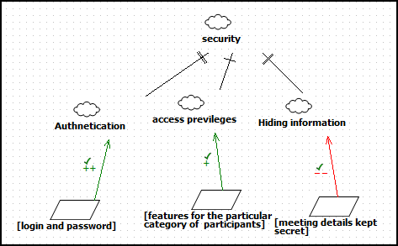

3. WRS ( World, Requirement, Specification)

1. Problem
Nowadays, scheduling a meeting has become a common problem for many people and there are lot of software vendors to offer such a system for scheduling their meetings, especially with a powerful vantage point (cf., Microsoft, IBM-Lotus, etc.). The meeting scheduler has to satisfy all kind of attendees (potential, active, important and inactive) with varying schedules and preferences. The problems that are usually faced for arranging the meetings are:
- Communication gap for their availability
- Time consuming
- No proper replies
- Decision making
- Notifying all the members
- Difficult to handle manually
It is pretty much possible to construct such a meeting scheduler that can come out with the best date, time, and venue for a meeting without having to constantly disturb the users for the change of preferences or whenever a problem arises. TeraSoft Inc. Comes forward to create such an ideal system, one that will determine a best fitting date, time, and venue with as minimal user interaction as possible after extensive conflict resolution done by the system. This system, the TeraSoft Distributed Meeting Scheduler (or TDMS), will streamline the meeting scheduling process.

2.Goal
To deliver a detailed, precise and accurate requirements description of the meeting scheduler system which captures real customers' real needs/wants as precisely, concisely and conceptually as possible and as well as build a prototype. The prototype that we build will have the features that will satisfy the sub-goals.
Sub goals :-
- Initialise/Cancel a meeting
- Resolve Conflicts
- Check for the available dates from everyone
- Get preference and exclusion sets
- Check for the preference for the location
- Request for the equipments
- Schedule a meeting
- Notify changes to everyone

3.1 Improved Understanding for the Domain, Stakeholders Functional and Non-Functional Objectives
3.1.1 [DR1] In the application domain, meetings are arranged in the following manner.
3.1.2 [DR2] A meeting initiator, the person who is requesting a meeting, will ask all potential meeting attendees, people who have received a meeting invitation from the initiator, for the following information.
3.1.3 [DR3] a set of dates and times on which they cannot attend the meeting (hereafter, referred to as exclusion set); and
3.1.4 [DR4] a set of dates and times on which they would prefer the meeting to take place (hereafter referred to as preference set);
3.1.5 [DR5] A meeting date shall be defined by a calendar date, day of the week, time and time zone.
3.1.6 [DR6] The exclusion and preference sets shall contain a time interval with a start and end date/time that is prescribed by the meeting initiator (hereafter referred to as date range).
3.1.7 [DR7] The initiator asks active participants, people who are going to speak or give a presentation in a meeting, for any special equipment they might need at the meeting location (e.g., overhead projector, workstation, network connection, telephone, etc.).
3.1.8 [DR8] The meeting initiator asks important participants, people who have a higher priority over other participants, to state preferences about the meeting location from a list of places.
3.1.9 [DR9, DR10] The proposed meeting date shall belong to the stated date range and to none of the exclusion sets; furthermore it shall belong to as many preference sets as possible.
3.1.10 [DR11] The proposal should be made as early as possible based on the rate at which the potential meeting attendees respond with their preference and exclusion sets or the percentage of responses received from the active and important participants.
3.1.11 [DR12] A date conflict occurs when no such date can be found.
3.1.12 [DR13] A conflict is strong when no date can be found within the date range and outside all exclusion sets;
3.1.13 [DR14] A conflict is weak when dates can be found within the date range and outside all exclusion sets, but no date can be found at the intersection of all preference sets.
3.1.14 [DR15] Conflicts can be resolved in the following order, including: the initiator extends the date range; and some participants add some new dates to their preference sets; or some participants remove some dates from their exclusion set; or some participants withdraw from the meeting.
3.1.15 [DR16] Each conflict resolution shall be done as quickly as possible based on the rate at which the potential meeting attendees respond with their modified conflict resolution methods.
3.1.16 [DR17] It shall meet the equipment requirements.
3.1.17 [DR18] A meeting room must be available at the selected meeting date and time.
3.1.18 [DR19] Furthermore it [the meeting room] shall belong to one of the locations preferred by the majority of important participants.
3.1.19 [DR20] It is absolutely necessary, however, to allow each meeting to take place in a virtual place, e.g., through teleconferencing using laptop computers.
3.1.20 [DR21] The number of negotiations shall be not exceed the maximum number of negotiations needed to resolve a conflict, but a new round of negotiations may be required when no such room can be found.
3.1.21 [DR22] The meeting initiator can be one of the participants or a meeting representative.
3.1.22 [DR23] The meeting initiator can cancel or reschedule a meeting.
3.1.23 [DR24] All participants can attend the meeting fully (present for whole meeting ), partially ( can attend meeting for a particular time slot) or not attend the meeting.
3.1.24 [DR25] The meeting can be scheduled to be one-time or recurring. It means the initiator will be given an option if the meeting is one time or it will recur after a week/ month/ year. If it is recurring then automatically requests will be sent for those meeting till the initiator cancels the meeting.
3.1.25 [DR26] Meeting locations should be convenient

3.2 Improved Understanding for Software System Requirement: Functional Requirement
3.2.1 [FR1] The purpose of DMS is to support the organization of meetings – that is, to determine, for each meeting request, a meeting date and location so that more than a threshold (say 70%) of the important participant’s preferences on the date and location need to be satisfied. A meeting can be held when the total number of active and important participants needs to be more than thresholds say 50% and in that more than 70% of important participants effectively participate.
3.2.2 [FR2] SDMS shall assist users in the following activities.
3.2.3 [FR3] Monitor meetings which include arranging the meeting location and date, after consensus from the participants and getting the resources for the meeting, especially when they are held in a distributed Manner.
3.2.4 [FR4] Plan meetings under the constraints expressed by participants (see domain theory);
3.2.5 [FR5] Re-plan a meeting to support the changing user constraints which is possible only if an important participant request for it and the threshold of the number of important participants falls below 70%. If the absence of the important participant does not reduce below the threshold then the meeting cannot be changed.
3.2.6 [FR6] To modify the exclusion set, preference set and/or preferred location by the initiator in the meeting request email sent to all the participants before a meeting date/location is proposed. After the defined time the meeting details should not be changed.
3.2.7 [FR7] to take some external constraints into account after a date and location have been proposed - e.g., due to the need to accommodate a more important meeting. - here, the original meeting date or location may then need to be changed; sometimes the meeting may even be cancelled.

3.2.8 [FR8] In all cases some bound on re-planning should be set up.

3.2.9 [FR9] Support conflict resolution according to resolution policies stated by the client;
3.2.10 [FR10] Manage all the interactions among participants required during the organization of the meeting, for instance:
3.2.11 [FR11] to support the negotiation and conflict resolution processes;
3.2.12 [FR12] .. Everybody who received the meeting request are updated (includes important, active participants and also participants who declined the meeting request.) to make participants aware of what's going on during the planning process;
3.2.13 [FR13] .. Everybody who received the meeting request are updated (includes important, active participants and also participants who declined the meeting request.) to keep participants informed about schedules and their changes;
3.2.14 [FR14] The meeting scheduler system must in general handle several meeting requests in parallel
3.2.15 [FR15] Meeting requests can be competing when they overlap in time or space and in such cases ties are broken by the meeting initiator who decides if the meeting needs to be cancelled/postponed/changed.
3.2.16 [FR16] The meeting initiator indicates a deadline to include preferences and exclusion sets.
3.2.17 [FR17] If a conflict exists, after the preference and exclusion set deadline is set and reached, additional time is given to resolve the conflicts, otherwise the meeting date is finalized.
3.2.18 [FR18] Partial attendance of a person can be allowed to meetings that are scheduled and organized at the same time. For example if there are 2 meetings first is from 11 to 1 and second is from 11 to 2 then participant will be able to attend first meeting from 11 to 12 and second meeting from 12 to 1. This ensures his meeting schedule does not clash in time.
3.2.19 [FR19] Each of the different type of user should have different access privileges that makes sure that all users do not get access rights to add/delete the attendees of a particular meeting. Only the meeting coordinator shall have the sole authority to make the modifications.
3.2.20 [FR20] A secure login username and password is required for each of the user to access the system
3.2.21 [FR21] A participant should only be able to only see the meeting information that he/she initiated or is part of by concealing others participant’s information from a user so that data integrity and the privacy of the person is ensured. Also different roles have different access privileges. For example a regular participant must not be able to view or choose list of meeting rooms as only an important participant can choose from a list of meeting rooms. Only the meeting coordinator shall have the sole authority to view the calendar of the participant of the meeting to schedule effectively.
3.2.22 [FR22] A participant should only be able to search the meeting information that he/she initiated or is part of by concealing others participant’s information from a user so that data integrity and the privacy of the person is ensured. Also different roles have different access privileges. For example a regular participant must not be able to search for the list of meeting rooms as only an important participant can choose from a list of meeting rooms. Only the meeting coordinator shall have the sole authority to search for and view the calendar of a participant of the meeting to schedule effectively.
3.2.23 [FR23] The meeting initiator should be able to invite another person even after sending the original meeting request. Here a participant can request or suggest to the coordinator that another person be invited to the meeting and the coordinator sends the invite. The meeting coordinator can also include the person if he accidently left him/her out during the initial invitation process.
3.2.24 [FR24] The system should automatically decline conflicting meeting requests for each user. This gives the user the right to decide which meeting he/she would prefer to attend or partially attend.
3.2.25 [FR25] The meeting coordinator can create reminders for a meeting as far in advance as he/she wants. Each user is reminded only relevant information about the meeting. The number of meeting reminders to be sent is controlled by the meeting coordinator depending on the size, importance of the meeting. Reminders are sent only to users who have accepted the meeting requests.
3.2.26 [FR26] Initiator can open another person's calendar, contacts, or tasks to see if that person is available for meeting. This requirement is not needed as by exclusion sets and preferred sets provided by participants the Initiator will come to know their availability. It will lead to security issues so this requirement is removed.
3.2.27 [FR27] Any participant should be able to cancel the meeting. This requirement is removed as it was conflicting with DR23. Also if any of the participant cannot attend the meeting then it is better to allow that participant to withdraw from meeting rather than cancelling the meeting.

3.3 Improved Understanding for Software System Requirement: Non-Functional Requirement

SECURITY:
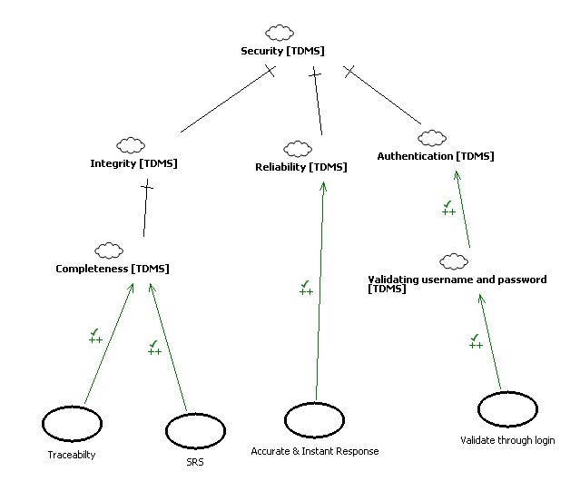

FLEXIBILTY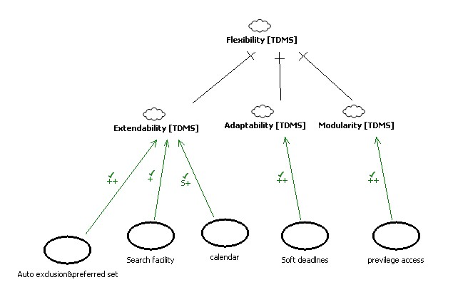
MAINTAINABILITY: 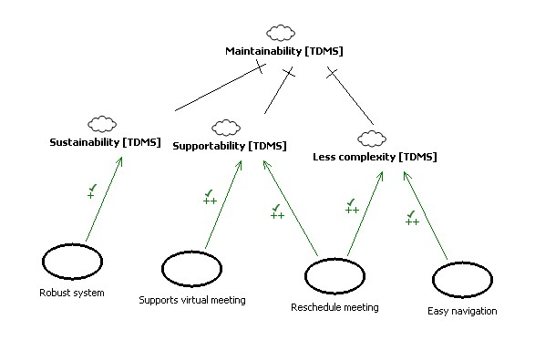

USABILITY:
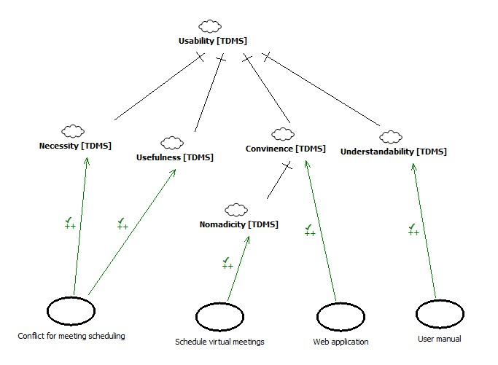
3.3.1 [NFR1] In meeting the functional requirements, non-functional requirements should also be taken account. They include:
3.3.2 [NFR2] A meeting shall be monitored, using valid and updated information including exclusion and preferred sets, locations and resource requests. Here, availability of precise aforementioned information to the meeting initiator regardless of his/her geographic location shall then be important to consider.
3.3.3 [NFR3] The system shall allow the meeting initiator to re-plan the meeting, by using the changing and most updated information available including preferred and exclusion sets, locations and resource requests. The important and active participants shall be able to change their sets whenever deemed necessary.
3.3.4 [NFR4] The only allowed interactions between the system and active participants shall be to inquire and provide exclusion and preferred sets, and resource requirements. The only allowed interactions between the system and important participants shall be to inquire and provide exclusion and preferred sets, and preferred locations. The only allowed interactions between the system and regular participants shall be to inquire and provide exclusion and preferred sets. The only allowed interactions between the system and meeting initiator shall be meeting management operations and update on participants’ feedback. The system shall not allow other type of interactions.
3.3.5 [NFR5] The intended system shall reduce the decision-making time once all the responses from the potential attendees arrive through Internet or Email. The system shall not be liable to reduce the overhead caused by delayed response of potential attendees.
3.3.6 [NFR6] The system shall exactly reflect the way meetings are managed (see the domain theory above);
3.3.7 [NFR7] The meeting date/time should fall in the majority of preference sets of all potential participants and the location should fall in the majority of the location preference sets of active participants. The system shall also perform swift selection of date/time and location for meeting once the required sets are available.
3.3.8 [NFR8] The system shall provide a web interface using which a meeting initiator can initiate as many distinct (not already existent) meeting requests as possible
3.3.9 [NFR9] The system shall not: 1) allow a person to attend more than one meetings at the same time 2) allocate a meeting room to more than one meetings at the same time
3.3.10 [NFR10] The system shall allow a meeting initiator to specify a lower bound at the time of meeting initiation. The lower bound shall be a date/time before which a meeting date/time and location must be decided. The system shall also allow a meeting initiator to change the lower bound if he/she deems it necessary
3.3.11 [NFR11] The user interfaces shall be interactive and easy for use by the non-expert users. Interface will include usage of proper input descriptors, indications on whether the input is optional or mandatory, and notifications to the users (participants and initiator) in case he/she enters some invalid input
3.3.12 [NFR12] The system shall allow a meeting initiator to term a meeting as professional or private at the time of initiating a meeting. The system functionality will remain unaffected in professional as well as private meeting
3.3.13 [NFR13] The system: 1) shall allow the meeting initiator to add as many participants (active, important, active/important, and regular) as possible at any time before the final date/time and location decision of the meeting 2) shall also allow meeting initiator to add participants after the meeting date/time and location has been decided. In that case the participants will not be providing the preferred set, exclusion set, preferred location and equipment requirements 3) allow the participants to provide a list of email address to which he wishes to be communicated and reached
3.3.14 [NFR14] The system: 1) Shall allow standard inputs to get date/time, address from the user 2) Shall allow users to specify their preferred formats and display the date according to that format 3) shall allow users to select preferred language and then show to user the entire interface in the preferred language 4) Will cater the partial reuse
3.3.15 [NFR15] Meeting requests can be competing when they overlap in time or space. Concurrency must thus be managed.
3.3.16[NFR16] The meeting initiator indicates a deadline to include preferences and exclusion sets.
3.3.17 [NFR17] If a conflict exists, after the preference and exclusion set deadline is set and reached, additional time is given to resolve the conflicts, otherwise the meeting date is finalized.
3.3.18 [NFR18] Security is provided by giving the access privileges for each type of user. Users shall be able to log into the system via a login screen with a user name and password. A participant should only be able to see and search the meeting information that he/she initiated or is part of.

4. Preliminary Prototype and User Manual

4.1. Prototype
Prototypes for the following Blitkreig Meeting Scheduler System page will be presented: Login, Home, Schedule New Meeting, New Incoming Meeting Request and Conflict Resolution pages. It is important to note that the “New Incoming Meeting Request” page will have a slightly different functionality depending on the type of the user. All the users will be able to opt for a specific meeting and specify their available and unavailable date and time blocks for the meeting, but the active users would be able to also request meeting resources, while important participants would be able to request meeting locations.

1. Register Page
Any new user will be able to register himself with the Blitzkrieg Meeting Scheduling System by providing his details, and after it is verified by clicking the link that has been sent to his mail, he can access this system.
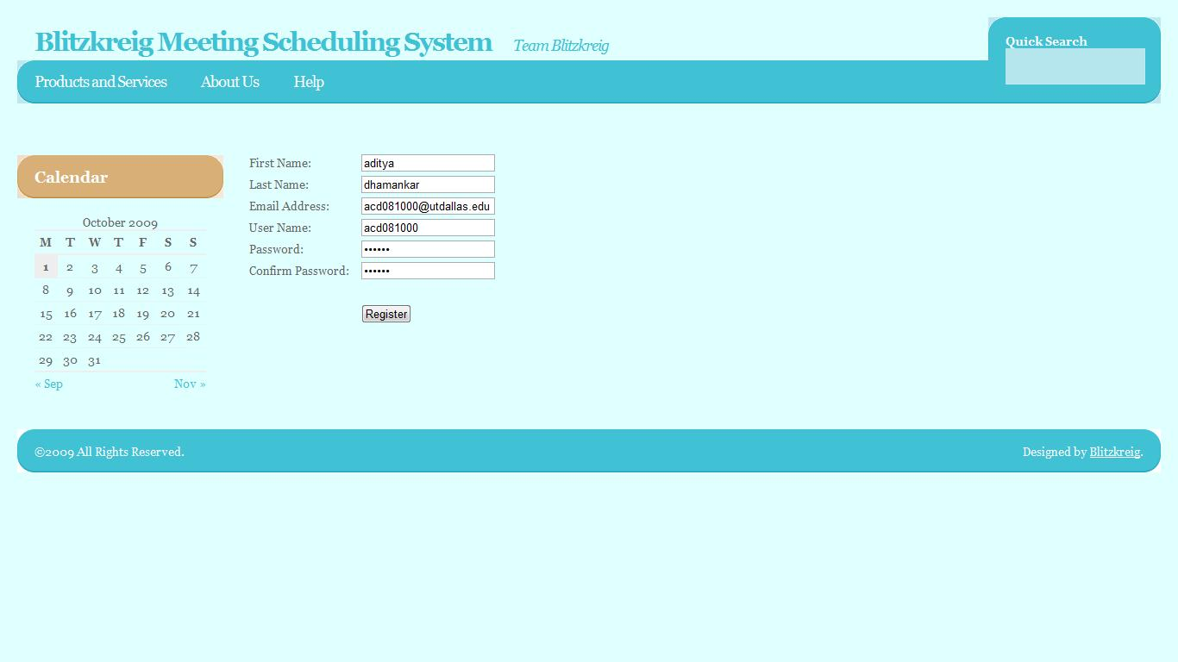

2. Login Page
User will be able to login, register or reset their passwords on this page.
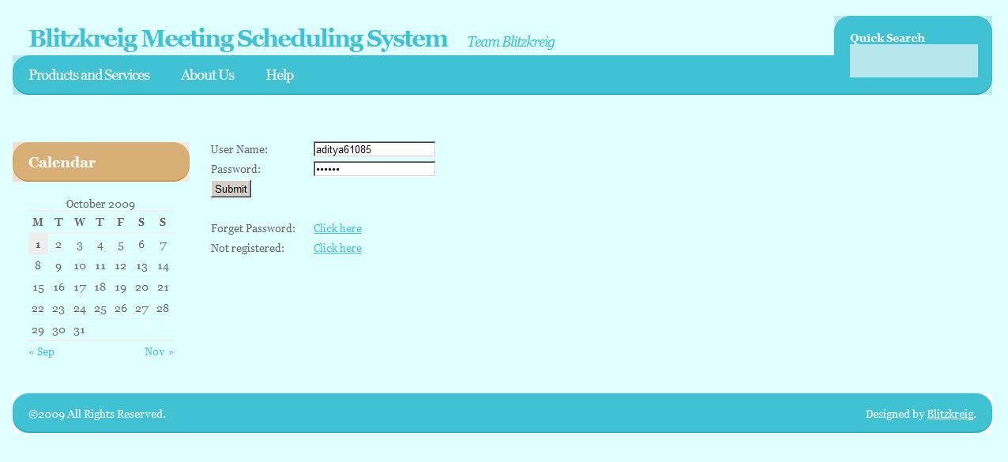

3. User Profile
When any user gives his information and creates his profile, he can give his common preferred set and the exclusion set as well along with his contact details so that if any request comes to the user and if the user doesn’t reply for the invitation, this information is taken for scheduling the meeting which is an added advantage.
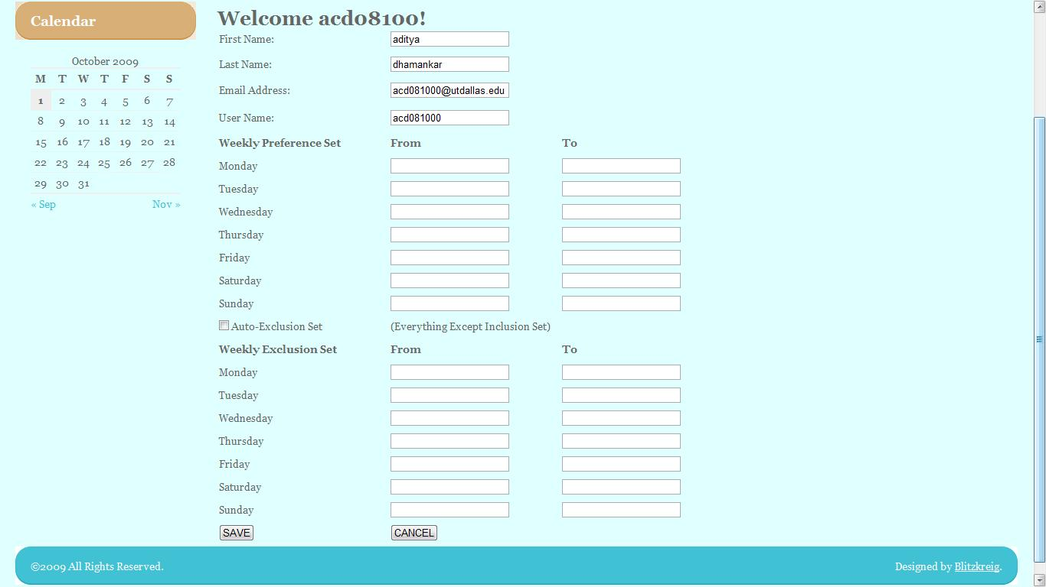

4. Home Page
Blitzkrieg Meeting Scheduling System User will be able to view the list of proposed and upcoming meetings that has been finalized, view incoming requests that has not been finalized and the initiated meetings that has not been finalized.

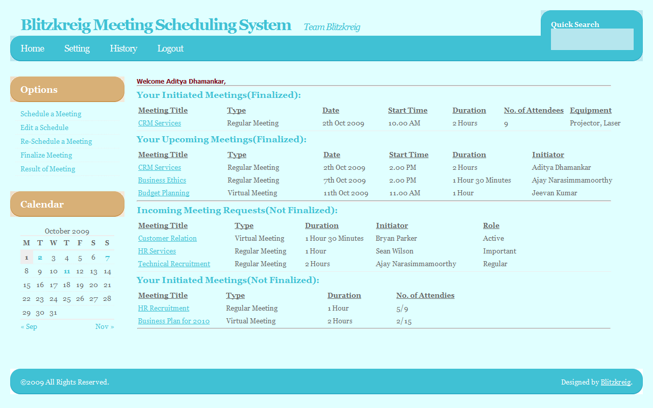

5. Schedule New Meeting
This is the prototype of the schedule new meeting page that the Initiator would use to propose a new meeting.
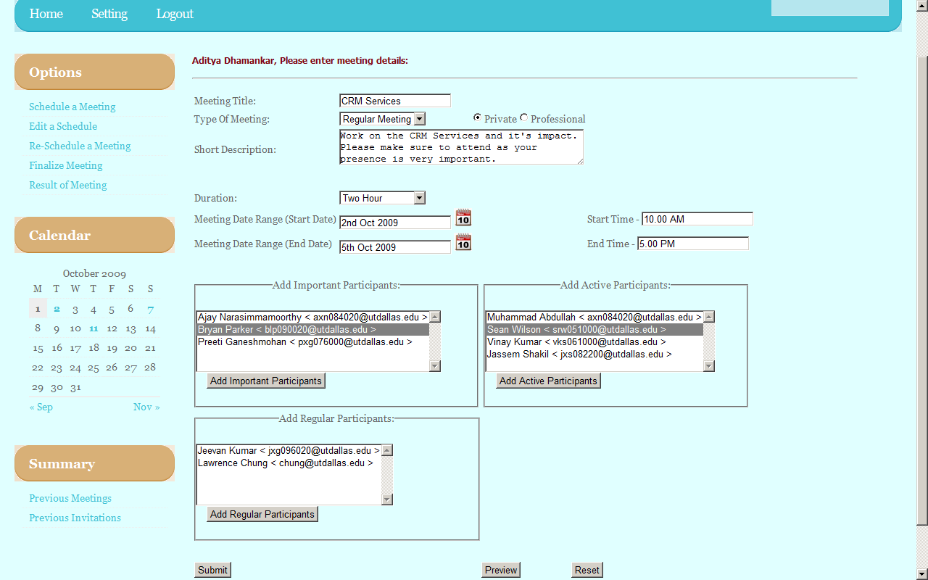

6. New Incoming Meeting Request – Active Participant
Active participants would specify their available and unavailable date/time blocks as well as request resources for the meeting. Also there is an option of selecting the common preferred /exclusion set instead of specifying it again unless there are changes in it.

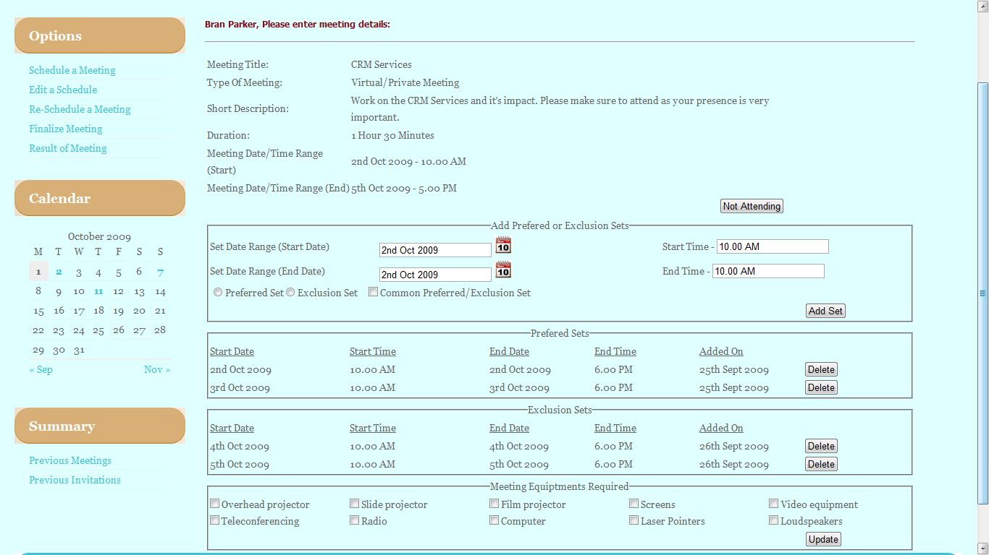

7. New Incoming Meeting Request – Important Participant
Important participants would specify their available and unavailable date/time blocks as well as request meeting locations.
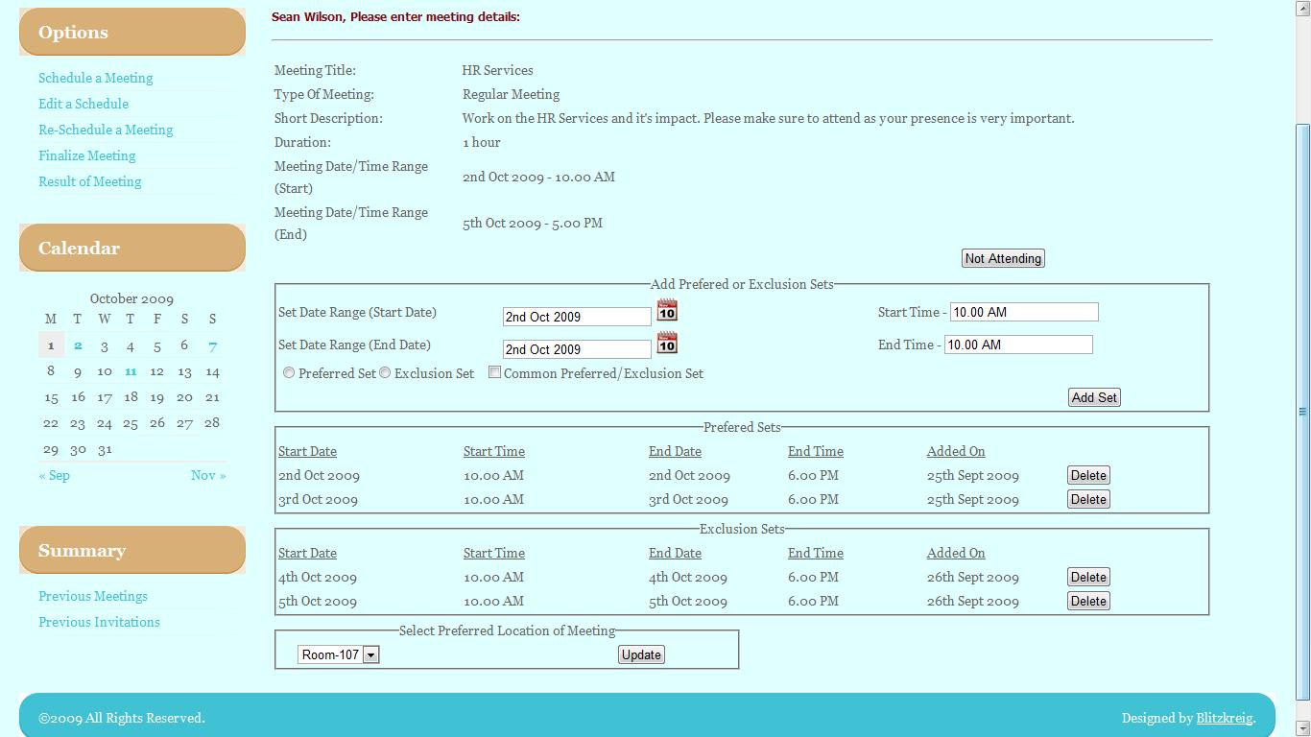

8. New Incoming Meeting Request – Regular Participant
Regular participants would simply be able to specify available and unavailable date/time blocks.
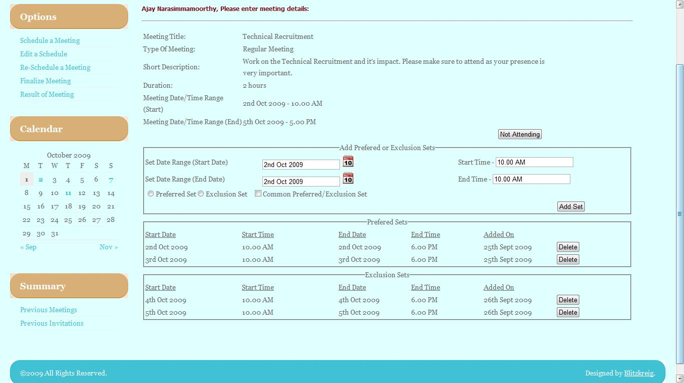

9. Conflict Resolution
Initiator clicks on a meeting they have planned and are then brought to this screen which has certain information on preferences of the attendees. They can then choose to edit the meeting details. Otherwise, the meeting goes with the highest ranked location and most preferred time and date.
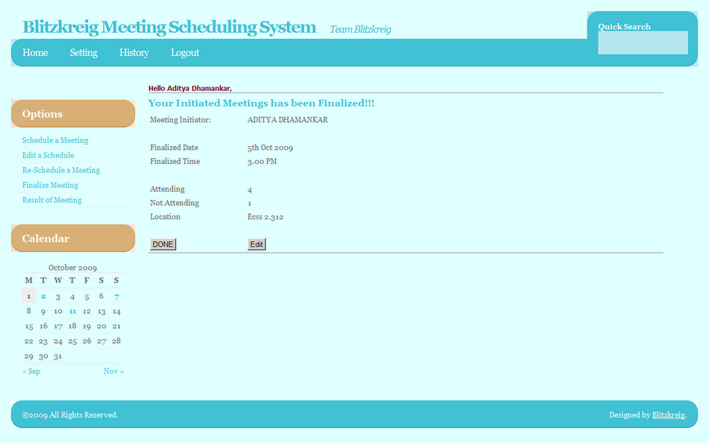

4.2. User Manual

1. Login page

Action Register in the system:
- Click “Register”. Input your name and email on the following screen.

Action Log in the system:
- Type user name.
- Type password.
- Click “Log in” button.

Action Request forgotten password:
- Click “request password” link. Enter your email address to have your password sent.

2. Home page

Action Schedule a new meeting:
- Click “Schedule New Meeting” link.

Action Edit a scheduled meeting:
- Click “Edit Meeting” link.

Action Reschedule a meeting:
- Click “Reschedule meeting” link.

Action Finalize meeting:
- Click “Finalize Meeting” link.

Action Result of Meeting:
- Click “Result of meeting” link.

3. Schedule New Meeting page

Action Schedule a new meeting
- Write the meeting title.
- Select the type of meet.
- Select the date and time the Date/Time range of consideration begins.
- Select the date and time the Date/Time range of consideration ends.
- Write the description of the meeting.
- Select the attendees of the meeting (repeat the following steps for each attendee):
  - Write the email of the attendee.
  - Select the type of attendee (Active, Important or Regular)
  - Push “Add Attendee” button.
- Click “Submit” button.

Action Request for Equipment for the meeting:
- Select the Equipment that is to be requested for the meet.
- Select the list of members along with their e-mail ids to whom the request should be sent.

Action Reset the creation of a new meeting:
- Click “Reset” button.

4. Finalize Meeting Page:
This page consists of three sections:
- The first section displays the replies from various participants and consists of the following:
  - Participant Name
  - Participant Type (Regular/Active/Important)
  - Preferred Set (Date/Time/Location)
  - Exclusion Set(Date/Time)
  - Result
Clicking the Resolve button leads to the next section.
- The second section displays the list that was obtained based on the meeting satisfying criteria which specifies the number of attendees along with the preferred set.
- The third section displays the finalized meeting schedule. Clicking the Submit button displays the result in the result page.

5. User Profile Page:
This page displays the details about the user and his common weekly preference and exclusion sets. This page also contains a checkbox that enables the user to automatically include the common exclusion set based on the preference set input.

6.Result Page:
This page displays the finalized meeting schedule by the initiator listing the date, time and location of the meet along with the number of attendees and non-attendees.

5 .Traceability Matrix & Table

5.1 Domain vs System
 | DR1 | DR2 | DR3 | DR4 | DR5 | DR6 | DR7 | DR8 | DR9 | DR10 | DR11 | DR12 | DR13 | DR14 | DR15 | DR16 | DR17 | DR18 | DR19 | DR20 | DR21 | DR22 | DR 23 | DR24 | DR25 | DR26
FR1 | X | X | X | X | X | X | X | X | X | X | X | X | X | X | X | X | X | X | X | X | X | X | X | X | X
FR2 | X |  |  |  |  |  |  |  |  |  | X | X | X | X | X |  |  |  |  | X
FR3 | X |  |  |  |  |  |  |  |  |  | X | X | X | X | X |  |  |  |  | X
FR4 | X | X | X | X |  |  | X | X | X | X | X | X | X | X | X |  |  |  | X |  |  |  |  |  |  | X
FR5 | X | X | X | X |  |  |  | X | X | X | X | X | X | X | X | X |  |  | X |  | X |  | X |  |  | X
FR6 | X | X | X | X |  |  |  | X | X | X | X | X | X | X | X |  |  |  | X |  |  |  |  |  |  | X
FR7 | X |  |  |  |  |  |  |  |  |  | X |  |  |  |  |  |  |  |  |  |  |  |  |  |  | X
FR8 | X |  |  |  |  |  |  |  |  |  | X |  |  |  |  | X |  |  |  |  | X |  | X
FR9 | X |  |  |  |  |  |  |  |  |  | X | X | X | X | X | X |  |  |  |  | X
FR10 | X |  |  |  |  |  |  | X |  |  | X | X | X | X | X | X |  | X | X |  | X
FR11 | X |  |  |  |  |  |  |  |  |  | X | X | X | X | X | X |  |  |  |  | X
FR12 | X |  |  |  |  |  |  | X |  |  |  | X | X | X | X |  |  | X | X |  |  |  |  |  |  | X
FR13 | X |  |  |  |  |  |  | X |  |  |  | X | X | X | X |  |  | X | X |  |  |  |  |  |  | X
FR14 | X |  |  |  |  |  |  |  |  |  | X
FR15 | X |  |  |  |  |  |  |  |  |  | X
FR16 | X |  |  |  |  | X
FR17 | X |  |  |  |  | X
FR18 | X |  |  | X |  |  |  |  | X | X |  | X | X | X | X |  |  |  |  |  |  |  |  | X | X
FR19 | X | X |  |  |  |  | X | X
FR21 | X | X
FR22 | X | X
FR23 | X | X |  |  |  |  | X | X |  |  |  |  |  |  |  |  |  |  |  | X |  |  |  | X
FR24 | X |  |  |  |  |  |  |  |  |  |  | X | X | X | X | X
FR25 | X | X |  |  |  |  | X | X
FR26 | X |  |  |  |  |  |  |  | X | X | X |  |  |  | X |  |  |  |  |  | X |  |  | X
FR27 | X |  |  |  |  |  |  |  |  |  |  |  | X |  |  | X |  |  |  |  | X |  |  | X | X
NFR1 | X |  |  |  | X | X | X | X |  |  | X | X | X | X | X | X |  | X | X |  | X
NFR2 | X |  |  |  |  |  |  |  |  |  |  | X | X | X | X |  |  |  |  | X
NFR3 | X |  |  |  |  |  |  |  |  |  | X |  |  |  |  | X |  |  |  |  | X
NFR4 | X |  |  |  |  |  |  |  |  |  | X | X | X | X | X | X |  |  |  |  | X
NFR5 | X |  |  |  |  |  |  |  |  |  | X | X | X | X | X |  |  |  |  | X
NFR6 | X | X | X | X | X | X | X | X | X | X | X | X | X | X | X | X | X | X | X | X | X | X
NFR7 | X |  |  |  |  |  |  | X |  |  | X |  |  |  |  |  |  | X | X |  |  |  |  |  |  | X
NFR8 | X |  |  |  |  |  |  |  |  |  | X
NFR9 | X |  |  |  |  |  | X |  |  |  | X | X | X | X |  |  | X | X | X
NFR 10 | X |  |  |  |  |  |  |  |  |  | X
NFR 11 | X |  |  |  |  |  |  |  |  |  | X
NFR 12 | X
NFR 13 | X |  |  |  |  | X |  |  |  |  | X |  |  |  | X | X |  |  |  |  |  | X
NFR 14 | X |  |  |  | X |  |  |  |  |  | X |  |  |  | X |  |  |  | X
NFR 15 |  |  |  |  |  |  |  |  |  |  |  |  |  |  |  |  |  |  |  |  |  |  | X
NFR 16 |  |  |  |  |  | X |  |  |  | X
NFR 17 |  |  |  |  |  | X |  |  |  | X |  |  |  |  |  |  |  |  |  |  |  |  |  |  |  | X
NFR 18 | X | X |  |  |  |  | X | X

5.2 Prototype Features

PF1 | The home page contains a search bar that will return the results based on the input in the search bar.
PF2 | Every web page contains a calendar that highlights the important dates for the user along with the event on that date.
PF3 | The home page displays the list of meetings (both finalized and not finalized) that the user has initiated and the requests he has obtained.
PF4 | The meeting initiator provides a date and time range while scheduling a meet so that the participants can choose the corresponding ones between the provided upper and lower limits.
PF5 | The meeting that is to be held could be a regular meet, or a virtual meet such as video conferencing.
PF6 | Once the replies from various participants are obtained, the conflict is then resolved by using the satisfying criteria given in the requirements specification.
PF7 | The active participants are allowed to mention their preferred and exclusion sets and they can request for equipments.
PF8 | The important participants are allowed to mention their preferred and exclusion sets and the meeting location.
PF9 | The regular participants are just allowed to specify their preferred and exclusion sets.
PF10 | Functionality for recovering the password is provided.
PF11 | The new users are allowed to register in the system.
PF12 | The option for including a common preference or exclusion set is provided.
PF13 | The participant need not enter the preferred and exclusion set if he enables the checkbox that states use my common preference/exclusion set.

5.3 System Vs Prototype
 | PF1 | PF2 | PF3 | PF4 | PF5 | PF6 | PF7 | PF8 | PF9 | PF10 | PF11 | PF12 | PF13
FR1 |  |  | X | X | X | X | X | X | X |  |  | X | X
FR2 |  |  |  | X | X | X
FR3 |  | X | X |  | X
FR4 |  |  |  | X |  | X | X | X | X |  |  | X | X
FR5 |  |  |  |  |  | X
FR6 |  |  |  |  |  | X
FR7 |  |  |  |  |  | X
FR8 |  |  |  |  |  | X
FR9 |  |  | X |  |  | X | X | X | X
FR10 | X | X | X
FR11 |  |  |  |  |  | X | X | X | X
FR12 | X | X | X
FR13 | X | X | X
FR14 |  |  |  | X
FR15 |  |  |  |  |  | X
FR16
FR17
FR18 |  | X |  | X |  | X |  | X | X |  |  | X
FR19 |  |  |  | X |  |  | X | X | X | X | X |  | X
FR21 | X |  |  | X |  |  | X | X | X | X | X |  | X
FR22 | X |  |  | X |  |  | X | X | X | X | X |  | X
FR23 |  |  | X |  | X | X | X | X | X
FR24 |  |  | X |  |  | X
FR25 |  | X | X | X | X
FR26 | X | X | X |  |  | X |  |  |  |  | X
FR27 |  |  | X |  |  | X | X | X |  |  |  |  | X
NFR1 | X | X | X | X | X | X | X | X | X | X | X | X | X
NFR2 |  | X |  |  |  | X
NFR3 |  |  |  |  |  |  | X | X | X
NFR4 |  | X | X
NFR5 | X | X | X | X |  | X | X | X | X |  | X | X | X
NFR6 |  | X | X | X | X | X | X | X | X
NFR7 |  | X | X
NFR8 |  |  |  | X
NFR9 |  |  | X |  |  |  | X | X | X
NFR10 | X | X | X
NFR11 | X | X | X | X |  |  | X | X | X | X | X | X | X
NFR12 |  |  |  |  | X
NFR13 |  |  | X | X | X | X | X | X | X |  | X
NFR14 | X | X | X | X |  |  |  |  |  |  |  | X | X
NFR15
NFR16
NFR17
NFR18 |  |  | X | X |  |  |  |  | X | X | X |  | X

5.4 Functional vs Nonfunctional
 | NFR1 | NFR2 | NFR3 | NFR4 | NFR5 | NFR6 | NFR7 | NFR8 | NFR9 | NFR10 | NFR11 | NFR12 | NFR13 | NFR14 | NFR15 | NFR16 | NFR17 | NFR18
FR1 |  | X | x |  | x | x | x | x | x | x | x | x | x | x | X | X | X | x
FR2 | x | X |  |  | x
FR3 | x | X |  |  | x |  |  |  |  |  |  |  |  |  |  |  |  | x
FR4 | x |  | x | x
FR5 | x |  | x | x |  | x | x |  |  |  |  |  |  |  | X |  |  | x
FR6 | x |  | x |  |  |  | x |  |  | x |  |  | x | x |  |  |  | x
FR7 | x |  | x |  |  |  |  |  |  |  |  |  | x | x
FR8 | x |  | x | x |  |  | x |  | x
FR9 | x |  |  | x |  |  |  |  |  |  |  |  |  | x |  |  |  | x
FR10 | x | X |  | x | x | x |  |  |  |  |  |  |  |  |  |  |  | x
FR11 | x |  | x | x
FR12 | x | X |  | x |  | x
FR13 | x | X |  | x |  | x
FR14 | x | X |  |  |  |  |  |  |  | x |  |  |  | x
FR15 | x | X |  | x |  | x |  |  | x | x |  |  | x | x
FR16 | X | X |  |  | X | X |  |  |  | X |  |  |  |  |  |  | x
FR17 | X |  |  |  | X | X |  |  |  | X |  |  |  |  |  | X | X
FR18 | x | X |  | x |  | x |  |  |  |  | x |  | x
FR19 | x |  | x | x |  | x |  |  |  |  |  |  | x |  |  |  |  | x
FR21 | x |  | x | x |  | x |  |  |  |  |  | x | x |  |  |  |  | x
FR22 | x |  | x | x |  | x |  |  |  |  |  | x | x |  |  |  |  | x
FR23 | x | X | x |  |  | x |  |  |  | x |  |  | x
FR24 | x | X |  | x |  |  | x |  | x | x |  |  |  |  |  |  |  | x
FR25 | x | X | x |  |  |  | x |  |  | x
FR26 | x | X | x | x | x | x |  |  |  | x |  |  | x |  |  |  |  | x
FR27 | x |  |  | x |  |  | x |  |  |  | x |  |  |  | X

5.5 Phase I vs Phase II
Phase I | Phase I | Phase I | Phase II | Phase II | Phase II
Preliminary Requirements | Issues | Improved Understanding | Additional Requirements | Issues | Improved Understanding
DR1 | 2.1.1 | 3.1.1 |  | 2.1.1 | 3.1.1
DR2 | 2.1.2 | 3.1.2 |  | 2.1.2 | 3.1.2
DR3 | 2.1.3 | 3.1.3 |  | 2.1.3 | 3.1.3
DR4 | 2.1.3 | 3.1.4 |  | 2.1.3 | 3.1.4
DR5 | 2.1.4 | 3.1.5 |  | 2.1.4 | 3.1.5
DR6 | 2.1.5 | 3.1.6 |  | 2.1.5 | 3.1.6
DR7 | 2.1.6 | 3.1.7 |  | 2.1.6 | 3.1.7
DR8 | 2.1.7 | 3.1.8 |  | 2.1.7 | 3.1.8
DR9 | 2.1.8 | 3.1.9 |  | 2.1.8 | 3.1.9
DR10 | 2.1.8 | 3.1.9 |  | 2.1.8 | 3.1.9
DR11 | 2.1.9 | 3.1.10 |  | 2.1.9 | 3.1.10
DR12 | 2.1.10 | 3.1.11 |  | 2.1.10 | 3.1.11
DR13 | 2.1.11 | 3.1.12 |  | 2.1.11 | 3.1.12
DR14 | 2.1.12 | 3.1.13 |  | 2.1.12 | 3.1.13
DR15 | 2.1.13 | 3.1.14 |  | 2.1.13 | 3.1.14
DR16 | 2.1.14 | 3.1.15 |  | 2.1.14 | 3.1.15
DR17 |  | 3.1.16 |  |  | 3.1.16
DR18 |  | 3.1.17 |  |  | 3.1.17
DR19 | 2.1.15 | 3.1.18 |  | 2.1.15 | 3.1.18
DR20 |  | 3.1.19 |  |  | 3.1.19
DR21 | 2.1.16 | 3.1.20 |  | 2.1.16 | 3.1.20
DR22 |  | 3.1.21 |  |  | 3.1.21
FR1 | 2.2.1 | 3.2.1 |  | 2.2.1 | 3.2.1
FR2 |  | 3.2.2 |  |  | 3.2.2
FR3 | 2.2.2, 2.2.3 | 3.2.3 |  | 2.2.2, 2.2.3 | 3.2.3
FR4 |  | 3.2.4 |  |  | 3.2.4
FR5 | 2.2.4, 2.2.5 | 3.2.5 |  | 2.2.4, 2.2.5 | 3.2.5
FR6 | 2.2.6 | 3.2.6 |  | 2.2.6 | 3.2.6
FR7 |  | 3.2.7 |  |  | 3.2.7
FR8 |  | 3.2.8 |  |  | 3.2.8
FR9 |  | 3.2.9 |  |  | 3.2.9
FR10 |  | 3.2.10 |  |  | 3.2.10
FR11 |  | 3.2.11 |  |  | 3.2.11
FR12 | 2.2.7 | 3.2.12 |  | 2.2.7 | 3.2.12
FR13 | 2.2.7 | 3.2.13 |  | 2.2.7 | 3.2.13
FR14 |  | 3.2.14 |  |  | 3.2.14
FR15 | 2.2.8 | 3.2.15 |  | 2.2.8 | 3.2.15
NFR1 |  | 3.3.1 |  |  | 3.3.1
NFR2 | 2.3.1 | 3.3.2 |  | 2.3.1 | 3.3.2
NFR3 | 2.3.2 | 3.3.3 |  | 2.3.2 | 3.3.3
NFR4 | 2.3.3 | 3.3.4 |  | 2.3.3 | 3.3.4
NFR5 | 2.3.4 | 3.3.5 |  | 2.3.4 | 3.3.5
NFR6 | 2.3.5 | 3.3.6 |  | 2.3.5 | 3.3.6
NFR7 | 2.3.6 | 3.3.7 |  | 2.3.6 | 3.3.7
NFR8 | 2.3.7 | 3.3.8 |  | 2.3.7 | 3.3.8
NFR9 | 2.3.8 | 3.3.9 |  | 2.3.8 | 3.3.9
NFR10 | 2.3.9 | 3.3.10 |  | 2.3.9 | 3.3.10
NFR11 | 2.3.10 | 3.3.11 |  | 2.3.10 | 3.3.11
NFR12 | 2.3.11 | 3.3.12 |  | 2.3.11 | 3.3.12
NFR13 | 2.3.12 | 3.3.13 |  | 2.3.12 | 3.3.13
NFR14 | 2.3.13 | 3.3.14 |  | 2.3.13 | 3.3.14
 |  |  | DFR23 |  | 3.1.22
 |  |  | DFR24 | 2.1.17 | 3.1.23
 |  |  | DFR25 | 2.1.18 | 3.1.24
 |  |  | DFR26 | 2.1.19 | 3.1.25
 |  |  | FR16 |  | 3.2.16
 |  |  | FR17 |  | 3.2.17
 |  |  | FR18 | 2.2.9 | 3.2.18
 |  |  | FR19 | 2.2.10 | 3.2.19
 |  |  | FR20 |  | 3.2.20
 |  |  | FR21 | 2.2.11 | 3.2.21
 |  |  | FR22 | 2.2.12 | 3.2.22
 |  |  | FR23 | 2.2.13 | 3.2.23
 |  |  | FR24 | 2.2.14 | 3.2.24
 |  |  | FR25 | 2.2.15 | 3.2.25
 |  |  | FR26 | 2.2.16 | 3.2.26
 |  |  | FR27 | 2.2.17 | 3.2.27
 |  |  | NFR15 |  | 3.3.15
 |  |  | NFR16 |  | 3.3.16
 |  |  | NFR17 |  | 3.3.17
 |  |  | NFR18 | 2.3.14 | 3.3.18

6. Product Specification Models

The below diagrams(use case and class diagram) shows the flow control of the project where in after registering with the meeting scheduler system, with the login details the members are allowed to create their profile(with common preferred and exclusion set). Then any member who wishes to initiate a meeting can initiate and send invitations to the members he likes to, and categorize them into important participants, Active participants and regular participants. The important participant is given the privilege of choosing the meeting location and the active participant places a request for the meeting equipments. If there is any change in the meeting schedule, then notifications are sent to all the members by the meeting initiator.

6.1 Use Case Description:–
This template is used to write a use case diagram to show how an initiator can schedule a meeting. The system under design is a Terasoft Meeting Scheduler System.
ID: | UC-1
Title: | Schedule a meeting
Description: | Initiator sends meeting invitation to participants. Participants provide preference and exclusion set of dates to initiator. Depending on this information meeting is scheduled. Important participants can give location preference and active participants can give equipment request.
Primary Actor: | Initiator
Preconditions: | Initiator is logged into system  Potential participants are registered users of the system
Postconditions: | Meeting is scheduled or cancelled
Main  Success Scenario: | 1. Initiator selects the potential participants from the menu.  2. Initiator sends meeting invitation with date range to potential participants.  3. Participants select preference and exclusion date sets.  4. After receiving data from participants, meeting will be scheduled or cancelled.
Extensions: | 4a. No date available such that it is outside the exclusion set of all participants.  --- 4a1. Meeting shall be scheduled if more than 70% of important participants and more than 50% of all participants can be present for the meeting.  --- 4a2. Initiator cancels meeting if criterion specified in 4a1 is not satisfied and tries again later (reschedules the meeting).
Frequency of Use: | A few times every week
Status: | Reviewed
Author: | Meghana Satpute
Priority: | Medium

6.2 Use Case Diagram :-

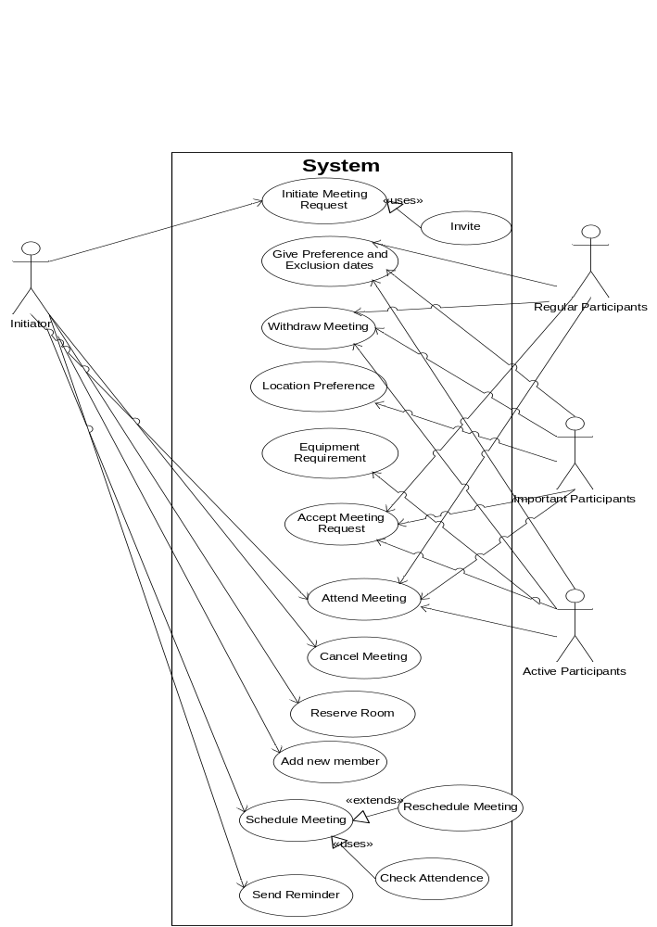
Fig 6.2 Use Case Diagram

6.3 Class Diagram :-
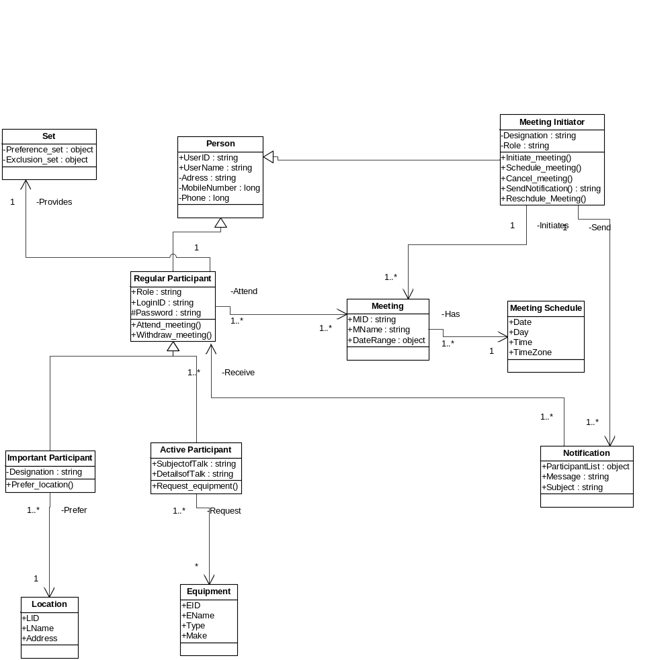

Fig. 6.3 Class Diagram

7. Our Project – Why Better?
Top eleven reasons why our team project stands better than others:
- The percentage of the change that our project could accommodate(25%) is calculated systematically and not randomly unlike other teams by giving weightage to the requirements based on the level of difficulty of change.
  - Calculated percentage: Requirement Changes/Total Requirements
- Our team follows the evolutionary spiral model which allows us to reiterate the requirement process, but some teams follow the Role Actor Diagram process which does not give the freedom to go back and change the requirements if there was a mistake in obtaining them.
- Our team project has the traceability matrix with respect to Domain requirements Vs Functional requirements, Domain requirements Vs Non-Functional requirements and System Requirements Vs Prototype, whereas other teams have only one traceability matrix (System Vs Domain)
- Based on the clear understanding of participants (Active, Important and Regular), we have developed separate interface for each participants to handle meeting requests.
- Our prototype has a higher requirement compliance percentage than most of the other teams as other teams prototype was not according to the requirements and even included more req. making it complex
- Our system is flexible as even if 50% of the active participants are available, the meeting goes on. Whereas, other teams system cancels the meeting even if any of the active participant declines the meeting.
- Our system is efficient because we are maintaining deadlines for participant's input. This will prevent delays in scheduling meeting due to no response of one or more participants.
- Our prototype has a "User Profile / Availability" page that allows user to edit his/her profile and also the preference/exclusion sets of the days in the week. This common preference and exclusion set will facilitate the participant to use this set for every meeting request, rather than explicitly specify the sets for every request. According to the prototype of the other teams the user has to mention his preferred and exclusion set every time he responds.
- Our system is more efficient because the participants can change their default preferred and exclusion set in their profile page and resolve the conflicts if he has been rejected in the first response, thereby giving scope for the importance of the users which is not present in others team.
- Only our team has the navigation between the web pages, the calendar that shows the upcoming events and the search bar to quickly find out the meeting requests in case of many.
- Our system has a clear distinction of roles and allowable actions that are exactly according to the requirements, whereas some teams gave special permissions to the participants like "Active Participant can cancel the meeting if he/she is not attending". Also one of the teams specified the category of users based on the organizational structure rather then the users specified in the requirements.

8. References
[1] Requirement Engineering – Advanced Requirement Engineering. CS/SE 6361 Section 001, Fall 2009.
http://www.utdallas.edu/~chung/RE/syllabus.htm
[2] Software Project Management Plan Template < OOSE < Twiki. Software Project Management Plan Template. http://wwwbruegge.informatik.tu-muenchen.de/twiki/bin/view/OOSE/SoftwareProjectManagementPlanTemplate
[3] Project Phase I: Requirements Elicitation: Initial Understanding
http://www.utdallas.edu/~chung/RE/Project1.pdf
[4] Ambulance Dispatch System: Software Project Management Plan: Gang of Eight (GoE)- Summer 2007
[5] WRS Template: http://www.utdallas.edu/~chung/RE/WRS-template.rtf
[6] Preliminary Definition, Issues and Improved Understanding: Knack Works
http://www.utdallas.edu/~chung/RE/Presentations09S/RE_Submit.zip
[7] Diagram for the roles of participants: Team Kuiler, Phase 2 Presentation, Spring 2009
http://www.utd.edu/~chung/RE/Presentations09S/KuilerTeam_Documents.zip
[8] http://en.wikipedia.org/wiki/Use_case#Use_case_templates
[9] http://alistair.cockburn.us/Basic+use+case+template
[10] http://www.accompa.com/product-management-blog/2009/10/08/use-case-template-example- requirements-management-basics/

9. Definitions, Acronyms and Abbreviations
MI Meeting Initiator
MA Potential Meeting Attendees
ES Exclusion Set
PS Preference Set
DC Date Conflict
SDC Strong Date Conflict
WDC Weak Date Conflict
SPMP Software Project Management Plan
SRS Software Requirement Specification

10. Glossary

A
Active Participant: Participants who along with exclusion and preference sets can also specify special equipment requirements
E
Elicitation: An activity in Requirements Engineering Process to collect requirements from customer/user for formulating initial understanding
Evolutionary Spiral Model: Requirements Engineering Model based on iterations of Requirements Elicitation, Requirements Analysis & Negotiation, Requirements Specification and Requirements Validation
Exclusion Set: Set of meeting date and time tuples on which potential attendees cannot attend meeting
I
Important Participant: Potential attendee who along with exclusion and preference sets can specify preferred meeting locations
M
Meeting Initiator: Person who initiates and controls a meeting scheduling process
O
Organogram: Hierarchy of roles in an organization
P
Preference Set: Set of desirable meeting date and time tuples as specified by potential attendees
R
Regular Participant: A potential meeting attendee who can specify exclusion and preference sets
Requirements Analysis: An initial analysis performed to clearly define a problem related to requirements and to specify the nature of the proposed solution
Requirements Engineering: The task of capturing, structuring, and accurately representing the user's requirements so that they can be correctly embodied in systems which meet those requirements
Risk Management: A Method or technique to identify the future risks associated with a project along with their preventions and remedies
Ross: Proposed Why, What and How Model of Requirements Engineering
S
Software Project Management Plan: A document for management purposes that gives the basics of a project in terms of its objectives, justification, and how the objectives are to be achieved. This document is used as a record of decisions and a means of communication among stakeholders
Specification: Validation: An activity in Requirements Engineering Process that produces a model or description to represent requirements
Stakeholder: Any individual or organization who has some interest in the project
Systems Engineering: An activity in Software Development Lifecycle that includes project planning and management
V
Validation: An activity in Requirements Engineering Process that validates requirements engineering model

