Team Blitzkrieg

Distributed Meeting Scheduler

Interim Phase II

Final Report

Version 1.0

Team Blitzkrieg

Team Website: [http://utdallas.edu/~srw051000/SE6361\_Blitzkreig/](http://utdallas.edu/%7Esrw051000/SE6361_Blitzkreig/)

|  |  |  |
| --- | --- | --- |
| Student Name | Student Id | Email address |
| Aditya Dhamankar | acd081000 | acd081000@utdallas.edu |
| Ajay Narasimmamoorthy | axn084020 | axn084020@utdallas.edu |
| Bryan Parker | blp090020 | blp090020@utdallas.edu |
| Jassem Shakil | jxs082200 | jxs082200@utdallas.edu |
| Jeevan Kumar | jxg096020 | jxg096020@utdallas.edu |
| Muhammad Abdullah | mxa088100 | mxa088100@utdallas.edu |
| Preeti Ganeshmohan | pxg076000 | pxg076000@utdallas.edu |
| Sean Wilson | srw051000 | srw051000@utdallas.edu |
| Vinay Kumar | vks061000 | vks061000@utdallas.edu |
| MEGHANA SATPUTE | mns086000 | mns086000@utdallas.edu |

Submitted to:

Dr. Lawrence Chung

Associate Professor,

Department of Computer Science,

The University of Texas at Dallas

Revision History

|  |  |  |
| --- | --- | --- |
| Date | Version | Description |
| 11/12/2009 | 1.0 | Compiled Report |
|  |  |  |

Table of Contents

[1. Introduction 3](#_Toc245781236)

[1.1 Purpose 3](#_Toc245781237)

[1.2 Scope 3](#_Toc245781238)

[1.3 Project Overview 3](#_Toc245781239)

[1.4 Stakeholders 4](#_Toc245781240)

[1.5 Definitions, Acronyms and Abbreviations 4](#_Toc245781241)

[1.6 References 5](#_Toc245781242)

[2. Process Specification 5](#_Toc245781243)

[2.1 Process Overview 5](#_Toc245781244)

[2.2 Process Model 9](#_Toc245781245)

[2.2.1 Requirements Elicitation 10](#_Toc245781246)

[2.2.2 Requirements Analysis and Negotiation 10](#_Toc245781247)

[2.2.3 Requirements Specification 10](#_Toc245781248)

[2.2.4 Requirements Validation 11](#_Toc245781249)

[2.3 Process SADT 11](#_Toc245781250)

[2.3.1 Process SADT Level 0 11](#_Toc245781251)

[2.3.1 Process SADT Level 1 12](#_Toc245781252)

[2.3.1 Process SADT Level 2 13](#_Toc245781253)

[2.4 Activity Diagrams 14](#_Toc245781254)

[2.4.2 Final Phase I 15](#_Toc245781255)

[2.4.3 Interim Phase II 16](#_Toc245781256)

[2.4.4 Final Phase I 17](#_Toc245781257)

[3.1 Enterprise Requirements 18](#_Toc245781258)

[3.1.1 Preliminary Requirements 18](#_Toc245781259)

[3.1.2 Issues 18](#_Toc245781260)

[3.1.3 Improved Understanding 19](#_Toc245781261)

[3.2 Functional Requirements 20](#_Toc245781262)

[3.1.1 Preliminary Requirements 20](#_Toc245781263)

[3.1.2 Issues 20](#_Toc245781264)

[3.1.3 Improved Understanding 25](#_Toc245781265)

[3.3 Non-functional Requirements 26](#_Toc245781266)

[3.1.1 Preliminary Requirements 26](#_Toc245781267)

[3.1.2 Issues 26](#_Toc245781268)

[3.1.3 Improved Understanding 26](#_Toc245781269)

[4. Product Requirement Models and Specifications 27](#_Toc245781270)

[4.1 Major Use Cases 27](#_Toc245781271)

[4.1.1 Initiate Meeting Request 27](#_Toc245781272)

[4.1.2 Accept Meeting Request- Regular Participant 28](#_Toc245781273)

[4.1.3 Accept Meeting Request- Active Participant 29](#_Toc245781274)

[4.1.4 Accept Meeting Request- Important Participant 29](#_Toc245781275)

[4.1.5 Schedule Meeting 30](#_Toc245781276)

[4.2 Use Case Diagram 32](#_Toc245781277)

[4.3 Class Diagram 33](#_Toc245781278)

[4.4 Sequence Diagrams 34](#_Toc245781279)

[4.4.1 Initiate Meeting Request 34](#_Toc245781280)

[4.4.2 Accept Meeting Request- Regular Participant 34](#_Toc245781281)

[4.4.3 Accept Meeting Request- Active Participant 35](#_Toc245781282)

[4.4.4 Accept Meeting Request- Important Participant 36](#_Toc245781283)

[4.4.5 Schedule Meeting 37](#_Toc245781284)

[4.5 Product SADT 38](#_Toc245781285)

[4.5.1 Product SADT Level 0 38](#_Toc245781286)

[4.5.2 Product SADT Level 1 39](#_Toc245781287)

[4.6 SIG for NFRs 40](#_Toc245781288)

[4.6.1 Security 40](#_Toc245781289)

[4.6.3 Maintainability 41](#_Toc245781290)

[4.6.4 Flexibility 41](#_Toc245781291)

[4.7 KAOS Modeling 42](#_Toc245781292)

[4.7.1 Security 42](#_Toc245781293)

[4.7.2 Usability 42](#_Toc245781294)

[4.7.3 Maintainability 43](#_Toc245781295)

[4.7.4 Flexibility 43](#_Toc245781296)

1. Introduction

## 1.1 Purpose

The Distributed Meeting Scheduler System is a Web based software system that is proposed primarily for scheduling meetings. The purpose of DMS is to automate the process of organizing meetings i.e. to determine the meeting date and location for each meeting request, so that most of the intended participants will effectively participate.

1.2 Scope  
The scope of the system includes scheduling and rescheduling the meetings given the preference and exclusion set, supporting regular meetings and virtual meetings (like teleconferencing). The system is designed to be used by both non-experts and experts.

The main features of our system are as follows:

* This Distributed Meeting Scheduler System enables the user to schedule virtual or regular meetings based on the availability of resources and constraints put forward by the resources.
* The System is available online and also allows scheduling of one-time or recurring meetings.
* The System allows the user to schedule meetings, reschedule existing meetings, edit meetings, finalize meetings and check the result of meetings.
* The System is automated to a great extent, minimizing the number of rounds of negotiations.
* The System automatically shows distinct options, services and different access privileges according to the type of participant e.g. active participant, important participant or regular participant.
* The System will automate meeting reminders and resolve conflict resolution while participants can create reminders for a meeting as far in advance as he/she wants.
* The System also sends email notifications to all the participants of the specific meeting with all details of it.
* For faster access, the participants are able to search the meeting information that he/she initiated or is part of.
* The interactive and simplified view along with easy understanding of options makes this system robust and useful for expert and non-experts of the system.

## 1.3 Project Overview

The Distributed Meeting Scheduler System automates the process of scheduling meetings. It is a type of resource allocation and collaboration system. There are primarily two actors in the system:

1. **Meeting Initiator**

Responsible for initiating a meeting and defining an interval within which a meeting can be held.

1. **Potential Meeting Attendees**

These people will be attending a meeting and will provide availability timings and non-availability timings to the system. Some meeting attendees can be further classified into two categories:

1. *Important Participants:*

Meeting attendees who may specify their preferred meeting location

1. *Active Participants:*

Meeting attendees who may be providing special equipment requirements for the meeting like projector, internet connection etc.

1. *Regular Participants:*

Meeting attendees who specify their preferred and exclusion sets only

The system functions in the following manner:

1. The meeting initiator initiates a meeting along with the time interval within which the meeting can take place.
2. The meeting attendees provide their preference and exclusion sets along with their preferred meeting location.
3. The system then finds a feasible meeting time along with an available preferred meeting room for the meeting keeping in consideration the constraints and availability data provided by various actors of the System.
4. If there are any conflicts, the System supports conflict resolution using the conflict resolution policy provided by the client.

## 1.4 Stakeholders

The following are the stakeholders in this project.

1. TeraSoft [[3]](#Num3)

The organization which has requested services of Team Blitzkrieg for requirements engineering and development of the Distributed Meeting Scheduler System

1. Team Blitzkrieg

Development team responsible to carry out the aforementioned activities

1. Professor Lawrence Chung

Coordinated with TeraSoft on behalf of Team Blitzkrieg to gather customer’s requirements

## 1.5 Definitions, Acronyms and Abbreviations

MI Meeting Initiator

MA Potential Meeting Attendees

ES Exclusion Set

PS Preference Set

DC Date Conflict

SDC Strong Date Conflict

WDC Weak Date Conflict

SPMP Software Project Management Plan

SRS Software Requirement Specification

## 1.6 References

[1] Requirement Engineering – Advanced Requirement Engineering. CS/SE 6361 Section 001, Fall 2009. <http://www.utdallas.edu/~chung/RE/syllabus.htm>

[2] Software Project Management Plan Template < OOSE < Twiki. Software Project Management Plan Template. <http://wwwbruegge.informatik.tu-muenchen.de/twiki/bin/view/OOSE/SoftwareProjectManagementPlanTemplate>

[3] Project Phase I: Requirements Elicitation: Initial Understanding[http://www.utdallas.edu/~chung/RE/Project1.pdf](http://www.utdallas.edu/~chung/RE/Project1.pdf" \t "_blank)

[4] Ambulance Dispatch System: Software Project Management Plan: Gang of Eight (GoE)- Summer 2007

[5] WRS Template: <http://www.utdallas.edu/~chung/RE/WRS-template.rtf>

[6] Preliminary Definition, Issues and Improved Understanding: Knack Works <http://www.utdallas.edu/~chung/RE/Presentations09S/RE_Submit.zip>

[7] Diagram for the roles of participants: Team Kuiler, Phase 2 Presentation, Spring 2009 <http://www.utd.edu/~chung/RE/Presentations09S/KuilerTeam_Documents.zip>

2. Process Specification

2.1 Process Overview

The project has been divided into two phases. Every phase has in-turn two sub-phases. These sub-phases are called interim and final. The following represents the hierarchical overview of the phases of the project.



**Hierarchical Overview of the Project Phases**

The following is a brief overview of the top level phases:

**Phase I:**

Phase I is the starting point of the project. The input to this phase is the initial understanding of the requirements, formulated by TeraSoft and Professor Lawrence Chung. The major goal of this phase is to draft a preliminary Software Project Management Plan, perform issue analysis on the initial understanding of the requirements, come-up with solutions and formulate the improved understanding for these requirements. A prototype has been developed against the improved understanding of requirements. In order to validate the requirements and the prototype, traceability matrices between various types of requirements and between requirements and prototype have been created. Phase I ends with two additional deliverables including Requirements Creeping Rate and justification for excellence of our deliverables. The aforementioned tasks have been accomplished in two sub-phases, whose description will soon follow.



**Interim Phase I- Process**



**Final Phase I- Process**

**Phase II:**

Phase II of the project commences with the formulation of Process Specifications which discuss in detail the process followed during the modeling and prototyping of the system. This phase also introduces some new requirements in the project, thus engendering the need to re-perform issue analysis (using semi-formal notation) of the new requirements and the reconstruction of the improved understanding for these requirements. Several product requirements model have been developed during the project along with associated traceability matrices. A Vision document has been crafted as well. The phase concludes with the development of running prototype. The aforementioned tasks have been completed in two sub-phases, whose description will soon follow.



**Interim Phase II- Process**



**Final Phase II- Process**

2.2 Process Model  
In order to cater the changing requirements, Spiral Model will be used for requirements elicitation, specification and validation. The team will produce each deliverable by:

1. Analyzing and discussing requirements in team meetings
2. Constructing deliverables
3. Reviewing deliverables for amendments before submission



### 2.2.1 Requirements Elicitation

Initial requirements were provided by the professor. Additional requirements were added by either elicitation of the professor or by further refinement of the initial problem description.

### 2.2.2 Requirements Analysis and Negotiation

Each requirement was analyzed thoroughly for completeness, unambiguousness, soundness, and consistency. As the result of requirements analysis, an improved understanding of each requirement was created. The improved understanding includes each requirement with the necessary corrections to remove any of the aforementioned issues.

While carrying out Requirements Analysis, the "Why, What, How" model proposed by Ross will be used to answer the three most important questions: Why the system is needed?

1. What system features will serve and satisfy this context?
2. How the system is to be constructed?
3. How the system is to be constructed?

### 2.2.3 Requirements Specification

In order to ensure efficient maintenance of the requirements, the requirements have been organized into multiple requirements sets, each set reflecting the requirements for a particular type of requirement, such as domain, functional, and non-functional requirements.

### 2.2.4 Requirements Validation

In order to ensure the requirements were meeting customer expectations, an initial prototype was constructed showing the initial functionality of the system. The benefits of using evolutionary prototyping are as below:

1. Misunderstanding between client and requirement engineers are exposed
2. Missing services may be detected
3. Confusing services may be identified
4. A working system is available early in the process
5. The prototype may serve as the basis for deriving a system specification

2.3 Process SADT

2.3.1 Process SADT Level 0



2.3.1 Process SADT Level 1

2.3.1 Process SADT Level 2

2.4 Activity Diagrams  
2.4.1 Interim Phase I  


2.4.2 Final Phase I

2.4.3 Interim Phase II

2.4.4 Final Phase I  
  
3. Requirements Description

3.1 Enterprise Requirements

### 3.1.1 Preliminary Requirements

|  |  |
| --- | --- |
| DR23 | The meeting initiator can cancel or reschedule a meeting. |
| DR24 | All participants can fully, partially or not attend a meeting. |
| DR25 | The meeting can be scheduled to be one-time or recurring. |
| DR26 | Meeting locations should be convenient |

### 3.1.2 Issues

**ISSUE STATEMENT: [DR24]**

"All participants can fully, partially or not attend a meeting."

**Problem:** (*Type of Issue: ambiguity*) The statement sounds suggestive and partial attendance is not clearly defined.

**Option 1:** Define partial attendance as the 50% or more participants attend the meeting.   
  
**Option 2:** Define partial attendance as same participant can attend different meetings partially.

**Option 2**: Define partial attendance as same participant can attend different meetings partially but in non-overlapping manner.

**Solution:** Option 3

**Rationale:** Option 1 is already covered and allowing a participant to attend more than 1 meetings in non –overlapping manner seems more feasible as participant cannot attend different meetings in same time interval. So for example if there are 2 meetings first is from 11 to 1 and second is from 11 to 2 then participant will be able to attend first meeting from 11 to 12 and second meeting from 12 to 1.

**Reference:** None

**ISSUE STATEMENT: [DR25]**

" The meeting can be scheduled to be one-time or recurring..”

**Problem:** (*Type of Issue: ambiguity*) Here the word “recurrence” does not explicitly say when the meeting can be recurrent. Also the statement sounds suggestive and a more defined approach needs to be taken.

**Option 1:** The meeting is recurrent every day at the time specified.

**Option 2:** The meeting is recurrent every week at the day and time specified.

**Option 3:** The meeting is recurrent every month at the date and time specified.

**Option 4:** The meeting is recurrent every year at the date and time specified.

**Option 5:** The meeting coordinator decides when the meeting should reoccur..

**Solution:** Option 5

**Rationale:** The meeting can be scheduled to be one-time or recurring. It means the initiator will be given an option if the meeting is one time or it will recur every day/week/ month/ year. If it is recurring then automatically requests will be sent for those meeting till the initiator cancels the meeting.

**Reference:** None.

**ISSUE STATEMENT: [DR26]**

" Meeting locations should be convenient.”

**Problem:** (*Type of Issue: ambiguity, redundant*) Convenient can mean different things to different people. It is not clearly defined. It can mean near from participant’s home or near from participant’s office or from the preferred location participant has selected.

**Option 1:** All participants can give preferred location and the most preferred one is selected to be the meeting location.

**Option 2:** Only important participants can select their preferred location and the most preferred one by them is selected to be the meeting location.

**Option 3:** Ignore this requirement.

**Solution:** Option 3

**Rationale:** Option 2 is already covered. We can allow all participants to select preferred location (Option 1) but there can be a situation where location will be selected by regular participant’s preference and if 49% of them cancel the meeting then meeting will be still scheduled. Such a meeting might not be convenient to the important participants. Since Option 2 exists already, we will remove this requirement.

**Reference:** None.

### 3.1.3 Improved Understanding

[DR23] The meeting initiator can cancel or reschedule a meeting.

[DR24] All participants can attend the meeting fully (present for whole meeting ), partially (can attend meeting for a particular time slot) or not attend the meeting.

[DR25] The meeting can be scheduled to be one-time or recurring. It means the initiator will be given an option if the meeting is one time or it will recur after a week/ month/ year. If it is recurring then automatically requests will be sent for those meeting till the initiator cancels the meeting.

## 3.2 Functional Requirements

### 3.1.1 Preliminary Requirements

|  |  |
| --- | --- |
| FR18 | Some meetings are scheduled and organized at the same time where partial attendance can be allowed |
| FR19 | Each of the different type of user should have different access privileges |
| FR20 | A secure login username and password is required for each of the user to access the system |
| FR21 | A participant should only be able to see the meeting information that he/she initiated or is part of |
| FR22 | A participant should only be able to search the meeting information that he/she initiated or is part of |
| FR23 | The meeting initiator should be able to invite another person even after sending the original meeting request. |
| FR24 | The system should a**utomatically decline conflicting meeting requests for each user** |
| FR25 | The meeting coordinator can Create reminders for a meeting as far in advance as he/she wants. |
| FR26 | Initiator can open another person's calendar, contacts, or tasks to see if that person is available for meeting. |
| FR27 | Any Participant should be able to cancel the meeting |

### 3.1.2 Issues

**ISSUE STATEMENT: [FR18]**

“Some meetings are scheduled and organized at the same time where partial attendance can be allowed.”

**Problem:** (*Type of Issue: ambiguity*) The statement sounds vague and partial attendance is not clearly defined. Also who schedules and organizes these meetings isnt defined clearly

**Option 1:** Define partial attendance as continue with holding the meeting even if 50% or more participants attend the meeting.

**Option 2:** Define partial attendance as same participant can choose to attend or not attend different meetings partially as per his/her will.

**Option 2**: Define partial attendance as same participant can attend different meetings partially but in non-overlapping manner.

**Solution:** Option 3

**Rationale:** Option 1 is already covered and allowing a participant to attend more than 1 meeting in non –overlapping manner seems more feasible as participant cannot attend different meetings in same time interval. So for example if there are 2 meetings first is from 11 to 1 and second is from 11 to 2 then participant will be able to attend first meeting from 11 to 12 and second meeting from 12 to 1. This ensures his meeting schedule does not clash in time.

**Reference:** None

**ISSUE STATEMENT: [FR19]**

“Each of the different type of user should have different access privileges.”

**Problem:** (*Type of Issue: ambiguity*) The statement sounds vague and here “different” in terms of user types and access privileges arent listed which would make the requirement more clear. Also the statement sounds suggestive and a more defined approach needs to be taken.

**Option 1:** Define access privilege as any meeting participant shall be able to invite and include another participant to the meeting.

**Option 2:** Define access privilege as any meeting participant shall not be able to include another participant to the meeting. He/She can invite another person to the meeting only through the meeting coordinator.

**Solution:** Option 2.

**Rationale:** Option 2 makes sure that all users do not get access rights to add/delete the attendees of a particular meeting. Only the meeting coordinator shall have the sole authority to make the modifications..

**Reference:** None

**ISSUE STATEMENT: [FR21]**

“A participant should only be able to see the meeting information that he/she initiated or is part of.”

**Problem:** (*Type of Issue: ambiguity*) The statement sounds vague and here “what” type of information a particular attendee can see which would make the requirement more clear. Also the statement sounds suggestive and a more defined stand needs to be taken

**Option 1:** The meeting attendee should be able to see any participants meeting information along with his/her own.

**Option 2:** The meeting attendee should be able to view only his/her own meeting information depending on their role as regular, important or active participant or meeting coordinator.

**Solution:** Option 2

**Rationale:** Security is ensured by concealing others participant’s information from a user so that data integrity and the privacy of the person is ensured. Also different roles have different access privileges. For example a regular participant must not be able to view or choose list of meeting rooms as only an important participant can choose from a list of meeting rooms. Similarly active participant shall not be allowed to create/modify or delete a meeting location or time which is the sole authority of the meeting coordinator. Only the meeting coordinator shall have the sole authority to view the calendar of athe participant of the meeting to schedule effectively.

**Reference:** None

**ISSUE STATEMENT: [FR22]**

“A participant should only be able to search the meeting information that he/she initiated or is part of.”

**Problem:** (*Type of Issue: ambiguity, redundance*) The statement sounds vague and here “what” type of information a particular attendee can search for which would make the requirement more clear. Also the statement sounds suggestive and a more defined stand needs to be taken. In addition this requirement is redundant as a similar requirement to view particular information is already defined

**Option 1:** The meeting attendee should be able to search for any participants meeting information along with his/her own.

**Option 2:** The meeting attendee should be able to search for only his/her own meeting information depending on their role as regular, important or active participant or meeting coordinator.

**Solution:** Option 2

**Rationale:** Security is ensured by concealing others participant’s information from a user so that data integrity and the privacy of the person is ensured. Also different roles have different access privileges. For example a regular participant must not be able to search for the list of meeting rooms as only an important participant can choose from a list of meeting rooms. Similarly active participant shall not be allowed to search for and modify/delete a meeting location or time which is the sole authority of the meeting coordinator. Only the meeting coordinator shall have the sole authority to search for and view the calendar of a participant of the meeting to schedule effectively.

**Reference:** None

**ISSUE STATEMENT: [FR23]**

“The meeting initiator should be able to invite another person even after sending the original meeting request”

**Problem:** (*Type of Issue: ambiguity*) The statement sounds vague and here “why” the coordinator wants to include another person to the meeting is unclear. Also the statement sounds suggestive and a more defined stand needs to be taken.

**Option 1:** The meeting coordinator shall include another person as a participant according to his/her liking.

**Option 2:** The meeting coordinator shall include another person as a participant depending on their role as regular, important or active participant if an existing member suggests that person’s inclusion or if the coordinator feels that person has been missed out initially..

**Solution:** Option 2

**Rationale:** The flexibility to include a person to the meeting by the meeting coordinator even after the initial invite has been sent should be allowed by the system. Here a participant can request or suggest to the coordinator that another person be invited to the meeting and the coordinator sends the invite. The meeting coordinator can also include the person if he accidently left him/her out during the initial invitation process.

**Reference:** Microsoft Office Outlook Meeting Scheduler features

**ISSUE STATEMENT: [FR24]**

“The system should automatically decline conflicting meeting requests for each user.”

Problem:

The system has the ability to decline meeting requests for the user if there is a conflict in the meetings without notifying the user.

Option 1:      The system cancels any conflicting meeting requests without notifying the user.

Option 2:     The system notifies the user of the declined meeting request.

Option 3:     The user is given the option of the decline the meeting request during a conflict. He has the ability to decline the earlier accepted meeting and can attend the new meeting. In addition,  the user also has the capability to partially attend a meeting.

Solution:         Option 3

Rationale:       This gives the user the right to decide which meeting he/she would prefer to attend or partially attend.

Reference:      Microsoft Office Outlook Meeting Scheduler features

**ISSUE STATEMENT: [FR25]**

“The meeting coordinator can create reminders for a meeting as far in advance as he/she wants.”

Problem: Unclear on what information would the reminders contain. Also, how often are the meeting reminders sent before a meeting or if only 1 reminder is sent.

Option 1:      The reminders sent contain only the meeting location and time.

Option 2:      The reminders sent contain only the meeting location, meeting attendees and time.

Option 3:      The reminders sent contain only the meeting location, meeting attendees, time and brief information about the meeting.

Option 4:      The reminders sent contain only the meeting location, time and brief information about the meeting. The number of reminders sent is decided by the meeting coordinator to all participants who accepted the meeting.

Option 5:      The reminders sent contain only the meeting location, time and brief information about the meeting. The number of reminders sent is decided by the meeting coordinator to important participants.

Option 6:      The reminders sent contain only the meeting location, time and brief information about the meeting. The number of reminders sent is decided by the meeting coordinator to active participants.

Option 7:      The reminders sent contain only the meeting location, time and brief information about the meeting. The number of reminders sent is decided by the meeting coordinator to regular participants.

Solution:         Option 4

Rationale:       Each user is reminded only relevant information about the meeting. The number of meeting reminders to be sent is controlled by the meeting coordinator depending on the size, importance of the meeting. Reminders are sent only to users who have accepted the meeting requests.

Reference:      Microsoft Office Outlook Meeting Scheduler features

**ISSUE STATEMENT: [FR26]**

“Initiator can open another person's calendar, contacts, or tasks to see if that person is available for meeting.”

**Problem:**

(Type of Issue: Redundancy, conflicting) This requirement is redundant as the Initiator will come to know by preference and exclusion sets provided by participants. Also it is conflicting with requirements FR21 and FR22 which say “A participant should only be able to see/search the meeting information that he/she initiated or is part of”

**Option 1:**  Allow Initiator to see another participant’s calendar.

**Option 2:**  Remove the requirement.

**Solution:** Option 2

**Rationale:** This requirement is not needed as by exclusion sets and preferred sets provided by participants the Initiator will come to know their availability. It will lead to security issues so this requirement is removed

**Reference:** Microsoft Office Outlook Meeting Scheduler features

**ISSUE STATEMENT: [FR27]**

“Any participant should be able to cancel the meeting.”

**Problem:** (*Type of Issue: conflicting*) This requirement is conflicting with requirement DR23 which say “The meeting initiator can cancel or reschedule a meeting.”

**Option 1:**  Allow all participants to cancel the meeting.

**Option 2:**  Remove the requirement.

**Solution:** Option 2

**Rationale:** This requirement is removed as it was conflicting with DR23. Also if any of the participant cannot attend the meeting then it is better to allow that participant to withdraw from meeting rather than canceling the meeting.

**Reference:** Microsoft Office Outlook Meeting Scheduler features

### 3.1.3 Improved Understanding

[FR18] Partial attendance of a person can be allowed to meetings that are scheduled and organized at the same time. For example if there are 2 meetings first is from 11 to 1 and second is from 11 to 2 then participant will be able to attend first meeting from 11 to 12 and second meeting from 12 to 1. This ensures his meeting schedule does not clash in time.

[FR19] Each of the different type of user should have different access privileges that makes sure that all users do not get access rights to add/delete the attendees of a particular meeting. Only the meeting coordinator shall have the sole authority to make the modifications..

[FR21] A participant should only be able to only see the meeting information that he/she initiated or is part of by concealing others participant’s information from a user so that data integrity and the privacy of the person is ensured. Also different roles have different access privileges. For example a regular participant must not be able to view or choose list of meeting rooms as only an important participant can choose from a list of meeting rooms. Only the meeting coordinator shall have the sole authority to view the calendar of athe participant of the meeting to schedule effectively.

[FR22] A participant should only be able to search the meeting information that he/she initiated or is part of by concealing others participant’s information from a user so that data integrity and the privacy of the person is ensured. Also different roles have different access privileges. For example a regular participant must not be able to search for the list of meeting rooms as only an important participant can choose from a list of meeting rooms. Only the meeting coordinator shall have the sole authority to search for and view the calendar of a participant of the meeting to schedule effectively.

[FR23] The meeting initiator should be able to invite another person even after sending the original meeting request. Here a participant can request or suggest to the coordinator that another person be invited to the meeting and the coordinator sends the invite. The meeting coordinator can also include the person if he accidently left him/her out during the initial invitation process.

[FR24] The system should automatically decline conflicting meeting requests for each user. This gives the user the right to decide which meeting he/she would prefer to attend or partially attend.

[FR25] The meeting coordinator can create reminders for a meeting as far in advance as he/she wants. Each user is reminded only relevant information about the meeting. The number of meeting reminders to be sent is controlled by the meeting coordinator depending on the size, importance of the meeting. Reminders are sent only to users who have accepted the meeting requests.

[FR26] Initiator can open another person's calendar, contacts, or tasks to see if that person is available for meeting. This requirement is not needed as by exclusion sets and preferred sets provided by participants the Initiator will come to know their availability. It will lead to security issues so this requirement is removed.

[FR27] Any participant should be able to cancel the meeting. This requirement is removed as it was conflicting with DR23. Also if any of the participant cannot attend the meeting then it is better to allow that participant to withdraw from meeting rather than cancelling the meeting.

## 3.3 Non-functional Requirements

### 3.1.1 Preliminary Requirements

|  |  |
| --- | --- |
| NFR18 | Information about meetings should be secure. |

### 3.1.2 Issues

**ISSUE STATEMENT: [NFR18]**

“Information about meetings should be secure.”

**Problem:** (Type of Issue:  *incompleteness*) The requirement is incomplete as it does not specify what exactly expected by “secure” system and what information needs to be secure. i.e. the information about the participants or the meeting details.

**Option 1:** Define security as the access privileges for each type of user. Users shall be able to log into the system via a login screen with a user name and password. A participant should only be able to see and search the meeting information that he/she initiated or is part of.

**Option 2:** All participants will have same privileges.

**Option 3:** Meeting details will be kept secret.

**Solution:** Option 1

**Rationale:** Option 3is out of the scope of our system. Option 2 seems inappropriate as all participants are not of equal importance and there is no point giving equipment request access to regular participants or access to cancel meeting by regular participants. So Option 1 is most suitable as it will allow different types of participants to do different things that they are required to do.

**Reference:** None

### 3.1.3 Improved Understanding

[NFR18] Security is provided by giving the access privileges for each type of user. Users shall be able to log into the system via a login screen with a user name and password. A participant should only be able to see and search the meeting information that he/she initiated or is part of.  
  
4. Product Requirement Models and Specifications

4.1 Major Use Cases

4.1.1 Initiate Meeting Request

* **Use Case: UC-1** Initiate Meeting
* **Level:** User Goal
* **Primary Actor:** Meeting Initiator
* **Stakeholders and Interest:**
  + Meeting Initiator: wants to initiate a meeting
  + Regular Participants: potential attendee of the meeting
  + Active Participants: potential attendee and speaker of the meeting
  + Important Participants: potential important attendee of the meeting
* **Pre-Conditions**
  + Meeting initiator is signed in to the Meeting Scheduler
* **Success Guarantee (Post Conditions)**
  + Meeting is successfully initiated by the meeting initiator and all the potential participants are invited
* **Main Success Scenario**

1. The meeting initiator logs-in to the Meeting Scheduler by providing the credentials.
2. The meeting initiator browses to the initiate meeting page
3. Meeting initiator specifies the meeting title, type of meeting, description of meeting, meeting duration
4. Also, the meeting initiator specifies the time window within which the meeting can take place and the threshold before which all the participants should respond or the meeting date, time and location will be decided
5. The meeting initiator then invites potential meeting attendees by specifying their Name, Email Addresses, Attendee Type (Regular, Important, Active)
6. Finally the Meeting Initiator submits the meeting initiation request to the Meeting Scheduler system.

* **Extensions**

1.a The meeting initiator provided user id or password is wrong

1. The system prompts the meeting initiator to re-enter his/her user id and password.

2. The meeting initiator re-enters his/her user id and password.

3. The meeting initiator logs-on to the system.

4.a. For the time window, the end date/time is less then the start date/time or start date/time is greater then the end date/time

1. The system displays an error to the meeting initiator indicating an invalid Input.

2. The initiator corrects the time window by removing the inconsistency

4.b. The meeting threshold does not lie between the time window specified by the meeting initiator

1. The system displays an error to the meeting initiator, prompting that the threshold should lie between the time window specified
2. The initiator re-specified the threshold date

5.a. The meeting initiator does not specify Participant Name, Participant Type, Participant Email or specifies invalid Participant Email

1. The system prompts meeting initiator to provide missing information or correct any invalid information.

2. The initiator specifies the missing information

5.b. Include: Check-Out

* **Special Requirements**
  + The meeting scheduling system is up and running
  + Availability of Internet
* **Technology and Data Variation**
  + SMTP protocol for sending emails
  + PHP for web application development
  + MySQL as database
* **Frequency of Occurrence** Frequent

### 4.1.2 Accept Meeting Request- Regular Participant

* **Use Case: UC-2** Accept Meeting Request- Regular Participant
* **Level:** User Goal
* **Primary Actor:** Regular Participant
* **Stakeholders and Interest:**
  + Regular Participant: wants to provide preference and exclusion sets
  + Meeting Scheduling System: authenticates provided sets and saves them for the purpose of scheduling the meeting
  + Meeting Initiator: wants to receive Regular participant’s feedback
* **Pre-Conditions**
  + Regular participant has logged-in to the system.
  + Regular participant has received a meeting request.
* **Success Guarantee (Post Conditions)**
  + Exclusion and preference sets provided by the Regular participant are authenticated and stored by the system.
* **Main Success Scenario**

1. The Regular participant selects to accept the meeting request.
2. The Regular participant provides his exclusion and preference sets.
3. The system stores the exclusion and preference sets provided by the Regular participant.
4. The system generates a notification through email to the meeting initiator, regarding the feedback of Regular participant.

* **Extensions**

1.a The Regular participant declines the meeting request.

* 1. The system deletes the Regular participant from the list of potential meeting attendees.
  2. The system sends an email to the meeting initiator, regarding the
  3. decision of Regular participant.

2.a. The Regular participant uses his common exclusion and preference sets.

1. The Regular participant sets check on “Use Common Preference and Exclusion sets.”
2. The participant clicks on “Submit” button.

2.b. The Regular participant provides new exclusion and preference sets.

1. The participant specifies start date from the calendar.
2. The participant specifies end date from the calendar.
3. The participant enters start time.
4. The participant enters end time.
5. The participant places a check either on the Exclusion or Preference set checkbox.
6. The participant clicks on “Add” button to add this entry into the set.
7. The participant clicks on the “Submit” button when the required sets have been provided.

3.a. The provided sets do not fall in the date/time range, as specified by the

meeting initiator.

* 1. The system displays an error indicating an invalid input.
  2. The member rectifies the error.
* **Special Requirements**
  + The meeting scheduling system is up and running
  + The common exclusion and preference are available
  + Availability of Internet and Email
* **Technology and Data Variation**
  + SMTP protocol for sending emails
  + PHP for web application development
  + MySQL as database
* **Frequency of Occurrence**

Frequent

### 4.1.3 Accept Meeting Request- Active Participant

* **Use Case: UC-4** Accept Meeting Request- Active Participant
* **Level:** User Goal
* **Primary Actor:** Active Participant
* **Stakeholders and Interest:**
  + Active Participant: wants to provide preference and exclusion sets and the equipment requests
  + Meeting Scheduling System: authenticates provided sets and saves them for the purpose of scheduling the meeting
  + Meeting Initiator: wants to receive Active participant’s feedback
* **Pre-Conditions**
  + Active participant has logged-in to the system.
  + Active participant has received a meeting request.
* **Success Guarantee (Post Conditions)**
  + Exclusion and preference sets provided by the Active participant are authenticated and stored by the system.
* **Main Success Scenario**

1. The Active participant selects to accept the meeting request and provides exclusion and preference sets.
2. The Active participant specifies his equipment requirement using the equipment list provided by the Meeting Scheduler.
3. The system generates an email to the Meeting initiator, regarding the feedback of the active participant.

* **Extensions**

1.a. Include: Accept Meeting Request- Regular Participant

* **Special Requirements**
  + The meeting scheduling system is up and running
  + The common exclusion and preference are available
  + The potential meeting locations are available
  + Availability of Internet and Email
* **Technology and Data Variation**
  + SMTP protocol for sending emails
  + PHP for web application development
  + MySQL as database
* **Frequency of Occurrence**

Frequent

### 4.1.4 Accept Meeting Request- Important Participant

* **Use Case: UC-3** Accept Meeting Request- Important Participant
* **Level:** User Goal
* **Primary Actor:** Important Participant
* **Stakeholders and Interest:**
  + Important Participant: wants to provide preference and exclusion sets and the preferred meeting location
  + Meeting Scheduling System: authenticates provided sets and saves them for the purpose of scheduling the meeting
  + Meeting Initiator: wants to receive Important participant’s feedback
* **Pre-Conditions**
  + Important participant has logged-in to the system.
  + Important participant has received a meeting request.
* **Success Guarantee (Post Conditions)**
  + Exclusion and preference sets provided by the Important participant are authenticated and stored by the system.
* **Main Success Scenario**

1. The Important participant selects to accept the meeting request and provides exclusion and preference sets.
2. The Important participant specifies his preferred meeting location.
3. The system generates an email to the Meeting initiator, regarding the feedback of the important participant.

* **Extensions**

1.a. Include: Accept Meeting Request- Regular Participant

* **Special Requirements**
  + The meeting scheduling system is up and running
  + The common exclusion and preference are available
  + The potential meeting locations are available
  + Availability of Internet and Email
* **Technology and Data Variation**
  + SMTP protocol for sending emails
  + PHP for web application development
  + MySQL as database
* **Frequency of Occurrence**

Frequent

### 4.1.5 Schedule Meeting

* **Use Case: UC-5** Schedule Meeting
* **Level:** User Goal
* **Primary Actor:** Meeting Initiator
* **Stakeholders and Interest:**
  + Meeting Initiator: monitors and controls meeting scheduling process
  + Regular Participant: wants to attend the meeting
  + Active Participant: wants to attend the meeting
  + Important Participant: wants to attend the meeting
  + Meeting Scheduling System: schedules the meeting
* **Pre-Conditions**
  + Meeting initiator has logged-in to the system.
  + Inputs from all three types of participants have arrived.
* **Success Guarantee (Post Conditions)**
  + Meeting is scheduled and participants are informed.
* **Main Success Scenario**

1. The Meeting initiator clicks on the link of an un-finalized meeting.
2. The System displays the exclusion and preference sets of participants.
3. The Meeting initiator clicks on “Get Meeting Options”.
4. The system generates a list of possible meeting options.
5. The Meeting initiator selects the desirable meeting option and clicks on the “Finalize Meeting” button.
6. The system generates notification to all participants.

* **Extensions**

3.a The inputs from all participants have not arrived.

* 1. The System will inform the Meeting initiator that all participants have not responded.
  2. The System will ask the Meeting initiator if he/she still wants to get the meeting options.
  3. The Meeting initiator selects either “Yes” or “No”.

4.a. The System cannot determine a meeting option: Start Negotiation.

1. The System prompts the Meeting initiator that a meeting option cannot be determined. The System also presents the reason.
2. The System displays a list of possible actions including Add Preference Sets and Remove Exclusion Sets.
3. The Meeting initiator selects the desirable options.
4. The System generates notification to all participants to re-provide their preference and exclusion sets.

4.b. The System cannot determine a meeting option. Reschedule Meeting.

1. The System prompts the Meeting initiator that a meeting option cannot be determined. The System also presents the reason.
2. The System displays a list of possible actions including Reschedule Meeting.
3. The Meeting initiator selects the option.
4. The Meeting initiator sets a new date and time range for the meeting.
5. The System generates notification to all participants to re-provide their preference and exclusion sets.

4.c. The System cannot determine a meeting option: Cancel Meeting

1. The System prompts the Meeting initiator that a meeting option cannot be determined. The System also presents the reason.
2. The System displays a list of possible actions including Cancel Meeting.
3. The Meeting initiator selects the desirable options.
4. The System generates notification to all participants regarding the cancellation of the meeting.

* **Special Requirements**
  + The meeting scheduling system is up and running
  + The common exclusion and preference are available
  + Availability of Internet and Email
* **Technology and Data Variation**
  + SMTP protocol for sending emails
  + PHP for web application development
  + MySQL as database
* **Frequency of Occurrence**

Frequent

4.2 Use Case Diagram  


4.3 Class Diagram

4.4 Sequence Diagrams

4.4.1 Initiate Meeting Request

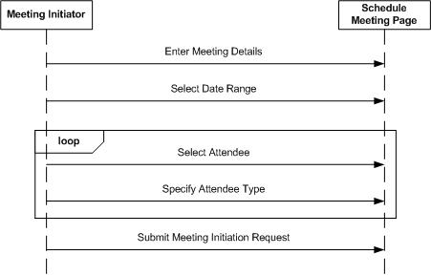  
  
4.4.2 Accept Meeting Request- Regular Participant  
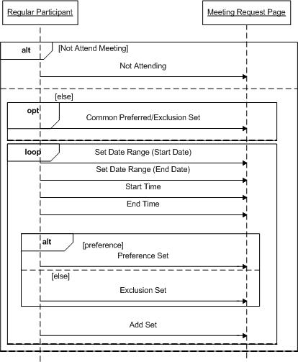

### 4.4.3 Accept Meeting Request- Active Participant

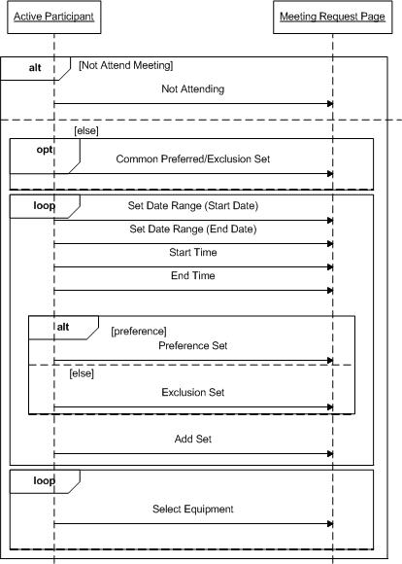

### 4.4.4 Accept Meeting Request- Important Participant

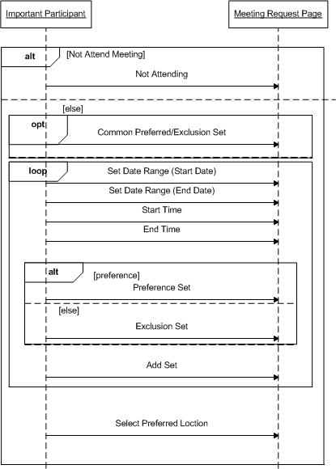

### 4.4.5 Schedule Meeting

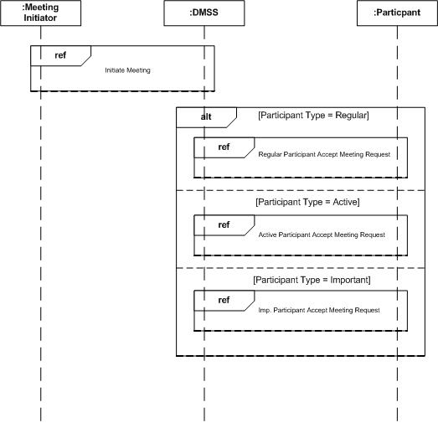

4.5 Product SADT

4.5.1 Product SADT Level 0

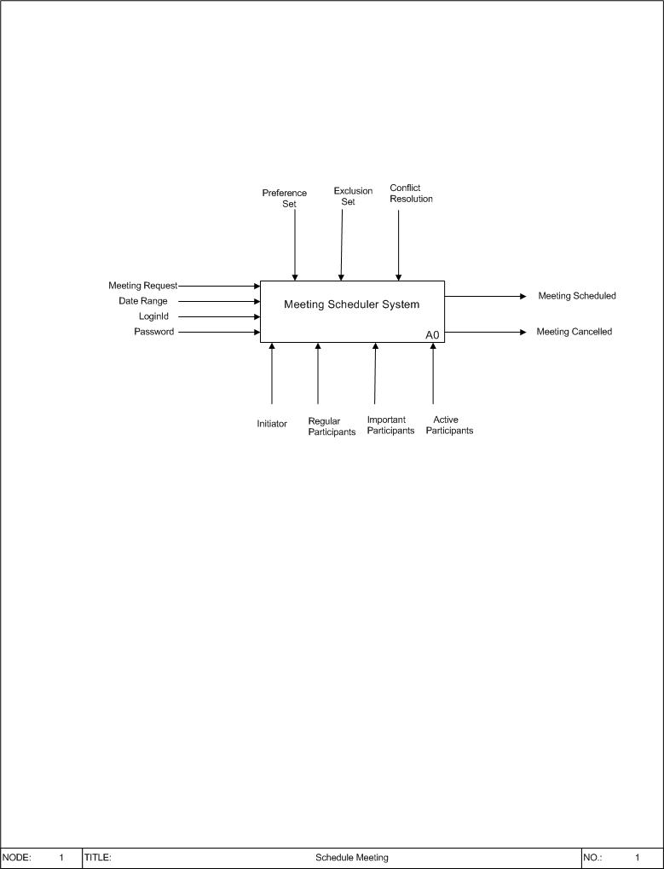

### 4.5.2 Product SADT Level 1

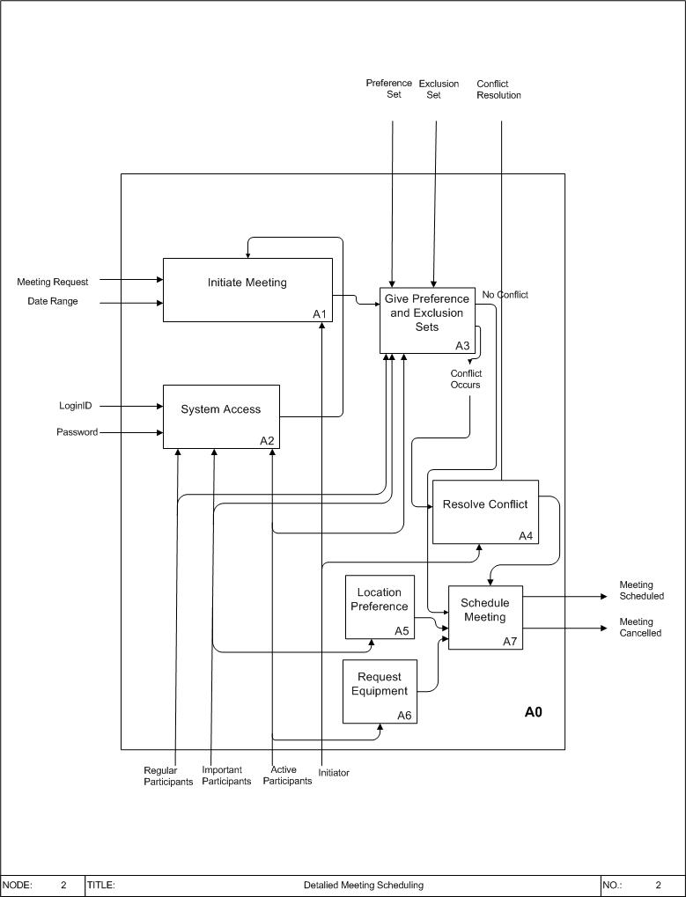

4.6 SIG for NFRs

4.6.1 Security

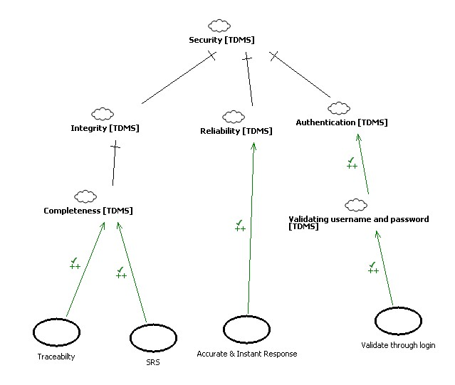  
  
4.6.2 Usability

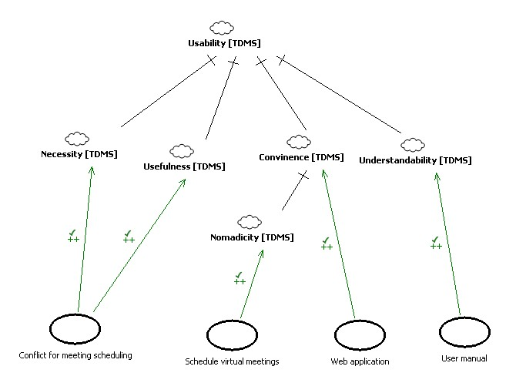

### 4.6.3 Maintainability

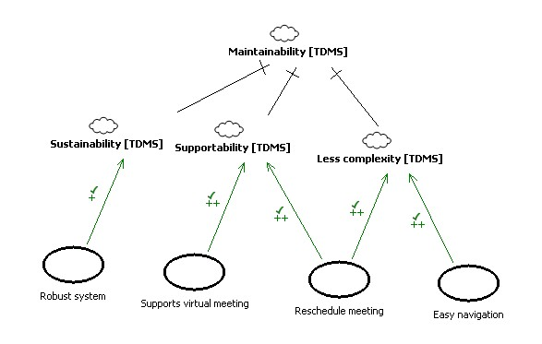

### 4.6.4 Flexibility

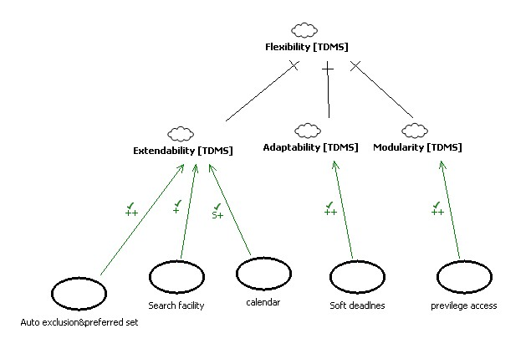

## 4.7 KAOS Modeling

4.7.1 Security  
  
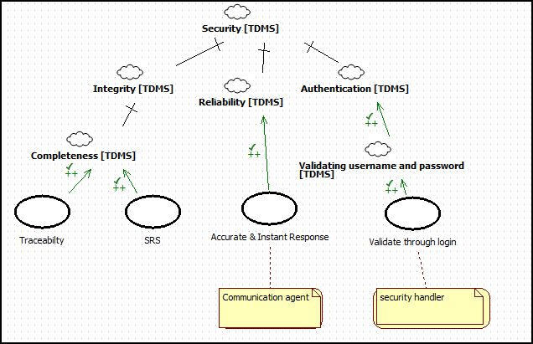

4.7.2 Usability

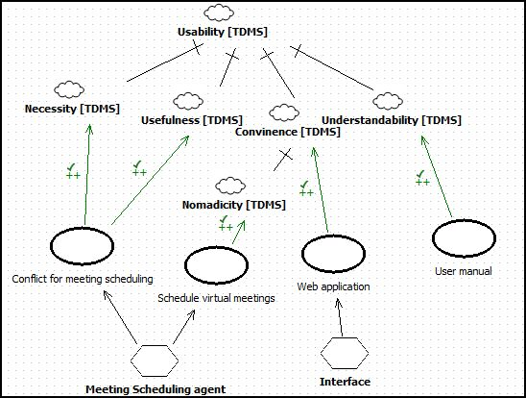

4.7.3 Maintainability

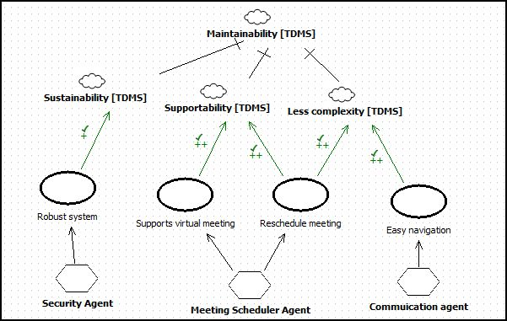

### 4.7.4 Flexibility

