Team Blitzkrieg
Distributed Meeting Scheduler

Interim Phase II

Vision Document
Version 1.0

Team Blitzkrieg
Team Website: http://utdallas.edu/~srw051000/SE6361_Blitzkreig/
Student Name | Student Id | Email address
Aditya Dhamankar | acd081000 | acd081000@utdallas.edu
Ajay Narasimmamoorthy | axn084020 | axn084020@utdallas.edu
Bryan Parker | blp090020 | blp090020@utdallas.edu
Jassem Shakil | jxs082200 | jxs082200@utdallas.edu
Jeevan Kumar | jxg096020 | jxg096020@utdallas.edu
Muhammad Abdullah | mxa088100 | mxa088100@utdallas.edu
Preeti Ganeshmohan | pxg076000 | pxg076000@utdallas.edu
Sean Wilson | srw051000 | srw051000@utdallas.edu
Vinay Sampath Kumar | vks061000 | vks061000@utdallas.edu
MEGHANA SATPUTE | mns086000 | mns086000@utdallas.edu

Submitted to:
Dr. Lawrence Chung
Associate Professor,
Department of Computer Science,
The University of Texas at Dallas

Revision History

Date | Version | Description | Author
11/06/2009 | 1.0 | Vision Document | Vinay, Preeti

Table of Contents
1. Introduction 5
1.1 Purpose 5
1.2 Scope 5
1.3 Definitions and Glossary 5
1.5 References 7
1.6. Project Overview 7
2. Positioning 8
2.1 Business Opportunity 8
2.2 Problem Statement 8
2.3 Product Position Statement 9
3. Key Stakeholder and User Descriptions 9
3.1 Market Demographics 9
3.2 Stakeholder and User Summary 10
3.3 User Environment 11
3.4. Key Stakeholder Profiles 11
3.4 1. Meeting Coordinator 11
3.4.2 Meeting Attendee 12
3.5 Key Stakeholder or User Needs 13
3.6 Business Use-Case 14
3.7 Design Class Diagram 15
3.8 Alternatives and Competition 15
4. Product Overview 16
4.1 Product Perspective 16
4.2 Summary of Capabilities 16
4.3 Assumptions and Dependencies 17
4.4 Cost and Pricing 17
4.5 Licensing and Installation 17
5. Product Features 17
6.Constraints 17
6.1 Security 17
6.2 Usability 17
6.3 Responsiveness 17
6.4 Capacity 18
6.5 Miscellaneous 18
7. Quality Ranges 18
8. Precedence and Priority 18
9. Other Product Requirements 18
9.1 Applicable Standards 18
9.2 System Requirements 18
9.3 Performance Requirements 18
9.4 Environmental Requirements 18
10. Documentation Requirements 18
10.1 User Manual 18
10.1.1. Login page 18
10.1.2. Home page 19
10.1.3. Schedule New Meeting page 19
10.1.4. Finalize Meeting Page 19
10.1.5. User Profile Page 20
10.1.6. Result Page 20
10.2 Online Help 20
10.3 Installation Guides, Configuration, and Read Me File 20
10.4 Labeling and Packaging 20

1. Introduction

1.1 Purpose
The purpose of this document is to collect, analyze, and define high-level needs and features of the Meeting Scheduling System. It focuses on the capabilities needed by the stakeholders, and the target users, and why these needs exist. The details of how the Meeting Scheduling System’s fulfils these needs are detailed in the use-case and supplementary specifications. It focuses on the capabilities of the stakeholders and the users targeted.

1.2 Scope
Our project Distributed Meeting Scheduler automates the process of scheduling meetings. It is a Web based software system that is intended for supporting people to schedule their meetings online. This scheduler system also allows rescheduling the existing meetings, allow full or partial attendance and sending the notifications to participants. The main function of this project is to schedule meetings based on the availability of resources and constraints put forward by the resources.

This Vision document shall primarily focus on the high level needs of the users along with the general requirements and features. In addition, information pertaining to user wants and needs, for use in determining future system requirements and features, are also included.

1.3 Definitions and Glossary
Exclusion set – it is a set of dates on which attendees cannot attend the meeting
Preference set - a set of dates on which attendees would prefer the meeting to take place
Deliverable – work-product or outcome of an activity
Date range - a time interval established by the meeting coordinator during which he would like the meeting to occur
Process Specification – A document that specifies the process that a team follows to conduct any activity that pertains to the development of software
User Manual – A document that covers the prototype by specifying the features in it, aided with the description and screenshots
Active participant - a participant who will play a major role in the meeting and is responsible for specifying equipment requirements; is identified by the meeting coordinator
Important participant - a participant who is necessary to the purpose of the meeting and is given the privilege of requesting a meeting location preference; is identified by the meeting coordinator
Duration - The time span of a proposed meeting
Strong date conflict - a conflict when scheduling the meeting dates that occurs when no date can be found within the date range and outside all exclusion sets.
Delegate - To have another person act on your behalf by authorizing them functions to perform
Virtual meeting - A meeting simultaneously held at multiple remote locations, e.g. teleconferencing
Software Project Management Plan – A detailed management plan that illustrates the activities conducted in the process of developing software.
Software Requirements Specification – A document that specifies the Requirements (features and services) that the software must possess in order to solve the problem
Vision Document – A document that specifies the people, software and hardware that would interact with the software system, or are affected in some way or the other by the software system
Report – Will contain all the product requirement models
Prototype – A working model of the software system that is to be developed. Gives users and customers the clarity of the fully developed software system.
Requirements Engineering Spiral Model – A requirement engineering model that the team follows in order to collect requirements, analyse them and resolve issues, document them, and finally validating them.
Semi-formal Notation – The notation that is neither too conceptual nor too formal, and is used to define a requirement or specification
Domain Requirements – Requirements or Knowledge that are extracted from the domain
Non-Functional Requirements – Requirements that cannot be formulated, but that can be fulfilled by different features and functions or adding some value/constraints to the features in the software system
Use Case Diagram – A semiformal notation that represents a user’s interaction with a system and the system’s behaviour
Class Diagram – A static model that shows the classes in a software system and the association between them
Sequence Diagram – A dynamic model that shows the interaction between objects to define a scenario in a software system
Soft-Goal Interdependency Graph (SIG) – A hierarchical structure that shows the dependencies between various soft goals
Requirements Creeping Rate – It can be defined as the percentage of change divided by time
Traceability – The relationship between different levels in the software development lifecycle
NFR Model – A goal oriented analysis model that is used to establish relationship between non-functional requirements and operational soft goals
Activity Diagram – A semiformal diagram that is used to express an activity or workflow

1.5 References
- References and templates provided by Dr. Lawrence Chung.
- Previous Project - presentations and reports.
- http://utdallas.edu/~chung/RE/Presentations07F/
- RAD Consulting Team webpage http://utdallas.edu/~jrs039000/RADConsulting.html

1.6. Project Overview
There are primarily two actors in the system:
1. Meeting Coordinator - Responsible for initiating a meeting and defining an interval within which a meeting can be held.
2. Potential Meeting Attendees - These people will be attending a meeting and will provide availability timings and non-availability timings to the system. Some meeting attendees can be further classified into three categories:
a) Important Participants: Meeting attendees who may specify their preferred meeting locations
b) Active Participants: Meeting attendees who may be providing special equipment requirements for the meeting like projector, internet connection etc.
c) Regular Participants: Meeting attendees who specify their preferred and exclusion sets only
The system functions in the following manner:
1. The meeting coordinator initiates a meeting along with the time interval within which the meeting can take place
2. The meeting attendees provide their availability and non-availability information along with their preferred meeting location
3. The system then finds a feasible meeting time along with an available preferred meeting room for the meeting keeping in consideration the constraints and availability data provided by various actors of the system
4. If there are any conflicts, the system supports conflict resolution using the conflict policy provided by the client
5. The system also supports changing user constraints before the date and location of the meeting is finalized.

2. Positioning
2.1 Business Opportunity
Simulating the presence of the meeting attendees in real-time is an important aspect of meeting scheduling system. This can involve adjusting deciding on a single time, date and location for the meeting which presents a challenging job to the meeting coordinators. The system intends to provide the coordinators and attendees an easy platform for scheduling meetings including the management of meeting equipment, capability of virtually conduct meetings and video conferencing – all by negotiating and prioritizing.

The business can improve their process of scheduling meeting from using a simple Microsoft Spread Sheet to an effective TERASOFT MEETING SCHEDULER. By having an TERASOFT MEETING SCHEDULER the company does not have to spend hours in negotiating with the participants about the meetings. This can leave more room for other tasks of the organization.

The processes or products can achieve a new level of innovation each time they are worked on, thus promoting a less expensive and better quality product. This will in effect translate to better quality product and customer satisfaction which in effect opens up more business opportunity.

2.2 Problem Statement
The problem of | scheduling meetings in manual method
Affects | meeting coordinator and attendees
the impact of which is | Conflicts, delay, improper maintenance and difficulty in managing meetings and resolving date and time conflicts
a successful solution would be | Monitor Meetings → Accurately control and manage the entire meeting scheduling process  Plan Meeting → Select most convenient meeting date and time, and location  Re-plan Meeting → Support variations and changes in the Schedule  Resolve Conflicts → Perform negotiations  Manage Interactions → Maintain necessary but minimal communication  Manage Concurrent Meetings → Allow users to submit and manage multiple meeting requests
2.3 Product Position Statement
For | meeting coordinator and attendees
Who | need to have meetings effectively, easily and efficiently scheduled
The TeraSoft Meeting Scheduler (TMS) | is a software solution
That | The system suggests a convenient meeting time along with an available meeting room preferred by important attendees for the meeting keeping in consideration the constraints. Also ability to resolve all the conflicts, inform the users about the final time, date and location of the meeting along with other details associated with the meeting, synchronize with their calendars.
Unlike | Time Constraint, Unidentified Roles, Availability of attendees, Availability of meeting locations, Convenience and Efficiency, Convenience and no supporting features like virtual meetings.
Our product | Reduces time and effort, Identifies roles and customizes meeting scheduling process accordingly, Ensures availability of attendees as per their convenience, Ensures availability of most appropriate meeting location, Easy to use for naïve users, resolve conflicts and inform everybody about the decided entities.

3. Key Stakeholder and User Descriptions

3.1 Market Demographics
The target market segment includes all business organizations that schedule frequent meetings or conferences amongst their employees or customers and have major issues in deciding on dates, times and locations for some particular events to take. The estimated market size of this meeting scheduling system is pretty huge running into a hundred million dollars.
The processes or products can achieve a new level of innovation each time they are worked on, thus promoting a less expensive and better quality product. This will in effect translate to better quality product and customer satisfaction which in effect opens up more business opportunity.

3.2 Stakeholder and User Summary

Name | Description | Responsibilities
System Analyst | This is a stakeholder that works with the stakeholders to gather their needs. | Leads and coordinates requirements elicitation and use-case modelling by outlining the system's functionality and delimiting the system
System Developers | This is a stakeholder that must be involved regularly to maintain the development cycle | Ensures that the system is going to be maintainable and the architectural solution supports the functional and non-requirements
Project management teams | This is a stakeholder that works with the Analysts to correctly translate requests/needs into requirements to be used for design. | Plans, manages and allocates resources, shapes priorities, coordinates interactions with customers and users, and keeps the project team focused. Also establishes a set of practices that ensure the integrity and quality of project artefacts.
Maintenance team | This is a stakeholder that must be involved regularly to maintain the development cycle. | This role is responsible for  providing timely, appropriate feedback on the  project artefacts being reviewed.
Meeting Coordinator | Primary End User of the System | Responsible for initiating a meeting and defining an interval within which a meeting can be held. . Also establishes a set of practices that ensure the integrity and quality of project artefacts.
Meeting Attendee | Primary End User of the System | The meeting attendees provide their availability and non-availability information along with their preferred meeting location, time and availability of resources or declining the invitation.

3.3 User Environment
Remote access is wireless (cell phone, personal data assistant) or using a landline (dial-up modem). The following operating systems for the mobile devices are supported: Palm Technologies, Smartphone 2003 (from Microsoft), Palm OS (from Palm Inc.) and the Pocket PC (from Microsoft). There is interoperability between other applications that offer services that include virtual meetings, video conferencing, e-mail clients, calendar applications and database systems.

3.4. Key Stakeholder Profiles

3.4 1. Meeting Coordinator

Representative
Description | A company employee specifically a secretary or a manager who will use the system to propose and arrange meetings depending on the issue, date, time, availability of resources, job and position in the organization.
Type | Expert user with experience to handle meeting arrangements
Responsibilities | Ensure that all necessary data to initiate meetings is input and that conflicts with regard to meeting time, date, location and attendees are resolved at the earliest and are minimal.
Success Criteria | Success is completely defined by the meeting coordinators satisfaction and ease of continued use of the system. Arranging for meetings should be simple and conflict resolution quick.
Involvement | We will have sample customers to help evaluate our design and market research results will also guide our vision.
Deliverables | None
Comments / Issues | None

3.4.2 Meeting Attendee

Representative
Description | A company employee or an external customer of the organization who will decide if an initiated meeting has to be attended or not depending on their availability and need. They provide a list of times they are available to the meeting coordinator.
Type | Casual User since they do not extensively communicate with the system.
Responsibilities | Make sure that they respond to all meeting invitations and inform the meeting coordinator of their preferred and exclusion sets well in advance.
Success Criteria | Success is defined by the minimal conflicts in meeting arrangements and uninterrupted use of the system.
Involvement | We will have sample customers to help evaluate our design and market research results will also guide our vision.
Deliverables | None
Comments / Issues | None

3.5 Key Stakeholder or User Needs

Need | Priority | Concerns | Current Solution | Proposed Solutions
Initiate/Schedule Meetings easily | High | Ability to schedule and manage meetings easily through an online system | Select software that facilitate initiation | Provide forms taking comprehensive information on meetings to be initiated
Record invitee response | High | Level of appropriate detail | Select software that record data | Provide simplified view of the meeting details and the options to be selected
Resolve date, time and location conflicts | High | Ability to resolve conflicts | None | Provide dynamic and efficient conflict resolution
Select Meeting Location | High | Management of the meeting rooms | None | Allow the coordinator to select a location from the available list and then the important participant gets a request to accept or give a preferred meeting location
Select Preferred Date for Meeting | High | Ability to select a meeting date which is convenient for most of the participants | None | Allow Meeting coordinator to select the start date and end date and the system takes the exclusion set and preference set of each participant and it gets the best available date.
Be secure | Moderate to high | Confidentiality, integrity, availability, authentication, and non-repudiation | None | Include necessary features and channels to make the application secure
Be convenient | Moderate to high | Ability to make the right decision | None | Use user friendly ways for system usage

3.6 System Use-Case
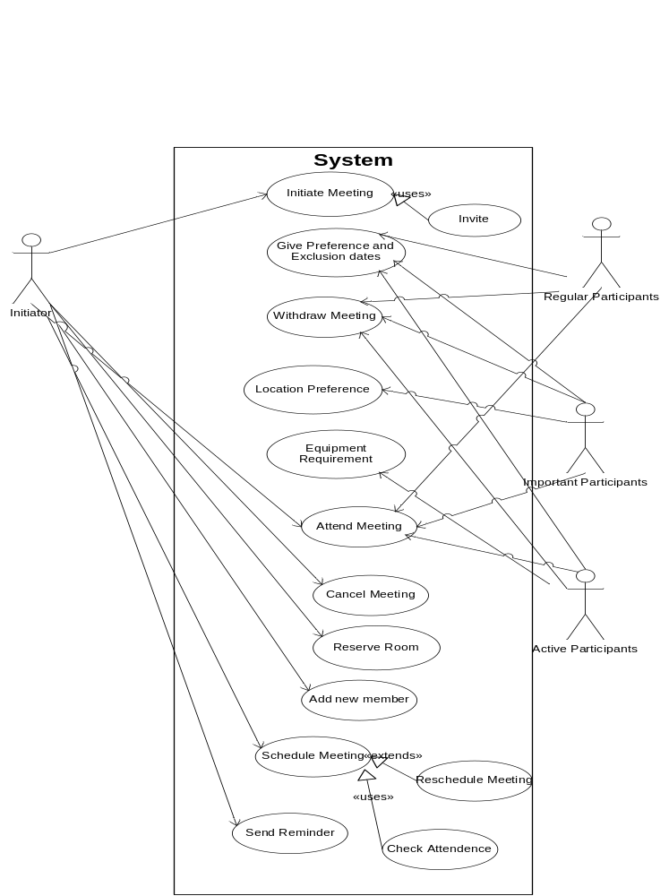

3.7 Design Class Diagram
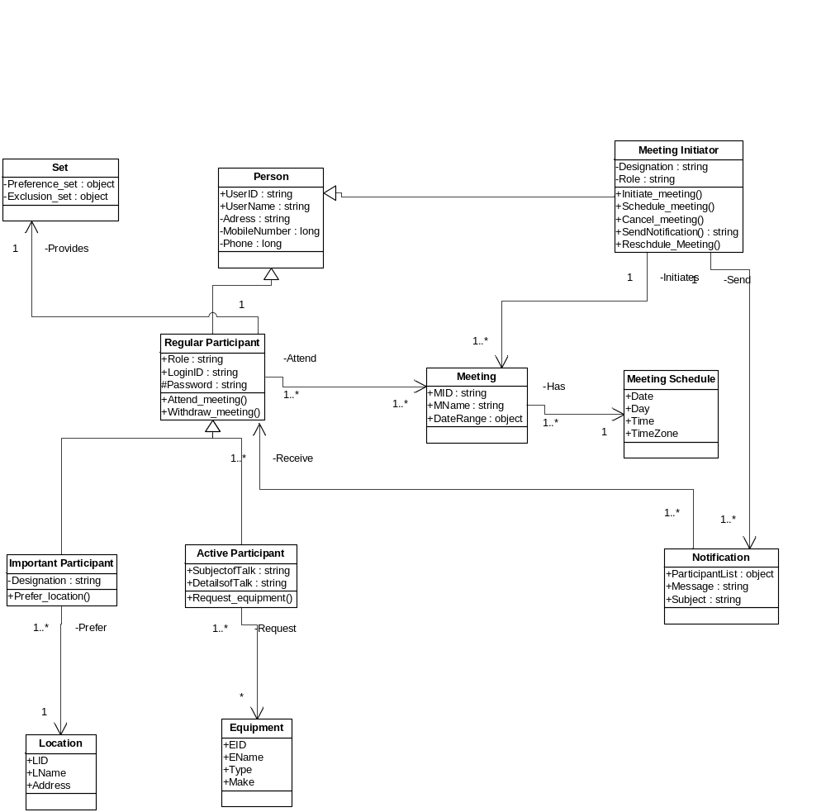

3.8 Alternatives and Competition
- Microsoft NetMeeting
- IBM-Lotus Notes

4. Product Overview

4.1 Product Perspective

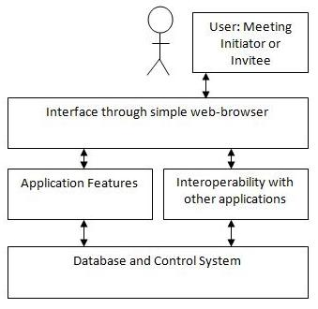
Figure 1 Overview of TeraSoft Architecture

4.2 Summary of Capabilities
Table 4-1 Customer Support System
Customer Benefit | Supporting Features
Access to the system with ease | Access via the Internet through a user friendly GUI
Initiate meetings conveniently | Allow easy forms with menus, calendars
Respond to meeting invitation with simplicity | Easy options while filling up forms
Interoperability with other application | Synchronization with other applications
Virtual meetings | Able to remotely connect to the meeting via a bridge line and UI.
Less time involved | Dynamic conflict resolution: date, time and location decided instantly

4.3 Assumptions and Dependencies
- Meeting coordinators have knowledge of who the invitees are.
- A business organization or a group of organizations involve all the users on this system

4.4 Cost and Pricing
TBD

4.5 Licensing and Installation
This product is a generic designed for TeraSoft but will be marketed to the customers on a license-basis. Installation and maintenance of this product shall be performed by the customer with minimal support from the company.

5. Product Features
The main features of our system are as follows:-
- The system is automated to a great extent and thereby minimizing the back and forth rounds of negotiations.
- The coordinator does not have to worry about the meeting reminders and conflict resolution.
- The system also has a clear distinction of the users or the meeting participants. There are 3 clear users like important participants, Active participants and Non-Privileged participants which help in the conflict resolution and also deal with the Privacy aspect.
- In the next round/iteration, the system will also be able to develop the nomadicity and virtual meeting solutions.
- The interactive view that the participants will have, enables a smooth and easy flow to schedule a meeting and most decisions based on location and feasibility will be taken care by the system, thereby giving the user more free time.
- Other features include Dynamically resolve conflicts, Set reminders, Synchronize meeting schedules with calendars, View all invitations from a single location, Remotely attend meetings, Change preferences, Authenticated login to the system, Secure database, Simple graphical user interface

6.Constraints

6.1 Security
TERASOFT MEETING SCHEDULER incorporates Confidentiality, Integrity and Authentication.

6.2 Usability
TERASOFT MEETING SCHEDULER is easy is use over a GUI through simple web-browsers.

6.3 Responsiveness
All conflict resolution is dynamic and the results are produced instantly.

6.4 Capacity
TERASOFT MEETING SCHEDULER can involve any number of business users at any instance.

6.5 Miscellaneous
- Performance – refers to Speed and Accuracy of the system
- Security – achieved by Authorization and login
- Usability – achieved by Simple and user-friendly system that can be used by both experts and non-experts
- Nomadicity and Accessibility – achieved by web based system
- Reliability – achieved by high precision automation by the system
- Flexibility – refers to feasibility to change and modify the system for changing requirements

7. Quality Ranges
Not Specified

8. Precedence and Priority
The system will be ready by December 2009.

9. Other Product Requirements

9.1 Applicable Standards
The system must comply with all existing web-standards (HTML, PHP, TCP/IP, etc.)

9.2 System Requirements
Availability of a web-browser on any operating system and a connection to the Internet.

9.3 Performance Requirements
All response must be immediate.

9.4 Environmental Requirements
Not specified.

10. Documentation Requirements

10.1 User Manual

10.1.1. Login page

Action Register in the system:
- Click “Register”. Input your name and email on the following screen.

Action Log in the system:
- Type user name.
- Type password.
- Click “Log in” button.

Action Request forgotten password:
- Click “request password” link. Enter your email address to have your password sent.

10.1.2. Home page

Action Schedule a new meeting:
- Click “Schedule New Meeting” link.

Action Edit a scheduled meeting:
- Click “Edit Meeting” link.

Action Reschedule a meeting:
- Click “Reschedule meeting” link.

Action Finalize meeting:
- Click “Finalize Meeting” link.

Action Result of Meeting:
- Click “Result of meeting” link.

10.1.3. Schedule New Meeting page

Action Schedule a new meeting
- Write the meeting title.
- Select the type of meet.
- Select the date and time the Date/Time range of consideration begins.
- Select the date and time the Date/Time range of consideration ends.
- Write the description of the meeting.
- Select the attendees of the meeting (repeat the following steps for each attendee):
  - Write the email of the attendee.
  - Select the type of attendee (Active, Important or Regular)
  - Push “Add Attendee” button.
- Click “Submit” button.

Action Request for Equipment for the meeting:
- Select the Equipment that is to be requested for the meet.
- Select the list of members along with their e-mail ids to whom the request should be sent.

Action Reset the creation of a new meeting:
- Click “Reset” button.

10.1.4. Finalize Meeting Page
This page consists of three sections:
- The first section displays the replies from various participants and consists of the following:
  - Participant Name
  - Participant Type (Regular/Active/Important)
  - Preferred Set (Date/Time/Location)
  - Exclusion Set(Date/Time)
  - Result
Clicking the Resolve button leads to the next section.
- The second section displays the list that was obtained based on the meeting satisfying criteria which specifies the number of attendees along with the preferred set.
- The third section displays the finalized meeting schedule. Clicking the Submit button displays the result in the result page.

10.1.5. User Profile Page
This page displays the details about the user and his common weekly preference and exclusion sets. This page also contains a checkbox that enables the user to automatically include the common exclusion set based on the preference set input.

10.1.6. Result Page
This page displays the finalized meeting schedule by the initiator listing the date, time and location of the meet along with the number of attendees and non-attendees.

10.2 Online Help
Online help about functions and features will be available.

10.3 Installation Guides, Configuration, and Read Me File
Installation guides and configuration manuals will be provided to support the maintenance and change if needed.

10.4 Labeling and Packaging
Not applicable.

