Team Blitzkrieg
Distributed Meeting Scheduler

Phase I: Interim

Software Requirements Specification

Team Blitzkrieg

Team Website: http://utdallas.edu/~srw051000/SE6361_Blitzkreig/
Student Name | Student Id | Email address
Aditya Dhamankar | acd081000 | acd081000@utdallas.edu
Ajay Narasimmamoorthy | axn084020 | axn084020@utdallas.edu
Bryan Parker | blp090020 | blp090020@utdallas.edu
Jassem Shakil | jxs082200 | jxs082200@utdallas.edu
Jeevan Kumar | jxg096020 | jxg096020@utdallas.edu
Muhammad Abdullah | mxa088100 | mxa088100@utdallas.edu
Preeti Ganeshmohan | pxg076000 | pxg076000@utdallas.edu
Sean Wilson | srw051000 | srw051000@utdallas.edu
Vinay Kumar | vks061000 | vks061000@utdallas.edu

Contents
Revision History 5
1. Introduction 6
1.1. Domain Requirements 6
1.2. Functional Requirements 7
1.3. Nonfunctional Requirements 7
2. ISSUES WITH PRELIMINARY DEFINITION: 8
2.1 ISSUES WITH THE DOMAIN, STAKEHOLDERS FUNCTIONAL AND NON-FUNCTIONAL OBECTIVES: 8
2.1.1 ISSUE STATEMENT: [DR1] 8
2.1.2 ISSUE STATEMENT: [DR2] 8
2.1.3 ISSUE STATEMENT: [DR3, DR4] 9
2.1.4 ISSUE STATEMENT: [DR5] 10
2.1.5 ISSUE STATEMENT: [DR6] 10
2.1.6 ISSUE STATEMENT: [DR7] 11
2.1.7 ISSUE STATEMENT: [DR8] 11
2.1.8 ISSUE STATEMENT: [DR9, DR10] 12
2.1.9 ISSUE STATEMENT: [DR11] 12
2.1.10 ISSUE STATEMENT: [DR12] 13
2.1.11 ISSUE STATEMENT: [DR13] 13
2.1.12 ISSUE STATEMENT: [DR14] 14
2.1.13 ISSUE STATEMENT: [DR15] 14
2.1.14 ISSUE STATEMENT: [DR16] 15
2.1.15 ISSUE STATEMENT: [DR18] 15
2.1.16 ISSUE STATEMENT: [DR21] 16
2.2 ISSUES WITH SOFTWARE SYSTEM REQUIREMENTS: FUNCTIONAL REQUIREMENTS 16
2.2.1 ISSUE STATEMENT: [FR1] 16
2.2.2 ISSUE STATEMENT: [FR3] 17
2.2.3 ISSUE STATEMENT: [FR3] 18
2.2.4 ISSUE STATEMENT: [FR5] 18
2.2.5 ISSUE STATEMENT: [FR5] 19
2.2.6 ISSUE STATEMENT: [FR6] 19
2.2.7 ISSUE STATEMENT: [FR12, FR13] 20
2.2.8 ISSUE STATEMENT: [FR15] 21
2.3 ISSUES WITH SOFTWARE SYSTEM REQUIREMENTS: NON -FUNCTIONAL RQUIREMENTS: 21
2.3.1 ISSUE STATEMENT: [NFR2] 21
2.3.2 ISSUE STATEMENT: [NFR3] 22
2.3.3 ISSUE STATEMENT: [NFR4] 22
2.3.4 ISSUE STATEMENT: [NFR5] 23
2.3.5 ISSUE STATEMENT: [NFR6] 24
2.3.6 ISSUE STATEMENT: [NFR7] 24
2.3.7 ISSUE STATEMENT: [NFR8] 25
2.3.8 ISSUE STATEMENT: [NFR9] 26
2.3.9 ISSUE STATEMENT: [NFR10] 26
2.3.10 ISSUE STATEMENT: [NFR11] 27
2.3.11 ISSUE STATEMENT: [NFR12] 27
2.3.12 ISSUE STATEMENT: [NFR13] 28
2.3.13 ISSUE STATEMENT: [NFR14] 28
3. ISSUES WITH PRELIMINARY DEFINITION: 29
3.1 IMPROVED UNDERSTANDING FOR THE DOMAIN, STAKEHOLDERS FUNCTIONAL AND NON-FUNCTIONAL OBECTIVES: 29
3.2 IMPROVED UNDERSTANDING FOR SOFTWARE SYSTEM REQUIREMENTS: FUNCTIONAL REQUIREMENTS 31
3.3 IMPROVED UNDERSTANDING FOR SOFTWARE SYSTEM REQUIREMENTS: NON -FUNCTIONAL RQUIREMENTS: 32
4. Preliminary Prototype and User Manual 34
4.1. Prototype 34
Login Page 34
Home Page 35
Schedule New Meeting 36
New Incoming Meeting Request – Active Participant 37
New Incoming Meeting Request – Important Participant 38
New Incoming Meeting Request – Regular Participant 39
Conflict Resolution 40
4.2. User Manual 40
5. Traceability 42
5.1. Domain vs System Requirements 42
5.2. Functional vs Nonfunctional 42
5.3. Requirements vs Prototype 43
Reference 43
Appendix 43

Revision History

Version | Date | Description | Editor
0.6 | 2009/09/15 | Added Domain Issues | Sean Bryan
1.0 | 2009/09/17 | Added Functional & Nonfunctional Issues | Preeti, Vinay, Jassesm, Muhammad
1.3 | 2009/09/21 | Added Domain Improved Understanding | Sean, Bryan
1.7 | 2009/09/24 | Added Functional Improved Understanding | Preeti, Vinay
2.0 | 2009/09/27 | Added Nonfunctional Improved Understanding | Jassem, Muhammad
2.1 | 2009/09/30 | Finished integrating the document. | Sean , Bryan
2.3 | 2009/10/01 | Updated the Prototype Section | Ajay

1. Introduction

1.1. Domain Requirements
DR1 | In the application domain, meetings are typically arranged in the following manner.
DR2 | A meeting initiator will ask all potential meeting attendees for the following information based on their personal agenda:
DR3 | a set of dates on which they cannot attend the meeting (hereafter, referred to as exclusion set); and
DR4 | a set of dates on which they would prefer the meeting to take place (hereafter referred to as preference set);
DR5 | A meeting date shall be defined perhaps by a pair (calendar date, time period).
DR6 | The exclusion and preference sets should be contained in some time interval prescribed by the meeting initiator (hereafter referred to as date range).
DR7 | The initiator could also ask, in a friendly manner, active participants to provide any special equipment requirements on the meeting location (e.g., overhead projector, workstation, network connection, telephone, etc.).
DR8 | She may also ask important participants to state preferences about the meeting location.
DR9 | The proposed meeting date should belong to the stated date range and to none of the exclusion sets;
DR10 | furthermore it should ideally belong to as many preference sets as possible.
DR11 | The proposal should be made as early as possible.
DR12 | A date conflict occurs when no such date can be found.
DR13 | A conflict is strong when no date can be found within the date range and outside all exclusion sets;
DR14 | A conflict is weak when dates can be found within the date range and outside all exclusion sets, but no date can be found at the intersection of all preference sets.
DR15 | A conflict can be resolved by the initiator extends the date range; and
DR15 | A conflict can be resolved by some participants remove some dates from their exclusion set; and
DR15 | A conflict can be resolved by some participants withdrawing from the meeting; and
DR15 | A conflict can be resolved by some participants adding some new dates to their preference set.
DR16 | Each conflict resolution should be done as quickly as possible and with no more interactions than is really needed.
DR17 | It shall meet the equipment requirements
DR18 | A meeting room must be available at the selected meeting date.
DR19 | furthermore it [the meeting room] should ideally belong to one of the locations preferred by as many important participants as possible.
DR20 | It is absolutely necessary, however, to allow each meeting to take place in a virtual place, e.g., through teleconferencing using laptop computers.
DR21 | The number of negotiations shall be kept minimal, but a new round of negotiation may be required when no such room can be found.
DR22 | The meeting initiator can be one of the participants or some representative (e.g., a secretary).

1.2. Functional Requirements
FR1 | The purpose of DMS is to support the organization of meetings – that is, to determine, for each meeting request, a meeting date and location so that most of the intended participants will effectively participate.
FR2 | SDMS shall assist users in the following activities:
FR3 | Monitor meetings, especially when they are held in a distributed manner;
FR4 | Plan meetings under the constraints expressed by participants (see domain theory);
FR5 | Re-plan a meeting to support the changing user constraints, for instance:
FR6 | to modify the exclusion set, preference set and/or preferred location before a meeting date/location is proposed; and
FR7 | to take some external constraints into account after a date and location have been proposed - e.g., due to the need to accommodate a more important meeting. - here, the original meeting date or location may then need to be changed; sometimes the meeting may even be cancelled.
FR8 | In all cases some bound on re-planning should be set up.
FR9 | Support conflict resolution according to resolution policies stated by the client;
FR10 | Manage all the interactions among participants required during the organization of the meeting, for instance:
FR11 | to support the negotiation and conflict resolution processes;
FR12 | to make participants aware of what's going on during the planning process;
FR13 | to keep participants informed about schedules and their changes; and
FR14 | The meeting scheduler system must in general handle several meeting requests in parallel.
FR15 | Meeting requests can be competing when they overlap in time or space. Concurrency must thus be managed.

1.3. Nonfunctional Requirements
NFR1 | In meeting the functional requirements, non-functional requirements should also be taken account. They include:
NFR2 | A meeting should be accurately monitored, especially when it is held in a virtual place. Here, nomadicity will then be important to consider;
NFR3 | Re-planning of a meeting should be done as dynamically and with as much flexibility as possible;
NFR4 | The amount of interaction among participants(e.g., number and length of messages, amount of negotiation required) should be kept minimal;
NFR5 | The intended system should considerably reduce the amount of overhead usually incurred in organizing meetings where potential attendees are distributed over many different places and  communicate with each other, for example, via Internet;
NFR6 | The system should reflect as closely as possible the way meetings are typically managed (see the domain theory above);
NFR7 | The meeting date and location should be as convenient as possible, and available as early as possible, to all (potential) participants;
NFR8 | The system should accommodate as much decentralized requests as possible; any authorized user should be able to request a meeting independently of her whereabouts;
NFR9 | Physical constraints should not be broken --- e.g., a person may not be at two different places at the same time; a meeting room may not be allocated to more than one meeting at the same time; etc.;
NFR10 | The system should provide an appropriate level of performance:
NFR10 | the elapsed time between the submission of a meeting request and the determination of the corresponding date/location should be minimal; or
NFR10 | a lower bound should be fixed between the time at which the meeting date is determined and the time at which the meeting is actually taking place;
NFR11 | The system should be usable by non-experts;
NFR12 | The system should be customizable to professional as well as private meetings - ...;
NFR13 | The system should be flexible enough to accommodate evolving data - e.g., the sets of concerned participants may be varying, the address at which a participant can be reached may be varying, etc.;
NFR14 | The system should be easily extensible to accommodate the following typical variations:
NFR14 | handling of explicit priorities among dates in preference sets;
NFR14 | variations in date formats, address formats, interface language, etc.; and
NFR14 | partial reuse in other contexts - e.g., to help establish course schedule.

2. ISSUES WITH PRELIMINARY DEFINITION:

2.1 ISSUES WITH THE DOMAIN, STAKEHOLDERS FUNCTIONAL AND NON-FUNCTIONAL OBECTIVES:

2.1.1 ISSUE STATEMENT: [DR1]
“In the application domain, meetings are typically arranged in the following manner.”
Problem: (Type of Issue: ambiguity) The statement implies that there are multiply ways to arrange a meeting.
Option 1: Define several ways to arrange a meeting.
Option 2: Remove the word “typically.”
Option 3: Remove the entire statement.
Solution: Option 2
Rationale: If the word “typically” is removed, then the statement will imply that there is only one way that a meeting is arranged. This eliminates any ambiguity and saves time, compared to creating multiple variations of the same method. Removing the statement would cause confusing because there would be no overall summary of what is going to be described.
Reference: None

2.1.2 ISSUE STATEMENT: [DR2]
“A meeting initiator will ask all potential meeting attendees for the following information based on their personal agenda”
Problem: (Type of Issue: ambiguity) The statement does not give the definition of a “meeting initiator” and a definition for “potential meeting attendees.”
Option 1: Define the meeting initiator as a person who requests a meeting. Define the potential meeting attendees as people who have received a meeting invitation from the meeting initiator with a request to fill out the following information based on their personal agenda.
Option 2: Define the meeting initiator as someone who starts the meeting and the potential meeting attendees are the people who could possibly attend the meeting based on their agenda information.
Solution: Option 1
Rationale: A much more accurate description and definition of a meeting initiator and potential meeting attendees. This greatly reduces any ambiguous doubts about what roles the individuals have within the meeting scheduler system.
Reference: None

2.1.3 ISSUE STATEMENT: [DR3, DR4]
“a set of dates on which they cannot attend the meeting (hereafter, referred to as exclusion set) and a set of dates on which they would prefer the meeting to take place (hereafter referred to as the preference set)”
Problem: (Type of Issue: incompleteness) Does not completely state what information is included in the exclusion and preference sets.
Option 1: An exclusion and preference set contains a set of dates and times that correspond with those dates that they prefer (or do not prefer) the meeting to take place.
Option 2: An exclusion and preference set contains a set of dates and times that correspond with those dates within the date/time range that the meeting initiator has specified.
Solution: Option 2
Rationale: This option is more complete and specific compared to the first option. Time need to be included with the dates because not all potential meeting participants are available/ unavailable throughout the entire dates that they choose. Also, they have to choose the dates/times within the specified time/range, otherwise a potential participant might set a preference time at 1:00 a.m. in the morning.
Reference: None

2.1.4 ISSUE STATEMENT: [DR5]
“A meeting date shall be defined perhaps by a pair (calendar date, time period).”
Problem: (Type of Issue: incompleteness) There is not clear decision as what constitutes as a meeting date.
Option 1: Remove the word “perhaps” and define the meeting dates as a pair consisting of a calendar date and time.
Option 2: Remove the word “perhaps” and define the meeting dates as consisting of a calendar date, the day of the week, and time.
Solution: Option 2
Rationale: Removing the word “perhaps” gives the statement a concise decision, and defining the meeting date to also include the day of the week better clarifies when the meeting takes place.
Reference: None

2.1.5 ISSUE STATEMENT: [DR6]
“The exclusion and preference sets should be contained in some time interval prescribed by the meeting initiator (hereafter referred to as date range).”
Problem: (Type of Issue: unsoundness & ambiguity,) The statement sounds suggestive and time interval is not clearly defined.
Option 1: Remove “should be” and define the time interval as a start date and end date.
Option 2: Replace “should be” with “shall” and define the time interval as a start and end date/time with upper and lower bounds.
Solution: Option 2
Rationale: Removing “should be” makes the statement more concrete and a start/end time interval is required, not just the date, to prevent the selection of a time that a meeting would never occur ( For example: 3 a.m. in the morning)
Reference: None

2.1.6 ISSUE STATEMENT: [DR7]
“The initiator could also ask, in a friendly manner, active participants to provide any special equipment requirements on the meeting location (e.g., overhead projector, workstation, network connection, telephone, etc.).”
Problem: (Type of Issue: ambiguity) The statement does not clearly define an active participant and the phrase “could also ask, in a friendly manner” is subjective and suggestive, which creates ambiguity.
Option 1: Remove and replace the phrase “could also ask, in a friendly manner” with “asks” and define active participants as people who are going to actively participate in a meeting (such as give a presentation) who can request special equipment to be provided at the meeting location.
Option 2: Remove “could also ask, friendly manner” and define active participants as people who will provide special equipment to the meeting location.
Solution: Option 1
Rationale: Replacing the phrase makes the initiator obligated to contact active participants to inquire about special equipment needs. It also removes the interpretation that the active participants are the ones bringing the equipment.
Reference: None

2.1.7 ISSUE STATEMENT: [DR8]
“She may also ask important participants to state preferences about the meeting location.”
Problem: (Type of Issue: unsoundness & ambiguity) The statement specifies the initiator to be of a certain gender, important participants is not defined, and the possible meeting location preferences are broad.
Option 1: Define important participants as people who are deemed important by the initiator and are allowed to state a meeting location preference to be anywhere.
Option 2: Replace “she” with “initiator” and define important participants as people with a higher priority over other participants, whom can also be an active participant. They also have the option to state a preferred meeting location from a list of locations set by the meeting initiator.
Solution: Option 2
Rationale: Replacing “she” does not give the impression that the initiator can only be of a specific gender. The initiators role isn’t to decide which participants are considered important because an important participant has a pre-defined level of importance. Also, allowing the important participant to set a meeting preference to be anywhere would complicate the system and the final decision of the meeting location.
Reference: None

2.1.8 ISSUE STATEMENT: [DR9, DR10]
“The proposed meeting date should belong to the stated date range and to none of the exclusion sets; furthermore it should ideally belong to as many preference sets as possible.”
Problem: (Type of Issue: unsoundness) The statement is suggesting what “should be,” which leaves room open interpretations as to whether are not something should be done.
Option 1: Remove the two “should” words.
Option 2: Replace the two “should” words with “shall” and remove “ideally.”
Solution: Option 2
Rationale: Replacing the words with “shall” and removing “ideally” strongly emphases the constraints in which the system operates to determine a meeting date and time.
Reference: None

2.1.9 ISSUE STATEMENT: [DR11]
“The proposal should be made as early as possible.”
Problem: (Type of Issue: ambiguity) The statement does not clearly state what is “early.”
Option 1: Remove the statement.
Option 2: Define “early” with respect to the rate at which the potential meeting attendees respond with their preference/exclusion sets or the percentage of responses received from each type of potential attendee (active/important).
Solution: Option 2
Rationale: Replacing “should” with “must” elevates the priority that a feature needs to be implemented. If the statement was removed there is possibility that a proposal will take a long amount of time. Also, defining the meaning of “early” guarantees that a proposal will be reached within a certain amount of time.
Reference: None

2.1.10 ISSUE STATEMENT: [DR12]
“A date conflict occurs when no such date can be found.”
Problem: (Type of Issue: ambiguity) The statement does not give a time aspect to the date.
Option 1: Remove the statement.
Option 2: Change the word date to meeting date, which was defined as a calendar date and time period.
Solution: Option 2
Rationale: By clarifying that that a date conflict occurs when no such meeting date can be found removes any ambiguity that could have arisen as a result of a user thinking it was referring to a date only.
Reference: None

2.1.11 ISSUE STATEMENT: [DR13]
“A conflict is strong when no date can be found within the date range and outside all exclusion sets;”
Problem: (Type of Issue: ambiguity) The statement does not give a time aspect to the date.
Option 1: Remove the statement.
Option 2: Change the word date to meeting date, which was defined as a calendar date and time period.
Solution: Option 2
Rationale: By clarifying that that a date conflict occurs when no such meeting date can be found removes any ambiguity that could have arisen as a result of a user thinking it was referring to a date only.
Reference: None

2.1.12 ISSUE STATEMENT: [DR14]
“A conflict is weak when dates can be found within the date range and outside all exclusion sets, but no date can be found at the intersection of all preference sets.”
Problem: (Type of Issue: ambiguity) The statement does not give a time aspect to the date.
Option 1: Remove the statement.
Option 2: Change the word date to meeting date, which was defined as a calendar date and time period.
Solution: Option 2
Rationale: By clarifying that that a date conflict occurs when no such meeting date can be found removes any ambiguity that could have arisen as a result of a user thinking it was referring to a date only.
Reference: None

2.1.13 ISSUE STATEMENT: [DR15]
“Conflicts can be resolved in several ways, including:”
Problem: (Type of Issue: ambiguity) This statement is insinuating that there may be additional ways (other than given) to resolve date conflicts.
Option 1: Remove the statement.
Option 2: Brainstorm about each and every possible way to resolve a date conflict.
Option 3: Assume that the stated points are the "only" ways to solve a date conflict in the case of the DMS. When resolving a date conflict, the system will default to one of these choices.
Solution: Option 3
Rationale: By specifying that these are the only ways to resolve a date conflict, it removes any ambiguity that existed before.
Reference: None

2.1.14 ISSUE STATEMENT: [DR16]
"Each conflict resolution should be done as quickly as possible and with no more interactions than is really needed."
Problem: (Type of Issue: ambiguity) This statement does not define what "quickly as possible" means, and the statement "no more interactions than is really needed" adds no value to this statement.
Option 1: Remove the statement.
Option 2: Define “quickly as possible” with respect to the rate at which the potential meeting attendees respond with their modified conflict resolution methods. Remove the statement "no more interactions than is really needed".
Solution: Option 2
Rationale: By defining the meaning of "quickly as possible", it guarantees that a resolution will be reached within a certain amount of time.
Reference: None

2.1.15 ISSUE STATEMENT: [DR18]
"Furthermore it should ideally belong to one of the locations preferred by as many important participants as possible."
Problem: (Type of Issue: ambiguity) The word ideally states a condition in which it is not required.
Option 1: Remove the statement.
Option 2: Remove ideally, and replace the statement "as many important participants as possible" with "the majority of important participants".
Option 3: Remove the ideally statement.
Solution: Option 2
Rationale: By removing ideally, you state a requirement that is more concrete.
Reference: None

2.1.16 ISSUE STATEMENT: [DR21]
"The number of negotiations should be kept minimal, but a new round of negotiation may be required when no such room can be found."
Problem: (Type of Issue: ambiguity) The statement sounds suggestive and minimal is not clearly defined.
Option 1: Remove the statement.
Option 2: Remove the should word.
Option 2: Replace should with shall and define minimal as the "maximum number of negotiations needed to resolve a conflict."
Solution: Option 3
Rationale: By removing should and specifying a more concrete value for minimal, the statement strongly emphasizes the constraints in which the system operates to resolve a conflict.
Reference: None

2.2 ISSUES WITH SOFTWARE SYSTEM REQUIREMENTS: FUNCTIONAL REQUIREMENTS

2.2.1 ISSUE STATEMENT: [FR1]

“The purpose of DMS is to support the organization of meetings – that is, to determine, for each meeting request, a meeting date and location so that most of the intended participants will effectively participate.”

Problem: Unclear on the following:
a. Who are the intended participants? Does it include both the important and active participants?
b. How many participants are required so that a meeting date and location could be decided?
Option 1:
a. All the important participants are treated as required. Active participants could be optionally present in the meeting.
b. All the important participants’ preferences need to be satisfied for the meeting to be held.

Option 2:
a. All the important and active participants are treated as required.
b. Important and active participant’s preferences to be satisfied for the meeting to be held.

Option 3:
a. All the important participants and active participants could be optionally present in the meeting.
b. More than a threshold (say 70%) of the important participant’s preferences on the date and location need to be satisfied. A meeting can be held when the total number of active and important participants needs to be more than thresholds say 50% and in that more than 70% of important participants participate.

Solution: Option 3

Rationale: This allows the meeting to be flexible if an important participant has other priorities. The thresholds are decided by the client.
Reference: None

2.2.2 ISSUE STATEMENT: [FR3]

“Monitor meetings, especially when they are held in a distributed Manner.”
Problem:
Does not describe what responsibilities does monitoring involve.

Option 1:
Responsible for initiating the meeting, fixing a meeting date after consensus with the participants and presiding over the meeting (making meeting notes).

Option 2:
Involves only fixing the meeting date.

Option 3:
Involves re-planning if meeting date is postponed/cancelled/preponed.

Option 4:
Includes arranging the meeting location and date after consensus from the participants and getting the resources for the meeting.

Solution: Option 4

Rationale: The participant who monitors the meetings is responsible for the meeting and aids in smooth conduction of the meeting.

Reference: None

2.2.3 ISSUE STATEMENT: [FR3]
“Monitor meetings, especially when they are held in a distributed Manner.”
Problem:
Does not describe who is supposed to monitor the meetings.
Option 1:
Active participant

Option 2:
Important participant

Option 3:
Meeting initiator

Solution: Option 3

Reason: The meeting initiator who monitors the meetings is responsible for the coordination and aids in smooth conduction of the meeting.

Reference: None

2.2.4 ISSUE STATEMENT: [FR5]
“Re-plan a meeting to support the changing user constraints.”
Problem:
Does not mention who is responsible to re-plan the meeting

Option 1:
Any user who requests for a change becomes the meeting initiator and is responsible for the meeting. This user could be an important or an active participant.

Option 2:
Only the meeting initiator is allowed to make changes to the meeting when a participant requests for it.

Solution: Option 2

Rationale: Makes it organized and easy to track requests and changes.
Reference: None

2.2.5 ISSUE STATEMENT: [FR5]
“Re-plan a meeting to support the changing user constraints.”
Problem:
Does not list the whether the user is an important or active participant.
Option 1:
Important or active participant can cause changes to the meeting.

Option 2:
Meeting is re-planned only if an important participant requests for it.

Option 3:
Meeting is re-planned only if an important participant request for it and the threshold of the number of important participants falls below 70%. If the absence of the important participant does not reduce below the threshold then the meeting cannot be changed.

Solution: Option 3

Rationale: Allows the meeting to be changed only when the majority of the important participants cannot attend the meeting. The threshold is decided by the client.

Reference: None

2.2.6 ISSUE STATEMENT: [FR6]
“To modify the exclusion set, preference set and/or preferred location before a meeting date/location is proposed.”
Problem:
When is the latest a meeting schedule can be changed?
Option 1:
Anytime before the meeting starts.

Option 2:
A defined period – like 10 mins, 1 hours etc

Option 3:
This could be informed by the initiator in the meeting request email sent to all the participants. After the defined time the meeting details should not be changed.

Solution: Option 3

Rationale: Keeps the meeting organized by avoiding confusions and clashes.

Reference: None

2.2.7 ISSUE STATEMENT: [FR12, FR13]
“ ..to make participants aware of what's going on during the planning process;
.. to keep participants informed about schedules and their changes; ”
Problem:
Are all the participants (active, important and users who declined the meeting) informed about changes in the meeting.
Option 1:
Only the users who accepted the meeting are kept updated.

Option 2:
All the important participants who were sent the meeting request are updated. All the active participants who accepted the meeting request are updated.

Option 3:
Everybody who received the meeting request are updated (includes important, active participants and also participants who declined the meeting request.)

Solution: Option 3

Rationale: This allows users who declined a meeting due to different priority to have the option of attending a meeting if the time/location is changed.

Reference: None

2.2.8 ISSUE STATEMENT: [FR15]
“Meeting requests can be competing when they overlap in time or space.”
Problem:
How are the ties broken?
Option 1:
First come – first serve. Meetings that are booked first are prioritized first.

Option 2:
Ties are broken by the meeting initiator who decides if the meeting needs to be cancelled/postponed/changed.

Solution: Option 2

Rationale: This allows a meeting to be cancelled if the meeting initiator decides to do so by looking at the priorities of the other meetings. In the absence of the meeting initiator, the decision is taken by an important participant. Ties are broken by taking votes from the important participants.

Reference: None

2.3 ISSUES WITH SOFTWARE SYSTEM REQUIREMENTS: NON -FUNCTIONAL RQUIREMENTS:

2.3.1 ISSUE STATEMENT: [NFR2]
A meeting should be accurately monitored, especially when it is held in a virtual place. Here, nomadicity will then be important to consider;
Problem: (Type of Issue: Unsoundness, Incompleteness) The word “should” does not provide binding provision. The word “accurately” is not defined and cannot be measured. Also, the definition for “nomadicity” in context to the project is missing.
Option 1: Replace word “should” with “shall”. Remove word “accurately” and eliminate the entire sentence “Here, nomadicity will then be important to consider”.
Option 2: Replace word “should” with “shall”. The word “accurately” only provides emphasis on the functional requirement of selecting time/date within the time frame and not belonging to any of the exclusion set, and deciding on a voted and available location with requested resources. The entire sentence “Here, nomadicity will then be important to consider” is eliminated.
Option 3: Replace word “should” with “shall”. The word “accurately” refers to the availability of valid and updated information including exclusion and preferred sets, locations and resource requests. The word “nomadicity” refers to the availability of precise aforementioned information to the meeting initiator regardless of his/her geographic location.
Solution: Option 3
Rationale: Option 3 is better because it entails minimum change in the actual non-functional requirement while providing further explanation of the terms.
Reference: None

2.3.2 ISSUE STATEMENT: [NFR3]
Re-planning of a meeting should be done as dynamically and with as much flexibility as possible;
Problem: (Type of Issue: Ambiguity, Incompleteness) Who will re-plan the meeting is not specified. The word “should” does not provide binding provision. The words “dynamically” and “flexibility” are not defined and cannot be quantified and measured.
Option 1: Meeting initiator shall re-plan the meeting. The word “should” is replaced with “shall”. The word “dynamically” refers to the capability of system to make decisions on the basis of most updated inform available including preferred and exclusion sets, locations and resource requests. The word “flexibility” refers to allowing the important and active participants to change their feedback whenever deemed necessary.
Option 2: The system shall re-plan the meeting in-case of a conflict. The word “should” is replaced with “shall”. The word “dynamically” refers to the capability of system to make decisions on the basis of most updated information available including preferred and exclusion sets, locations and resource requests. The word “flexibility” refers to allowing the important and active participants to change the date range and providing their exclusion and preferred sets from the new range.
Solution: Option 1
Rationale: Option 1 is better because it is a simple, logical and more feasible solution.
Reference: None

2.3.3 ISSUE STATEMENT: [NFR4]
The amount of interaction among participants(e.g., number and length of messages, amount of negotiation required) should be kept minimal;
Problem: (Type of Issue: Unsoundness, Ambiguity) The word “should” does not provide binding provision. The interaction takes place between the participants and the system and not among the participants directly. The provided examples are incomplete and ambiguous. The word “minimal” cannot be quantified.
Option 1: Replace word “should” with “shall”. The only allowed interactions between the system and active participants are to inquire and provide exclusion and preferred sets, and resource requirements. The only allowed interactions between the system and important participants are to inquire and provide exclusion and preferred sets, and preferred locations. The only allowed interactions between the system and regular participants are to inquire and provide exclusion and preferred sets. The only allowed interactions between the system and meeting initiator are meeting management operations and update on participants’ feedback.
Option 2: Replace word “should” with “shall”. All the interactions are broadcasted to all participants to burgeon common understanding, thus resulting in decreased number of future interactions.
Solution: Option 1
Rationale: Option 1 involves less exchange of messages which is suitable in most of the cases, where future interactions are not required at all.
Reference: None

2.3.4 ISSUE STATEMENT: [NFR5]
The intended system should considerably reduce the amount of overhead usually incurred in organizing meetings where potential attendees are distributed over many different places and communicate with each other, for example, via Internet;
Problem: (Type of Issue: Unsoundness, Ambiguity) The word “should” does not provide binding provision. The system under discussion is an electronic web-based system whose performance does not depend on the geographical distribution of the participants. An overhead is caused if the participants do not respond to the system which is also possible if the participants are not geographically distributed. The statement quotes Internet as an example which implies that other ways of communication are also allowed, which are however not mentioned.
Option 1: Replace word “should” with “shall”. Ignore the stated overhead completely. Internet, Email, Instant Messaging and SMS are the allowed methods of communication.
Option 2: Replace word “should” with “shall”. Ignore the stated overhead completely. Internet and Email are the allowed methods of communication.
Solution: Option 2
Rationale: Inclusion of other methods of communication will make the system more complex. Also, the availability of Internet/Web application and Email on portal devices warrants elimination from consideration for other methods of communication.
Reference: None

2.3.5 ISSUE STATEMENT: [NFR6]
The system should reflect as closely as possible the way meetings are typically managed (see the domain theory above);
Problem: (Type of Issue: Unsoundness, Ambiguity, Inconsistency) The word “should” does not provide binding provision. The phrase “as closely as possible” cannot be quantified. The word “typically” implies that a meeting can be managed in other ways as well.
Option 1: Replace word “should” with “shall”. “As closely as possible” implies exactly. “Typically” is ignored. Only one way of management of meeting is automated in the system.
Option 2: The use of word “should” is maintained in order to avoid binding provision for automating the exact management of meeting process. “Typically” is ignored. Only one way of management of meeting is automated in the system.
Solution: Option 1
Rationale: Option 1 is better because it does not allow any unforeseen/unpredictable behavior of the system during its life cycle.
Reference: None

2.3.6 ISSUE STATEMENT: [NFR7]
The meeting date and location should be as convenient as possible, and available as early as possible, to all (potential) participants;
Problem: (Type of Issue: Ambiguity, Incompleteness, Inconsistent) The definition for “convenient” is not provided. “As early as possible” is ambiguous and cannot be quantified. Only important and not every participant can provide preference for location.
Option 1: “Convenient” means the selected date/time and location for meeting should not entail need to change exclusion sets. “As early as possible” implies the selection of first available date and time from preference sets. “All potential participants” are further categorized as regular, important and active participants.
Option 2: “Convenient” means the selected date/time and location for meeting should fall in as many preferred sets and location preferences as possible. “As early as possible” implies the swift selection of date/time and location for meeting once the required sets are available. “All potential participants” are further categorized as regular, important and active participants.
Solution: Option 2
Rationale: Option 2 is better because it is logical and simpler to work with.
Reference: None

2.3.7 ISSUE STATEMENT: [NFR8]
“The system should accommodate as much decentralized requests as possible; any authorized user should be able to request a meeting independently of her whereabouts;”
Problem: (Type of Issue: Incompleteness, Unsoundness) The definition of a decentralized request has not been provided with respect to the system under consideration. Secondly, the word “as much” creates confusion as to how many number of decentralized requests a system shall allow. Also the word “authorized user” is vague. Lastly, the usage of word “her” is incorrect as the user can be a male or a female.
Option 1: The system shall allow the meeting initiator to specify as many distinct meeting requests as possible. By distinct we mean that the system shall not allow the meeting with same meeting information more then once
Option 2: The system shall allow every user to initiate as many meeting requests as possible.
Option 3: Meeting Initiator shall submit requests by using the web interface provided by the system.
Solution: Option 1 and 3
Rationale: The composition of option 1 and 3 is the best solution as the “meeting initiator” will be able to make as many meeting requests as possible. The system shall make sure that no two same meetings are entered. Also as the solution will be a web application, hence the whereabouts of the initiator are not of any concern.
Reference: None

2.3.8 ISSUE STATEMENT: [NFR9]
“Physical constraints should not be broken --- e.g., a person may not be at two different places at the same time; a meeting room may not be allocated to more than one meeting at the same time; etc.;”
Problem: (Type of Issue: incompleteness) The use of word “etc” creates an incompleteness in the aforementioned NFR. It indicates that there are many possible physical constraints in the system of which only two are specified.
Option 1: Due to the incompleteness the NFR is ignored.
Option 2: The system shall not 1) allow a person to attend more then one meetings at the same time 2) allocate a meeting room to more than one meetings at the same time
Solution: Option 2
Rationale: Option 2 is the best solution as the system shall cater to the compliance of aforementioned physical constraints. Furthermore in addition to these if a new physical constraint comes then it can be included too
Reference: None

2.3.9 ISSUE STATEMENT: [NFR10]
“The system should provide an appropriate level of performance:
- the elapsed time between the submission of a meeting request and the determination of the corresponding date/location should be minimal; or
- a lower bound should be fixed between the time at which the meeting date is determined and the time at which the meeting is actually taking place;”
Problem: (Type of Issue: incompleteness, ambiguity, unsoundness) The NFR provides the level of performance in the sense that the meeting date/time and location should be decided as early as possible. Is this the only performance measure? Secondly the first point in the NFR, the system does not quantify the word “minimal” secondly the minimal is more dependent on the meeting attendees.
Option 1: Ignore the first performance level and allow the meeting initiator to specify a lower bound, before which a meeting date/time and location shall be decided.
Option 2: The system shall decide on its own the lower bound within which the meeting date/time and location is decided. The system shall take into account the meeting date and the request initiation date
Solution: Option 1
Rationale: Option 1 is the best solution as it provides control to the meeting initiator to specify the time window within which all the decision has to be made by the system
Reference: None

2.3.10 ISSUE STATEMENT: [NFR11]
“The system should be usable by non-experts;”
Problem: (Type of Issue: incompleteness) The NFR does not define the term usable and the ways using which the usability requirements are matched. Furthermore, the users (termed as non-experts) are not defined. The requirement should have at least mentioned the worst type of user a system can interact with.
Option 1: Due to the incompleteness the NFR is ignored.
Option 2: The user interfaces shall be interactive enough for use by the non-expert users. This includes usage of proper input descriptors, indications on whether the input is optional or not, notification to the user in case he enters some invalid input.
Solution: Option 2
Rationale: Option 2 is the best solution as it caters to the usability requirements of the system and will help a non-expert in using out system easily.
Reference: None

2.3.11 ISSUE STATEMENT: [NFR12]
“The system should be customizable to professional as well as private meetings - ...;”
Problem: (Type of Issue: incompleteness) The NFR does not define the terms professional meetings and private meetings. Until and unless we know the meaning of these terms we cannot make a decision on what actually is the requirement
Option 1: There will be no distinction between a professional and a private meeting.
Option 2: The meeting initiator shall term a meeting as professional or private at the time of initiating a meeting. The system functionality will remain unaffected in both cases.
Solution: Option 2
Rationale: Option 2 is more appropriate solution as it allows some distinction between private and professional meetings. Furthermore if in future we get to know the distinction, we can easily implement the system functionality
Reference: None

2.3.12 ISSUE STATEMENT: [NFR13]
“The system should be flexible enough to accommodate evolving data - e.g., the sets of concerned participants may be varying, the address at which a participant can be reached may be varying, etc.;”
Problem: (Type of Issue: incompleteness) The use of word “etc” creates an incompleteness in the aforementioned NFR. It indicates that there are many possible ways to make the system flexible to accommodate changing data, of which only two are discussed. Furthermore, the level of flexibility is also not defined
Option 1: Ignore the NFR due to its incompleteness
Option 2: Remove the word “etc” from the NFR and allow the meeting initiator to 1) the meeting initiator shall add as many participants (active, important, active/important, and regular) as possible at any time before the final date/time and location decision of the meeting 2) the system shall allow the participants to provide a list of email address to which he wishes to be communicated and reached.
Solution: Option 2
Rationale: Option 2 is more appropriate solution as it implements a level of flexibility rather than having no flexibility at all
Reference: None

2.3.13 ISSUE STATEMENT: [NFR14]
“The system should be easily extensible to accommodate the following typical variations:
- handling of explicit priorities among dates in preference sets;
- variations in date formats, address formats, interface language, etc.; and
- partial reuse in other contexts - e.g., to help establish course schedule.”
Problem: (Type of Issue: incompleteness, ambiguity) The requirement is incomplete as it does not specify every type of variation which the system has to support. Secondly, the number of languages to be supported by the system and their details are not specified. Lastly, the terms “partial reuse” is ambiguous as reuse may refer to logic reuse or data reuse or both.

Option 1: Allow only one date/time format, address format and interface language
Option 2: Allow generic inputs to get date/time, address from the user. Also allow users to specify their preferred formats and display the date according to that format. Regarding the language the user shall select preferred language and the system shall show all the interfaces in the preferred language.
Option 3: The system will cater to partial reuse
Solution: Option 2 and 3
Rationale: Option 2 and 3 seem appropriate to ensure extensibility of the system to support aforementioned variations.
Reference: None

3. ISSUES WITH PRELIMINARY DEFINITION:

3.1 IMPROVED UNDERSTANDING FOR THE DOMAIN, STAKEHOLDERS FUNCTIONAL AND NON-FUNCTIONAL OBECTIVES:
3.1.1 [DR1] In the application domain, meetings are arranged in the following manner.
3.1.2 [DR2] A meeting initiator, the person who is requesting a meeting, will ask all potential meeting attendees, people who have received a meeting invitation from the initiator, for the following information.
3.1.3 [DR3] a set of dates and times on which they cannot attend the meeting (hereafter, referred to as exclusion set); and
3.1.4 [DR4] a set of dates and times on which they would prefer the meeting to take place (hereafter referred to as preference set);
3.1.5 [DR5] A meeting date shall be defined by a calendar date, day of the week, and time.
3.1.6 [DR6] The exclusion and preference sets shall contain a time interval with a start and end date/time that is prescribed by the meeting initiator (hereafter referred to as date range).
3.1.7 [DR7] The initiator asks active participants, people who are going to actively participant in a meeting, for any special equipment they might need at the meeting location (e.g., overhead projector, workstation, network connection, telephone, etc.).
3.1.8 [DR8] The meeting initiator asks important participants, people who have a higher priority over other participants, to state preferences about the meeting location from a list of places.
3.1.9 [DR9, DR10] The proposed meeting date shall belong to the stated date range and to none of the exclusion sets; furthermore it shall belong to as many preference sets as possible.
3.1.10 [DR11] The proposal should be made as early as possible based on the rate at which the potential meeting attendees respond with their preference and exclusion sets or the percentage of responses received from the active and important participants.
3.1.11 [DR12] A date conflict occurs when no such date can be found.
3.1.12 [DR13] A conflict is strong when no date can be found within the date range and outside all exclusion sets;
3.1.13 [DR14] A conflict is weak when dates can be found within the date range and outside all exclusion sets, but no date can be found at the intersection of all preference sets.
3.1.14 [DR15] Conflicts can be resolved in the following order, including: the initiator extends the date range; and some participants add some new dates to their preference sets; or some participants remove some dates from their exclusion set; or some participants withdraw from the meeting.
3.1.15 [DR16] Each conflict resolution shall be done as quickly as possible based on the rate at which the potential meeting attendees respond with their modified conflict resolution methods.
3.1.16 [DR17] It shall meet the equipment requirements.
3.1.17 [DR18] A meeting room must be available at the selected meeting date and time.
3.1.18 [DR19] Furthermore it [the meeting room] shall belong to one of the locations preferred by the majority of important participants.
3.1.19 [DR20] It is absolutely necessary, however, to allow each meeting to take place in a virtual place, e.g., through teleconferencing using laptop computers.
3.1.20 [DR21] The number of negotiations shall be not exceed the maximum number of negotiations needed to resolve a conflict, but a new round of negotiations may be required when no such room can be found.
3.1.21 [DR22] The meeting initiator can be one of the participants or a meeting representative.

3.2 IMPROVED UNDERSTANDING FOR SOFTWARE SYSTEM REQUIREMENTS: FUNCTIONAL REQUIREMENTS
3.2.1 [FR1] The purpose of DMS is to support the organization of meetings – that is, to determine, for each meeting request, a meeting date and location so that all the important participants and active participants shall be present in the meeting and effectively participate.
3.2.2 [FR1] The purpose of DMS is to support the organization of meetings – that is, to determine, for each meeting request, a meeting date and location so that more than a threshold (say 70%) of the important participant’s preferences on the date and location need to be satisfied. A meeting can be held when the total number of active and important participants needs to be more than thresholds say 50% and in that more than 70% of important participants effectively participate.
3.2.3 [FR2] SDMS shall assist users in the following activities.
3.2.4 [FR3] Monitor meetings which include arranging the meeting location and date, after consensus from the participants and getting the resources for the meeting, especially when they are held in a distributed Manner.
3.2.5 [FR3] The meeting initiator monitors meetings and is responsible for the coordination and aids in smooth conduction of the meeting, especially when they are held in a distributed Manner.
3.2.6 [FR4] Plan meetings under the constraints expressed by participants (see domain theory);
3.2.7 [FR5] Only the meeting initiator is allowed to Re-plan or make changes to a meeting to support the changing user constraints.
3.2.8 [FR5] Re-plan a meeting to support the changing user constraints which is possible only if an important participant request for it and the threshold of the number of important participants falls below 70%. If the absence of the important participant does not reduce below the threshold then the meeting cannot be changed.
3.2.9 [FR6] To modify the exclusion set, preference set and/or preferred location by the initiator in the meeting request email sent to all the participants before a meeting date/location is proposed. After the defined time the meeting details should not be changed.
3.2.10 [FR7] to take some external constraints into account after a date and location have been proposed - e.g., due to the need to accommodate a more important meeting. - here, the original meeting date or location may then need to be changed; sometimes the meeting may even be cancelled.

3.2.11 [FR8] In all cases some bound on re-planning should be set up.

3.2.12 [FR9] Support conflict resolution according to resolution policies stated by the client;
3.2.13 [FR10] Manage all the interactions among participants required during the organization of the meeting, for instance:
3.2.14 [FR11] to support the negotiation and conflict resolution processes;
3.2.15 [FR12] .. Everybody who received the meeting request are updated (includes important, active participants and also participants who declined the meeting request.) to make participants aware of what's going on during the planning process;
3.2.16 [FR13] .. Everybody who received the meeting request are updated (includes important, active participants and also participants who declined the meeting request.) to keep participants informed about schedules and their changes;
3.2.17 [FR14] The meeting scheduler system must in general handle several meeting requests in parallel
3.2.18 [FR15] Meeting requests can be competing when they overlap in time or space and in such cases ties are broken by the meeting initiator who decides if the meeting needs to be cancelled/postponed/changed.

3.3 IMPROVED UNDERSTANDING FOR SOFTWARE SYSTEM REQUIREMENTS: NON -FUNCTIONAL RQUIREMENTS:
3.3.1 [NFR1] In meeting the functional requirements, non-functional requirements should also be taken account. They include:
3.3.2 [NFR2] A meeting shall be monitored, using valid and updated information including exclusion and preferred sets, locations and resource requests. Here, availability of precise aforementioned information to the meeting initiator regardless of his/her geographic location shall then be important to consider.
3.3.3 [NFR3] The system shall allow the meeting initiator to re-plan the meeting, by using the changing and most updated information available including preferred and exclusion sets, locations and resource requests. The important and active participants shall be able to change their sets whenever deemed necessary.
3.3.4 [NFR4] The only allowed interactions between the system and active participants shall be to inquire and provide exclusion and preferred sets, and resource requirements. The only allowed interactions between the system and important participants shall be to inquire and provide exclusion and preferred sets, and preferred locations. The only allowed interactions between the system and regular participants shall be to inquire and provide exclusion and preferred sets. The only allowed interactions between the system and meeting initiator shall be meeting management operations and update on participants’ feedback. The system shall not allow other type of interactions.
3.3.5 [NFR5] The intended system shall reduce the decision-making time once all the responses from the potential attendees arrive through Internet or Email. The system shall not be liable to reduce the overhead caused by delayed response of potential attendees.
3.3.6 [NFR6] The system shall exactly reflect the way meetings are managed (see the domain theory above);
3.3.7 [NFR7] The meeting date/time should fall in the majority of preference sets of all potential participants and the location should fall in the majority of the location preference sets of active participants. The system shall also perform swift selection of date/time and location for meeting once the required sets are available.
3.3.8 [NFR8] The system shall provide a web interface using which a meeting initiator can initiate as many distinct (not already existent) meeting requests as possible
3.3.9 [NFR9] The system shall not: 1) allow a person to attend more than one meetings at the same time 2) allocate a meeting room to more than one meetings at the same time
3.3.10 [NFR10] The system shall allow a meeting initiator to specify a lower bound at the time of meeting initiation. The lower bound shall be a date/time before which a meeting date/time and location must be decided. The system shall also allow a meeting initiator to change the lower bound if he/she deems it necessary
3.3.11 [NFR11] The user interfaces shall be interactive and easy for use by the non-expert users. Interface will include usage of proper input descriptors, indications on whether the input is optional or mandatory, and notifications to the users (participants and initiator) in case he/she enters some invalid input
3.3.12 [NFR12] The system shall allow a meeting initiator to term a meeting as professional or private at the time of initiating a meeting. The system functionality will remain unaffected in professional as well as private meeting
3.3.13 [NFR13] The system: 1) shall allow the meeting initiator to add as many participants (active, important, active/important, and regular) as possible at any time before the final date/time and location decision of the meeting 2) shall also allow meeting initiator to add participants after the meeting date/time and location has been decided. In that case the participants will not be providing the preferred set, exclusion set, preferred location and equipment requirements 3) allow the participants to provide a list of email address to which he wishes to be communicated and reached
3.3.14 [NFR14] The system: 1) Shall allow standard inputs to get date/time, address from the user 2) Shall allow users to specify their preferred formats and display the date according to that format 3) shall allow users to select preferred language and then show to user the entire interface in the preferred language 4) Will cater the partial reuse

4. Preliminary Prototype and User Manual

4.1. Prototype
Prototypes for the following Blitkreig Meeting Scheduler System page will be presented: Login, Home, Schedule New Meeting, New Incoming Meeting Request and Conflict Resolution pages. It is important to note that the “New Incoming Meeting Request” page will have a slightly different functionality depending on the type of the user. All the users will be able to opt for a specific meeting and specify their available and unavailable date and time blocks for the meeting, but the active users would be able to also request meeting resources, while important participants would be able to request meeting locations.

Login Page
User will be able to login, register or reset their passwords on this page.
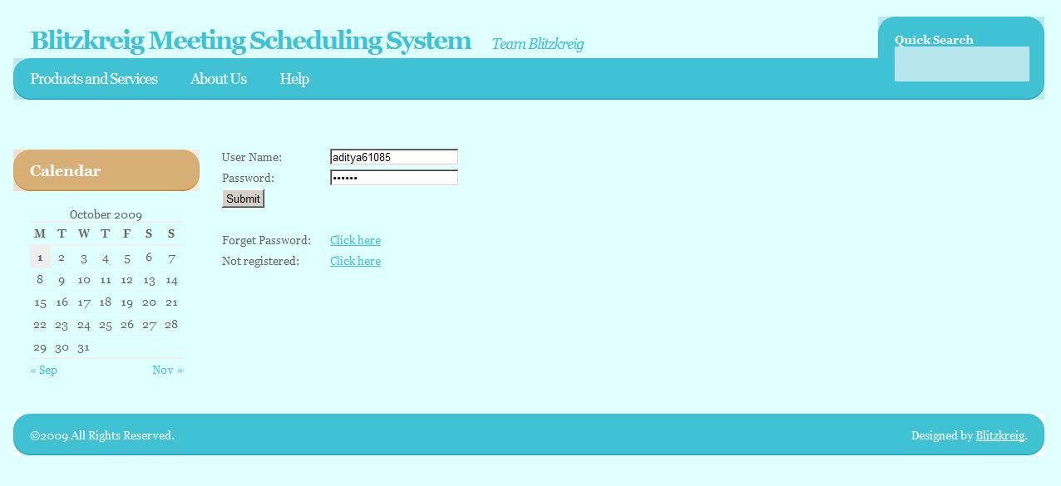

Home Page
Blitzkreig Meeting Scheduling System User will be able to view the list of proposed and upcoming meetings that has been finalized, view incoming requests that has not been finalized and the initiated meetings that has not been finalized.
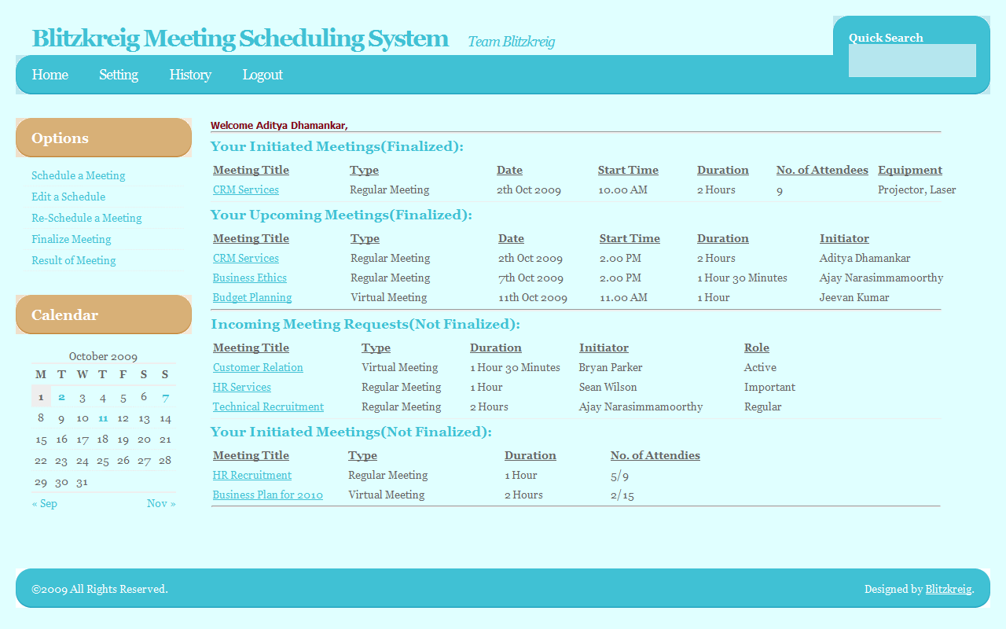

Schedule New Meeting
This is the prototype of the schedule new meeting page that the Initiator would use to propose a new meeting.
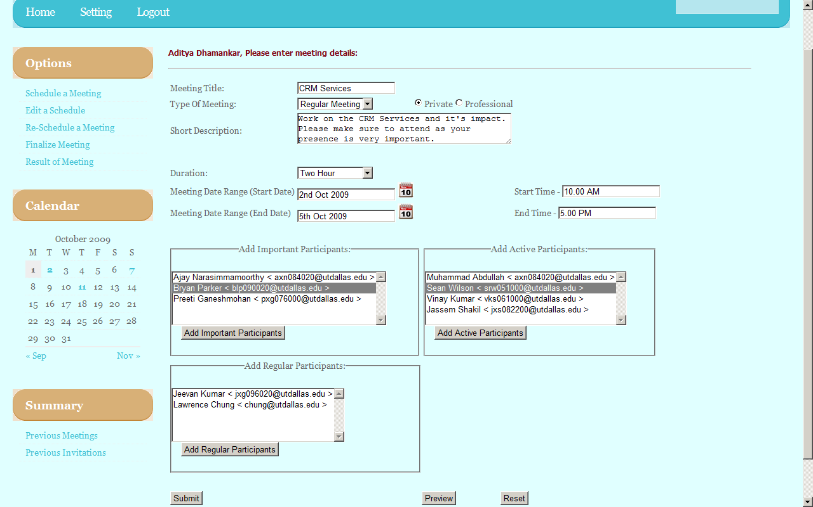

New Incoming Meeting Request – Active Participant
Active participants would specify their available and unavailable date/time blocks as well as request resources for the meeting.

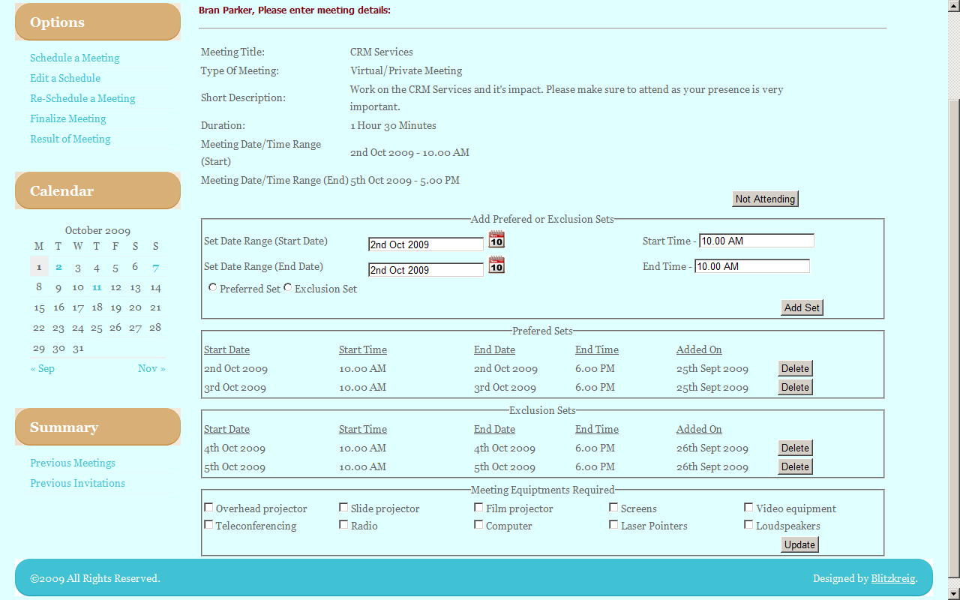

New Incoming Meeting Request – Important Participant
Important participants would specify their available and unavailable date/time blocks as well as request meeting locations.
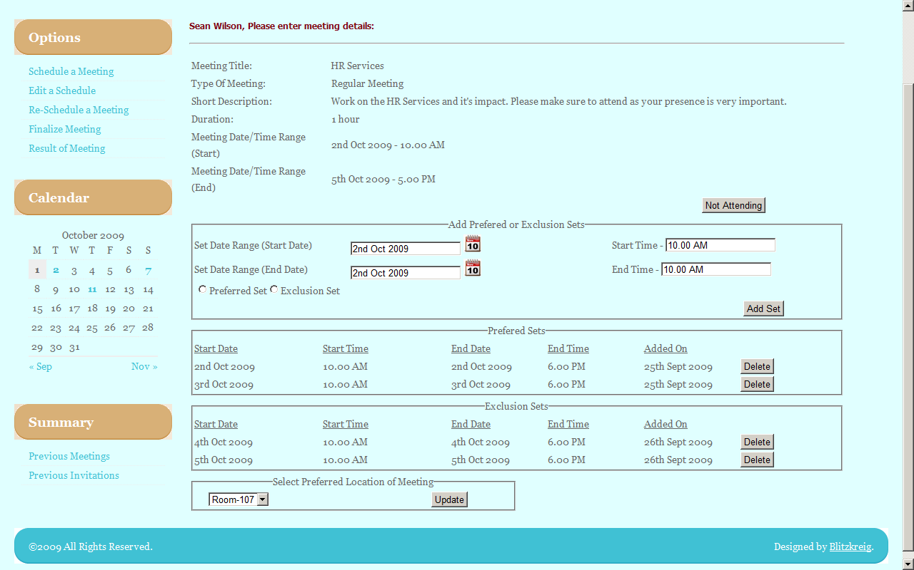

New Incoming Meeting Request – Regular Participant
Regular participants would simply be able to specify available and unavailable date/time blocks.
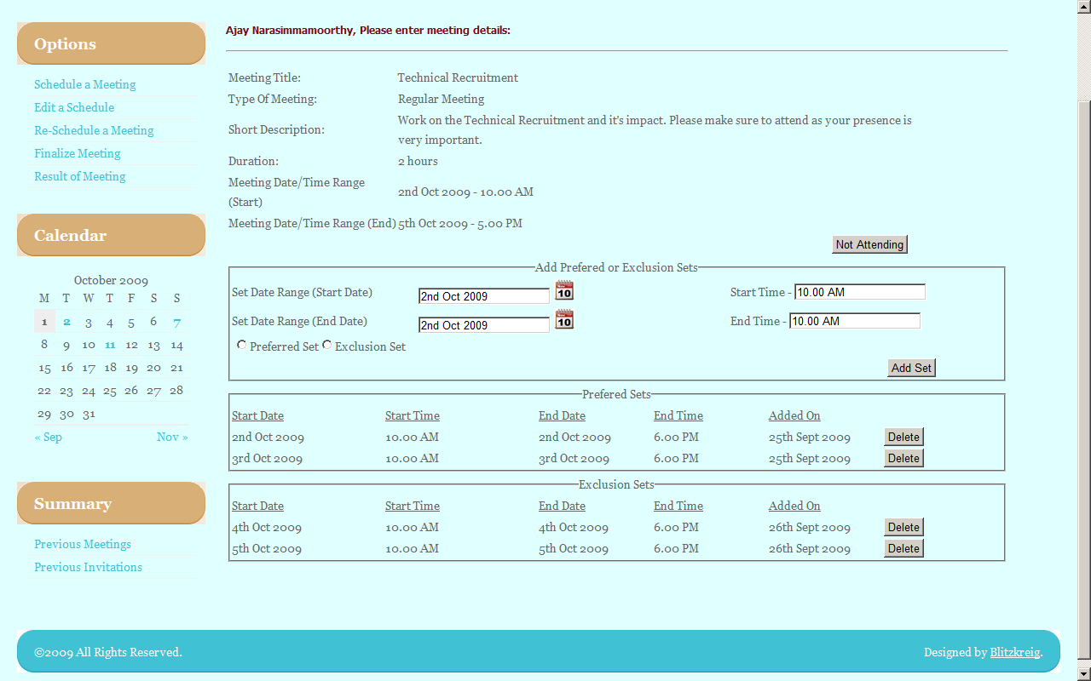

Conflict Resolution
Initiator clicks on a meeting they have planned and are then brought to this screen which has certain information on preferences of the attendees. They can then choose to edit the meeting details. Otherwise, the meeting goes with the highest ranked location and most preferred time and date.
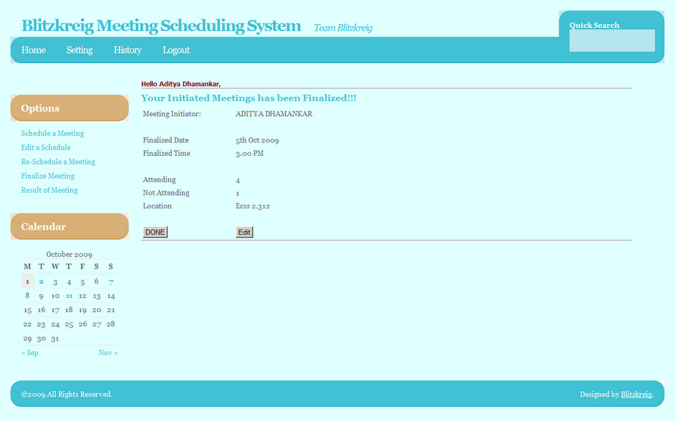

4.2. User Manual

Login page

Action Register in the system:
- Click “Register”. Input your name and email on the following screen.

Action Log in the system:
- Type user name.
- Type password.
- Click “Log in” button.

Action Request forgotten password:
- Click “request password” link. Enter your email address to have your password sent.

Home page

Action Schedule a new meeting:
- Click “Schedule New Meeting” link.

Action Edit a scheduled meeting:
- Click “Edit Meeting” link.

Action Reschedule a meeting:
- Click “Reschedule meeting” link.

Action Finalize meeting:
- Click “Finalize Meeting” link.

Action Result of Meeting:
- Click “Result of meeting” link.

Schedule New Meeting page

Action Schedule a new meeting
- Write the meeting title.
- Select the type of meet.
- Select the date and time the Date/Time range of consideration begins.
- Select the date and time the Date/Time range of consideration ends.
- Write the description of the meeting.
- Select the attendees of the meeting (repeat the following steps for each attendee):
  - Write the email of the attendee.
  - Select the type of attendee (Active, Important or Regular)
  - Push “Add Attendee” button.
- Click “Submit” button.

Action Request for Equipment for the meeting:
- Select the Equipment that is to be requested for the meet.
- Select the list of members along with their e-mail ids to whom the request should be sent.

Action Reset the creation of a new meeting:
- Click “Reset” button.

Finalize Meeting Page:
This page consists of three sections:
- The first section displays the replies from various participants and consists of the following:
  - Participant Name
  - Participant Type (Regular/Active/Important)
  - Preferred Set (Date/Time/Location)
  - Exclusion Set(Date/Time)
  - Result
Clicking the Resolve button leads to the next section.
- The second section displays the list that was obtained based on the meeting satisfying criteria which specifies the number of attendees along with the preferred set.
- The third section displays the finalized meeting schedule. Clicking the Submit button displays the result in the result page.

Result Page:
This page displays the finalized meeting schedule by the initiator listing the date, time and location of the meet along with the number of attendees and non-attendees.

5. Traceability

5.1. Domain vs System Requirements
To be provided later.

5.2. Functional vs Nonfunctional
 | NFR1 | NFR2 | NFR3 | NFR4 | NFR5 | NFR6 | NFR7 | NFR8 | NFR9 | NFR10 | NFR11 | NFR12 | NFR13 | NFR14
FR1 |  | x | x |  | x | x | x | x | x | x | x | x | x | x
FR2 | x | x |  |  | x
FR3 | x | x |  |  | x
FR4 | x |  | x | x
FR5 | x |  | x | x |  | x | x
FR6 | x |  | x |  |  |  | x |  |  | x |  |  | x | x
FR7 | x |  | x |  |  |  |  |  |  |  |  |  | x | x
FR8 | x |  | x | x |  |  | x |  | x
FR9 | x |  |  | x |  |  |  |  |  |  |  |  |  | x
FR10 | x | x |  | x | x | x
FR11 | x |  | x | x
FR12 | x | x |  | x |  | x
FR13 | x | x |  | x |  | x
FR14 | x | x |  |  |  |  |  |  |  | x |  |  |  | x
FR15 | x | x |  | x |  | x |  |  | x | x |  |  | x | x

5.3. Requirements vs Prototype
To be provided later.

Reference

Appendix
To be provided later.

