TeraSoft Distributed Meeting Scheduler System
Project Phase 1.2

Dr. Lawrence Chung
CS 6361 – Advanced Requirements Engineering
University of Texas at Dallas
Fall 2009

System Requirements Specification
Version 1.1

Requirements Engineering Team– The Pioneer

Vinit Patwa (vrp071000@utdallas.edu)
Prasanna Kumar Thiagarajan (pxt081000@utdallas.edu)
Shiva Sangam (sxs070800@utdallas.edu)
Azharuddin Mohammed (axm084000@utdallas.edu)
Ritesh Patel (rmp006100@utdallas.edu)
Tarun Chandra Samireddy (tcs080020@utdallas.edu)
Rutvij Desai (rsd081000@utdallas.edu)
Sirisha Balantrapu(sxb088100@utdallas.edu)
Shubhada Deshmukh (snd016000@utdallas.edu)
Preethi Varambally (pxv065000@utdallas.edu)
Swaroop Govindappa (sxg075100@utdallas.edu)
“The hardest single part of building a software system is deciding precisely what to build. No other part of the conceptual work is as difficult as establishing the detail technical requirements, including the entire interface to people, to machines, and to other software systems. No part of
the work so cripples the resulting system if done wrong. No other part is more difficult to rectify later.”
[Brooks, 1987]

Revision History
Version | Date | Description | Author
1.00 | 09/21/09 | Title page, Project overview, and preliminary requirements added | Sirisha
1.01 | 09/24/09 | Updated the previous version and added all other subpoints under Introduction | Shubhada
1.02 | 09/25/09 | Updated Preliminary Requirements – ER, FR, NFR. | Preethi / Swaroop
1.03 | 09/26/09 | WRS (ER,FR,NFR) | Preethi, Swaroop, Ritesh, Azhar,Shiva, Sirisha
1.04 | 09/27/09 | Added the issues related to preliminary requirements. | Shubhada, Prasanna,
1.05 | 09/28/09 | Added problem, goals and domain and functional requirements after improved understanding | shubhada
1.06 | 09/29/09 | Done Proofreading and added Traceability Matrix | Meghana
1.07 | 10/15/09 | Updated preliminary requirements, improved understanding and project flow diagram | Preethi, Swaroop
1.08 | 10/18/09 | Updated prototype | Azhar, Vinit
1.09 | 10/20/09 | RE process flow , Traceability | Prasanna, Tarun
1.10 | 10/21/09 | Added meeting and Responsibility Records | Shubhada,Preethi,Swaaroop, Ritesh,Prasanna

Meeting Record

No. | Date | Agenda | Participants
1 | Aug 29, 2009 | Preliminary plan discussed | Prasanna, Shiva, Tarun, Azhar, Meghana
2 | Sept 1, 2009 | Preliminary plan finalised | Shubhada, Vinit, Shirisha, Shiva, Ritesh, Azhar, Tarun, Meghana
3 | Sept 5, 2009 | Discussed project1.pdf document | Ritesh, Shubhada, Meghana, Prasanna
4 | Sept 10, 2009 | work discussed for Phase 1.1 | Shubhada, Vinit, Shirisha, Shiva, Ritesh, Azhar, Tarun,  Meghana, Prasanna
5 | Sept 15, 2009 | work distributed for Phase 1.1 (issues and requirement teams) | Shubhada, Vinit, Shirisha, Shiva, Ritesh, Azhar, Tarun,  Meghana, Prasanna
6 | Sept 19, 2009 | issues discussed | Shubhada, Vinit, Meghana, Prasanna
7 | Sept 21,2009 | Requirements Discussion | Ritesh, Azhar, Shirisha, Swaroop, Preethi, Shiva
8 | Sept 24, 2009 | discussed problem, goal and improved understanding | Shubhada, Vinit, Shirisha, Shiva, Ritesh, Azhar, Tarun,  Meghana, Prasanna, Rutvij
9 | Sept 29, 2009 | discussed Phase 1.1 documentation | Shubhada, Shirisha, Shiva, Ritesh, Azhar, Tarun,  Meghana, Prasanna, Rutvij
10 | Sept 30, 2009 | Discussed presentation details | Swaroop, Preethi, Vinit, Shirisha, Shiva, Ritesh, Azhar,  Tarun, Meghana, Prasanna, Rutvij
11 | Oct 6, 2009 | Discussed presentation details and practiced presentation | Swaroop, Preethi, Vinit, Shirisha, Shiva, Ritesh, Azhar,  Tarun, Meghana, Prasanna, Rutvij
12 | Oct 20, 2009 | Discussed about the things done, and things needed to be done before submission of phase 1.2 | Shubhada, Sirisha, Shiva, Prsanna, Azhar, Tarun, Preethi, Swaroop, Ritesh, Rutvij,Vinit
13 | Oct 21, 2009 | Merging and Reviewing Final Documents | Sirisha, Shiva, Prsanna, Azhar, Tarun, Preethi, Swaroop, Ritesh, Rutvij,Vinit

Team Members | Signature
Vinit Patwa
Prasanna Kumar Thiagarajan
Shiva Sangam
Azharuddin Mohammed
Ritesh Patel
Tarun Chandra Samireddy
Rutvij Desai
Sirisha Balantrapu
Shubhada Deshmukh
Preethi Varambally
Swaroop Govindappa
Meghana Satpute

- Contents
System Requirements Specification 1
Requirements Engineering Team– The Pioneer 1
Revision History 2
Meeting Record 3
2 INTRODUCTION 7
2.1 Project Overview 7
2.2 Purpose 7
2.3 Scope 8
2.4 Usablity 8
2.5 Definitions 8
2.6 RE PROCESS 9
2.6.1 Iterative development 10
2.6.2 VAriation of evolutionary iterative model 10
2.7 Stakeholders 11
2.8 PROJECT FLOW Diagram 12
2.9 Roles and Responsiblities 13
3 PRELIMINARY REQUIREMENTS 13
4 ISSUES WITH PRELIMINARY DEFINITION GIVEN (AMBIGUITIES, INCOMPLETENESS, INCONSISTENCY, CONFLICTS) 18
4.1 Issues with II.1 The Domain, Stakeholders, Functional and Non-Functional Objectives 18
4.1.1 Issue- 1 18
4.1.2 Issue- 2 18
4.1.3 Issue- 3 19
4.1.4 Issue- 4 19
4.1.5 Issue- 5 20
4.1.6 Issue- 6 20
4.1.7 Issue- 7 21
4.2 Issues with II.2 Software System Requirements: Functional Requirements 21
4.2.1 Issue- 1 21
4.2.2 Issue- 2 22
4.2.3 Issue- 3 22
4.3 Issues with II.3 Software System Non-Functional Requirements 22
4.3.1 Issue- 1 22
4.3.2 Issue- 2 23
4.3.3 Issue- 3 23
4.3.4 Issue- 4 23
4.3.5 Issue- 5 24
4.3.6 Issue- 6 25
5 WRS (World Requirements Specification) 25
5.1 World/Domain properties (w) 25
5.1.1 Problem 25
5.1.2 Goals 26
5.1.3 Enterprise Functional Requirements 27
5.1.4 Enterprise Non-Functional Requirements 29
5.2 Requirements and specifications(RS) 29
5.2.1 Functional RS – Improved understanding of II.2 29
5.2.2 Non-functional RS -Improved understanding of II.2 Software System Requirements: NFRs 31
6 TRACEABILITY 33
6.1 Forward Traceability (domain requiRements to functional requirements and non functional REQUIREMENTS) 33
6.2 – Backward Traceability 34
7 WHY OUR PROJECT IS BETTER THAN OTHERS, 37
8 SCREEN SHOTS OF THE PROTOTYPE 38
9 CHANGEABILITY 43
10 REFERENCES 43

INTRODUCTION

Project Overview

Scheduling Meetings was done manually once upon a time when offices were not automated. This was a tough and time consuming job as everything was done manually (e.g. typing agendas, writing meetings etc).

The project includes creating a TeraSoft Distributed Meeting scheduler, a facility for scheduling meetings which has many potential applications, scheduling courses and flights, room assignments at hospitals and hotels courses, flights, scheduling national and international meetings as well as scheduling virtual meetings. This particular type of system is intended for supporting people to schedule their meetings.
Scheduling meetings is one of the most important tasks in the modern workplace. Task of scheduling a meeting manually is definitely not easy. It takes lots of efforts and planning to fix up a date which is convenient to most of the members in the team if not all. With the advent of computer technologies the task of setting up meetings has become a little easy than before. As companies continue to grow, they tend to seek for better software that will help them improve their current scheduling system and increase productivity within their organization.
Scheduling a meeting really is not as simple as it looks, even with scheduling software. A lot of judgment is involved, and there's a real sense of propriety required. In bringing any group of people together, there are so many factors to take into account. It could be that there's a certain pecking order, and some people have to work around more important people's schedules. Or, some people can best be contacted by phone, some by e-mail, or some through a third party such as a secretary or administrative assistant. Decisions about where the meeting is held are important as well, and very political. For some meetings, a simple announcement will do. For others, participants will need to be polled for their availability and then confirmed later.

Purpose
The purpose of this document is to record the process of requirement elicitation for TeraSoft distributed meeting scheduler. This document specifies the domain, functional and nonfunctional requirements. It is intended to be used as reference document in TeraSoft distributed meeting scheduler software lifecycle. Requirement elicitation is a very important activity in a project’s life cycle. After reviewing the preliminary requirements the problem is defined and multiple solutions are proposed to solve the problem. The goals are set to resolve the problem and according to set goals the solution is chosen.

Scope
The scope of the system will include
- Scheduling the meeting.
- Gathering the responses from attendee.
- Confirming the location and time of the meeting.
- Canceling the meeting.
- Changing the meeting schedule and/or location.
- Scheduling concurrent meetings.
- Conducting virtual meetings.

Usablity
- Automate the process of meeting scheduling to save the time and efforts of meeting organizer.
- Select a date and time such that all the active and important participants can participate.
- Allocate the convenient location to maximize attendance.
- Send the reminders about the meeting to participants.
- Change and reschedule meeting in a situation when it is needed to do so.
- Manage the virtual meetings. Provide audio video interface to remote attendees.

Definitions
Meeting organizer - A person who is responsible for managing meetings
Meeting Initiator -One who arranges the meeting
Exclusion Set - Set of dates on which participants can not attend meeting
Preference Set -Set of dates on which participants prefer to attend meeting
Date Conflict - It occurs when no date can be suitable for meeting.
Date Range -The time between start date and end date including start and end date.
Duration -The meeting time period in hours and minutes.
Active Participants -Participants who are going to do the presentations in the meeting
Important Participants – Must be there participants. Without them the meeting can not be conducted.
Regular Participants - All the other participants who are not designated as Active or Important Participants.
Location - Physical location of the meeting room.
Required equipment -Equipments such as microphone, projector, blackboard, and stationary needed to conduct the meeting. To be chosen from list of given equipments.
Virtual meeting -Meeting held by teleconferencing.

RE PROCESS
The basic idea behind iterative enhancement is to develop a software system incrementally, allowing the developer to take advantage of what was being learned during the development of earlier, incremental, deliverable versions of the system. Key steps in the process were to start with a simple implementation of a subset of the software requirements and iteratively enhance the evolving sequence of versions until the full system is implemented. At each iteration, design modifications are made and new functional capabilities are added.
It should offer a sampling of the key aspects of the problem and provide a solution that is simple enough to understand and implement easily. To guide the iteration process, a project control list is created that contains a record of all tasks that need to be performed. The control list is constantly being revised as a result of the analysis phase
The iteration involves the redesign and implementation of a task from the project control list, and the analysis of the current version of the system. The goal for the design and implementation of any iteration is to be simple, straightforward, and modular, supporting redesign at that stage or as a task added to the project control list. The level of design detail is not dictated by the interactive approach. The analysis of an iteration is based upon user feedback, and the program analysis facilities available. It involves analysis of the structure, modularity, usability, reliability, efficiency, & achievement of goals. The project control list is modified in light of the analysis results

2.6.1 Iterative development
Iterative development slices the deliverable business value (system functionality) into iterations. In each iteration a slice of functionality is delivered through cross-discipline work, starting from the model/requirements through to the testing/deployment. The unified process groups iterations into phases: inception, elaboration, construction, and transition

2.6.2 VAriation of evolutionary iterative model
We have used a variant of the iterative model, where after the last stage which is prototype evaluation, there is a possibility for the users to suggest or add in more changes to the project. These changes in the requirements would be once again taken down by the requirement engineers and the project is developed iteratively on the existing built system along with these new changes incorporated with it.

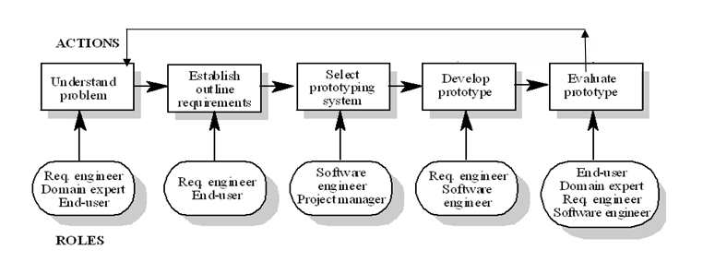
Evolutionary Iterative Model:

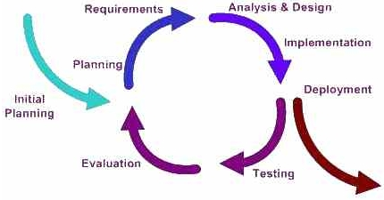
RE Process:

Stakeholders
The following stakeholders were identified in this project:
- Meeting Scheduler / Initiator
- Participants
- Requirements Engineer
- Project Manager
- Developer

PROJECT FLOW Diagram
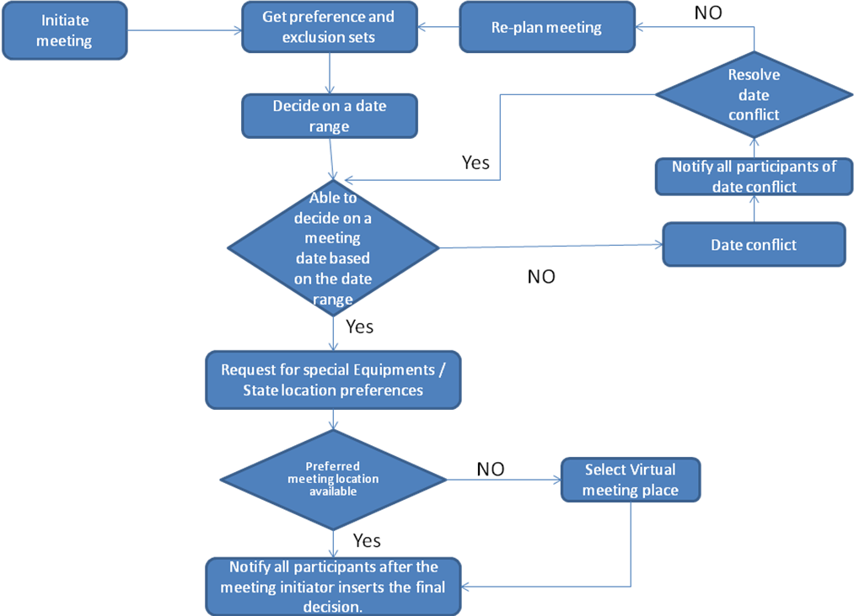

Roles and Responsiblities

Team Members | Role
Rutvij , Preethi, Ritesh | User World
Sirisha, Meghana, Shubhada | System World
Swaroop, Shiva, Prasanna | Subject World
Vinit, Tarun, Azharuddin | Developer World

PRELIMINARY REQUIREMENTS

3.1 ENTERPRISE REQUIREMENTS

EFR-1 | A “meeting initiator” shall initiate a meeting.
EFR-2 | The meeting initiator is one of the participants and it means that any participants can be a meeting initiator.
EFR-3 | The Proposed meeting date should belong to the stated date range and not to any of the exclusion sets.
EFR-4 | Proposed meeting date should fall in as many preference set as possible.
EFR-4 | Meeting initiator will ask all potential meeting attendees for set of dates they cannot attend the meeting (exclusion sets) and the set of dates they would prefer the meeting to  take place.(preference sets)
EFR-5 | The exclusion and preferences sets should be contained in some time interval prescribed by the meeting initiator.
EFR-6 | A meeting room should be available at the selected meeting date.
EFR-7 | The initiator must ask all the attendees to provide any special equipment requirements.
EFR-8 | A meeting room should meet the equipment requirement
EFR-9 | A new round of negotiations may be required when no room can be found. The number of negotiations should be kept minimal.
EFR-10 | Initiator may ask the attendees to state preferences about the meeting location
EFR-11 | Meeting location should ideally belong to one of the locations preferred by as many important participants as possible.
EFR-12 | Meeting place can be virtual through Teleconferencing, Video conferencing using laptop computers, or can be Real locations.
EFR-13 | A virtual Meeting location is chosen when none of the real locations are convenient to all the attendees.
EFR-14 | Meeting date shall be defined by a pair (Calendar date , time and period)
EFR-15 | Every meeting has its own priority in terms of internal company’s standard.
EFR-16 | Several meetings might be initiated concurrently. If the conflicts (time and location) take place, it should be resolved based on the meeting priority. If the two conflicting meetings’ priorities are the same, the meeting that is initiated later should be canceled
EFR-17 | A date conflict occurs when no meeting date belonging to the preference sets of the attendees can be found within the date range.
EFR -18 | Date conflict should be resolved with least possible interactions.
EFR-18 | Date conflict is strong when it is not in date range and outside exclusion sets
EFR-19 | A date conflict is weak when it is in date range and outside exclusion sets
EFR-20 | The Initiator extends the data range to resolve conflict.
EFR-21 | Some participants remove some dates from their exclusion set to resolve conflicts.
EFR-22 | Some participants’ withdraw from meeting to resolve conflicts.
EFR-23 | Some participants add new dates to their preference sets.
EFR-24 | If the meeting is canceled, it could be re-scheduled later.

3.2 PRILIMINARY FUNCTIONAL REQUIREMENTS

SFR-1 | The system should monitor meetings especially when they are held in a distributed manner.
SFR-2 | System shall provide function that enables initiator to send out the meeting information to all of the potential meeting attendees.
SFR-3 | The system should provide functionality for the meeting attendees to select their exclusion set.
SFR-4 | The system should provide functionality for the meeting attendees to select their preference set.
SFR-5 | The system shall make the exclusion and preference sets contained in some time interval prescribed by the meeting initiator (hereafter referred to as date range)
SFR-6 | The system shall provide functionality for the attendees to notify the initiator of any special equipment requirements (e.g., overhead projector, workstation, network connection, telephone, etc.)
SFR-7 | The system shall provide functionality for the attendees to state their preferences about the meeting location to the initiator.
SFR-8 | The system shall make the proposed meeting date belong to the preference set and the final decision is based on the meeting initiator.
SFR-9 | The system shall make the proposed meeting date ideally belong to as many preference sets as possible.
SFR-10 | The system shall provide functionality to check for a date conflict.
SFR-11 | The system shall notify all participants of a strong conflict when no date can be found within the date range and outside all exclusion sets.
SFR-12 | The system shall notify all participants of a weak conflict when date can be found within the date range and outside all exclusion sets, but no date can be found at the intersection of all preference sets.
SFR-13 | The system shall provide functionality for the initiator to extend the date range to facilitate conflict resolution.
SFR-14 | The system shall provide functionality for the attendees to remove some dates from their exclusion sets to facilitate conflict resolution.
SFR-15 | The system shall provide functionality for the attendees to withdraw from the meeting to facilitate conflict resolution.
SFR-16 | The system shall provide functionality for the attendees to add new dates into their preference sets to facilitate conflict resolution.
SFR-17 | The system shall provide functionality to check the availability of a meeting location.
SFR-18 | The system shall provide options for the meeting initiator to select a real or a virtual meeting location.
SFR-19 | The system shall handle the negotiation to decide the meeting location.
SFR-20 | The system shall provide functionality to hold meetings according to the constraints expressed by participants.
SFR-21 | The system shall provide functionality to re-plan a meeting if the exclusion set, preference set and/or preferred location is modified before a meeting date/location is proposed.
SFR-22 | The system shall provide functionality to re-plan a meeting if some external constraints need to be taken into account after a date and location have been proposed.
SFR-23 | The system shall notify all participants after the meeting initiator inserts the final decision (about meeting date and location) in the system.
SFR-24 | The system shall manage all the interactions among participants required during the organization of the meeting

3.3 PRILIMINARY NON-FUNCTIONAL REQIREMENTS

SNFR1 | A meeting should be accurately monitored, especially when it is held in a virtual place.
SNFR2 | Re-planning of a meeting should be done as dynamically and with as much flexibility as possible.
SNFR3 | The amount of interaction among participants(e.g., number and length of messages, amount of negotiation required) should be kept minimal.
SNFR4 | The intended system should considerably reduce the amount of overhead usually incurred in organizing meetings where potential attendees are distributed over many different places and communicate with each other, for example, via Internet.
SNFR5 | The system should reflect as closely as possible the way meetings are typically managed (see the domain theory above).
SNFR6 | The meeting date and location should be as convenient as possible, and available as early as possible, to all (potential) participants
SNFR7 | The system should accommodate as much decentralized requests as possible; any authorized user should be able to request a meeting independently of her whereabouts
SNFR8 | Physical constraints shall be maintained Eg., a person may not be at two different places at the same time; a meeting room may not be allocated to more than one meeting at the same time.
SNFR9 | The system shall handle appropriate number of concurrent users.
SNFR10 | The system shall have an appropriate level of performance.
SNFR11 | The system shall be easily usable by non-experts.
SNFR12 | The system shall be configurable. E.g.: The rules for conflict resolution may change and the system should be able to handle this change.
SNFR13 | The system should be scalable. i.e it should be able to accommodate additional functionalities.
SNFR14 | The system shall be customizable to professional as well as private meetings
SNFR15 | The system should be easily extensible to accommodate variations.
SNFR16 | The system should be accessible only by authorized users only.
SNFR17 | The system should be easily maintainable
SNFR18 | The attendees should be able to use the system regardless their location.
SNFR19 | The system should have a good user interface.
SNFR20 | The system should be reliable.

ISSUES WITH PRELIMINARY DEFINITION GIVEN (AMBIGUITIES, INCOMPLETENESS, INCONSISTENCY, CONFLICTS)

Issues with II.1 The Domain, Stakeholders, Functional and Non-Functional Objectives

Issue- 1
Requirement – “The initiator could also ask, in a friendly manner, active participants to provide any special equipment requirements on the meeting location”

Description – The requirement is ambiguous. There is no assertive proposal made by the initiator so this could also mean that the initiator will ask about the equipment requirements at the meeting location instead of asking about the requirements at the time of sending out the request.

Option1:
Rephrase the sentence such that it clearly conveys what it is exactly supposed to mean.
Decision and rationale :
The initiator shall ask active participants to provide any special equipment requirements on the meeting location prior to the meeting date.

Issue- 2
Requirement – The initiator may ask important participants to state preference about the meeting location

Description - The requirement is ambiguous. The requirement doesn’t specify the case of preference confliction among important participants.

Option 1: The system shall give more priority to the important participants who submit the location preference earlier.
Option 2: The decision is solely based on the meeting initiator.

Decision and Rationale: The solution would be option 2 because it specifies the case of preference confliction among important participants in more detail.

Issue- 3
Requirement – The meaning of the terms ” potential attendees”, “active participants”, “important participants” is not specified
Description - The requirement is ambiguous. The potential attendees can be important or active participants for other meeting. Similarly they can be active and important participants.

Decision and Rationale: The meeting initiator should have the responsibility of specifying the role for each of the participants (potential, active and important) for the meeting.

Issue- 4
Requirement – “Conflicts can be resolved in several ways”
Description: This requirement is unclear or ambiguous in the context “several”. It doesn’t define the regular or the necessary ways in which the conflicts could be resolved.
The requirement doesn’t specify which method should be given more preference in
resolving the conflict.
Option 1: This conflict can be solved when the initiator extends the date range in case of a date conflict
Option 2: Some participants remove dates from the exclusion sets
Option 3: Some participants withdraw from the meeting
Option 4: New dates are added to the preference set
Option 5: Meetings are prioritized according to their importance
Option 6: Preference is given to ‘important’ participants
Option 7: In an urgent situation, a meeting is postponed to accommodate a high priority meeting
Decision and Rationale: WE think that option 1 to be more appropriate because the context in which “conflicts “ is used is the DATE conflict. Extending the date range minimizes the date conflicts (by minimizing the exclusion sets) .

Issue- 5
Requirement – “It should ideally belong to one of the locations preferred by as many important participants as possible”
Description: The requirement is ambiguous in the context “ideal”. It does not mention or hint the exact idea or the context in which this used.
Options 1: The meeting location here can be ideal in the sense that the place of meeting is commutable or easy to reach or a virtual place (in case) by all or most of the important participants.
Options 2: The meeting location here can be ideal in the sense that the location is a place of interest to most of the important participants.
Options 3: The meeting location here can be ideal in the context that the meeting location satisfies all the meeting equipment requirements i.e, the conference rooms , the technical support , the boarding.
Decision and Rationale: We choose option 1 to be more appropriate because it will provide the option of holding the meeting at a location feasible or reachable by all or most of the important participants. This option also supports time constraints that may hinder the participation of most of the important members.( In case where there has to be an agreement made and all the members need to be present physically).

Issue- 6
Requirement – Some participants withdraw from the meeting.
Description - The requirement is incomplete or does not specify whether the participants are potential, active or important participants. It could specify the case that active or important participants withdraw from the meeting.

Option1: If this is the case, the meeting is cancelled.
Option2: If this is the case, the meeting date is rescheduled to the next available preference date on which every participant is available. And all participants receive e-mails about the reschedule via e-mail.
Option 3: If this is the case, the system shall give the initiator a choice if he/she wants to cancel or continue to have the meeting.

Decision and Rationale: The solution would be Option2 because it’s more specific how participants withdraw and what its result is.

Issue- 7
Requirement – The SDMS system needs to include cancellation process.
Who will be given the permission to cancel the meeting?
Description: The requirement is incomplete as it states the need to include the cancellation process. It is ambiguous because the phrase “needs to” doesn’t clearly states the necessity of cancellation process in the Initial requirement plan. The authorization of the person who cancels the meeting is not mentioned . The cancellation process is not included in the initial requirement plan but this feature can be included in the system .
Case-I:
The meeting initiator(important or active only) can cancel the meeting
Options 1: The scheduled meeting leads to cancellation when most of the important members fail to attend the meeting on the scheduled date and update the details before the scheduled time and date. There should be constraint on the time before which final updates need to be sent by all the important members or active members. Based on the final updates the meeting initiator can cancel the meeting depending on the number of attendees and the priority of the attendees.
Option 2: The meeting leads to cancellation when most of the important members fail to attend the meeting and inform the changes to the directory.
Case II:
An active participant cancels the meeting .
Option 1:An active participant is both active and important . Therefore, the active participants reserve the power to cancel the scheduled meeting.

Issues with II.2 Software System Requirements: Functional Requirements

Issue- 1
Requirement – Meeting requests can be competing when they overlap in time or space.
Description - This requirement is incomplete. It does not specify what the system should do when two different meetings are initiated by different initiators at the same time and/or at same location.
Option 1 - The meeting which is initiated first by the initiator will be held
Option 2 - Depending upon the rank or position of initiator preference will be given
Option 3 - System will select the meeting to be held by random selection.
Decision and rationale – We think option 1 is more appropriate because it will be conflicting if the rank is same. Also if system randomly selects the meeting then it might result in to cancellation of previously well planned meeting so option 1 will schedule meeting on First Come First Serve basis which will result in to least modifications regarding scheduling meeting.

Issue- 2
Requirement – In all cases some bound on re-planning should be set up.
Description - This requirement is incomplete. It does not specify what the system should do when it needs to re-plan the meeting.
Option 1 – Send a message to initiator to re initialize meeting with new dates.
Option 2 – Send the other acceptable dates for meeting to initiator depending on the already done voting. If no such date is available then send a message to initiator to re initialize the meeting.
Option 3 - System will select the meeting to be held by random selection.
Decision and rationale – We think option 2 to be more appropriate because it will make rescheduling process faster if there are any acceptable meeting dates available. Also it will start the process of scheduling immediately after cancellation.

Issue- 3
Requirement – the original meeting date or location may need to be changed;
sometimes the meeting may even be cancelled.
Description - This requirement is incomplete. It does not specify who is going to cancel or reschedule the meeting.
Option 1 – The initiator or active participant can reschedule or cancel the meeting.
Option 2 – The TeraSoft Meeting scheduling system can cancel or reschedule the meeting depending on participant response changes or conflicts with other more important meeting.
Decision and rationale – We think option 1 and 2 both are appropriate.
Giving authority of cancellation or rescheduling to initiator or active participants makes system more flexible. It also prevents any unauthorized changes to meeting schedule by anybody else.
Allowing system to cancel and reschedule meeting saves time overhead needed for manual rescheduling of meeting.

Issues with II.3 Software System Non-Functional Requirements

Issue- 1
Requirement – Meeting date should be as convenient as possible.
Description - This requirement is incomplete. It does not specify what the “convenient date” means.
Option 1 - Date on which maximum number of participants can attend.
Option 2 - Date on which 100% of important members can attend.
Option 3 - Date on which 100% of important members and 70% of regular members can attend
Decision and rationale – We think option 3 to be more appropriate because it will ensure that all the important participants and active participants will be attending the meeting. Also if system selects one of remaining two options then there is a chance that important participants will not be there for the meeting or nobody other than important participants will be attending the meeting.

Issue- 2
Requirement – Meeting should be accurately monitored.
Description - This requirement is incomplete. It does not specify what the system should monitor and how should it monitor exactly. Is it the proceedings of the meeting or the presence of participants or anything else?
Option 1 – Interaction among the initiator and participants is taken care of.
Option 2 - The presence of important participants is taken care of.
Option 3 – Remove the requirement..
Decision and rationale – We think option 2 is more appropriate because it will be important characteristics of meeting to be made sure because as per our assumption the meeting will get cancelled if important participants can not attend or cancel the meeting.

Issue- 3
Requirement – The system should accommodate as much decentralized requests as possible. In other words user should be able to initiate the meeting independent of his/her whereabouts.
Description - This requirement is ambiguous. It does not exactly specify what kinds of requests system should handle.
Option 1 – Requests to initiate the meeting can be sent by email, IM, SMS, or phone.
Option 2 – Initiator can login to the website and initiate the meeting.
Decision and rationale – We think option 2 to be more appropriate because it will provide an option of initiating meeting from any palace where user has access to the web. The growing number of web enabled devices will make this option real location independent.

Issue- 4
Requirement – The system should be flexible enough to accommodate evolving data
- e.g., the sets of concerned participants may be varying; the address at which a participant can be reached may be varying, etc.
Description - This requirement is incomplete. It does not specify in what manner the sets of concerned participants may vary. It can mean several different situations.

Case I
1- contact information of participant changes 2 – Ranking of participant changes regular participant can become important participant.
Option 1 – The contact information – phone, email and ranking of participant is saved in a database and used for all meeting scheduling related activities. The participant or administrator can change this information.
Option 2 – The participant sends the request to initiator to use new contact information for further communication.
Decision and rationale – We think option 1 to be more appropriate because it allows changes in participant’s information and it satisfies previously stated requirement of minimization of interaction.

Case II
More participants are needed to be added or removed from participant sets after the meeting is initialized.
Option 1 – Initiator can add or remove more participants any time.
Option 2 – Initiator and important participants can add more participants but only initiator can remove the participants.
Option 3 – Cannot change the participant set once meeting is initialized.
Decision and rationale – We think option 2 is more appropriate as it provides flexibility of managing set of participants. It also satisfies the previously stated requirement of minimization of interaction.

Issue- 5
Requirement – Amount of interaction among participants should be kept minimal.
Description - This requirement is ambiguous. It does not specify what type of interaction is reduced. It can be number of times interaction between initiator and participants occur or length of e-mail messages or number of minutes they talk over phone. Also ‘minimal’ word is vague as it does not set any upper bound on the interaction.
Option 1 – Phone interaction among the initiator and participants is maximum 10 minutes.
Option 2 – Length of email messages exchanged will be less than 50 words.
Option 3 – Remove the requirement.
Decision and rationale – We think option 3 is more appropriate because option 1 and 2 are out of the scope of our project and here we will prefer to use software system to schedule the meeting rather than e-mail and phone conversations.

Issue- 6
Requirement – The system should considerably reduce the amount of overhead.
Description - This requirement is ambiguous. It does not specify what overhead is reduced. It can be in terms of cost or time the participant need to spend to reach at meeting location. Also ‘considerably’ word does not give much information.
Option 1 – The meeting will be held at location which is preferred by most of the participants that will reduce the time they need to reach the meeting location.
Option 2 – Initiator decides location by his preference
Decision and rationale – We think option 1 is more appropriate because it will reduce the transportation time. The initiator can select the location which is preferred by most of the participants.

WRS (World Requirements Specification)
Requirement Specification is a document which describes the Enterprise, functional, nonfunctional requirements for the TeraSoft Distributed Meeting Scheduler system that is planned for product development in the near future. It tells what is expected from the system and how the system should behave under certain conditions. The Requirement Specification Document is not just a list of requirements; moreover, it helps the project stakeholders reach an agreement on the functionalities of the system and the conditions to which it must conform.

world/domain PROPERTIES (w)

Problem
Scheduling a meeting is an intractable task. As the number to entities increase the complexity scheduling process increases exponentially. If a meeting is needed to be scheduled then someone has to send the invitation by physical mail, email, phone etc to expected participants. After that they have to keep track of who is coming, who is not coming. What are the convenient days, times, locations for the participants? Someone has to manually schedule a meeting and monitor it. The organizer has to collect the responses from participants, and analyze those responses depending on that analysis he has to make choices regarding several things. Consider these scenarios-
- If the meeting gets scheduled on a day when the active participant cannot join. All the other participants will show up but meeting will get canceled.
- The meeting needed to be rescheduled then organizer has to get in touch with all the participants and collect the information again.
- The reminder of meeting is needed to be sent, then the meeting organizer has to keep the contact information of all the participants on file. He has to take efforts to contact them
TeraSoft Distributed Meeting Scheduler system wants to schedule meeting for its users. It shall allow any user who can login into the system to initiate a meeting and invite anyone who has an email id. It should make sure that all the active and important participants will be able to attend the meeting and the location of the meeting is convenient for them. The system shall handle scheduling meetings concurrently with respect to time and location. It will manage the remote meeting held by teleconferencing.

goals
- The user should be able to initiate a new meeting and invite the participants to join the meeting.

- The location should be convenient to active and important participants.

- The needed equipments for meeting should be available at meeting place.

- The meeting should be rescheduled if the participation of active or important participants is not 100%.

- The initiator should be able to cancel meeting.

- The initiator should be able to reschedule a meeting.

- The initiator, active participants and important participants should be able to invite more participants.

- Two or more meeting requests for same location or same timeslot should be handled by system

- The participants should be able to attend meeting remotely.

- The important meeting should be given preference while scheduling meetings.

Enterprise Functional Requirements

EFR-1 | A “meeting initiator” shall initiate a meeting by selecting a “date range” and “location” for the meeting.(traces to preliminary requirement EFR-7 and 3.1.2 issue 2)
EFR-2 | The Proposed meeting date should belong to the stated date range and to none of the exclusion sets
EFR-3 | A meeting room must be available at the selected meeting date and time.  (traces to SFR-6)
EFR-4 | A meeting room should meet the equipment requirement.  (traces to SFR-7)
EFR-5 | Meeting place will be virtual or Real location.
EFR-6 | Meeting date should be defined by Calendar date , time and period.
EFR-7 | All the important participants should be able to attend the meeting.
EFR-8 | The participants should be able to change their responses at any time before the meeting date.
EFR-9 | The time confusion due to different time zones shall be solved by the system.
EFR-10 | The meeting initiator can be one of the participants or some representative.
EFR-12 | A date conflict occurs when no date can be found that belongs to all the preference sets.
EFR-13 | A date conflict is strong when no date can be found within the date range and outside all exclusion sets.
EFR-14 | A date conflict is weak when dates can be found within the date range and outside all exclusion sets, but no date can be found at the intersection of all preference sets.
EFR-15 | The date conflict should be solved by extending the date range by the initiator. (traces to preliminary EFR-8)
EFR-16 | The date conflict should be solved by some attendees adding some new dates into their preference sets.
EFR-17 | The date conflict should be solved by some attendees removing some dates from their exclusion sets.
EFR-18 | The date conflict should be solved by some attendees withdrawing from the meeting.
EFR-19 | The number of negotiations shall be within the maximum number of negotiations needed to resolve a conflict.

Enterprise Non-Functional Requirements

ENFR-1 | The physical meeting location should be commutable, easy to reach.
ENFR-2 | Initiator shall be updated regarding any changes in location status by facility manager.
ENFR-3 | Initiator shall be updated regarding any changes in equipment status by facility manager.
ENFR-4 | The system shall not reveal the information of it’s users.

Requirements and specifications(RS)

Requirement - Things, events or phenomenon in application domain or environment which we want to make true with the software system to be built. Requirements are about the environment.
Specification - What the system does to fulfill the user requirements is a specification.
Separating software requirements from specification is difficult task. We are stating software requirements and specifications together in this section.

Functional RS – Improved understanding of II.2
SFR-1 | The user who has login privileges can initiate a meeting.
SFR-2 | The meeting scheduler should request the meeting date range, meeting name, important and active participants, regular participants, location and equipment needed to the initiator.
SFR-3 | The meeting scheduler system should request the ‘importance level’ of the meeting to initiator when he initiates the meeting.
SFR-4 | The meeting scheduler system should allow initiator to cancel the meeting.
SFR-5 | The meeting scheduler system should allow the initiator to reschedule the meeting.
SFR-6 | The meeting scheduler system should cancel the meeting to resolve the conflict with more important meeting.
SFR-7 | If the meeting is canceled by meeting scheduler then it should send the other acceptable schedules to initiator depending on already done voting.
SFR-8 | If the acceptable schedules cannot be found to reschedule the meeting an email shall be sent to initiator to reschedule the meeting with new date range.
SFR-9 | Participant shall be able to communicate by email with other participants from meeting scheduler web site.
SFR-10 | An initiator should select the ‘room location’ from given list. The availability of room should be checked and if it is not available then initiator has to choose other meeting room.
SFR-11 | The initiator should select the ‘equipments’ needed for the meeting from the equipments list plus active participants should have the option of selecting the equipments when they confirm their attendance to meeting.
SFR-12 | The meeting initiator may designate one or more meeting participants as “important” meaning that their attendance at the meeting is required in order to have the meeting.
SFR-13 | The system should send the reminder 4 days before the meeting date to participants who did not respond to invitation.
SFR-14 | As soon as the active or important member declines the meeting invitation the system shall send an email to initiator regarding rescheduling a meeting.
SFR-15 | At least 100% of active and important participants, and 70% of regular participants should agree on the schedule( i.e. time, date, duration, location) of the meeting.
SFR-16 | The meeting must be confirmed as soon as the SFR-11 is satisfied.
SFR-17 | As soon as meeting is confirmed, the confirmation should be sent to participants by email.
SFR-18 | Meeting scheduler shall provide audio visual aid to conduct meeting remotely.
SFR-19 | The scheduler should send the reminder 15 minutes before the meeting time to all the participants.
SFR-20 | The participants should be able to change their response at any time before the meeting.
SFR-21 | The meeting scheduler shall send a cancellation email to all the participants in case the meeting gets canceled.
SFR-22 | According to actual location of meeting the time zone information shall be added to meeting information.

Non-functional RS -Improved understanding of II.2 Software System Requirements: NFRs
SNFR1 | A meeting should be accurately monitored, especially when it is held in a virtual place. Here, nomadicity will then be important to consider
SNFR2 | A meeting shall take care of most recent information such as exclusion sets, preference sets, locations and equipment requests.
SNFR3 | Re-planning of a meeting should be done as dynamically and with as much flexibility as possible
SNFR4 | The amount of interaction among participants(e.g., number and length of messages, amount of negotiation required) should be kept minimal
SNFR5 | The intended system should considerably reduce the amount of overhead usually incurred in organizing meetings where potential attendees are distributed over many different places and communicate with each other, for example, via Internet
SNFR6 | The system should reflect as closely as possible the way meetings are typically managed (see the domain theory above)
SNFR7 | The meeting date and location should be as convenient as possible, and available as early as possible, to all (potential) participants
SNFR8 | The system shall take care of concurrent meeting requests by giving priority to important meetings.
SNFR9 | The system shall take care to see that each attendee participates in just one meeting.
SNFR10 | The system shall decide upon a time deadline after which changes to the preference sets, exclusion sets, location preferences cannot be made.
SNFR11 | The system should accommodate as much decentralized requests as possible; any authorized user should be able to request a meeting independently of her whereabouts
SNFR12 | The system shall be user friendly.
SNFR13 | The system shall add participants at any point (before or during the meeting). However the participants added during the meeting shall not state their preferences.
SNFR14 | The system shall use standard formats for date and time and also allow users to select their preferred language.
SNFR15 | The system shall be easily extensible to accommodate variations.
SNFR16 | The system shall be customizable to formal as well as informal meetings.

TRACEABILITY
This section provide traceability matrix for better understanding in case of inconsistency occurring. If this happens, the stakeholders easily trace back from the problem to the root that causes the problem. Traceability refers to the completeness of the information about every step in a development process. A traceability matrix is created by associating requirements with the work products that satisfy them. Traceability is very important because requirements are volatile and as the project enhances, developer needs to trace back to original requirements.

6.1 Forward traceability (domain requiRements to functional requirements and non functional REQUIREMENTS)
The forward traceability shows the mapping only between the requirements. Here we are mapping the Enterprise Requirements with the functional and non functional requirements.
EFR-1 | A “meeting initiator” shall initiate a meeting by selecting a “date range” and “location” for the meeting. | SFR-1, SFR-2,  SFR-3
EFR-2 | The Proposed meeting date should belong to the stated date range and not to none of the exclusion sets | SFR-14  SFR-20
EFR-3 | A meeting room must be available at the selected meeting date. | SFR-10
EFR-4 | A meeting room should meet the equipment requirement. | SFR-11
EFR-5 | Meeting place will be virtual or Real location. | SNFR-8
EFR-6 | Meeting date should be defined by Calendar date , time and period. | SFR-2  SNFR-6
EFR-7 | The date conflict should be solved by extending the date range by the initiator. | SFR-5, SFR-7  SFR-8
EFR-8 | All the important participants should be able to attend the meeting. | SFR-14  SFR-15
EFR-9 | The participants should be able to change their responses at any time before the meeting date. | SNFR-9
EFR-10 | The time confusion due to different time zones shall be solved by the system. | SFR-20  SFR-21
EFR-12 | The meeting initiator can be one of the participants or some representative. | SFR-1

6.2 – BACKWORD TRACEABILITY
Our forward traceability showed the mapping between the requirements, precisely the enterprise and Functional, Non functional requirements. Now, in the backward traceability, we are actually showing the mapping between the Functional and the Non functional requirements which could also be considered in the previous section(forward traceability). But the mapping between the Functional and Enterprise requirements clearly depicts the backward traceability. Though according to the definition, as explained in the class , the forward and backward traceability is done between the Requirements and the System design, we are showing the traceability only between the requirements.

SFR-1 | The user who has login privileges can initiate a meeting. | ER-5,ER-1,ER-12
SFR-2 | The meeting scheduler should request the meeting date range, meeting name, important and active participants, regular participants, location and equipment needed to the initiator. | ER-1,  ER-6,SNFR-6
SFR-3 | The meeting scheduler system should request the ‘importance level’ of the meeting to initiator when he initiates the meeting. | ER-1
SFR-5 | The meeting scheduler system should allow the initiator to reschedule the meeting. | ER-7
SFR-6 | The meeting scheduler system should cancel the meeting to resolve the conflict with more important meeting. | ER-6,SNFR-6
SFR-7 | If the meeting is canceled by meeting scheduler then it should send the other acceptable schedules to initiator depending on already done voting. | ER-7
SFR-8 | If the acceptable schedules can not be found to reschedule the meeting an email shall be sent to initiator to reschedule the meeting with new date range. | ER-7
SFR-9 | Participant shall be able to communicate by email with other participants from meeting scheduler web site. | ER-7,SNFR-9
SFR-10 | An initiator should select the ‘room location’ from given list. The availability of room should be checked and if it is not available then initiator has to choose other meeting room. | ER-3,SNFR-2,SNFR-3  SNFR-6
SFR-11 | The initiator should select the ‘equipments’ needed for the meeting from the equipments list plus active participants should have the option of selecting the equipments when they confirm their attendance to meeting. | ER-4,SNFR-4
SFR-12 | The meeting initiator may designate one or more meeting participants as “important” meaning that their attendance at the meeting is required in order to have the meeting. | SNFR-1,SNFR-3
SFR-13 | The system should send the reminder 4 days before the meeting date to participants who did not respond to invitation. | ER-3,SNFR-8
SFR-14 | As soon as the active or important member declines the meeting invitation the system shall send an email to initiator regarding rescheduling a meeting. | ER-2,ER-8
SFR-15 | At least 100% of active and important participants, and 70% of regular participants should agree on the schedule( i.e. time, date, duration, location) of the meeting. | ER-8
SFR-17 | As soon as meeting is confirmed, the confirmation should be sent to participants by email. | ER-7,SNFR-3,SNFR-9
SFR-18 | Meeting scheduler shall provide audio visual aid to conduct meeting remotely. | ER-7,SNFR-6
SFR-19 | The scheduler should send the reminder 15 minutes before the meeting time to all the participants. | ER-9
SFR-20 | The participants should be able to change their response at any time before the meeting. | ER-2
SFR-21 | The meeting scheduler shall send a cancellation email to all the participants in case the meeting gets canceled. | ER-10
SFR-22 | According to actual location of meeting the time zone information shall be added to meeting information. | ER-10

WHY OUR PROJECT IS BETTER THAN OTHERS,
Instead of approaching our friendly computer salesperson and say, show me what your system can do, what we say is, this is what I need: show me that your system can do!!!!!!
The truth is that all the systems are probably very good. Each has features that its proponents claim to make it immeasurably better than the others. The only thing is one of them will be better than others, and one will suit us best of all.
And, we are proud to claim that we are better!!
We have done a sample project that represents the typical situation that our system will have to handle. We also made up some input data in exactly the form in which we would normally receive them and design some management reports that show exactly what we would like the system to produce.
Firstly, We used incremental model unlike other groups who used spiral model. In our model cycles are divided up into smaller, more easily managed iterations
A working version of software is produced during the first iteration, so we have working software early on during the software life cycle. Subsequent iterations build on the initial software produced during the first iteration.
Our model is easier to test and debug during a smaller iteration. It is easier to manage risk because risky pieces are identified and handled during its iteration and each iteration is an easily managed milestone which is a complete contradiction to the spiral in which risk analysis requires highly specific expertise. So, Project’s success is highly dependent on the risk analysis phase and it does not work well with small projects.
Moreover, we covered more stake holders and took domain experts into consideration which other groups did not. We provided solid precise definition to active and important participants and also reflected that in their roles.
Secondly, we have come up with improved understandings after integrating the issues and initial requirements. For this to happen, both the requirements team and development team sat together. We could not see this any other teams.
Thirdly, we divided ourselves into four categories along with some exclusive roles assigned to those set of people in that category. After the sub group work is done, the teams sat together to avoid interactional and integral problems. We exactly replicated how a corporate project is managed unlike some groups in which everybody worked on everything.

SCREEN SHOTS OF THE PROTOTYPE

Home Page

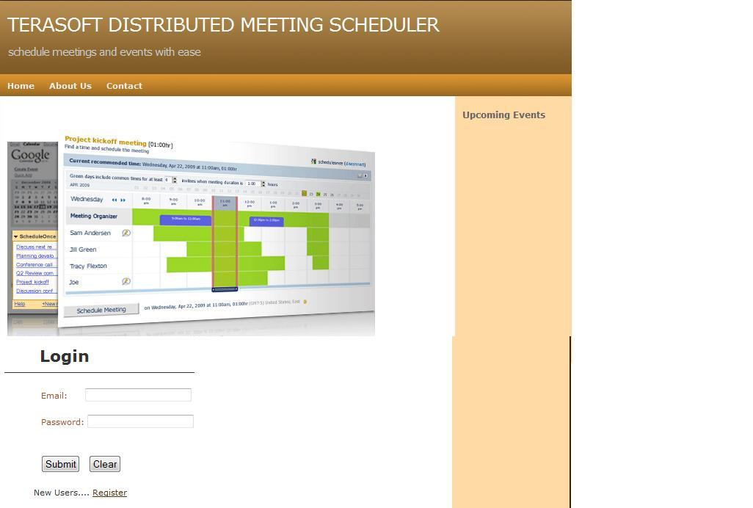

New User Registration
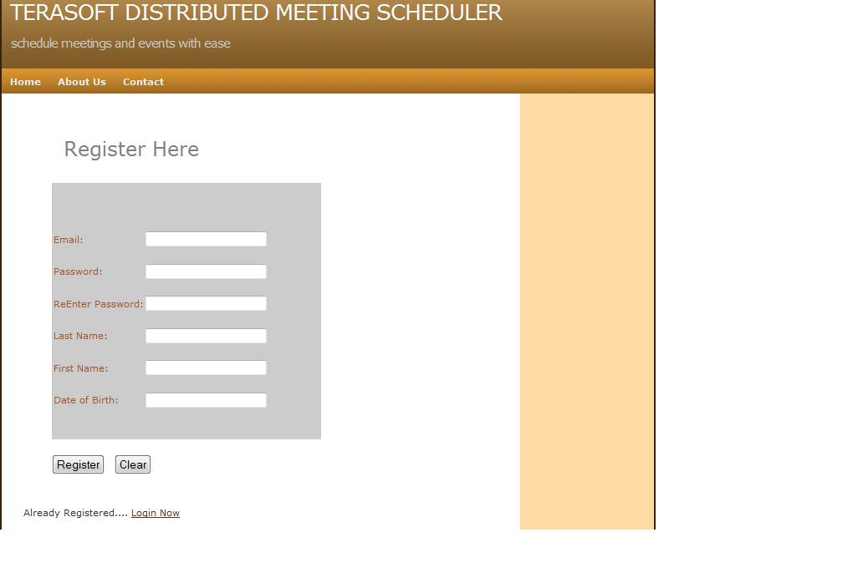

Initiate a Meeting
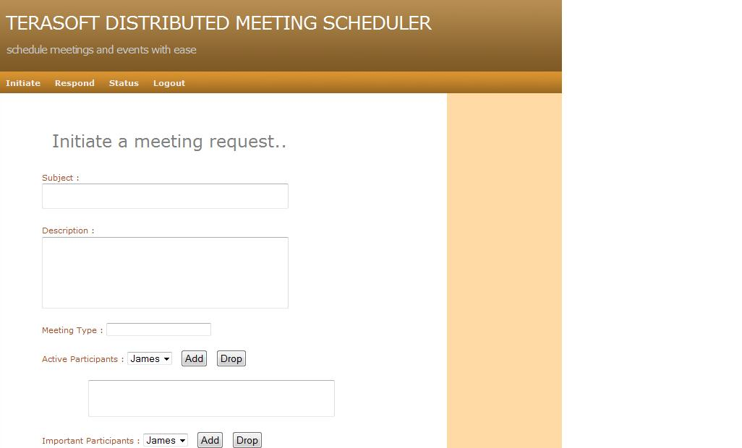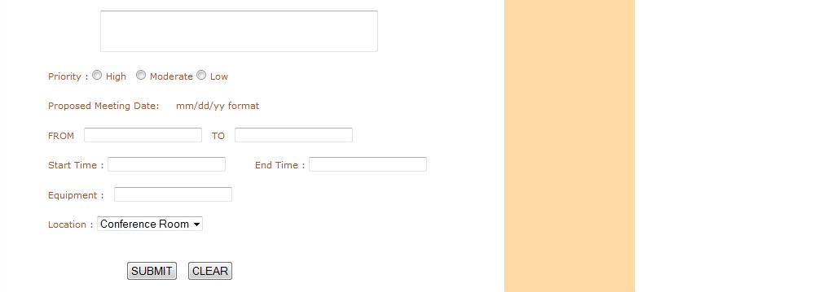

Respond To a Meeting
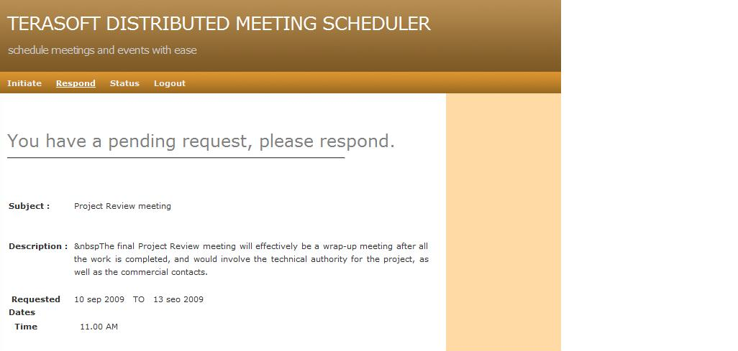

Meeting Status
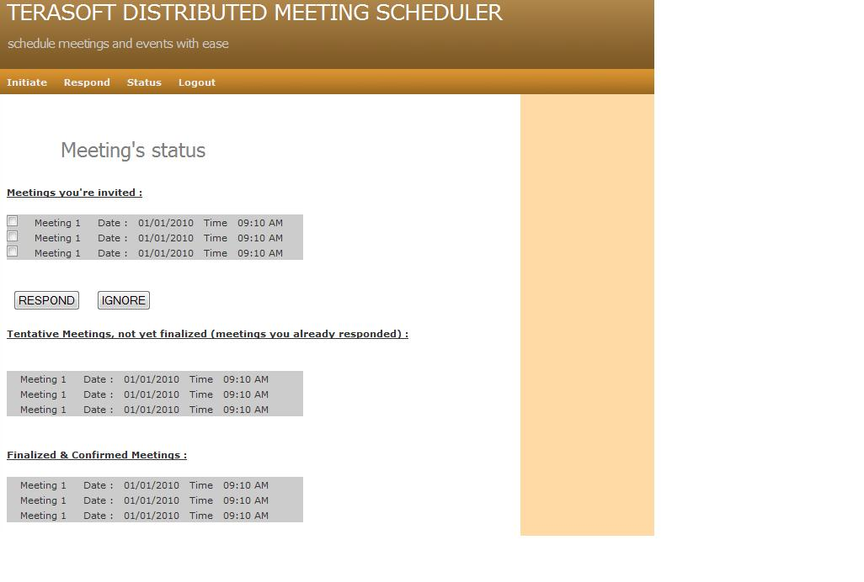

CHANGEABILITY
The requirements and specifications can be changed up to 20% with a variance of +/-5%. This value is not accurate and is based on the following criterions

- The intensity of change on prototype
- The Time and Resource required to implement the change in the provided limited resources
- How deviated is the new requirement from the old requirement
- The New changes should support validation and traceability factors
- The impact of new changes onto other existing modules

An accurate value can be inferred by assigning weight-age to the requirements by using the matrix method and calculating the threshold value and determining the impact of change. If the calculated value exceeds this threshold value then we shall not modify the requirements or else modify the requirement.

REFERENCES
  - http://www.utdallas.edu/~chung/RE/syllabus.htm
  - http://en.wikipedia.org/wiki/Traceability
  - http://www.jiludwig.com/Traceability_Matrix_Structure.html
  - http://www.utdallas.edu/~chung/RE/Presentations09S/
  - http://www.utdallas.edu/~chung/RE/Presentations08F/

