TeraSoft Distributed Meeting Scheduler System

Dr. Lawrence Chung
CS 6361 – Advanced Requirements Engineering
University of Texas at Dallas
Fall 2009

USER MANUAL

Requirements Engineering Team– The Pioneer

Screen 1 : Login Page

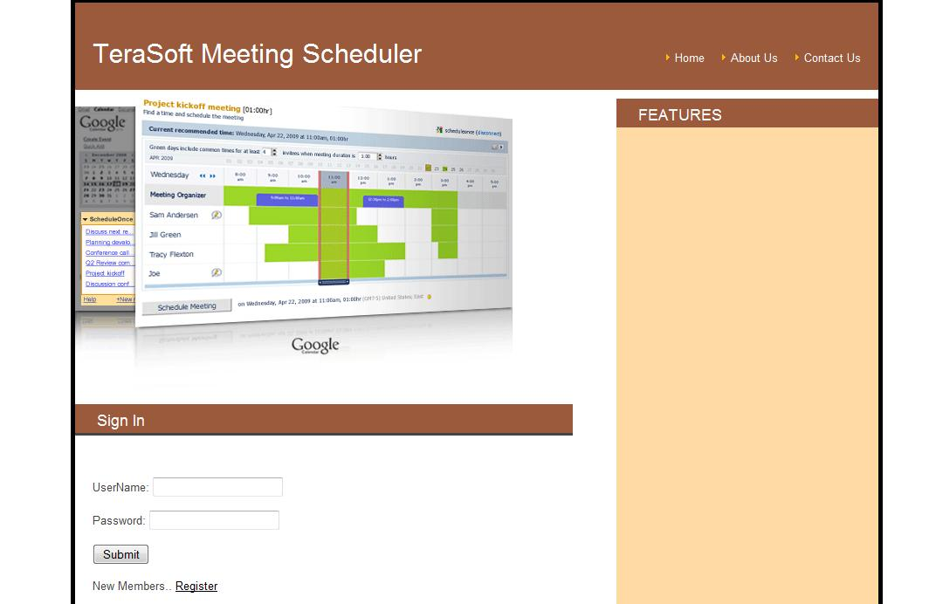

This is the Login page for the system. This is the first page which user will see.
User will need to put his username and correct password enter the system.
Users who put login credentials correctly can enter to the system and new users will need register to use the system.
Once the user puts correct credentials, Welcome Page will be displayed.

Screen 2: Registration Page

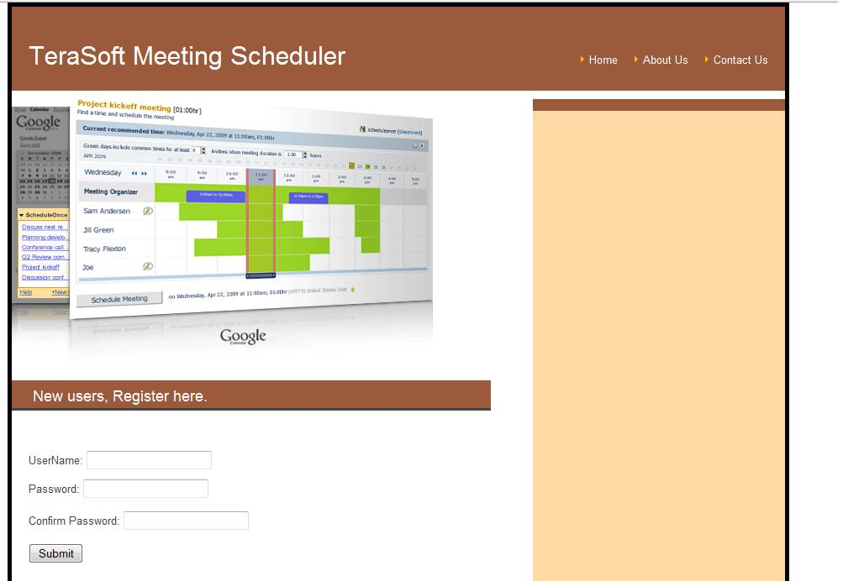

If you are a new user then this is the Page where you can create your account, so that you can access the system.
To Register, fill the info in UserName, Password,Confirm Password.
Few of this information can be used to help user to login again, if user forgets the password.

Screen 3: Invalid User Page

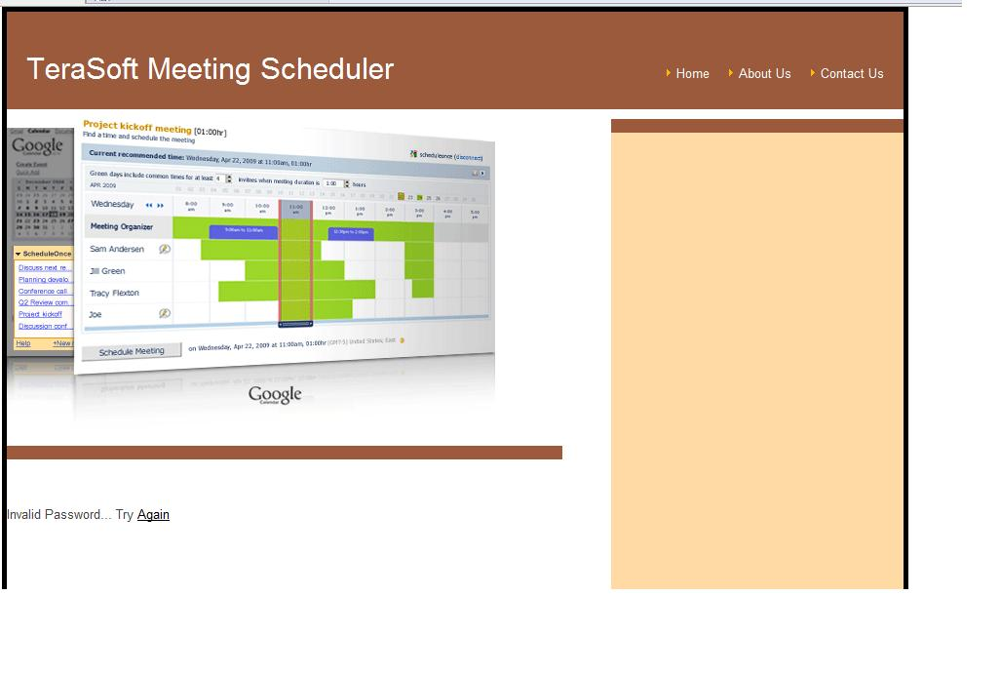
If wrong user name or password is entered, User will see the Invalid Password Page.

Screen 4: Welcome Page

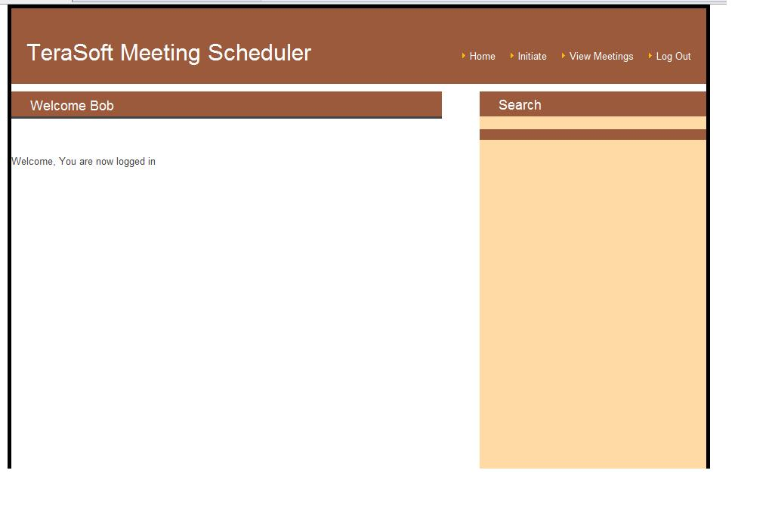

On Welcome Page, User can either Initiate meeting, can view the status of his meetings, logout.
If user clicks on Initiate Meeting link, system will bring Initiate meeting page and user can initiate meeting and invite other users for the meetings.
If user clicks on View Meeting link, system will bring status page and user can view the status of the meetings, he has initiated or accepted.
If user clicks on logout link, system will let user logout.

Screen 5: Initiate Meeting Page

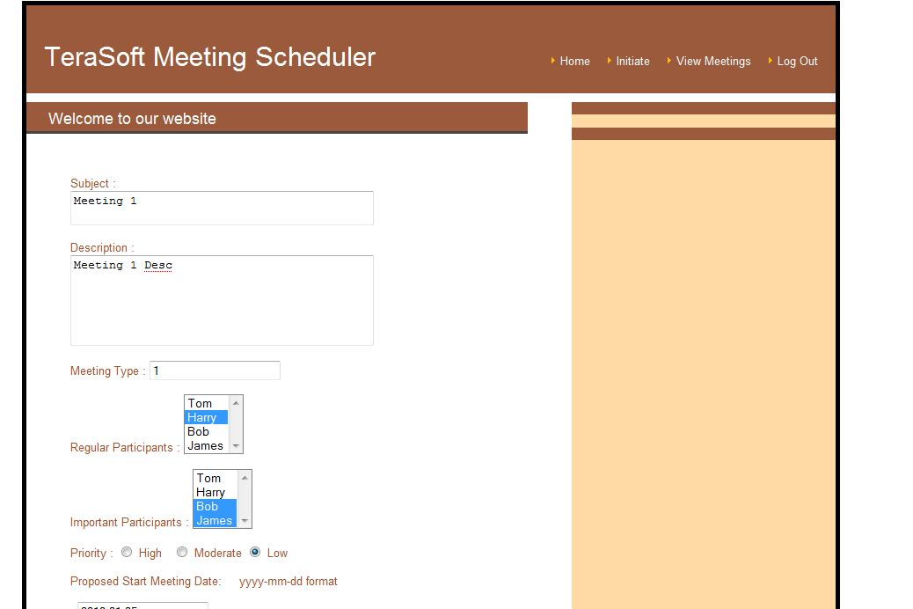

On Welcome Page, if user clicks on Initiate Meeting link, system will bring Initiate meeting page and user can initiate meeting and invite other users for the meetings.
Here User can put Subject , Description for the meeting, user can put Meeting type, can add the other participants as Regular or Important Participants. User can also give priority to the meeting. Meeting initiator can propose Meeting date and time and add any equipment if needed and can decide about the Location for the meeting.
Once User Submits the Meeting request, meeting request will be sent to all the participants and all participants either can accept or proposed some modification in meeting details. Participant can also reject meeting request.

Screen 6: View Meeting Page

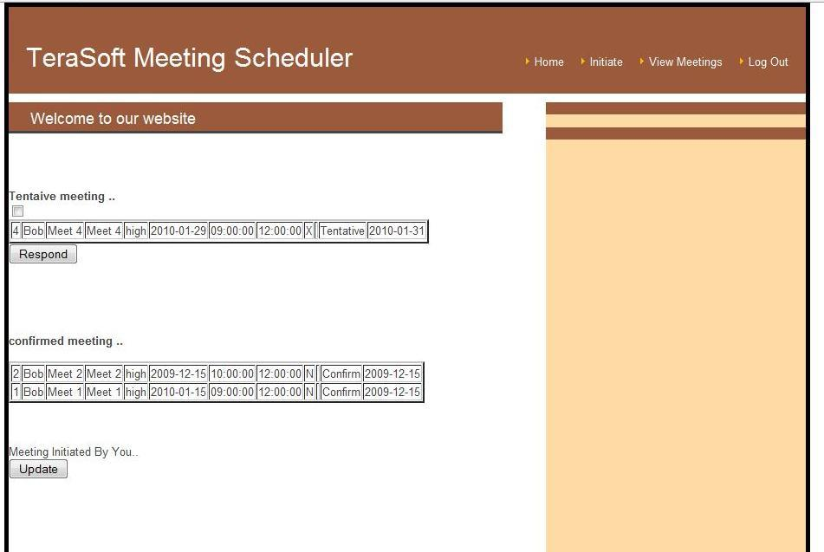

If user clicks on status link, system will bring status page and user can view the status of the meetings, he has initiated or accepted.
On this page, User can see, Meetings to which user is tentative meetings, confirmed meetings and meetings initiated by user.
User can respond to the meetings he/she has been invited. User can respond to one of those by checking the box and clicking on the Respond button. This will bring Respond to meeting page.

Screen 7: Response Page
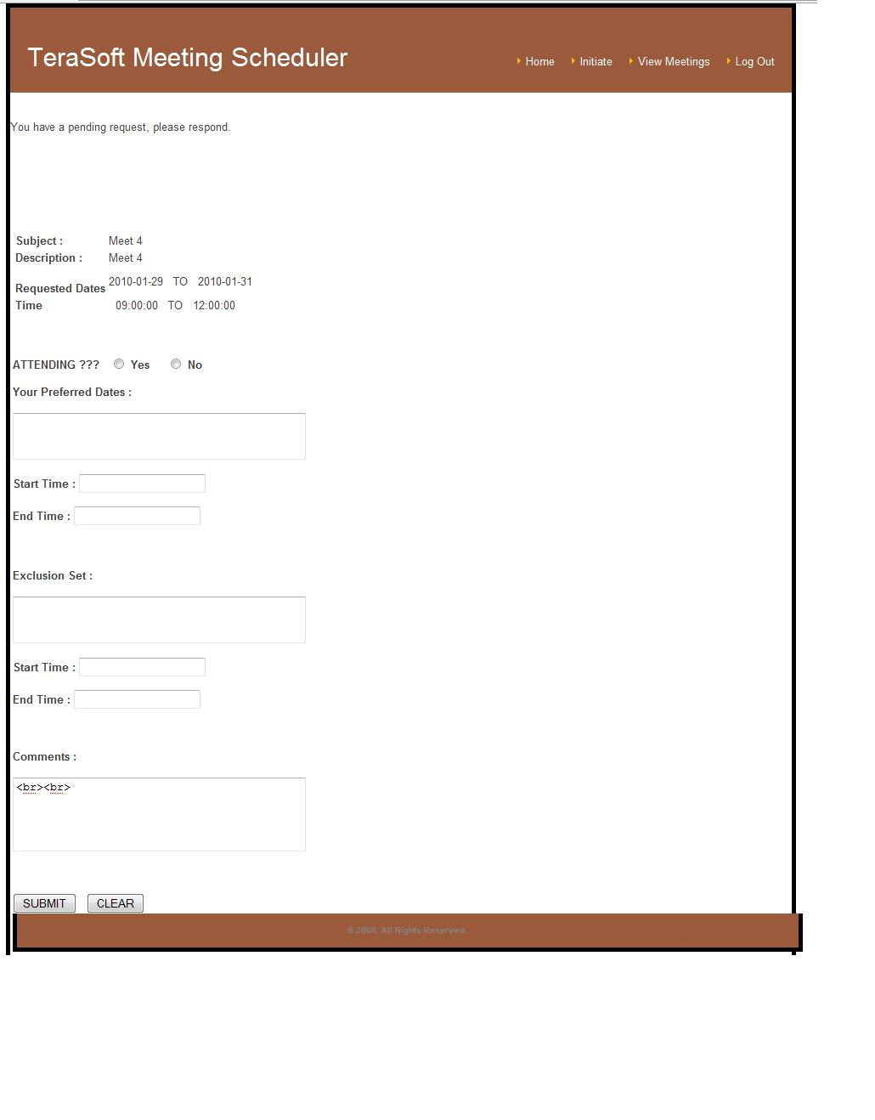
User can respond to any invited meeting. User can also proposed new timings and submit the request to the meeting initiator.
Screen 8: Update Meeting Page (Conflict Resolution)

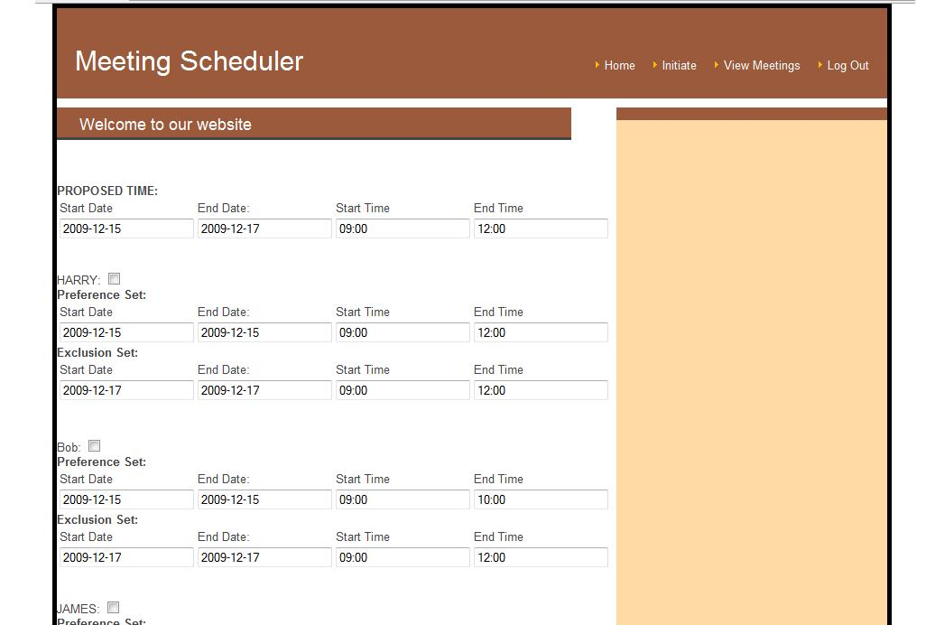

When meeting has been initiated and all the participants have responded, then Meeting initiator can respond to that meeting.

User can either Send an update on the page, or User can confirm the meeting or User can cancel the meeting.

Screen 9: Confirm Meeting

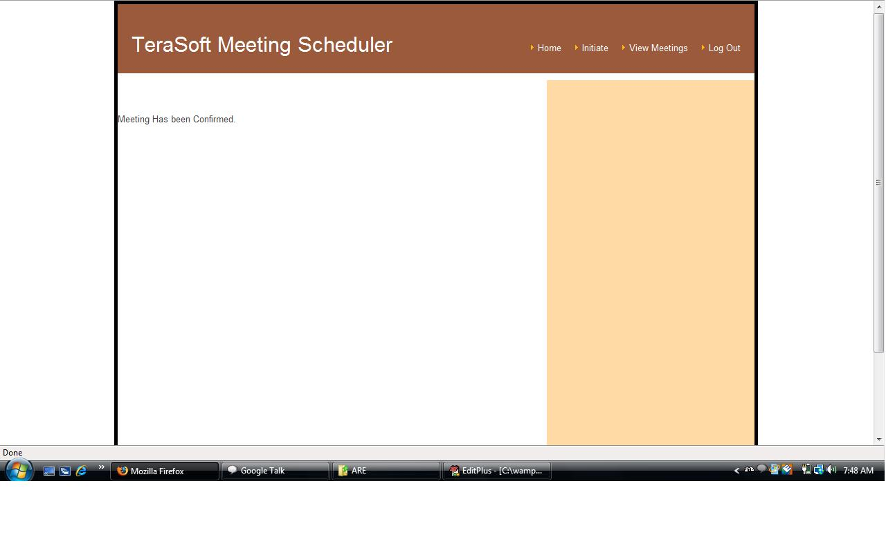

Once User clicks on Confirm on update meeting page, then meeting will be confirmed.

Screen 10: Cancel Meeting

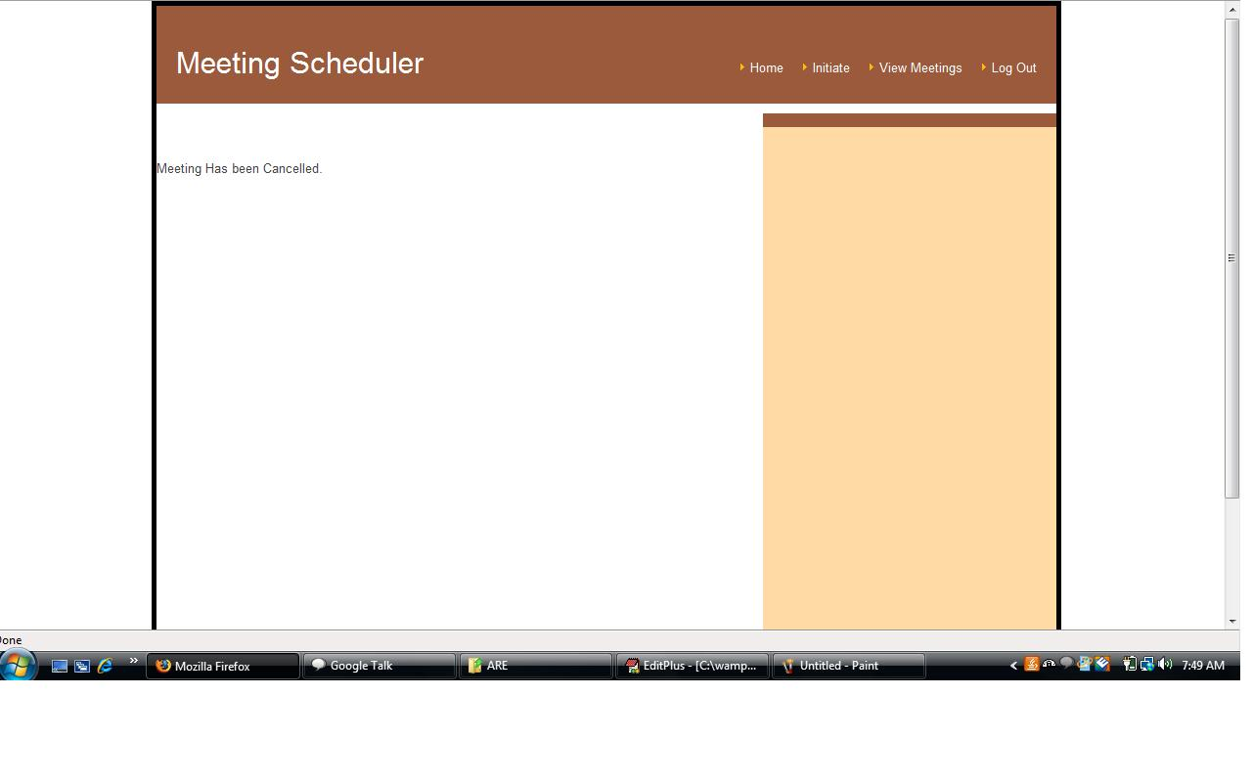

Once User clicks on Cancel on update meeting page, then meeting will be cancelled.

Screen 10: Logout

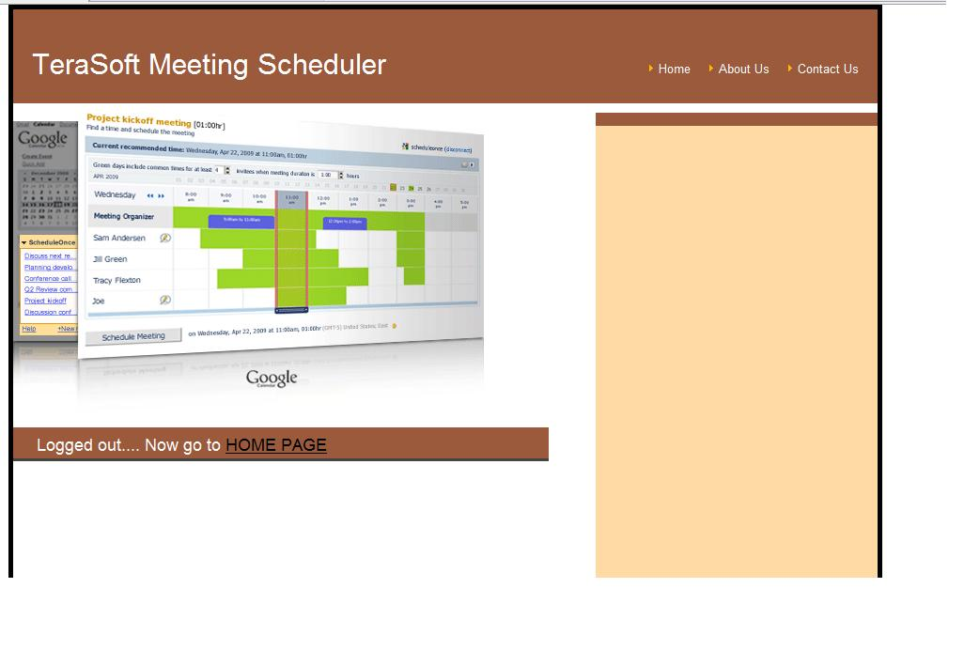

User can logout of the system by clicking on Logout Page.

