User Manual
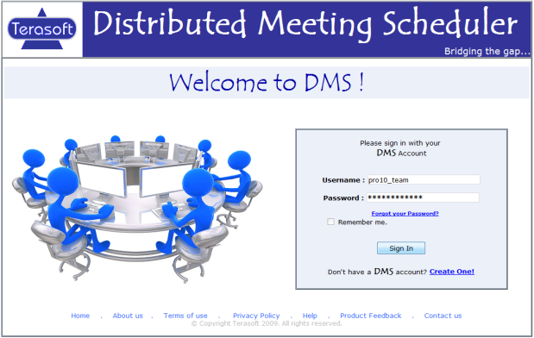
1. Login Screen:
This is the screen where users can log in to the DMS application. User has the option to set a new password incase he/she forgets the password and can optionally set the system to remember his/her login. New users also have an option to register.

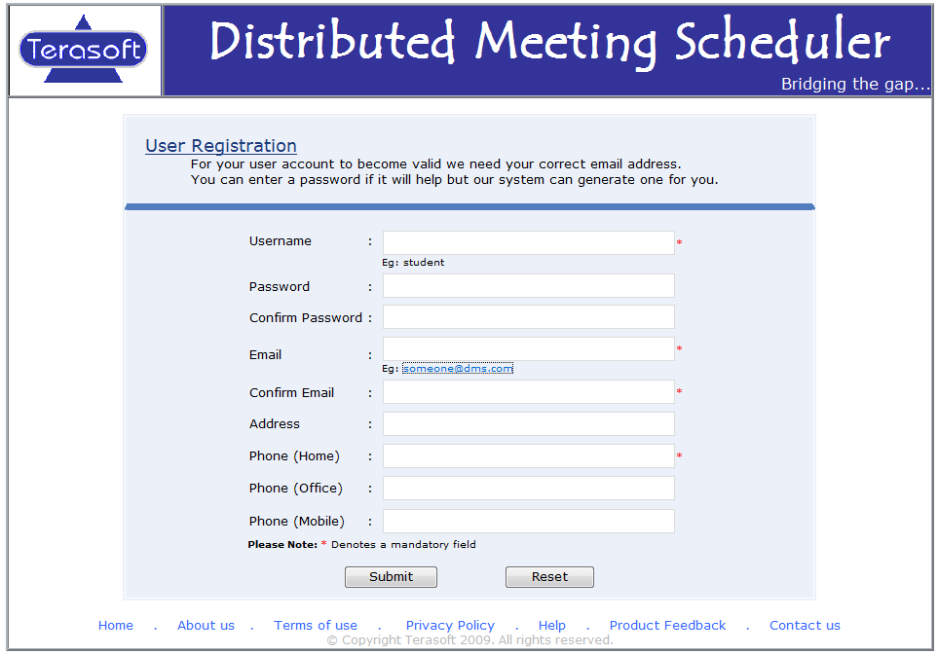

2. User registration:
In this page a new user can enter his credentials to create a new account with the DMS. The username, password and email are the only required fields.
The system can generate a password for the user if he/she prefers to do so and email it to the provided email id.
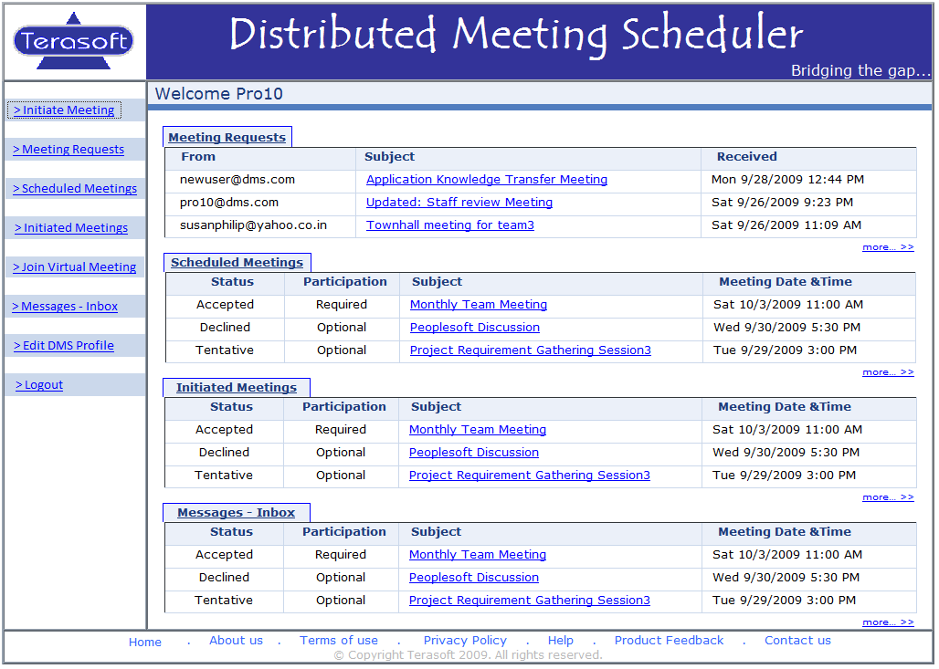
3. Home Page:
In the home page the user can view a snapshot his/her pending meeting requests, meetings scheduled, meetings initiated by the user and the messages in the inbox. Each of these can also be accessed independently from the left hand side menu items.

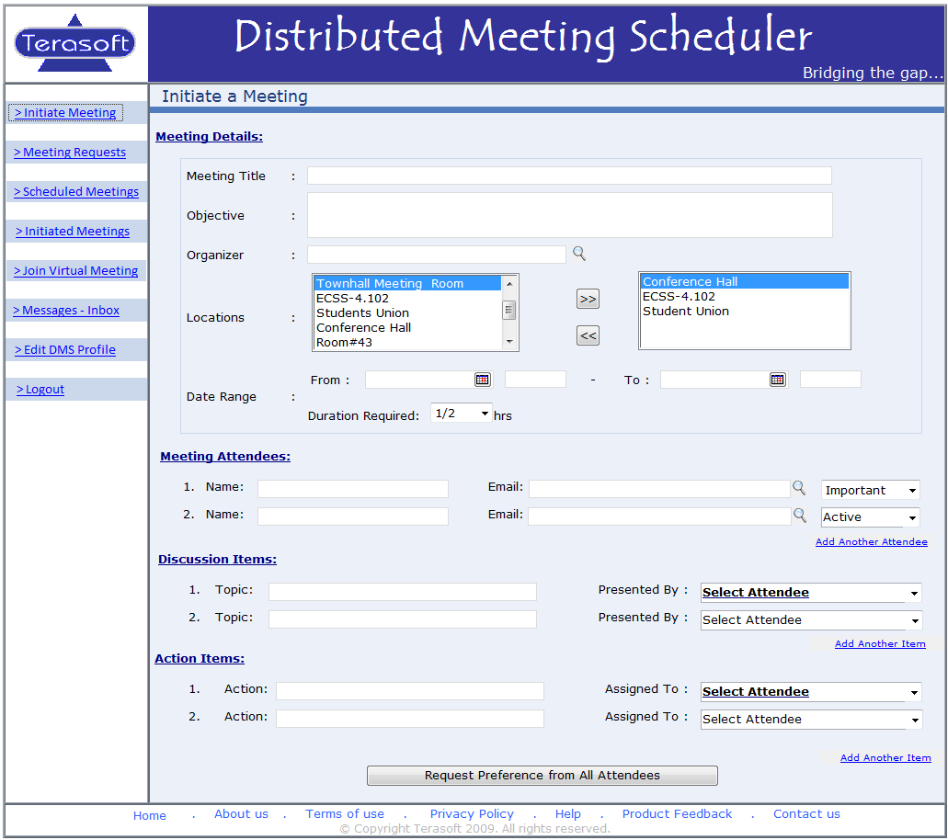
4. Initiate a Meeting:
Initiate meeting is the top most among the menu items on the left hand side of the DMS layout. This page allows a user to initiate a meeting after providing the required details like the meeting title, objectives, attendees, discussion and action items. The initiator can specify a date range and set of location for the attendees to select from. Then the initiator can request preferences from all attendees.
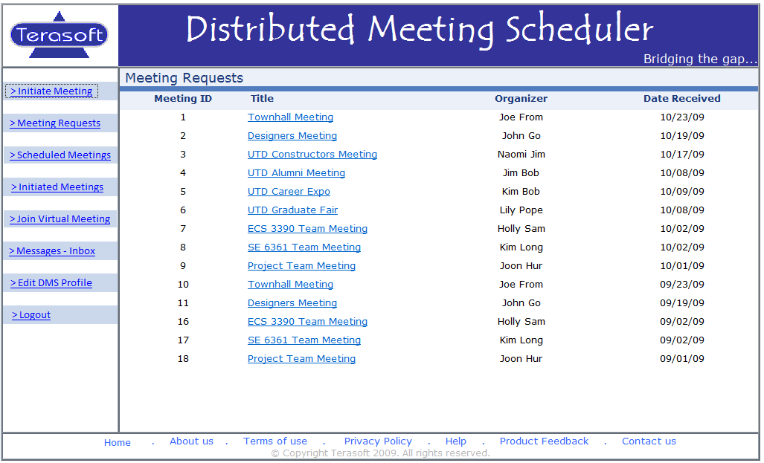
5. Meeting Requests:
The meeting requests page lists all the requests from different initiators for the users preference set to schedule the meeting concerned. This screen shows meetings the user has not provided a preference set for yet. The user can specify a preference set by clicking on the meeting title. From that screen, the user can specify the location (if he is an important participant), the dates she is available (for everyone), and/or the equipment required (for the active participants).

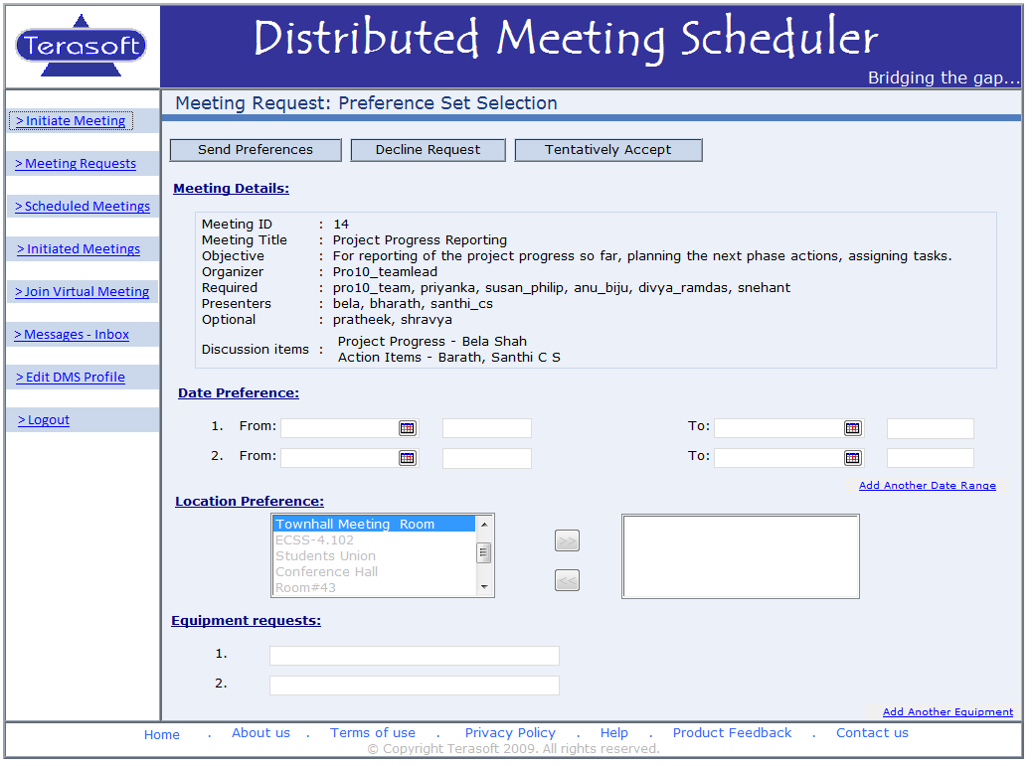
6. Preference Set Selection Screen:

Once the user selects a title from the Meeting Requests screen, the user comes to this screen. The user can view the details of the meeting and can decide if she wants to decline the request. If she decides to go to the meeting after viewing the details, then he can fill in the location, date, and time if he is an important participant. If she is an active participant, then she can fill in the date, time, and the required equipment. If she is an optional participant, then she can fill in the date and time. The user can only choose dates within the date range. After the user fills in the required information, the user can send the preference set.

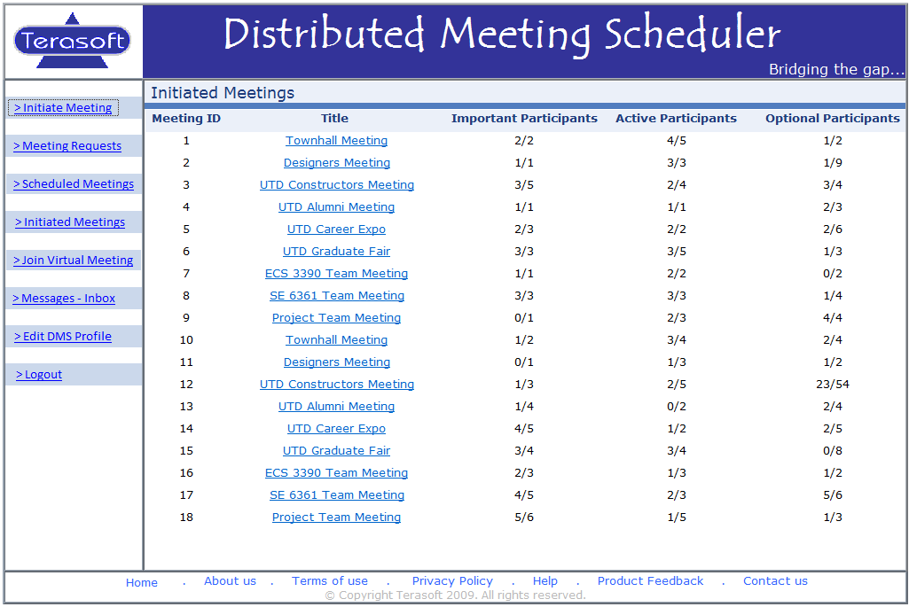
7. Initiated Meetings:

The meetings that have been initiated by the user will show up in this screen. Details that are shown on the screen are: meeting id, title, and the number of important participants, active participants, and optional participants that have sent a preference set. The user can click on particular title to get more details about the meeting. When the user clicks on a particular title, he is taken to another screen where she/he can confirm the schedule, cancel or change the meeting details.

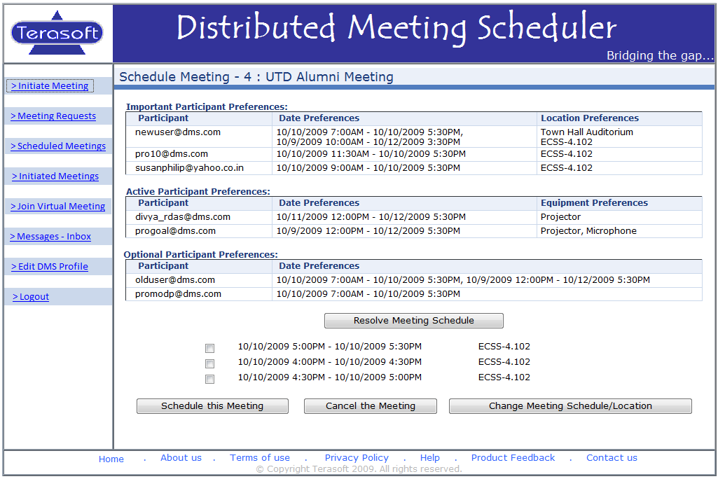
8. Schedule Meeting Screen
From the Initiated Meetings screen, the user can choose a meeting title and come to this screen if he initiated said meeting. The user can look at the preferences of the participants and ask the meeting scheduler system to resolve and find dates that the meeting can be on. From there, the user can choose a date and schedule the meeting. This will send a message to all participants. If the user wants to cancel the meeting due to a strong conflict, then the user can press Cancel Meeting.

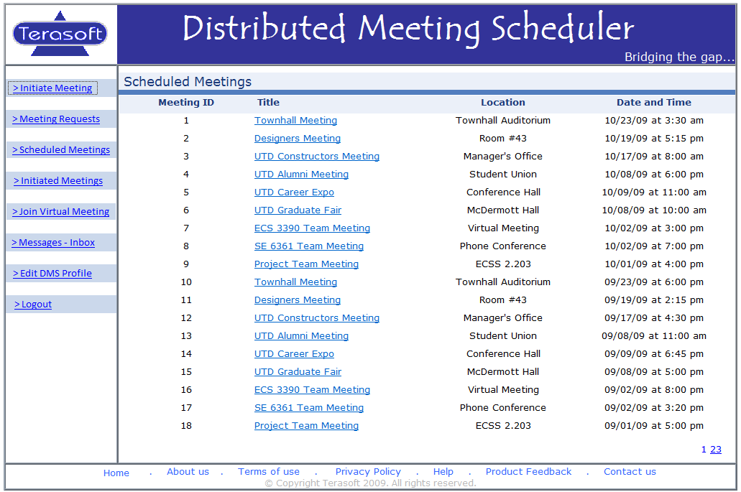
9. Scheduled Meetings Screen:

This screen shows the scheduled meetings for the user at a glance. The user can choose the meeting title and can change their preference set, location, or equipment requests from the screen that comes up.

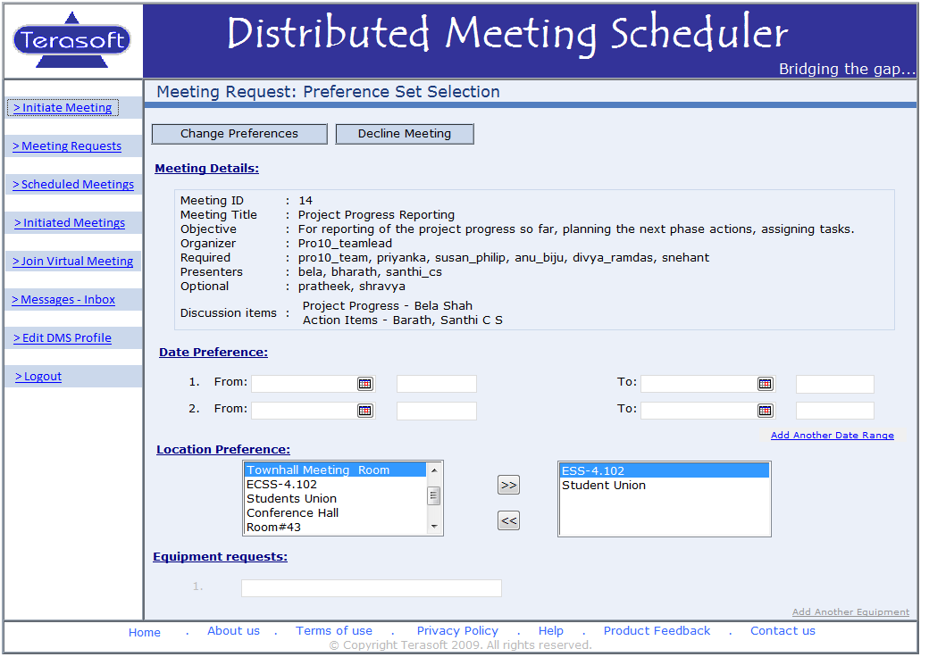
10. Change Preference Set Screen:

Once the user selects a meeting title from the Scheduled Meetings screen, the user comes to this screen. The user can view the details of the meeting and can decline the meeting if he cannot make it. The user can change the date preference, location preference, and equipment preference according to their level of importance. For example, an important participant can change location and date preference.

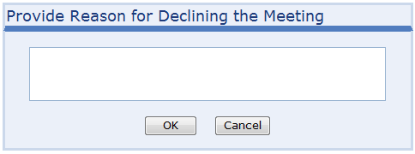
When a user opts to decline a meeting request during selecting of preference sets or at a later time, he/she has to provide a reason to the initiator as to why the request is being declined. This screen pops up whenever a user clicks on decline meeting or decline request.

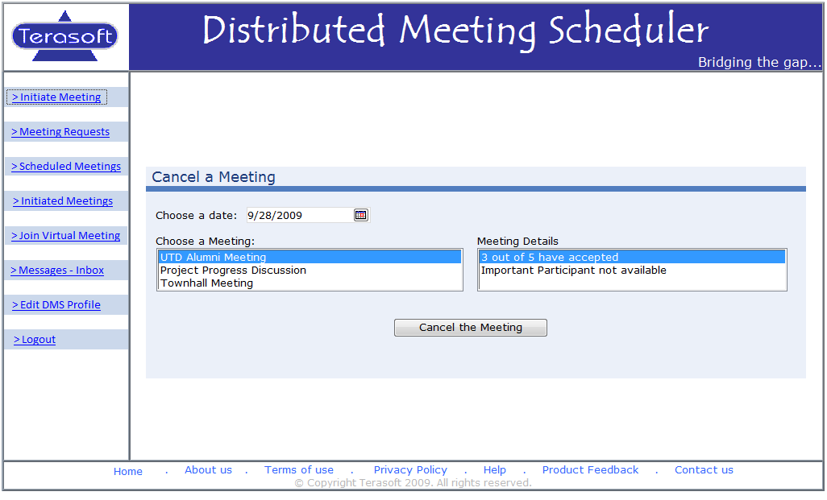
11. Cancel a Meeting:

A meeting initiator can decide to cancel a meeting at any time. The cancel meeting page allows the user to perform this operation. Only the meetings initiated by the user are shown in the listing. Also the list of meetings is populated based on the date selected. The initiator can also provide an optional reason as to why he/she is cancelling the meeting. A message is sent out to all attendees upon cancellation.

12. Virtual Meeting

Terasoft DMS supports virtual/web conferencing and sharing of desktop or selected applications during a monitored web conference. The below screens show the initiation of a web conference, desktop sharing using DMS virtual conference, and also application sharing options through it.

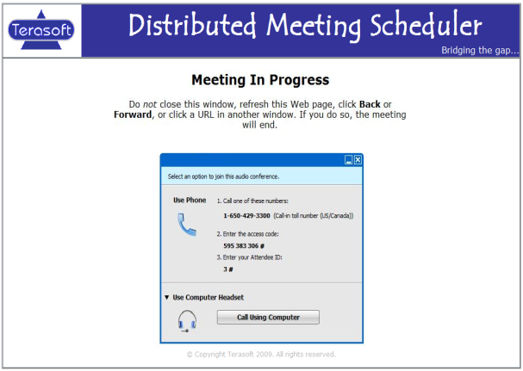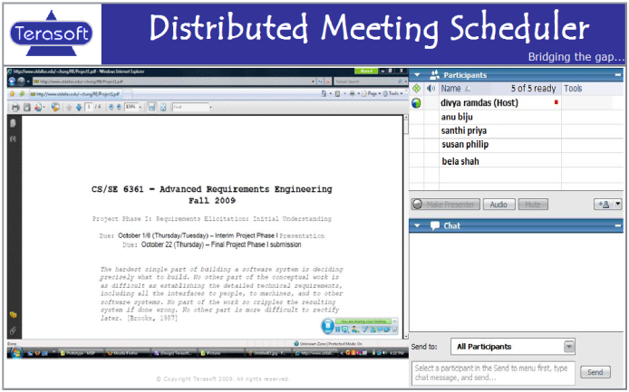
Meeting initiation Desktop Sharing

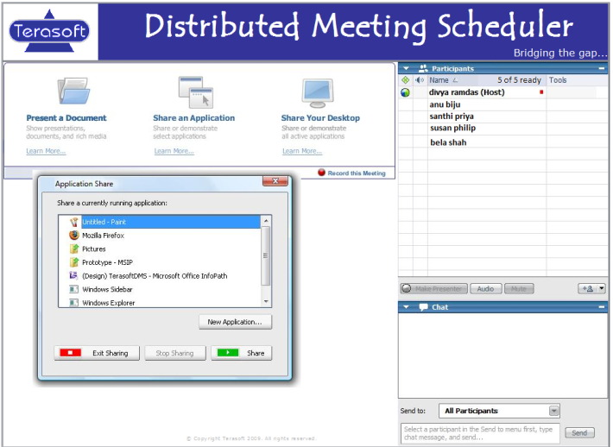
Application Sharing

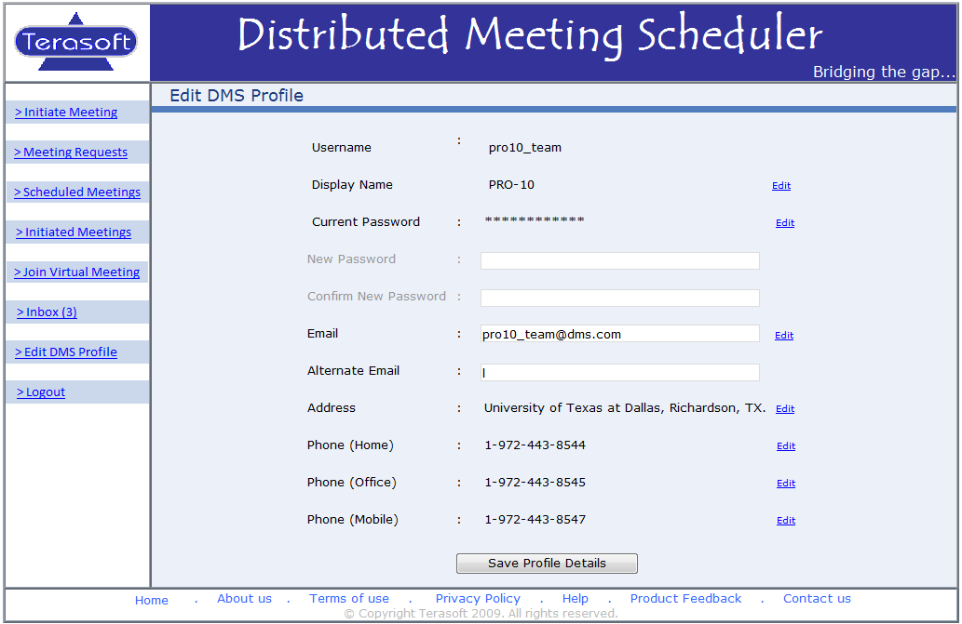
13. Edit DMS Profile:

DMS users can update and maintain their online DMS profile details using the edit profile screen. It provides option to change user password, screen name, email, address and phone.

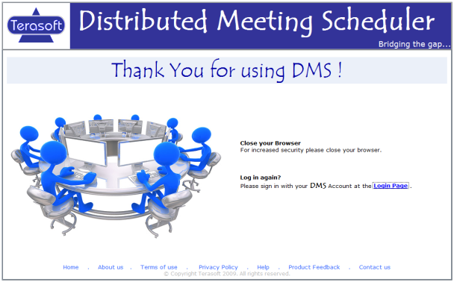

14. Logout Screen:

The screen users are taken to once they log off from the application. The user can go back to the login page from this page.

