Improved WRS Document
H.O.P.E.
Version 0.19
November 29, 2010

SE 6361.001 - Team Crutch
Ashley Pham alp084000@utdallas.edu
Blake Jensen blake.jensen@student.utdallas.edu
Caitlin Fowler cmf067000@utdallas.edu
Don Martin ddm033000@utdallas.edu
Eric Blackburn ejb022000@utdallas.edu
Frank (Zhenzhou Sun) zxs101020@utdallas.edu
Julie Rauer jrr053000@utdallas.edu
Justin Wilson jdw067000@utdallas.edu
Mohammad Al-Zinati mohammad.al-zinati@student.utdallas.edu
Zac Elsik zle041000@utdallas.edu

http://groups.google.com/group/utd-re-deliverables

Table of Contents
Table of Contents

Improved WRS Document 1
Table of Contents 2
1. Introduction 3
1.1 Project Overview 3
1.2 Version changes 3
2. Issues with Preliminary Definition Given 5
2.1. Customer Domain Requirement Issues 5
2.2. Customer Functional Requirement Issues 17
2.3. Customer Non-Functional Requirement Issues 34
3. WRS Improved Understanding 41
3.1. W: Problems and Goals 41
3.2. W: Domain 43
3.3. RS: Functional Requirements 48
3.4. RS: Non-Functional Requirements 52
4. Preliminary Prototype and User Manual 54
5. Traceability Matrix 57
6. Creeping Rate 57
7. Why our proposal is the best 58
Appendix A - Category Information 60
Appendix B - Prototype UML Diagrams 67
Appendix C - NFR SIG Diagrams 71
Appendix D - Traceability Matrix TM2.2 76
Appendix E - Transition Matrix 91

1. Introduction
1.1 Project Overview
As the elderly population grows, there is a growing need for tools that improve quality of living for members of this population. Difficulties with hearing loss, memory loss, and vision and speech impairment are common problems encountered by the elderly.
Team Crutch is developing a software application for Android cell phones that will mitigate the communication barriers faced by people with these deficiencies. The application will provide functionality that helps people with these disorders communicate with others and vice versa.
1.2 Version changes

Version | Changes | Date Modified
0.1 | Wrote introduction.  Began writing Domain Issues. | 09/02/2010
0.2 | Continued with Domain Issues. | 09/09/2010
0.3 | Continued Domain Issues.  Began FR Issues. | 09/11/2010
0.4 | Continued FR Issues. | 09/16/2010
0.5 | Continued FR Issues.  Began NFR Issues. | 09/23/2010
0.6 | Completed NFR Issues. | 09/25/2010
0.7 | Finished NFR Issues.  Began NFR Improved Understanding. | 09/25/2010
0.8 | Finished NFR Improved Understanding.  Finished Domain Issues.  Began Domain Improved Understanding.  Wrote “why out proposal is the best” and the creeping rate. | 09/28/2010
0.9 | Finished Domain Improved Understanding.  Finished FR Issues.  Began FR Improved Understanding. | 09/28/2010
0.10 | Finished FR Improved Understanding. | 09/29/2010
0.11 | Formatting and proofreading revisions. | 09/29/2010
0.12 | Converted word document into a Google Docs document | 09/30/2010
0.13 | Worked on adding and changing existing issues. | 10/12/2010
0.14 | Worked on adding additional issues.  Worked on “Why We’re Better” section. | 10/14/2010
0.15 | Worked on improving FR Improved Understanding wording.  Worked on operationalizing NFR’s.  Began work on improved category lists. | 10/19/2010
0.16 | Broke Improved Understanding FR’s down into more atomic units, integrated category lists. | 10/20/2010
0.17 | Implemented additional requirements in Issues and Improved Understanding. | 11/9/2010
0.18 | Added Appendix B - UML Diagrams  Added Appendix C – Traceability Matrix  Added Appendix D – Transition Matrix | 11/10/2010
0.19 | Added Appendix E – NFR SIG Diagrams  Updated Prototype Screen Shots | 11/29/2010
2. Issues with Preliminary Definition Given
2.1. Customer Domain Requirement Issues

2.1.1. Target Customer

Issue: The main target customer is not specifically stated.

Proposal 1: Target customer will refer to a person of age 65 and older. Elderly people will not be considered technologically savvy.

Proposal 2: Target Customer will refer to a person with a disability, regardless of age. These people will also not be considered technologically savvy.

Proposal 3: Target Customer will refer to a person with a disability that leads to difficulty with communication. Also, the target customer will not be technically savvy and will be over the age of 50. Younger ages will be considered as possible users if they are not technically savvy enough or have a severe enough disability that keeps them from using advanced communication devices, like the Proloquo2Go product.
Decision: The decision criteria are based on the need to have a niche population that has not been addressed by current communication aiding products. Currently technologically savvy and young, 30 years old and younger, have already been targeted by other products. The criteria are also related to the need for the HOPE product to serve a wide range of needs in order to keep the target audience large enough for sales, to support the development costs. Lastly and importantly, the target customer needs to represent a need for the product do to some inability to communicate because of a disability.

If a user is over 50 years old but not disabled then the HOPE system would not help them. The HOPE system is meant to aid the disabled that have difficulty with communication because of the disability. Proposal 3 addresses these points and keeps the target audience both wide and focused at the same time. By selecting a target audience that is less experienced with and/or able to use technology such as cell phones, the belief is that more advanced users are still considered as potential customers that can benefit from the device, even though they are not the target. As such, Proposal 3 has been chosen.

2.1.2. Disability Definition
Issue: “Disability” is an ambiguous qualification. The type and extent of disabilities need to be specified.
Proposal 1: The system will accommodate speech loss, hearing loss, vision loss, and memory loss, with further refinement of each disability defined clearly as sub issues.
Proposal 2: The system will accommodate speech loss, hearing loss, vision loss, memory loss, and motor difficulties, with further refinement of each disability defined clearly as sub issues. Reading disabilities will not be supported.
Proposal 3: The system will accommodate speech loss, hearing loss, vision loss, memory loss, motor difficulties, and reading disabilities, with further refinement of each disability defined clearly as sub issues.

Proposal 4: The system will only accommodate speech loss with its definition as a sub issue.

Decision: The decision criterion is the ability to assist the largest population possible.

Given the sub-issue decision criteria below, Proposal 2 has been chosen.

2.1.2.1 Speech Loss
Issue: “Speech loss” is an ambiguous qualification. The type and extent of disabilities that will be considered needs to be specified.
Proposal 1: The system will support speech impediments but not total speech loss or speech disabilities such as aphasia.
Proposal 2: The system will be built to support mute individuals as a lowest common denominator for speech disabilities. Users with speech impediments are assumed to be mute by the system.
Decision: The decision criteria are ease of implementation and the number of users supported.
Proposal 2 accounts for both speech impediments and mute individuals from the system’s view. Additionally, it will not require the system to implement support for varying degrees of speech loss. As such, Proposal 2 has been chosen.
2.1.2.2. Hearing Loss

Issue: “Hearing loss” is an ambiguous qualification. The type and extent of disabilities that will be considered needs to be specified.
Proposal 1: The system will support partial hearing loss but not total hearing loss.
Proposal 2: The system will be built to support deaf people as a lowest common denominator for hearing loss.
Decision: The decision criteria are ease of implementation and the number of users supported.
Proposal 2 accounts for both partial hearing loss and total hearing loss from the system’s view. Additionally, it will not require the system to implement support for varying degrees of hearing loss. As such, Proposal 2 has been chosen.

2.1.2.3. Vision loss
Issue: Vision loss is an ambiguous qualification. The type and extent of disabilities need to be specified.
Proposal 1: The system will support partial vision loss but not total vision loss.
Proposal 2: The system will be built to support blind people as a lowest common denominator for vision loss.
Decision: The decision criteria are ease of implementation and the number of users supported.
It is difficult for blind people to use a touchscreen device. As such, only partial vision loss will be supported. Proposal 1 has been chosen.
2.1.2.4. Memory Loss
Issue: Memory loss is an ambiguous qualification. The type and extent of disabilities need to be specified.
Proposal 1: Extreme short term memory issues (such as forgetting how to use the HOPE device while operating it) will not be supported. Moderate short term memory issues (such as forgetting the day of the week) and long term memory issues (such as remembering relatives or personal identification information) will be supported.
Proposal 2: Extreme short term memory issues and short term memory issues will not be supported, but long term memory issues will be supported.

Proposal 3: Extreme short term memory issues will be supported, as will moderate short term memory issues and long term memory issues.

Decision: The decision criterion is the ability for the user to use the product, and the total number of users supported.
Extreme short term memory issues cannot be supported, since the users will be unable to use the device. As such, Proposal 3 is not viable.
Proposal 1 supports more users than Proposal 2, so Proposal 1 has been chosen.
2.1.2.5. Motor Difficulties

Issue: Motor difficulties are not mentioned a possible disability in the customer’s requirements document.

Proposal 1: Users with fine motor difficulties (e.g. the ability to hold the phone and touch large buttons) will be supported. Users with gross motor difficulties (such as being unable to hold the phone steady or at all) will not be supported.

Proposal 2: Users with gross motor control problems will be supported, in addition to users with fine motor control difficulties.

Proposal 3: Motor difficulties will not be supported.

Decision: The decision criteria are the basic ability to use the system, difficulty of implementation, and number of users supported.

Proposal 1 will be implemented since fine motor control issues are more applicable to mobile phone use. While users with gross motor difficulties may not be supported, those users would not be physically capable of using the system.

2.1.2.6. Reading Disabilities
Issue: The inability to read text was not considered as a possible disability in the customer’s requirements document.
Proposal 1: Users will be required to be capable of reading text to use the system
Proposal 2: Users will not be required to be capable of reading text to use the system with the exception of the Blackboard feature, which uses text only.
Decision: The decision criteria are the basic ability to use the system and, difficulty of implementation, and the number of users supported.
Proposal 1 would be easier to implement. However, Proposal 2 would support a larger demographic. Since supporting the visually impaired is already one of the system’s goals, supporting users with reading disabilities will require similar features. The Blackboard feature will be helpful for the majority of the population without reading disabilities. Therefore, this specific feature will not be used by the population with reading disabilities. As such, Proposal 2 has been chosen.
2.1.3. Living Situation

Issue: The possible different context of living situations and the type of communication that will need to occur is vague.
Proposal 1: The HOPE system will support users who live with their family, alone, and in a hospital/nursing home setting. The different types of assistive persons who live in each area will be taken into account.

Proposal 2: The HOPE system will support users who live with their family, alone, and in a hospital/nursing room setting. Additionally, retirement centers will be considered as possible usage locations. The different types of assistive persons who live in each area will be taken into account.

Proposal 3: The HOPE system will assume that users live alone, as a lowest common denominator. All external communication will be general, instead of customized toward any particular living location. Assistive persons will not be assumed to be constant companions, as in a family or hospital/nursing home setting.

Proposal 4: The lowest common denominator of all of the living situations mentioned in Proposal 2 will be taken into account so that the application can be generalized to many living situations.

Decision: The decision criteria are time, reaching the largest audience, and having high validation returns for each living environment. Time and audience are weighted twice as much as environment validation.

Proposal 4 meets the most of the criteria by reducing development time. By implementing general features, less environment-specific features will be required, saving development time and keeping the system simple for the technologically-uneasy elderly population. Additionally, general features will address a large audience.
2.1.4. Daily Activities

Issue: The Daily Activities list in the customer requirement document is incomplete. It lacks a significant amount of typical activities that HOPE customers would need to communicate.
Proposal 1: The customer requirements document’s definition’s list of activities will be used. The team will ask for feedback from user about items they would like added in the future product releases.
Proposal 2: Users will define their own list of daily activities.
Proposal 3: The team will research likely activities by meeting with stakeholders and conducting brainstorming/internet research sessions. Add as many of those activities early in the development of the product.
Decision: The decision criteria include development time, the number of activities available, and the ability for customers to communicate daily activities.
Proposal 3 meets all three requirements. The other proposals either are too narrow in scope or would take too long to implement early in the development process of the application.
2.1.5. Assistive Person

Issue: Whether an assistive person will use the HOPE device directly is not clearly stated.
Proposal 1: Assistive persons will use the system to communicate with the elderly. The use of icons will help elderly people understand what the assistive person is trying to communicate.
Proposal 2: Assistive persons will interact with the system to set up advanced features that are too complicated for elderly users to initialize. They will also interact with the system to use the Blackboard feature.
Proposal 3: Assistive persons will not be expected to use the HOPE device.

Decision: The decision criteria are development time, usefulness of the system for assistive persons, and the complexity of the system as presented to the elderly users.

Proposal 1 will not be implemented since the assumption is that the users have difficulties communicating with the outside world, and not that they have difficulties comprehending what assistive persons are trying to communicate to them.
Proposal 2 has been chosen since some features would require a lot of additional effort to make them simple enough for elderly users to set up or use. It will be easier to implement complicated features that assistive persons are expected to set up or use if those features are not intended for the elderly person to be able to use. The assistive person also needs to interact with the system to use the Blackboard feature in order to communicate with the disabled person.
2.1.6. Greetings

Issue: The list of possible greetings is incomplete.

Proposal 1: The system will only implement the greetings listed in the preliminary definition.

Proposal 2: The development team will perform brainstorms and online searches for common terms.

Proposal 3: The development team will meet with identified stakeholders and monitor greeting uses, and include those heard by 50% of population observed.

Proposal 4: The development team will validate brainstormed greetings with stakeholders, looking for new additions to the list in the process.

Decision: The decision criteria are development time, project scope, and likelihood of use.

Proposal 4 utilizes the best elements of Proposals 2 and 3. By creating a list beforehand and using that to validate the core needs of the stakeholders, the brainstormed list can be validated and refined.
2.1.7. Multi-Dimensional Vocabulary

2.1.7.1. Pictures

Issue: What constitutes a picture is not defined.

Proposal 1: A picture is taken using a camera on the phone or outside of the phone and later added to the phone.

Proposal 2: A picture is a clip art type image or drawing.

Proposal 3: A picture is either taken with a camera, is clip art, or a drawing.

Decision: The decision criteri is the ability to distinguish the term “picture” from the term “icon”.
Proposal 1 meets the criteria fully. Pictures will photographs of the real world.
2.1.7.2. Icons

Issue: What constitutes an icon is not defined.

Proposal 1: An icon is a clip art cookie cutter type image or drawing.

Proposal 2: An icon includes images taken with a camera.

Decision: The decision criterion is the ability to distinguish the term “picture” from the term “icon”.

Proposal 1 meets the criteria fully. Icons will be computer graphic drawings.

2.1.7.3. Speech
Issue: Speech is not defined in the customer requirements document. Criteria such as the language, accent, and loudness are not stated.

Proposal 1: Assume that system generated speech is in English, using a mid-eastern American accent. Volume will be controlled by the phone settings.

Proposal 2: Allow any language, and have volume controlled by the phone settings.

Proposal 3: Assume that system generated speech is in English, and let third party applications alter the accent. Volume will be controlled by the phone settings.

Decision: The decision criteria include development time and project scope.

Proposal 3 meets all of the criteria, and will be easiest to implement.

2.1.7.4. Text
Issue: The size, colors, and fonts for text are undefined.
Proposal 1: Allow the size, color, and fonts to be customized.
Proposal 2: The system will use black fonts on light backgrounds, provide small medium and large size options, and use non serif fonts.
Decision: The decision criteria include development time, readability, and layout organization.

Proposal 2 meets the need for quick implementation by providing a controlled display size of the text. The controlled variables facilitate the delivery of a clean layout. Proposal 1 would be too complicated for the elderly users. As such, Proposal 2 will be implanted.
2.1.7.5. Sign
Issue: What constitutes a sign is not defined.
Proposal 1: “Sign” refers to sign language.
Proposal 2: “Sign” refers to alert signs like road signs, hazard symbols (toxic, poison, etc.), and notification signs (such as exit signs in hallways).
Proposal 3: “Sign” is identical to “icon” and should be removed from the domain.
Decision: Decision criteria include reducing redundancy and keeping the project scope manageable.

Proposal 3 has been chosen since a sign language feature will not be implemented. As such, “sign” and “icon” can be used synonymously and “sign” will be removed from the domain.
2.1.8. Other Activities

Issue: The other activities have not been defined as needed.

Proposal 1: Only consider the activities listed in the Preliminary Definition: watching TV, drinking Cola, explaining that customer is not feeling well, asking for a person’s name, asking where the customer is, washing, taking a bath, going to the restroom, eating/drinking, walking, transferring to the bed, saying hi, saying bye, saying sorry, and expressing that it was nice to meet someone.

Proposal 2: The development team will brainstorm a list of other possible activities, and validate the list with customers in order to elicit more activity options along with determining appropriate activities to incorporate into the application.

Decision: Decision criteria are focused on how well the end system reflects the activities that customers will need to communicate about.

Proposal 1 seems to cover many basic activities, but doesn’t cover other possible activities like wanting the temperature in the room changed. Proposal 2 provides the means to better satisfy the validation criteria. Therefore, Proposal 2 shall be chosen.

2.1.9. Emergency Situations

Issue: Possible emergency situations have not been defined.

Proposal 1: Consider all emergencies as one unified topic that requires the 911 to be called. Do not differentiate between different situations and types of emergencies.

Proposal 2: Identify three major categories of emergencies: Fire, Medical, and Police.

Proposal 3: Identify three major categories of emergencies: Fire, Medical, Police. Also, identify subcategories for each. Fire: Grease, House, Small, Large, Grass. Medical: Heart Attack, Fallen and Can’t Get Up, Stroke, Bleeding. Police: Lost, Theft, Assaulted, Car Crash.

Decision: Decision criteria include development time and the time taken to identify the appropriate emergency category. Also, identifying the reason for the emergency is important in order to get the correct emergency personnel to the customer.

Proposal 1 is perceived to be too general though it would be quick to implement. Proposal 3 is possible too specific and would require too many decisions in a time of panic. Also, proposal 3 has the longest development time of the listed proposals. Proposal 2 aims to strike a balance between the other two proposals. Proposal 2 provides specifics concerning the emergency while providing the ability to quickly identify and select the provided options. Therefore, Proposal 2 shall be chosen.

2.1.10. Usable

Issue: The customer requirements document states, “the system should be easily usable by the assistive person…” This is a non-functional requirement, not a domain issue.

Proposal 1: Address this part of the customer requirements document in the non-functional requirements issues section.

Proposal 2: Address this part of the customer requirements document in the domain issues section.

Decision: The decision criterion is making the improved understanding document organized and understandable.

Proposal 1 shall be chosen since the issue being discussed is a non-functional requirement, not a domain issue. (See 2.3.1.)
2.1.11. Search

Issue: The customer requirements document states, “providing a good search interface …” This is a functional requirement, not a domain issue.

Proposal 1: Address this part of the customer requirements document in the functional requirements issues section.

Proposal 2: Address this part of the customer requirements document in the domain issues section.

Decision: The decision criterion is making the improved understanding document organized and understandable.

Proposal 1 shall be chosen since the issue being discussed is a functional requirement, not a domain issue. (See 2.2.3)

2.1.12. Navigation of the System

Issue: The customer requirements document states, “A sentence should be generated by a minimum amount of navigation of the system.” This is a non-functional requirement, not a domain issue.

Proposal 1: Address this part of the customer requirements document in the non-functional requirements issues section.

Proposal 2: Address this part of the customer requirements document in the domain issues section.

Decision: The decision criterion is making the improved understanding document organized and understandable.

Proposal 1 shall be chosen since the issue being discussed is a non-functional requirement, not a domain issue. (See 2.3.4).

2.1.13. Platform

Issue: The customer requirements document does not specify a platform for the system to run on.

Proposal 1: The HOPE system will be developed for the iPhone.

Proposal 2: The HOPE system will be developed for the iPhone with a separate iPad version.

Proposal 3: The HOPE system will be developed for Windows Phone 7.

Proposal 4: The HOPE system will be developed for Android.

Proposal 5: The HOPE system will be developed for both the iPhone and Android.

Decision: The decision criteria are development time, userbase size, and ease of use.

Proposal 4 will be chosen because Android it’s easier to develop for than the iPhone, and it has a wider userbase than the iPhone. Android phones are easier for elderly users to obtain since all major U.S. cell phone carriers have them, so even if the elderly user is tied into their relative’s family plan, they will still have access to the device. The Android version will also be portable to Android tablets coming out

Additionally, developing for both the iPhone and Android (or iPhone and iPad) would require too much development time for the scope of this project.

2.1.14. Questions

Issue: The list of possible questions is incomplete.

Proposal 1: The system will only implement the questions listed in the preliminary definition.

Proposal 2: The development team will perform brainstorms and online searches for common terms.

Proposal 3: The development team will meet with identified stakeholders and monitor question uses, and include those heard by 50% of population observed.

Proposal 4: Add an option to the end screen that allows the phrase to be stated as a question rather than a declarative statement.

Decision: The decision criteria are development time, project scope, and likelihood of use. In further consideration of development and most importantly, the implementation of questions should require a small amount of space in relation to the rest of the Hope application.

Proposal 4 best addresses the need to limit the increase in size caused by adding questions that will be closely associated with the same statements that are declarative in the application. For example, “I want to take a bath” can be made into a question “Can I take a bath?” and both can be accessible on the same end point screen. Proposal 4 shall be chosen.

2.2. Customer Functional Requirement Issues

2.2.1 Proper Categories
Issue: What makes a category “proper” is not defined.

Proposal 1: A proper category is defined by consensus of the Requirement Engineers.

Proposal 2: Proper categories are defined, proposed, and approved by 50 percent of the stakeholders after a presentation by the Requirements Engineers.

Proposal 3: Types of categories will not be addressed.

Decision: Criteria include time, taking into account categories that shall be commonly used by customers, and the scope of the project.

Proposal 2 takes into account time and likelihood of customer utilization. The time goal is to produce a work product by December 20.

2.2.2. Various Dimensions of Vocabulary

Issue: “Various dimensions of vocabulary”, as stated in the Preliminary Definition is ambiguous.

Proposal 1: Assume that the statement refers to Icons, Text, Pictures, and Speech.
Proposal 2: Assume that the statement refers to nouns, verbs, and pronouns.
Decision: Criteria include time and scope.

Proposal 1 takes into account both criteria while also maintaining consistency with the domain criteria that defines multi-dimensional vocabulary.

2.2.3. Search

Issue: How search will be implemented is not stated.
Proposal 1: Let advanced users select a search icon, which will bring up a text input field. As they type, all related vocabulary items will appear as query results. These results can be categories, completed sentences, or contacts.
Proposal 2: Have the same query returns as Proposal 1, but allow users to search the system with voice input in addition to text input. Note: this is automatically supported in Android 2.2 and higher.
Proposal 3: Do not implement a search function.
Decision: Proposal 3 has been chosen since advanced users will not be expected to use the system to communicate with vocabulary terms. They are only expected to use the system to use advanced features. (See 2.1.5)
2.2.4. Navigation - Forward
Issue: How the users will select categories to navigate through the system is not stated.

Proposal 1: Category icons will be pressed.
Proposal 2: Category names will be spoken into the phone.

Proposal 3: Category shall be typed.
Decision: Criteria include usability of the navigation for the target audience.

Proposal 1 shall be implemented. Touch icons accommodate the lowest common denominator of the target audience. Blind users and users with moderate to gross motor difficulties are not supported.

Additionally, speaking names would not be optimal for mute users and typing names would be too complex for the target audience.
2.2.5. Navigation - Back
Issue: How the users will go back through the system is not specified.

Proposal 1: Only the standard Android back button will be used.
Proposal 2: Both the standard Android back button and software touch back buttons will be used.

Decision: Criteria include usability of the navigation for the target audience.

Proposal 2 is a superset of proposal 1, and will aid users whose Android phones have small back buttons which may be hard for an elderly user to press. As such, Proposal 2 has been chosen.
2.2.6. Icon Navigation
Issue: The number of icons visible at once is not stated.
Proposal 1: Users will be able to swipe vertically to view additional icons.
Proposal 2: All available icons will be displayed at once.
Proposal 3: Users shall have control over the number if icons displayed at once. Vertical swipes will allow users to view additional icons.
Decision: Criteria include optimizing visibility of icons and usability for users with fine motor control problems.

Proposal 1 best meets the specified criteria. Larger icons are easier to press and find, which takes into account visibility and usability.

2.2.7. Sentence Generation

Problem: How sentences will be generated is not stated.

Proposal 1: Whole sentences shall be selected after navigating through categories to designated end points. Qualifying options at end points will change the tense of generated sentences, and change them from statements to questions.

Proposal 2: Sentences will be constructed by appending phrase components. These sentences will be represented as a row of images, where each image refers to a phrase component. Phrases shall be fragments such as “I want to”, “take”, “cold”, “bath”, “now”

Decision: Criteria include development time and simplicity of the system.

Proposal 1 meets the specified criteria by providing a simple and consistent method of sentence generation. This method is also optimal for development purposes. Dynamic sentence creation also provides flexibility and easy usability for the target audience.
2.2.8. Emergency

2.2.8.1. Emergency List

Issue: Types of emergencies that will be accommodated are not stated.
Proposal 1: Fire, medical, and police emergencies will be addressed:
Proposal 2: Stakeholders will be surveyed for a possible list of emergencies.

Proposal 3: Provide 1 generic emergency that correlates to all possible emergencies.
Decision: Providing life-saving help in critical situations, time to implement, and scope of the project are the criteria.

Proposal 1 provides specificity of the emergency situation while keeping time to implement done. By being specific about the emergency and keeping the interface simple at the same time, Proposal 1 is the best meets the criteria.

2.2.8.2. Emergency Reaction

Issue: The response of the emergency button is not specified.

Proposal 1: A text will be sent to family, friends, and other specified emergency contacts.

Proposal 2: Emergency button will dial 911.

Proposal 3: Call 911 with a general message that replays to the 911 operator.

Proposal 4: Call 911 with a specific message that replays to the 911 operator.

Proposal 5: Pressing the emergency button will display a new screen. The top third of this screen will be a general emergency button that dials 911. The bottom two thirds of the screen will display three icons for calling the police, fire department, or medical services. Relatives will be sent a text message when any of the buttons in this screen are pressed.

Decision: The ability to get the help needed for the phone and provide different levels of emergencies that coordinate with the decision in 2.1.10 are the criteria.

Proposal 5 combines the best elements of Proposal 1, 3, and 4. As such, Proposal 5 will be implemented.

2.2.9. Meaning

Issue: How meaning will be given to icons to reduce ambiguity is not stated.
Proposal 1 Text labels will be provided below each icon. The text labels can be customized for each icon via the “Relabel Icons” feature under “Menu”.

Proposal 2: Audio will be provided for an icon after performing a 1-second long press on an icon.
Proposal 3: Self-explanatory images will be provided.
Decision: A combination of proposal 1 and 2 will be chosen. This will provide support for deaf users and users with vision problems and also allow users to assign their own meaning in order to easily remember icons.

2.2.10. Color

Issue: Color options are not addressed.
Proposal 1: Design engineers determine the appropriate color schemes that will be available.
Proposal 2: The background colors can be changed by the user using a gradient bar of the 3 primary colors.
Proposal 3: Participant’s preference and exclusion sets will be loaded from an external corporate database that contains all employee schedules.

Proposal 1 meets the time requirements and allows for design engineers to understand the environment of the applications layout. This allows them to create a more generally acceptable visual interface for the target audience. Providing too many options is not optimal for elderly customers.
2.2.11. Icon Size

Issue: Icon sizes are not specified in the customer requirements document.
Proposal 1: There will be 6 category buttons visible at once, taking up 3/4 of the screen. This will help users push the buttons, find the correct buttons, and see the button icons clearly. This will aid users with moderate motor difficulties and moderate vision issues. Regular selection buttons will be half as tall and just as wide as an icon.
Proposal 2: Users will be able to set their own icon sizes, with the default layout following Proposal 1. This would be an advanced person for assistive persons (See Domain Issue 2.1.5 - Assisting Person). This feature would help users find the icon size that fits their level of vision loss best, and would be a useful feature for Android devices with different screen sizes.
Decision: Criteria include usability and which solution will be most helpful for the target audience.
Proposal 2 would make the system more usable after adjustment. If the user does not wish to customize the icon size, the default size of 6 icons per screen is in place. However, this feature gives the user the option of changing the icon size in the case that the default size is not preferred.

2.2.12. Integrating Already Available Technologies

Issue: The technologies that will be integrated are not stated.

Proposal 1: An alarm clock and calendar from existing Android features will be integrated.

Proposal 2. Speech to text and text to speech Android Technologies will be integrated

Decision: The decision criteria are relevance to the user, usability, and development time.

External technologies such as alarm clocks and calendars are not central toward facilitating communication for the elderly. They’re extraneous features that would take additional development time. While they would add value to the system, this value is not directly related to communication. However, the text to speech and speech to text features are valuable to our target audience and already provided by Android. As such, Proposal 2 shall be chosen - no external android Applications will be integrated.
2.2.12.1. Meaningful Technology Integration

Issue: The customer requirements document mentions: “Integrating already available technologies … in a meaningful manner.” “Meaningful manner” is an ambiguous phrase.
Proposal 1: Survey the target population on the uses that integrated technology will likely serve. Implement uses that occur 30-50% of the time, with requirements engineers deciding if implementation suits time constraints
Proposal 2: Analyze daily activities, questions, and greetings to find potential areas of application for integrated technologies. The integrated technology will cooperate with and support that application functionality. Only technologies that are applicable to our target audience will be implemented.
Decision: Development time, scope, and domain knowledge are decision criteria. Having to become domain experts about the use of every integrated technology is too time consuming for a iterative development process moving at our current development pace and within our stated deadlines.
Proposal 2 allows for the stated requirements gathering. Furthermore, this keeps the scope of the integrated technologies focused on the requirements aimed at improving communication.
2.2.13. Displaying Relevant Items Before Other Items

Issue: Displaying relevant items before other items may confuse elderly users.
Proposal 1: Display relevant items within a category before other items.
Proposal 2: Don’t display relevant items within a category before other items.

Decision: The decision criterion is making the system understandable by elderly users.
Since changing the order of icons in a category, especially without the user’s explicit input, will only confuse non-technologically savvy users. As such, Proposal 2 has been chosen. The icon order and display shall remain static.
2.2.13.1. Relevant Items vs Most Frequently Used Items

Issue: “Relevant” is not defined.

Proposal 1: Relevant is equivalent to most frequently used. They are synonyms.

Proposal 2: Relevant means displaying items that belong in the currently selected category.

Proposal 3: Relevant items will change according to the time of day and day of the week, suggesting actions to users in accordance with their past selections at that time. The suggested item could appear in a special part of the screen to keep it away from normally selected items.

Decision: The decision criterion is ease of use by elderly users and implementation time.

Proposal 1 is the easiest for an elderly user to understand, and to implement. Proposal 2 is already an assumption of the category system of navigation, and would make relevant a meaningless, redundant term if chosen.

Proposal 3 would either confuse users by making new selections available, or help them remember selections they should make. Proposal 3 also conflicts with the favorites feature, and will not be useful if the user does not follow a rigorous schedule.

As such, Proposal 1 has been chosen.
2.2.14. Repeating Sentences

Issue: What previously generated sentences will be available and why those sentences are selected is not specified.
Proposal 1: A list will be provided from a button on the home screen of 10 or less most recently generated sentences. Selecting a sentence from the list will keep that sentence on the list.
Proposal 2: A list will be provided from a button on the home screen of an unlimited number of previously generated sentences. Selecting a sentence will keep it on the list.
Proposal 3: User selected favorite sentences will be available in a “Favorite” section from the main screen. In addition, users will be able to repeat any of the 25 most recently generated sentences by clicking on the “Recents” icon from the main screen.
Proposal 4: On an end point screen, once a completed phrase has been constructed, there is a speak button which will allow the user to have the system speak the repeated phrase again.
Decision: The decision criteria are usability by the elderly audience.
Proposal 3 will be implemented in order to allow users to manually pick sentences that they would like to repeat and access sentences that they recently generated. The recently generated sentences will also be available for easy access to recent phrases. This can help users with short term memory issues, as phrases also give clues to activities performed throughout the day.

2.2.15. Additional Features

Issue: The preliminary definition document leaves room for additional, unspecified features unrelated to communication.

Proposal 1: A Magnifying glass feature will be included. Users will be able to point to an object on the screen after selecting this option, and that selection will be displayed at twice its original size.

Proposal 2: A Fall detection feature will be implemented. If the phone has a gyroscope, it will attempt to detect quick, long falls. After the detection, the phone will state that it will call for help in 20 seconds.

Proposal 3: A GPS tracking feature will be included in the application. Relatives and individuals with authorization will be able to access the user’s current location.

Proposal 4: No additional features will be implemented.

Decision: Decision criteria include time and effort to develop and relevance to the user.

Proposal 4 will be implemented because the other proposals do not fulfill the system’s goal of facilitating communication with the elderly. Adding unnecessary and unrelated features may confuse elderly users who desire simplicity.
2.2.16. Interacting With Icons

Issue: The customer requirements document is incomplete. Some features are not discussed.

Proposal 1: When an icon is held for 1 second, the Android text to speech application will state the name of the icon function out loud. This feature is called “long press”.
Proposal 2: When an icon is touched, text to speech application will state the name of the icon out loud.

Proposal 3: There will be no support for text to speech

Decision: Criteria include usability and relevance of the function to hearing impaired users.

Proposal 1 will be implemented because it provides a helpful, but not excessive amount of text to speech activity. Proposal 2 would create the risk of the user unintentionally using the text to speech function and proposal 3 provides no support at all.

2.2.17. Home Screen Layout

Issue: The contents of the home screen were not defined.
Proposal 1: The following categories will be provided:

  - Speak (contains categories for communicating via sentence generation)
  - Emergency (contains emergency contact options)
  - Favorites (contains some of the most used phrases)
  - Contacts (contains list of customer defined important contact information with pictures)
  - “Recents” (contains the most recent 25 sentences generated),
  - The 6th button would be Me (which would contain simple information about customer that can be selected and spoken by the application)
Additionally, the day of the week will be displayed at the top of the screen to aid users with memory loss issues. The name of the week will be spoken aloud when touched.
Proposal 2: Only the Speak and Emergency categories will be provided.

Proposal 3: The home screen will contain all of the categories that would have been inside the Speak section, in addition to having Emergency, Favorites, Contacts, Recents, and Me categories.

Decision: The decision criteria are keeping the home screen simple while supporting extensive functionality.

Proposal 1 keeps the home screen simple by only having 6 large icons on the screen. Given the icon size requirement in 2.2.4, it will be possible to see all six at once. Proposal 2 lacks as many options as the other proposals, and Proposal 3 provides too many options to fit on the screen at once.

2.2.17.1. Speak Category

Issue: The contents of the Speak section need to be defined.
Proposal 1: The speak section will include category icons for Hygiene, Greetings, Feelings, Activities, Health and Simple Answers category.

Proposal 2: The speak section will include the same category icons as Proposal 1, but the customer can add more custom categories.

Decision: The decision criteria are keeping the system simple. To this end, using big icons with less than 6 observable at a time is important. This will reduce the difficulty of finding and selecting categories for the visually and motor impaired.
Proposal 1 meets the criteria and has been chosen. Proposal 2 would provide too many options for the elderly user.
2.2.17.2. Contacts Category
Issue: Need to define contents of the Contacts icon.

Proposal 1: Text listing of each contact by name and pressing the row containing the contact brings up the option to call them.
Proposal 2: Have Images inside the contact icons that are set up in 2 per row and 3 rows are visible at a time. The icons will touch each other and all 6 visible contacts will be occupying ¾ of the screen as a whole. When the icon is pressed, the option to call the person comes up. The name of the contact will be at the bottom of the icon.
Proposal 3: Have contacts set up in categories of family trees, with the top of the family tree as the first icon.
Decision: The customer needs to be able to associate a face with a name, to aide with memory issues and search speed. The ability to avoid accidental calls needs to be addressed. An icon format, following the layout of the rest of the phone is preferred as well. Above all, keeping the icons big and few in number is ideal, in order to keep with the simplicity of the customer interface.
Proposal 2 meets all the criteria and has been chosen.

2.2.17.3. Favorites Category
Issue: The concept of Favorites needs to be defined.

Proposal 1: Have a text list of about 5 statements that have been recently selected along with a speak button next to each.
Proposal 2: Have a list of favorites. Each favorite is represented by the end point icon of the sentence and the text of the sentence. 5 statements will be provided, with a speak button next to each.
Proposal 3: Proposal 2, but allow more than 5 favorites.
Decision: The simplicity of the options presented in the Favorites category is important. Being able to interpret the statement offered as a favorite is important. This is why an icon representing the sentence, as well as the sentence text should be displayed.
Proposal 2 meets both criteria closer than any other proposals, and has been chosen.

2.2.17.3.1. Adding Favorites
Issue: Need to define how statements will be added to favorites.

Proposal 1: Automatically add a statement to the top of the favorite list when it has been used 3 times, starting over the counter. If already in the favorites’ list, move it to the top.

Proposal 2: There will be an “add to favorites button” on the endpoint screen where sentences are displayed and spoken. When pressed, that statement is added to the top of the favorites list (or moved to the top if already present).
Proposal 3: The favorites list will be populated by the most relevant (meaning most frequently used) items. The more uses an item has, the closer to the top of the list it will appear.
Decision: The decision criteria are the ability for elderly users to understand the system. To this end, adding favorites needs to be flexible and intentional. Automatic favorite updates may confuse elderly users, both due to icon repositioning and the fact that they did not add the new items themselves.

Proposal 2 provides the most user control of the proposals. As such, Proposal 2 has been chosen.
2.2.17.4. Recents Category
2.2.17.4.1. Recents Contents

Issue: Need to define contents of the Recents icon.

Proposal 1: Recents contains the 25 most frequently generated sentences by the user.

Proposal 2: Recents Category contains the last 5 daily activiites performed by the user.

Proposal 3: Recents Category contains the last 25 sentences generated by the user.

Decision: Criteria include value to the user, usability, and ease of implementation

Proposal 1 is similar to the “Favorites” category where users manually choose phrases they would like to repeat. Proposal 2 might be confusing for the user, and would not be as useful as Proposal 3.

Proposal 3 is chosen because it is simple to implement and useful to users.
2.2.17.5. Me Category
2.2.17.5.1. Me Contents

Issue: Need to specify the contents of the Me category.

Proposal 1: Name, medical history, address, own phone number, emergency contact.

Proposal 2: Name, address, own phone number, emergency contact.
Proposal 3: Name, address, own phone number, and “Everything About Me”.
Proposal 4: Name and address.
Decision: The idea of the Me category is for the customer to be able to communicate simple and important information about themselves. Simple meaning only a couple of statements, 5 or less.
Proposal 3 meets the criteria’s scope. Also, the simple options about the customer are in line with the objective of the entire application, make the application easy. Easy meaning few options and big buttons, for the customer to use. Also, this information provided by Me will not be available as a spoken statement anywhere else on the phone. Therefore, Proposal 3 will be chosen due to its high modularity.

2.2.17.5.1.1. “Everything About Me” Contents

Issue: Need to define contents of the “Everything About Me” icon.

Proposal 1: Only contains medical information. Medical information includes doctor visits, medicine taken, allergies, and the user’s blood type.

Proposal 2: Have a medical, address, and important contacts section. Medical information includes doctor visits, medicine taken, allergies, and the user’s blood type.

Proposal 3: Allow for the addition of sections, by an assistive person (a skilled user), with each section having a title and paragraph body. This will allow for the skilled person to set up any important information deemed necessary.

Decision: The implementation needs to be simple, fast to program, yet flexible, allow user to define contents.

Proposal 3 is fast to program and allows for any information deemed necessary to be put into the “Everything About Me” category.

2.2.17.5.1.2. “Everything About Me” Target User

Issue: Need to define who is the target user for the Information icon.

Proposal 1: The customer will be the one to input the information and read it.

Proposal 2: The customer will input the information and a skilled person, like the customers doctor, will be reading the content.

Proposal 3: An assistive person (a skilled user) will input the information and the customer will read it.

Proposal 4: An assistive person (a skilled user) will input the information and another assistive person will read it.

Decision: The idea of the information icon is for it to be a thorough document of important information about the customer. This is likely to be a good amount of information.

Proposal 4 has been selected. The proposal allows for detailed information to be input into the document stated in 1.5, and this section would be useful to a skilled person that needs quick and obvious access to information about the customer.
2.2.17.5.1.3. How to input the information into the “Everything About Me” section.
Issue: There is a need to specify how the information section will be populated.

Proposal 1: Keyboard of the phone.

Proposal 2: Use speech to text.

Decision: The information added will likely need to be formatted in order to be more readable and obvious as to how the input the information.

Proposal 1 meets both criteria. The keyboard is a long standing input device that most of the skilled population has used before. Also, the keyboard provided input buttons that allow for document formatting where as the speech to text doesn’t provide an explicit formatting option list.
2.2.17.5.2. Me Target User

Issue: Need to define who is the target user for the Me icon.

Proposal 1: The customer will be the one to input the information and read it.

Proposal 2: The customer will input the information and an assistive person (a skilled user), such as the customers doctor, will be reading the content.

Proposal 3: An assistive person (a skilled user) will input the information and the customer will read it. The customer will be the one accessing the information and pushing a speak button in order to communicate the content of the sub categories of the “Me” section.

Proposal 4: A skilled person will input the information and a skilled person will be reading it.

Decision: As in the 1.6 The idea of the Me category is for the customer to be able to communicate simple information about themselves. In particular, the information that will be useful in exchanging contact information between the customer and the other person.

Proposal 3 meets the criteria for the function of the “Me” section’s contents. The content will be dynamic and can’t be done by icons. Implementing text to speech capabilities make the Me button a viable tool for communication.

2.2.17.5.3. Me Input Method

Issue: Need to define how to input the information into the Me category..
Proposal 1: Keyboard of the phone.
Proposal 2: Use speech to text.
Decision: The information added will likely need to be formatted in order to be more readable by the phones text to speech program. Also, the information will be dynamic and not standard input that can be predicted, prediction would allow the assignment of icon images.
Proposal 1 meets both criteria. The keyboard is a long standing input device that most of the skilled population has used before. Also, the keyboard provided input buttons that allow for document formatting whereas the speech to text doesn’t provide an explicit formatting option list.

2.2.17.5.4 “Everything about Me”
2.2.18. Endpoint Screen Layout
Issue: Endpoint Screen Layout needs to be defined.
Default: After the user reaches the end of the category hierarchy, they are presented with an endpoint screen.
Proposal 1: The endpoint screen will have a picture of the final chosen phrase at the top, the text of sentence being spoken, and a button to have the system speak the system. There will also be options to change the sentence tense from statements to questions.

Proposal 2: The endpoint screen will have a breadcrumb of all the category and vocabulary icons that led to the endpoint laid out in a linear fashion across the top of the screen. If the breadcrumb is too long, it will wrap around to the next lowest line of the screen. The screen will also show the text of the sentence being spoken, a button to have the system speak the sentence, and options to change the sentence tense from a statement to a question.
Decision: The decision criterion is usability by the target user.
Proposal 2 is the same as Proposal 1 except for the icon at the top of the screen.

2.2.19. Communication Blackboard

Issue: Assistive people need an easy way to communicate to elderly users.

Proposal 1: Implement a communication blackboard screen. Assistive people can type into this screen using the Android keyboard to make large text appear at the top of the screen. The font size will be large enough so that one line of text will take up 1/6 of the screen’s height.
Assistive people can also press a button to use Android’s built-in speech to text functionality to speak text into the top of the screen. If the speech to text output is not what the user desires, they can modify the text using the Android keyboard.

Proposal 2: Proposal 2 is the same as Proposal 1 without the option for speech to text functionality.

Proposal 3: Don’t implement a communication blackboard screen. Instead, have assistive people generate sentences in the same manner elderly people do, allowing the icons and sentences generated by this process to communicate meaning to the elderly recipient.

Decision: The decision criteria are usefulness to the communication disabled, and usability by the assistive person.

Proposal 1 will be chosen since it provides an easy way for assistive people to communicate with hearing impaired users and possibly visually impaired users. The benefit to these types of users outweighs the need to ensure that every feature of the system can be used by all users. As such, while most elements of the system support users who can’t read, this feature does not.
Proposal 3 will not be chosen because it is too cumbersome for assistive people to use, despite the advantage it gives for users who can’t read text due to the associated icon.

2.2.20 Assistive Person Command Locations

Issue: The location for functions meant for assistive people is not specified.

Proposal 1: Features meant only for assistive people will be located on the home screen next to features meant for elderly users.

Proposal 2: Features meant only for assistive people will be located in the standard Android menu bar, which is accessed by pressing the Android menu key while on the homescreen.

Decision: The decision criteria are usability by assistive people and system understandability for elderly users.

Proposal 2 will be chosen since it helps prevent elderly users from accidentally accessing features too advanced for them to use, while leaving feature access readily available for assistive people who know where to look.

2.2.21 Sign Language Setting

Issue: No sign language accommodations are mentioned in the preliminary definition.

Proposal 1: Sign language feature is available to the user by default. In every place a “speak” option is available, a “sign” option will also be available.

Proposal 2: A sign language feature is available, but must be activated via user settings. When the sign language feature is turned on, a “sign” button will be available everywhere a “speak” button is available. Pressing the “sign” button will display the phrase in American Sign Language. In addition, the one-second text to speech feature will include the sign language expression in addition to the audio when the sign language setting is on.

Proposal 3: A sign language feature will not be implemented.

Decision: The decision criteria include value added to the application for the target audience, ease of implementation, and added complexity to the system.

Proposal 3 is chosen since a sign language feature will not provide a significant amount of extra value to the target audience. Users with complete hearing loss are still able to comprehend written text and images provided in the application. Only a small audience will need this additional feature. Therefore, adding a sign language feature will add unnecessary complexity to the system and will not be implemented.

2.3. Customer Non-Functional Requirement Issues

2.3.1. Usability

Issue: “Usability” is not clearly defined, and “very easy to learn” is an ambiguous qualification.
Proposal 1: Usability is a term used to describe the visibility and functionality of the buttons and icons.
Proposal 2: Usability will not be considered as a critical non-functional requirement.
Proposal 3: Usability is a measure of how intuitive the system is. In order to make the system easier to use, a 10 minute tutorial which explains basic functions will be included.
Decision: Proposal 3 will be selected. “Usability” will be defined as a measure of how intuitive the system is. This should cover any and all issues covered by proposals 1 and 2.
2.3.2. Understandability

Issue: “Quick to Understand” is not clearly defined.
Proposal 1: If the user understands the system within one day, the system will be considered quick to learn.
Proposal 2: If the user understands the system within one hour, the system will be considered quick to learn.

Proposal 3: If the user understands the system within ten minutes, the system will be considered quick to learn.

Decision: Proposal 3 will be selected. Many of the individuals interacting with the system will not be the primary owners of the software. In order to communicate effectively through the software, the system will need to be comprehensible to the individuals the primary user interacts with.
2.3.3. Vocabulary

Issue: “Intuitive and clear vocabulary” is not clearly defined.
Proposal 1: “Intuitive and clear” vocabulary shall be that which is within standard English vernacular and sentence structure.
Proposal 2: “Intuitive and clear” vocabulary shall be that which is within formal English only; no support for slang or other vernacular will be implemented.
Decision: Proposal 2 shall be chosen. Slang English and colloquialisms are not easily understood across wide groups of English speaking peoples, and should thus be excluded.
2.3.4. Navigability

Issue: What is meant by, “Navigation should be seamless and evident to all users?”
Proposal 1: The user interface should be intuitive and mimic the interface interactions of the device the software is being run on.
Proposal 2: Navigation should be easy, but may require an initial tutorial or explanation.
Decision: Proposal 1 shall be chosen. The Android interface is becoming widespread, and an interface with the same style of interactions should be recognizable to the general public.
2.3.5. Scoping Dynamic and Flexible Sentence Generation

Issue: The scope of how dynamic and flexible sentences are to be constructed is undefined.

Proposal 1: Highest amount of dynamic and flexibility sentence generation capable is defined as individual letter manipulation. Letters and their combinations are chosen by the customer.

Proposal 2: Highest amount of dynamic and flexibility sentence generation capable is defined as word combination manipulation. Customers have the available to construct any possible permutation of words.

Proposal 3: Highest amount of dynamic and flexibility sentence generation capable is defined as navigating through hierarchical predefined categories. The customer is limited by the predefined structure of the application.

Decision: Decision criteria are based on development time and relevance to the target customer.

The customer is considered a person with communication disabilities whom is most likely elderly. In order to coordinate with the ideal navigation and usability of the application, Proposal 3 has been chosen. Proposal 1 and 2 defeat the purpose of the proposed app. The person able to utilize proposal 1 and 2 would not need this app, they could use their phone’s keyboard and the text to speech function already on the phone.

2.3.6. Minimal Clicks

Issue: An ideal number for the maximum number of clicks in order to generate a sentence needs to be suggested.

Proposal 1: Three clicks is the ideal ceiling and to keep the number for clicks minimal, the ceiling should be avoided.

Proposal 2: Six clicks is the ideal ceiling and to keep the number for clicks minimal, the ceiling should be avoided.

Proposal 3: Ten clicks is the ideal ceiling and to keep the number for clicks minimal, the ceiling should be avoided.

Decision: The criteria to consider include the need to keep each screen simple and without too many categories to choose from.

Proposal 2 provides an appropriate ceiling. Including a selection on the home screen, Proposal 3 only allows for 2 other clicks. This doesn’t seem ideal. All possible categories would have to be available on the screen after the home screen. Proposal 3 seems excessive. A sentence shouldn’t take more clicks than the number for words in the sentence. Proposal 2 has been chosen.

2.3.7. Real World Communication

Issue: How closely the Hope application will be to real world communication needs to be defined.

Proposal 1: Sentences will be constructed using the phone keyboard in order to allow the customer to reflect their own definition of real world type communication.

Proposal 2: Predefined hierarchical categories that lead to endpoints will be used to navigate to predefined simple phrases. For example, “I want to take a warm bath” will be created by navigating a hierarchy structure similar to: Want > Hygiene > Bath > Warm.

Decision: The target customer and purpose for the app to start with are the prime criteria.

Proposal 2 meets the purpose of providing communication to the communication disabled, elderly, and non-technologically savvy individuals. Proposal 1 is an implementation of a feature already provided by the android phone. Therefore, Proposal 2 has been chosen.

2.3.8. Icon to Speak Speed Minimization

Issue: The ideal minimal speed between when the user selects speak and the time for the application to produce speech needs to be defined.
Proposal 1: A time span will be considered minimal if pressing the speak option calls the relevant speech production function immediately.
Proposal 2: Test the speech function and if there is a lag of 2 seconds or more, find out why and attempt to reduce the speed to no more than 2 seconds between selecting the speak option and the actual speech occurring.

Proposal 3: Focus on functionality and not the time it takes for speech to occur.
Decision: The lowest possible delay is ideal while meeting the requirements of the language generator of the system.

Proposal 2’s benchmark addresses the speed time and establishes a proposal to make the benchmark approachable in the case there are issues. Proposal 1 doesn’t discuss the need to make speed of the press to speak a priority. If there is a lag greater than 2 seconds, proposal 1 doesn’t care. Proposal 3 doesn’t care about speed whatsoever. Because speed is an important feature to consider, proposal 2 has been chosen.

2.3.9. Fast Emergency Calls

Issue: Need to provide a “fast” benchmark definition within the context of emergency calls.

Proposal 1: A fast emergency call can be made with 4 button clicks or less and the time to begin dialing is 5 seconds or less.

Proposal 2: An emergency call can be made with 6 button clicks or less and the time to begin dialing is 7 seconds or less.
Proposal 3: The message sent for the emergency call should speak at a rate of 140 words per minute.
Proposal 4: The message sent for the emergency call should speak at a rate of 180 words per minute.
Decision: The criteria are to reflect the need for the phone to be securely contacting emergency, avoid accidental dials, while avoiding hunt and pecking when in distress. Also, the emergency responders should be able to understand an automatic message generated by the phone, and the assumption is that the normal rate of speech will fit this criteria.

Proposal 1 should be a small enough amount of clicks to be considered fast navigation, less than 5 seconds during an emergency, and proposal 1 should provide enough depth to keep accidental callings of 911, for example, from happening. Also, Proposal 3 is considered the normal rate speech; therefore this should meet the last of the criteria and provide the functional requirement for emergency contact speed requirements. Proposal 1 and 3 have been chosen as a combined definition for what a fast emergency call means.
2.3.10. Accuracy of Emergency Calls
Issue: In the context of emergency calls, what does “accurate” mean?
Proposal 1: “Accurate” shall be defined as the correct authorities being contacted for the emergency at hand.

Proposal 2: “Accurate” shall be defined as the ease with which the user selects the correct authorities for the current emergency.
Decision: Proposal 2 shall be implemented. As long as it is sufficiently easy for the user to select the right button, it will be trivial to ensure that the right authorities (Police, Fire, or Medical Services) will be contacted.
2.3.11. Customizability

Issue: The Preliminary Definition does not address any forms of customization available to the user (See 2.1.1)

Proposal 1: Customizability should not be implemented since it would confuse technologically challenged users who become used to the default interface.

Proposal 2: Only advanced users will be able to customize the system. The system should be customizable to every user in the context of making sense of an visual clue as the user wants, how he/she wants to view the clues and what speech should be generated (if the user wants to generate it).

Proposal 3: Users will be able to customize the size of icons, label used to describe an icon, and enable/disable“Hold to Speak”.

Decision: The decision criteria include making the system usable for elderly users, while also allowing it to be customizable to each individual user.

Proposal 3 allows for a reasonable amount of customization that will help make the application more usable to each individual user. This offers a simple degree of customization, avoiding any complex customizing options that may confuse the user.

2.3.11.1 Customize Icon Size

Issue: The preliminary definition does not mention any icon size customizability.

Proposal 1: The icon sizes are customizable at any time. The user clicks on an icon and is able to pick from a small, medium, or large icon size for that icon.

Proposal 2: Icons are automatically the “Standard” size by default. However, the icon sizes are customizable in the “Menu” section. A “Resize Icons” option will be available under “Menu”. Under this option, users are able to choose from 4 icon sizes – Small, Standard, Large, and Extra Large. Choosing one of these sizes will make all icons the size of the chosen option.

Proposal 3: Resizing icons will not be an option for users due to added complexity to the system.

Decision: Criteria include how useful the feature is to the target population, ease of implementation, and added complexity to the system.

Proposal 2 is chosen because it allows simple resizing of the icons without too much added complexity to the system. Users can easily pick the desired size by visiting the “Menu” section. This can be customized during the initial set-up of the system.

2.3.11.2 Customize Icon Label

Issue: The preliminary definition does not mention any icon label customizability

Proposal 1: The icon labels are customizable at any time. The user clicks on an icon and is able to re-label the icon by inputting the new icon label on the keyboard.
Proposal 2: Icon labels are customizable through the “Menu” section. A “Re-label Icons” feature will be available under “Menu”. In this section users will be able to manually input any labels that they would like to change from the default icon labels through text input from the keyboard.

Proposal 3: Icon re-labeling will not be available in the system due to added complexity.

Decision: Criteria include how useful the feature is to the target population, ease of implementation, and added complexity to the system.

Proposal 2 is chosen because it allows re-labeling of the icons only through the “Menu” section. This way users can customize icon labels in one place and added complexity is not added to the main functionality of the system. Users can also choose the specific icons they wish to re-label. If this is too complex for the user, this customization can be performed by the assistive person during the initial set-up.

2.3.11.3 Enable/Disable “Hold to Speak”

Issue: Preliminary Definition does not address customization of the “Hold to Speak” feature.

Proposal 1: “Hold to Speak” feature is on at all times. The user cannot disable this feature.

Proposal 2: The user will be able to enable/disable the “Hold to Speak” feature under the “Menu” section.

Proposal 3: “Hold to Speak” feature is customizable on a per icon basis. The user can enable or disable the feature for each individual icon.

Decision: Criteria include providing a balance of usability, simplicity, and customization.

Proposal 2 best meets these three requirements by allowing the setting to be enabled or disabled in one place. This should add a usable level of customization to the system.

2.3.12. Extensibility

Issue: What kinds of conditions should the system to be able to accommodate?
Proposal 1: The system shall be extensible to incorporate changes to language, users, or hardware.
Proposal 2: The system shall be extensible to incorporate changes to language, users, hardware, visual changes, or changes to the code.
Decision: Proposal 2 shall be chosen. Proposal 2 will give the system a higher degree of flexibility, which will make the system easier to extend and change.
3. WRS Improved Understanding
Note: Use the tractability matrix to see where these observations and requirements came from.
3.1. W: Problems and Goals

3.1.1 Problems

There are individuals that have trouble communicating due to various disabilities. Current solutions do not meet the needs for those individuals that have communication disabilities. For those that have hearing issues, solutions such as hearing aids are perceived as ugly and to carry a negative stigma that affects the way the wearers are treated by others. For other communication issues, there exists solutions, but the solutions are not portable. In addition to these issues, current communication aids, in emergency situations, lack the ability to contact emergency personnel through service such as 911.

3.1.1.1 Problem: People with communication disabilities have problems communicating.

3.1.1.2. Problem: It’s hard to communicate messages to people with certain communication disabilities.

3.1.1.3. Problem: Communication aids (e.g. communication boards and hearing aids) can be expensive.

3.1.1.4. Problem: Communication aids can be socially inhibiting (by changing the way people react to the wearer).

3.1.1.5. Problem: Some people may deny a need for communication aids, since they must admit they have a problem.

3.1.1.6. Problem: Hearing aids may be physically unattractive.

3.1.1.7. Problem: Some communication aids are not portable (e.g. communication boards).

3.1.1.8. Problem: Placing emergency calls on a smart-phone can be difficult. Users must describe their situation and location when calling 911 manually, since little to no instant information may be provided. Some cell phones may have trouble specifying the user’s location when calling 911.
3.1.2: Goals

With knowledge of the problems, the goal is to help those with communication disabilities in a way that is not currently being provided. The goal is to help those individuals communicate with others and for others to communicate with them. The communication device needs to be portable and able to contact emergency personnel for assistance quickly and easily.

3.1.2.1. Goal: Helping people with communication disabilities communicate with other people.

3.1.2.2. Goal: Helping people communicate to people with communication disabilities.

3.1.2.3. Goal: Provide an alternative to other communication aids, such as communication boards or hearing aids.

3.1.2.4. Goal: Portable solution.

3.1.2.5. Goal: Handling emergency situations quickly and easily

3.2. W: Domain

3.2.1. Users (See 2.1.1)

The system’s users will be the elderly. Elderly refers to a person with a disability, regardless of age. These people will not be considered technologically savvy.
3.2.2. Supported Disabilities (See 2.1.2 and its sub-issues)

The lowest common denominator of disabilities supported are users who are deaf, mute, have moderate vision impairments, have moderate short term and long term memory issues, have fine motor control issues, and can’t read.
3.2.3. Supported Living Conditions (See 2.1.3)

The lowest common denominator of all the following living conditions will be taken into account so that the application can be generalized to many living situations: living with a family, alone, in a hospital/nursing room setting and retirement centers.

There is a distinct difference for the conditions in various living environments, most notably in a nursing home institution or hospital verses a home environment. Within institutions there tends to be a built-in structure. Many of the needs of the residents are already anticipated by the staff at the nursing home. The key need in this instance is a very clear way of communicating between the residents and those that aid them. It is not unusual for such residents to have some type of communication problem. In contrast, the needs of an elderly person living with their families are quite different. There is more independence and a greater need to communicate their basic needs. More features of the product will be more applicable in the home environment. An example, the use of the 9-1-1 feature at home compared to the nursing home which has a resident doctor on call at all times.

3.2.4. Daily Activities (See 2.1.4)
Reference: http://en.wikipedia.org/wiki/Activities_of_daily_living

1.1. Eat/Drink Activities:
1.1.1. Breakfast:
1.1.1.1. Egg
1.1.1.2. Bagels
1.1.1.3. Cheese
1.1.1.4. Cereal
1.1.1.5 Oatmeal
1.1.1.6 Toast
1.1.2. Lunch/ Dinner:
1.1.2.1. Pizza
1.1.2.2. Chinese food
1.1.2.3. Steak
1.1.2.4. Burger
1.1.2.5. Fries
1.1.2.6. Salad
1.1.3. Dessert/Snack:
1.1.3.1. Pie
1.1.3.2. Cheese cake
1.1.3.3. Chocolate
1.1.3.4. Cookies
1.1.3.5. Ice cream
1.1.3.6. Yogurt
1.1.4. Fruits:
1.1.4.1. Apple
1.1.4.2. Orange
1.1.4.3. Banana
1.1.4.4. Peach
1.1.4.5. Grapes
1.1.4.6. Grapefruit
1.1.5. Drinks:
1.1.5.1. Water
1.1.5.2. Milk
1.1.5.3. Juice
1.1.5.4. Coffee
1.1.5.5. Tea
1.1.5.6. Cola
1.1.6. Taste:
1.1.6.1. Salt
1.1.6.2. Pepper
1.1.6.3. Sweet
1.1.6.4. Spices
1.1.6.5. Bad
1.1.6.6. Delicious
1.2. Housework Activities:
1.2.1. Cooking
1.2.2. Vacuuming
1.2.3. Mopping
1.2.4. Sweeping
1.2.5. Doing dishes
1.2.6. Doing laundry
1.2.7. Feed pet
1.2.8. Groom Pet
1.3. Bedroom Activities:
1.3.1. I want to get dressed
1.3.2. I want to get undressed
1.3.3. I want to sleep
1.3.4. I want a blanket
1.3.5. I want a pillow
1.3.6. I want a blanket
1.3.7. I want to lie down
1.3.8. I want to get up
1.3.9. I want the lights on
1.3.10. I want the lights off
1.4. Functional Transfers Activities:
1.4.1. Go outside
1.4.2. Go inside
1.4.3. Go downstairs
1.4.4. Go upstairs
1.4.5. Go to my room

3.2.5. Assistive Persons (See 2.1.5)

Assistive persons will interact with the system to set up advanced features that are too complicated for elderly users to initialize and be able to interact with the user via the blackboard feature.
3.2.6. Greetings (See 2.1.6)

The Greetings category shall contain the following sections:

1. Greetings:
1.1. Daily Greetings:
1.1.1. Hello
1.1.2. Goodbye
1.1.3. See you later
1.1.4. Good morning
1.1.5. Good afternoon
1.1.6. Good evening
1.1.7. Good night
1.1.8. Have a good day
1.1.9. How are you?
1.2. Ceremonies:
1.2.1. Merry Christmas
1.2.2. Happy New Year
1.2.3. Happy Halloween
1.2.4. Happy birthday
1.2.5. Congratulations
1.3. Greetings Replies:
1.3.1. I’m fine
1.3.2. Not bad, thank you, and you?
1.3.3. I’m well, thank you
1.3.4. And you?
1.3.5. You’re welcome
1.3.6. Thanks
1.3.7. No, thanks
3.2.7. Multi-Dimensional Vocabulary (See 2.1.7)

The system vocabulary has been defined as follows:
Pictures refer to photographs taken with a camera.
Icons refer to symbols - cookie cutter type image or drawing.
Speech - Assume that system generated speech is in English, and let third party applications alter the accent. Volume will be controlled by the phone settings.
Text - The system will use black fonts on light backgrounds, provide small medium and large size options, and use non serif fonts.
3.2.8. Other Activities (See 2.1.8)

The Other Activities category shall contain the following sections:

1.1. Leisure Activities:
1.1.1. Home Leisure:
1.1.1.1. Watch TV
1.1.1.2. Listen to music
1.1.1.3. Play Cards
1.1.2. Outside Leisure:
1.1.2.1. Go walk
1.1.2.2. Go Movie
1.1.2.3. Go concert
1.1.2.4. Go theater
1.1.2.5. Play Golf
1.1.2.6. Go picnic
1.2. Shopping Activities:
1.2.1. Shopping groceries
1.2.2. Shopping clothes
1.2.3. Shopping gifts
1.3. Social Activities:
1.3.1. Visit relatives
1.3.2. Go to a banquet
1.3.3. Go on a Date
1.4. Exercise Activities:
1.4.1. Walking
1.4.2. Running
1.4.3. Swimming
1.4.4. Weight-lifting

3.2.9. Category Definition

A category is a descriptor containing the multi-dimensional vocabulary items having a similar meaning, relation and/or purpose. A disjoint category is one that does not have its items overlap with any other category. An overlapping category is one that has one or more of its items overlap with items in other categories.
Categories can be either activity-based or item-based at the root level e.g. items as in ‘Food’, ‘Drink’, ‘People’ etc. and activities like ‘ I want to eat’, ‘I want to go’ etc.
3.2.10. Emergency Situations (See 2.1.9)

The three major categories of emergencies are: Fire, Medical, and Police.

3.2.11 Questions

Add an option to the end screen that allows the phrase to be stated as a question rather than a declarative statement.
3.3. RS: Functional Requirements

3.3.1. Categories (See 2.2.1)

See Appendix A for category information.

3.3.2. Various Dimensions of Vocabulary (See 2.2.2)

Assume that the statement “various dimensions of vocabulary” refers to Icons, Text, Pictures, and Speech.

3.3.3. Navigation (See 2.2.4, 2.2.5)

Category icons will be pressed in order to navigate through the system. Touch icons accommodate the lowest common denominator of the target audience.

The standard Android button or software touch back button will be pressed to navigate to the previous screen visited.

3.3.4. Icon Navigation (See 2.2.6)

A vertical touch swipe will rotate the screen to view additional icons if there are greater than 6 icons for a given menu.

3.3.5. Sentence Generation (See 2.2.7, 2.3.7)

The system shall output a sentence after a sequence of categories is selected to an end point. The sentence end point is determined by the system via pre-programmed sentence routes.

3.3.6. Emergency (See 2.2.8)

3.3.6.1 When the emergency button is pressed, the main emergency screen shall be displayed. The top third of this screen will be a general emergency button. When pressed, the system dials 911. The bottom two thirds of the screen will display three icons for representing the police, fire department, or medical services. Upon the press of each of these buttons, the system shall call the corresponding emergency number.

3.3.6.2 Relatives will be sent a text message when any of the buttons on this screen are pressed.

3.3.7. Meaning (See 2.2.9)

Text labels will be provided below each icon. Audio will be provided for an icon after an icon is pressed for 1 second.

3.3.8. Color (See 2.2.10)

The colors displayed shall be a white background with black text with the exception of icon images.

3.3.9. Icon Size (See 2.2.11)

Six Category icons are displayed at a time on each screen. Each icon takes up 3/4 of the screen. The icon size is customizable via the “Resize Icons” feature under “menu”.

3.3.10. Integrating Already Available Technologies (See 2.2.12)

3.3.10.1 When the text to speech button is pressed, a text input will produce an audio output of the text.

3.3.10.2 When the speech to text button is pressed, a speech input will produce a text output to the screen.

3.3.11. Displaying Relevant Items Before Other Items

Icon order and display is static. This will not change with the frequency that icons are used.

3.3.12. Repeating Sentences (See 2.2.14)

Once a sentence end point has been reached, there is a speak button on the screen. Pushing this button will repeat the phrase constructed. Clicking “save to favorites” will add the phrase to the “favorites” list. The 25 most recently generated phrases are also available for repeated selection under the “Recents” category from the main screen.

3.3.13. Interacting With Icons (See 2.2.16)

When an icon is held for 1 second, the Android text to speech application will state the name of the icon function out loud. This feature is called “long press”.

3.3.14. Home Screen Layout (See 2.2.17, 2.2.20)

The following categories will be displayed on the Home Screen:
    - Speak (contains categories for communicating via sentence generation)
    - Emergency (contains emergency contact options)
    - Favorites (contains some of the most used phrases)
    - Contacts (contains list of customer defined important contact information with pictures)
    - Recents (contains the 25 most recently generated phrases)
    - The 6th button would be Me (which would contain simple information about customer that can be selected and spoken by the application)

3.3.14.1. The day of the week will be displayed at the top of the home screen.
The name of the week will be spoken aloud when touched.
3.3.14.2. Pushing the “Speak” button will display category icons for Hygiene, Greetings, Feelings, Activities, Health and Simple Answers category.
3.3.14.3 .Pushing the “Contacts” button will display the Contacts screen. The contacts screen will have images inside the contact icons with 3 rows of icons visible at a time. The icons will touch each other and all 6 visible contacts will be occupying ¾ of the screen as a whole. When the icon is pressed, the option to call the person is displayed. The name of the contact will be displayed at the bottom of the icon.
3.3.14.4. Pushing the “Favorites” button will display an icon list. The icon list consists of sentences added via the “add to favorites” button. Each phrase on the list is represented by the end point icon of the phrase followed by the phrase text.

3.3.14.5 Pushing the “Recents” button takes the user to a section that contains the 25 most recently
generated sentences. 5 sentences are viewable at a time.
3.3.14.6. Pushing the “Me” button will display the user’s name, address, and an “Everything About Me” button. A skilled person will input the information using the phone’s keyboard and the customer will read it. A speak icon will be displayed following each line of information. Pushing the speak icon will verbally communicate the piece of information specified.

3.3.14.6.1 Pushing the “Everything About Me” button takes the user to he “Everything About Me” section. This section displays a list of sections added by an assistive person using the phone’s keyboard. Each individual section consists of a title and paragraph body input by the assistive person.
The “Everything About Me” section will be located in the “Me” section.
3.3.15. Endpoint Screen Layout (See 2.2.18)

3.3.15.1 After the user reaches an end point designated by the system, an end point screen is displayed. This screen will have a breadcrumb trail of all the category icons that led to the endpoint displayed in a line across the top of the screen.

3.3.15.2 The screen will also show the text of the sentence being spoken, a button to have the system speak the sentence, and “Question” button. Pushing this button changes the sentence tense from a statement to a question.

3.3.16. Communication Blackboard (See 2.2.19, 2.2.20)

Implement a communication blackboard screen. Assistive people can type into this screen using the Android keyboard to make large text appear at the top of the screen. The font size will be large enough so that one line of text will take up 1/6 of the screen’s height.
Assistive people can also press a button to use Android’s built-in speech to text functionality to speak text into the top of the screen. If the speech to text output is not what the user desires, they can modify the text using the Android keyboard.
The blackboard will be located in the standard Android menu bar, which is accessed by pressing the Android menu key while on the homescreen.

3.4. RS: Non-Functional Requirements

3.4.1. Usability (See 2.3.1)

The system should be easy to use.
Usability is a measure of how intuitive the system is. In order to make the system easier to use, a 10 minute tutorial which explains basic functions will be included.
3.4.2. Understandability (See 2.3.2)

The system will be considered “easily understandable” if the user is able to navigate the system with ease after viewing the user manual and tutorial.
3.4.3. Clarity (See 2.3.3)

“Intuitive and clear” vocabulary shall be that which is within formal English only; no support for slang or other vernacular will be implemented.

3.4.4. Navigation (See 2.3.4)

The user interface shall make navigation intuitive via the implementation of features enumerated in sections 3.3.3, 3.3.13, and 3.3.14.
3.4.5. Sentence Generation (See 2.3.5 and 2.3.7)

The user shall navigate hierarchical, predetermined categories in order to generate sentences.
3.4.6. Number of Clicks (See 2.3.6)

The user should never have to click more than six times in order to access a desired function.
3.4.7. Performance (See 2.3.8, 2.3.9, 2.3.10)

3.4.7.1 The system should provide an appropriate level of performance: the elapsed time between the click of an icon and the sound generation should be minimal, and emergency calls should be fast.
3.4.7.2 Test the speech function and if there is a lag of 2 seconds or more, find out why and attempt to reduce the speed to no more than 2 seconds between selecting the speak option and the actual speech occurring.

3.4.7.3 A fast emergency call can be made with 4 button clicks or less and the time to begin dialing is 5 seconds or less.

3.4.7.4 The message sent for the emergency call should speak at a rate of 140 words per minute.

3.4.8. Emergency Call Accuracy (See 2.3.10)

Emergency calls should be accurate.
“Accurate” shall be defined as the ease with which the user selects the correct authorities for the current emergency.
3.4.9. Customizability (See 2.3.11)

The following forms of customization will be available under the “Menu” section: “Resize Icons” , “Relabel Icons”, and “ Hold to Speak”.

3.4.9.1 Resize Icons

User will be able to resize icons by visiting the “Resize Icons” option under “Menu”. Here they will be able to choose from 4 settings of icon sizes – small, standard, large, and extra large.

3.4.9.2 Relabel Icons

User will be able to assign their own text labels to an icon via the “Relabel Icons” option under Menu”. Here they will be able to click on any icon, and enter the text they would like associated with the icon with the keyboard.

3.4.9.3 “Hold to Speak”

“Hold to Speak” is an option provided under “Menu”. It allows the user to enable or disable the one-second press Text to Speech feature.

3.4.10. Extensibility (See 2.3.12)

The system shall be extensible to incorporate changes to language, users, hardware, visual changes, or changes to the code.
4. Preliminary Prototype and User Manual

4.1 Prototype Screenshots

4.1.1. Home Screen
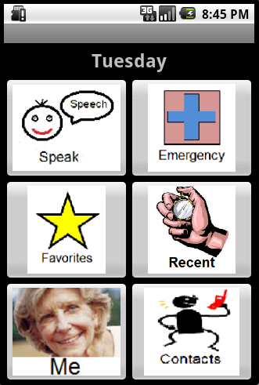

4.1.2. Speak
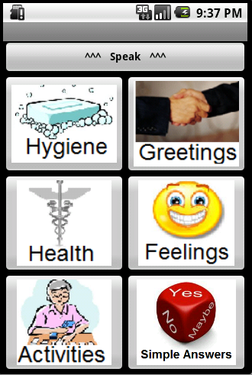

4.1.3. Speak-Dinner
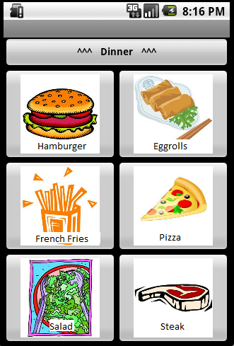

4.1.4 Sleep
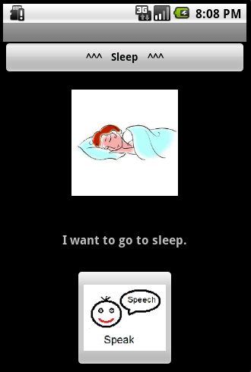

4.1.5. Recent
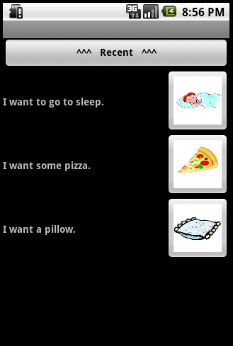

4.1.6. Emergency
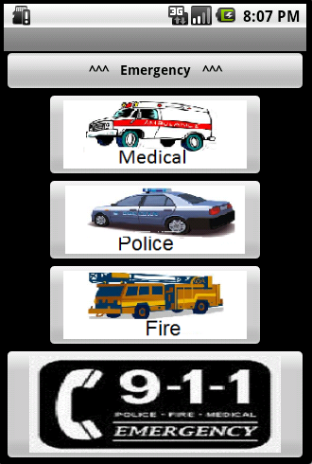

4.2 User Manual

See user manual document.

5. Traceability Matrix

(See Appendix D.)
6. Creeping Rate

We can support a 25% creeping rate.
In reference to the Pareto Principle, 20 % of the requirements would 80% of the remaining time of Phase 1 if altered. With this in mind, we caution that we can accommodate 25% change in requirements. This is under the assumption that 10% of the requested changes will take 40% of the rest of Phase 1 ((since those changes will affect more), and 15% of the requested changes will take less than 5% of the time left in Phase 1 (since those changes will affect less).

7. Why our proposal is the best

To understand why the Hope system, being developed by Team Crutch, is an important asset, an emphasis needs to be made as to how we, at Team Crutch, are approaching the development of this application differently. The difference begins with the customer. Focusing on the needs of not only the various communication disabilities, we have put special emphasis on the needs of the elderly.

Products like Proloque2Go have rave reviews, but a survey of the reviews, located inside Apple’s iTunes app store, shows their customers are between the age of 10 and 25 years of age [1]. Small buttons with vague icons all compact on a cluttered screen is not user friendly for the elderly. Yet, Proloque2Go ‘s home screen does just that, with 16 categories within the confines of ¾ the available screen space [1]. This is too small.

There are several important ideas that reverberate throughout our application. We have focused on emphasizing the importance of descriptive icons, with text descriptions that help portray the meaning of an icon. We have worked on simplifying navigation by reducing screen clutter, ie. Increasing icon size and reducing the number of icons visible at one time. Without these features, we believe that our target customers will find the usability of the product to be difficult and impractical.

Team Crutch believes that we are on the right track towards delivering a much needed product. By following an incremental iterative evolutionary model to quickly develop a prototype from thorough requirements specification, we are able to develop prototypes that we believe gain more insight into the customer’s actual needs and desires.

In order to ensure our development process is the best, we have established detailed descriptions of our Process Plan in the Project Plan. We believe that our efforts to establish a detailed and documented Process Plan has helped us keep coordinated while working on this complex product. If there are any issues with the deliverables needed to aid in the construction of the HOPE software, we know who worked on them and the factors that influenced them.

In addition to the detailed process planning, extensive focus has been put towards traceability of the HOPE software system’s development. The traceability is not only from top down from the identified problems to the product as a solution. Traceability is also horizontal from one iteration in the development cycle to another. With extensive efforts to trace the entire development from initial inception to the current cycle, the resulting product is better able to reflect changes in requirements from the customers. With the ability to change comes the ability for our product to grow. The ability to grow makes our product better than the competitors today and establishes the ability to also be better than them tomorrow.

In the end, the product is about the customer and making their lives better. The Hope application has been engineered to do just that.

Our team focuses on what is important to the target audience – simplicity. We learned through validation that our customers value a simple, understandable system; like what Team Crutch will deliver.

We have not attempted to include overcomplicated or technologically infeasible ideas into our prototype. We are not attempting to do the impossible with our program, we simply want to aid in daily communication. For example, other HOPE system proposals specified features such as using sonar functionality to help the blind navigate. This feature would be technologically unwieldy, in addition to bothering people near the user.

The validation trip we took verified that we are doing things the customers will approve of. We are keeping their needs and wants at the forefront as we continue to develop the system.

Our system does not store sensitive personal information unlike other HOPE system proposals, which could be a personal safety risk if the device is ever compromised or stolen.

The range of disabilities our HOPE system takes into account is broad. We manage to support those with hearing, vision, speech, and motor difficulties. No other group is able to offer support to such a large user base.

[1] “Proloque2Go,” iTunes Preview, 2010 (Online): Available: http://itunes.apple.com/app/proloquo2go/id308368164?mt=8 (Accessed: September 28, 2010)

Appendix A

Proper Categories:

1. Hygiene:
1.1. Bath:
1.1.1. Shower
1.1.2. Bath towel
1.1.3. Soap
1.1.4. Conditioner
1.1.5. Shampoo
1.2. Dental:
1.2.1. Brush teeth
1.2.2. Mouth wash
1.2.3. Clean denture
1.3. Toilet:
1.3.1. Pee
1.3.2. Poop
1.3.3. Toilet paper
1.3.4. Flush
1.4. Hair:
1.4.1. Cut
1.4.2. Wash
1.4.3. Comb
1.4.4. Blow dry
1.5. Hands/Feet:
1.5.1. Wash
1.5.2. Cut nails
1.6. Shave:
1.6.1. Face
1.6.2. Legs
1.6.3. Head
1.6.4. Shaving cream
1.7. Lotion:
1.7.1. Hand
1.7.2. Face
1.7.3. Body
2. Greetings:
2.1. Daily Greetings:
2.1.1. Hi
2.1.2. Hello
2.1.3. Bye
2.1.4. Goodbye
2.1.5. See you later
2.1.6. Good morning
2.1.7. Good afternoon
2.1.8. Good evening
2.1.9. Good night
2.1.10. Have a good day
2.1.11. What’s up
2.1.12. You’re welcome
2.1.13. Thanks
2.2. Ceremonies:
2.2.1. Merry Christmas
2.2.2. Happy New Year
2.2.3. Happy Halloween
2.2.4. Happy birthday
2.2.5. Congratulations
2.3. Greetings Replies:
2.3.1. I’m fine
2.3.2. Not bad, thank you, and you?
2.3.3. I’m well, thank you
2.3.4. And you?
2.3.5. You’re welcome
2.3.6. Thanks
2.3.7. No, thanks
3. Health:
3.1. Take Medications
3.2. Take Vitamins
3.3. Take Medical Shot
3.4. Visit Doctor
3.5. Visit Psychiatrist
3.6. Visit Counselor
3.7. Visit Physical Therapist
3.8. Visit Dentist
3.9. Periodic Tests:
3.9.1. Blood Sugar
3.9.2. Blood Pressure
3.9.3. Temperature
3.9.4. Heart Beat Rate
4. Feelings:
Reference: http://www.psychpage.com/learning/library/assess/feelings.html
Reference: http://www.healthyplace.com/abuse/hollis-triumph-over-tragedy/
the-feelings-chart/menu-id-1890/
4.1. Pleasant Feelings / Happy:
4.1.1. Satisfied
4.1.2. Proud
4.1.3. Cheerful
4.1.4. Good
4.1.5. Hopeful
4.1.6. Glad
4.1.7. Feel Safe
4.2. Unpleasant Feelings / Sad:
4.2.1. Hurt
4.2.2. Hopeless
4.2.3. Depressed
4.2.4. Upset
4.2.5. Defeated
4.2.6. Lonely
4.2.7. Guilty
4.2.8. Embarrassed
4.2.9. Disappointed
4.2.10. Miserable
4.3. Angry Feelings:
4.3.1. Furious
4.3.2. Aggressive
4.3.3. Suspicious
4.3.4. Enraged
4.4. Scared Feelings:
4.4.1. Fearful
4.4.2. Panicky
4.4.3. Afraid
4.4.4. Frightened
4.4.5. Threatened
4.4.6. Nervous
4.5. Confused Feelings:
4.5.1. Bewildered
4.5.2. Trapped
4.5.3. Troubled
4.5.4. Disorganized
4.5.5. Uncertain
4.5.6. Undecided
4.6. Physical Feelings:
4.6.1. I feel Cold
4.6.2. I feel Hot
4.6.3. I feel Tired
4.6.4. I feel sleepy
4.6.5. Pain
4.6.6. Too loud
4.6.7. Too dark
4.6.8. Too bright
4.6.9. Too quiet
4.7. Opinion:
4.7.1. I agree
4.7.2. I disagree
4.7.3. I like
4.7.4. I don’t like
4.7.5. I prefer
4.7.6. I don’t prefer
5. Activities:
Reference: http://en.wikipedia.org/wiki/Activities_of_daily_living
5.1. Eat/Drink Activities:
5.1.1. Breakfast:
5.1.1.1. Egg
5.1.1.2. Bagels
5.1.1.3. Cheese
5.1.1.4. Serial
5.1.2. Lunch/ Dinner:
5.1.2.1. Pizza
5.1.2.2. Chinese food
5.1.2.3. Steak
5.1.2.4. Burger
5.1.2.5. Fries
5.1.3. Dessert/Snack:
5.1.3.1. Pie
5.1.3.2. Cheese cake
5.1.3.3. Chocolate
5.1.3.4. Cookies
5.1.4. Fruits:
5.1.4.1. Apple
5.1.4.2. Orange
5.1.4.3. Banana
5.1.4.4. Peach
5.1.5. Drinking:
5.1.5.1. Water
5.1.5.2. Milk
5.1.5.3. Juice
5.1.5.4. Coffee
5.1.5.5. Tea
5.1.5.6. Cola

5.1.6. Taste:
5.1.6.1. Salt
5.1.6.2. Pepper
5.1.6.3. Sweet
5.1.6.4. Spices
5.1.6.5. Bad
5.1.6.6. Delicious
5.2. Housework Activities:
5.2.1. Cooking
5.2.2. Cleaning
5.2.3. Doing Laundry
5.2.4. Taking care of Pets
5.3. Bedroom Activities:
5.3.1. I want to get dressed
5.3.2. I want to get undressed
5.3.3. I want to sleep
5.3.4. I want a blanket
5.3.5. I want a pillow
5.3.6. I want a blanket
5.3.7. I want to lie down
5.3.8. I want to get up
5.3.9. I want the lights on
5.3.10. I want the lights off
5.4. Functional Transfers Activities:
5.4.1. Go outside
5.4.2. Go inside
5.4.3. Go downstairs
5.4.4. Go upstairs
5.4.5. Go to my room
5.5. Leisure Activities:
5.5.1. Home Leisure:
5.5.1.1. Watch TV
5.5.1.2. Listen to music
5.5.1.3. Play Cards
5.5.2. Outside Leisure:
5.5.2.1. Go walk
5.5.2.2. Go Movie
5.5.2.3. Go concert
5.5.2.4. Go theater
5.5.2.5. Play Golf
5.5.2.6. Go picnic
5.6. Shopping Activities:
5.6.1. Shopping groceries
5.6.2. Shopping clothes
5.6.3. Shopping gifts
5.7. Social Activities:
5.7.1. Visit relatives
5.7.2. Go to a banquet
5.7.3. Go on a Date
5.8. Exercise Activities:
5.8.1. Walking
5.8.2. Running
5.8.3. Swimming
5.8.4. Weight-lifting
6. Simple Answers:
6.1. Agree:
6.1.1. Yes
6.1.2. No
6.2. Size:
6.2.1. More
6.2.2. Less
6.2.3. Big
6.2.4. Small
6.2.5. Many
6.2.6. Few
6.3. Time:
6.3.1. Today
6.3.2. Tomorrow
6.3.3. Yesterday
6.3.4. Later
6.3.5. Earlier
6.3.6. Now
6.4. Solve Misunderstanding:
6.4.1. What?
6.4.2. I'm Sorry!
6.4.3. No Problem!
6.4.4. Don't worry!

Appendix B

1. Use Case Diagram
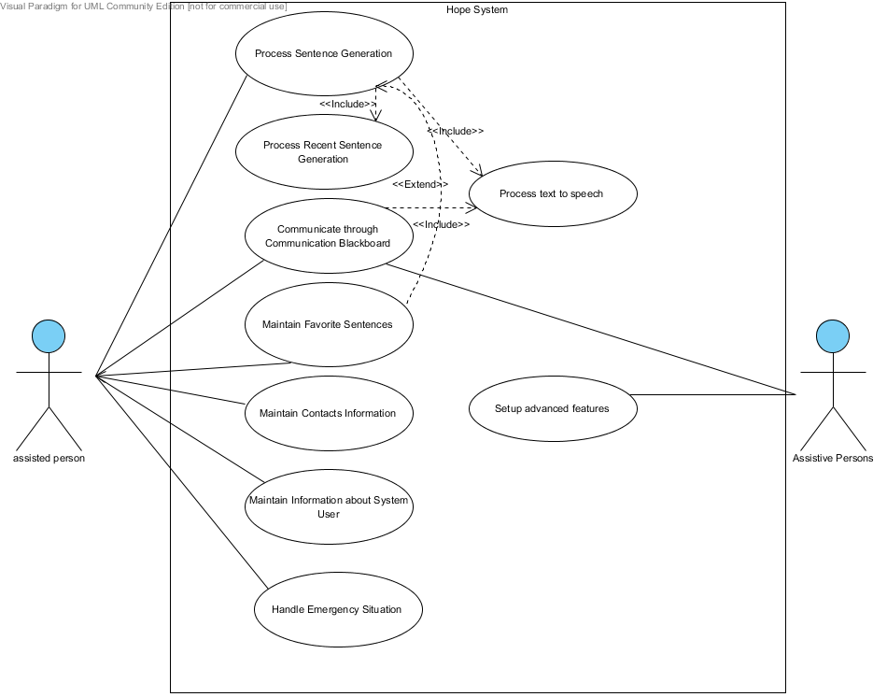

2. Domain Class Diagram
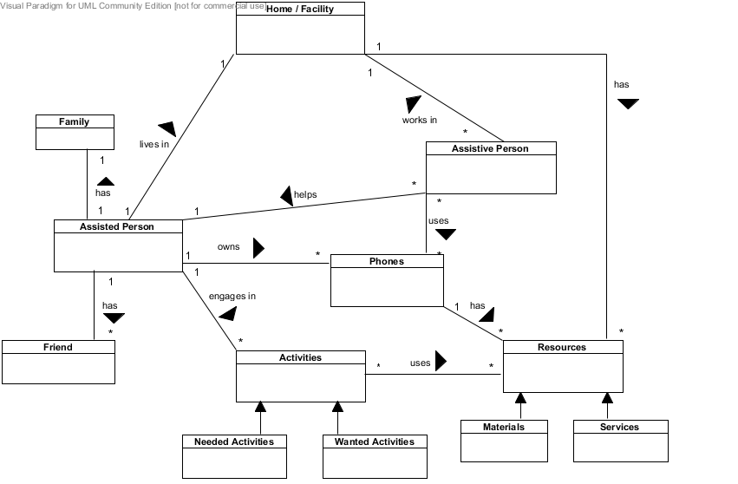

3. Activity Diagram - Process Sentence Generation
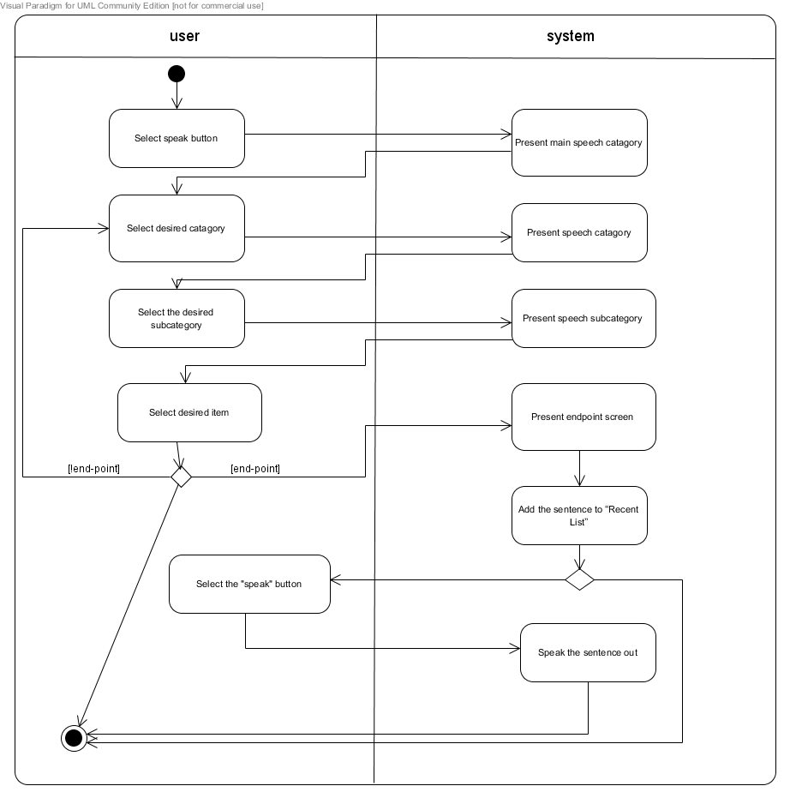

4. Black Box System Sequence Diagram - Process Sentence Generation
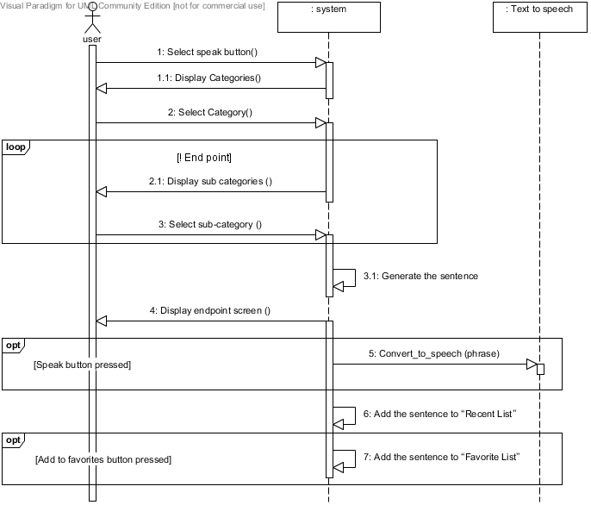

Appendix C
- 3.1.2.1. Goal: Helping people with communication disabilities communicate with other people.
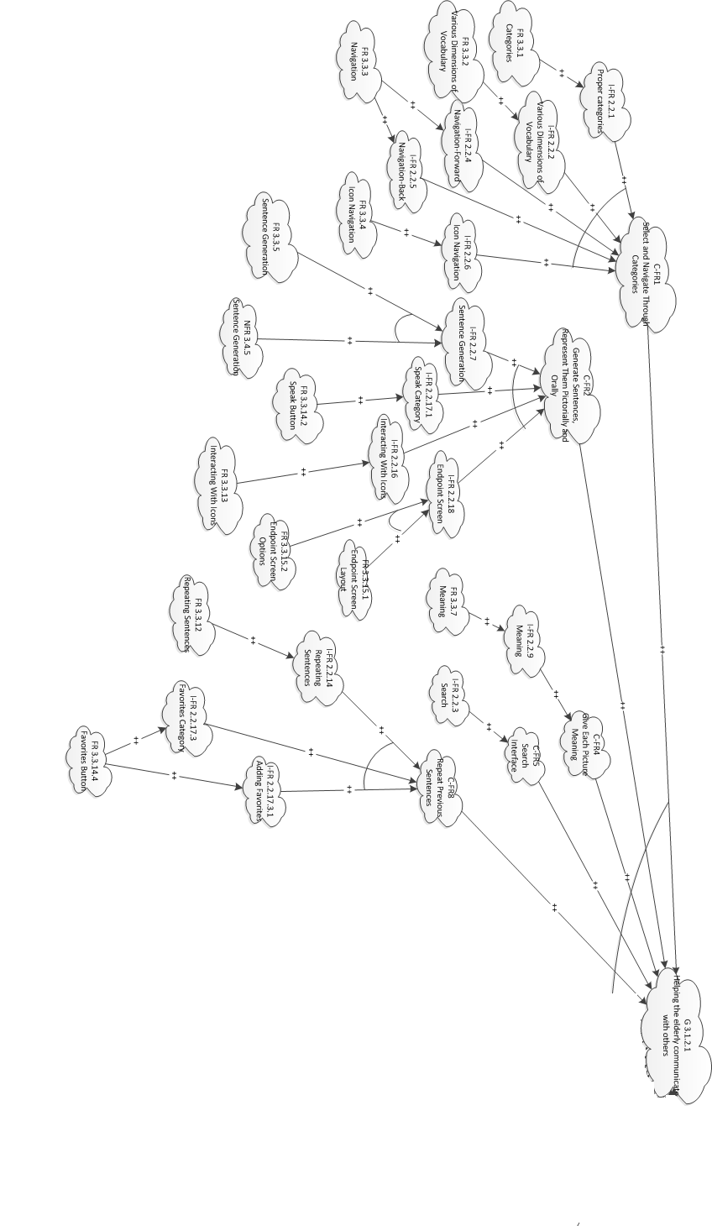
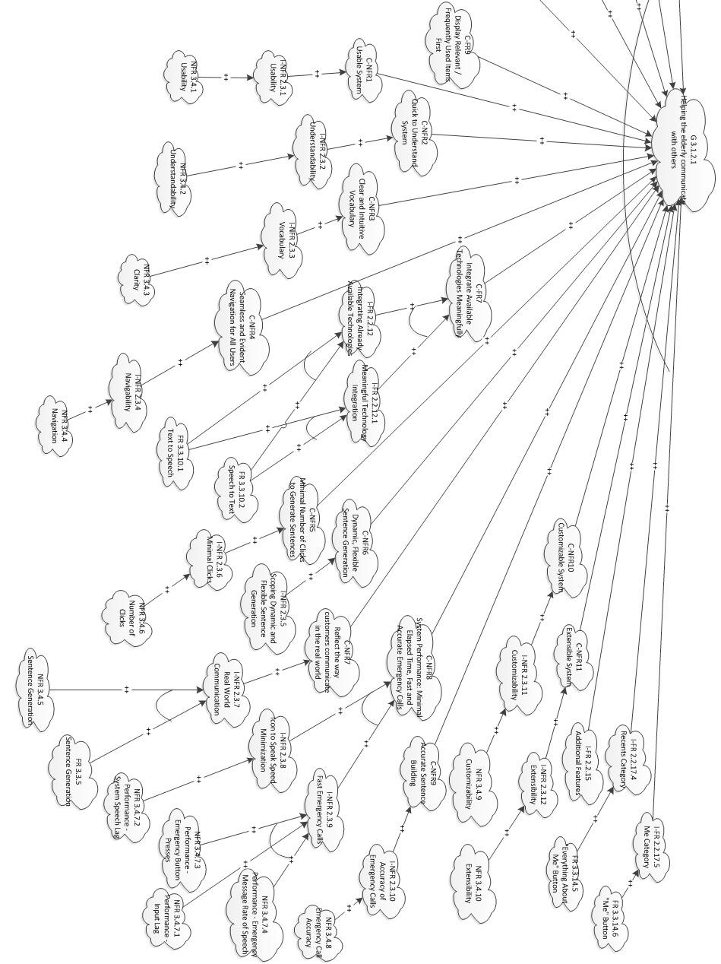

- 3.1.2.2. Goal: Helping people communicate to people with communication disabilities.
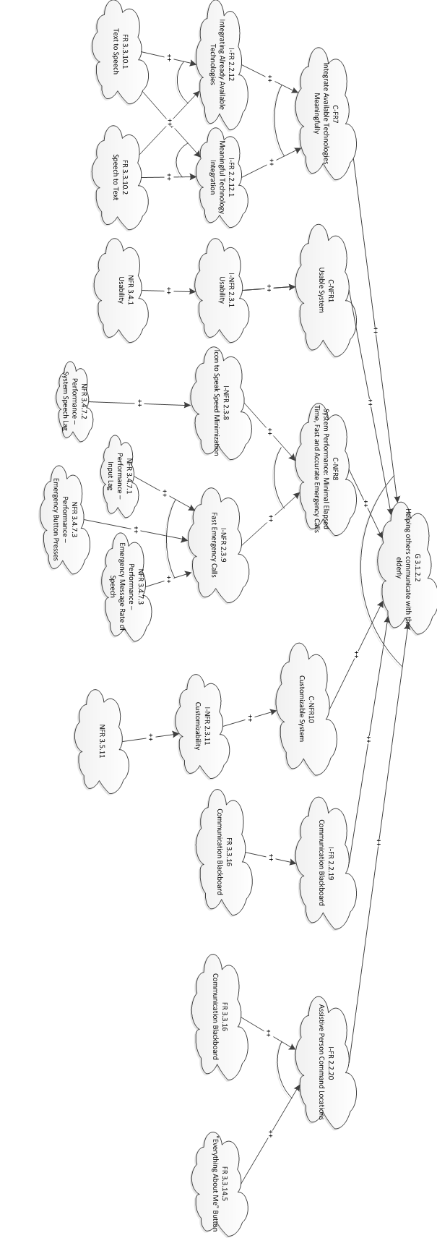
- 3.1.2.3. Goal: Provide an alternative to other communication aids, such as communication boards or hearing aids.

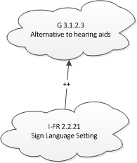

- 3.1.2.5. Goal: Handling emergency situations quickly and easily.


