HELPING ELDERLY LIVE PLEASANTLY
FINAL PHASE II
SOFTWARE REQUIREMENTS SPECIFICATION
TEAM SUPERNOVA

TEAM MEMBERS
AMRUTA
ASHOK
DEENA
JAYASHREE
PRATIBHA
RYAN
SAHANA
SINDHUJA
SUPRIYA

SUBMITTED TO:
DR.LAWRENCE CHUNG
ASSOCIATE PROFESSOR
DDEPARTMENT OF COMPUTER SCIENCE
THE UNIVERSITY OF TEXAS AT DALLAS
TABLE OF CONTENTS

1 Revision History 4
2 PROCESS 5
3 INTRODUCTION 6
3.1 PURPOSE 6
3.2 PROJECT SCOPE 6
3.3 PROJECT DELIVERABLES 6
3.4 PROJECT RESPONSIBILITIES 7
4 PROCESS MODEL 8
4.1 REQUIREMENTS ELICITATION 8
4.2 REQUIREMENTS ANALYSIS AND NEGOTIATION 8
4.3 REQUIREMENTS SPECIFICATION 8
4.4 REQUIREMENTS VALIDATION 9
5 DEFINITIONS, ACRONYMS, AND ABBREVIATIONS 10
6 PRELIMINARY DEFINITION 11
6.1 PROBLEM STATEMENT 11
6.2 USE CASES – LEVEL 0 12
6.3 USE CASES –LEVEL 1: 12
6.4 SYSTEM SEQUENCE DIAGRAM 14
6.5 WHITE BOX SEQUENCE DIAGRAMS 15
6.6 SUMMARY OF DOMAIN REQUIREMENTS 17
6.7 SUMMARY OF FUNCTIONAL REQUIREMENTS 19
6.8 SUMMARY OF NONFUNCTIONAL REQUIREMENTS 19
7 ISSUES WITH PRELIMINARY DEFINITION GIVEN 20
7.1 DOMAIN ISSUES 20
7.2 ISSUES WITH FUNCTIONAL REQUIREMENTS 28
7.3 ISSUES WITH NON-FUNCTIONAL REQUIREMENTS 37
8 DECISION AND RATIONALE: INTEGRATED MODEL (IMPROVED UNDERSTANDING) 44
8.1 WORLD 44
8.2 IMPROVED UNDERSTANDING OF FUNCTIONAL REQUIREMENTS 47
8.3 IMPROVED UNDERSTANDING OF NON- FUNCTIONAL REQUIREMENTS 48
9 NFRs and Systematic Decision making 50
9.1 Usability 50
9.2 Security: 51
9.3 Performance: 51
10 Issues with the improved understanding 53
10.1 DOMAIN REQUIREMENTS 53
10.2 FRs 53
10.3 NFRs 55
11 Second Improved understanding 57
11.1 DOMAIN REQUIREMENTS 57
11.2 Functional Requirements 59
11.3 Non-Functional Requirements 60
12 PRELIMINARY PROTOTYPE AND USER MANUAL 63
12.1 MAIN MENU 63
12.2 VISION 64
12.3 HEARING 64
12.4 SPEAKING 65
12.5 MEMORY 66
12.6 EVERYDAY LIVING 67
13 Improved understanding of the Preliminary Prototype and User Manual 69
13.1 MAIN MENU 69
13.2 TEXT TO SPEECH CONVERTOR 69
13.3 Emergency Services 71
13.4 IMAGE TO SPEECH CONVERSION 75
13.5 Photo Album 78
14 TRACEABILITY 79
15 APPENDIX A- WHY IS OUR PROJECT BETTER? 81
16 APPENDIX B - FUTURE SCOPE: 83
17 APPENDIX C – MINUTES OF MEETING 84

Revision History
Editor | Version | Comment
Ryan | 0.0 | Initial template created
Jayashree | 0.1 | Updated section 2
Ashok | 0.2 | First draft of section 3
Amruta | 0.3 | Updated functional requirements
Sahana | 0.4 | Cleaned up world issues
Prathiba | 0.5 | updated Problems and Goals
Deena | 0.6 | Added traceability matrix
Sindhuja | 0.7 | Added some more issues
Ryan | 1.0 | Cleaned up content in many areas and formatting
Amruta, Supriya | 1.1 | Added positives and negatives for all domain requirement issues

PROCESS
Any requirement which uses the term 'shall' indicates that the functionality is critical core functionality to be implemented in the first version of the HELP system. Other functionality that is identified by our requirements gathering process that is not considered critical core functionality and may be implemented instead in a later version of the HELP system are referenced using the word ‘will’.
The process we are using is an agile evolutionary process. Change is inevitable in software projects so our process is designed to adapt to the changes and allow modification where ever necessary to the requirements and other documents. Where evolution was necessary is noted in the Revision history.

INTRODUCTION

PURPOSE

Life expectancy has been on the rise since the last few decades and so are the problems associated with old age. Loss of speech, hearing, memory and vision are some of the problems related with the onset of advanced age. It is imperative that the existing applications have to be augmented for the need of the 21st century. These problems are addressed by the HOPE system. However, there are certain more features which have not been addressed in the HOPE system.
Elderly people suffering from memory loss will need Medication reminders, Photo Albums of people and places which are not implemented in HOPE. Elderly people living independently will need a finance planner application to draft their budgets and manage their accounts effectively which also is not implemented in HOPE. Hence, we came up with a new system called HELP (Helping Elderly Live Pleasantly) which has additional features like Finance Planner, Medication Reminder and Photo Albums which are missing in the HOPE system.

Features that are to be implemented in HELP are
- Blue tooth for sending vital data signs to the doctor from an Android phone
- Finance Planner to draft budgets regularly
- Medication Reminders to assist elderly people to take medicines on time
- Photo Albums to remember people and places

Here, the HOPE is our As-Is and the HELP is our To-Be. We HOPE our efforts Help Elderly Live Pleasantly (HELP).

HELP = HOPE – PROBLEMS

HOPE + Additional Features = HELP

PROJECT SCOPE
The scope of the HELP system starts at the point the user starts using a feature and ends at the point at which user can successfully address his/her issue or difficulty.

PROJECT DELIVERABLES
Phase | Deliverable | Date
Phase 0 | Preliminary Project Plan | September 2nd, 2010
Phase 1 | Interim Project 1  -->Requirement Specification  -->Presentation | September 30th/October 5th, 2010
Phase 1 | Final Project 1  -->Improved Requirement Specification  -->Presentation | October 21st, 2010
Phase 2 | Interim Project 2  -->Improved Requirement Specification  -->Implementation  -->Testing  -->Presentation | November 11th, 2010
Phase 2 | Final Project 2  -->Final project plan  -->Any dependency/traceability between Project I and Project II  -->Presentation | November 30th/December 2nd, 2010

PROJECT RESPONSIBILITIES

See Process Specification for details on Project Responsibilities.

PROCESS MODEL
For the implementation of HELP system, our team follows the Spiral Process Model.
Considering time and resources available are having 2 cycles. Each cycle involves traversing through the four quadrants.
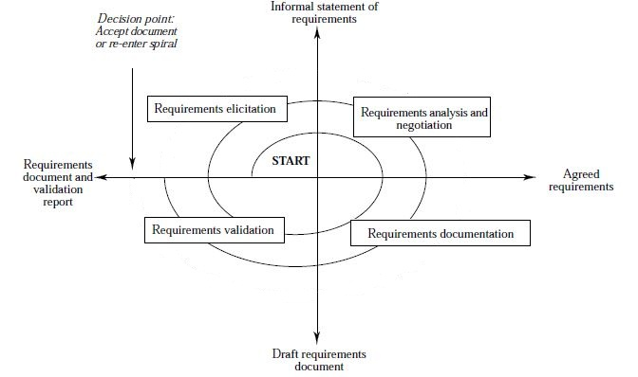The steps followed in the spiral model are:

REQUIREMENTS ELICITATION
Initial requirements are provided by the professor. Additional requirements are added by further refinement of the initial problem description.

REQUIREMENTS ANALYSIS AND NEGOTIATION
Each requirement is analyzed thoroughly for completeness, unambiguousness, soundness, and consistency. As the result of requirements analysis, an improved understanding of each requirement is created. The improved understanding includes each requirement with the necessary corrections to remove any of the issues associated with it.
While carrying out Requirements Analysis, the Integrated model will be used to define the following:
- The domain requirements
- The functional requirements
- The non functional requirements

REQUIREMENTS SPECIFICATION
In order to ensure efficient maintenance of the requirements, the requirements have been organized into multiple requirements sets, each set reflecting the requirements for a particular type of requirement, such as domain, functional, and non-functional requirements.

REQUIREMENTS VALIDATION
In order to ensure the requirements were meeting customer expectations, an initial prototype is constructed showing the initial functionality of the system. The benefits of using evolutionary prototyping are given below:
- Misunderstandings between client and requirement engineers are exposed.
- Missing services may be detected.
- Confusing services may be identified.
- A working system is available early in the process.
- The prototype may serve as the basis for deriving a system specification.

DEFINITIONS, ACRONYMS, AND ABBREVIATIONS
HOPE - Helping Older People Easily
HELP - Helping Elderly Live Pleasantly

PRELIMINARY DEFINITION
The domain requirements, functional requirements and non- functional requirements are given below:

PROBLEM STATEMENT

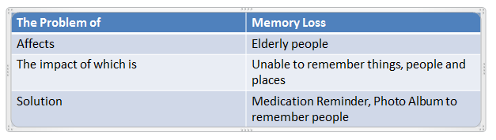

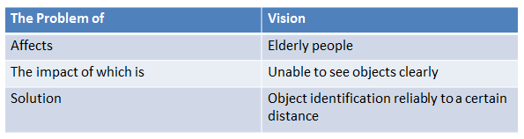
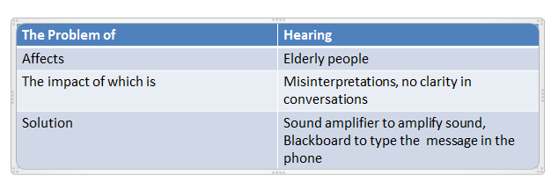

USE CASES – LEVEL 0
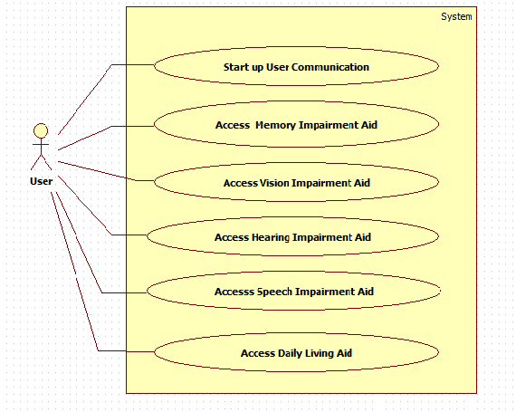

USE CASES –LEVEL 1:
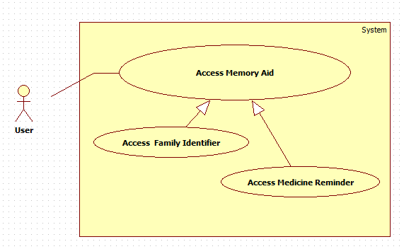
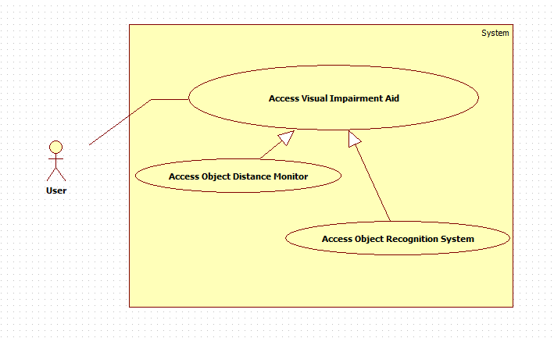
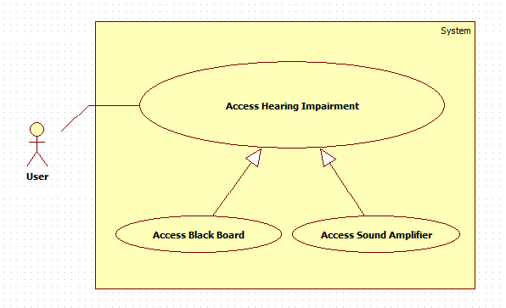
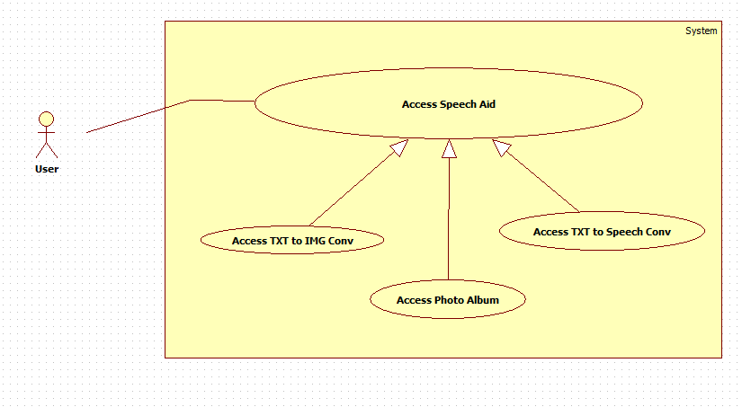
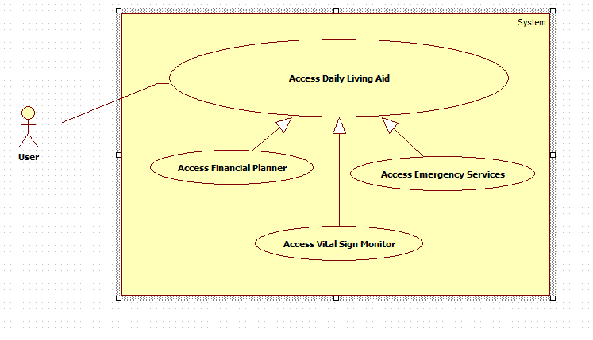

SYSTEM SEQUENCE DIAGRAM
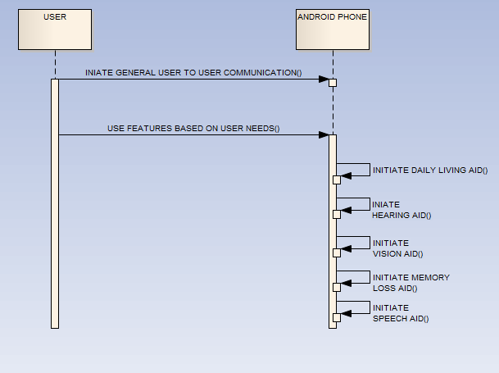

WHITE BOX SEQUENCE DIAGRAMS

SEQUENCE DIAGRAM FOR HEARING AID:
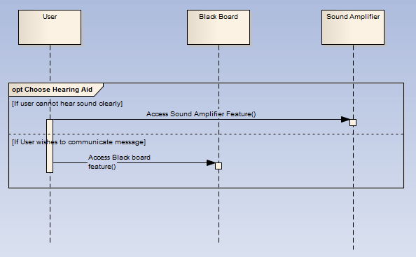

SEQUENCE DIAGRAM FOR VISION AID
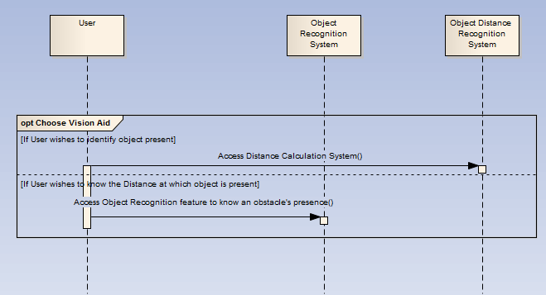

SEQUENCE DIAGRAM FOR DAILY LIVING
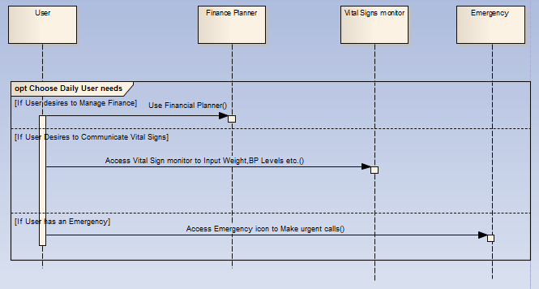

SEQUENCE DIAGRAM FOR SPEECH AID
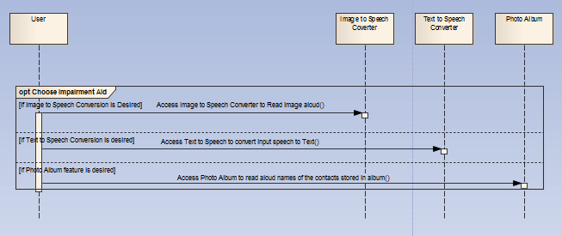

SEQUENCE DIAGRAM FOR MEMORY LOSS AID
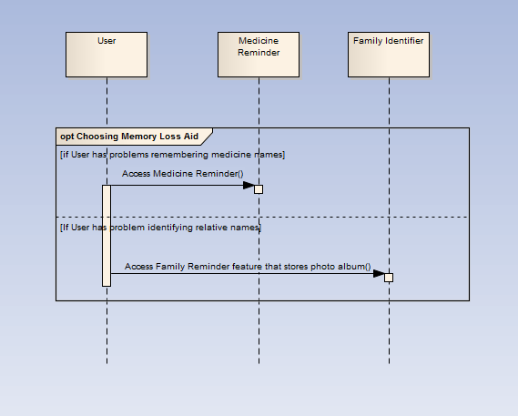

SUMMARY OF DOMAIN REQUIREMENTS
S.NO | Requirements Specification | Forward Traceability
DR1 | A smart phone is required | WF1
DR2 | The user needs basic knowledge about using the smart phone and should be able to use it easily. | WF2, WF20, WF21, WF22, WF23
DR3 | The phone must have HELP in it. | WF3
DR4 | Old people suffering from hearing problem need a converter | WF4
DR5 | Phone must have an in-built microphone, typically to record the speech. | WF5
DR6 | Clicking on the icon converts speech to text | WF6
DR7 | Some elderly people who have problem in hearing find it difficult to understand what is being spoken to them. In order to help them, the system will provide a feature by which the word being told is converted into an image and displayed. | WF8
DR8 | Old people suffering from speech disorders may need images/icons for immediate help in emergency situations. | WF7, WF9
DR9 | When a certain image is clicked, its functionality is read aloud. | WF7, WF9
DR10 | When 2 people have problems in oral communication, they can use pictogram for communication. | WF13, WF17
DR11 | Some of the older people have the problem with the speech clarity, their words stutter or halt, which makes the articulation coordination difficult, and this problem is known as ‘MOTOR APHASIA'. Our system must provide the opportunity for people with speech impairments to express their message effectively. | WF13, WF17
DR12 | The person must be near to the user of the phone. | WF18
DR13 | The user must have an idea to use the message board. | WF23
DR14 | When the user is typing message to the unknown person, the opposite one must be able to understand the scenario. | WF12
DR15 | Old people with visual impairments need a tool for object recognition. | WF14, WF15
DR16 | Obstacles while walking must be detected by the camera. | WF21
DR17 | The camera should give a beep sound when the object is detected. | WF14
DR18 | Old people suffering from memory loss due to aging need help remembering people and places. | WF8
DR19 | Some elderly people who have memory loss problem cannot remember to have their medicines at the correct time. This feature generates reminders to help these people have their tablets at the correct time. | WF20
DR20 | Old people may have issues with managing daily finances effectively. | WF23
DR21 | Add a Finance planner application. | WF20
DR22 | Old people may find it difficult to keep track of investments in current assets. | WF23
DR23 | Elderly people may need immediate assistance in case of emergency situations. | WF18, WF19
DR24 | Remote devices such as weighing machine, sphygmomanometer, cardio belt, etc. must be blue tooth enabled | WF20
DR25 | User shall have a keypad, typically to type in text. | WF15
DR26 | Click on button converts text to speech. | WF10

SUMMARY OF FUNCTIONAL REQUIREMENTS
S.No | Requirements Specification | Forward Traceability
FR1 | Intended people can communicate effectively and perform their day to day activities without much difficulty. | FR001
FR2 | The elderly people have problems of distorted speech and hence a speech to text converter is required to convey speech clearly. | FR002
FR3 | The speech to image converter converts speech to image for elderly people with problems. | FR003
FR4 | The image to speech converter is used to convey messages. | FR004
FR5 | Text to speech converter is for people with unclear speech. | FR005
FR6 | Object recognition will identify objects in front of them. | FR006
FR7 | Helps Elderly people with vision problems to detect presence of objects in their path. | FR007
FR8 | Stores Picture Album consisting of the photos of relatives and friends of the user to help the user recognize them. | FR008
FR9 | Reminds user to take their medicines by displaying the name or image of the medicine. | FR009
FR10 | Elderly people can draft budgets; meet bill payment deadlines; manage current finances in bank accounts, property and other investments; procure the insurance amount when needed by linking the user's insurance and bank accounts for direct fund transfers. | FR010
FR11 | Elderly people perform speed dial to emergency services or to their relatives or doctors. | FR011
FR12 | Elderly people send the results of their blood pressure readings etc. to their doctors by taking readings from devices such as weighing machine, sphygmomanometer, cardio belt etc. via Bluetooth and transfer the data to a smart phone. | FR012
FR13 | Blackboard helps user to create a message and send it to others. | FR013

SUMMARY OF NONFUNCTIONAL REQUIREMENTS
S.No | Requirements Specification | Forward Traceability
NFR1 | Speech to text converter should be able to convert spoken words to text quickly. | NFR001
NFR2 | The output audio should be clear. | NFR002
NFR3 | Conversion from speech to image must be done as quickly as possible. | NFR003
NFR4 | Words spoken by the person should be loud enough. | NFR004
NFR5 | The functionality of the message should be audible to the old person. | NFR005
NFR6 | The image icon when clicked should read its functionality aloud immediately. | NFR006, NFR024
NFR7 | Conversion from text to speech must be as quickly as possible. | NFR007
NFR8 | Speech produced by the system should be audible. | NFR008
NFR9 | The message should be clear to the listener. | NFR008
NFR10 | The font should be readable to the user. | NFR009
NFR11 | The camera must produce a beep sound when it recognizes an object around it immediately. | NFR010
NFR12 | The retrieval of the photos should be fast. | NFR011
NFR13 | Store few photos to identify a contact, pet or an object. | NFR012
NFR14 | The reminder should be invoked at the correct time. | NFR013
NFR15 | The phone should display the name or image of the medicine at the correct time. | NFR014
NFR16 | An icon for latest news will be available to the elderly people | NFR015
NFR17 | Budgets should be drafted accurately. | NFR016
NFR18 | User's details should be secure | NFR017
NFR19 | The system should manage financial assets accurately. | NFR018
NFR20 | The new and old investments should be kept track of to enable an understanding of current financial status | NFR019
NFR21 | The system that implements bluetooth communication should be usable and reliable. Completeness in connection is an important factor since all further actions depend on proper pairing of the devices. | NFR020
NFR22 | Data transferred and recorded should be accurate and precise since it is used in maintaining the case history of the patient. | NFR021
NFR23 | The objects should be large enough to be recognized. | NFR022
NFR24 | The blackboard application should allow the user to communicate their idea quickly. | NFR023
NFR25 | Emergency calls should be completed within a short period of time. | NFR025

ISSUES WITH PRELIMINARY DEFINITION GIVEN
This section addresses ambiguities, incompleteness, inconsistency, and conflicts discovered in the initial definition of the requirements which was provided to us.

DOMAIN ISSUES
This section describes issues we encountered with section II.1 of the original document. The Domain, Stakeholders, Functional and Non-Functional Objectives are covered.
Issue IDR001: A smart-phone is required
Description | For the HELP system to be useful the elderly person needs to have a smart-phone.
Options | Option A: Android phone is required  + many handsets are available  + good support for development  - high cost  Option B: iPhone is required  + Apple stuff is user friendly  - don’t have a choice of handsets  Option C: no phone  - system cannot meet the requirements
Decision | We chose to require an Android phone because the advantage of offering multiple handsets and being easier to develop outweigh the other options.

Issue IDR002: The user needs basic knowledge about using the phone
Description | The user needs basic knowledge about using the phone.
Options | Option A: We can assume the user already knows how to use the phone  + saves development time  - If the user does not know its usage they cannot use the system  Option B: We can create a user manual to assist the user  + makes the project more usable  - takes time to create a user manual
Decision | We choose option A because usability is very important.

Issue IDR003: The phone must have HELP in it.
Description | This requirement is incomplete. The working condition of HELP is not clearly defined.
Options | Option A: The working status of HELP should be defined clearly  + improves the description of the requirements  Option B : Remove this incomplete requirement  - may miss out on an aspect of the domain
Decision | Option A is preferred. We clearly define the requirement by rephrasing it as follows: “A running condition of the HELP system must be installed in the phone.

Issue IDR004: Old people suffering from hearing problem need a converter
Description | Problem: Type of Issue (Incompleteness)  This statement does not specify what type of converter should be used
Options | Option 1: Mention the name of the converter to be used  - Increases development time and cost.  Option 2: Remove this feature  + Save development time and cost  - Everyday living of elderly people with hearing problems is affected to large extent
Decision | Option 1 is preferred. We can use a speech to text converter which translates spoken words to text

Issue IDR005: Phone must have an inbuilt micro-phone typically to record the speech
Description | Problem: Type of Issue (ambiguity):  This statement implies that there are many ways to use the microphone
Options | Option1: Define all possible ways  + A clear idea of how to use a microphone is provided.  - It is tedious to describe all possible ways  Option2: Remove the word “typically”  + The ambiguity in the sentence is removed.
Decision | Option 2 is preferred. Without “typically” the statement means that the microphone is used to record the speech

Issue IDR006: Clicking on the icon converts speech to text
Description | Problem: Type of Issue (Incompleteness)  The above statement does not specify what icon should be clicked
Options | Option1: Specify the name of icon to be clicked  + Specifying which icon to be clicked gives a better picture of the functionality of the icon  Option2: Remove the statement  - The functional part of the speech to text converter remains ambiguous, incomplete.
Decision | Decision and Rationale: Option 1 is preferred. Specifying the name of the icon completes the statement.

Issue IDR007: Speech to Image need
Description | Some elderly people who have problem in hearing find it difficult to understand what is being spoken to them. In order to help them, the system provides a feature by which the word being told is converted into an image and displayed.
Options | Option A: Implement this by storing the images of some words that are often spoken to the user, in the phone, so that when the phone senses that the particular word has been told, it displays the corresponding image to the user.  +allows an important functionality for people with problem in hearing  -increases development time as we need to analyze the words that are often spoken to the user and add the respective images to the phone’s memory  Option B: Don’t implement this  +no increase in development time  -does not provide the needed functionality
Decision | We choose option A because it is necessary to provide a feature by which old people can understand what is being told to them.

Issue IDR008: Communication assistance
Description | Old people suffering from speech disorders may need images/icons for communicating their needs
Options | Option1: Define the meaning of the words “needs” and “speech disorders” clearly  + defining the meaning of speech disorders helps in better understanding of the problem that the elderly people are facing.  - Significant increase in development cost and time if all problems are taken into consideration.  Option2: Remove the word “may”  + Removes the ambiguity involved in the requirement.  - A binding compulsion is inserted in the statement.  Option3: Remove this feature  + Saves time and money  - The system is deprived of a simple and efficient way of providing communication assistance.
Decision | Option1 is preferred. By clearly defining the context of the words used we can understand the use of this feature in a better manner

Issue IDR009: When a certain image is clicked, its functionality is read aloud
Description | Problem: Type of Issue (Incompleteness)  The above statement does not specify what image(s) can be clicked.
Options | Option1: Specify the name of the image to be clicked  + A clear idea of which icon to be clicked is necessary to make use of its functionality  Option2: Remove the statement  + Saves development time and reduces cost.  - The system will not be user friendly.
Decision | Option 1 is preferred. Specifying the type(s) of image clarifies the requirement.

Issue IDR010: Speech difficulty
Description | Some of the older people have the problem with the speech clarity, their words stutter or halt, which makes the articulation coordination difficult. This problem is known as 'MOTOR APHASIA'. Our system must provide the opportunity for the people with speech impairments to express their message effectively.
Options | Option A: The system should provide a user interface to type the message they want to express.  +Easy to implement.  -Some people may not have expertise in typing quickly, which may cause inconvenience for opposite person to wait longer.  Option B: Use stylus to write the message on the phone screen and this handwritten message will be converted to text using the OS provided functionality.  +Easy to use.  - Difficult to implement.
Decision | We choose option A, as the implementation is easier.

Issue IDR011: The person assisting the old person must be near the user of the phone.
Description | The above statement is too ambiguous.
Options | Option1: Expand the requirement such that having a person near is not enough. He must be aware that older person is going to give the message.  + Better clarity is provided by stating that an assistant must stay near the elderly people with communication problems in order to assist them in what they want to convey.  Option2:Specify the allowable distance  + the allowable range of distance in the vicinity of the elderly person is specified.  - Correct units to measure the distance may or may not be used.
Decision | Option 1 is preferred to make the statement more clear.

Issue IDR012: The user must have an idea to use the message board.
Description | The above statement is too ambiguous.
Options | Option1: Define clearly if the user needs to have an idea in typing or finding an option.  + Understanding how and why to use the message board is important to actually implement its functionality.  - Increases development cost and effort.  Option2: Define the message board to be understood by anyone.  + The word message board is universally understood as a board is used to convey messages.  - Ambiguous and incomplete.
Decision | Option 1 is preferred, so that having idea of message board is clearly defined.

Issue IDR013: Understanding of the situation
Description | When the user is typing message to the unknown person, the opposite one must be able to understand the scenario.
Options | Option 1: Define the word scenario clearly.  + Having a clear knowledge of the scenario is important in reacting to the situation.  - Increases development time.  Option 2: Remove the entire statement.  + Saves implementation time.  - System is incomplete as there is no proper specification of how to use the features that are implemented in the system.
Decision | Option1 is preferred, so that the situation would be clearly defined.

Issue IDR014: Old people with visual impairments need some tool for object recognition
Description | This requirement is incomplete. It needs to be described in more detail.
Options | Option1: The camera will be used to identify objects with the object identification activity.  + Recognizes objects clearly in its vicinity.  - High cost  - Requires a high quality camera.  Option2: Remove this feature.  + Do not require a camera.  - Cannot help people with visual imparities to know the objects around them.
Decision | Option1 is preferred. A camera will be used to recognize objects

Issue IDR015: Camera detection distance
Description | The exact detection distance needed is not addressed
Options | Option 1: The camera can recognize objects up to a distance of 15 feet.  + Objects in a distance of 15 feet are clear when seen in the camera.  Option 2: The camera can recognize objects up to a distance of 30 feet.  - Objects cannot be recognized  Option 3: The camera can recognize objects up to a distance of 45 feet.  - Objects cannot be recognized
Decision | Option 1 is preferred. A camera can only recognize objects reliably up to a certain distance. Since reliability is a key goal of the system, we expect the camera to identify objects only to a range of 15 feet.

Issue IDR016: Camera should give beep sound when an object is detected
Description | Problem (Type of Issue: Ambiguity)  The alert message might not be loud enough for the person to hear.
Options | Option1: The alert message should be loud enough for the old person to hear.  + Elderly person can hear the warning message and knows that there is some object near them.  - Loud sound might cause disturbance to people around.  Option2: Remove this statement  + Saves implementation time.  - Elderly people do not know that there is an object nearby.
Decision | Option1 is preferred. The beep sound should have high audible levels for the old person to hear.

Issue IDR017: Need for help remembering people and places
Description | Issue Problem: Incompleteness. The kind of help that old people need is not mentioned precisely in the requirement.
Options | Option A: The kind of help that needs to be offered must be defined clearly.  + Requirement is more clear and complete.  + User using this feature can understand what type of help is provided.  Option B: Remove this statement.  + Reduce requirement gathering time  - Cannot help elderly people to remember places or people
Decision | Option A is preferred because it is a very essential feature for old people.

Issue IDR018: Need for help with medicine
Description | Some elderly people who have memory loss cannot remember to have their medicines at the correct time. This feature generates reminders to help these people have their tablets at the correct time.
Options | Option A: Implement this by displaying the name or image of the tablet to be taken by the user at that time  +Helps the elderly people have their tablets at the correct time  - Every time the doctor prescribes a new medicine, it has to be added as a reminder in the phone  Option B: Don’t implement this  +no increase in development time  -does not provide the needed functionality for people having memory loss
Decision | We choose option A because it is necessary to provide a feature to help the old people with memory loss have their tablets at the correct time.

Issue IDR019: Old people may have issues with managing daily finances effectively
Description | The word "may" does not indicate the degree of seriousness of the requirement and its effect towards the elderly. Furthermore, "effectively" adds vagueness to the requirement as there can be difference in the way it is perceived by different people.
Options | Option1: Remove words such as "May" and "Effectively”.  - Requirement is not clear  Option2: Clearly define and restructure the requirement.  + Requirement is more specific.  + No ambiguity.
Decision | Option 2, since by wording the statement in such a way that there is more emphasis on understanding the importance of these statements than merely removing these words help to increase the understanding of the requirement.

Issue IDR020: Add a Finance planner application
Description | This requirement is too vague.
Options | Option1:Implement certain important applications alone, by integrating particular bank accounts with most transactions and drafting a partial budget based on the resources available  + Helps an elderly person to draft budget  + Helps elderly person to manage the monthly expenses.  - Elderly person needs to provide details of bank accounts.  Option2: Do not implement this requirement  + Need not provide the details of bank accounts.  - Elderly person cannot manage monthly expenses efficiently.
Decision | Option 1 is preferred. Narrowing the scope of the problem might result in incompleteness, but it might give a rough idea of a part of the whole picture. Drafting the complete budget by keeping this subset in mind would be more advantageous.

Issue IDR021: Old people may find it difficult to keep track of investments and current assets.
Description | The word "may" does not indicate the degree of seriousness of the requirement and its effect towards the elderly. It might be difficult to accommodate and accurately evaluate the entire list of assets as their list is extensive and the values might increase or fall with time
Options | Option1: Include a specified range of liquid assets that will effect in case of financial emergencies.  + Helps the old person to store all the assets.  - Old people must provide the list of assets that earn them income.  Option2: Do not address this requirement.  + Elderly people need not provide any details of their income or assets.  - Cannot help elderly people to keep a note of their investments and assets.
Decision | Option 1 is better. By specifying a specific range of assets and investments alone than taking into all the possible assets an elderly person might possess we are limiting the scope and also providing an effective way to manage a critical requirement of the elderly.

Issue IDR022: Elderly people may need immediate assistance in case of emergency situations.
Description | This requirement is incomplete. The details of the potential emergency situations are left off as well as the types of assistance which might be needed.
Options | Option 1: Clearly specify what the terms emergency and immediate mean.  + provide a more precise requirement  + closely reflect the intent of the original requirement  Option 2: Remove the word “may” to eliminate the ambiguity.  + simple fix
Decision | Option 1 is the better choice. By clearly defining the meaning of the words used, we can get a better picture of what exactly the stakeholder means when the words immediate and emergency are used.

Issue IDR023: Medical devices should be Bluetooth enabled
Description | If the phone is going to be able to connect to the medical devices, they need to be Bluetooth enabled and provide an interface by which the phone can connect.
Options | Option 1: Do not use Bluetooth enabled devices and eliminate this feature  +save cost of Bluetooth devices  +save development time  -removes a lifesaving feature  Option 2: Make use of Bluetooth technology, by compromising a little on the expense.  - costs more  - takes more development time  + save lives
Decision | The best solution is option 2. Given the speed and widespread use of emergent technologies such as Bluetooth, it is not a bad idea to invest a little more on devices which help in saving lives of people.

Issue IDR024: The smart-phone shall have a keypad, typically to type in text.
Description | Problem (Ambiguity)  This statement implies that there are multiple ways to use keypad.
Options | Option 1: Define multiple ways  - smart phone does not have multiple ways to type text.  - Ambiguous  Option 2: Remove word “typically”  + there is only one way to type text.  + Requirement is clear
Decision | Option 2 is preferred. After removal of the word “typically” it means that keypad is always used to type text in this context.

Issue IDR025: Click on button converts text to speech.
Description | Problem (Ambiguity)  The above statement does not specify clearly what button should be clicked.
Options | Option 1: Define clearly the button(s) which can be clicked in this way  + button should be named clearly so that user knows what happens when the button is clicked.  + Easy to implement.  Option 2: Remove this requirement.  - Buttons are ambiguous.  - User does not know what happens when the button is clicked.
Decision | Option 1 is preferred. Defining clearly name of button would make the statementunambiguous for the users using the system.

ISSUES WITH FUNCTIONAL REQUIREMENTS

Issue IFR001
Description | “Intended people can communicate effectively and perform their day to day activities without much difficulty.”  Problem (Type of Issue: Incomplete, Ambiguity)  Who are intended people? Does this imply all the people or only a set of them?  Whom are these people going to communicate with?
Options | Option1:  a. All the people are considered as intended.  b. They are going to communicate with everybody.  Option2:  a. Elderly people are considered to be intended people.  b. Elderly people suffering with difficulties communicate with people around to perform day to day activities.  Option3:  a. Younger people are considered as intended people.  b. Younger people communicate with people around to perform daily activities.
Events | System Events: The system should convert the input speech from the elderly person to text.  External Events: The elderly person must speak at such a proximity(say 10cm from the microphone) that the input is recognisable by the system
Decision | Option 2 is preferred as HELP system is intended to help elderly people communicate effectively with other people and perform their day to day activities with much difficulty.

Issue IFR002
Description | “The elderly people have problems of distorted speech and hence a speech to text converter is required to convey speech clearly.”  Problem 1 (Type of Issue: Ambiguity)  Does not specify who provides speech. Also the term clearly is not quantified.
Options | Option1: The speech of the elderly person has problems in clarity. Speech to Text converter is required to address this issue. The term clearly means every word being interpreted.  + Speech to text converter helps the elderly people with problems in speech communicate effectively with the other person.  -Development time is high.  Option2: Remove this requirement.  +Development time is minimized.  -It does not solve the problem of speech clarity in elderly people.
Events | System events:The system should convert the input speech from the elderly person to text.  External events:The elderly person must speak at such a proximity(say 10 am from the microphone) that the input is recognizable the system.
Decision | Option 1 is preferred because elderly person suffering from hearing issues cannot hear the speech of the other person and hence needs an external interface. Hence, this feature aids in easier communication.

Issue IFR003
Description | “The elderly people have problems of distorted speech and hence a speech to text converter is required to convey speech clearly.”  Problem 2 (Type of Issue: Incomplete)  Does not specify what the kinds of problems are.
Events | System events:The system should convert the input speech from the elderly person to text.  External events: The elderly person must speak at such a proximity(say 10 am from the microphone) that the input is recognizable the system.
Options | Option1: People suffering with loss of vision.  Option2: People suffering from memory loss.  Option3: People suffering with hearing issues.
Decision | Option 3 is preferred as speech to text is used to help people suffering from hearing problems.

Issue IFR004
Description | “Convert speech to image for elderly people with problems.”  Problem 1 (Type of Issue: Ambiguity)  Does not specify who provides speech.
Events | System events:The system should convert the input speech from the elderly person to text.  External events:The elderly person must speak at such a proximity(say 10 am from the microphone) that the input is recognisable the system.
Options | Option1: Elderly person  Option2: Person with whom elderly person is communicating
Decision | Option 2 is preferred because elderly person suffering from hearing issues cannot hear the speech of the other person (person with whom elderly person tries to communicate).

Issue IFR005
Description | Problem 2 (Type of Issue: Ambiguity and Incompleteness)  Does not specify what the kinds of problems are
Options | Option1: People suffering with loss of vision.  Option2: People suffering from memory loss.  Option3: People suffering with hearing issues.
Event | System Event:The system must address an the impairment of the elderly person by converting user input which has distortions into a form that can be perceived by the system  External Event:User input must be given to the system such that the system can recognise it i.e it should be at the detectable realm of the system(varies according to considered feature)
Decision | Option 3 is preferred as speech to text is used to help people suffering from hearing problems.

Issue IFR006
Description | “The image to speech converter is used to convey messages.”  Problem 1 (Type of Issue: Ambiguity)  What messages does it convey?
Options | Option1: Any kind of message.  Option2: Messages corresponding to day to day activities.
Events | System event:The system should read out the name of the image that the user clicks.  External event:The user should click on the correct image to be able to express what he wants.
Decision | Option 2 is preferred as elderly people with unclear speech use images to represent their day to day activities so that the person assisting them can understand what they try to express.

Issue IFR007
Description | The above requirement does not specify to whom is the message conveyed. It also does not describe who is trying to convey the message.
Options | Option1: Elderly people are the recipient of the message and people around or people assisting elderly person are trying to convey the message.  Option2: Elderly people are trying to convey message to people near them.
Events | System event:The system should read out the name of the image that the user clicks.  External event:The user should click on the correct image to be able to express what he wants.
Decision | Option 2 is preferred as elderly person suffering with unclear speech uses this converter to express their views to people assisting them.

Issue IFR008
Description | “Text to speech converter is for people with unclear speech.”  This requirement is incomplete. For what purpose do people with unclear speech use text to speech converter?
Options | Option1: To express the feelings or convey information.  Option2: To say “hello” to other person
Events | System Event: Should convert input text to audio  External Event: User should input what he wants to communicate to the other user in the form of text
Decision | Option 1 is preferred as elderly people with unclear speech want to convey a message to people around them and this text to speech converter helps them to do so.

Issue IFR009
Description | Problem 2 (Type of Issue: Unclear)  a. Does not specify to who is the recipient?  b. Does not specify who inputs text?
Options | Option1: Elderly person is the recipient and people near him input text.  Option2: Elderly person provides text and people near them are supposed to understand speech produced.
Events | System Event: The system should convert input text to audio  External Event:The user should input what he wants to communicate to the other user in the form of text
Decision | Option 2 is preferred as the statement becomes clear.

Issue IFR010
Description | “Object recognition will identify objects in front of them.”  Problem 1 (Type of issue: Incomplete)  What kind of objects is recognized?
Options | Option1: Real world object.  +Makes the statement more clear and complete.  Option2: Remove the word “object”  -Does not specify what is to be recognized.
Events | System event:The system must recognize the objects in front of it and tell the name of the object to the user.  External event:The object should be at a close proximity to the object(say 22 m) to the system.
Decision | Option 1 is preferred as it clearly specifying what type of object is recognized.

Issue IFR011
Description | Problem 2(Type of issue: Ambiguity)  What does the word “them” imply?
Options | Option1: People around or near to elderly person.  -It is of no use to the people helping the elderly person as they do not have problems with vision.  Option2: Elderly person  +The elderly people with problems in vision find it very useful as the system tells them what object is present in front of them.
Events | System event:The system must recognize the objects in front of it and tell the name of the object to the user.  External event:The object should be at a close proximity to the object(say 22 m) to the system.
Decision | Option 2 is preferred as object recognition helps people with no or less vision to identify objects in front of them.

Issue IFR012
Description | “Elderly people with vision problems can detect the presence of objects in their path.”  (Type of Issue: Incompleteness)  The statement does not mention how the operation is performed.
Options | Option 1: The phone uses the microphone and speaker like SONAR to detect objects in the path of the user and give a loud beep sound when it detects an object.  +Helps to effectively implement this requirement to aid the elderly people with problems in vision detect objects in their path.  -It is costly to implement.  Option2: Remove the statement.  +Implementation cost is reduced.  -Does not solve the problem of helping elderly people with problems in vision.
Events | System Event: The system will detect an object at the proximity of the user(22 meters) and notify the presence of an obstacle by giving a beep sound  External Event: An object comes up at a distance of 22 meters from the user’s current position
Decision | Option 1 is preferred because it mentions the process of detecting an object in the path of the user.

Issue IFR013
Description | “The system stores a picture album consisting of the photos of relatives and friends of the user to help the user recognize them.”  Problem (Type of issue: Incompleteness)
Options | Option 1: The user has to type the name of the person he is not able to recognize and the phone displays the photo of that person.  +It is a good way to implement this requirement.  -Creating the photo album may consume a lot of time.  Option 2: Remove the statement.  -It is not helpful for the elderly people with memory loss to recognize their relatives and friends.
Events | System event:The system should store the a picture album of the photos of relatives and friends of the user and display the correct photo when the user types the name of the person.  External event:The user has to type the name of the person whom he is not able to recognize.
Decision | Option 1 is preferred as the system stores a picture album consisting of the photos of relatives and friends of the user and the user has to type the name of the person he is not able to recognize and the phone displays the photo of that person.

Issue IFR014
Description | “The system shall have a facility to remind the user to take his medicines by displaying the name or image of the medicine.”  Problem (Type of issue: Incompleteness)  The statement does not specify when the system should give the reminder to the user.
Options | Option1: The system should give the reminder to the user to take medicines at the time specified by the user.  +Helps the elderly people take their medicines on time.  Option 2: Remove the statement.  -It does not solve the problem of helping the elderly people with memory loss have their medicines on time.
Events | System event:The system should store the user’s schedule of taking medicines and remind the user to take the medicines by displaying the name or image of the medicine.  External event: The user has to input his schedule of taking medicines as prescribed by the doctor into the system.
Decision | Option 1 is preferred as the time when the reminder should be generated should be specified.

Issue IFR015
Description | “The system helps the old people draft budgets; meet bill payment deadlines; manage current finances in bank accounts, properties and other investments and procure the insurance amount when needed by linking the user's insurance and bank accounts for direct fund transfers.”  (Type of issue: Incompleteness)  The problem does not specify about the type of budget to be drafted and the possibilities of missing out on deadlines and defaulting payment are not considered
Options | Option 1: There should be a conservative budget that is drafted such that it provides scope for saving. This conservative budget enables in acting as a buffer if there are any misses in deadlines as a result of which fines can be levied or if there happens to be other unforeseen expenses in realms that are not covered in this partial budget.  +Provides a comprehensive planning system for the elderly person to plan their finance  -Difficult to identify the domain of interest based on certain asset values alone  Option 2: Implement a more flexible budget, assuming deadlines would not be missed as there are regular reminders to indicate approaching deadlines, and there can be other sources of income as very few aspects of the overall financial picture of the person is considered.  +Easy to implement and feasible to understand  -Can be incomplete as it does not consider the entire domain of requirements
Events | System Event: The system must consider the various assets and properties and draft budgets at the beginning of every month
Decision | Option 1 is preferred. A conservative budget keeps in mind the error coefficients that the reminders, even if they are missed, keeping in mind that the elderly might have a very ephemeral memory, there would not be any assumptions that there can be finances coming from other sources, the presence or absence of which are unknown.

Issue IFR016
Description | “The system will help the old people draft budgets; meet bill payment deadlines; manage current finances in bank accounts, properties and other investments and procure the insurance amount when needed by linking the user's insurance and bank accounts for direct fund transfers.”  (Type of issue: Vagueness)  The requirement does not provide authenticity that the funds would be transferred. Automating the process might not be feasible enough as Insurance companies tend to ask for a case to case description and do not agree before certain important conditions laid down by them, with regards to type the ailment are met.
Options | Option1: Consider only certain cases when direct transfers can be made and neglect others.  +more feasible and implementable  -Does not consider the entire range of investments made by the user  Option2: Do not implement this requirement  -Does not address daily planning difficulty of elderly and hence does not provide a solution
Events | System Event: The system must consider the various assets and properties and draft budgets at the beginning of every month
Decision | Option 2 is preferred. The feature tends to be incomplete by itself if it caters to a few and neglects others. Hence this might give raise to unnecessary doubts to the user, if the feature can be used for a particular case or not. Lack of resource (Time) also seems to be another factor for considering Option2 as the possible solution.

Issue IFR017
Description | “The system will help the old people draft budgets; meet bill payment deadlines; manage current finances in bank accounts, properties and other investments and procure the insurance amount when needed by linking the user's insurance and bank accounts for direct fund transfers.”  (Type of issue: Incompleteness)  Managing different accounts, range of properties whose values change over time and the economy can be difficult. Changing values of various currencies should also be taken into account.
Options | Option1: Average out a value based on previous trends and calculate an approximate estimate than a complete one.  -Can be a speculative budget and hence be incorrect at the current trend.  Option2: Speculate a value based on current trends but keep in mind that the economy is bound to any adverse changes. Hence draft a conservative conversion for currencies and be as specific as possible as the duration is monthly. Provide scope for altering values by automate the process  +Provides a feature keeping in mind conservative theory  - Can be too restrictive even when more resources are available
Events | System Event: The system must consider the various assets and properties and draft budgets at the beginning of every month
Decision | Option 2 is preferred. Automating the conversion and estimation process based on current trends might lead to additional overhead but is more specific and precise. Considering the fact that the budget itself is a part of the entire picture, precision can always be advantageous.

Issue IFR018
Description | “The system helps the old people perform speed dial to their relatives or doctors.”  Problem (Type of issue: Ambiguity)  The statement does not mention how the speed dialing should be performed.
Options | Option 1: In the phone, each number is stored for a relative or the doctor. The user should press a number to dial the number of the person with whom he wants to talk.  +Helps the elderly contact their relatives or doctor immediately by saving their time to dial the numbers or search for the person the contacts list.  -Requires more time to develop.  Option 2: Remove the statement.  +Reduces the development time.  -Creates difficulty for the user to contact his relatives or doctors during times of emergency.
Events | System event:The system should dial to the appropriate person when the user presses a number.  External event:The user should input the numbers for each of the his contacts into the system and press the number when he wants to contact the other person.
Decision | Option 1 is preferred as it specifies how the mechanism of speed dialing performed.

Issue IFR019
Description | “The phone will have a feature to help the old people send the results of their blood tests, blood pressure readings etc. to their doctors immediately by enabling Bluetooth in remote devices such as weighing machine, sphygmomanometer, cardio belt etc. and transfer the data to Android based cell phones. The user must make sure that Bluetooth is turned on, paired, and connected with the device to which it has to communicate, so that the data can be immediately transferred and recorded for future use.”  Problem 1 (Type of issue: Incompleteness)  The above statement does not specify how to transfer the data from the device to the cell phone
Options | Option 1: Include a user manual that gives steps to pair, and connect with the cell phone.  -It is difficult for the user to look up in the user manual every time while using the cell phone.  Option 2: Have an assistant to help the patient with transferring the data and record it for future use.  -It is not possible for an assistant to be available always near the patient.  Option 3: Make a simple user interface that is clear for everyone to understand and use.  +A simple user interface helps the user learn operating the cell phone on his own thereby making the user independent.  Option 4: Do not use Bluetooth for transferring the data  +Reduces development time and cost.  -There is no other way to transfer the data from the remote devices to the cell phone.
Events | System event: The system has to receive results of blood tests,blood pressure readings etc. from remote devices and send the results to the doctors immediately.  External event: The user has to turn on the Bluetooth in the system and connect it with the device with which it has to communicate.
Decision | Option 3 is best. Providing the user with an easy to use GUI helps in fast and easy transmittance of data directly from the remote device to the smart phone.

Issue IFR020
Description | Problem 2(Type of issue: Vagueness)  Unclear about the following:  i) The format in which data is received on the smart phone  ii) How to record the data for future use
Options | Option 1: Provide a simple button in the GUI for storing received data in the format in which they were sent.  +It is easy to implement.  Option 2: Do not save the data received from the remote device.  -It does not serve the purpose of using the Bluetooth facility in the cell phone.  Option 3: Store data in a format different from how it was received. (Like change the units of measurement used, as in kilograms and pounds for weight data).  -Conversion from one unit to another may take time.  -Errors may occur during the conversion.
Events | System event: The system has to receive results of blood tests,blood pressure readings etc. from remote devices and send the results to the doctors immediately.  External event: The user has to turn on the Bluetooth in the system and connect it with the device with which it has to communicate.
Decision | Option 1is best. Developing the system with a user interface that provides options of storing data in the desired format helps greatly in maintaining case history of patients.

Issue IFR021
Description | “The phone shall have a chalkboard facility where a click on an image creates a message so that the user can send it to the other person.”  Problem (Type of issue: Incompleteness)  The statement does not mention how the conversion from image to text takes place.
Options | Option 1: The common messages that the user would send a message like “good morning”, “how are you” etc. are matched with an image and stored in the phone. When the images are clicked, the corresponding message is displayed and the user can send it to anyone.  +It helps people convey their messages to other people without difficulty.  -Development may take more time.  Option 2: Remove the statement.  +Reduces development time.  -It makes it difficult for the elderly people to communicate with each other.
Event | System event:The system has to receive results of blood tests,blood pressure readings etc. from remote devices and send the results to the doctors immediately.  External event:The user has to turn on the Bluetooth in the system and connect it with the device with which it has to communicate.
Decision | Option 1 is preferred as it specifies how the chalkboard facility works.

ISSUES WITH NON-FUNCTIONAL REQUIREMENTS
Here we address the issues with the original understanding of the nonfunctional requirements.

Issue INR001: NFR1-Speech to text converter should be able to convert spoken words to text quickly
Description | Problem (Type of Issue: Ambiguity):The term “quickly” is not specific
Options | Option1: Define the time range for the conversion  +Time range being specific makes it easy to understand  Option2: Remove the statement  +Reduces development time.  -It makes it difficult for the elderly people to communicate with each other
Decision | Option1 is preferred. The time range should be specified in seconds.

Issue INR002: NFR2-The output audio should be clear
Description | Problem:(Type of Issue: Unsoundness):The term “clear” is not specific
Options | Option 1:Rephrase the statement as “The audio should not have any delay or distortion”  +Makes the requirement specific  Option 2:Remove the Feature  + Reduces development time.  -It makes it difficult for the elderly people to communicate with each other
Decision | Option1.Speech to text converter provides an important interface for people  to communicate clearly

Issue INR003:NFR3- Conversion from speech to image must be done as quickly as possible.
Description | Problem (Type of Issue: Ambiguity): The phrase “as quickly as possible” does not specify how quickly the work has to be done.
Options | Option 1: “As quickly as possible” implies within 100 milliseconds.(Assumed time of Response)  +Exact time period specified makes it easy to implement  Option 2: Remove the statement.  +Reduces development time.  -It makes it difficult for the elderly people to communicate with each other
Decision | We choose option 1 as it indicates the exact time period within the speech should be converted into the image.

Issue INR004:NFR4- Words spoken by the person should be loud enough.
Description | Problem (Type of Issue: Vagueness) The phrase “loud enough” does not specify the level of loudness required.
Options | Option 1: The words spoken should be loud. This measure is given in decibels to make it more specific.  +Specifying decibel levels makes the requirement specific  Option 2: Merely specify the voice should be loud enough to be sensed.  -word ‘loud’ not clearly defined
Decision | We choose option 1 as it is indicates how loud the speech should be thereby removing the ambiguity

Issue INR005:NFR5- The functionality of the message should be audible to the old person
Description | Problem (Type of Issue: Ambiguity)There is no way to assess if the feature is audible, as the audibility faculty varies from person to person
Options | Option 1:Define the range for audio levels  +Specific audio level makes it easy to implement  Option 2: Remove the statement  +Reduces development time.  -It makes it difficult for the elderly people to communicate with each other
Decision | Option1 is preferred. The range of audio levels should be specified clearly to prevent ambiguity

Issue INR006:NFR6- The image icon when clicked should read its functionality aloud immediately
Description | Problem (Type of Issue: Incompleteness)The term immediately is not precise
Options | Option 1: Define the time range by which the functionality should be read aloud  +Specifying the time range makes the requirement easy to implement  Option 2: Remove the statement  +Reduces development time.  -It makes it difficult for the elderly people to communicate with each other
Decision | Option1 is preferred. The time range should be specified in seconds thereby making the requirement more specific

Issue INR007:NFR7- Conversion from text to speech must be as quickly as possible.
Description | Problem (Type of Issue: Unsoundness, Inconsistency):- The phrase “as quickly as possible” cannot be quantified.
Options | Option 1: “As quickly as possible” implies fast. Hence a specified time bound must be specified  +Easy to implement when the requirement is specific  Option 2: Remove this phrase  +Reduces development time.  -It makes it difficult for the elderly people to communicate with each other
Decision | Option 1 is preferred. It is simple and does not show different behavior of the system.

Issue INR008:NFR8- Speech should be audible.
Description | Problem (Type of Issues: Unsoundness, incompleteness): The word “should” does not provide binding provision. NFR does not define audible.
Options | Option 1: Due to incompleteness, NFR is ignored.  +Reduces development time.  -It makes it difficult for the elderly people to communicate with each other  Option 2: The use of word “should” is maintained in order to avoid binding provision. Person assisting the user must be able to hear the words to communicate easily.  +Easy to understand
Decision | Option 1 is preferred. It is simple and does not show different behavior of the system.

Issue INR009:NFR9-The message should be clear to the listener.
Description | Problem (Type of Issue: Ambiguity) There is no specific sense clarity of the message.
Options | Option1: Make the message clear by keeping the screen wider.  +Easy to read  Option2: Remove the entire statement.  +Reduces development time.  -It makes it difficult for the elderly people to communicate with each other
Decision | Option1 is preferable, to make the statement specific. The reader is going to see that the message in a wide screen, and hence in bigger font, thereby addressing issues with reading.

Issue INR010:NFR10- The font should be readable to the user
Description | Problem (Type of Issue: Unsoundness): The degree of readability varies from person to person.
Options | Option 1: Have a resizing option to increase or decrease the font size depending upon the vision capability of the user  +customizing makes the requirement user friendly  Option 2: Follow the standard font template for all applications.  -Standard font cannot be read by all  Option 3: Remove this requirement.  +Reduces development time.  -It makes it difficult for the elderly people to communicate with each other
Decision | Option 1. The resizing option provides more flexibility to the application as it can be altered to cater to the user’s needs. Some people might not be comfortable with standard font levels and might have their priorities.

Issue INR011:NFR11- The camera must produce a beep sound when it recognizes an object around it immediately
Description | Problem (Type of Issues: Ambiguity, Vagueness): The term immediately is not precise. Also, the term ‘around’ does not specify how much distance in the vicinity is covered.
Options | Option1: Specify the time interval in seconds within which the beep sounds must be heard clearly, and specify the distance that needs to be maintained for the object to be recognized by the camera.  +Easy to implement when requirement is specific  Option2: Remove this requirement.  +Reduces development time.  -It makes it difficult for the elderly people to communicate with each other
Decision | Option1 is preferred. The beep sound that is produced upon detecting an object in the vicinity, within the specified time frame greatly aids the elderly people who are suffering from vision problems.

Issue INR012:NFR12-The retrieval of the photos should be fast
Description | Problem (Type of Issue: Incompleteness): There should be a set time bound to specify the retrieval time of a picture from the album
Options | Option 1: The retrieval of a picture should not take more than 5 MS.  +Easy to implement when the time is specified  Option 2: Do not address this requirement.  +Reduces development time.  -It makes it difficult for the elderly people to communicate with each other
Decision | Option 1.This time bound though assumed makes the requirement more specific and hence easier to implement.

Issue INR013:NFR13-Store few photos to identify a contact, pet or an object
Description | Problem (Type of Issue: Vagueness): “Few” is not a quantifiable term.
Options | Option 1: Specify that there should not be more than 2 photos for a particular contact.  +Easy to implement when the number of photos to be put in the photo album are specified  Option 2: Do not implement this requirement.  +Reduces development time.  -It makes it difficult for the elderly people to communicate with each other
Decision | Option 1 is more preferable as it removes the vagueness in the requirement, thereby making it more specific and hence addressable.

Issue INR014:NFR14- The reminder should be invoked at the correct time
Description | Problem (Type of Issue: Vagueness): There is no such benchmark as Correct time. It is an ephemeral concept
Options | Option1: Specify a stipulated time at which the reminder must be sounded.  +Easy to implement when the time is specific  Option 2:Do not implement this requirement  +Reduces development time.  -It makes it difficult for the elderly people to communicate with each other
Decision | Option 1 is more preferable as it removes the vagueness in the requirement, thereby making it more specific and hence addressable.

Issue INR015:NFR15- The phone should display the name or image of the medicine at the correct time.
Description | Problem (Type of Issue: Vagueness): There is no such benchmark as Correct time. It is an ephemeral concept
Options | Option1: Specify a stipulated time at which the name and image must be sounded.  +Easy to implement when the time is specified  Option 2:Do not implement this requirement  +Reduces development time.  -It makes it difficult for the elderly people to communicate with each other
Decision | option1. On implementing option 1 the requirement tends to become more specific.

Issue IN0016:NFR16- An icon for latest news will be available to the elderly people
Description | Problem (Type of Issue: Ambiguity) The term latest does not specify how recent the news should be.
Options | Option 1: Specify the time frame in days that possibly classifies news as latest or outdated.  +Easy to implement when the time is specific  Option 2: Remove this requirement.  +Reduces development time.  -It makes it difficult for the elderly people to communicate with each other
Decision | Option 1. If there is a specification that the news is updated weekly or daily it serves in removing the ambiguity in the requirement.

Issue IN0017:NFR17-Budgets should be drafted accurately
Description | Problem :( Type of Issues: Unsoundness, Incompleteness} The word "should" does not provide a binding provision. The word "accurately" is not defined and cannot be measured
Options | Option1: Replace "should" with "shall". Remove "accurately"  Option2: Replace "should" with "shall". "Accurately" indicated the requirement of precision in drafting the budget to the final value.  +Easy to implement when the requirement is specific
Decision | Option 2 is better as it entails minimum change in actual nonfunctional requirement while providing further explanation of the terms

Issue IN0018:NFR18-User's details should be secure
Description | Problem:{Type of issue: Incompleteness}There is an ambiguity in understanding the idea of security
Options | Option1: Replace "Should" with "shall". Define the security need by specifying that the bank details of the user are critical and should not be compromised to any third party  -Difficult to specify all user details to the third party  Option 2: All the details that need to be secured are listed explicitly to prevent any assumptions. What might be considered trivial from the developer's perspective to protect might actually be considered vital for the user. Replace "Should" with "Shall"  +Easy to understand when the requirement is specific
Decision | Option 2 is better as it entails highest degree of understanding.

Issue IN0019: NFR19- The system should manage financial assets accurately.
Description | Problem {Type of issue: Incompleteness} The word "should" does not provide a binding provision. The word "accurately" is not defined and cannot be measured
Options | Option1: Replace "should" with "shall". Remove "accurately"  -Need to be specific  Option2: Replace "should" with "shall”. All calculations should be estimated to the nearest precision, date format representation ambiguities must be addressed and conventional predictive strategies for calculations involving futuristic needs should be adopted  +Easy to implement when the requirement is specific
Decision | Option 2 is better as it entails minimum change in actual nonfunctional requirement while providing further explanation of the terms

Issue IN0020: NFR20- The newer, older investments should be kept track of to enable an understanding of current financial status
Description | Problem :{ Type of issue: Incompleteness, Traceability} the word "should" does not provide a binding provision
Options | Option1: Track assets that can be liquidated immediately than immovable assets. This is because these are the ones that can be used in case of emergencies and hence make it more convenient to limit scope. Replace "should" with "shall"  -Not specific  Option 2: Keep into account all the properties that are in holding at present as it provides a higher degree of accuracy. Replace "should" with "shall"  +Easy to implement when the requirement is accurate
Decision | Option 2 is better as it takes into consideration the essential aspects that would prove to be more useful thereby increasing the ease of manageability.

Issue IN0021 -NFR21- The system that implements Bluetooth communication should be usable and reliable. Completeness in connection is an important factor since all further actions depend on proper pairing of the devices.
Description | Problem :{ Type of Issue: Vagueness} the words usable and reliable are used, but not clearly defined, and hence cannot be quantified. Completeness does not specify a measurable extent. The word “should” does not provide binding provision.
Options | Option 1: The word “should” is replaced by “shall”. The word “usable” and “reliable” refer to how successfully the system can be used with Bluetooth support. The word “completeness” refers to successfully establishing a connection between the devices, so that they are ready to send/receive data.  -Too many issues  Option 2: The word “should” is replaced by “shall”. Remove the words “completeness” from the requirement. The sentence then becomes “The system implementing Bluetooth communication shall be usable and reliable.  +Easy to implement when the requirement is specific and free of issues
Decision | Option 1 is better because it entails minimum change in the actual non-functional requirement while providing further explanation of the terms

Issue IN0022:NFR22- Data transferred and recorded should be accurate and precise since it is used in maintaining the case history of the patient.
Description | Problem: (Type of Issues: Unsoundness, Incompleteness) the word “should” does not provide binding provision. The word “accurately” is not defined and cannot be measured. The definition for “precise” in the context to the project is missing. The term case history does not give details about the period (number of days) since it is maintained.
Options | Option 1: Replace word “should” with “shall”. Remove word “precise” and add the prefix “recent” before case history to indicate that it is maintained since a specific number of days and is not too old.  -Not a specific requirement and many issues  Option 2: Replace word “should” with “shall”. Define the words accurate and precise so that they are measurable and can be quantified. Also maintain a standard for all case histories to be taken and used within a time frame.  +Easy to implement when the requirement is specific and simple
Decision | Option 2 is better because it is a simple, logical and more feasible solution.

Issue IN0023:NFR23: The objects should be large enough to be recognized
Description | Problem: (Type of Issues: Vagueness) “Large Enough” is a generic term
Options | Option 1: Replace word “should” with “shall”. Range of identifiably should be specified (e.g.: 20-20K Hz is the assumed range of Sound for Humans)  -Easy to implement when the requirement is specific  Option 2: The requirement need not be implemented  +Reduces development time.  -It makes it difficult for the elderly people to communicate with each other
Decision | Option 1 clears the ambiguity in the requirement and thereby makes it feasible to implement.

DECISION AND RATIONALE: INTEGRATED MODEL (IMPROVED UNDERSTANDING)
 | Functional | Non-Functional
W | 5.1.3 | 5.1.4
R | 5.2.1 | 5.2.2
S | 5.2.1 | 5.2.2

WORLD
This section includes the improved understanding of the domain requirements. It breaks down the problems, goals, and functional and nonfunctional aspects of the domain requirements.

PROBLEMS
HEARING:
1. Elderly people often have difficulty hearing things which are spoken to them
2. This is a problem for basic communication as well as causing difficulties in everyday tasks.
3. Most people with hearing loss are not interested in wearing the hearing aid.
4. For the people with severe hearing loss, always the other person has to express their words in the sign language, which may be difficult for the opposite person.
5. When they are crossing the road, if any vehicle is coming fast and even though driver horns, due to hearing loss it may lead to the accident.
6. People with hearing loss are not able to hear the emergency sirens, which may be difficult in all times.
SPEECH CLARITY:
1. Elderly people often have difficulty clearly expressing themselves.
2. This is a barrier to interaction with other elderly people and to family members and assistants.
3. Elderly people often have to carry a notepad with them to express anything to other person.
4. They may not call the family members loudly, even though they are in emergency condition.
VISION:
1. Vision problems present a host of difficulties for many elderly people.
2. They often have trouble reading things.
3. There are not able to find any obstacle in front of them whenever they are walking.
4. They cannot find their related things, even though they are nearby them.
MEMORY LOSS:
1. It can be difficult to remember family members and names.
2. They may have difficulty in taking medicines on time and also in remembering the names of the medicine.
3. They may forget important meeting and doctor appointment dates and time.
4. It may be difficult for them to remember all of their financial matters.
EVERYDAY LIVING:
1. The elderly they may not be able to go to the doctor to get the BP measurement and heart rate.
2. Knowing the updated news may be difficult for the older people, as some of them may have difficulty in walking, even to the TV in their home.
3. They may need a schedule remainder even for their routine works.

GOALS
G1: Assist someone with hearing loss to communicate with another person
G2: Help someone with hearing loss to understand a speaker
G3: Help someone with difficulty speaking to express an idea
G4: Help someone with vision difficulty to identify an object
G5: Help someone with vision difficulty to navigate
G6: Help someone with memory loss to remember family members
G7: Help an elderly person remember to take their medicine and where it is
G8: Allow an elderly person call for help from family, an assistant, or the authorities
G9: Monitor a medical device
G10: Help the people with memory loss to get remainders for important meetings and doctor appointments.
G11: Keep an elderly person up to date on their financial situation.
G12: Provide an elderly person with news that is important to them.

IMPROVED DOMAIN REQUIREMENTS
S.No | Requirements Specification | Backward Traceability
WF1 | The user shall have an Android phone | DR1
WF2 | The user shall know how to use the basic features of the Android phone | DR2
WF3 | The phone must have HELP running on it. | DR3
WF5 | Old people suffering from hearing problem need a speech to text converter | DR4
WF6 | The phone must have an inbuilt microphone to record speech | DR5
WF7 | The elderly who have trouble hearing need a speech-to-text application to hear well | DR6
WF8 | The images of the frequently used words and relatives are stored in the phone’s memory | DR8, DR9, DR18
WF9 | The elderly who have trouble hearing need a speech-to-image application to understand quickly. | DR7
WF10 | Old people suffering from speech disorders need to be able to use images or icons to ask for help when in need. | DR8, DR9
WF11 | People with extremely unclear vision need things read aloud to them instead of being able to read text. | DR26
WF12 | When two people have problems in oral communication they should use pictogram for communication. | DR14
WF13 | Old people having speech clarity problems would benefit from a system which provides a user interface to type the message they want to express. | DR11, DR10
WF14 | Old people with visual impairments need a camera for object recognition. | DR15, DR17
WF15 | The elderly with vision problems would like obstacles detected at a distance of 2m when they are walking. | DR15
WF16 | The user requires a keypad to type text. | DR25
WF17 | A text to speech application would help people who have trouble speaking clearly. | DR11
WF18 | There should always be a person within 10 meters of the old person to help him. | DR12, DR23
WF19 | The elderly expect their phone to respond to commands within 2 seconds. | DR23
WF20 | The elderly people expect any application to be installed within 30 seconds. | DR2, DR9, DR24
WF21 | It is helpful for an elderly person who is walking to have a warning within 80-100 dB if there is an obstacle. | DR16
WF22 | The user expects the charge on their phone to last for at least one day. | DR2
WF23 | Elderly people prefer to use applications which are user friendly. | DR2, DR13, DR22
WF24 | The user prefers systems which never crash. | DR2

IMPROVED UNDERSTANDING OF FUNCTIONAL REQUIREMENTS
The purpose of HELP is to provide a platform for helping the elderly, the disabled – having unclear speech, hearing loss, weak vision and/or memory loss, in day-to-day communication. This platform conforms to doing functional requirements.
S.No | Requirements Specification | Backward Traceability
FR001 | Elderly people use HELP to communicate effectively with other people and perform their day to day activities without a frustrating level of difficulty. | FR1
FR002 | The speech to text converter will be used to interpret every word spoken by the elderly person. | FR2
FR003 | The speech to image converter will help the user with hearing problems to understand the meaning of words spoken by another person. | FR3
FR004 | Elderly people with speech clarity difficulty shall use image to speech converter to convey messages corresponding to day to day activities to people within 5 meters. | FR4
FR005 | An elderly person with unclear speech shall use text to speech converter to express messages to people within 5 meters. | FR5
FR006 | Object recognition will identify real world objects in front of the elderly person. | FR6
FR007 | The object recognition feature will help elderly people with vision problems to detect presence of objects using SONAR and produces a 80-100 dB beep sound to warn the user about the object. | FR7
FR008 | The photo album feature will store photos of relatives and friends of the user so that the user can browse and select the person they cannot recognize and the name and customizable description of the person is displayed. | FR8
FR009 | The medication assistant shall remind the user to take their medicines by displaying the name or image of the medicine at the time prescribed by the doctor. | FR9
FR010 | The system will help the old people to draft budgets, meet utilities and insurance payment deadlines. There has to be a precise budget that needs to be drafted for the various financial factors considered as it enables them in managing a portion of their finances. | FR10
FR010 | The call for help feature will allow the user to select from the emergency services, family and their assistant and puts them in touch within 10 seconds. | FR11
FR012 | The medical device monitor will allow elderly people to send their vital signs data from remote devices such as a weighing scale, sphygmomanometer and cardio belt to the smart phone via Bluetooth, where it is saved in the same format in which it is received and maintaining the case history of patients. | FR12
FR013 | The blackboard facility shall help a user to type in text messages or selects an image which conveys their exact meaning. | FR13

IMPROVED UNDERSTANDING OF NON- FUNCTIONAL REQUIREMENTS
S.No | Requirements Specification | Backward Traceability
NFR001 | The speech-to-text converter should be able to convert spoken words to text within 10 seconds. | NFR1
NFR002 | The output audio should be without noise interference and be output within a 1 second delay. | NFR2
NFR003 | Conversion from speech to image must be done within 2 seconds. | NFR3
NFR004 | The system should be able to detect words spoken by the user at 60 dB and convert them to images within 2 seconds. | NFR4
NFR005 | All sound produced by the system will be within 80-100 dB. | NFR5
NFR006 | Any image icon when clicked should read its functionality aloud within 2 seconds. | NFR6
NFR007 | Conversion from text to speech must take place within 10 seconds. | NFR7
NFR008 | The output audio from the system should be able to be heard correctly at least 99% of the time and the speed should not exceed 100 words per minute to the elderly people. | NFR8
NFR009 | The font should be re-sizable within the range of 12 to 30 according to the user’s convenience. | NFR10
NFR010 | Object detection should identify an object within 22 meters with 99% accuracy. | NFR11
NFR011 | The retrieval of the photos should take place within 0.5 seconds. | NFR12
NFR012 | The system should allow storage for at least 2 photos to identify a contact, pet or object. | NFR13
NFR013 | The reminder should be sounded within 2 seconds of the time scheduled for medicine. | NFR14
NFR014 | The phone should never display the wrong medicine image. | NFR15
NFR015 | The news provided by the system should be no more than 3 days old. | NFR16
NFR016 | Financial Budgets should be drafted up to 3 digits after the decimal point. | NFR17
NFR017 | All details provided to the system by the user should be secure from access for which they did not give permission. | NFR18
NFR018 | The financial assistant should manage financial assets such that calculations are precise to 4 decimal points, and date format is MMM DD YYYY. | NFR19,NFR20
NFR019 | The financial assistant will manage investments since 1900 so as to maintain current financial status. | NFR19,NFR20
NFR020 | The readings from Bluetooth medical devices should match the data which was read by the device 99.99% of the time. | NFR21,NFR22
NFR021 | The user interface should be rated 4.5 out of 5 or higher when given to elderly people. | NFR21
NFR022 | Vital signs data should be transferred from the medical device to the Android phone within 30 seconds. | NFR22
NFR023 | The blackboard application should allow the user to communicate their idea using fewer than 5 key-presses 90% of the time. | NFR24
NFR024 | The elapsed time between the click of an icon and the sound generation should be less than 1 second. | NFR6
NFR025 | Emergency calls should be completed within 10 seconds. | NFR25

NFRs and Systematic Decision making

Usability

Changeability
System should allow the user to change the size of the icons and also the range of speech output according to his requirements.

Convenience
All the icons are clearly readable to the user.

Understadability
For the easier understandability, user manual was provided. Usage of the system is easier.

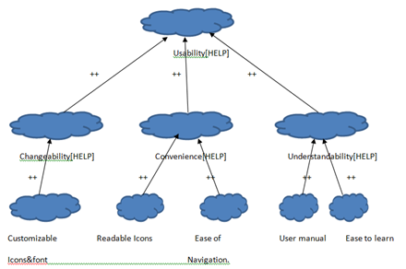

Security:

Reliability
System will provide the accurate and faster responses.

Authentication
HELP system main page contains the password authentication which can be added by the user for his convenience. So, the unknown person cannot use the system.
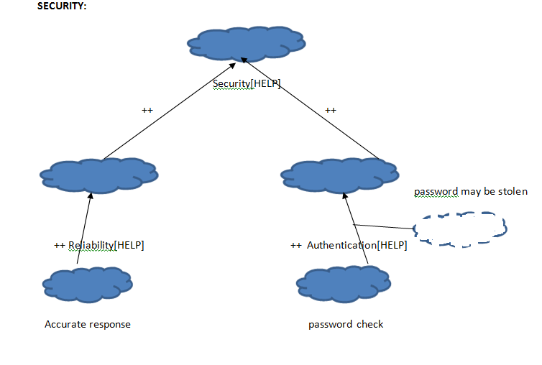

Performance:

Accuracy
HELP is able to provide the accurate results

Responsiveness
All the responses are available within seconds.

Minimum overhead
Navigation through the icons is easier as they are divided into related categories. Searching the required icon takes very less time.
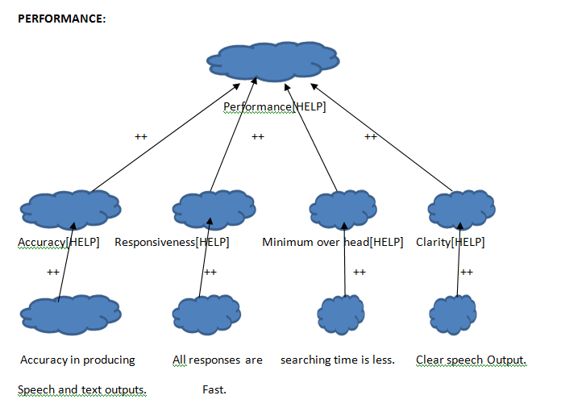

Issues with the improved understanding

DOMAIN REQUIREMENTS

Issue ID+ 001: Incomplete
The user shall know how to use the basic features of the Android phone
Description | This domain requirement does not mention what features of the phone should be known to the user.
Options | Option 1: Knowledge of how various converters like text to speech converter, image to speech converter etc. in the phone work.  Option 2: Knowledge of typing, making calls, and knowing how to navigate between different applications in the phone.  Option 3: Knowledge of the hardware and software components of the phone.
Decision | We choose Option 2 because the basic knowledge of operating a phone is necessary to know how to handle the advanced features of the phone.

Issue ID+002: Ambiguity
The user shall have an Android phone.
Description | This statement does not describe clearly what type of phone needs to be used by the elderly people.
Options | Option 1:The user shall have a Google phone operating on the Android platform.  Option 2:Remove the statement.
Decision | We choose Option 1 because it gives a better specification of the phone to be used.

Issue ID+003: Incomplete
The phone must have an inbuilt microphone to record speech.
Description | This statement does not mention the actual purpose behind having an inbuilt microphone in the phone.
Options | Option 1:The phone must have an inbuilt microphone to record speech and speak out the words to the user in a louder tone.  Option 2: Remove the statement.
Decision | We choose Option 1 because it explains the necessity of the microphone in detail.

FRs

Issue IF+001 – Incomplete, Ambiguity
The speech to text converter will be used to interpret every word spoken by the elderly person.
Description | Does not specify in what format is the output data.
Options | Option 1: Output is a text format and the format can be read by the other person.  Option 2: Output is in audio format and the other person can hear that.  Option 3: Eliminate this statement
Decision | We choose Option 1 because the main task of speech to text converter is to convert every word spoken by the elderly person with unclear speech into a text format and the text should be readable by person assisting the elderly person.

Issue IF + 002 – Incomplete
Object recognition will identify real world objects in front of the elderly person.
The object recognition feature will help elderly people with vision problems to detect presence of objects using SONAR and produces 80-100 dB beep sound to warn the user about the object.
Description | Each of the above functional requirements describes the object recognition feature and none of them is clear in explaining the functionality.
Options | Option 1: Combine both the functional requirements and merge them into one. So that the functionality of object recognition with corresponding inputs and outputs would be clear.  Option 2: Do not combine.
Decision | We choose Option 1 because merging both of them into a single functional requirement explains the functionality of the features as well as inputs and output of the object recognition.

Issue IF + 003 – Incomplete, Ambiguity
The system will help the old people to draft budgets, meet utilities and insurance payment deadlines. There has to be a precise budget that needs to be drafted for the various financial factors considered as it enables them in managing a portion of their finances.
Description | Does not specify various financial factors.  Does not include how the utilities and insurance payments are made.
Options | Option 1: Remove the statement  Option 2: Describe the various financial factors and also explain how the utilities and insurance payments are made.  Option 3: Specify what type of budget it drafts
Decision | We choose Option 2 because the above requirement does not specify that only the factors that earn income in the form of cash will only be considered in drafting a budget, in order to meet deadlines bank accounts need to be linked and payment is done through auto pay.

Issue IF + 004 – Incomplete, Ambiguity
The call for help feature will allow the user to select from the emergency services, family and their assistant and puts them in touch within 10 seconds.
Description | The above statement does not clearly specify how the user selects from emergency service and other emergency services provided
Options | Option 1: User selects by clicking a button and it provides emergency service for 911, family, assistant and doctor.  Option 2: User selects by using voice command.  Option 3: Provides emergency services for friend, relative etc.
Decision | We choose Option 1 because the requirement needs to be more specific where the user clicks on either family, 911, assistant or doctor and emergency service immediately dials to that particular number within 10 seconds.

Issue IF + 005 – Ambiguity
The medical device monitor will allow elderly people to send their vital signs data from remote devices such as a weighing scale, sphygmomanometer and cardio belt to the smart phone via Bluetooth, where it is saved in the same format in which it is received and maintaining the case history of patients.
Description | Does not specify whether vital signs are sent to the doctor and if so in what way the data is sent.
Options | Option 1: Vital sign readings are sent to the doctor using text or email.  Option 2: Vital sign readings are sent to the assistant for review.  Option 3: Vital sign readings must be stored in server.
Decision | We choose Option 1 because vital signs received from the remote device must be sent to the doctor to analyze patient’s history using email or text.

Issue IF + 006 – New Requirement for American Sign Language

Description | The vocabulary should also include sign language icons for people who may not have speech capability at all and may be well versed in American Sign Language (ASL) symbols.
Options | Option 1: Add all American Sign language Symbols and spell them out  Option 2: Add symbols for alphabets A – Z and spell them out  Option 3: Add symbols for A –Z and when clicked display them to text area and spell them out.
Decision | We choose Option 2 because of time and resource constraint.

NFRs

Issue IN+001 – Tradeoff between Ease of Use and Authorized access
Description | There is a tradeoff which we identified between providing unauthorized access and Ease of Use. Guidance should be provided within the NFRs as to how to address this tradeoff
Options | Option 1: Maximize Authorized access at the expense of Ease of Use.  Option 2: Maximize Ease of Use at the expense of Authorized Access  Option 3: Pursue a middle road where both NFRs are satisficed.
Decision | We choose Option 3 because both requirements are necessary and there is a middle of the road approach which allows acceptable Authorized Access as well as Acceptable Ease of Use

Issue IN+002 – Tradeoff between Reliability and Responsiveness
Description | There is a tradeoff which we identified between providing reliability and responsiveness. Guidance should be provided within the NFRs as to how to address this tradeoff
Options | Option 1: Maximize Reliability at the expense of Responsiveness.  Option 2: Maximize Responsiveness at the expense of Reliability.  Option 3: Pursue a middle road where both NFRs are satisficed.
Decision | We choose Option 2 because Responsiveness is given a ++ rating and the customers report that responsiveness is a very important requirement and this can justify a – to reliability since it still doesn’t break the NFR.

Issue IN+003 – Preference for the Android API
Description | The android API is developed to maximize efficiency and provide excellent results. We have not specified in the previous requirements whether we should use it, however.
Options | Option 1:Prefer the Android API for all algorithms  Option 2: Prefer custom algorithms  Option 3: Prefer the Android API for all algorithms where it satisfices all the other NFRs
Decision | We choose Option 3 because it is most important to follow all the NFRs, but if they are satisficed by the Android API then we should prefer that since those algorithms should be quite well made. In addition this decision minimizes unnecessary development time.

Second Improved understanding

DOMAIN REQUIREMENTS
S.No | Requirements Specification | Backward Traceability
WF1 | The user shall have a Google phone operating on the Android platform. | DR1
WF2 | The user shall know how to use the basic features of the Android phone like knowledge of typing, making calls, and knowing how to navigate between different applications in the phone. | DR2
WF3 | The phone must have HELP running on it. | DR3
WF5 | Old people suffering from hearing problem need a speech to text converter | DR4
WF6 | The phone must have an inbuilt microphone to record speech and speak out the words to the user. | DR5
WF7 | The elderly who have trouble hearing need a speech-to-text application to hear well | DR6
WF8 | The images of the frequently used words and relatives are stored in the phone’s memory | DR8, DR9, DR18
WF9 | The elderly who have trouble hearing need a speech-to-image application to understand quickly. | DR7
WF10 | Old people suffering from speech disorders need to be able to use images or icons to ask for help when in need. | DR8, DR9
WF11 | People with extremely unclear vision need things read aloud to them instead of being able to read text. | DR26
WF12 | When two people have problems in oral communication they should use pictogram for communication. | DR14
WF13 | Old people having speech clarity problems would benefit from a system which provides a user interface to type the message they want to express. | DR11, DR10
WF14 | Old people with visual impairments need a camera for object recognition. | DR15, DR17
WF15 | The elderly with vision problems would like obstacles detected at a distance of 2m when they are walking. | DR15
WF16 | The user requires a keypad to type text. | DR25
WF17 | A text to speech application would help people who have trouble speaking clearly. | DR11
WF18 | There should always be a person within 10 meters of the old person to help him. | DR12, DR23
WF19 | The elderly expect their phone to respond to commands within 2 seconds. | DR23
WF20 | The elderly people expect any application to be installed within 30 seconds. | DR2, DR9, DR24
WF21 | It is helpful for an elderly person who is walking to have a warning within 80-100 dB if there is an obstacle. | DR16
WF22 | The user expects the charge on their phone to last for at least one day. | DR2
WF23 | Elderly people prefer to use applications which are user friendly. | DR2, DR13, DR22
WF24 | The user prefers systems which never crash. | DR2

Functional Requirements
S.No | Requirements Specification | Backward Traceability
FR001 | Elderly people use HELP to communicate effectively with other people and perform their day to day activities without a frustrating level of difficulty. | FR1
FR002 | The Speech to text converter will help the person that communicates with the elderly person to interpret every word spoken by the elderly person in a text format. | FR2
FR003 | The speech to image converter will help the user with hearing problems to understand the meaning of words spoken by another person. | FR3
FR004 | Elderly people with speech clarity difficulty shall use image to speech converter to convey messages corresponding to day to day activities to people within 5 meters. | FR4
FR005 | An elderly person with unclear speech shall use text to speech converter to express messages to people within 5 meters. | FR5
FR006 | Object recognition will identify real world objects present in front of elderly person with vision problems and give a warning message about the object to the elderly person. Objects are detected using SONAR and produce a 100 dB beep sound to warn the elderly person about the object. | FR6, FR7
FR007 | The photo album feature will store photos of relatives and friends of the user so that the user can browse and select the person they cannot recognize and the name and customizable description of the person is displayed. | FR8
FR008 | The medication assistant shall remind the user to take their medicines by displaying the name or image of the medicine at the time prescribed by the doctor. | FR9
FR009 | The HELP System will help the elderly people to draft budgets, meet utilities and insurance payment deadlines. There has to be a precise budget that needs to be drafted for various financial factors like monthly cash income received by the elderly person as it enables elderly person in managing a portion of their finances. Bank accounts are linked to this feature to meet utilities and insurance payment deadlines using auto pay. | FR10
FR010 | Emergency service features shall help the elderly person to call 911, family, doctor and assistant in case of emergency using a button click rather than searching for the contact or dialing the number of person within 10 seconds. | FR11
FR011 | The medicine device monitor will allow elderly people to send their vital signs data from remote devices such as weighing scale, sphygmomanometer and cardio belt to the smart phone via Bluetooth, where the data is saved in the same format in which it is received and then data is sent to the doctor via sms or email. Data of the vital signs is stored in the smart phone to analyze the case history of patients. | FR12
FR012 | The blackboard facility shall help a user to type in text messages or selects an image which conveys their exact meaning. | FR13
FR013 | Elderly people with no speech capability or unclear speech and well versed in ASL can use symbols to spell out the alphabets on clicking the particular alphabet symbol. | FR4

Non-Functional Requirements
S.No | Requirements Specification | Backward Traceability
NFR001 | The speech-to-text converter should be able to convert spoken words to text within 10 seconds. | NFR1
NFR002 | The output audio should be without noise interference and be output within a 1 second delay. | NFR2
NFR003 | Conversion from speech to image must be done within 2 seconds. | NFR3
NFR004 | The system should be able to detect words spoken by the user at 60 dB and convert them to images within 2 seconds. | NFR4
NFR005 | All sound produced by the system will be within 80-100 dB. | NFR5
NFR006 | Any image icon when clicked should read its functionality aloud within 2 seconds. | NFR6
NFR007 | Conversion from text to speech must take place within 10 seconds. | NFR7
NFR008 | The output audio from the system should be able to be heard correctly at least 99% of the time and the speed should not exceed 100 words per minute to the elderly people. | NFR8
NFR009 | The font should be re-sizable within the range of 12 to 30 according to the user’s convenience. | NFR10
NFR010 | Object detection should identify an object within 22 meters with 99% accuracy. | NFR11
NFR011 | The retrieval of the photos should take place within 0.5 seconds. | NFR12
NFR012 | The system should allow storage for at least 2 photos to identify a contact, pet or object. | NFR13
NFR013 | The reminder should be sounded within 2 seconds of the time scheduled for medicine. | NFR14
NFR014 | The phone should never display the wrong medicine image. | NFR15
NFR015 | The news provided by the system should be no more than 3 days old. | NFR16
NFR016 | Financial Budgets should be drafted up to 3 digits after the decimal point. | NFR17
NFR017 | All details provided to the system by the user should be secure from access for which they did not give permission. | NFR18
NFR018 | The financial assistant should manage financial assets such that calculations are precise to 4 decimal points, and date format is MMM DD YYYY. | NFR19,NFR20
NFR019 | The financial assistant will manage investments since 1900 so as to maintain current financial status. | NFR19,NFR20
NFR020 | The readings from Bluetooth medical devices should match the data which was read by the device 99.99% of the time. | NFR21,NFR22
NFR021 | The user interface should be rated 4.5 out of 5 or higher when given to elderly people. | NFR21
NFR022 | Vital signs data should be transferred from the medical device to the Android phone within 30 seconds. | NFR22
NFR023 | The blackboard application should allow the user to communicate their idea using fewer than 5 key-presses 90% of the time. | NFR24
NFR024 | The elapsed time between the click of an icon and the sound generation should be less than 1 second. | NFR6
NFR025 | Emergency calls should be completed within 10 seconds. | NFR25
NFR026 | The password protection shall be rated a 4.5 out of 5 in ease of use. | NFR021
NFR027 | The password protection shall prevent unauthorized access by a determined attacker. | NFR017
NFR028 | Any calculations performed by the system shall be done in the background to prevent the UI from becoming unresponsive. | NFR003, NFR011, NFR013
NFR029 | Algorithms chosen for the calculations shall be the most efficient possible to maximize responsiveness to the user. | NFR003, NFR011, NFR013
NFR030 | Algorithms which are provided by the Android system shall be preferred to custom applications unless they do not meet one of the other NFRs. | NFR003, NFR011, NFR013

PRELIMINARY PROTOTYPE AND USER MANUAL
This section describes an early understanding of the screens of the HELP system. It describes the pages in a way that is helpful to let the users understand an early concept of the system.

MAIN MENU
The main menu provides the user with a high level option to select the area in which they are seeking assistance. The options provided are “Sight”, “Hearing”, “Speaking”, ‘Memory” and “Everyday Living”

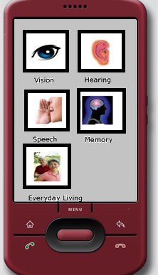

VISION
Under sight there would be broken down all the possible functions for assisting those with vision difficulty. This page includes the options to detect the distance of objects for the blind and object identification for those with difficulty seeing.
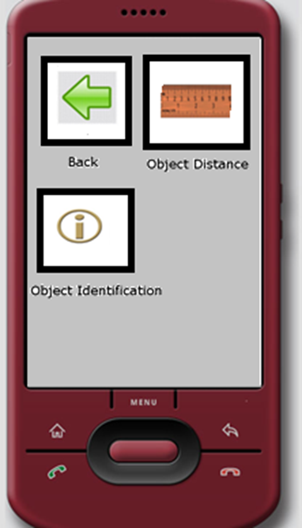

HEARING
Under hearing there would be broken down all the possible functions for assisting those with hearing problems. Options include a sound amplifier and a blackboard so the user and a companion can communicate by typing.
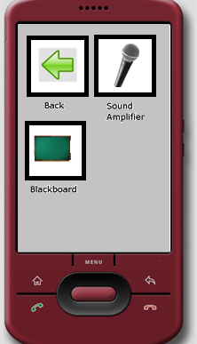

SPEAKING
Speaking includes the functions for communication assistance. This section also includes the blackboard function as well as text to speech and text to image options.
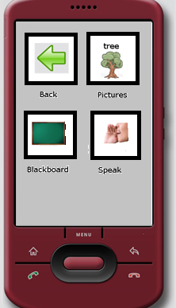

MEMORY
The memory section includes all the functionality to assist those with trouble remembering. Options under memory includes family photos and the medication assistant.
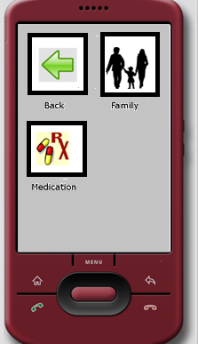

EVERYDAY LIVING
The everyday living section includes the functions which are useful to help the user in their everyday life but do not result from a specific difficulty. This section includes the financial assistance tool, call-for-help function, and the medical device monitor.
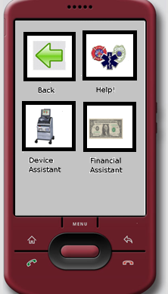

Improved understanding of the Preliminary Prototype and User Manual

MAIN MENU
The main menu allows you to select between the features which are implemented in the HELP system version 1.0. You can choose the following menu items:
Emergency
Text to speech
Speak it! (Image to speech)
Photo album
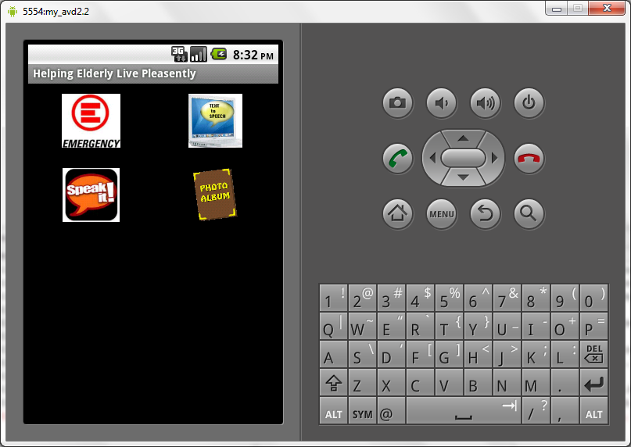

TEXT TO SPEECH CONVERTOR
The text to speech converter allows you to enter any text you would like to communicate and it will speak it out loud. You have the option to select the rate at which you would like the convertor to speak as well as the language which you are typing to improve the pronunciation.
Instructions for using the Text to speech convertor:
- Enter the text you would like to speak in the box
- Press the Speak button
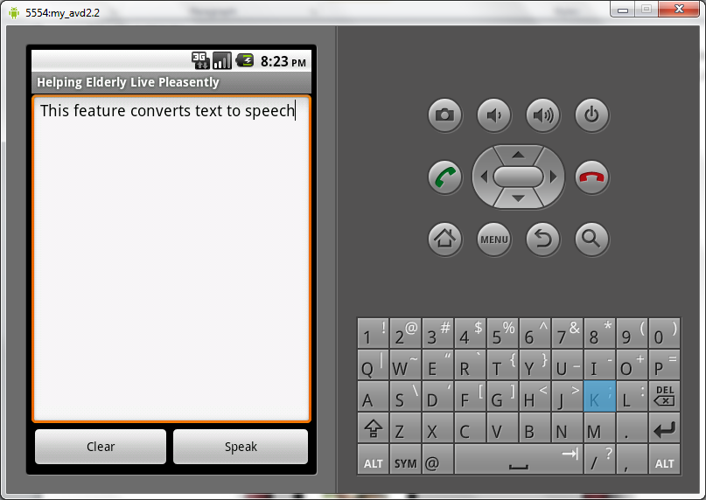
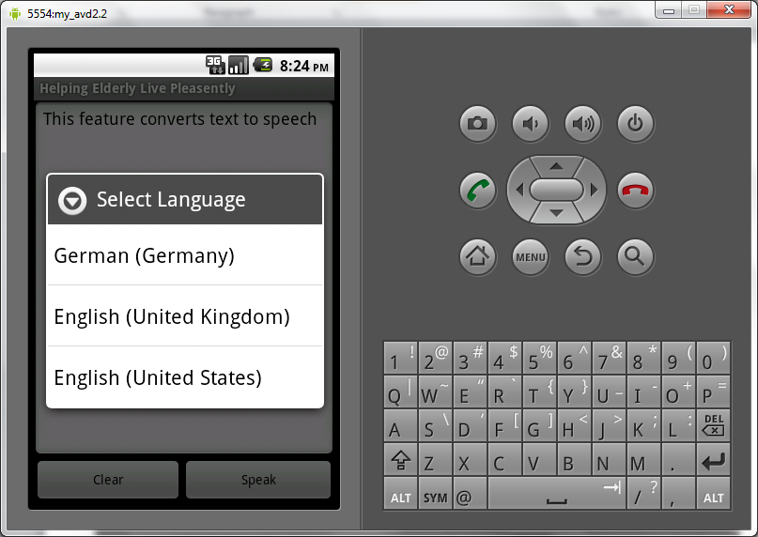
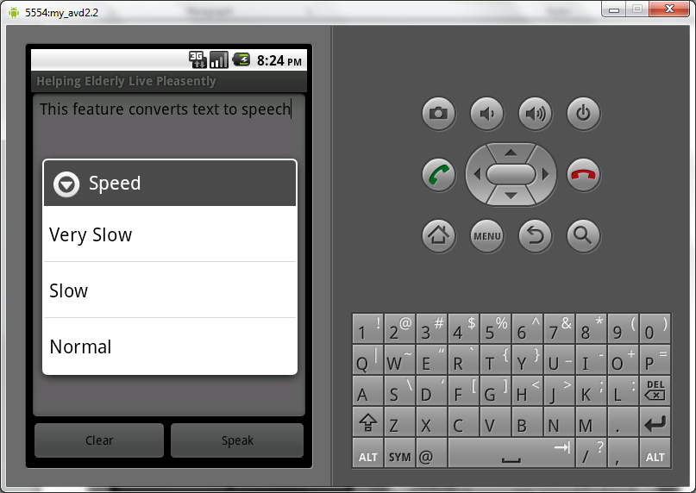
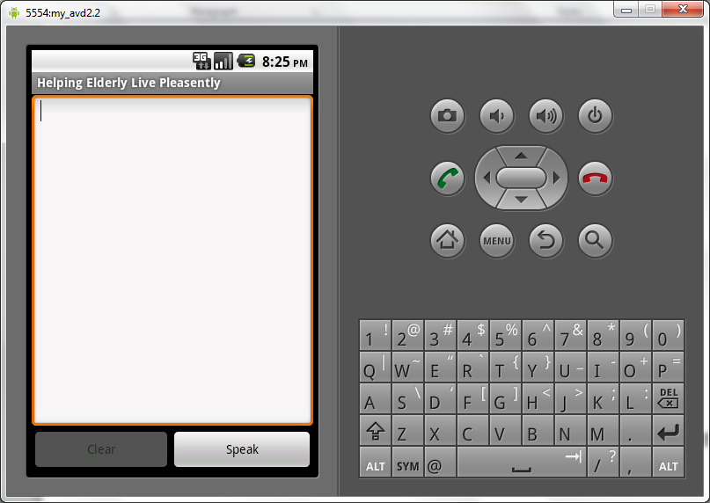

Emergency Services
This service is used in emergency situations to call
- 911
- Assistant
- Doctor
- Family
For example: If the elderly person or the person with disabilities is suffering from severing chest pain then user can use this service to call 911 and notify them. User can just click on the icon instead of dialing 911.
Emergency Screen which has four options embedded in it. They are
- 911
- Assistant
- Doctor
- Family
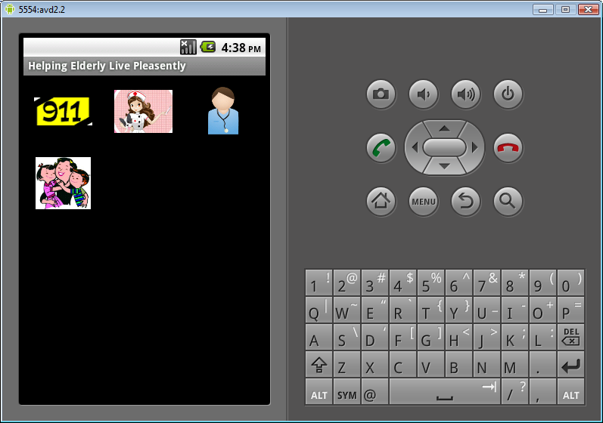

Click on 911 Icon will start calling 911
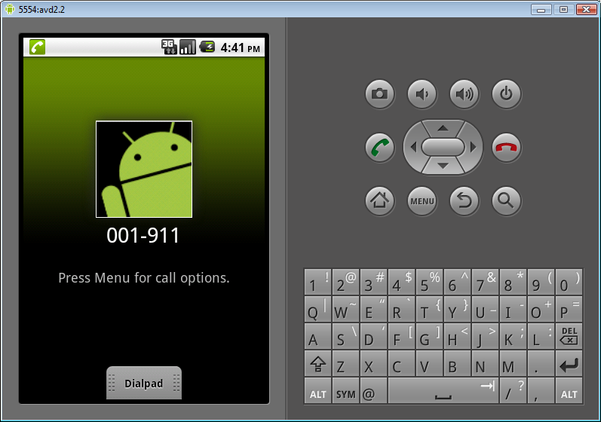
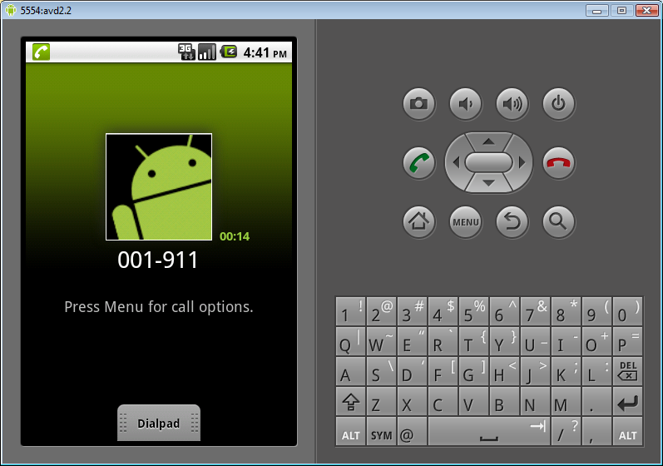
Clicking on Assistant Icon will start dialing Assistant contact that is already saved in Contact list
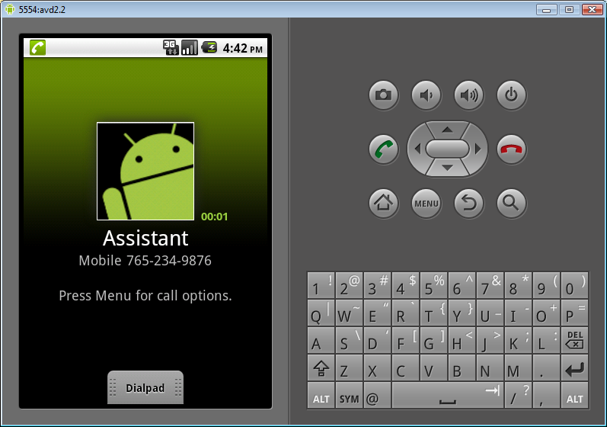
Clicking on Doctor Icon will call Doctor
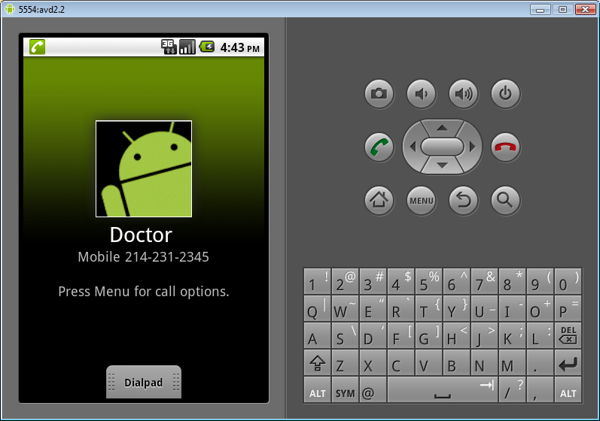
Clicking on Family Icon will start calling Family.
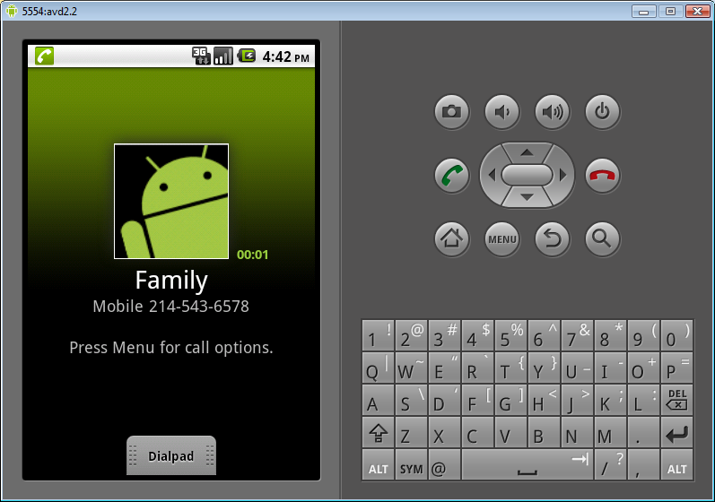

IMAGE TO SPEECH CONVERSION
The image to speech feature allows you to select common phrases to speak. Phrases are organized by category. To start, select from Daily Living, Greetings, Miscellaneous or sign language.
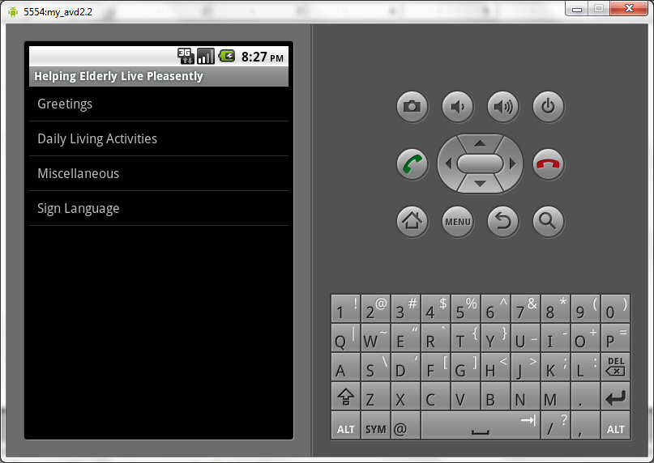
Daily Living allows you to say common greetings and phrases such as Hello, Goodbye, and Thank you.
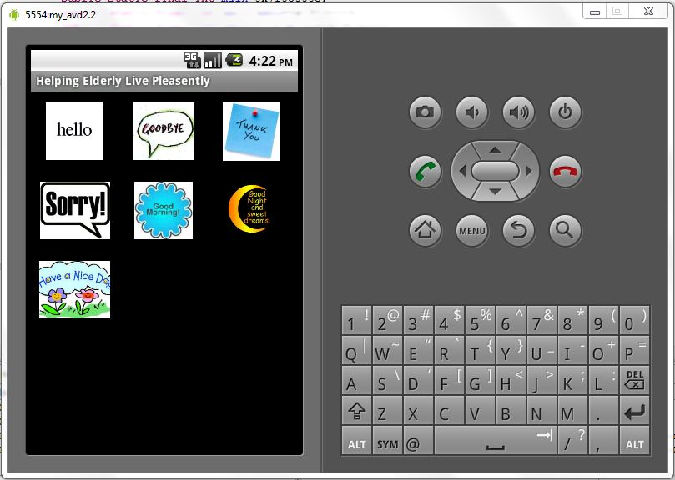
Daily living allows you to say things such as water, going to the bathroom and asking for your medicine.
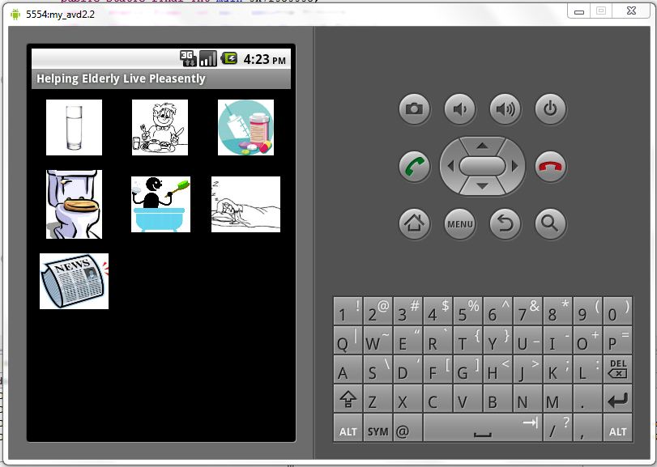
Miscellaneous allows you to ask for such things as coffee, beer, poker, or church.
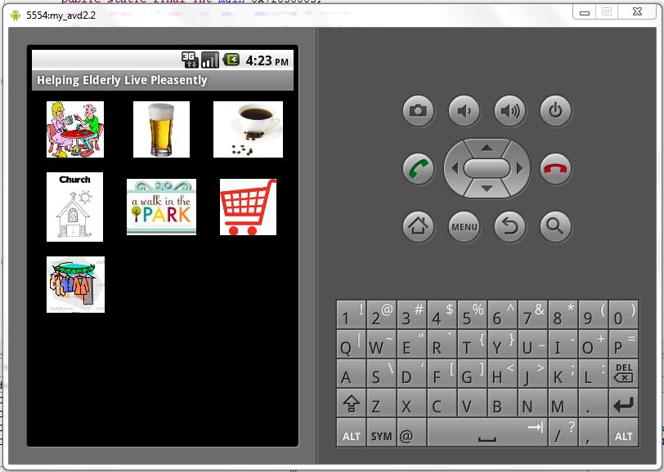
Sign language is for people who would prefer to use sign language icons instead of pictures. It allows you to type out any message which you could do using the letter hand symbols in American Sign Language.
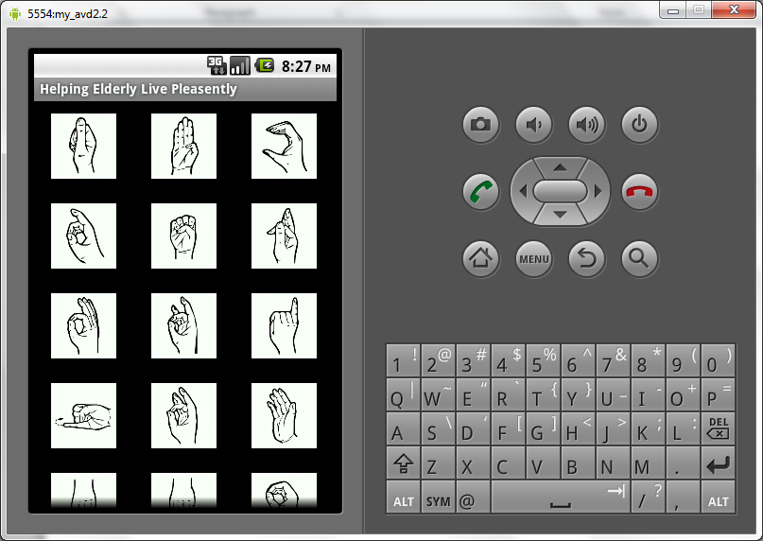

Photo Album
The photo album allows you to keep photos of all the people you interact with and keeps a short description of them so you can remember them easily. It also keeps and displays their name.
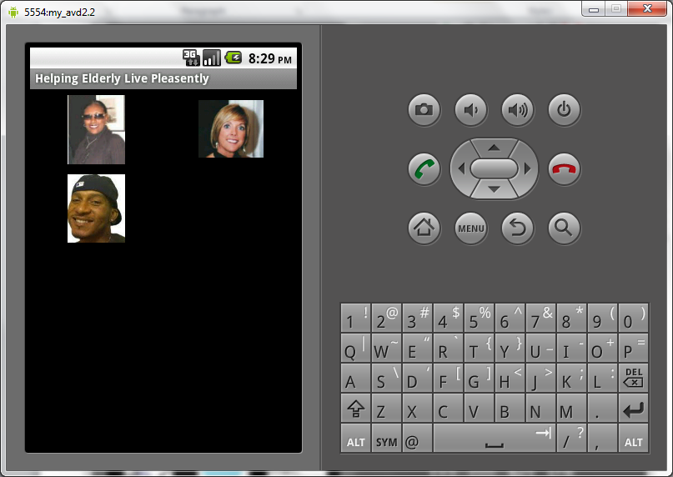
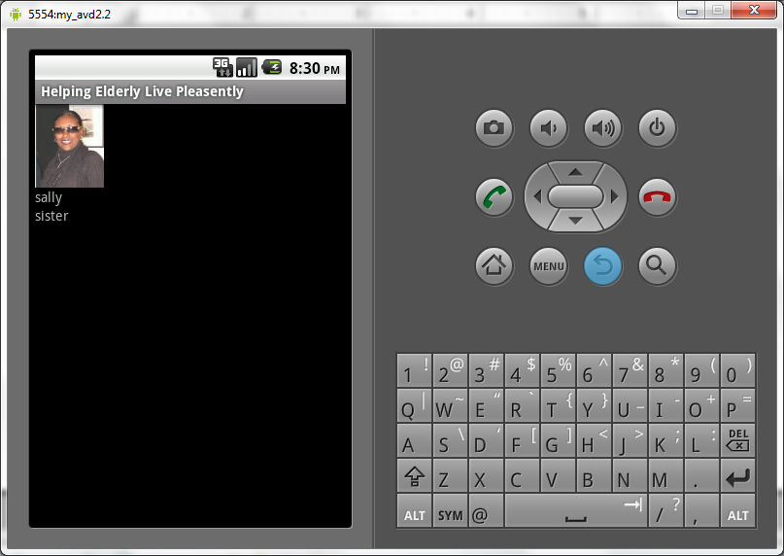

TRACEABILITY
This section describes the traceability of our requirements analysis.
 | DR1 | DR2 | DR3 | DR4 | DR5 | DR6 | DR7 | DR8 | DR9 | DR10 | DR11 | DR12 | DR13 | DR14 | DR15 | DR16 | DR17 | DR18 | DR19 | DR20 | DR21 | DR22 | DR23 | DR24 | DR25 | DR26
FR1 | X | X | X | X | X | X | X | X | X | X | X | X | X | X | X | X | X | X | X | X | X | X | X | X | X | X
FR2 | X | X | X | X | X | X | X | X | X | X | X | X | X | X | X | X | X | X | X | X | X | X | X | X | X | X
FR3 | X | X | X |  | X | X |  |  |  |  |  | X
FR4 | X | X | X |  | X |  | X |  |  |  |  | X
FR5 | X | X | X |  |  |  |  | X | X | X | X | X | X | X
FR6 | X | X | X |  |  |  |  |  |  |  | X | X |  |  |  |  |  |  |  |  |  |  |  |  |  | X
FR7 | X | X | X |  | X |  |  |  |  |  |  |  |  |  | X | X
FR8 | X | X | X |  | X |  |  |  |  |  |  |  |  |  | X | X | X
FR9 | X | X | X |  |  |  |  |  |  |  |  |  |  |  |  |  |  | X
FR10 | X | X | X | X |  |  |  |  |  |  |  |  |  |  |  |  |  |  | X
FR11 | X | X | X |  |  |  |  |  |  |  |  |  |  |  |  |  |  |  |  | X | X | X
FR12 | X | X | X | X |  |  |  |  |  |  |  |  |  |  |  |  |  |  |  |  |  |  | X
FR13 | X | X | X |  |  |  |  |  |  |  | X | X |  |  |  |  |  |  |  |  |  |  |  | X
FR14 | X | X | X |  |  |  |  | X | X | X | X | X | X |  |  |  |  |  |  |  |  |  |  |  | X
NFR1 | X | X | X |  | X | X |  |  |  |  | X | X
NFR2 | X | X | X | X |  |  |  | X | X | X | X | X |  |  |  |  |  |  |  |  |  |  |  |  |  | X
NFR3 | X | X | X |  | X |  |  |  |  |  |  | X
NFR4 | X | X | X |  | X |  |  |  |  |  |  | X
NFR5 | X | X | X | X |  |  |  | X | X | X | X | X |  |  |  |  |  |  |  |  |  |  |  |  |  | X
NFR6 | X | X | X | X |  |  |  | X | X | X | X | X
NFR7 | X | X | X | X |  |  |  |  |  |  | X | X |  |  |  |  |  |  |  |  |  |  |  |  |  | X
NFR8 | X | X | X | X | X | X | X | X | X | X | X | X |  |  |  |  |  |  |  |  |  |  |  |  |  | X
NFR9 | X | X | X | X |  |  |  | X | X | X | X | X |  |  |  |  |  |  |  |  |  |  |  |  |  | X
NFR10 | X | X | X |  |  | X |  |  |  |  | X |  |  |  |  |  |  |  |  |  |  |  |  |  | X | X
NFR11 | X | X | X |  |  |  |  |  |  |  |  |  |  |  | X | X | X
NFR12 | X | X | X |  |  |  |  |  |  |  |  |  |  |  |  |  |  | X
NFR13 | X | X | X |  |  |  |  |  |  |  |  |  |  |  |  |  |  | X
NFR14 | X | X | X | X |  |  |  |  |  |  |  |  |  |  |  |  |  |  | X
NFR15 | X | X | X |  |  |  |  |  |  |  |  |  |  |  |  |  |  |  | X
NFR16 | X | X | X | X
NFR17 | X | X | X |  |  |  |  |  |  |  |  |  |  |  |  |  |  |  |  | X | X | X
NFR18 | X | X | X |  |  |  |  |  |  |  |  |  |  |  |  |  |  |  |  | X | X | X
NFR19 | X | X | X |  |  |  |  |  |  |  |  |  |  |  |  |  |  |  |  | X | X | X
NFR20 | X | X | X |  |  |  |  |  |  |  |  |  |  |  |  |  |  |  |  | X | X | X
NFR21 | X | X | X |  |  |  |  |  |  |  |  | X |  |  |  |  |  |  |  |  |  |  |  | X
NFR22 | X | X | X |  |  |  |  |  |  |  |  | X |  |  |  |  |  |  |  |  |  |  |  | X
NFR23 | X | X | X |  |  |  |  | X |  |  | X |  | X | X
NFR24 | X | X | X | X |  |  |  | X |  |  | X | X
NFR25 | X | X | X | X |  |  |  | X |  |  | X |  |  |  |  |  |  |  |  |  |  |  | X

APPENDIX A- WHY IS OUR PROJECT BETTER?

- HELP system caters all disabilities like Vision, Hearing, Speaking and Memory. We have gone a step ahead and added features like the Finance Planner and Medical Device Monitor taking into account the limitations in finances and mobility of the elderly.
- Systematic decision making has been carried out in each phase of our project. As a team we all have had many different views and opinions. We considered all options, did trade off analysis and Prioritized tasks based on resource considerations before taking any decision.
- Traceability has helped us ensure correctness of the system. We have maintained forward and backward traceability between domain assumptions and functional requirements as well as domain assumptions and nonfunctional requirements.
- In order to address changing requirements and to aid the evolution of the project in interim phases, the Spiral Model has been used for requirements elicitation, analysis, specification and validation.
- We have used the Pareto principle (also known as 80-20 rule) which advocates the idea that 20% of the inputs are responsible for the 80% of the generated results.
- We have exercised Version Control by using Tortoise SVN to control and coordinate changes that have been done by all the team members.
Thus, we believe HELP system will solve problems and help stakeholders achieve their goals.
Key Features of HELP:
- Emergency Service feature helps the elderly person call 911, family, doctor and or an assistant in case of emergency by just a click of a button, instead of searching/dialing a number. This helps save precious time which is a crucial necessity in case of emergency situations.
- At times when the doctor needs to check the Blood-pressure and Heart-rate, the elderly people make frequent visits to the doctor. This can be an overhead as there are situations when these tests need to be done on a regular basis. This can now be done at the comfort of home using the Medical Device Monitor feature provided by the HELP system. Using this feature, the vital sign readings from the sphygmomanometer, cardio-belt and weighing machine will be read via Blue-tooth and can be sent to the doctor as an e-mail/message.
- Managing finances efficiently is of vital importance. Many elderly people may not have a regular monthly income. Even if they do, they may not be able to manage finances and draft budgets taking into account all their available resources efficiently due to the disabilities that come with age. Our HELP system provides a Finance Planner feature to help them manage their finances efficiently.
- Along with old age there is a gradual increase in health related problems and the elderly might require medications on a regular basis. But due to problems like degradation in memory capabilities, it might be difficult to remember taking these medicines on time which could have a negative effect on their health. Our HELP system provides the Medication Reminder feature, in which one can set the name, image and the time at which a particular medicine has to be taken.
- Loss of memory is a very common problem among the elderly. In some cases, it is difficult for them to even remember their family members, friends and relatives. HELP provides the Photo Album feature in which one can easily store pictures of kith and kin, places they might visit periodically, things that they might use and so on along with details. These stored pictures in the album can be easily accessed by the elderly even and help them recognize people/things/places easily.
- We have Sign Language icons for people who may not have speech capability at all and may be well versed in American Sign Language (ASL) symbols.

APPENDIX B - FUTURE SCOPE:

- As our HELP system has certain intrinsic features it will be useful for the on-going research in the lab.
- Taking into account limited resources like manpower and time, we will implement the remaining key features like medication reminder, medical device monitor, the financial planner and the others listed above.
- The system will save and present at least the last 5 phrases/words constructed by the user through the system, conveniently from the main screen.
- To allow personalization, the users/assistive persons will be able to associate their own text/name to an icon/image in the system and also be able to set the size of the icons on the screen.

APPENDIX C – MINUTES OF MEETING

Date: September 7th 2010
Location: EECS 4th Floor
Time: 8.00 p.m – 10.00 p.m
Total time: 120 minutes
Agenda: SRS Template, Initial Requirements (Domain, Functional and Non-Functional)
Participants:
- Amruta
- Ashok
- Deena
- Jayashree
- Sindhuja
- Supriya
- Ryan
- Sahana
- Prathiba
Summary: Discussed and finalized the SRS template, Choosing the type of Model and finalized the model for process and requirements. Allocation of Modules to respective team sub groups.

Date: September 14th 2010
Location: EECS 4th Floor
Time: 8.00 p.m -10.30 p.m
Total time: 150 minutes
Agenda: Discussing the Issue Statements and coming up with improved Requirements (Domain, Functional and Non-Functional)
Participants:
- Amruta
- Ashok
- Deena
- Jayashree
- Sindhuja
- Supriya
- Ryan
- Sahana
- Prathiba

Summary: Brainstorming based on Role Play(Domain Experts, Requirement Engineers, End User and Software Engineer) on the initial set of requirements to come up with an improvised version of them.

Date:September 20th 2010
Location: EECS 4th Floor
Time: 8.00 p.m -10.10 p.m
Total time: 130 minutes
Agenda: Reviewed Individual Sub Team Documentation and Integrated a rough draft of the SRS Document Template

Participants:
- Amruta
- Ashok
- Deena
- Jayashree
- Sindhuja
- Supriya
- Ryan
- Sahana
- Prathiba
Summary: Each team was allotted a certain set of requirements to work on, and a peer review of their work was conducted. On complete agreement, the rough draft of the SRS was integrated taking into account the feedback of all team members.

Date: September 28th 2010
Location: EECS 4th Floor
Time: 8.00 p.m -10.00 p.m
Total time: 120 minutes
Agenda: Preparing the Presentation, Finalising the SRS Document

Participants:
- Amruta
- Ashok
- Deena
- Jayashree
- Sindhuja
- Supriya
- Ryan
- Sahana
- Prathiba
Summary: The members of the group were in turn divided into sub groups and allocated specific modules to come up with for the presentation. The SRS Document was finalized.

Date: September 29th 2010
Location: EECS 4th Floor
Time: 1.00 p.m -3 p.m
Total time: 120 minutes
Agenda:Presentation Mock Up,Document Review Cycle 2

Participants:
- Amruta
- Ashok
- Deena
- Jayashree
- Sindhuja
- Supriya
- Ryan
- Sahana
- Prathiba
Summary: The works of the individual team members were posted onto the groups and aggregated. The template for the presentation was agreed upon and the final presentation was brought to the meeting. A Mock up presentation was carried out and the Final SRS document was given a High End Review.

Date: October 14th 2010
Location: EECS 4th Floor
Time: 1.00 p.m -3 p.m
Total time: 120 minutes
Agenda: Improvising phase 1 document, Justification of why we are better

Participants:
- Amruta
- Ashok
- Deena
- Jayashree
- Sindhuja
- Supriya
- Ryan
- Sahana
- Prathiba
Summary: Each team member has been allotted a subsection of the document to make modifications and improve them. Discussed the important topics on which our main focus needs to be, and what information needs to be part of few subsections. Our major focus was on the Justification of the project.

Date: October 19th 2010
Location: EECS 4th Floor
Time: 1.00 p.m -3 p.m
Total time: 120 minutes
Agenda: Integrated all modifications, reviewed the document

Participants:
- Amruta
- Ashok
- Deena
- Jayashree
- Sindhuja
- Supriya
- Ryan
- Sahana
- Prathiba
Summary: The works of the individual team members were posted onto the groups and aggregated. The final document was brought to the meeting. Each team member has been assigned a section of the document to be reviewed. Upon acceptance of each section after review, the final document has been finalized.

Date: October 28th 2010
Location: EECS 4th Floor
Time: 8.00 p.m – 10.00 p.m
Total time: 120 minutes
Agenda: Vision Document, Process specification, Implementation of the system
Participants:
- Amruta
- Ashok
- Deena
- Jayashree
- Sindhuja
- Supriya
- Ryan
- Sahana
- Prathiba
Summary: Discussed and finalized the features to be implemented for this phase and about the vision document. Allocation of Modules to respective team sub groups.

Date: November 4th 2010
Location: EECS 4th Floor
Time: 8.00 p.m – 10.00 p.m
Total time: 120 minutes
Agenda: Vision Document, Process specification, Implementation of the system
Participants:
- Amruta
- Ashok
- Deena
- Jayashree
- Sindhuja
- Supriya
- Ryan
- Sahana
- Prathiba
Summary: Discussed about the implementation of the system for this phase and about the vision document. Allocation of Modules to respective team sub groups.

Date: November 9th 2010
Location: EECS 4th Floor
Time: 8.00 p.m – 10.00 p.m
Total time: 120 minutes
Agenda: Vision Document, Process specification, Implementation of the system
Participants:
- Amruta
- Ashok
- Deena
- Jayashree
- Sindhuja
- Supriya
- Ryan
- Sahana
- Prathiba
Summary:Went through the implementation of the system and discussed about the vision document. Planned the schedule for the next meeting.
Date: November 16th 2010
Location: EECS 4th Floor
Time: 8.00 p.m – 10.00 p.m
Total time: 120 minutes
Agenda: Vision Document, Process specification, Implementation of the system,WRS
Participants:
- Amruta
- Ashok
- Deena
- Jayashree
- Sindhuja
- Supriya
- Ryan
- Sahana
- Prathiba
Summary: Discussed about the diagrams to be drawn in process and product specification, reviewed the demo for implementation of the system for this phase. Allocation of Modules to respective team sub groups.
Date: November 23rd 2010
Location: EECS 4th Floor
Time: 8.00 p.m – 10.00 p.m
Total time: 120 minutes
Agenda: Presentation, Vision Document, Process specification, WRS, Preliminary Plan
Participants:
- Amruta
- Ashok
- Deena
- Jayashree
- Sindhuja
- Supriya
- Ryan
- Sahana
- Prathiba
Summary: Allocation of slides for the presentation to respective team sub groups and reviewed the diagrams drawn in the process specification.
Date: November 29th 2010
Location: EECS 4th Floor
Time: 8.00 p.m – 11.00 p.m
Total time: 220 minutes
Agenda: Presentation, Vision Document, Process specification, WRS, Preliminary Plan, Implementation of the system
Participants:
- Amruta
- Ashok
- Deena
- Jayashree
- Sindhuja
- Supriya
- Ryan
- Sahana
- Prathiba
Summary: Proof read all documents and checked the working of the final prototype and also discussed the final presentation

