OMNISOFT Distributed Meeting Scheduler System
Final Project Phase 2.2

User Manual
Version 2.0
Requirements Engineering
Team Website: http://www.utdallas.edu/~nml061000

Team – The Steelers

Rutvij Desai (rsd081000@utdallas.edu)
Michael Hale (mah056000@utdallas.edu)
Wanjun Huang (wxh063000@utdallas.edu)

Nelson Lopez (nml061000@utdallas.edu)

Malini Srinivasan (mxs076200@utdallas.edu)

Sai Prasanth Sridhar (sps076000@utdallas.edu)

Limin Tang (lxt064000@utdallas.edu)

Dr. Lawrence Chung
CS 6361 – Advanced Requirements Engineering
University of Texas at Dallas
Spring 2010

Table of Contents
Screen Shots:- 3
LOGIN PAGE 3
2. USER REGISTRATION (NEW USER) 4
3. Home Screen: 5
4. Created Meetings 6
4a.Create a Meeting (1) 7
4b.Create Meeting (2) 8
5. Edit a Meeting 9
6. Edit Profile Information 10
7. Edit Preference Sets: 11
8. Edit Exclusion Sets: 12
9. Edit Response Information 13
10. Logout Page 14
11. Search for Contact page 15
Screen Shot Descriptions:- 16

Screen Shots:-

LOGIN PAGE

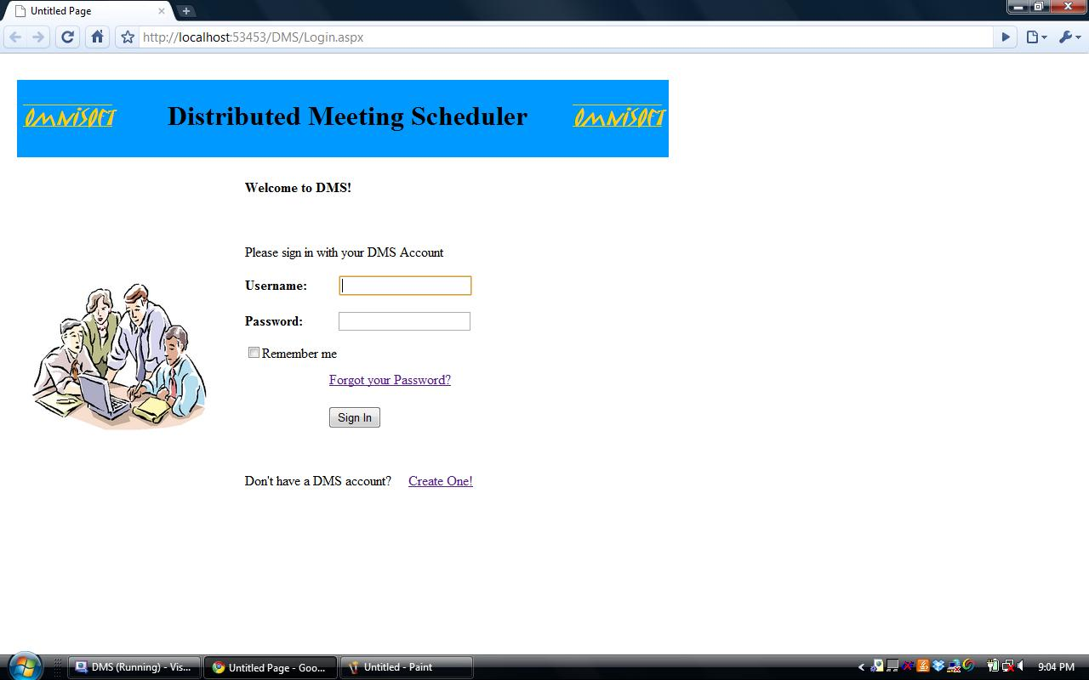

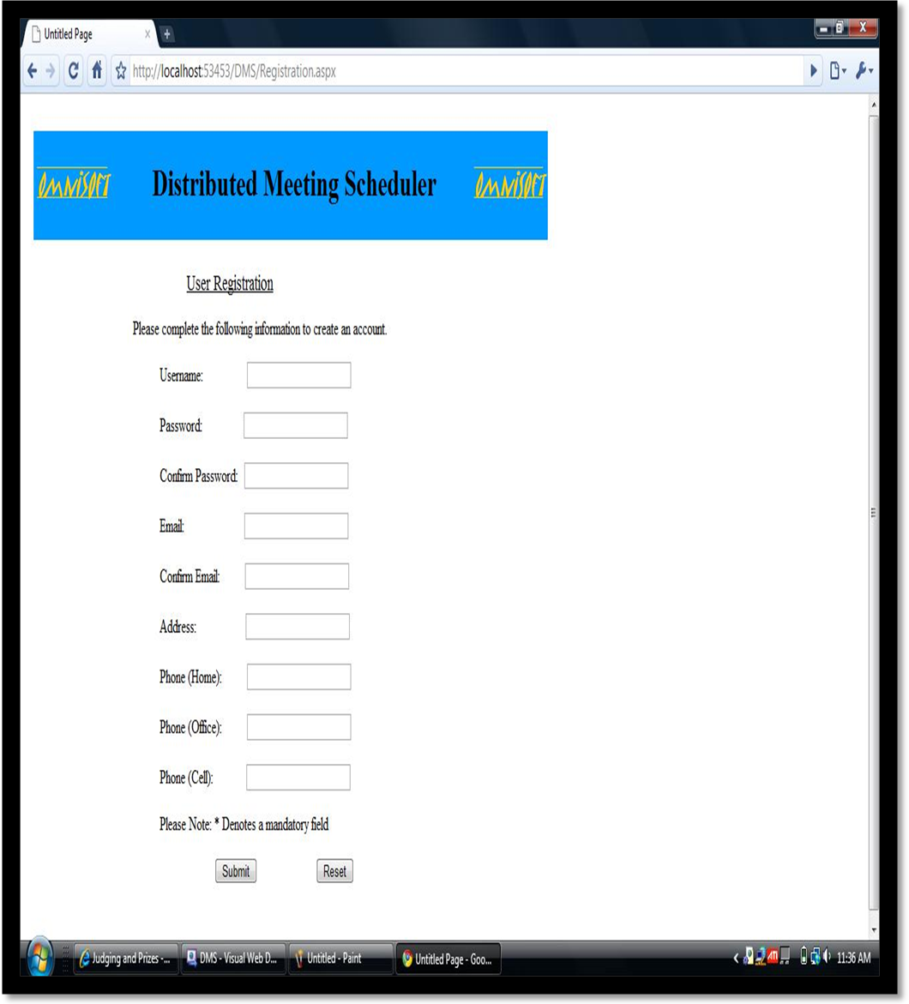
2. USER REGISTRATION (NEW USER)

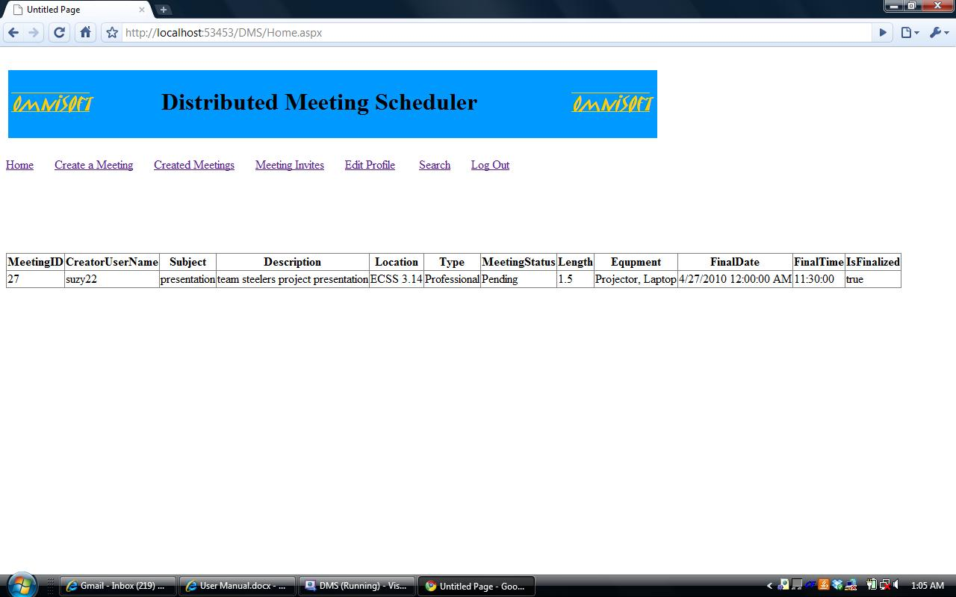
3. Home Screen:

4. Created Meetings
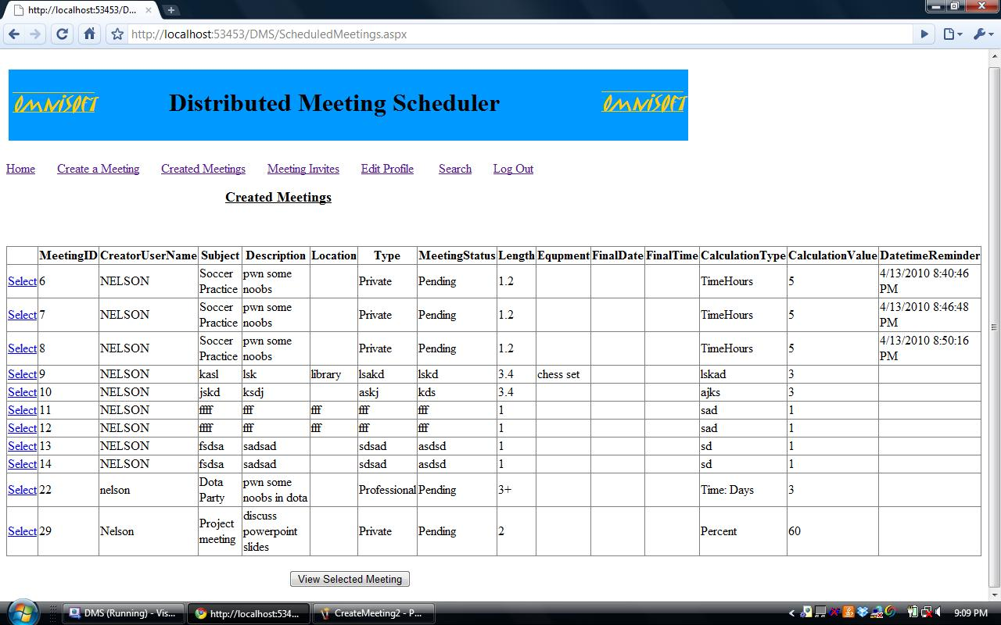

4a.Create a Meeting (1)
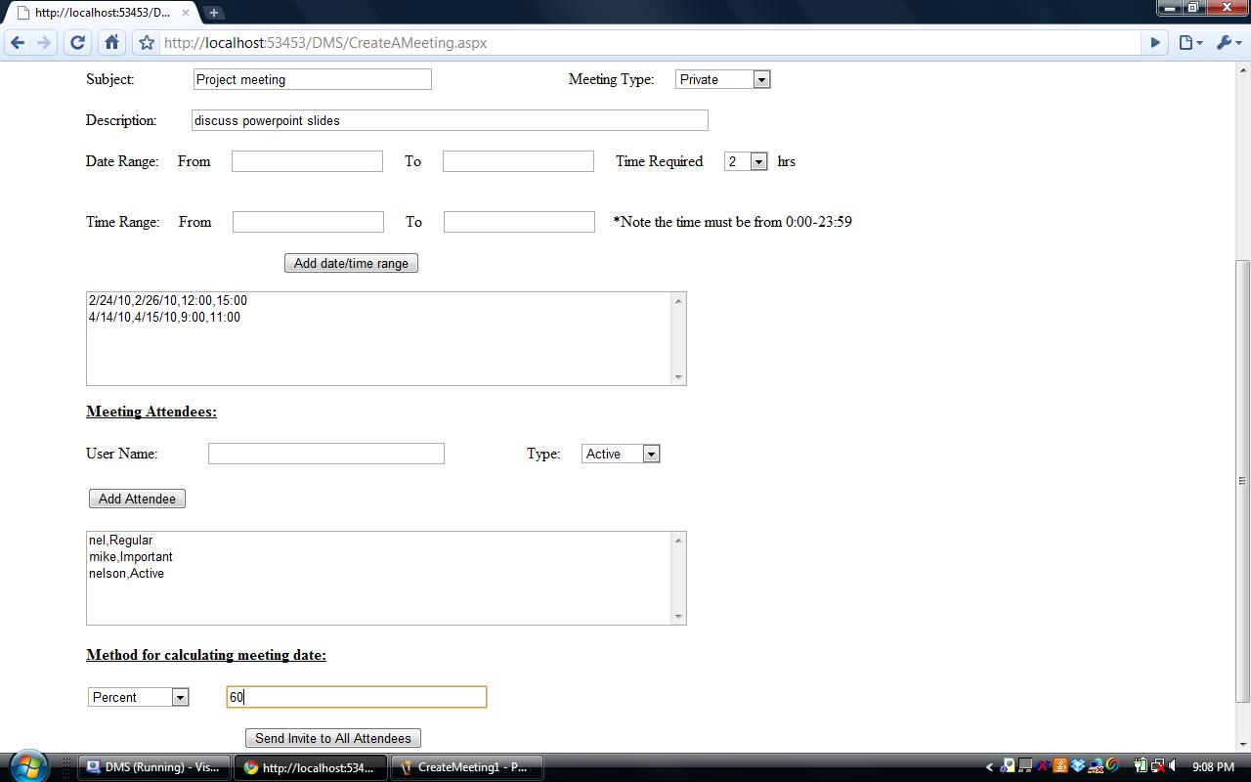
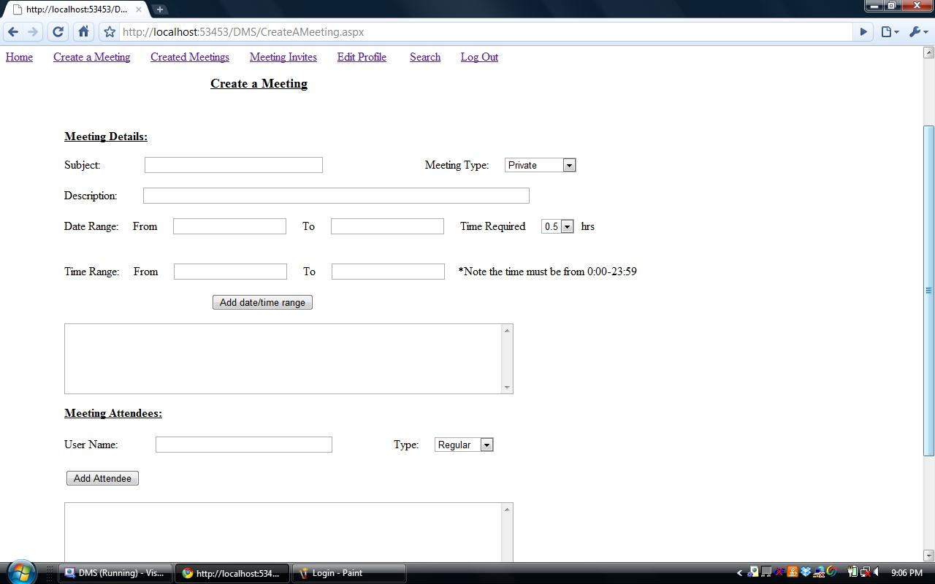

4b.Create Meeting (2)

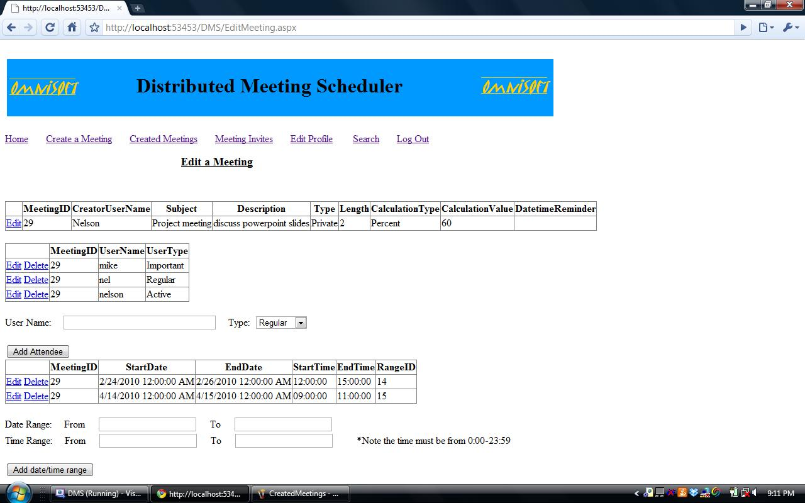
5. Edit a Meeting

6. Edit Profile Information
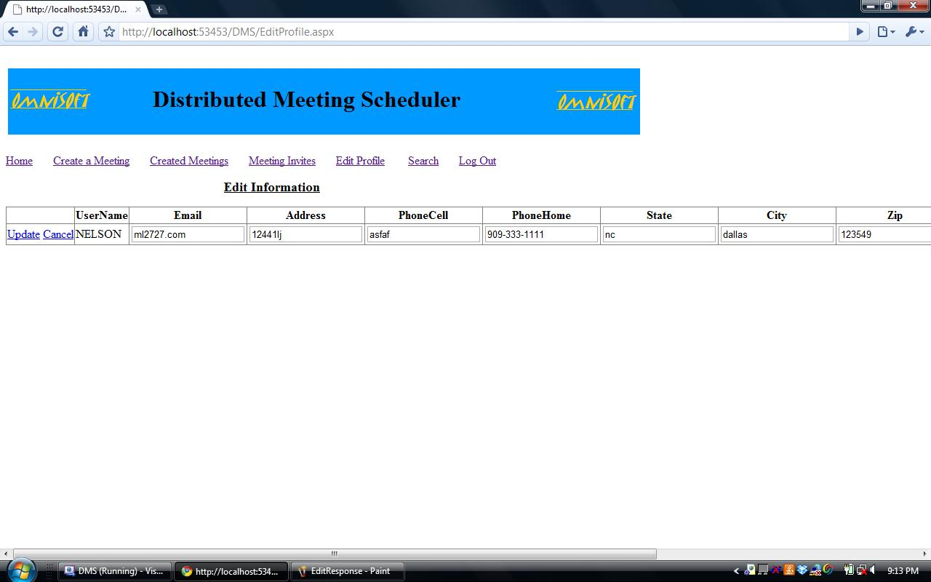

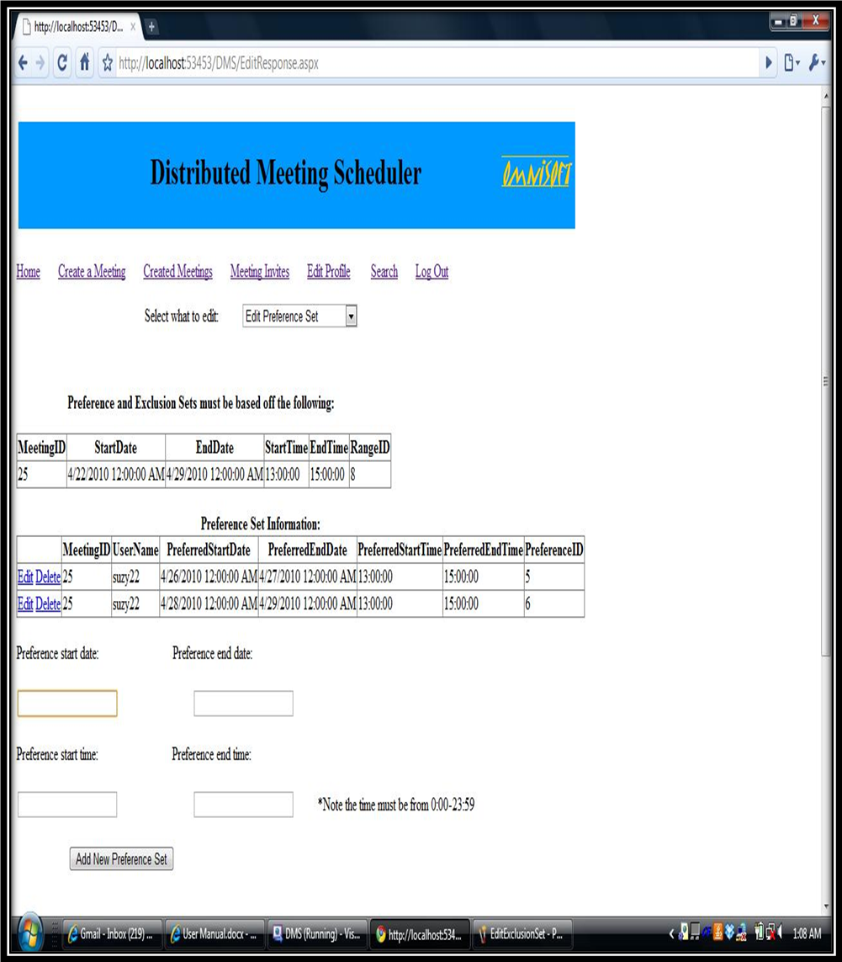
7. Edit Preference Sets:

8. Edit Exclusion Sets:
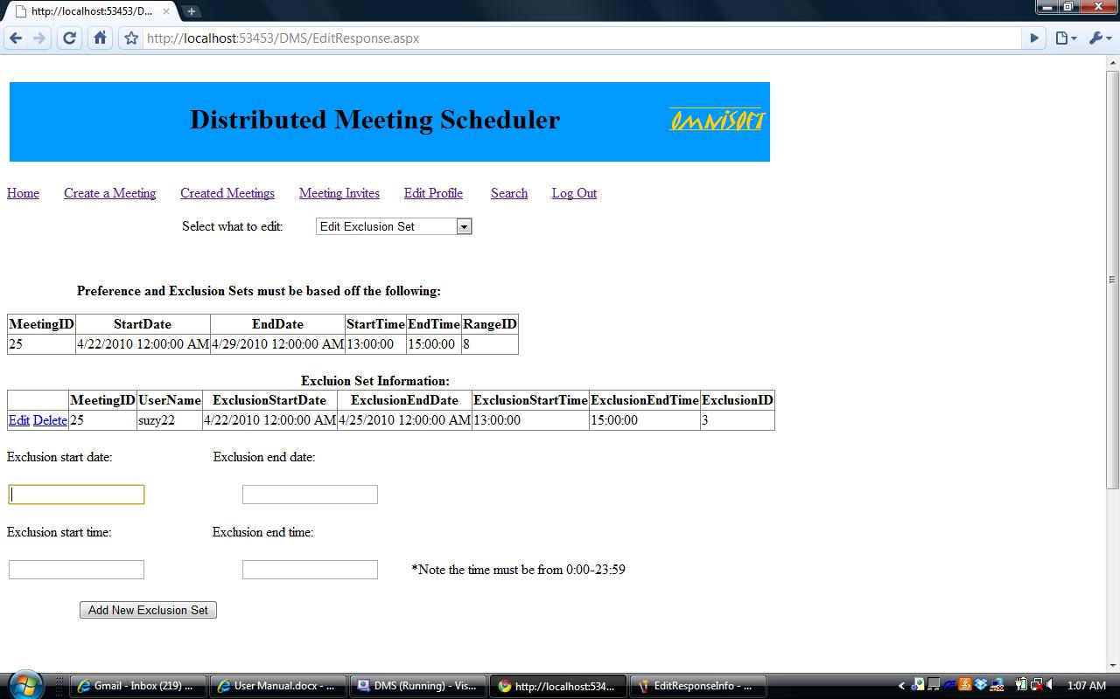

9. Edit Response Information

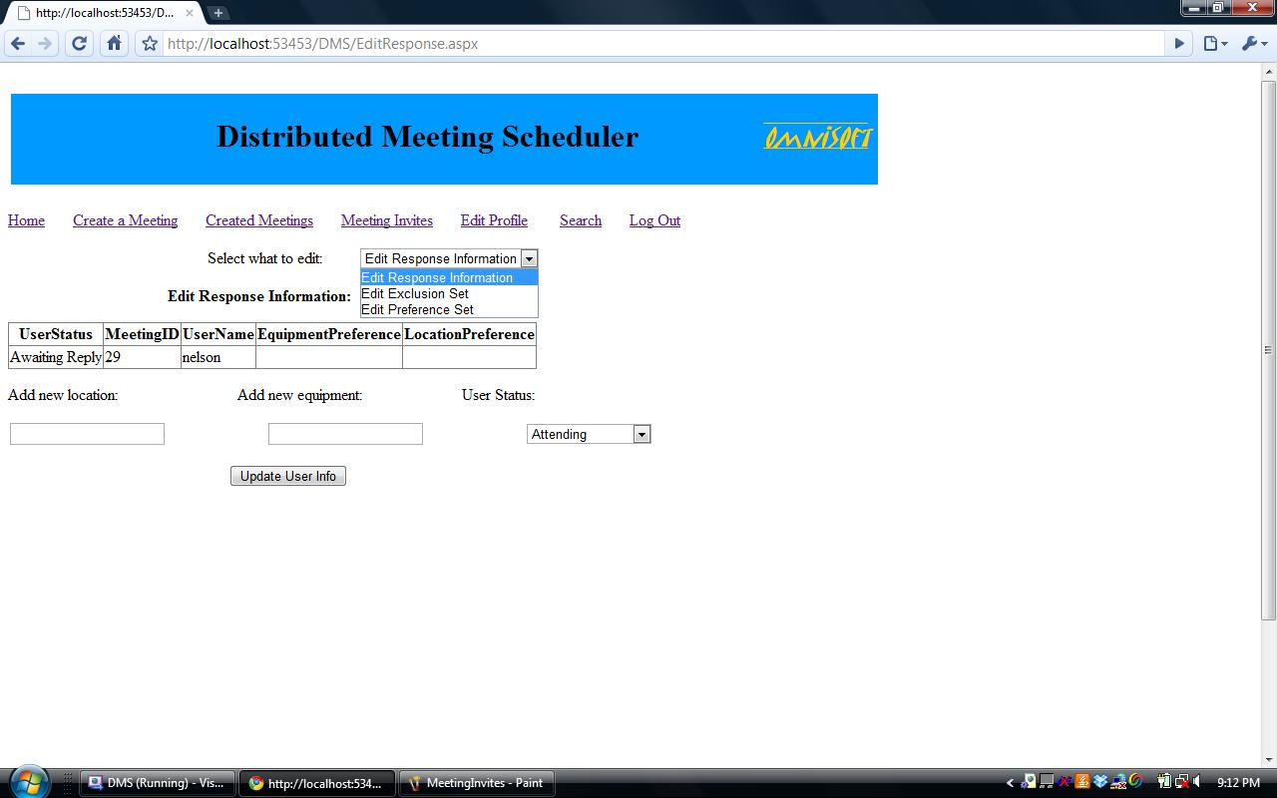

10. Logout Page

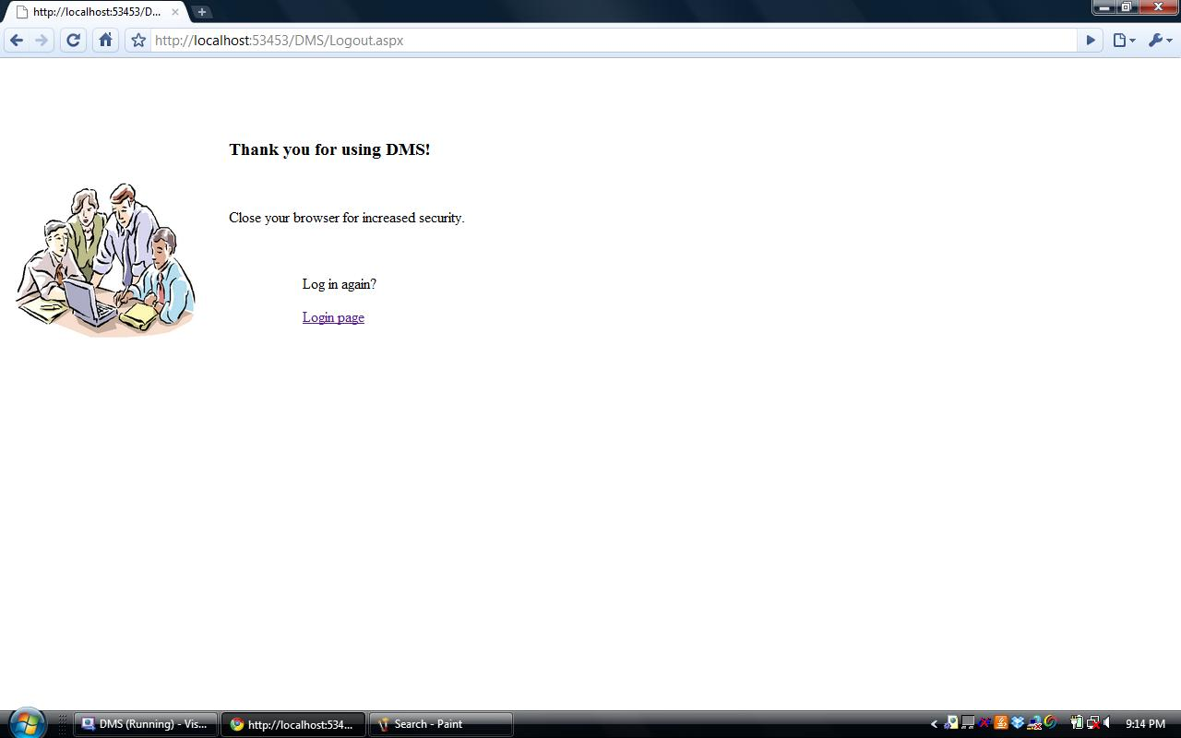

11. Search for Contact page
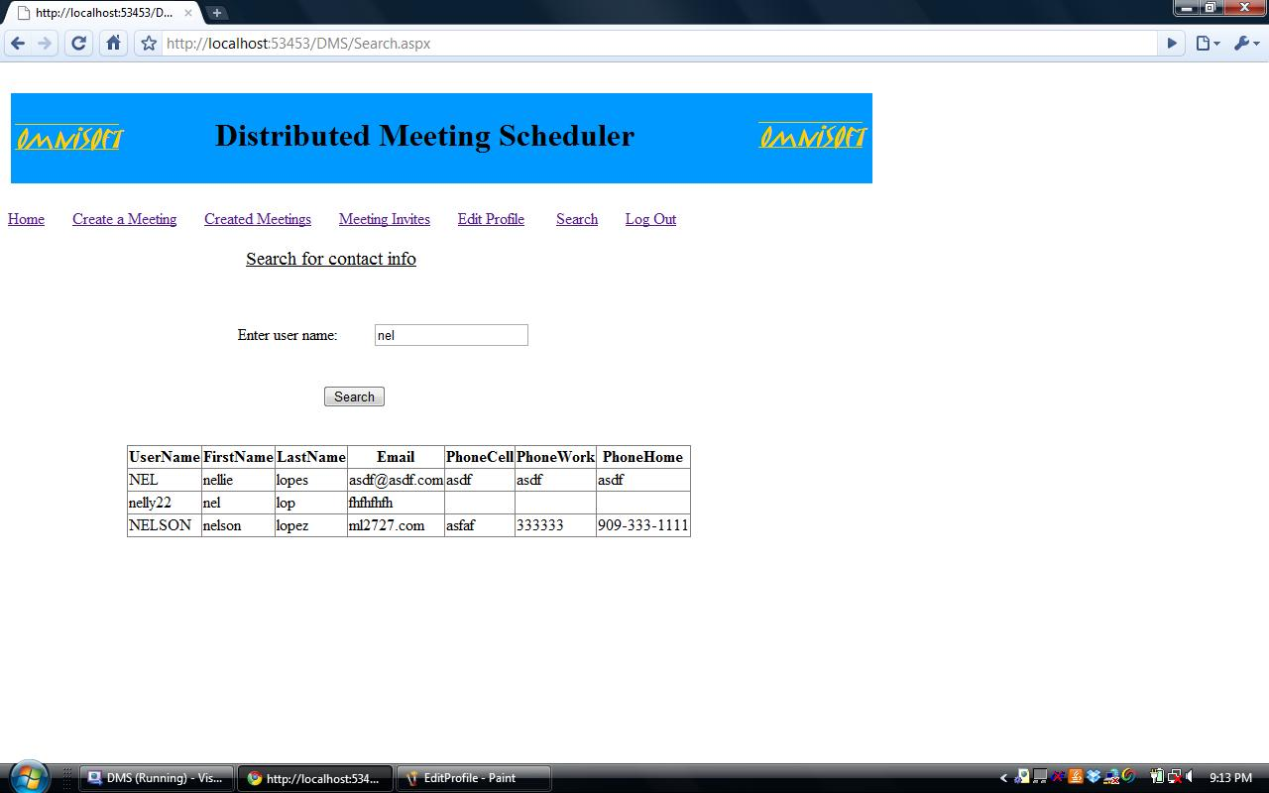

Screen Shot Descriptions:-
Login Page - OmniSoft DMS web based users, can login to schedule/re-schedule meetings, respond to meeting invites and express their constraints involved in attending a meeting.
New User - To schedule meetings with ease and explore the service that we offer, one has to create an account to become a member of OmniSoft DMS.
Home Page – It displays the meetings the user has to attend. It displays a list of created meetings, pending meetings that he has to respond.
Create a Meeting (1 & 2) – Any user can be an Initiator by sending meeting invites to participants, where he/she can describe the need for the meeting, suggest possible location, specify a date and time range where, participants can choose their preference set. It also provides initiator the functionality to choose participants whom he prefers as important participant.
Edit a Meeting – Initiator can edit meetings according to new exclusion & preference sets of the meeting attendees, so as to enable all the attendees to attend the meeting.
Edit Profile Information – The User of the DMS can change his/her Personal Information by going to this Particular page.
Edit Preference Sets – This is to edit the Preference Sets of the Meeting Attendees. They have an option of changing their preferences at any specified time.
Edit Exclusion Sets – This Page is required so as to edit the Exclusion sets of the Meeting attendees, such as they have option to edit the Date and Time Range.
Edit Response Information – Participants can edit his/her response in the specified date and time range as specified by the meeting scheduler.
Logout – For security reasons users shall logout from DMS when they are done with the scheduling process.
Search For Contact Page - Our System has a Search Contact Page which searches all the information of the Participants who are a member of OmniSoft Meeting Scheduler System. It searches a valid User using a keyword or an alphabet, It provides User Contact Details which shall help the Meeting Initiator to contact the Users through Telephone or E-Mail in order to discuss about the proceeding of the Meeting.

