Web based Meeting Scheduler System
Project phase 1.1

CS 6361 – Advanced Requirements Engineering, Spring 2010

University of TEXAS at DALLAS

System Requirements Specification
Version 2.07

Team–“call of duty”

Anuj Gupta (axg094220@utdallas.edu)................Team Lead for final report 1.2
Hariharan Rajagopalan (hxr088000@utdallas.edu)
Kawaljit Grover (kxg098020@utdallas.edu)
Kerem kulak (kxk080100@utdallas.edu)
Neha Priyadarshini (nxp083000@utdallas.edu)................Team Lead for interim phase 1.1
Priya Priya (pxf081000@utdallas.edu).................Team Lead for interim phase 2.1
Satwant Singh (sxs094920@utdallas.edu).................Team Lead for final report 2.2
Sujatha Sridhar (sxs061400@utdallas.edu)

Team Website URL: http://callofdutyutdallas.web.officelive.com/default.aspx

Submitted to:
Dr. Lawrence Chung
Associate Professor,
Department of Computer Science,
The University of Texas at Dallas

“The hardest single part of building a software system is deciding precisely what to build. No other part of the conceptual work is as difficult as establishing the detail technical requirements, including the entire interface to people, to machines, and to other software systems. No part of
the work so cripples the resulting system if done wrong. No other part is more difficult to rectify later.”
[Brooks, 1987]

Revision History
Author | Date | Description | Version
Team | 01/25/2010 | Initial version of the project plan document | 10.1
Neha | 02/07/2010 | Updated the previous version and added all other sub points under Introduction | 1.02
Kerem | 2/10/2010 | Updated Preliminary Requirements – DR, FR, and NFR. | 1.03
Priya | 2/12/2010 | Updated Non functional requirements with issues and their solution | 1.04
Neha | 2/17/2010 | Added problem, goals and domain after improved understanding | 1.05
Priya | 2/17/2010 | Updated with improved understanding of non functional requirements | 1.06
Neha | 219/2010 | Updated with improved understanding of functional requirements | 1.07
Sujatha | 2/21/2010 | Updated Functional requirements with issues and their solution | 1.08
Hariharan | 2/22/2010 | Updated Domain and Stakeholders requirements with issues and their solution | 1.09
Satwant | 2/23/2010 | Updated with Forward Traceability | 1.10
Sujatha | 2/24/2010 | Updated User Manual | 2.01
Neha, Priya | 2/26/2010 | Merging Documents | 2.02
Sujatha | 2/27/2010 | Updated with Backward Traceability | 2.03
Kawal | 2/27/2010 | Updated Screenshots in user manual | 2.04
Priya | 2/27/2010 | Document review | 2.05
Neha | 2/28/2010 | Document review | 2.06
Neha | 3/1/2010 | Updated traceability | 2.07

- Table of Contents

1 Introduction 6
1.1 Project Overview 6
1.2 Stakeholders 6
1.3 Project Scope 7
1.4 Project Usability 7
1.5 Project Deliverables 8
1.6 Evolution of this Document 8
1.7 Definitions, Acronyms and Abbreviations 8
1.7.1 Definitions and Acronyms 8
1.7.2 Abbreviations 9
1.8 Requirement Engineering Process 10
1.9 Roles and Responsibilities 10
2 Preliminary Requirement Specification 10
2.1 Domain/ Stake holders Requirement Specification 10
2.2 Functional Requirement Specification 11
2.3 Non Functional Requirement Specification 12
3 Issues with Preliminary Definition Given (Ambiguities, Incompleteness, Inconsistency, Conflicts) 12
3.1 Issue in Domain, Stake holder, Functional and Non functional Objective 12
3.1.1 Issue - [DR_001] 12
3.1.2 Issue- [DR_002] 13
3.1.3 Issue- [DR_003, DR_004] 13
3.1.4 Issue- [DR_005] 13
3.1.5 Issue- [DR_006] 14
3.1.6 Issue - [DR_007] 14
3.1.7 Issue- [DR_008] 14
3.1.8 Issue- [DR_009] 15
3.1.9 Issue- [DR_010] 15
3.1.10 Issue- [DR_011] 15
3.1.11 Issue- [DR_012] 16
3.1.12 Issue- [DR_013] 16
3.1.13 Issue- [DR_014] 16
3.1.14 Issue- [DR_015] 17
3.2 Issue with Software System Requirement: Functional Requirement 17
3.2.1 Issue- [FR_001] 17
3.2.2 Issue- [FR_002] 17
3.2.3 Issue- [FR_004] 18
3.2.4 Issue- [FR_005] 18
3.2.5 Issue –[FR_011] 19
3.3 Issue with Software System Requirement: Non Functional Requirement 19
3.3.1 Issue- [NFR_002] 19
3.3.2 Issue- [NFR_003] 19
3.3.3 Issue- [NFR_004] 20
3.3.4 Issue- [NFR_005] 20
3.3.5 Issue- [NFR_006] 20
3.3.6 Issue- [NFR_007] 21
3.3.7 Issue- [NFR_008] 21
3.3.8 Issue- [NFR_009] 22
3.3.9 Issue- [NFR_010] 22
3.3.10 Issue- [NFR_011] 22
4 World Requirement Specification 23
4.1 World/Domain Properties 23
4.1.1 Problem 23
4.1.2 Goal 24
4.1.3 Improved Understanding of Domain, Stake Holder, Functional and Non Functional objective 25
4.1.3.1 Domain Functional Requirement 25
4.1.3.2 Domain Non Functional Requirement 26
4.2 Requirement and Specification 26
4.2.1 Improved understanding of Software System Requirement: FRs 26
4.2.2 Improved understanding of Software System Requirements: NFRs 27
5 User Manual and Screen Shots 29
5.1 Login Page (S1) 29
5.2 Register Page (S2) 29
5.3 Home Page (S3) 30
5.4 Initiate Meeting Request (S4) 30
5.5 Meeting Status (S5) 31
5.6 Pending Request Page (S6) 32
6 Traceability 32
6.1 Forward Traceability (Domain requirement to Work Product) 33
6.2 Backward Traceability 33
7 References 34

Introduction
The Web based Meeting Scheduler is aimed at developing an application to schedule, monitor, plan and re-plan meetings to help OmniSoft Inc. in accelerating their business by scheduling their meetings sooner and faster. It eliminates email and phone tag, and ensures a satisfying scheduling experience for all attendees.
Purpose
The purpose of this document is to present a detailed description of the Web Meeting Scheduler System. This document explains the purpose and features of the system and the constraints under which it must operate. This document defines the requirements gathering process used to elicit requirements from the product stakeholders. The document specifies the overall vision, domain, functional and non-functional requirements that are essential to the success of this product. This document is intended for both the stakeholders and the developers of the system and will be used as a reference for the design and validation phases of the project.

Project Overview
The web based meeting scheduler (WMS) is a user friendly tool developed to assists humans in office environments to schedule meetings efficiently. The policies used in the distributed meeting scheduler paves way for negotiation of various processes on behalf of their users and comes up with an agreement on a common meeting time that is acceptable to all the users and abides by all the constraints set by the hosts and attendees. In summary the Web-based Meeting Scheduler follows a decision oriented methodology that depends on knowledge based approach. The purpose of WMS is to support the organization of meetings and to determine for each meeting request, a meeting date and location so that most of the intended participants shall effectively participate.

The principal users of this system are the Meeting Initiator and Meeting Attendees/Participants. It is the responsibility of the meeting initiator to schedule the meeting based on the availability of the attendees along with the constraints expressed by the attendees/participants. The meeting scheduler system shall have the ability to handler several meeting requests in parallel and resolve conflicts.

The key functionalities of this system are:
- Schedule/ plan meetings
- Monitor meetings, especially held in a distributed environment
- Re-planning of meetings to support changing user constraints
- Support conflict resolution
- Keep participants informed of the meeting schedules and any changes

Stakeholders

The following are the probable stake holders and listed are the interest they have in the system being developed.
- Clients
- Users
- Project Manager
- Team Lead
- Subject Matter expert
- Module Lead
- Development Team
- Testing Team

Client: The client prefers comprehensive meeting initiation and negotiation. The meeting scheduling process, and all related processes, should be intuitive, flexible, and full-featured.
User: The user prefers accurate, fast, and intuitive initiation of meetings. The user prefers to easily manage their preference sets, exclusion sets, and monitor meetings correctly. The user prefers conflicts to be solved accurately and negotiations to be kept minimal.
- Initiator : Person or persons that creates a meeting
- Participant: Person that attends a meeting
- Important Participant: Person that the meeting directly influences
- Active Participant: Person that presents some portion of a meeting
- Potential Participant: Person that may or may not be attending a meeting

Project Manager: The Project manager prefers a high degree of control to system data and business logic. The project Manager desires detailed system accounting access for accurate logging and system monitoring.
Development team: The development team prefers a well-defined system to design and implement.
Team Lead: The team leader needs to coordinate between different team members, requiring well controlled system to monitor the flow.
Mediator: The mediator prefers a localized and intuitive access to the system to mediate any conflicts, which arise in the process of the business logic flow regarding meetings.
Testing team: The testing team prefers a lucid and comprehensive set of system functional and non-functional requirements to execute testing. The test team also prefers the user operations to be as simple as possible that the tests can be executed swiftly.

Project Scope
The scope of the system shall include
- Scheduling the meeting in efficient way.
- Gathering the feedback from attendee.
- Cancelling the meeting.
- Changing the meeting schedule and/or location.
- Scheduling concurrent meetings in timely manner.
- Conducting virtual meetings.
- Confirming the location and time of the meeting.
- Minimize users effort in co-ordinating and scheduling meetings

Project Usability
- Automate the meeting schedule process to enable efficient use of the time and efforts of meeting organizer.
- Select a date and time according to the availability of the participants.
- Allocate the location that is convenient to all the participants.
- Send reminders to the participants about the meeting and any schedule changes.
- Reorganize and modify the meeting schedule if required.
- Arrange virtual meetings (audio and video conferencing) in case there are remote attendees.

Project Deliverables
The project is divided into two phases with each phase having two sub-phases. The below table provides on the deliverables in each phase and their corresponding deadlines:
 | Deliverable | Completion Date
Phase 1 | Preliminary Project Plan 1.0 | 2010.01.28
Phase 1 | Interim Report 1.1 | 2010.03.02
Phase 1 | Final Presentation and Report 1.2 | 2010.03.25
Phase 2 | Interim Report 2.1 | 2010.04.15
Phase 2 | Final Presentation and Report 2.2 | 2010.04.27

Evolution of this Document
This document shall be updated as the project progresses. A new revision shall be released after each modification. Every modification has to be logged in the Revision History.
Updates should be expected in the following sections:
a. References – will be updated as necessary.
b. Definitions, acronyms, and abbreviations – will be updated as necessary.
c. Organizational Structure – will be updated as the roles and responsibilities are assigned for each phase.
d. Management objectives and priorities – will be updated to as priorities change.
e. Assumptions, dependencies and constraints – will be updated as necessary.
f. Risk management – will be updated as new risks are identified.
g. Technical Process – will be updated as requirements become clearer.
h. Work elements, schedule and budget – will be updated in the case of schedule or budget changes.

Definitions, Acronyms and Abbreviations

Definitions and Acronyms
Following are the important terms and their definitions related to schedule meeting:
- Meeting organizer - One who is responsible for managing meetings. Example –ensure meeting should start and end at scheduled time, review agenda, prepare minutes of meeting.
- Meeting Initiator - One who make necessary arrangements for the meeting. Example - decide location.
- Exclusion Set – Dates or times ranges when participants cannot attend meeting.
- Preference Set – Give the dates preference for meeting.
- Date Conflict – When date and time of the two meetings conflict.
- Date Range –Give the range of dates when meetings take place.
- Duration -The time duration of meeting.
- Active Participants – One or more participants who give presentations in the meeting. They are the one who called for to attend meeting.
- Regular Participants – Participants who attend meeting, listen and ask questions from the active participant.
- Important Participant- A person that the meeting directly influences
- Location – Physical location of the meeting room.
- Required equipment - Equipments such as microphone, projector, blackboard, and stationary needed to conduct the meeting.
- Virtual meeting – When participants are located at different location, then meeting is held by teleconference, videoconference etc.
- Meeting Proposal- An invitation to the meeting including meeting topic, date range and duration that is sent to a list of potential participants

Abbreviations
SRS – Software Requirement Specifications
WMS – Web based meeting Scheduler
FR – Functional Requirement
NFR –Non functional requirement
DR- Domain requirement

Requirement Engineering Process
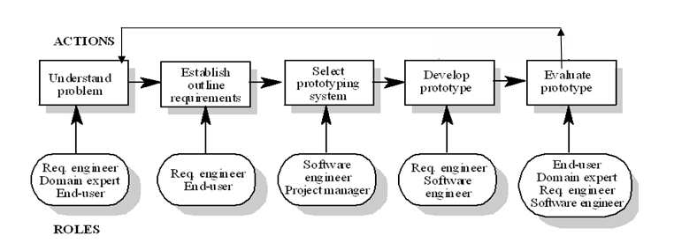
Figure 1: Evolutionary Iterative Model

Roles and Responsibilities

Team Members | Role
Client | Kerem Kulak
Project Manager | Neha
Team Lead | Priya Priya
Subject Matter Expert | Anuj
Module lead | Sujatha
Team Members | Hari, Satwant, Kawal

Preliminary Requirement Specification

Domain/ Stake holders Requirement Specification

Based on the requirements description on the class web page [1], this section presents preliminary domain requirement list. For better traceability, each functional requirement is labelled as DR_001,
DR_002....DR_00N

DR_001 | In the application domain, meetings are typically arranged in the following manner.
DR_002 | A meeting initiator will ask all potential meeting attendees for the following information based on their personal agenda:
DR_003 | a set of dates on which they cannot attend the meeting (hereafter, referred to as exclusion set); and
DR_004 | a set of dates on which they would prefer the meeting to take place (hereafter referred to as preference set);
DR_005 | A meeting date shall be defined perhaps by a pair (calendar date, time period).
DR_006 | The exclusion and preference sets should be contained in some time interval prescribed by the meeting initiator (hereafter referred to as date range).
DR_007 | The initiator could also ask, in a friendly manner, active participants to provide any special equipment requirements on the meeting location (e.g., overhead projector, workstation, network connection, telephone, etc.).
DR_008 | She may also ask important participants to state preferences about the meeting location.
DR_009 | The proposed meeting date should belong to the stated date range and to none of the exclusion sets;
DR_010 | The proposal should be made as early as possible.
DR_011 | A date conflict occurs when no such date can be found.
DR_012 | Conflicts can be resolved in several ways, including
DR_013 | Each conflict resolution should be done as quickly as possible and with no more interactions than is really needed.
DR_014 | Furthermore it [the meeting room] should ideally belong to one of the locations preferred by as many important participants as possible.
DR_015 | The number of negotiations shall be kept minimal, but a new round of negotiation may be required when no such room can be found.

Functional Requirement Specification
Based on the functional requirements given on the class web page1], this section presents preliminary functional requirement list. For better traceability, each functional requirement is labelled as FR_001,
FR_002....FR_00N

FR_001 | The system shall support organization of meetings and determine, for each meeting request, a meeting date and location so that most of the intended participants will effectively participate
FR_002 | The system shall monitor meetings, especially when they are held in a distributed manner or periodically;
FR_003 | The system shall plan meetings under the constraints expressed by participants
FR_004 | Re-plan a meeting to support the changing user constraints, that include modification to the exclusion set, preference set and/or preferred location before a meeting date/location is proposed; and
FR_005 | Re-plan a meeting to support some external constraints, after a date and location have been proposed
FR_006 | The system shall support conflict resolution according to resolution policies;
FR_007 | The system shall manage all the interactions among participants required during the organization of the meeting
FR_008 | The system shall support the negotiation and conflict resolution processes;
FR_009 | The system shall keep participants informed about schedules and their changes
FR_010 | The meeting scheduler system must in general handle several meeting requests in parallel.
FR_011 | Meeting requests can be competing when they overlap in time or space.

Non Functional Requirement Specification
Based on the non-functional requirements given on the class web page [1], this section presents preliminary non-functional requirement list. For better traceability, each functional requirement is labelled as NFR_001, NFR_002... NFR_00N.
Usability | NFR_001 | The system should be usable
Reliability | NFR_002 | A meeting should be accurately monitored, especially when it is held in a virtual place. Here, nomadicity will then be important to consider
Reliability | NFR_007 | Physical constraints should not be broken --- e.g., a person may not be at two different places at the same time; a meeting room may not be allocated to more than one meeting at the same time; etc.;
Flexibility | NFR_003 | Re-planning of a meeting should be done as dynamically and with as much flexibility as possible;
Flexibility | NFR_010 | The system should be flexible enough to accommodate evolving data - e.g., the sets of concerned participants may be varying, the address at which a participant can be reached may be varying, etc.;
Performance | NFR_004 | The amount of interaction among participants(e.g., number and length of messages, amount of negotiation required) should be kept minimal;
Performance | NFR_006 | The meeting date and location should be as convenient as possible, and available as early as possible, to all (potential) participants;
Performance | NFR_008 | The system should provide an appropriate level of performance:  The elapsed time between the submission of a meeting request and the determination of the corresponding date/location should be minimal  A lower bound should be fixed between the time at which the meeting date is determined and the time at which the meeting is actually taking place
Customizable | NFR_005 | The system should reflect as closely as possible the way meetings are typically managed (see the domain theory above);
Customizable | NFR_009 | The system should be customizable to professional as well as private meetings - ...;
Extensibility | NFR_011 | The system should be easily extensible to accommodate the following typical variations:  - handling of explicit priorities among dates in preference sets;  - variations in date formats, address formats, interface language, etc.

Issues with Preliminary Definition Given (Ambiguities, Incompleteness, Inconsistency, Conflicts)

Issue in Domain, Stake holder, Functional and Non functional Objective

Issue - [DR_001]
Requirement - In the application domain, meetings are typically arranged in the following manner.
Description - This statement is ambiguous and generalized. Also it does not states all the ways a meeting is scheduled

Option1: Mention all the ways how meeting is scheduled generally
Option2: Remove the word “typically.”
Decision and rationale: Since we are not going to mention all the ways the meeting is scheduled generally, we can use option 2 so the statement shall not generalized. If the word “typically” is removed, it eliminates any ambiguity and saves time

Issue- [DR_002]
Require - “A meeting initiator will ask all potential meeting attendees for the following information based on their personal agenda”
Description - This statement is not explicit in mentioning the ways of communication between initiator and attendees and does not give the definition for a “meeting initiator” and a definition for “potential meeting attendees.”
Option1: Define the meeting initiator as a person who requests a meeting. Define the potential meeting attendees as people who have received a meeting invitation from the meeting initiator with a request to fill out the following information based on their personal agenda. Also mention how the attendees get the invitation
Option2: Define the meeting initiator as someone who starts the meeting and the potential meeting attendees are the people who could possibly attend the meeting based on their agenda information.
Decision and rationale: A description and definition of a meeting initiator and potential meeting attendees. This greatly reduces any ambiguous doubts about what roles the individuals have within the meeting scheduler system.

Issue- [DR_003, DR_004]
Requirement - “a set of dates on which they cannot attend the meeting (hereafter, referred to as exclusion set) and a set of dates on which they would prefer the meeting to take place (hereafter referred to as the preference set)”
Description – The statement is in complete and does not define exactly the terms exclusion set and preference set
Option1: An exclusion and preference set contains a set of dates and times that correspond with those dates that participants prefer (or do not prefer) the meeting to take place.
Option2: An exclusion and preference set contains a set of dates and times that correspond with those dates within the date/time range that the meeting initiator has specified.
Decision and rationale: Option 2 is specific and more complete than option 1 because it specifies that the exclusion set and the preference set is a set of date and time which should be within the date/time range that the initiator has specified.

Issue- [DR_005]
Requirement - “A meeting date shall be defined perhaps by a pair (calendar date, time period).”
Description – The statement is not defined properly. “Shall be defined” phrase is not presenting a definite content that the meeting date would have.
Option1: Remove the word perhaps.
Option2: Replace the word perhaps with “Certainly”.
Decision and rationale: Option 1 is specific, more complete and clear, than option 2.

Issue- [DR_006]
Requirement - The exclusion and preference sets should be contained in some time interval prescribed by the meeting initiator (hereafter referred to as date range).
Description – The statement is not defined properly and is ambiguous. It sounds suggestive and time interval is not clearly defined.
Option1: Remove “should be” and define the time interval as a start date and end date
Option2: Replace “should be contained in some” with “must belong to” and define the time interval as a start and end date/time with upper and lower bounds.
Decision and rationale: Option 2 is specific and more complete than option 1 because it definitely says that the exclusion and preference set cannot be outside the date and time range specified by the initiator Issue-

Issue - [DR_007]
Requirement - The “The initiator could also ask, in a friendly manner, active participants to provide any special equipment requirements on the meeting location (e.g., overhead projector, workstation, network connection, telephone, etc.).”
Description – The statement does not clearly define an active participant and the phrase “could also ask, in a friendly manner” is subjective and suggestive, which creates ambiguity.
Option1: Remove and replace the phrase “could also ask, in a friendly manner” with “asks” and define active participants as people who are going to speak or give a presentation in a meeting (such as give a presentation) who can request special equipment to be provided at the meeting location.
Option2: Remove “could also ask, friendly manner” and define active participants as people who shall provide special equipment to the meeting location.
Decision and rationale: Option 1 would be the right choice as replacing the phrase makes the initiator obligated to contact active participants to inquire about special equipment needs. It also removes the interpretation that the active participants are the ones bringing the equipment.

Issue- [DR_008]
Requirement - She may also ask important participants to state preferences about the meeting location.
Description – The statement assumes that the initiator is of a particular gender. The preference of the location is broad and important participants are not defined.
Option1: Define important participants as people who are deemed important by the initiator and are allowed to state a meeting location preference to be anywhere, and replacing the word she with meeting Initiator.
Option2: Replace “she” with “initiator” and define important participants as people with a higher priority over other participants, whom can also be an active participant. They also have the option to state a preferred meeting location from a list of locations set by the meeting initiator.
Decision and rationale: Replacing “she” will tell us that the initiator can be of any gender. The initiators role is to decide which participants are considered important, and also, allowing the important participant to set a meeting preference to be anywhere would give some privilege to the important participants.

Issue- [DR_009]
Requirement - The proposed meeting date should belong to the stated date range and to none of the exclusion sets; furthermore it should ideally belong to as many preference sets as possible.
Description – The statement is not proper and the “should “word is used which sounds like a possibility.
Option1: Remove the two “should” words.
Option2: Replace the first “should” by “must” and the next “should” with “shall” and remove “ideally.”
Decision and rationale: The option 2 is suitable because when we replace the first “should” by “must” it says that the proposed meeting date can be only in the date range specified by the initiator and by replacing the second “should” by “Shall" we state that the meeting date can belong to as many preference sets which implies many people shall attend the meeting.

Issue- [DR_010]
Requirement – The proposal should be made as early as possible.
Description – The statement is not accurate and the word “early” is not defined
Option1: Remove the statement.
Option2: Define “early” with respect to the rate at which the potential meeting attendees respond with their preference/exclusion sets or the percentage of responses received from each type of potential attendee (active/important).
Option3: Replace should with must
Decision and rationale: The option 2 is suitable because replacing “should” with “must” elevates the priority that a feature needs to be implemented. If the statement was removed there is possibility that a proposal shall take a long amount of time. When the definition of early is stated, the possibility of we getting the proposal at the earliest is high.

Issue- [DR_011]
Requirement – A date conflict occurs when no such date can be found.
Description – The statement is ambiguous and the word “Date” is not defined as to what it refers
Option1: Remove the statement.
Option2: Change the word date to meeting date
Decision and rationale: By clarifying that a date conflict occurs when no such meeting date can be found removes any ambiguity that could have arisen as a result of a user thinking it was referring to a date only.

Issue- [DR_012]
Requirement – Conflicts can be resolved in several ways, including:
Description – The statement is ambiguous and implies that there may be additional ways (other than given) to resolve date conflicts.
Option 1: Remove the statement.
Option 2: Discuss about each and every possible way to resolve a date conflict.
Option 3: Assume that the stated points are the "only" ways to solve a date conflict. When resolving a date conflict, the system shall default to one of these choices.
Decision and rationale: Option 3 satisfies our need by specifying that these are the only ways to resolve a date conflict, it removes any ambiguity that existed before.

Issue- [DR_013]
Requirement – Each conflict resolution should be done as quickly as possible and with no more interactions than is really needed.
Description – The statement is ambiguous and does not define what "quickly as possible" means, and the statement "no more interactions than is really needed" adds no value to this statement.
Option 1: Remove the statement.
Option 2: Define “quickly as possible” with respect to the rate at which the potential meeting attendees respond with their modified conflict resolution methods. Remove the statement "no more interactions than is really needed". Because it does not signify the number of interactions needed already.
Decision and rationale: Here our selection is option 2. By defining the meaning of "quickly as possible", it guarantees that a resolution shall be reached within a certain amount of time.

Issue- [DR_014]
Requirement – Furthermore it should ideally belong to one of the locations preferred by as many important participants as possible.
Description – The statement is ambiguous and the word ideally brings forth the meaning that “it” (the Meeting room) may be in different locations.
Option 1: Remove the statement.
Option 2: Remove the word “ideally” and replace the phrase “as many important participants as possible” by “the majority of important participants”
Decision and rationale: Here our selection is option 2. By removing “ideally”, it states a more concrete requirement

Issue- [DR_015]
Requirement – The number of negotiations should be kept minimal, but a new round of negotiation may be required when no such room can be found.
Description – The statement is complement to itself as it does not define about the new round of negotiation and also does not define the word minimal.
Option 1: Remove the word should.
Option 2: Replace should with shall and define minimal as the "maximum number of negotiations needed to resolve a conflict."
Decision and rationale: Here our selection is option 2. By removing should and defining a value for the word minimal makes the statement quantified and concrete.

Issue with Software System Requirement: Functional Requirement

Issue- [FR_001]
Requirement - The purpose of WMS is to support the organization of meetings – that is, to determine, for each meeting request, a meeting date and location so that most of the intended participants will effectively participate

Description: The requirement is unclear and ambiguous, does not specify who are the intended participants, does it include only important and active participant or all participants.

Option 1: The preferences of active and important participants have to be met to decide on a meeting location and time. All the important and active participants should be present in the meeting.

Option 2: All the important participants and active participants could be optionally present in the meeting. More than a certain threshold (say 60%) of the important participant’s preferences on the date and location need to be satisfied. A meeting shall be held when the total number of active and important participants is more than threshold value (say 50%) in which more than 70% of important participants participate.

Decision and Rationale: Option 2 has been chosen, as it allows the system to be more flexible in terms of scheduling meetings, if an important participant has other priorities. The thresholds are decided by the client.

Issue- [FR_002]
Requirement – “Monitor meetings, especially when they are held in a distributed manner or periodically;”
Description - The requirement is ambiguous as it does not describe what “a distributed manner” and “periodically” means. It indicates that users shall be able to monitor meetings that are held in a distributed manner or periodically, but does not specify who can monitor the meetings.

Option1: “A distributed manner” means, the meeting that involves participants in different geographical locations of the world will be monitored by the meting initiator in terms of how many people are participating and their time/location preferences.

Option2: “A distributed manner” means, the meeting that involves participants in different geographical locations of the world will be monitored by the important and active participants in terms of how many people are participating.

Decision and rationale Option 1 is chosen as the system shall allow monitoring meetings involving participants from different geographical locations. It provides control to the meeting initiator in terms of ensuring that only invited attendees are attending the meeting also considering the location/time preference, enabling smooth conduction of the meeting. Option2 would not be feasible as a meeting could have more than one important and active participants.

Issue- [FR_004]
Requirement – Re-plan a meeting to support the changing user constraints, that include modification to the exclusion set, preference set and/or preferred location before a meeting date/location is proposed;

Description - The requirement is incomplete as it does not indicate if all users or only certain set of users can modify the exclusion set, preference set in addition to location/time before a meeting/date location is proposed.

Option1: The system shall allow re-planning of the meeting by providing privilege to all active, important and regular, to make modification to exclusion set, preference set and/or preferred location before a meeting date/location is proposed but before the deadline specified by the meeting initiator.

Option2: The system shall allow re-planning of the meeting by permitting participants: active, important and regular to provide and modify the exclusion set, preference set but before a meeting deadline. The system shall allow only the important participants to state preferences about the meeting location and allow the active participants to request special equipments on the meeting location.

Decision and rationale Option 2 is chosen as the system shall allow meetings to be re-planned based on user constraint changes of important and active participants only in terms of location and equipment providing an ordered execution and monitoring of the system. Option1 could increase the rounds of negotiations to schedule a meeting.

Issue- [FR_005]
Requirement – Re-plan a meeting to support some external constraints, after a date and location have been proposed.
Description - This requirement is incomplete because it does not provide details on what are the possible external constraints.

Option1: The meeting initiator will reschedule the meeting for external constraints which include: the need to accommodate a more important meeting

Option2: Remove the requirement.

Decision and rationale: The Option1 is more precise in terms of what is the external constraint and provides more flexibility to the system in terms of re-planning, hence is the chosen option. Option2 does not provide the ability to re-plan meetings for any external constraints.

Issue –[FR_011]
Requirement - Meeting requests can be competing when they overlap in time or space.

Description: The requirement is not complete as it does not describe how the system should behave when there is an overlap of time and space.

Option 1: If meetings overlap in time and space, meeting with higher priority should take place. If the priorities are same then the meeting that was booked first will takes precedence.

Option 2: Meeting initiator shall decide if the meeting needs to be cancelled/postponed/changed.

Decision and Rationale: Option1 is chosen as this allows a meeting that was scheduled first to take precedence thus supporting the first come first served policy.

Issue with Software System Requirement: Non Functional Requirement

Issue- [NFR_002]
Requirement -A meeting should be accurately monitored, especially when it is held in a virtual place. Here, nomadicity will then be important to consider;
Description – This requirement is incomplete and ambiguous. It does not specify what the measure of accuracy is. It does not indicate if the system should be monitored in terms of proceedings, participation of attendees, interaction of the participants or the working of the equipment if any. Also, the definition for “nomadicity” in context to the project is missing.
Option 1: The word “accurately” only provides emphasis on the functional requirement of selecting time/date within the time frame and not belonging to any of the exclusion set, and deciding on a voted and available location with requested resources. The entire sentence “Here, nomadicity will then be important to consider” is eliminated.
The system shall ensure that interaction among the initiator and participants is correct.
Option 2: The word “accurately” refers to the availability of valid and updated information about exclusion and preferred sets, locations and resource requests. “Nomadicity” refers to the availability of precise abovementioned information to the meeting initiator regardless of his/her geographic location. Accurately also refers to the genuine information on proceedings, participation of attendees, interaction of the participants or the working of the equipment if any used for the meeting especially in a virtual environment.
Decision and rationale – Since this requirement emphasizes on the meeting held in virtual place, Option 2 provides more precise requirement highlighting the proper coordination among the participants and the proper working of the equipments if any were used.

Issue- [NFR_003]
Requirement - Re-planning of a meeting should be done as dynamically and with as much flexibility as possible;
Description – This requirement is incomplete and ambiguous. The words “dynamically” and “flexibility” cannot be quantified or measured as no clear definition is provided for them. It does not indicate who can/or has the authority to re-plan the meeting.
Option 1 –The system shall allow the meeting initiator to re-plan the meeting. The word “dynamically” indicates that the system shall find a suitable meeting time and date based on the information available including preferred and exclusion sets, locations and resource requests. The word “flexibility” refers to provision available to the important and active participants to change their feedback whenever necessary but before the meeting deadline.
Option 2 – The system shall re-plan the meeting in-case of a conflict. The word “dynamically” indicates that the system shall find a suitable meeting time and date based on the information available including preferred and exclusion sets, locations and resource requests. The word “flexibility” refers to allowing the important and active participants to change the date range and providing their exclusion and preferred sets from the new range before the meeting deadline.
Decision and rationale – Option 1 is more flexible as it offers control for the meeting initiator to decide on the date and time providing a simple and feasible solution.

Issue- [NFR_004]
Requirement - The amount of interaction among participants (e.g., number and length of messages, amount of negotiation required) should be kept minimal;
Description – This requirement is ambiguous. It does not specify the type of interaction that should be reduced. The word “minimal” cannot be quantified and not does provide a definition for the upper and lower bound of the interactions. It can be number of times interaction between initiator and participants occur to re-plan or reschedule a meeting based on the exclusion or preferred set or length of e-mail messages or number of minutes they talk over phone.
Option 1- The interactions between the active participants which happens via the system to inquire and provide exclusion and preferred sets, and resource requirements shall be kept minimal. The system shall allow interactions between the system and meeting initiator for meeting management operations or update on participants’ feedback.
Option 2 –The system shall broadcast to all participants, the interactions about providing exclusion or preferred sets for a meeting for every participant in the meeting, to keep all other participants updated.
Decision and Rationale:-Option 1 involves less exchange of messages which is suitable in most of the cases.

Issue- [NFR_005]
Requirement - The system should reflect as closely as possible the way meetings are typically managed (see the domain theory above);

Description – This requirement is inconsistent and ambiguous. The phrase “as closely as possible” cannot be quantified. Also the word “typically” implies that there are more than one ways of managing the meeting
Option 1- The system shall allow the scheduling of meetings and provides a way to interact among participant to discuss about conflicts and schedule changes. As closely as possible” implies exactly. “Typically” is ignored.
Option 2- “Typically” is ignored. Multiple ways of managing the meeting is automated in the system.
Decision and Rationale- Option 1 is better because it does not allow any unforeseen/unpredictable behaviour of the system during its life cycle.

Issue- [NFR_006]
Requirement - The meeting date and location should be as convenient as possible, and available as early as possible, to all (potential) participants;

Description – This requirement is inconsistent and ambiguous. It does not define the word “convenient”. “As early as possible” is ambiguous and cannot be quantified.

Option 1- The meeting date and location shall be convenient as possible and available as early as possible to all potential participants. “Convenient” means the date/time and location selected for the meeting should not require change of exclusion sets or preference sets. “As early as possible” implies the selection of first available date and time from preference sets. “All potential participants” can be regular, important or active participants.

Option 2- The meeting date and location shall be convenient as possible and available as early as possible to all potential participants. “Convenient” means the date/time and location selected for the meeting should be in line with as many preferred sets and location preferences as possible. “As early as possible” implies the quick selection of date/time and location for meeting once the required sets are provided by the participants. “All potential participants” are further categorized as regular, important and active participants.
Decision and Rationale- Option 1 is preferred as it is more appropriate in this situation.

Issue- [NFR_007]
Requirement - Physical constraints should not be broken --- e.g., a person may not be at two different places at the same time; a meeting room may not be allocated to more than one meeting at the same time; etc.;

Description – This requirement is incomplete. The word “etc” does not provide a complete list of all possible options for the physical constraints. It indicates that there are many possible physical constraints in the system of which only two are mentioned.
Option 1- The system shall not allow a person to attend more than one meetings at the same time. The system shall ensure that the same meeting room is not allocated to more than one meeting at the same time.

Option 2- Due to incompleteness the requirement is ignored.
Decision and Rationale- Option 1 is the ideal solution as the system complies with the indicated physical constraints.

Issue- [NFR_008]
Requirement - The system should provide an appropriate level of performance:
- The elapsed time between the submission of a meeting request and the determination of the corresponding date/location should be minimal
- A lower bound should be fixed between the time at which the meeting date is determined and the time at which the meeting is actually taking place
Description – This requirement is incomplete and ambiguous. The word “minimal” does not provide an upper/lower bound on the time value.

Option 1- The system shall provide and appropriate level of performance. The elapsed time between submission of meeting request and determination of the corresponding date/location shall be fixed in the system as one day. The system shall fix the lower bound between which the meeting date is determined and the actual meeting shall be taking place.

Option 2 - The system shall provide and appropriate level of performance. The time between the submission of the meeting request and the determination of the corresponding date/location shall be less than a threshold value as indicated by the meeting initiator. The meeting initiator shall fix a deadline date before which the meeting location/time shall be determined.
Decision and Rationale- Option 2 is the best solution as it provides more control to the meeting initiator in deciding the lower bound value.

Issue- [NFR_009]
Requirement - The system should be customizable to professional as well as private meetings - ...;

Description – This requirement is incomplete. The word “customizable” does not provide the details on how the system should be customized. It does not define the definition of private or professional meetings.
Option 1- The system shall allow the meeting initiator to indicate if the meeting is private in which case the meeting information shall not be made available or accessible to any other user in the system apart from the participants.

Option 2 - There is no distinction between private and professional meetings. The type of meeting depends on the purpose of meeting. The system can be used for any type of meetings. The same user interface will be provided for all the meeting initiations
Decision and Rationale- Option 2 is more appropriate solution as it provides more generic behaviour to the system. Since the meetings requests can only be viewed by the invited participant’s privacy is still maintained.

Issue- [NFR_010]
Requirement – The system should be flexible enough to accommodate evolving data - e.g., the sets of concerned participants may be varying, the address at which a participant can be reached may be varying, etc.;

Description – This requirement is ambiguous and incomplete. The use of word “etc” creates incompleteness in the requirement. It indicates that there are many possible ways to make the system flexible to accommodate changing data, of which only two are discussed. Furthermore, the level of flexibility is also not defined
Option 1- The system shall provide the ability to update profile (email, phone) already registered in the system. The system shall allow initiator to add participants to the already initiated meeting at any time before the meeting deadline.

Option 2 - The requirement is removed due to incompleteness.
Decision and Rationale- Option 1 is more ideal solution as it enables updating relevant user information, minimal of email and phone avoiding any unnecessary information exchange.

Issue- [NFR_011]
Requirement - The system should be easily extensible to accommodate the following typical variations:
- handling of explicit priorities among dates in preference sets;
- Variations in date formats, address formats, interface language, etc.

Description –The requirement is incomplete. It does not state all the possible variations that the system has to support. The number of languages that should be supported by the system is not specified.

Option 1- The system shall be available in different languages which can be customizable by the user for his/her use. User can also choose of the different available date formats provided in the system.

Option 2 - The system shall be made available only in the standard language “English” and standard date format.
Decision and Rationale- Option 1 is used as provides the flexibility to anyone using the system and not restricted by specific language.

World Requirement Specification
A requirement specification document is very important document for an information system. It serves as the means of communication between users and the system. It represents a system, description of current state of system, its problem and its future requirements. It helps the project stakeholders and designers to reach an agreement on the functionalities of the system and the conditions to which it must conform. The following section explains the improved understanding in terms of Domain, functional and non functional requirements for WMS which is planned for future development for the software system. It specifies the action and behaviour of the system under certain conditions.

World/Domain Properties

Problem
This project is designed for a system where the people are currently scheduling meetings manually or using software systems like Outlook, IBM-lotus for scheduling their meeting. To Schedule a meeting manually is a very cumbersome task. As the number of participant increases, the complexity of scheduling process increases exponentially. If someone wants to hold the meeting then he/she needs to sends a physical email invitation or inform through telephone to the entire expected participant. After that they also have to keep track record of those who have accepted their invitation and of those who have not. The person who holds the meeting also store the information about location convenient days time for the participants. All these involve an extra manual labour and effort and a person who has to manually organize a meeting and monitor it. The organizer has to collect the responses from participants, and analyze those responses depending on that analysis organizer has to make choices regarding several things.

Consider these scenarios-
- If the meeting gets scheduled on a day when the active participant cannot join. All the other participants shall show up but meeting shall get cancelled.
- If the meeting needed to be rescheduled then organizer has to get in touch with all the participants and collect the information again.
- The reminder of meeting is needed to be sent, and then the meeting organizer has to keep the contact information of all the participants on file. He has to take efforts to contact them.

The issues with scheduling meetings manually include:

- Considerable amount of effort and time consumption
- Hard to record information about convenient time, date and location for all participant
- Not precisely accurate
- It may not ensure the presence of all active and important participants.
- Tough to handle virtual meetings
- More complex and difficult when the number of participants are more
- Stressful process in order to find one date which is preferred by most.
- All loads on one person, so completely depended on that person(initiator)
- Low Performance
- Limited number of functionalities
The issues with meetings using software systems such as Outlook, IBM-Lotus includes

- Software dependant
- Considerable amount of involved while conflict resolutions as the system do not consider the preference date and exclusion date.
- When the initiator sends a meeting request, in most cases the only options available for the participant are either to Accept, or to Deny or to Propose new date and time. In that matter when the participants propose new date and time, the entire life cycle of scheduling the meeting is repeated. Especially when a meeting has many attendees, the discourse of negotiation will often go on several rounds before reaching an agreement of the appropriate meeting time.

Goal
The goals or objectives to be achieved by the WMS system in order to address the stated stakeholders' problems are the following:
- GOAL 1: Meeting Scheduler system shall be a web based system, accessible anytime and from the internet. Hence a software system independent solution.
- GOAL 2: The registered user shall be able to hold a new meeting and invite the participants to join the meeting.
- GOAL 3: System must have some of the basic function like:
- Initiator shall be able to cancel the meeting at any time.
- Initiator shall be able to reschedule it at any time.
- Initiator can extend invitation to any person.
- At any point of time initiator has authority to make any participant as an active and important participant
- GOAL 3: To ensure that more participants should attend the meeting.
- GOAL 4: To choose a convenient and accessible location for the important participant(s).
- GOAL 5: To make sure that meeting location is free and available on the date selected to hold the meeting.
- GOAL 6: To be able to schedule a virtual meeting and all participants should be able to attend meeting remotely.
- GOAL 7: System shall consider preference and exclusion sets for the participants based on which conflict resolution is automated. If there is any conflict regarding date, the system shall be able to resolve them using these options:
- Either by extending the date range proposed by initiator
- Or by including additional date(s) in the preferred set or by removing date(s) form the exclusion set
- GOAL 8: System should be able to reschedule meeting in case of location not free.
- GOAL 9: Two or more meeting requests for same location or same timeslot should be handled by system. The important meeting should be given preference while scheduling meetings. In case two meetings for same place or same time-slot, system should decide either by importance level of meeting or by first come first serve basis.
- GOAL 10: WMS system shall have good performance and less overhead by scheduling meetings sooner and faster.

Improved Understanding of Domain, Stake Holder, Functional and Non Functional objective
This section presents the improved Domain requirement list, based on the preliminary Domain requirements described in section 3.1. The same naming convention is used to as in preliminary domain Functional requirement section i.e. DFR_001, DFR_002...… DFR_00N.

Domain Functional Requirement

DFR_001 | In the application domain, meetings are arranged in the following manner.
DFR_002 | A meeting initiator shall ask all potential meeting attendees for the following information based on their personal agenda”
DFR_005 | The date shall be defined by the pair: calendar date and time period.
DFR_003 | The Proposed meeting date shall belong to the stated date range and not to none of the exclusion sets
DFR_004 | The system shall try to choose a date which is preferred by most participants.
DFR_006 | The exclusion and preference sets must belong to time interval prescribed by the meeting initiator
DFR_007 | A meeting room should have the equipment required for meeting.
DFR_008 | Meeting Initiator shall ask important participants to state preferences about the meeting location.
DFR_009 | The Proposed meeting date must belong to the stated date range and not to none of the exclusion sets, furthermore it shall ideally belong to as many preference sets as possible
DFR_010 | The proposal shall be made at least one day in advance before the meeting.
DFR_011 | A date conflict occurs when no such meeting date can be found.
DFR_012 | Each conflict resolution should be with minimum interaction needed.
DFR_013 | It should belong to one of the locations preferred by as many important participants as possible.
DFR_014 | The number of negotiations should be kept minimal,

Domain Non Functional Requirement
DNFR_001 | The physical meeting location should be commutable, easy to reach.
DNFR_002 | Several meetings might be initiated concurrently. If this results in conflicts (time and location), it should be resolved based on the meeting priority. If the priorities of two conflicting meetings are the same, the meeting initiated later shall be cancelled.

Requirement and Specification
Requirement: - A requirement for a computer system specifies what is desired from a system. For a business in particular this is, "What you want or desire from a system, which you believe shall deliver you a business advantage".
Specification: - A specification is an explicit set of requirements to be satisfied by a material, product, or service. It is a detailed description of design criteria for a piece of work. It is a set of requirements defining an exact description of an object or a process.

Improved understanding of Software System Requirement: FRs
This section presents the improved Functional requirement list, based on the preliminary Functional requirements described in section 3.2. The same naming convention is used to as in preliminary functional requirement section i.e. FR_001, FR_002...… FR_00N.

FR_001 | All the important participants and active participants could be optionally present in the meeting. More than a certain threshold (say 60%) of the important participant’s preferences on the date and location need to be satisfied. A meeting shall be held when the total number of active and important participants is more than threshold value (say 50%) in which more than 70% of important participants participate.
FR_002 | “A distributed manner” means, the meeting that involves participants in different geographical locations of the world will be monitored by the meting initiator in terms of how many people are participating and their time/location preferences.
FR_003 | The system shall plan meetings under the constraints expressed by participants
FR_004 | The system shall allow rep-planning of the meeting by permitting participants: active, important and regular to provide and modify the exclusion set, preference set but before a meeting deadline. The system shall allow only the important participants to state preferences about the meeting location and allow the active participants to request special equipments on the meeting location but before a meeting deadline.
FR_005 | Re-plan a meeting to support external constraints like two meeting held at same time or at same location, that meeting take place which is of higher priority
FR_006 | The system shall support conflict resolution according to given 4 resolution policies;
FR_007 | The system shall manage all the interactions among participants required during the organization of the meeting
FR_008 | The system shall support the negotiation and conflict resolution processes;
FR_009 | The system shall keep participants informed about schedules and their changes
FR_010 | The meeting scheduler system must in general handle several meeting requests in parallel.
FR_011 | The meeting scheduler system should cancel or reschedule the meeting with lower priority to resolve the conflict with a meeting with higher priority level when they overlap in time or space. If two equally important meeting overlaps then we choose first come first served.
FR_012 | The user who can login into the system/ or a new user who is successfully able to register can initiate a meeting
FR_013 | The meeting scheduler system shall allow the initiator to set ‘priority level’ of the meeting in order to avoid conflict in scheduling two or more meetings.
FR_014 | An initiator should select the ‘room/location’ from the list of available locations. The system should indicate the availability or unavailability of the room, in case of unavailability initiator has to choose other meeting room.
FR_015 | The initiator should select the ‘equipments’ needed for the meeting from the equipments list; also active participants should have the option of selecting the equipments when the confirm their attendance to meeting
FR_016 | The system should send the reminder one day before the final meeting date
FR_017 | The initiator shall have a privilege to make any participant to active, important or regular participant.
FR_018 | If the meeting is cancelled by meeting scheduler then it should send the other acceptable schedules to initiator depending on preference set entered.
FR_019 | If the acceptable schedules cannot be found to reschedule the meeting an email shall be sent to initiator to reschedule the meeting with new date range.
FR_020 | As soon as the all important participants reject the meeting invitation the system shall send an email to initiator regarding rescheduling a meeting.
FR_021 | The participants should be able to change their response at any time before the deadline
FR_022 | As soon as meeting is confirmed, the confirmation should be sent to participants via email

Improved understanding of Software System Requirements: NFRs
This section presents the improved non-functional requirement list, based on the preliminary non-functional requirements described in section 3.3. The same naming convention is used to as in preliminary functional requirement section i.e. NFR_001, NFR_002...… NFR_00N.
NFR_001 | The system should be usable
NFR_002 | The word “accurately” refers to the availability of valid and updated information about exclusion and preferred sets, locations and resource requests. “Nomadicity” refers to the availability of precise abovementioned information to the meeting initiator regardless of his/her geographic location. Accurately also refers to the genuine information on proceedings, participation of attendees, interaction of the participants or the working of the equipment if any used for the meeting especially in a virtual environment.
NFR_003 | The system shall allow the meeting initiator to re-plan the meeting. The word “dynamically” indicates that the system shall find a suitable meeting time and date based on the information available including preferred and exclusion sets, locations and resource requests. The word “flexibility” refers to provision available to the important and active participants to change their feedback whenever necessary but before the meeting deadline.
NFR_004 | The interactions between the active participants which happens via the system to inquire and provide exclusion and preferred sets, and resource requirements shall be kept minimal. The system shall allow interactions between the system and meeting initiator for meeting management operations or update on participants’ feedback
NFR_005 | The system shall allow the scheduling of meetings and provides a way to interact among participant to discuss about conflicts and schedule changes. As closely as possible” implies exactly.
NFR_006 | The meeting date and location shall be convenient as possible and available as early as possible to all potential participants. “Convenient” means the date/time and location selected for the meeting should not require change of exclusion sets or preference sets. “As early as possible” implies the selection of first available date and time from preference sets. “All potential participants” can be regular, important or active participants.
NFR_007 | The system shall not allow a person to attend more than one meeting at the same time. The system shall ensure that the same meeting room is not allocated to more than one meeting at the same time.
NFR_008 | The system shall provide and appropriate level of performance. The elapsed time between the submission of the meeting request and the determination of the corresponding date/location shall be less than a threshold value as indicated by the meeting initiator. The meeting initiator shall fix the lower bound between which the meeting date is determined and the actual meeting shall take place.
NFR_009 | There is no distinction between private and professional meetings. The type of meeting depends on the purpose of meeting. The system can be used for any type of meetings. The same user interface will be provided for all the meeting initiations. Since the meetings requests can only be viewed by the invited participant’s privacy is still maintained.
NFR_010 | The system shall provide the ability to update profile (email, phone) already registered in the system. The system shall allow initiator to add participants to the already initiated meeting at any time before the meeting deadline
NFR_011 | The system shall be easily extensible to accommodate the following typical variations:  - handling of explicit priorities among dates in preference sets;  - Variations in date formats, address formats, interface language, etc.  The system shall be available in different languages which can be customizable by the user for his/her use. User can also choose of the different available date formats provided in the system.

User Manual and Screen Shots

Login Page (S1)
After registering with the system, Users can login to the application by entering their User name and Password in the login screen and clicking on the button sign-in. If users have forgotten their password, then they can retrieve it by clicking “Forgot Password” button. User can register by clicking the “Register” button -
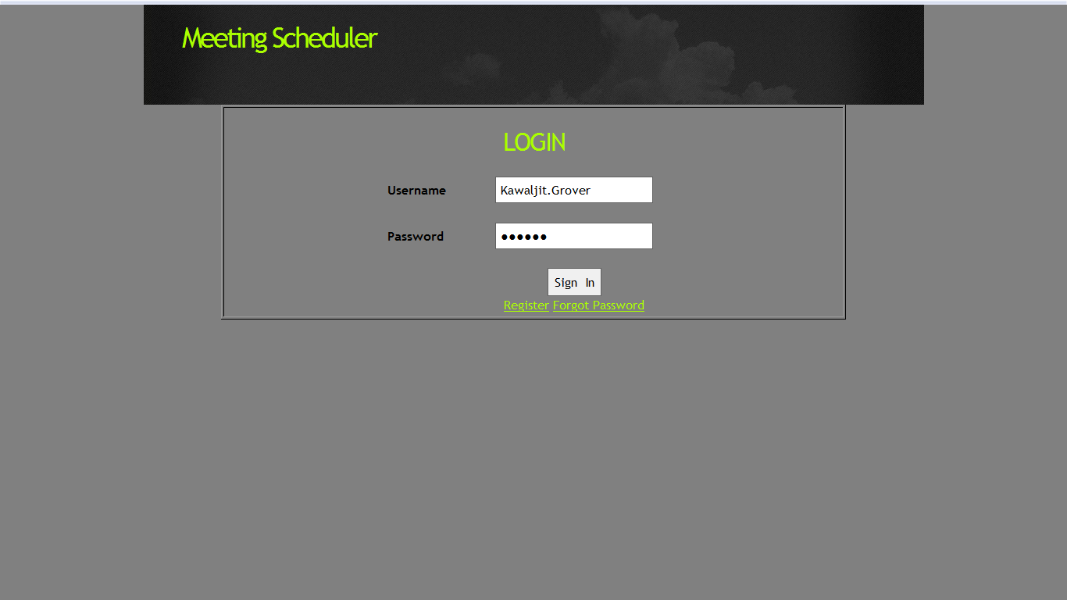

Register Page (S2)
New Users can register themselves through a self registration page provided by the application. They will provide the details like First Name, Last Name, Gender, Date of Birth, Country, State, City, Address, Language, and Phone Number and can select their User Name and Password. The final step in completing the Register page is by clicking on the “Submit” button.
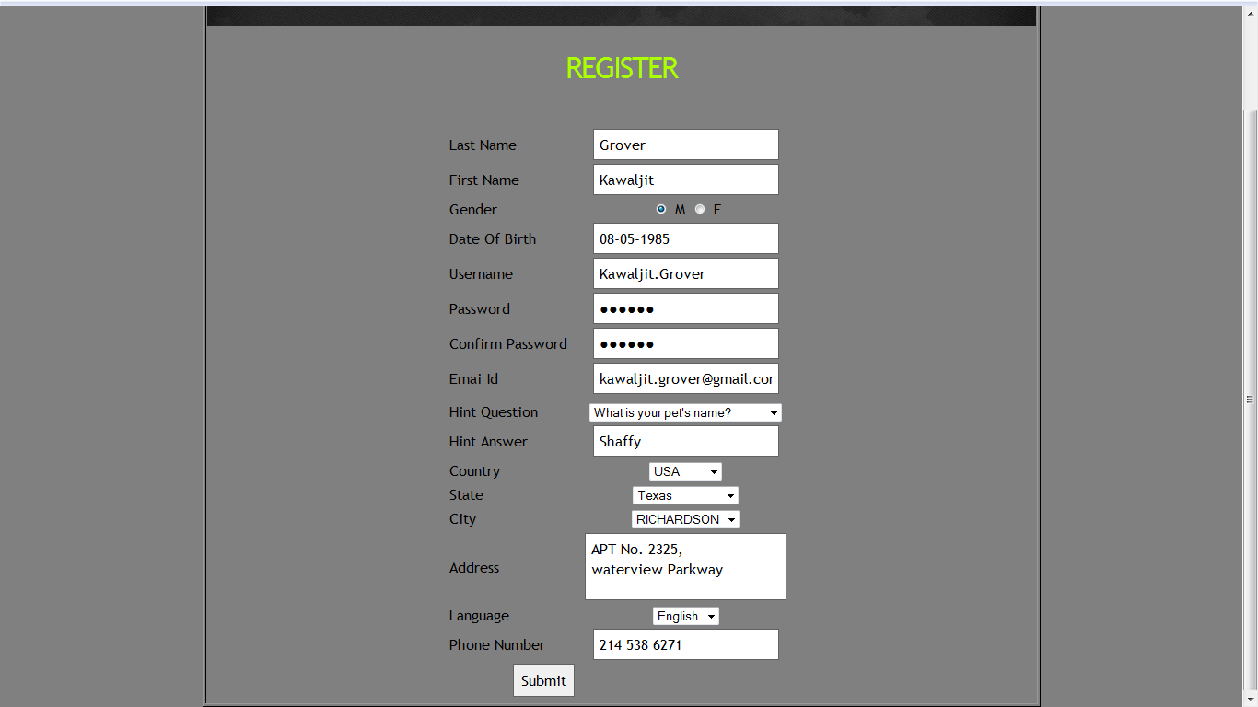

Home Page (S3)
After registering or login (in case already registered), users can either initiate a meeting or see the meeting status by clicking on respectibe links as shown below –
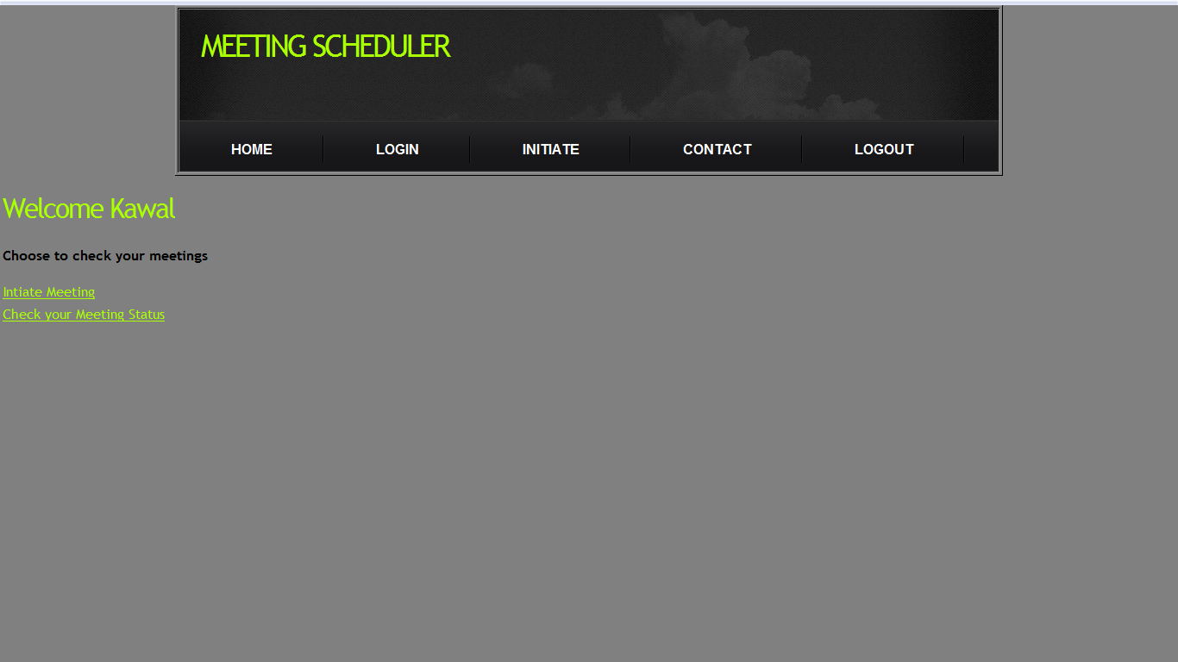

Initiate Meeting Request (S4)
Users can initiate a meeting request through “Initiate a meeting Request” page. Initiator would select the priority level as “High”,”Medium” or “Low” and enter the following details:
- Subject
- Description
- Meeting Type
- Active Participants
- Important Participants
- Regular Participants
- Equipment
- Location
- Date
- Time
- Deadline
After entering the above details the User presses the “Submit” key. To clear the form, the User clicks on the “Clear”button.
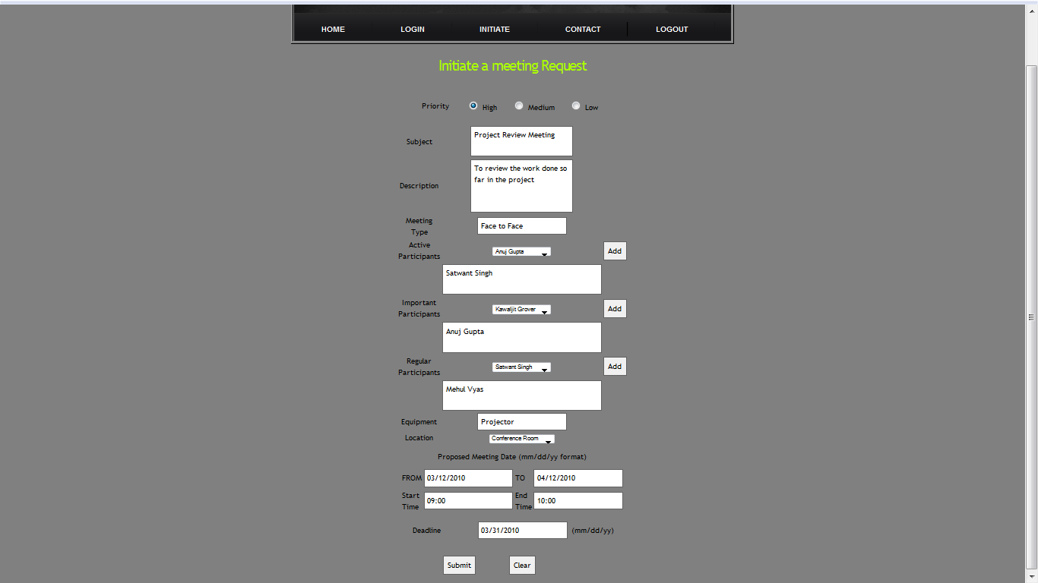

Meeting Status (S5)
This page lists the status of the meeting requests sent to the User. Meetings are categorised whether they are “Not Responded”, “Tentative”or “Finalized”. User can respond to the invite or ignore it.
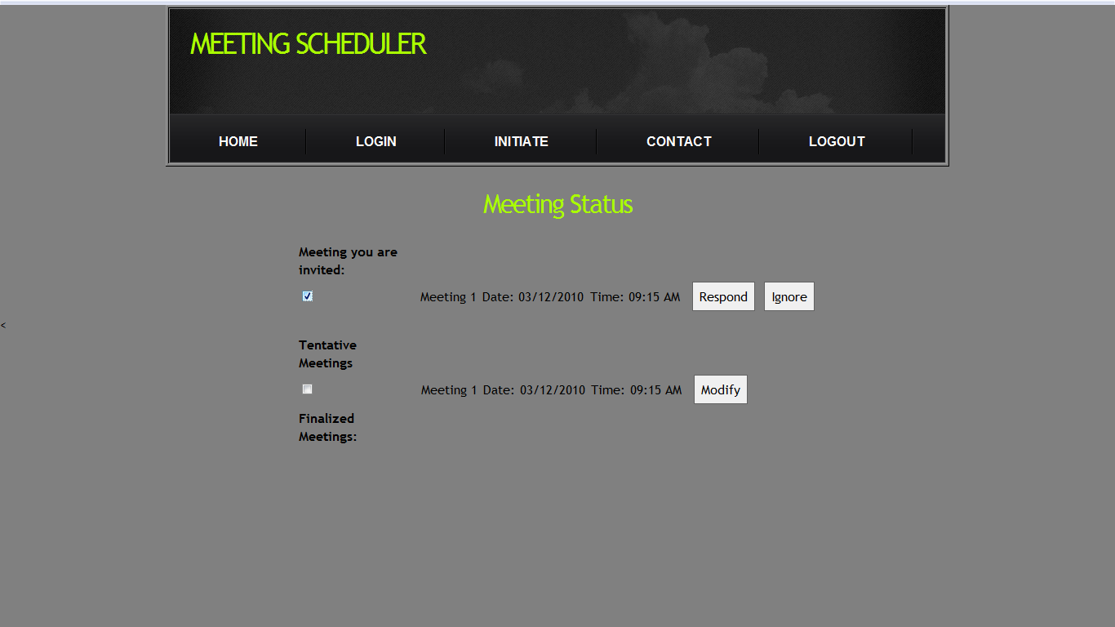

Pending Request Page (S6)
This page displays the pending request of the meeting. Users can respond to the meeting requests by providing their preferred dates, Exclusion dates and Comments and click on the “Submit” button. To clear the page “Clear” button is used.
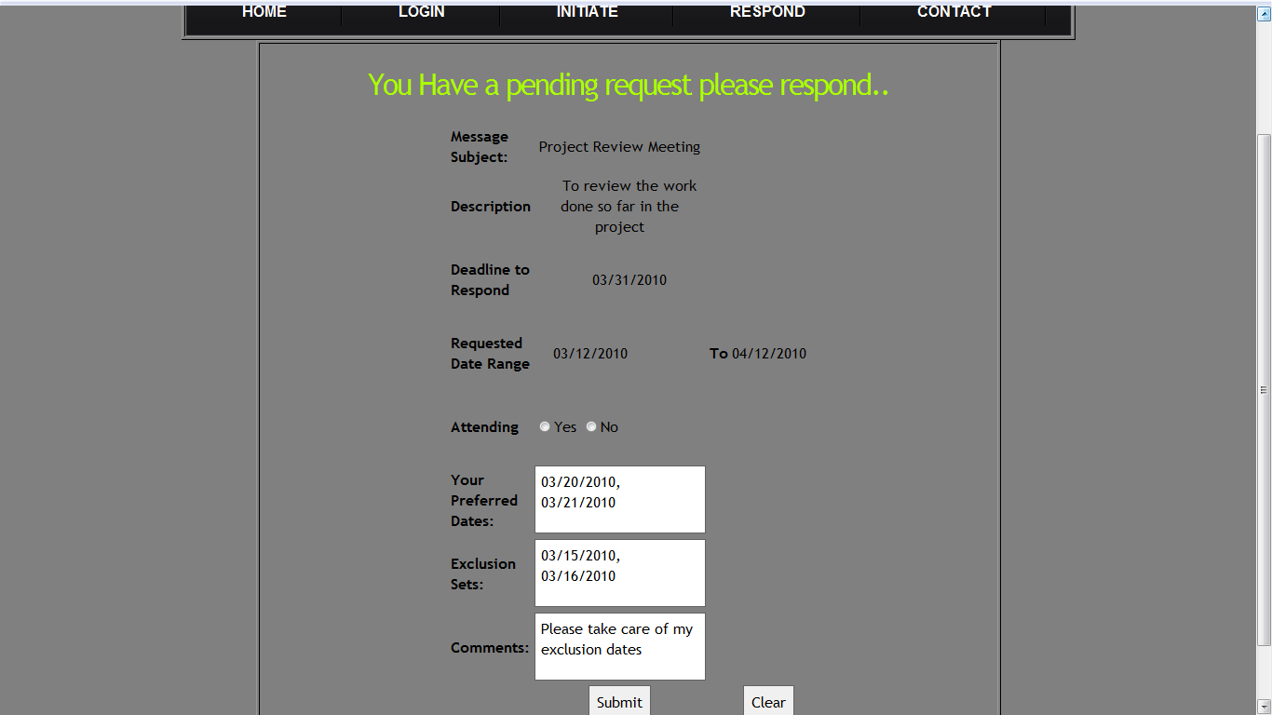

Traceability
Traceability refers to the completeness of the information about every step in a development process. A traceability matrix is created by associating requirements with the work products that satisfy them. Traceability is very important because requirements are volatile and as the project enhances, developer needs to trace back to original requirements.

Forward Traceability (Domain requirement to Work Product)

DFR-2 | A “meeting initiator” shall initiate a meeting. | S4,S1
DFR-3 | The date shall be defined by the pair: calendar date and time period. | S4
DFR-4 | The Proposed meeting date should belong to the stated date range and not to none of the exclusion sets. | S4
DFR-6 | The exclusion and preference sets must belong to time interval prescribed by the meeting initiator. | S4
DFR-7 | A meeting room should have the equipment required for meeting. | S4
DFR-8 | Meeting Initiator shall ask important participants to state preferences about the meeting location. | S4
DFR-13 | Meeting place should belong to one of the locations preferred by as many important participants as possible. | S6, S4

Backward Traceability
Screen ID | Screen Description | Backward Traceability
S1 | Login Screen | NFR_001  FR_012
S2 | Register Page | NFR_010
S3 | Homepage | FR_012
S4 | Initiate Meeting Request Page | DFR_005  DFR_007  FR_001  FR_013  FR_014  FR_015  FR_017  NFR_006
S5 | Meeting Status Page | NFR_007
S6 | Pending Request Page | DFR_006  FR_004  FR_019  NFR_011

References
- Project Description http://www.utdallas.edu/~chung/RE/Project1.pdf
- IEEE standards for SRS [IEEE-STD-830-1993]
- http://www.utdallas.edu/~chung/RE/Presentations09F
- http://pro-10.design.officelive.com/aboutus.aspx
- http://www.jiludwig.com/Traceability_Matrix_Structure.html

