Web based Meeting Scheduler System
Project phase 2.2

CS 6361 – Advanced Requirements Engineering, Spring 2010

University of TEXAS at DALLAS

User manual

Team–“call of duty”

Anuj Gupta (axg094220@utdallas.edu)................Team Lead for final report 1.2
Hariharan Rajagopalan (hxr088000@utdallas.edu)
Kawaljit Grover (kxg098020@utdallas.edu)
Kerem kulak (kxk080100@utdallas.edu)
Neha Priyadarshini (nxp083000@utdallas.edu)................Team Lead for interim phase 1.1
Priya Priya (pxf081000@utdallas.edu).................Team Lead for interim phase 2.1
Satwant Singh (sxs094920@utdallas.edu).................Team Lead for final report 2.2
Sujatha Sridhar (sxs061400@utdallas.edu)

Team Website URL: http://callofdutyutdallas.web.officelive.com/default.aspx

Submitted to:
Dr. Lawrence Chung
Associate Professor,
Department of Computer Science,
The University of Texas at Dallas
Table of Contents

1.1 Login Page (S1) 3
1.2 Register Page (S2) 4
1.3 Home Page (S3) 5
1.4 Initiate Meeting Request (S4) 6
1.5 Meeting Status (S5) 8
1.6 Pending Request Page (S6) 9
1.7 Meeting initiator view: User Responses (S7) 10
1.8 Meeting initiator view: Virtual Meeting Wizard (S8) 12
1.9 Meeting initiator view: Virtual Meeting Status (S9) 12
1.10 Meeting initiator view: Cancel Meeting (S10) 13

Login Page (S1)
After registering with the system, Users can login to the application by entering their User name and Password in the login screen and clicking on the button sign-in. If users have forgotten their password, then they can retrieve it by clicking “Forgot Password” button. User can register by clicking the “Register” button –
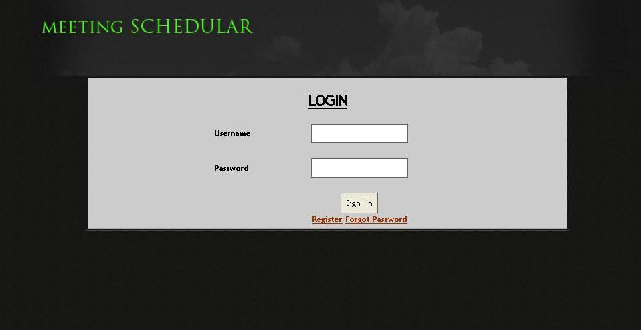

Register Page (S2)
New Users can register themselves through a self registration page provided by the application. They will provide the details like First Name, Last Name, Gender, Date of Birth, Country, State, City, Address, Language, and Phone Number and can select their User Name and Password. The final step in completing the Register page is by clicking on the “Submit” button.
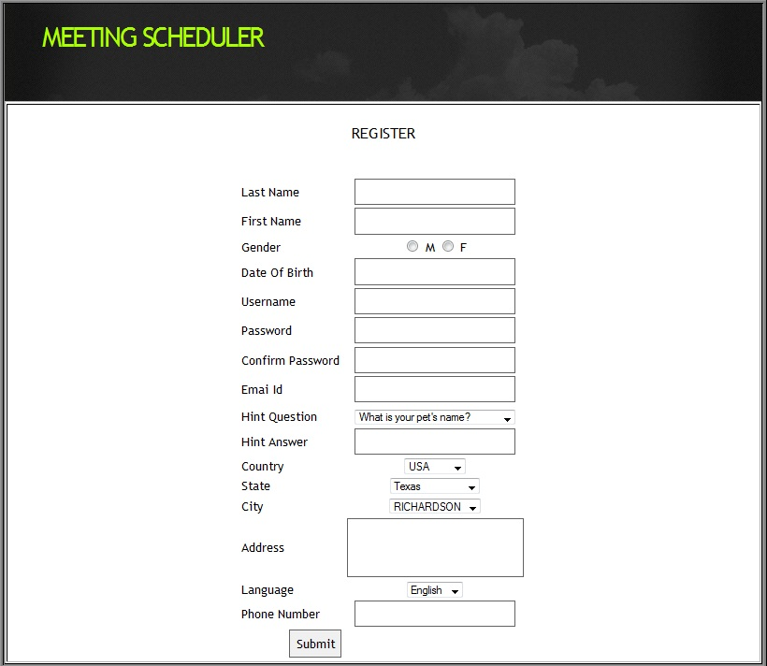

Home Page (S3)
After registering or login (in case already registered), users can either initiate a meeting or see the meeting status by clicking on respectibe links as shown below –
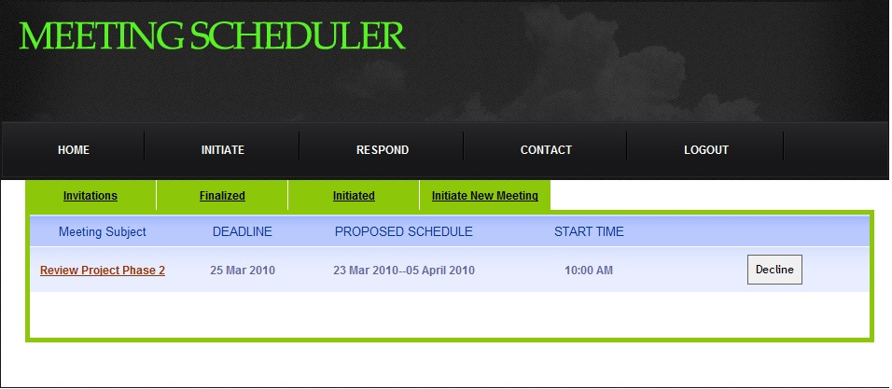

Initiate Meeting Request (S4)
Users can initiate a meeting request through “Initiate a meeting Request” page. Initiator would select the priority level as “High”,”Medium” or “Low” and enter the following details:
- Subject
- Description
- Meeting Type
- Active Participants
- Important Participants
- Regular Participants
- Equipment
- Location
- Date
- Time
- Deadline
After entering the above details the User presses the “Submit” key. To clear the form, the User clicks on the “Clear”button.
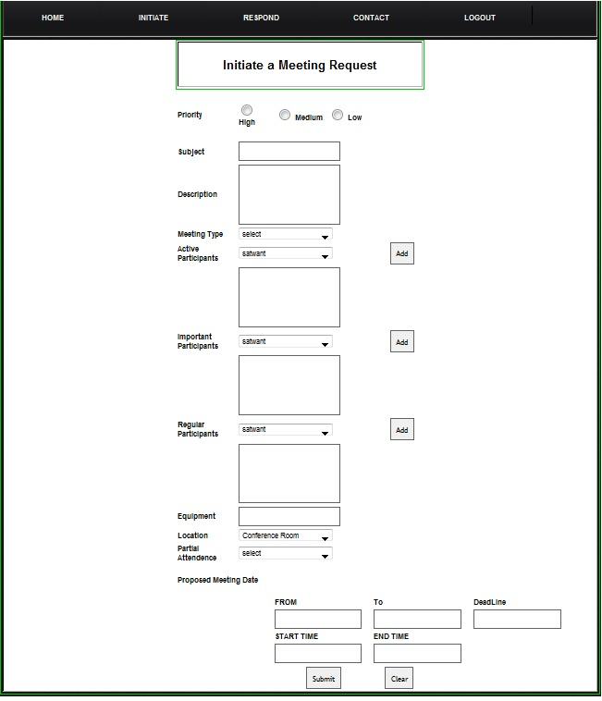

Meeting Status (S5)
This page lists the status of the meeting requests sent to the User. Meetings are categorised whether they are “Not Responded”, “Tentative”or “Finalized”. User can respond to the invite or ignore it.
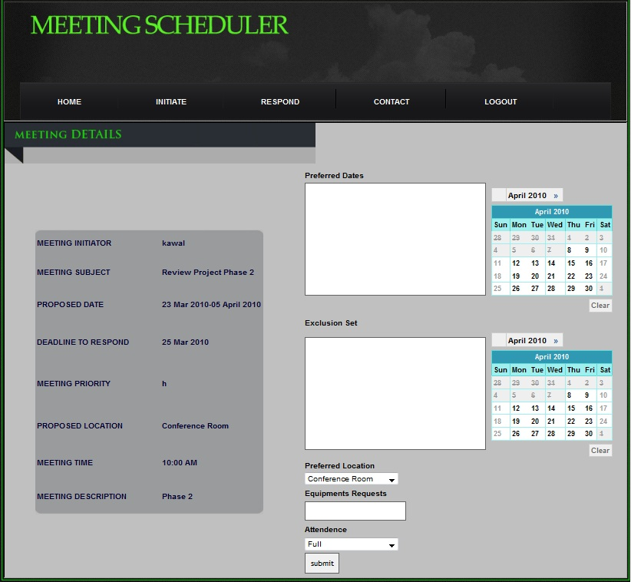

Pending Request Page (S6)
This page displays the pending request of the meeting. Users can respond to the meeting requests by providing their preferred dates, Exclusion dates and Comments and click on the “Submit” button. To clear the page “Clear” button is used.
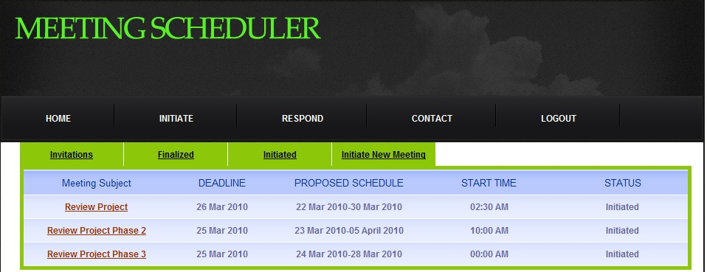

Meeting initiator view: User Responses (S7)
This page displays the information about preferred dates in green given by active and important participant and exclusion set in red. This detail helps the system to find one of date preferred by most of the important and active participants and thus helps in finding one date for meeting.
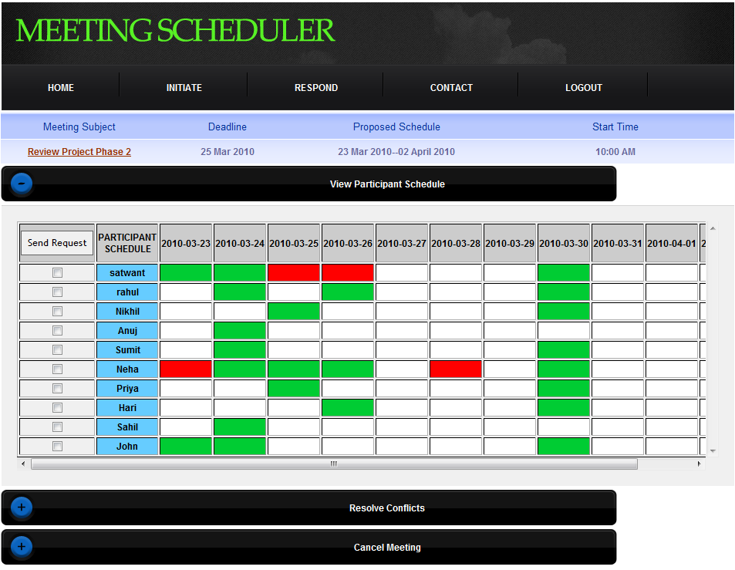

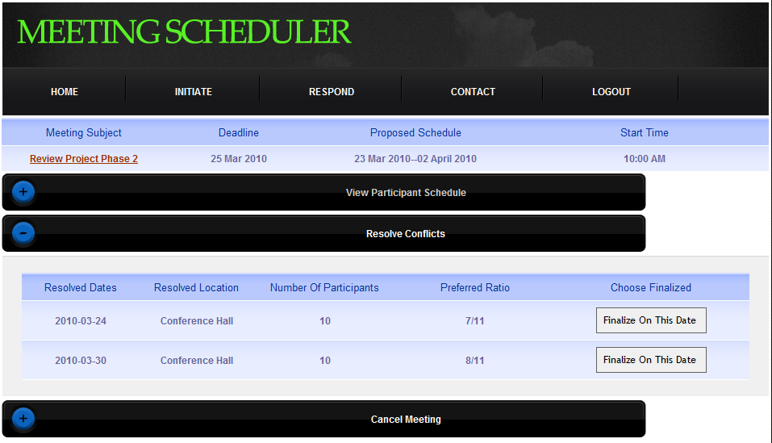

Meeting initiator view: Virtual Meeting Wizard (S8)
This page allows the meeting initiator to setup a Virtual Meeting.
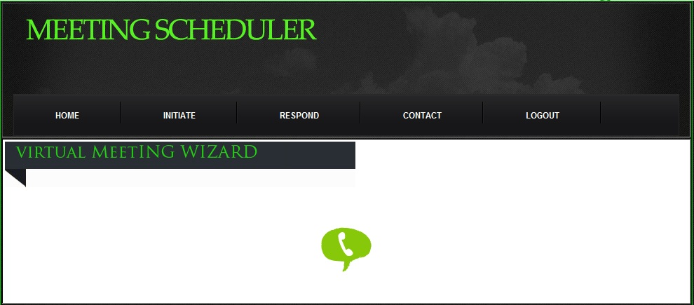

Meeting initiator view: Virtual Meeting Status (S9)
This page displays the status of the Virtual Meeting. The User can also see the status of the participants that are dialled in through the external application “Skype”. Users can initiate calls to new participants by clicking on the ‘Call Phones’ icon. One can also browse through the Employee directory by clicking on the ‘Directory’ icon and select one from the list and include them in the Virtual Meeting ongoing.
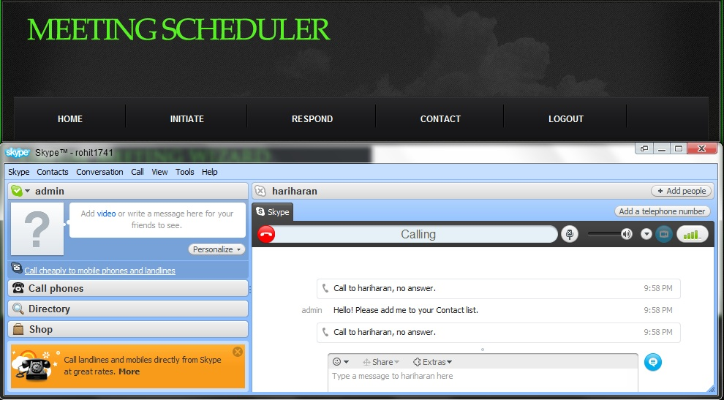

Meeting initiator view: Cancel Meeting (S10)
This page allows the meeting initiator to setup a Virtual Meeting.


