Failures and Causes

NASA Missions





Final Term Paper

By

Muhammad Ayaz Shaikh

SYSM 6309 - Advanced Requirements Engineering

Dr.: Lawrence Chung

Spring 2012

05/19/2012

Introduction

In this paper I am trying to explain the failures of NASA missions and its root causes. Critical failure in aerospace is defined to be those failures that resulted in a premature or unanticipated terrible loss of the vehicle. The point to pick this topic is to highlight the importance of little mishaps in big failure and loss. When I say big failure and loss – in aerospace specifically NASA, it means millions and billions of dollars with the loss of human lives.

Let’s start with what is NASA and why it exists? In other words what is NASA’s goal and mission towards the betterment of the Earth?

NASA

The Space Act of 1958, which charters NASA as a Federal agency, defines a broad spectrum of goals and purposes for the Agency. The NASA Strategic Plan separates responsibility for its programs into Strategic Enterprises, which identify at the most fundamental level what they do and for whom. Each Strategic Enterprise has a unique set of goals, objectives, and strategies that address the requirements of its primary external customers.

NASA Vision

• To advance and communicate scientific knowledge and understanding of Earth, the Solar System, and the universe

• To advance human exploration, use, and development of space

• To research, develop, verify, and transfer advanced aeronautics and space technologies

The Space Science Enterprise’s foremost role in support of the NASA mission is the discovery of new scientific knowledge about the universe. The Space Science Enterprise will:

*Discover how the universe began and evolved, how we got here, where we are going, and whether we are alone.*

NASA Goals

*We will be at the forefront of exploration and science. We will develop and transfer to industry cutting-edge technologies in aeronautics and space to fulfill our national needs. We will establish a permanent human presence in space, expanding and sustaining human exploration, use, and development of space in our solar system and providing benefits in science, technology, and commerce that will contribute to a better life on the Earth for this and future generations. As we pursue our mission, we will enrich our Nation's society and economy. We will communicate widely the content, relevancy, and excitement of NASA's missions and discoveries to inspire and to increase understanding and the broad application of science and technology.*

*In the longer term, it is our goal to undertake bold and noble challenges and to share the excitement of NASA's future programs with our fellow citizens. Our long-term goals include conducting international human missions to planetary bodies in our solar system such as the Moon and Mars; enabling advances to air and space systems to support "highways in the sky," "smart aircraft," and revolutionary space endeavors; supporting the maturation of established aeronautics and space industries and the development of new high-tech industries; enabling humans to forecast and assess the health of the Earth system; and establishing a virtual presence throughout our solar system.* <http://www.hq.nasa.gov/office/codez/stratplans/1996/vision.html>

In a nutshell NASA is an investment in America’s Future. As explorers, pioneers and frontiers in air and space they are inspiring and serving America and benefiting the quality of life in earth. If I briefly explain NASA is helping in

* Economic growth and security
* Preservation of the environment by early signaling
* Educational excellence to enlighten curious minds
* Peaceful exploration and discovery of universe to enrich human life

NASA Mission Statistics

NASA has conducted more than 6000 missions which include space, orbiter, manned and unmanned missions. In which NASA have got 95% success rate which is extremely remarkable. It means there were 422 missions failed and multibillion dollar loss.

Within these 6000 missions, there were 123 manned missions in which astronauts were flying towards the space. NASA achieved 98% success rate – 2% failure which means 3 failures and more than 50 human lives lost.

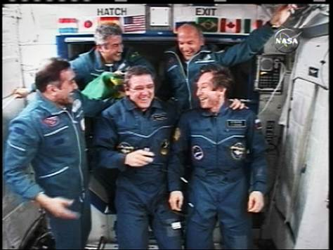

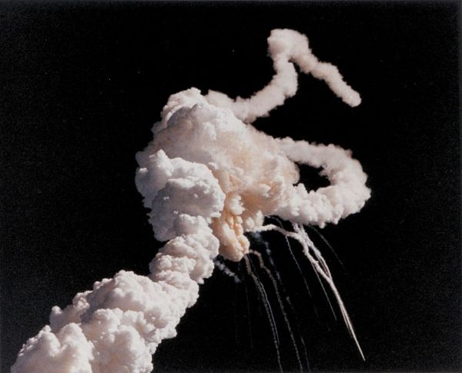

Failed NASA Mission

Missions and its Problems

The Orbiting Carbon Observatory (OCO) Satellite

*Courtesy of NASA*

**The Mission**: NASA intended the OCO to provide an orbiting platform from which scientists would be able to look at how carbon dioxide moved through the atmosphere. Hyped as a space-down look at global warming, the OCO was supposed to help researchers figure out climate change.

**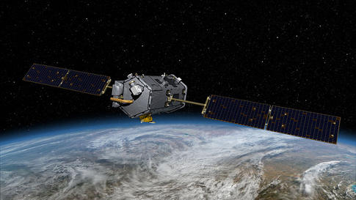The Problem**: Sadly, the OCO never made it into orbit, as the case containing the satellite failed to separate from the rocket during launch, leading the whole assembly to crash into the ocean 17 minutes after liftoff.

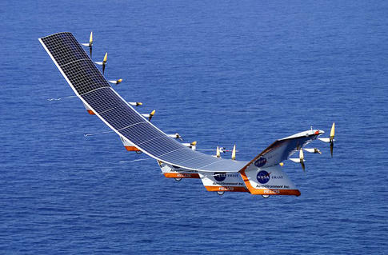

### NASA Helios

*Courtesy of NASA*

**The Mission**: Not actually a space probe, Helios was the last in a line of high altitude, solar powered atmospheric research platforms designed to fly in the upper atmosphere.

**The Problem**: While the previous aircrafts in the series succeeded in breaking a number of flight records, Helios just couldn’t hack it. About 30 minutes after taking off, Helios hit some powerful wind shear and crashed into the Pacific.

### The Mars Polar Lander (MPL)

*Courtesy of NASA*

**The Mission**: The Mars Polar Lander was part of an extensive 1998 push to study the red planet. The program consisted of a soil probe, a lander, and a satellite. As the lander, the MPL was supposed to study the climate and surface of Mars.

**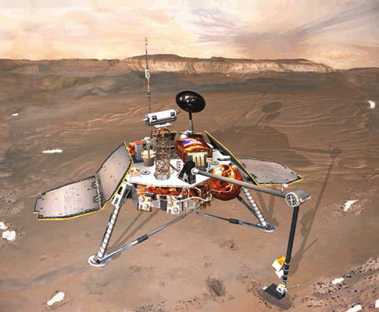The Problem**: No one really knows what happened to the MPL. The spacecraft successfully reached Mars, but NASA never made contact with the MPL. Anything from a faulty transmitter to a complete crash to interference from Marvin

could have caused the failure. NASA still hopes

to one day find the MPL and figure out what

went wrong.

### noaa19_1.jpg

### NOAA-19

**The Mission**: NOAA-19 was the last in a series of weather satellites that monitor atmospheric conditions, follow volcanic eruptions and conduct climate research.

**The Problem**: There have been satellites lost in space, those that have exploded on the runway, and then there’s this. During final servicing at a Lockheed-Martin facility in California, engineers failed to check if the satellite was bolted down before moving it, and accidentally knocked the multi-million dollar piece of equipment onto the ground, breaking a number of components. Whoops!

Issue Definition

The refreshed atmosphere structure is a move in the right direction, multiplying communication channels and delineating responsibilities for technical excellence. However, the core issues that relate NASA’s “culture” to improvements in system dependability and safety have so far, in my opinion, only been slightly addressed. If the investigation board had any message for NASA regarding culture, it is that something in NASA’s social organization and processes leads to technical failure of systems. To directly address the investigation board’s concern, we must determine the connection between culture and failure.

To make this connection, we need to understand the nature of faults and failures. Failure is generally the outcome of a chain of events that are made more likely by various contributing factors. Failure investigations start from the end of the failure process: the final failure effects, which can include complete system loss, like the Space Shuttle *Columbia* burning up in the atmosphere, or can be more kind, such as the scrub of a launch. The proximate causes are generally the technical items that malfunctioned and led to the failure effects: O-ring failure of the *Challenger* accident, or the foam that fell off the external tank and hit *Columbia*’s wing during ascent. But proximate causes have their genesis in root causes, suchashuman-induced errors in the application of the foam to the external tank in the *Columbia* case, the decision to launch *Challenger* on a morning when the temperature was lower than rated environmental limits, or human error in creating the shuttle’s original, flawed Solid Rocket Booster segment-joint design. Finally, there are contributing factors, such as pressures to launch the shuttle on an accelerated schedule, pressures to lower costs, or use of a teleconference instead of a face-to-face meeting contributing to miscommunication.

Frequently, we find that the failure effects and the proximate causes are technical, but the root causes and contributing factors are social or psychological. Successes and failures clearly have technical causes, but a system’s reliability strongly depends on human processes used to develop it, the decisions of the funders, managers, and engineers who collectively determine the level of risk. We humans make mistakes, either individual cognitive or physical mistakes, or as groups through lack of communication or miscommunication. Although the statistics have not been studied fully, my sense, from research in the field and listening discussions with other experienced engineers, is that 80 to 95 percent of failures are ultimately due to human error or miscommunication. Most of these are quite simple, which makes them appear all the more ridiculous when the investigation gets to the root cause and finds, for example, that it is due to a missed conversion factor of English to metric units, a simple error in a repair, a reversed sign in an equation, or one person not knowing that another person had a piece of information needed to make a proper decision.



The objective of root cause failure analysis is to identify “root cause(s)” so that these hidden failures may eliminate or modified and future occurrences of similar problems or mishaps may be prevented. One failure of analysis pitfall: If root cause failure analysis is not performed, and the analyst only identifies and fixes the proximate causes, then the underlying causes may continue to produce similar problems or mishaps in the same or related areas.

Solution and Advancements

How can NASA make progress directly addressing the investigation board recommendations?

The first step is recognizing that technical failures have individual and social causes. Evidence for this is overwhelming, and to do not need to look further for some mysterious “cultural issue.” The second step is to take action. While there is no single solution to this problem, there are many ways we can improve. NASA can perform research to better understand how humans make mistakes and what circumstances increase our “natural error rates.” NASA can use this research to change the environment in which we operate and communicate, and they can educate themselves to reduce the probability of making individual mistakes or miscommunication with others. NASA can improve the relationships between engineering, operations, and safety organizations, and can create design and operational engineering disciplines to better engineer systems to tolerate the predictable failures.

Above all, NASA needs to make tackling the individual and social causes of failure a priority. It should put a plan in place to start the research and to plan, coordinate, and assess organizational and educational innovations specifically targeted to improve dependability. Individual education, organizational change, and technical improvements will all be part of this plan. All these methods, and the efforts of all, will be needed to tackle this, one of NASA’s most difficult and deep-seated issues

References

* NASA\_APPEL\_ASK\_32i\_success\_failure\_nasa\_culture.pdf
* <http://www.msnbc.msn.com/id/12102538/ns/technology_and_science-space/t/new-crew-arrives-space-station/#.T7YGGtzO3oQ>
* <http://www.hq.nasa.gov/office/codez/stratplans/1996/vision.html>
* <http://www.popsci.com/military-aviation-amp-space/gallery/2009-03/top-10-nasa-probe-failures>
* <http://answers.yahoo.com/question/index?qid=20080104115202AAHbQuF>
* <http://www.hq.nasa.gov/office/codeq/accident/accident.pdf>
* <http://www.nap.edu/openbook.php?record_id=12950&page=22>
* <http://www.shmula.com/root-cause-failure-analysis/9261/>
* <http://www.knowitall.org/nasa/connect/index.html>