Software Project Management Plan

Team T-MIP
www.tmip-helpeople.com

Team Members:
Taraneh Parvaresh
Mairon Toçi
Ian Bùi
Pooria Kamran Rashani

Table of contents

Revision History 3
1 Introduction 4
1.1 Project Overview 4
1.2 Project Deliverables 4
1.3 Evolution of this document 5
1.4 References 5
1.5 Definitions, Acronyms and Abbreviations 5
2 Project Organization 6
2.1 Process Model 6
2.2 Organizational Structure 7
2.3 Project Responsibilities 7
3 Managerial Process 9
3.1 Management Objectives and Priorities 9
3.2 Assumptions, Dependencies and Constraints 9
3.3 Risk Management 9
3.4 Monitoring and Controlling Mechanism 10
4 Technical Process 11
4.1 Methods, Tools and Techniques 11
4.1.1Tools 11
4.2 Software Documentation 11
4.3 Project Support Functions 11
5 Work Elements, Schedule, and Budget 12
APPENDIX A ……………………………………....……………………………………………….......... 13
(Meeting Minutes)

Revision History

Version | Date | Comments | Author
0.0 | January 22, 2012 | Initial Version. Includes team members, deliverable milestones, team website, introduction, project organization summary. | Taraneh/Pooria
0.1 | January 24 | Revised Introduction. Split into Purpose and Product Description | Ian Bui
0.2 | January 25 | Revised Managerial Process. Updated tools and website | Mairon Toçi
0.3 | January 25 | First team review | T.I.P
0.4 | January 25 | Add constraints;  Appendix for Meeting; Table of Deliverables | Mairon  Taraneh
1.0 | January 26 | First formal version to turn in | Ian
1.1 | February 19 | Update minutes of meeting | Taraneh
1.2 | February 21 | Update minutes of meeting | Taraneh
1.3 | March 09 | Update Tools | Mairon
1.4 | March 09 | Update minutes of meeting | Taraneh
1.5 | March 23 | Update minutes of meeting | Taraneh

1 - Introduction

1.1 Purpose

This document describes the plan to produce a Systems Requirement Specifications (SRS) document for project HELPeople. The SRS will be used by system designers, developers and testers for implementing and testing the product. It is not a customer-facing document, but its content is derived from user requirements and needs.

1.2 Product Description

HELPeople is an application that runs on smart devices such as mobile phones or tablets. Its purpose it to help people communicate more easily and conveniently to accomplish certain daily tasks. Even though the app is intended primarily for the elderly and people with communicative disabilities, it may be used by anyone, even children.

As an app, HELPeople itself does not perform such tasks as Reminder or Direction. Rather, HELPeople is an intelligent interface with multiple sensory inputs that seamlessly integrates with other apps built for those specific purposes, e.g. Calendar, GPS Map, etc.

In essence, HELPeople is a unified interface through which disparate apps can communicate, share data, and intelligently interact with each other to serve a particular user need in a most efficient manner.

The key function of HELPeople is its ability to accept multiple inputs - voice, text, touch, image, biometrics, and to respond to user input via different means: audio, visual, vibration, etc.

1.3 Project Deliverables

Phase | Deliverables | Date
Initial | Preliminary project plan  URL | January 28, 2012
Phase 1 Interim | Revised Software Project Management Plan  PowerPoint Presentation  Preliminary Website  Mockups  Initial SRS document | March 10, 2012
Phase 1 Final | Revised Software Project Management Plan  WRS – Improved Understanding  Preliminary Traceability Matrix  Prototype | March 24, 2012
Phase 2 Interim | Revised Software Project Management Plan  SRS  Traceability Matrix  Presentation - possible | April 21, 2012
Phase 2 Final | Revised Software Project Management Plan  SRS  Traceability Matrix  Prototype  Presentation | May 19, 2012

1.4 Evolution of this document

This plan is a living document and will be subject to change as the project moves forward. Changes will be noted in the “Revision History” at the beginning of the document.

1.5 References

[1] Lawrence Chung, Advanced Software Engineering syllabus, SYSM6309, Spring 2012. http://www.utdallas.edu/~chung/SYSM6309/

1.6 Definitions, Acronyms and Abbreviations

UML: Unified Modeling Language
SRS: System Requirements Specification
SPMP: Software Project Management Plan

2 - Project Organization

2.1 Process Model

Team T-MIP will be utilizing the Spiral Model for the first two iterations of the Requirements Engineering. By using this model, Team T-MIP will be able to perform “analysis and negotiation” and be able to go back and perform the process a second time for a much more improved understanding of what is needed for the software.

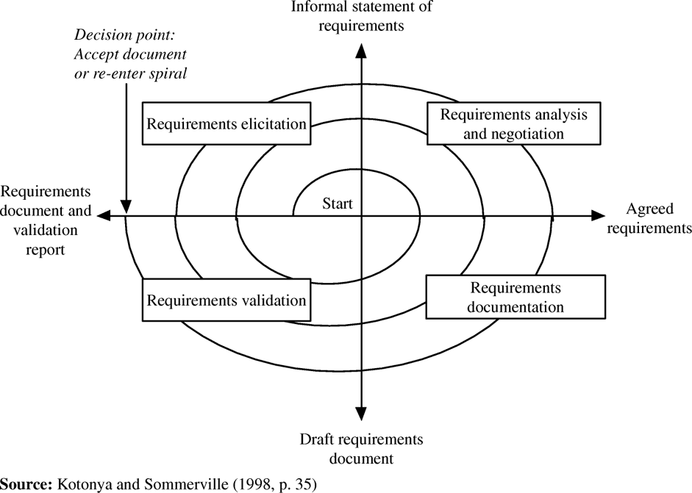

2.2 Organizational Structure

The project leads are as follows

Phase | Leader | Dates
Phase 1 Interim | Ian Bùi | Jan 14th – March 10th 2012
Phase 1 Final | Taraneh Parvaresh | March 11th – March 24th
Phase 2 Interim | Mairon Toçi | March 25th – April 21th
Phase 2 Final | Pooria Kamran Rashani | April 22th – May 19th

The team is formed of 4 members in whom one person would lead the team for each phase. For the first deliverable Ian Bùi will be the Team Leader for the project.

2.3 Project Responsibilities

All the team members will be involved in all phases of the project life cycle.
The role for each team member will change for every deliverable to help spread the workload around and ensure that no one team member is overwhelmed.

Phase | Role | Ian | Taraneh | Mairon | Pooria
1 Interim | Project Leader | X
 | Requirement Engineer |  | X | X | X
 | Quality Assurance |  |  | X | X
 | System/Interface Design |  | X | X
 | Documentation |  | X |  | X
1 Final | Project Leader |  | X
 | Requirement Engineer | X |  | X | X
 | Quality Assurance | X |  | X
 | System/Interface Design |  |  | X | X
 | Documentation | X |  |  | X
2 Interim | Project Leader |  |  | X
 | Requirement Engineer | X | X |  | X
 | Quality Assurance |  | X |  | X
 | System/Interface Design | X |  |  | X
 | Documentation | X | X
2 Final | Project Leader |  |  |  | X
 | Requirement Engineer | X | X | X
 | Quality Assurance | X |  | X
 | System/Interface Design |  | X | X
 | Documentation | X | X

Project Leader
The Project Manager will plan, execute and finalize project according strict deadlines. This includes acquiring resources and coordinating the efforts of team members in order to deliver projects according to plan. The Project Manager will also define the project’s objectives and oversee quality control throughout all phases.

Requirement Engineer
The Requirement Engineer will be charged with working with the project stakeholders and end users to elicit, understand, analyze and make ready the documentation for the system in order to solve a given problem. Also is responsible for assisting the Project Leader in elaborating on requirements and dependencies.

Quality Assurance
The Quality Assurance will collaborate with Project Leader to determine that the existing standards of the process are satisfactory and follow safety regulations.

System/Interface Design
The system/interface designer will work under the direction of project leader and is central to the process of designing mockups for the clearly defined requirements. Also is responsible for the team website and different creative decisions.

Documentation
Track changes during the project / Meeting minutes / Update documents with the last changes.

3 - Managerial Process

3.1 Management Objectives and Priorities

Team leader will maintain the responsibility of maintaining and containing the project schedule and ensuring that all work items are completed and on schedule. Leadership is also responsible for the creation of all deliverables and scheduling/running meetings.

3.2 Assumptions, Dependencies and Constraints

Assumptions:
- Team members are assumed to be able to perform and stay involved in the tasks that they are assigned
- Team members will not need assistance in performing the duties that they have been assigned
- Team members have access to computers and the needed software / tools

Dependencies:
- Documented and accurate communication between team members
- Team members completing assigned tasks on time
- Decisions made in a timely manner
- Deadlines set

Constraints
- If a deadline is unable to be met, it is to be communicated to all members 48 hours in advance
- If a member is unable to complete an assigned task, it is to communicated to the team leader to assist or reassign projects

3.3 Risk Management

To reduce the high failure rate of this high technological project we have to develop a better understanding of the dimensions of our project risk and how they can affect project performance.

Our project may encounter various types of risks:

- Technical risks include problems with project size, project functionality, platforms, methods, standards, or processes. These risks may result from excessive constraints, lack of experience, poorly defined requirements, or dependencies outside the direct control of the project team.
- Management risks include lack of planning, communications problems, organizational issues, lack of authority and control problems.
- Contractual and legal risks include changing requirements, market-driven schedules, health & safety issues, government regulation and product warranty issues.
- Other resource risks include inadequate tools, inadequate facilities, unavailability of computer resources and slow response times.

3.4 Monitoring and Controlling Mechanism

Weekly meetings and online communications are documented. Decisions are made by a voting process after some discussion. Some decisions are made, however, by phase leader like when and where to meet.

4 - Technical Process

4.1 Methods, Tools and Techniques

4.1.1 Tools

- Dropbox
- a general depository for documents (images, minutes, etc…)
- Email
- internal, external and interpersonal communication
- Microsoft Office Products
- documentation applications for formal deliverables
- Adobe Products
- create mockups and graphical user interfaces
- StarUML
- formal diagramming language
- Web Designer Premium
- create a webpage with web standards suitable for different platforms and browsers
- LucidChart Demo
- easy tool to mock up an iPhone.
- Team Viewer
- Web conferencing solution used for online meetings.

4.2 Software Documentation

StarUML diagrams will be provided after initial iteration. We will not implement the software itself according to provided documents. We will skip the coding part but deliver all required documents for design and implement the software.

4.3 Project Support Functions

Weekly meetings minutes will help to bring out and share our ideas to drive the project forward.

5 - Work Elements, Schedule, and Budget

Budget for this project is nil. This project scheduled to be completed by May 19th 2012.

Here is the outline of the timeline of major milestones:

Milestone | Date
Initial Project Plan | Jan 28th 2012
Interim Project I Presentation | Mar 10th 2012
Final Project I Presentation | Mar 24th 2012
Interim Project II Presentation | Apr 21st 2012
Final Project II Presentation | May 19th 2012

APPENDIX A

Meeting Minutes

Date: January 19, 2012 (6:30-8:00pm)
Place: UTD Student Center
Participants:
Ian Bui (Leader), Taraneh Parvaresh, Pooria Kamran, Mairon Toci

Activities:
1.Agree on the project
2.Discuss general product features
3.Choose a team name
4.Divide tasks and responsibilities:
a. Mairon - Build website
b. Taraneh/Pooria - 1st draft of Project Plan
c. Ian - Product Description
5.Set up next meeting

Date: January 25, 2012 (11:30-12:30pm)
Place: UTD Student Service Center
Participants:
Ian Bui (Leader), Taraneh Parvaresh, Pooria Kamran
Absent: Mairon Toçi (Taking care of building the website)

Activities:
1.Discuss general product features
2.Add minutes of meeting to SPMP document
3.Divide tasks and responsibilities:
a. Mairon - Update website and update Tools and constraints section in document
b. Pooria – Edit Project Plan
c. Taraneh - Look for versioning software, add appendix
d. Ian – Edit Product Description
4.Deliver SRS document instead of WRS
5.Decided User Manual is not a deliverable
6.Deliver “Traceability Matrix” in SRS document

Date: February 12, 2012 (4:00-7:00pm)
Place: Starbucks
Participants:
Ian Bui (Leader), Taraneh Parvaresh, Pooria Kamran, Mairon Toçi

Activities:
1.Discuss about the scope of project and the whole idea that we will work on it
2.We came up to build our application to be useful for 5 categories of people as below:

- Visual impairment
- Hearing impairment
- Mobility impairment
- Old people
- Normal people

3.Define Input/output of the application
Inputs: Audio, Touch, Camera, Wireless Device, Keyboard, 3rd party Apps
Outputs: Speaker, Visual Screen, Vibration, 3rd part Apps

4.We defined each input/output for different groups according to above-mentioned category

5.We categorized the type of applications that we shall use in to 3 groups of Internal apps, External apps and Network apps.

6. We discussed to have a new feature in HELP application as “Family tree”

Date: February 19, 2012 (4:00-6:00pm)
Place: UTD McDormett Library
Participants:
Ian Bui (Leader), Taraneh Parvaresh, Pooria Kamran, Mairon Toçi

Activities:
1.Discuss about “screen reader” and “voice commander” that are 2 useful tools, which we will use them in HELP

2.Listed out basic functionalities of the system
- Text to Speech
- Speech to Text
- Voice Commander
- Screen Reader
- API
- Image Recognition

3.Listed the apps in 4 different groups that we should use or develop in our project (Internal apps, External apps, Network apps and New apps)

Internal Apps:
- Calendar
- Contacts
- Clock
- Gallery
- Camera
- GPS
- Web Browser

External Apps:
- Music
- Radio
- News
- Weather

Network Apps:
- SMS
- MMS
- Email
- Voicemail
- Dialer

New Apps:
- Family Tree
- Emergency
- Medical
- Back Track

4.We agreed each one categorize these apps into levels so we can come up with final solution to put one icon for them in the main menu and place the rest as submenus for the first layer

5.Install Team Viewer and use it for our conference calls
6.Set up conference call for Tuesday 21 Feb

Date: February 21, 2012 (12:00-13:00pm)
Place: Conference Call
Participants:
Ian Bui (Leader), Taraneh Parvaresh, Pooria Kamran, Mairon Toçi

Activities:
1.Discussed about the categorization of different parts of the application
2.Discussed about the main layout of application UI
3.We will have large icons together with text for the main menu and subcategories will be defined in second page under the main menu items
4.We will have some main buttons in all pages like emergency, commander, and home icon
4.Defined responsibilities:
Taraneh & Pooria: Start the draft version of WRS
Mairon: Mockups and UI templates
Ian: List of usecases and functional requirements and prepare the definition of the project

Date: February 26, 2012 (3:30-6:30pm)
Place: UTD SOM 2.901
Participants:
Ian Bui (Leader), Taraneh Parvaresh, Pooria Kamran, Mairon Toçi

Activities:
1.Finalized input and output methods and add keyboard as input and vibration for output
2.Discussed about configuration section to cover below settings:
- Install
- Uninstall
- Update
- Customize

3.Grouped the application types as below:
A) Resident
- Native
- External
  - Integrated
  - Standalone
B) Non-Resident
- Network Based
- Internet Based

4.How to manage apps:
- ADD app
- Remove app
- List apps
- Launch an app
- Switch between apps
- Close current app
- Leave the previous app running
- Close app

For external apps we need to think about later on if we want to have the possibility to launch them from HELPeople or not.

5.We listed some requirements :
# Product should be able to accept commands either with voice or touch
# Product should respond to each command either visually or with voice
# Product should be able to describe each menu element on the screen orally
# Emergency icon should be available to call 911 or a family member
#Product should have access to most used apps via “H” button in all pages
.
.
.

6. We divided the responsibilities so each person make his/her part ready and on 4th march we’ll go to review them
Ian: Domain requirements
Taraneh: Functional Requirements
Pooria: Non-Functional Requirements
Mairon: User Manual

Date: March 4, 2012 (4:00-6:00pm)
Place: UTD SOM 2.901
Participants:
Ian Bui (Leader), Taraneh Parvaresh, Pooria Kamran, Mairon Toçi

Activities:
1.We went through each of the requirements together and give feedback
2.We come up to have different user profiles for the system so user can choose to have each of them to interact with the product
3. We went through WRS document to check the template and make sure what else we need to deliver

Date: March 7, 2012 (12:00-13:00pm)
Place: Conference Call
Participants:
Ian Bui (Leader), Taraneh Parvaresh, Pooria Kamran, Mairon Toçi

Activities:
1.We went through each of the requirements and issues together and give feedback
2.Discussed about the scenario and how to develop it
3.Discussed about the presentation
4.Put deadline to make revised documents ready for 9th March

Date: March 9, 2012 (12:30-13:30pm)
Place: Conference Call
Participants:
Ian Bui (Leader), Taraneh Parvaresh, Pooria Kamran, Mairon Toçi

Activities:
1.We went through each of the documents and presentation to make sure everything is ready
2.Discussed about the Traceability Matrix and decided to keep it as it is and get the feedback about the procedure from Dr.Chung
3. Agreed to make some small changes on software project plan document to have the updated one
4.Split the task for tomorrow’s presentation and defined for each section who is going to take the lead
5.Finalize all the documents and submit them before 5PM to Dr.Chung

Date: March 22, 2012 (12:00-14:30pm)
Place: Conference Call
Participants:
Taraneh Parvaresh (Leader), Ian Bui, Pooria Kamran, Mairon Toçi

Activities:
1.We went through all issues for domain requirements and revised requirements for domain part.
2.We went through all issues for functional requirements and revised them based on better understanding of the product
3.We decide that in next phase we need to define some user interface requirements as we have some of them in this phase but for more details we need to mention them precisely.

Date: March 23, 2012 (12:00-14:00pm)
Place: Conference Call
Participants:
Taraneh Parvaresh (Leader), Ian Bui, Pooria Kamran, Mairon Toçi

Activities:
1.We went through all non-functional issues and elaborate them more accurately
2.We agreed to change some part of setting in user manual, so we will have 2 settings in our product one would be general setting for the product like settings related to user profile selection and the other setting would be specifically for each of the applications like “sort”.
3.User manual needs some changes related to setting section
4.Imrpoved non-functional requirements need to revised
5.Creep rate section needs to be added to our documents
6.Update Traceability Matrix

