o



|  |
| --- |
|  |
| He |

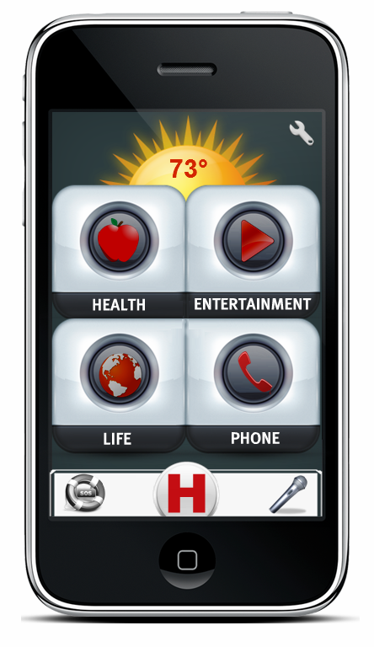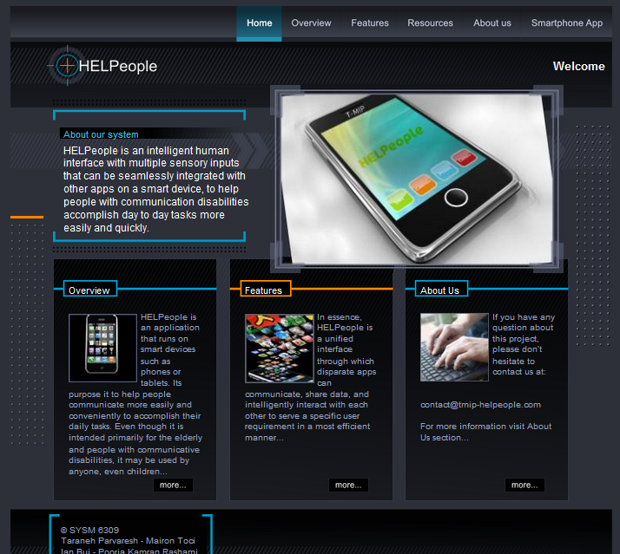

**Revision History**

|  |  |  |  |
| --- | --- | --- | --- |
| **Date** | **Version** | **Description** | **Author** |
| March 03, 2012 | 0.1 | Initial document, include most of the mockups. | Mairon Toci |
| March 09, 2012 | 0.2 | Reviewed | T-MIP |
| March 09, 2012 | 1.0 | Formal version to turn in (Interim Phase 1) | Mairon Toci |
| March 13, 2012 | 1.1 | Updated Content | Mairon Toci |
| March 23, 2012 | 1.1 | Reviewed | T-MIP |
| March 23, 2012 | 1.1 | Formal version to turn in (Final Phase 1) | Mairon Toci |
| April 16, 2012 | 1.2 | Add Downloading and Installing, Updated Life Center | Mairon Toci |
| April 19, 2012 | 1.3 | Reviewed | T-MIP |
| April 20, 2012 | 2.0 | Formal version to turn in (Interim Phase 2) | Mairon Toci |

**Table of Contents**

01. Introduction ………………………………………………………………………………….03

02. Downloading and Installing …………………………………………...…………………….03

2.1. iOS System……………………..………………………………………………...…04

2.1. Android System …………………………………..……………………………...…05

03. Key Charts …………………………………………………………………………………..06

04. Communication ……………………………………………………………………………...06

05. Home Screen ………………………………………………………………………………...07

06. Main Menus …………………………………………………………………………………08

6.1. Quick Access Menu ……………………………………………………………...…08

6.2. Weather Panel ………………………………………………………………………08

6.3. Time ……………………………………………………………………………...…09

6.4. SOS …………………………………………………………………………………09

6.5. HELP ……………………………………………………………………………….09

6.6. Commander …………………………………………………………………………10

07. Settings ………………………………………………………………………………………11

7.1. General Settings………………………………..……………………………………11

7.2. Subfolder Settings……………………………...……………………………………13

7.3. Application Settings…………………………………………………………………14

08. User Profile ………………………………………………………………………………….14

09. Health Center ……………………………………………………………………………..…15

10. Entertainment Center ……………………………………………………………………..…17

11. Life Center ………………………………………………………………………………..…18

12. Phone – Personal Communication Center ………………………………………………..…19

**Welcome**

T-MIP Solutions thanks you for choosing HELPeople platform that will enable your daily life operations in a simple, safe and fast way.

**The Best Choice**

HELPeople is a project whose mission is to improve the quality of life for those with communication disabilities through assistive technologies embedded in mobile devices. Leveraging existing mobile applications as well as those yet to be invented, our product, HELPeople aims to provide a simplified yet unified interface through which any user, with or without disabilities, can easily accomplish many of their important daily tasks via alternative methods of input and output.

HELPeople is designed and developed by the great interest of our specialized team in order to serve your needs by taking into account all suggestions and comments. We are determined to pursue our mission to deliver to our customers the best and most advanced service.

**HELPeople, your SMART friend!**

If you need more detailed explanations, information or assistance on HELPeople platform you can contact us at any time at: [contact@tmip-helpeople.com](mailto:contact@tmip-helpeople.com). You will always have at your disposal an authorized representative of T-MIP, which is ready to offer a full support about our innovative product.

*For more information, visit our website:* <http://www.tmip-helpeople.com>

1. **Introduction**

HELPeople is a NEW Smartphone application specially designed for older and physically-challenged users, with the aim of helping not only this target market, but at the same time by joining the mobile internet revolution.

T-MIP has developed its own, simpler interface, which it calls ‘HELPeople’, and it recommends apps that it thinks older or physical-challenged users will find particularly useful.

T-MIP's HELPeople application can also be installed on iOS and Android Smartphone’s which meets the basic system requirements. HELPeople provides a ‘fuss-free’ experience with well-spaced, large and clear application icons.

The key function of HELPeople is its ability to accept multiple inputs - voice, text, touch, image, biometrics, and to respond to user input via different means: audio, visual and/or vibration.

This manual will guide you and any of your friends through the application.

1. **Downloading and Installing**

To get the HELPeople application in your mobile you need to follow these simple steps. Note that this first realize is available only for iOS and Android systems.

* 1. **iOS System**

In order to start using the HELPeople iPhone app you will need to download it by visiting

The Apple iTunes store.

|  |  |  |
| --- | --- | --- |
|  |  |  |
| **Step 1.** From the Home Screen, tap All Apps Icon and then tap App Sotre | **Step 2.** Select the ‘Search’ button and search for HELPeople. Tap it. | **Step3.** A page with apps matching your search appears. Tap the HELPeople Icon |
|  |  |  |
| **Step 4.** The HELPeople info page appears. Tap on the blue button ‘Free’ | **Step 4.** The button will then turn green and be labeled ‘Install’. Tap on the green button | **Step 6.** The app is downloaded when the loading is complete. It is now ready to use |

**2.2. Android System**

In order to start using the HELPeople Android app you will need to download it by visiting The Android Market.

|  |  |  |
| --- | --- | --- |
|  |  |  |
| **Step 1.** Tap on the Market Icon | **Step 2.** Select the ‘Search’ button and search for HELPeople. Tap it. | **Step3.** A page with apps matching your search appears. Tap the HELPeople Icon. |
|  |  |  |
| **Step 4.** The HELPeople description page appears.  Tap on the grey button ‘Free’ | **Step 4.** Accept Permission pages will appear. Tap on the grey button ‘OK’. | **Step 6.** The app is downloaded when the loading is complete. It is now ready to use |

1. **Key Charts**

|  |  |
| --- | --- |
|  |  |
|  | Find **HELPeople** icon on your Smartphone application list and execute it to start HELPeople (See section 4) |
| http://files.softicons.com/download/system-icons/aquanox-icons-by-cyberchaos05/png/256/settings.png | Touch **SETTINGS** button (*or ask the system to run it*) to access and manage your application features (See section 6) |
| http://images3.wikia.nocookie.net/__cb20100130163437/lyricwiki/images/thumb/6/69/Microphone.png/120px-Microphone.png | Touch **VOICE COMAND** button to access and manage your application features (See section 5.6) |
| http://3.bp.blogspot.com/_zrfYoqeZbbU/TQq0Q4EdIWI/AAAAAAAAAGY/GjDTzjie97k/s1600/1292546613_keyboard.png | Touch **TEXT COMAND** button to access and manage your application features |
| http://www.ideophone.in/sos/sos.png | Touch **SOS** button (*or ask the system to execute it*) to access and manage your application features |
|  | Touch **HELP** button (*or ask the system to execute it*) to access and manage your application features |
| http://images-3.findicons.com/files/icons/1580/devine_icons_part_2/128/home_w.png | Touch **HOME** button (*or ask the system to execute it*) to go back to the main menu |
| http://cdn1.iconfinder.com/data/icons/cc_mono_icon_set/blacks/48x48/br_down.png | Touch **DOWN LIST ARROW** to see the rest of the list that is present under a certain category |
| http://cdn1.iconfinder.com/data/icons/cc_mono_icon_set/blacks/48x48/br_down.png | Touch **UP LIST ARROW** to see the previous part of the list that is present under a certain category |
|  | Touch **+ ADD** to add another application to a specific list using Customize App’s in settings menu |
| C:\Users\Mairon\Desktop\Layoutus\1195423990759977006molumen_multicolor_power_buttons_5.svg.med.png | Touch **ON** button (*or ask the system to execute it*) to turn on a feature of your application |
| C:\Users\Mairon\Desktop\Layoutus\1195429270821624493molumen_multicolor_power_buttons_4.svg.med.png | Touch **OFF** button (*or ask the system to execute it*) to turn off a feature of your application |

1. **Communication**

We started with a different viewpoint when we first started to engineer HELPeople. We think that most other software companies fail from the start. You may know that today hundreds of Smartphone applications exist, created with the good purpose to serve old or physically challenged people. We think that you don’t need genius apps to make this happen. What you really need are applications that can help with your daily tasks and more important, applications that you can easily access. We know that you enjoy seeing new landscapes build in your town, but we go further, and take into consideration your disappointment if you cannot go through it because you are in a wheelchair and you can’t find an entrance accessible by you.

    

Talk to HELPeople and you will get an audio response. Text this app and it will give you feedback. Touch it and it will change for you. Now T-MIP has designed a unique experience of communication. Chose your profile, change how you want to communicate with your phone. It’s your best smart friend. Go further on this manual to understand most of the features that HELPeople is ready to offer you today.

1. **Home Screen**

The home screen for the primary user consists of 4 categories that will lead the user to the different applications groups, as well as the Quick Access Menu, Settings and a Weather panel. It is the first screen that you will see once the application is started, and serves as the dashboard or landing page of the entire application. The four main categories are easy to remember because they have relation with our product name HELP – Health, Entertainment, Life and Phone.

Each icon is clearly indicated by a symbol associated with the functionality that it leads to, so that you can easily navigate the application. From the home screen, you can access:

* Weather Panel (See section 5.2)
* Phone Settings (See section 6)
* Quick Access (Emergency Calls; Help Center; Commander) (See section 5.1)
* Health Center (See section 8)
* Entertainment Center (See section 9)
* Life Center (See section 10)
* Phone Center (See section 11)

This allows you to access a category of functionality with a single click. The following is a screenshot of Home Screen.

****

1. **Main Menus**
   1. **Quick Access Menu**

Quick Access Menu is a fixed menu that will be present all the time while you are working through HELPeople app. It is a customized menu, which means:

* You can switch positions of microphone/keyboard commander and SOS button depending by your needs (if you are a left or right hand user).
* Depending on your selected profile, you will be able to use a voice OR a keyboard commander (Below you can see: on the left, the way that this menu looks if voice commander is selected or in the right, the way that this menu looks if the keyboard commander is selected.

****

|  |  |
| --- | --- |
| If you have selected the H (HELP) icon in the Quick Access Menu, the screen as in section 5.5 HELP will appear. | If you have selected the H (HELP) icon in the Quick Access Menu, the screen as in section 5.5 HELP will appear. |

****

|  |  |
| --- | --- |
| If you have selected the Voice Command icon in the Quick Access Menu, it will change color from grey to green and the screen as in section 5.6 Commander will appear. | If you have selected the Text Command icon in the Quick Access Menu, it will change color from grey to green and the screen as in section 5.6 Commander will appear. |

****

|  |  |
| --- | --- |
| If you have selected the SOS icon in the Quick Access Menu, it will change color from grey to red and the screen as in section 5.4 SOS will appear. | If you have selected the SOS icon in the Quick Access Menu, it will change color from grey to red and the screen as in section 5.4 SOS will appear. |

* 1. **Weather Panel**

The most used Smartphone application in 2011, the weather, is incorporated with the home screen of HELPeople. This application uses automatic updates so offers real time information for the weather at your current location. It also serves as an icon which leads to a more detailed weather application.

****

* 1. **Time**

You want to check the time, but your Smartphone clock has small digits. Our interface includes an easy readable electronic clock in each interface (excluding the home screen), so you will be always informed on the real time.

****

* 1. **SOS**

The above SOS screen is what you will see when you press the SOS feature from Quick Access Menu. From here, you can very quickly call or text 911, your doctor, or your emergency assistant, by pressing the corresponding icon. You can quickly approve through YES button a call to 911, or chose to call your predefined contact for doctor or assistant.

**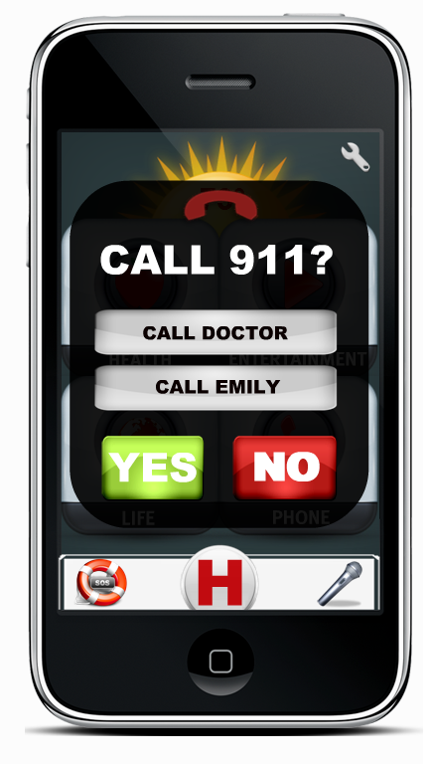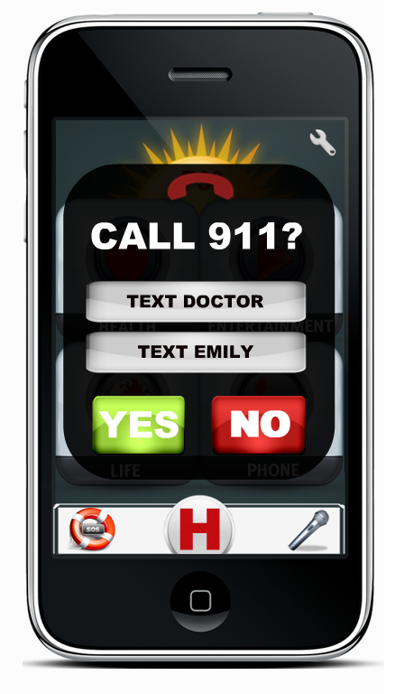**

* 1. **HELP**

The big H button in the Quick Access Menu is a like a Favorite/Bookmark button of the main applications that a user want to quick access or are really necessary for him/her. As the application is installed, into this category the following applications will appear: Phone; Medical Cabinet; Back Track; Wellness; Recognition; FunBox. The user can customize this category in the same way that is used for the other categories. To better understand the functionalities of the applications mentioned here, please keep reading this user manual.

**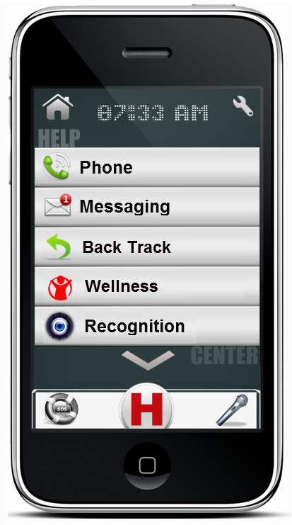 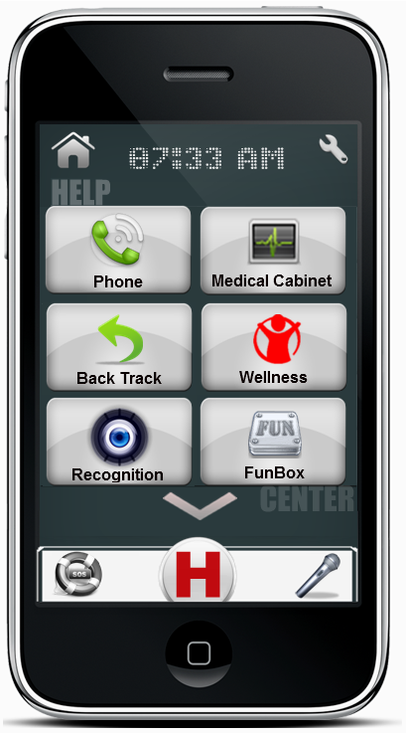**

* 1. **Commander**

The above Commander screen is what you will see when you press the Voice or Text Commander feature from Quick Access Menu. From here, you can ask your application to run another application, search for a list or in the web, give you information for different questions or many other things that you as user will “command”. For example: If you want to play a song that is stored in your device just speak or text using Commander: “Play Beatles Yesterday”, and HELPeople will do the rest.

**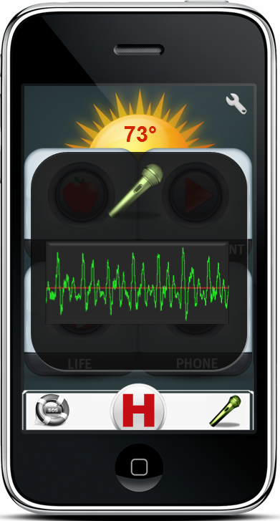 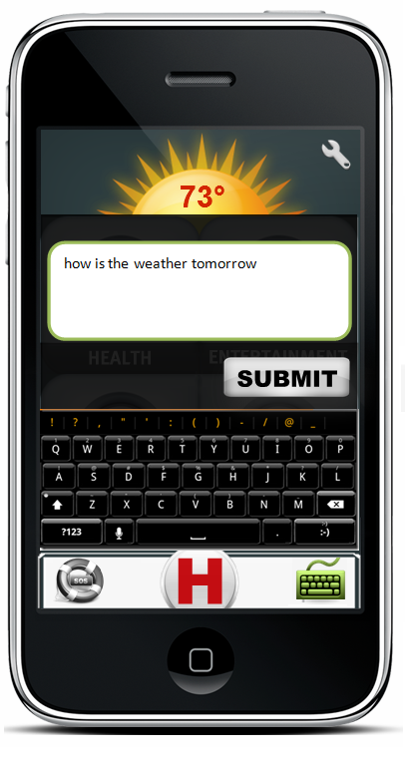**

1. **Settings**

Under Settings you can add/remove/change/customize the application in order to better suit your individual needs. Under different categories, you will find a set of tools that are especially related to that category. The general application settings can be accessed by using the settings button (or the following ways to access; see section 6.1) only from the home screen. Built-in apps and different subfolders will have their own settings menu accessible when you will use them (see section 6.2, 6.3)

* 1. **General Settings**

Suggested ways to access:

|  |  |
| --- | --- |
| Touch | Run HELPeople > Select Settings |
| Voice Command | Run HELPeople > Select Voice Command > Speak “Open Settings” |
| Text Command | Run HELPeople > Select Text Command > Write “Open Settings” |

**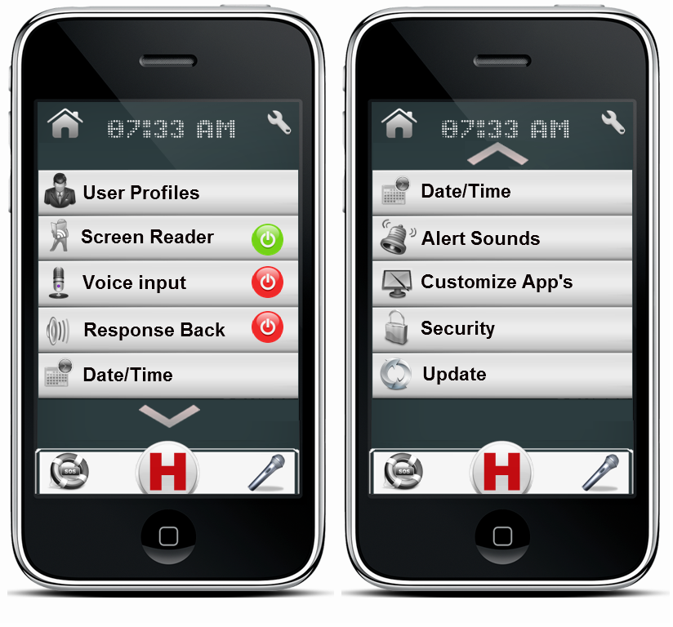**

|  |  |
| --- | --- |
|  |  |
| user Icon | **User Profile:** Customize your application input/outputs, folders, interface etc through selecting our predefined profiles or by using the one that you will create. (See section 7). |
| http://images-1.findicons.com/files/icons/1788/large_icons_social/256/rss_reader.png | **Screen Reader:** Directly activate/deactivate your screen reader without going to profile customization. |
| http://t0.gstatic.com/images?q=tbn:ANd9GcT8nFcbmhYmW_cYqW65u9m6HHWnxXslXwz6-SiEeQGPy-pSWuLoHKo36QaW | **Voice Input:** Activate/deactivate your voice input option to be open/closed all the time. Voice Input could be accessed from the Quick Access Menu (See section 5.1) if this option is deactivated. Optimal for audio profile, but not recommended to be activated. |
| http://images4.wikia.nocookie.net/__cb20091012190145/the404/images/7/72/Audio.png | **Response Back:** Let your phone notify you when your desired task is accomplished. |
| http://icons.iconseeker.com/png/fullsize/rhor-v2-part-3/date-and-time.png | **Date/Time:** HELPeople is designed to update the date/time at your current location. In case that you are in a non-WiFi area but still want to use some of the features of HELPeople, you can manually change the date/time of your new location. Mostly used from people who will travel abroad. |
| http://icons.iconarchive.com/icons/rokey/wifun/128/ringtones-icon.png | **Alert Sounds:** Take in control the way you want to be notified for an upcoming call, SMS, MMS, e-mail or notification. |
| http://icons.iconseeker.com/png/fullsize/air/customize.png | **Customize App’s:** Choose the app’s you really need. Delete those that you will never use. Change app’s folder destination. Sort in the way you are more comfortable. Everything should be in the place that makes more sense to you. |
| http://ionrisk.net/wp-content/uploads/2010/11/Gloss-PNGKKMenu_System_Security.png | **Security:** Manage your security keys and locks. |
| http://people.mozilla.com/~faaborg/files/20081216-platformIcons/softwareUpdate-256.png | **Update:** HELPeople is scheduled to be updated regularly. Anyway, if you want to anticipate an update, you can select this category from the Settings and the app will do the rest. |

* 1. **Subfolder Settings**

Suggested ways to access:

|  |  |
| --- | --- |
| Touch | Run HELPeople > Under Health/Entertainment/Life/Phone or Help Center (and their subdirectories) > Select Settings |
| Voice Command | Run HELPeople > Under Health/Entertainment/Life/Phone or Help Center (and their subdirectories)>Select Voice Command > Speak “Open Settings” |
| Text Command | Run HELPeople > Under Health/Entertainment/Life/Phone or Help Center (and their subdirectories)>Select Text Command > Write “Open Settings” |

**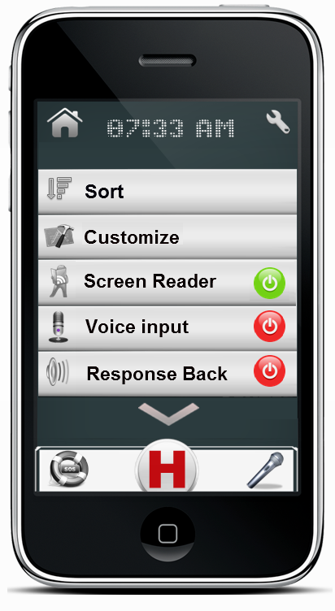**

|  |  |
| --- | --- |
|  |  |
| http://cdn5.iconfinder.com/data/icons/fatcow/32x32/sort_descending.png | **Sort:** Sort apps under a certain category in the way you are more comfortable. Everything should be in the place that makes more sense to you. |
| http://derekneely.com/wp-content/uploads/2009/11/xcode-icon.png | **Customize:** Choose the app’s you really need. Delete those that you will never use. Enable previously removed apps. Change app’s folder destination. Switch from list to icon view etc. |
| http://images-1.findicons.com/files/icons/1788/large_icons_social/256/rss_reader.png | **Screen Reader:** Directly activate/deactivate your screen reader without going to profile customization. |
| http://t0.gstatic.com/images?q=tbn:ANd9GcT8nFcbmhYmW_cYqW65u9m6HHWnxXslXwz6-SiEeQGPy-pSWuLoHKo36QaW | **Voice Input:** Activate/deactivate your voice input option to be open/closed all the time. Voice Input could be accessed from the Quick Access Menu (See section 5.1) if this option is deactivated. Optimal for audio profile, but not recommended to be activated. |
| http://images4.wikia.nocookie.net/__cb20091012190145/the404/images/7/72/Audio.png | **Response Back:** Let your phone notify you when your desired task is accomplished. |

* 1. **Application Settings**

A dedicated application settings menu will be available when you will run a specific app (native or integrated with HELPeople) by selecting the Settings button.

1. **User Profiles**

Suggested ways to access:

|  |  |
| --- | --- |
| Touch | Run HELPeople > Select Settings > User Profile |
| Voice Command | Run HELPeople > Select Voice Command > Speak “Open User Profile” |
| Text Command | Run HELPeople > Select Text Command > Write “Open User Profile” |

*The following is a screenshot of User Profiles menu.*

**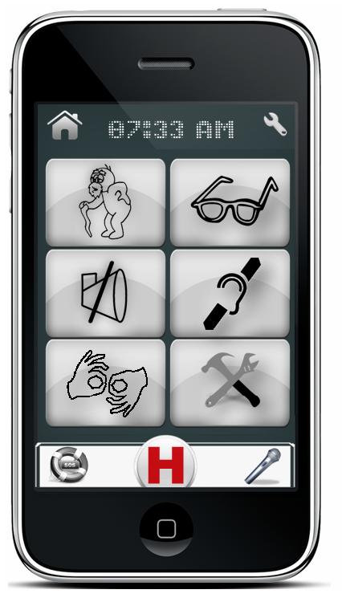**

|  |  |
| --- | --- |
|  |  |
| http://popcultureplaypen.files.wordpress.com/2011/08/old.gif | **Help Profile:** This user profile could be used by everyone, especially is customized specifically for old peoples. Users can access all HELPeople applications using touch-screen or by manually selecting the Voice Commander in the Quick Access Menu. By default ‘Screen Reader’ and ‘Response Back’ are disabled. Using this profile allows the user to have some special applications like FunBox in Entertainment category or a full featured Web Browser. |
| sunglasses outline | **Audio Profile:** This user profile is optimized with features which come in handy to people with visual difficulties. If you are blind or have difficulties identifying objects because of your eye sight, we recommend you use this profile. Users can access all HELPeople applications designed for this profile using audio commands. Since the Voice Commander in the Quick Access Menu is case sensitive, we recommend these users to keep it off and touch it every time they need to give “commands” to their phone. The Voice Commander could be switched left/right in the Quick Access Menu for easy access by left/right hand users. An option to leave the Voice Commander open for some time (or all the time) could be found under settings. This application profile is customized to give audio responses/feedback to the user using its Screen Reader feature. Also users of this profile could access web through a specific software: **Web Reader**, a Text to Speech based Web Browser (for more information see section 10) |
| http://images-5.findicons.com/files/icons/2141/web_design_creatives/128/mute.png | **Visual Profile:** This user profile is optimized with features which come in handy to people with speaking difficulties. If you are mute or have difficulties with your speech, we recommend you use this profile. Users can access all HELPeople applications using touch-screen or by manually selecting the Text Commander in the Quick Access Menu. By default ‘Screen Reader’ and ‘Response Back’ are disabled. Using this profile allows the user to have some special applications like **iTALK** (a text-to-speech application/see section 10), FunBox in Entertainment category or a full featured Web Browser. |
| http://cdn-img.easyicon.cn/png/5669/566928.gif | **Touch Profile:** This user profile is optimized with features which come in handy to people with hearing difficulties. If you are deaf or have difficulties hearing audio or signals, we recommend you use this profile. Users can access all HELPeople applications using touch-screen or by manually selecting the Voice Commander in the Quick Access Menu. Users have the option to switch from the Voice Commander to Text Commander and still stay under these profile features. Vibration alerts are activated. By default ‘Screen Reader’ and ‘Response Back’ are disabled.An application like **iTALK** could be used to come in help for audio to text translations. |
|  | **Only Visual Profile:** This user profile is optimized with features which come in handy to people with hearing and speaking difficulties. If you are deaf-mute or have difficulties hearing audio and you have speech impairment, we recommend you use this profile. Users can access all HELPeople applications using touch-screen or by manually selecting the Text Commander in the Quick Access Menu. All audio inputs are disabled for this profile. Audio outputs are used in specific applications such as iTALK. Using this profile allows the user to have some special applications like **iTALK** (a text-to-speech application/see section 10), FunBox in Entertainment etc. (See the above sections). |
| http://images-2.findicons.com/files/icons/1634/aqua_neue_graphite/128/customize.png | **Custom Profile:** This profile allow the user or its assistant to set a customized profile with audio/visual/text/vibration etc. features that can help better the experience of the user with his/her Smartphone using HELPeople. |

1. **Health Center**

Suggested ways to access:

|  |  |
| --- | --- |
| Touch | Run HELPeople > Select Health Button |
| Voice Command | Run HELPeople > Select Voice Command > Speak “Open Health Center” |
| Text Command | Run HELPeople > Select Text Command > Write “Open Health Center” |

*The following is a screenshot of Health Center menu (left list version / right icon version)*

In Health Center you are going to find a group of applications that are designed to help your everyday Health Activity, such as: Family History, Medical Cabinet, Calendar/Reminder, and Wellness. You could customize this group in your own way by adding/deleting apps, sorting them or choosing the list/icon view.

**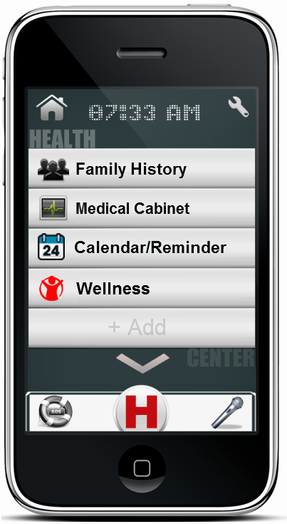 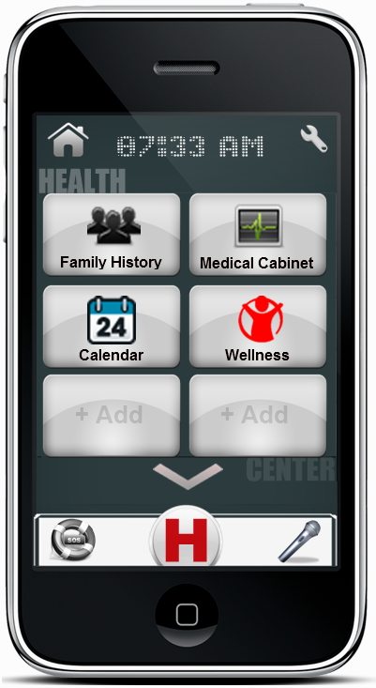**

|  |  |
| --- | --- |
|  |  |
| users icon | **Family History:** Build, update and show off your family tree. Whether you are a family history beginner or expert, this user-friendly app makes finding and learning more about your ancestors fun and easy. Add new family members to your pedigree, edit their information, add and edit life events, attach documents and even upload photos. |
| monitor icon | **Medical Cabinet:** is a comprehensive record-keeping app for your personal medical information. With this app, any and all information that is important to you is kept together in one place. It stores all data about medical history, allergies, operations, cornice disease etc, so in case of emergencies, doctors can consult with this file to retrieve info. |
| Calendar icon | **Calendar/Reminder:** now with your voice and in your words, delivered on time, every time. Speak or type! This new app version remembers everything. You will forget nothing anymore with this voice/text ‘to-do’ list. Simply record your personal memo, set the time and date, and you will be reminded in real time. |
| http://a2.twimg.com/profile_images/454483406/icona_piccola_bigger_normal.png | **Wellness:** is the essential app to simply find nutritional info for the food you eat and to keep track of your meals, exercise and weight. The Wellness application has all the necessary tools to help you succeed: - A quick food calorie finder and full nutrition information. – A daily food plan to keep track of what you’re eating. – A daily reminder for various tasks like taking pills or eating a meal etc. |

1. **Entertainment Center**

Suggested ways to access:

|  |  |
| --- | --- |
| Touch | Run HELPeople > Select Entertainment Button |
| Voice Command | Run HELPeople > Select Voice Command > Speak “Open Entertainment Center” |
| Text Command | Run HELPeople > Select Text Command > Write “Open Entertainment Center” |

*The following is a screenshot of Entertainment Center menu (left list version / right icon version)*

In Entertainment Center you are going to find a group of applications that are designed to keep you in shape and in a good mood, such as: Music, Video Recorder, Camera, Multimedia and FunBox. You could customize this group in your own way by adding/deleting apps, sorting them or choosing the list/icon view.

**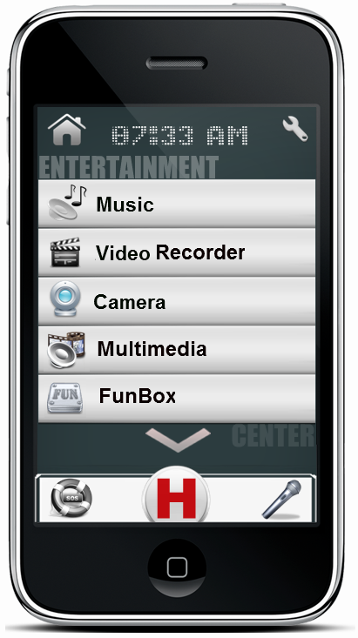 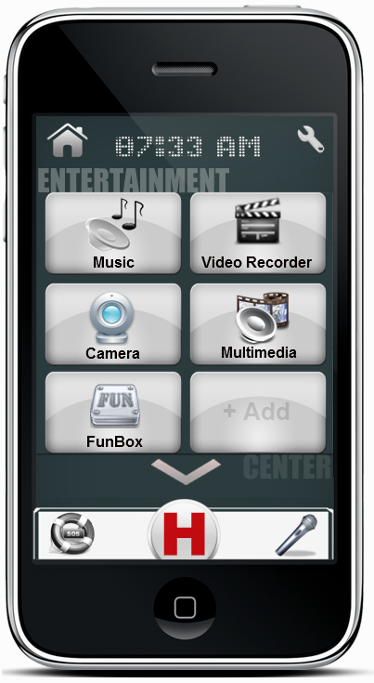**

|  |  |
| --- | --- |
|  |  |
| audio icon | **Music:** listen to all the music you want on your phone. It’s easy and fast. Upload your preferred music, from your preferred artist, into your phone and listen to them with just a click, anywhere, at any time. No need for internet connection while listening, no need for an antenna. Just upload and enjoy. |
| movies icon | **Video Recorder:** Record video with any Smartphone; share them on Facebook, YouTube and more. Customized with 20 live effects to record videos with. The best way to use your phone's camera to capture unforgettable memories. |
| http://icons.iconarchive.com/icons/iconshock/sigma-general/256/webcam-icon.png | **Camera:** Just have the desire to capture your beautiful life moments. Now you can easily access your phone camera. This app is also a light. Fun and easy camera app that lets you capture, manage, and share with total ease. |
| http://files.softicons.com/download/system-icons/crystal-project-icons-by-everaldo-coelho/png/256x256/apps/multimedia.png | **Multimedia:** Have everything that is stored is your phone, but not only that, show others your music, photos and videos. Add your preferred places, images or favorite videos into this easy manageable folder of art. Find what you want with just a click. |
| http://1.bp.blogspot.com/_owBFhiED79o/TN-qR2YTLyI/AAAAAAAAABg/mUu0zloCw9Y/s1600/ifunbox.png | **FunBox:** Is the package of your entertainment. Find things that relax and give pleasure to you in a single directory. Talk with your friends that are abroad by using Skype Chat, play Sudoku or Cards while you are waiting for someone, or check the last movies in Movie Theater or RedBox. *Note:* *This app bookmark is not offered for all profiles. We will let you know regarding future changes.* |

1. **Life Center**

Suggested ways to access:

|  |  |
| --- | --- |
| Touch | Run HELPeople > Select Life Button |
| Voice Command | Run HELPeople > Select Voice Command > Speak “Open Life Center” |
| Text Command | Run HELPeople > Select Text Command > Write “Open Life Center” |

*The following is a screenshot of Life Center menu (left list version / right icon version)*

In Life Center you are going to find a group of applications that are designed to help you in your daily life tasks, such as: Web Browser (Web Reader), Location, Recognition, Back Track, Places and talk. You could customize this group in your own way by adding/deleting apps, sorting them or choosing the list/icon view.

**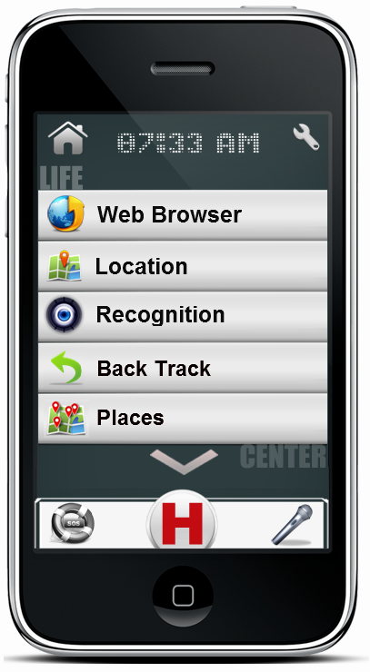 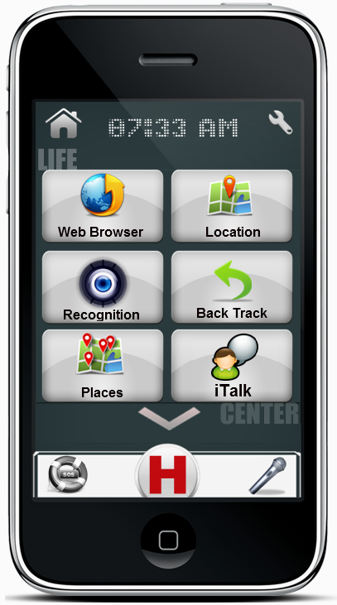**

|  |  |
| --- | --- |
|  |  |
| http://www.designswan.com/wp-content/uploads/2009/icon/browser/Browsers_009.png | **Web Browser:** access the World Wide Web. Browse everything you want to accomplish, it may not be in our helping app, but it is for sure on the internet. |
| http://www.designswan.com/wp-content/uploads/2009/icon/browser/Browsers_009.png | **Web Reader:** *If audio profile (or activated in customized profile) is selected, specific web-browser app will be available into this category.* Web Readeris a translation service that translates information available on the web, e.g., news, sports and weather bulletins, into messages that are understandable for our target group. |
| http://cdn4.iconfinder.com/data/icons/Mobile-Icons/128/04_maps.png | **Location:** is a voice guided GPS navigation app. It’s packed with Google maps and a robust set of navigation features. Both app and maps are updated for free. Maps are stored on the phone for offline use. Also it has the photo-based GPS feature, a great technology for people who easily forget places or cannot read a map. This technology prevents them from walking/driving the wrong way. By using a photo as a reference, the user only has to select the desired destination using the picture browser and the navigation starts. The only thing the user has to do is follow the instructions on the GPS. |
| http://files.softicons.com/download/art-icons/fearful-kat-icons-by-chicho21net/png/512/eye.png | **Recognition:** capture an image of a person and match against those stored in contacts list or family tree. Or, take the picture of an object and search the Internet for description. |
| http://icons.iconarchive.com/icons/custom-icon-design/pretty-office-5/256/go-back-icon.png | **Back Track:** remember the starting location (e.g. Where is the car parked?) and lead person back. A direct and easy to use feature of the Location app. |
| http://www.labulle.co.uk/images/map-places.png | **Places:** helps you discover nearby places you’ll love. Quickly search for Restaurants, Cafes, Bars and other places, while on the go. Places also makes it easy to quickly rate the places you visit. By rating places you’ll get place recommendations based on the places you like. This is a GPS based system, and uses your current location to show the nearest attractions that are around you. |
| http://www.mathiaspoulsen.com/wp-content/uploads/2011/10/Chat-icon.png | **iTalk:** justtype and let the phone be your voice. Pre-build with greetings and daily expressions. Add your favorite and most used quotes, the phone will talk for you. It includes a real-time text-to-speech translator for easy conversations between persons with speech difficulties and their friends. Also provides the inverse function. Record voices from the environment and receive as output the text in your screen. |
| http://aux4.iconpedia.net/uploads/7692641343153475.png | **Flashlight:** flashlight uses your phone's camera flashlight (led flash) to emit bright light or uses the LED light on your phone and fills your screen with bright white light to illuminate your world when you find yourself in a dark spot or concert. Note that some devices don't have a camera flashlight. In this case the led flashlight option will be disabled, but you can still use one of the screen lights. The screen light is the basic white screen flashlight, which is bright enough for daily use. You can use it as your primary flashlight option in case your device doesn't have a camera flashlight or you want to save the battery. |
| http://nichewebsiteformula.net/images/Magnifier.png | **Magnifier:** The Magnifier does what it says. It magnifies the screen you are looking at. This simple Magnifier will magnify anything you want, just lunch it and point at the item. |

1. **Personal Communication Center**

Suggested ways to access:

|  |  |
| --- | --- |
| Touch | Run HELPeople > Select Phone Button |
| Voice Command | Run HELPeople > Select Voice Command > Speak “Open Phone Center” |
| Text Command | Run HELPeople > Select Text Command > Write “Open Phone Center” |

*The following is a screenshot of Personal Communication (Phone) Center menu (left list version / right icon version)*

In Personal Communication (Phone) Center you are going to find a group of applications that are designed to easily connect you with other friends, such as: Phone Call, Messaging, E-mail, Social Networking and Contacts. You could customize this group in your own way by adding/deleting apps, sorting them or choosing the list/icon view.

**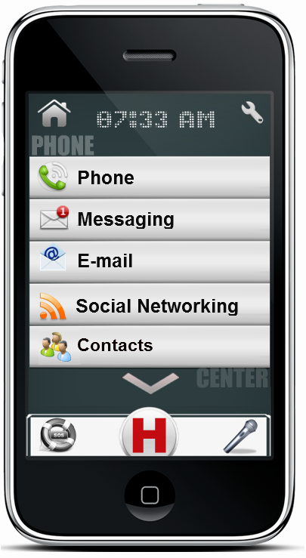 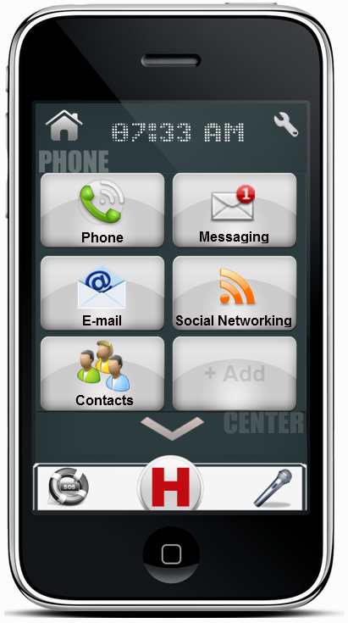**

|  |  |
| --- | --- |
|  |  |
| http://icons.iconarchive.com/icons/thiago-silva/palm/256/Phone-icon.png | **Phone:** Make or accept a phone call. Integrated with Help Contacts list creates a better visual feeling when you make or accept a phone call through audio/picture outputs for the contacted person. |
| unread mail icon | **Messaging:** Send and receive SMS/MMS using your network service provider. |
| http://ad-estates.co.uk/adestate_bk/pages/images/eMail%20Icon.png | **E-mail:** Send and receive e-mails from your saved account. It can be an exchange or web account (Yahoo, Gmail, Hotmail, AOL etc). |
| http://www.oaggle.com/wp-content/uploads/2010/08/RSS-Icon.png | **Social Networking:** Share your best experiences using your Facebook or Tweeter account. Stay tuned with your friends and their life’s. |
| http://youtubexbmc.googlecode.com/svn/branches/release/thumbnails/contacts.png | **Contacts:** Integrated with your phone contact list, this app offers you personalized bigger icons for each contact. Add a picture for each contact, create its profile and you will never forget anything related with him/her. |