He

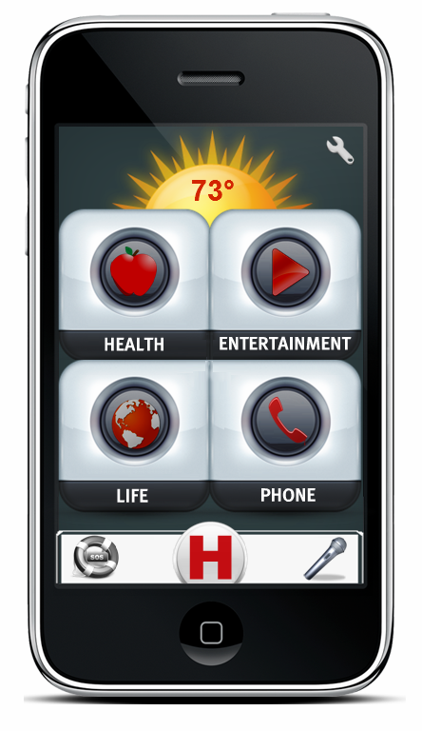
Table of Contents

01. Introduction ………………………………………………………………………………….02
02. Key Charts …………………………………………………………………………………..02
03. Communication ……………………………………………………………………………...03
04. Home Screen ………………………………………………………………………………...03
05. Main Menus …………………………………………………………………………………04
5.1. Quick Access Menu ……………………………………………………………...…04
5.2. Weather Panel ………………………………………………………………………05
5.3. Time ……………………………………………………………………………...…05
5.4. SOS …………………………………………………………………………………06
5.5. HELP ……………………………………………………………………………….06
5.6. Commander …………………………………………………………………………07
06. Settings ………………………………………………………………………………………08
07. User Profile ………………………………………………………………………………….10
08. Health Center ……………………………………………………………………………..…11
09. Entertainment Center ……………………………………………………………………..…12
10. Life Center ………………………………………………………………………………..…14
11. Phone – Personal Communication Center ………………………………………………..…15

Welcome
T-MIP Solutions thanks you for choosing HELPeople platform that will enable your daily life operations in a simple, safe and fast way.

The Best Choice
HELPeople is a project whose mission is to improve the quality of life for those with communication disabilities through assistive technologies embedded in mobile devices. Leveraging existing mobile applications as well as those yet to be invented, our product, HELPeople aims to provide a simplified yet unified interface through which any user, with or without disabilities, can easily accomplish many of their important daily tasks via alternative methods of input and output.
HELPeople is designed and developed by the great interest of our specialized team in order to serve your needs by taking into account all suggestions and comments. We are determined to pursue our mission to deliver to our customers the best and most advanced service.

HELPeople, your SMART friend!
If you need more detailed explanations, information or assistance on HELPeople platform you can contact us at any time at: contact@tmip-helpeople.com. You will always have at your disposal an authorized representative of T-MIP, which is ready to offer a full support about our innovative product.

For more information, visit our website: http://www.tmip-helpeople.com

- Introduction
HELPeople is a NEW Smartphone application specially designed for older and physically-challenged users, with the aim of helping not only this target market, but at the same time by joining the mobile internet revolution.
T-MIP has developed its own, simpler interface, which it calls ‘Pure’, and it recommends apps that it thinks older or physical-challenged users will find particularly useful.
T-MIP's Pure software can also be installed on any Smartphone which meets the basic system requirements. HELPeople provides a ‘fuss-free’ experience with well-spaced, large and clear application icons.
The key function of HELPeople is its ability to accept multiple inputs - voice, text, touch, image, biometrics, and to respond to user input via different means: audio, visual and/or vibration.
This manual will guide you and any of your friends through the application. We have tried to make it very simple, but below there are additional guidance and instructions.

- Key Charts
Find HELPeople icon on your Smartphone application list and execute it to start HELPeople (See section 4)
Touch SETTINGS button (or ask the system to run it) to access and manage your application features (See section 6)
Touch VOICE COMAND button to access and manage your application features (See section 5.6)
Touch TEXT COMAND button to access and manage your application features
Touch SOS button (or ask the system to execute it) to access and manage your application features
Touch HELP button (or ask the system to execute it) to access and manage your application features
Touch HOME button (or ask the system to execute it) to go back to the main menu
Touch DOWN LIST ARROW to see the rest of the list that is present under a certain category
Touch UP LIST ARROW to see the previous part of the list that is present under a certain category
Touch + ADD to add another application to a specific list using Customize App’s in settings menu
Touch ON button (or ask the system to execute it) to turn on a feature of your application
Touch OFF button (or ask the system to execute it) to turn off a feature of your application

- Communication
We started with a different viewpoint when we first started to engineer HELPeople. We think that most other software companies fail from the start. You may know that today hundreds of Smartphone applications exist, created with the good purpose to serve old or physically challenged people. We think that you don’t need genius apps to make this happen. What you really need are applications that can help with your daily tasks and more important, applications that you can easily access. We know that you enjoy seeing new landscapes build in your town, but we go further, and take into consideration your disappointment if you cannot go through it because you are in a wheelchair and you can’t find an entrance accessible by you.

Talk to HELPeople and you will get an audio response. Text this app and it will give you feedback. Touch it and it will change for you. Now T-MIP has designed a unique experience of communication. Chose your profile, change how you want to communicate with your phone. It’s your best smart friend. Go further on this manual to understand most of the features that HELPeople is ready to offer you today.

- Home Screen
The home screen for the primary user consists of 4 categories that will lead the user to the different applications groups, as well as the Quick Access Menu, Settings and a Weather panel. It is the first screen that you will see once the application is started, and serves as the dashboard or landing page of the entire application. The four main categories are easy to remember because they have relation with our product name HELP – Health, Entertainment, Life and Phone.
Each icon is clearly indicated by a symbol associated with the functionality that it leads to, so that you can easily navigate the application. From the home screen, you can access:
- Weather Panel (See section 5.2)
- Phone Settings (See section 6)
- Quick Access (Emergency Calls; Help Center; Commander) (See section 5.1)
- Health Center (See section 8)
- Entertainment Center (See section 9)
- Life Center (See section 10)
- Phone Center (See section 11)
This allows you to access a category of functionality with a single click. The following is a screenshot of Home Screen.
- Main Menus
  - Quick Access Menu
Quick Access Menu is a fixed menu that will be present all the time while you are working through HELPeople app. It is a customized menu, which means:
- You can switch positions of microphone/keyboard commander and SOS button depending by your needs (if you are a left or right hand user).
- Depending on your selected profile, you will be able to use a voice OR a keyboard commander (Below you can see: on the left, the way that this menu looks if voice commander is selected or in the right, the way that this menu looks if the keyboard commander is selected.

If you have selected the H (HELP) icon in the Quick Access Menu, the screen as in section 5.5 HELP will appear. | If you have selected the H (HELP) icon in the Quick Access Menu, the screen as in section 5.5 HELP will appear.

If you have selected the Voice Command icon in the Quick Access Menu, it will change color from grey to green and the screen as in section 5.6 Commander will appear. | If you have selected the Text Command icon in the Quick Access Menu, it will change color from grey to green and the screen as in section 5.6 Commander will appear.

If you have selected the SOS icon in the Quick Access Menu, it will change color from grey to red and the screen as in section 5.4 SOS will appear. | If you have selected the SOS icon in the Quick Access Menu, it will change color from grey to red and the screen as in section 5.4 SOS will appear.

  - Weather Panel
The most used Smartphone application in 2011, the weather, is incorporated with the home screen of HELPeople. This application uses automatic updates so offers real time information for the weather at your current location. It also serves as an icon which leads to a more detailed weather application.

  - Time
You want to check the time, but your Smartphone clock has small digits. Our interface includes an easy readable electronic clock in each interface (excluding the home screen), so you will be always informed on the real time.

  - SOS
The above SOS screen is what you will see when you press the SOS feature from Quick Access Menu. From here, you can very quickly call or text 911, your doctor, or your emergency assistant, by pressing the corresponding icon. You can quickly approve through YES button a call to 911, or chose to call your predefined contact for doctor or assistant.

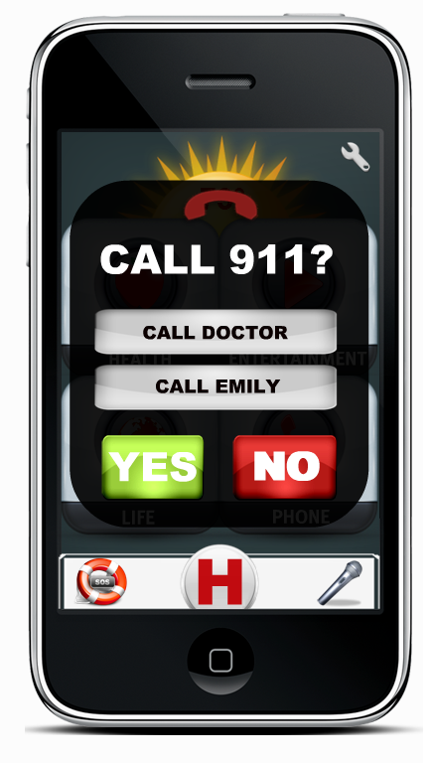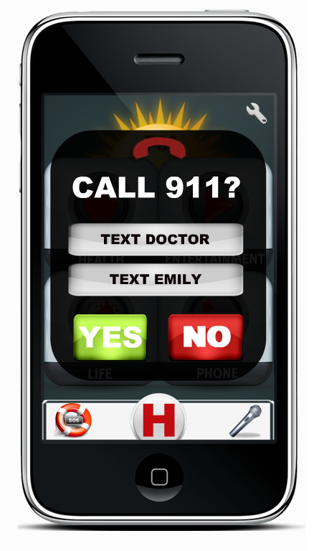

  - HELP
The big H button in the Quick Access Menu is a like a Favorite/Bookmark button of the main applications that a user want to quick access or are really necessary for him/her. As the application is installed, into this category the following applications will appear: Phone; Medical Cabinet; Back Track; Wellness; Recognition; FunBox. The user can customize this category in the same way that is used for the other categories. To better understand the functionalities of the applications mentioned here, please keep reading this user manual.

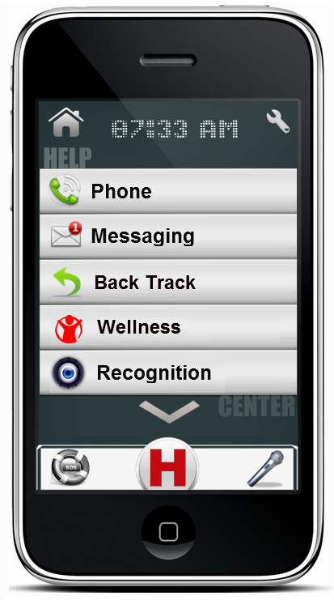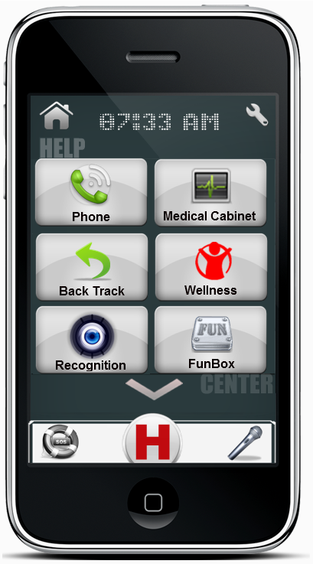
  - Commander
The above Commander screen is what you will see when you press the Voice or Text Commander feature from Quick Access Menu. From here, you can ask your application to run another application, search for a list or in the web, give you information for different questions or many other things that you as user will “command”. For example: If you want to play a song that is stored in your device just speak or text using Commander: “Play Beatles Yesterday”, and HELPeople will do the rest.

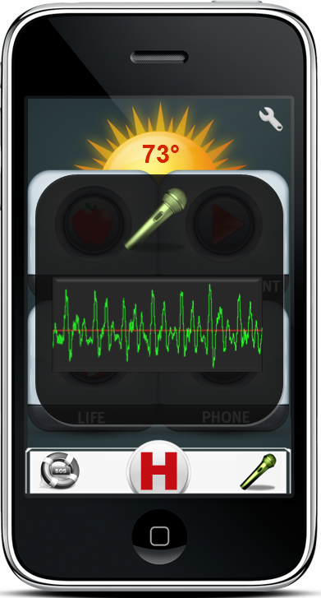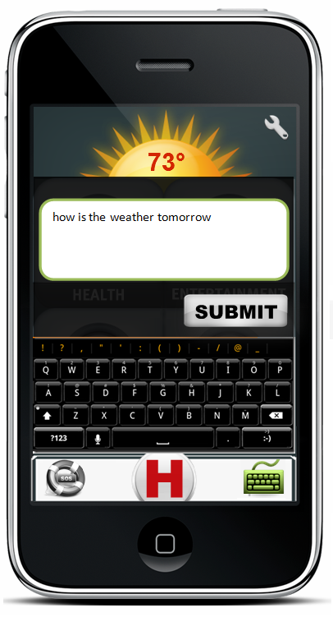

- Settings

Suggested ways to access:
Touch | Run HELPeople > Select Settings
Voice Command | Run HELPeople > Select Voice Command > Speak “Open Settings”
Text Command | Run HELPeople > Select Text Command > Write “Open Settings”

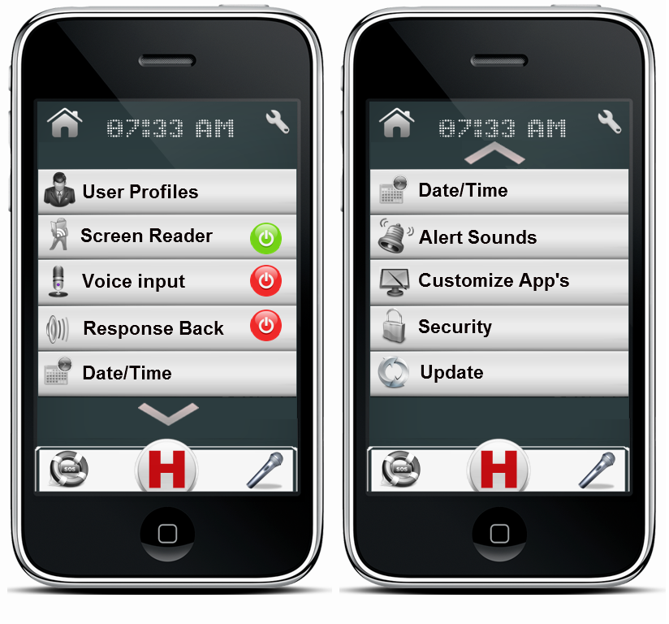
User Profile: Customize your application input/outputs, folders, interface etc through selecting our predefined profiles or by using the one that you will create. (See section 7).
Screen Reader: Directly activate/deactivate your screen reader without going to profile customization.
Voice Input: Activate/deactivate your voice input option to be open/closed all the time. Voice Input could be accessed from the Quick Access Menu (See section 5.1) if this option is deactivated. Optimal for audio profile, but not recommended to be activated.
Response Back: Let your phone notify you when your desired task is accomplished.
Date/Time: HELPeople is designed to update the date/time at your current location. In case that you are in a non-WiFi area but still want to use some of the features of HELPeople, you can manually change the date/time of your new location. Mostly used from people who will travel abroad.
Alert Sounds: Take in control the way you want to be notified for an upcoming call, SMS, MMS, e-mail or notification.
Customize App’s: Choose the app’s you really need. Delete those that you will never use. Change app’s folder destination. Sort in the way you are more comfortable. Everything should be in the place that makes more sense to you.
Security: Manage your security keys and locks.
Update: HELPeople is scheduled to be updated regularly. Anyway, if you want to anticipate an update, you can select this category from the Settings and the app will do the rest.
- User Profiles

Suggested ways to access:
Touch | Run HELPeople > Select Settings > User Profile
Voice Command | Run HELPeople > Select Voice Command > Speak “Open User Profile”
Text Command | Run HELPeople > Select Text Command > Write “Open User Profile”
The following is a screenshot of User Profiles menu.
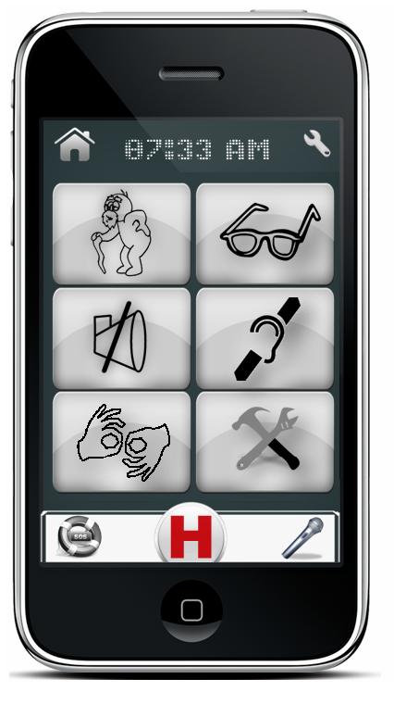
Help Profile: This user profile could be used by everyone, especially is customized specifically for old peoples. Users can access all HELPeople applications using touch-screen or by manually selecting the Voice Commander in the Quick Access Menu. By default ‘Screen Reader’ and ‘Response Back’ are disabled. Using this profile allows the user to have some special applications like FunBox in Entertainment category or a full featured Web Browser.
Audio Profile: This user profile is optimized with features which come in handy to people with visual difficulties. If you are blind or have difficulties identifying objects because of your eye sight, we recommend you use this profile. Users can access all HELPeople applications designed for this profile using audio commands. Since the Voice Commander in the Quick Access Menu is case sensitive, we recommend these users to keep it off and touch it every time they need to give “commands” to their phone. The Voice Commander could be switched left/right in the Quick Access Menu for easy access by left/right hand users. An option to leave the Voice Commander open for some time (or all the time) could be found under settings. This application profile is customized to give audio responses/feedback to the user using its Screen Reader feature. Also users of this profile could access web through a specific software: Web Reader, a Text to Speech based Web Browser (for more information see section 10)
Visual Profile: This user profile is optimized with features which come in handy to people with speaking difficulties. If you are mute or have difficulties with your speech, we recommend you use this profile. Users can access all HELPeople applications using touch-screen or by manually selecting the Text Commander in the Quick Access Menu. By default ‘Screen Reader’ and ‘Response Back’ are disabled. Using this profile allows the user to have some special applications like iTALK (a text-to-speech application/see section 10), FunBox in Entertainment category or a full featured Web Browser.
Touch Profile: This user profile is optimized with features which come in handy to people with hearing difficulties. If you are deaf or have difficulties hearing audio or signals, we recommend you use this profile. Users can access all HELPeople applications using touch-screen or by manually selecting the Voice Commander in the Quick Access Menu. Users have the option to switch from the Voice Commander to Text Commander and still stay under these profile features. Vibration alerts are activated. By default ‘Screen Reader’ and ‘Response Back’ are disabled. An application like iTALK could be used to come in help for audio to text translations.
Only Visual Profile: This user profile is optimized with features which come in handy to people with hearing and speaking difficulties. If you are deaf-mute or have difficulties hearing audio and you have speech impairment, we recommend you use this profile. Users can access all HELPeople applications using touch-screen or by manually selecting the Text Commander in the Quick Access Menu. All audio inputs are disabled for this profile. Audio outputs are used in specific applications such as iTALK. Using this profile allows the user to have some special applications like iTALK (a text-to-speech application/see section 10), FunBox in Entertainment etc. (See the above sections).
Customize Profile: This profile allow the user or its assistant to set a customized profile with audio/visual/text/vibration etc. features that can help better the experience of the user with his/her Smartphone using HELPeople.

- Health Center

Suggested ways to access:
Touch | Run HELPeople > Select Health Button
Voice Command | Run HELPeople > Select Voice Command > Speak “Open Health Center”
Text Command | Run HELPeople > Select Text Command > Write “Open Health Center”
The following is a screenshot of Health Center menu (left list version / right icon version)

In Health Center you are going to find a group of applications that are designed to help your everyday Health Activity, such as: Family History, Medical Cabinet, Calendar/Reminder, and Wellness. You could customize this group in your own way by adding/deleting apps, sorting them or choosing the list/icon view.
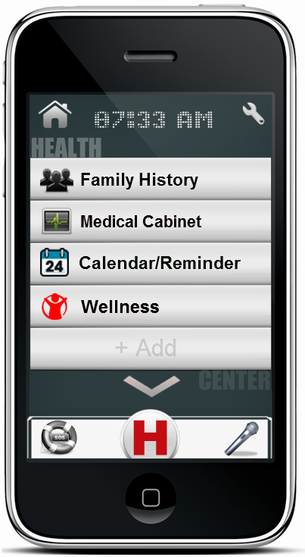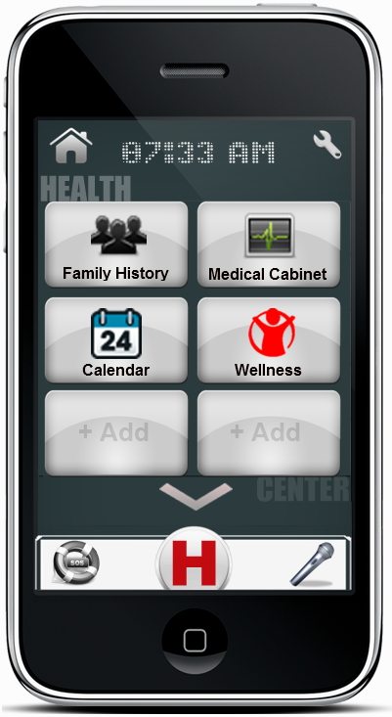
Family History: Build, update and show off your family tree. Whether you are a family history beginner or expert, this user-friendly app makes finding and learning more about your ancestors fun and easy. Add new family members to your pedigree, edit their information, add and edit life events, attach documents and even upload photos.
Medical Cabinet: is a comprehensive record-keeping app for your personal medical information. With this app, any and all information that is important to you is kept together in one place. It stores all data about medical history, allergies, operations, cornice disease etc, so in case of emergencies, doctors can consult with this file to retrieve info.
Calendar/Reminder: now with your voice and in your words, delivered on time, every time. Speak or type! This new app version remembers everything. You will forget nothing anymore with this voice/text ‘to-do’ list. Simply record your personal memo, set the time and date, and you will be reminded in real time.
Wellness: is the essential app to simply find nutritional info for the food you eat and to keep track of your meals, exercise and weight. The Wellness application has all the necessary tools to help you succeed: - A quick food calorie finder and full nutrition information. – A daily food plan to keep track of what you’re eating. – A daily reminder for various tasks like taking pills or eating a meal etc.

- Entertainment Center

Suggested ways to access:
Touch | Run HELPeople > Select Entertainment Button
Voice Command | Run HELPeople > Select Voice Command > Speak “Open Entertainment Center”
Text Command | Run HELPeople > Select Text Command > Write “Open Entertainment Center”
The following is a screenshot of Entertainment Center menu (left list version / right icon version)

In Entertainment Center you are going to find a group of applications that are designed to keep you in shape and in a good mood, such as: Music, Video Recorder, Camera, Multimedia and FunBox. You could customize this group in your own way by adding/deleting apps, sorting them or choosing the list/icon view.

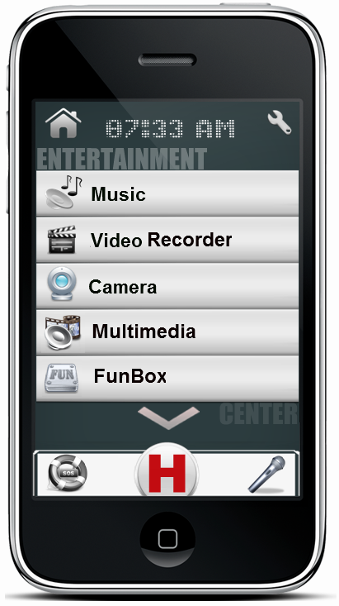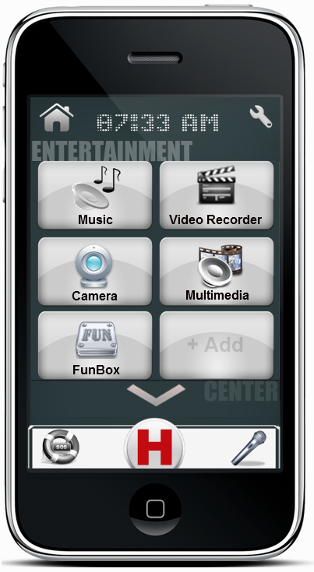
Music: listen to all the music you want on your phone. It’s easy and fast. Upload your preferred music, from your preferred artist, into your phone and listen to them with just a click, anywhere, at any time. No need for internet connection while listening, no need for an antenna. Just upload and enjoy.
Video Recorder: Record video with any Smartphone; share them on Facebook, YouTube and more. Customized with 20 live effects to record videos with. The best way to use your phone's camera to capture unforgettable memories.
Camera: Just have the desire to capture your beautiful life moments. Now you can easily access your phone camera. This app is also a light. Fun and easy camera app that lets you capture, manage, and share with total ease.
Multimedia: Have everything that is stored is your phone, but not only that, show others your music, photos and videos. Add your preferred places, images or favorite videos into this easy manageable folder of art. Find what you want with just a click.
FunBox: Is the package of your entertainment. Find things that relax and give pleasure to you in a single directory. Talk with your friends that are abroad by using Skype Chat, play Sudoku or Cards while you are waiting for someone, or check the last movies in Movie Theater or RedBox. Note: This app bookmark is not offered for all profiles. We will let you know regarding future changes.

- Life Center

Suggested ways to access:
Touch | Run HELPeople > Select Life Button
Voice Command | Run HELPeople > Select Voice Command > Speak “Open Life Center”
Text Command | Run HELPeople > Select Text Command > Write “Open Life Center”
The following is a screenshot of Life Center menu (left list version / right icon version)

In Life Center you are going to find a group of applications that are designed to help you in your daily life tasks, such as: Web Browser (Web Reader), Location, Recognition, Back Track, Places and talk. You could customize this group in your own way by adding/deleting apps, sorting them or choosing the list/icon view.
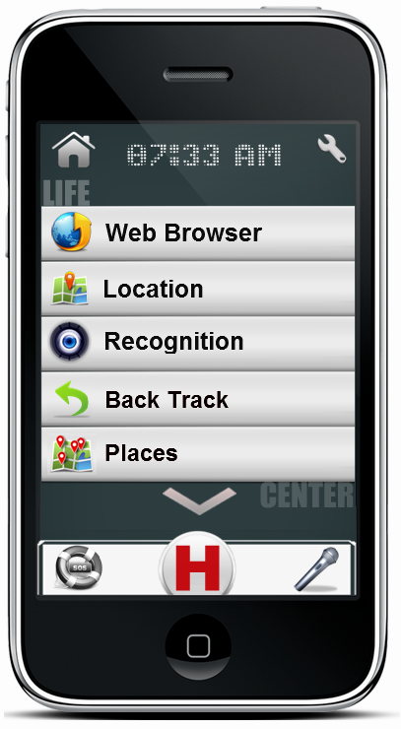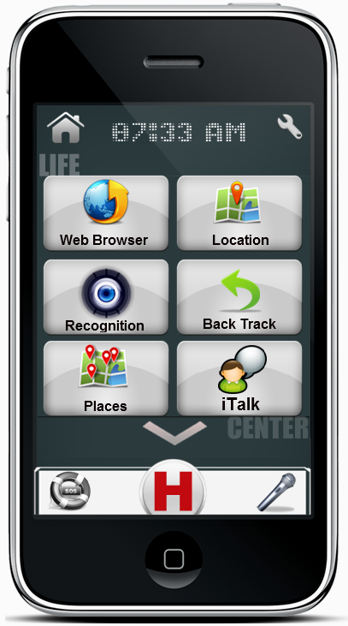
Web Browser: access the World Wide Web. Browse everything you want to accomplish, it may not be in our helping app, but it is for sure on the internet.
Web Reader: If audio profile (or activated in customized profile) is selected, specific web-browser app will be available into this category. Web Reader is a translation service that translates information available on the web, e.g., news, sports and weather bulletins, into messages that are understandable for our target group.
Location: is a voice guided GPS navigation app. It’s packed with Google maps and a robust set of navigation features. Both app and maps are updated for free. Maps are stored on the phone for offline use. Also it has the photo-based GPS feature, a great technology for people who easily forget places or cannot read a map. This technology prevents them from walking/driving the wrong way. By using a photo as a reference, the user only has to select the desired destination using the picture browser and the navigation starts. The only thing the user has to do is follow the instructions on the GPS.
Recognition: capture an image of a person and match against those stored in contacts list or family tree. Or, take the picture of an object and search the Internet for description.
Back Track: remember the starting location (e.g. Where is the car parked?) and lead person back. A direct and easy to use feature of the Location app.
Places: helps you discover nearby places you’ll love. Quickly search for Restaurants, Cafes, Bars and other places, while on the go. Places also makes it easy to quickly rate the places you visit. By rating places you’ll get place recommendations based on the places you like. This is a GPS based system, and uses your current location to show the nearest attractions that are around you.
iTalk: just type and let the phone be your voice. Pre-build with greetings and daily expressions. Add your favorite and most used quotes, the phone will talk for you. It includes a real-time text-to-speech translator for easy conversations between persons with speech difficulties and their friends. Also provides the inverse function. Record voices from the environment and receive as output the text in your screen.

- Personal Communication Center

Suggested ways to access:
Touch | Run HELPeople > Select Phone Button
Voice Command | Run HELPeople > Select Voice Command > Speak “Open Phone Center”
Text Command | Run HELPeople > Select Text Command > Write “Open Phone Center”
The following is a screenshot of Personal Communication (Phone) Center menu (left list version / right icon version)

In Personal Communication (Phone) Center you are going to find a group of applications that are designed to easily connect you with other friends, such as: Phone Call, Messaging, E-mail, Social Networking and Contacts. You could customize this group in your own way by adding/deleting apps, sorting them or choosing the list/icon view.
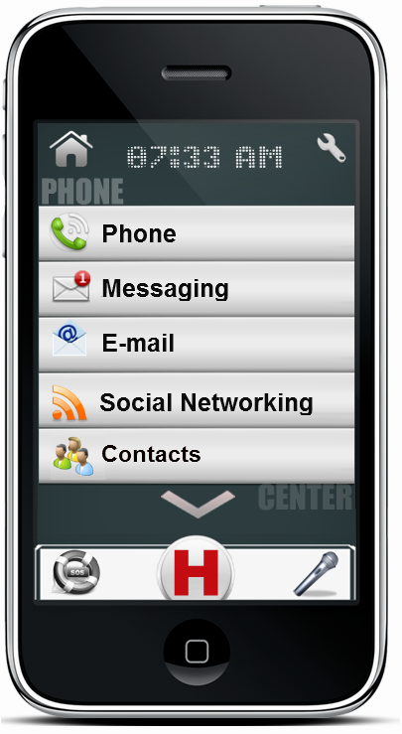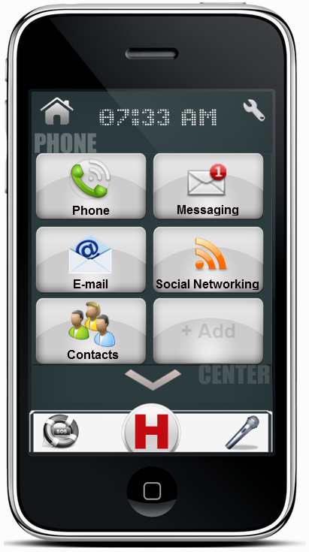
Phone: Make or accept a phone call. Integrated with Help Contacts list creates a better visual feeling when you make or accept a phone call through audio/picture outputs for the contacted person.
Messaging: Send and receive SMS/MMS using your network service provider.
E-mail: Send and receive e-mails from your saved account. It can be an exchange or web account (Yahoo, Gmail, Hotmail, AOL etc).
Social Networking: Share your best experiences using your Facebook or Tweeter account. Stay tuned with your friends and their life’s.
Contacts: Integrated with your phone contact list, this app offers you personalized bigger icons for each contact. Add a picture for each contact, create its profile and you will never forget anything related with him/her.

