WRS Document
Final Phase I

Team T-MIP
www.tmip-helpeople.com

Team Members:
Taraneh Parvaresh
Mairon Toçi
Ian Bùi
Pooria Kamran Rashani

Table of Contents
2 Revision History 3
3 Project responsibilities 4
4 Introduction 5
5 ISSUES WITH PRELIMINARY DEFINITION GIVEN 6
5.1 Domain Issues 6
5.2 Functional Requirements Issues 8
5.3 Non Functional Requirements Issues 18
6 WRS 22
6.1 W 22
6.1.1 Problem 22
6.1.2 Goal 22
6.1.3 Improved understanding of Domain, Stakeholders, Functional and Non-Functional objectives 22
6.2 RS 25
6.2.1 Functional RS – Improved understanding of Software System Requirements: FRs 25
6.2.2 Non-functional RS -Improved understanding of Software System Requirements: NFRs 26
7 Traceability MAtrix 28
8 CREEPING RATES………………...……………………………………..……….30
9 WHY WE THINK OUR SOULTION IS BEST………………….……..……..…30

Revision History

Version | Date | Comments | Author
0.0 | February 23, 2012 | Initial draft including document layout and some domain and functional requirements | Taraneh
0.1 | February 24, 2012 | Add Introduction | Ian
0.2 | March 02, 2012 | Add Problem, Goal, Stakeholders and Domain Requirements sections | Ian
0.3 | March 06, 2012 | Add Summary, Domain Issues | Ian
0.4 | March 07, 2012 | Add Functional requirements Issues | Taraneh
0.5 | March 07, 2012 | Revised Domain Issues | Ian
0.6 | March 08, 2012 | Revised Functional requirements and Traceability Matrix | Taraneh
0.7 | March 09, 2012 | Issues with Non-Functional Requirements and revised requirements | Pooria
0.8 | March 09, 2012 | Reviewed | Taraneh  Mairon  Ian  Pooria
1.0 | March 09, 2012 | First formal version to turn in | T-MIP
1.1 | March 21, 2012 | Updated version which include User Manual and updated Traceability Matrix | Mairon
1.2 | March 22, 2012 | Review requirements | T-MIP
1.3 | March 22, 2012 | Update revised functional requirements and issues with them | Taraneh
1.4 | March 23, 2012 | Updated Domain rqmts with Screen Reader | Ian
1.5 | March 23, 2012 | Review requirements | T-MIP
1.6 | March 23,2012 | Update revised non-functional requirements | Pooria
1.7 | March 23, 2012 | Add Creeping Rates and Why We’re The Best | Ian
1.8 | March 23, 2012 | Formal version to turn in (Final Phase 1) | Mairon

Project responsibilities

Phase 1 | Deliverables | Ian | Taraneh | Mairon | Pooria
 | Introduction | X
 | Preliminary Definition | X | X |  | X
 | Functional Requirements |  | X
 | Non-Functional Requirements |  |  |  | X
 | Mockups |  |  | X
 | User Manual |  |  | X
 | Scenario |  |  | X
 | Improved Understanding | X | X | X | X
 | Presentation | X

Introduction

HELPeople is a project whose mission is to improve the quality of life for those with communicative disabilities by employing assistive technologies that can be implemented on personal mobile devices.

The elderly, particularly the large Baby Boomer population, are entering their golden years just as the Smartphone era takes off. The emergence of mobile devices always connected to the internet can bring many benefits to, as well as challenges for, this significant growth market.

Fortunately, most people in this demography are already familiar with the personal computer. Many use it daily to do things like E-mail, search for information on the World Wide Web, network with family and friends, etc. However, performing these tasks on smaller handheld devices can be intimidating and difficult for them, especially as the effects of age such as impaired vision and memory begin to take their toll.

Leveraging existing mobile applications as well as those yet to be invented, HELPeople aims to provide a simplified yet unified interface through which any user, old or young, with or without disabilities, can easily accomplish many of their important daily tasks using their mobile devices.

ISSUES WITH PRELIMINARY DEFINITION GIVEN

Domain Issues
In this section we will cover the issues related to requirements collected in section 5 that we observed. The issues related to domain, stakeholders, functional and non-functional objectives have been addressed.

Issue IDR1:

Description | System shall provide multiple input methods.  Issue Type: Incomplete  What are those inputs? How should they be configured?
Options | 1: Touch by default; Voice on demand  2: Touch and Text by default; Voice on demand  3: Touch and Text by default; Voice on demand; Camera per app
Decision | Option 3: Touch and Text always available by default; Voice input can be invoked on demand; and Camera input available as needed by a specific app

Issue IDR2:

Description | System shall provide multiple output methods  Issue Type: Incomplete  What are those outputs? How are they configured?
Options | 1: Visual display (icons, images, etc.)  2: Visual plus Audio (spoken words in a selectable language)  3: Audio only (i.e. “Non-Visual” profile)  4: Vibration (“Silent” mode)
Decision | Option 1 by default; Option 2 or 3 can be configured via user profile; and Option 4 can be configured as an app-specific setting.

Issue IDR3:

Description | System shall provide API to integrate with other apps  Issue: Vague, Incomplete  Does not specify how this can be accessed by User
Options | 1: Let user switch from one App to another manually  2: Create one common interface that hides integration details from User
Decision | Option 2. But also provide a mechanism for user to move easily between Apps manually.

Issue IDR6:

Description | System shall provide Text To Speech (TTS) functions:  Issue: Vague, Incomplete  How many languages to support?
Options | - As many languages as supported natively by device’s OS  - Only one language (pre-configured)  - Only one language (user-configurable)
Decision | Only support English in first version. If demand exists, add other languages.

Issue IDR7:

Description | System shall provide Screen Reader functions.  Issue: Incomplete  What type of functionalities will be needed?  Which browsers will be supported?
Options | 1: Web browser only.  2: Screen Menus only.  3: Both.  4: Multiple web browser support
Decision | Option 3: Provide a Screen Menu reader AND a Web Browser reader for the default Browser that comes with the device (i.e. Safari for iOS, Chrome for Android)  Other browsers may be supported in future if demand exists

Issue IDR8:

Description | System shall support multiple mobile OS’s.  Issue: Vague  Which ones? Why?
Options | - Apple iOS  - Google Android  - Microsoft Windows Mobile  - Symbian
Decision | Option 1 & 2. iOS and Android only. This is to maximize market potential but keep development scope manageable.

Functional Requirements Issues

Issue IFR1:

Description | “Provide a tool to user so s/he can interact with the product and give commands to do certain tasks via speech or by touch”  Issue type: ambiguous, incomplete  Which certain tasks user can do via command? What’s the tool? What are the other input methods?
Options | Option 1:  - User can use the product by touching the icons  Option 2:  For each group of people dedicate a user profile:  - If the user is visually impaired so he should be able to give certain commands by voice like “open Calendar” to use this app.  - If the user is mute then there would be an option to choose the menus by touch or for certain commands use text as an input method
Decision | HELPeople! Will provide 3 types of input for users to interact with product as user profiles so user can choose among below options as input method:  - Touch  - Voice  - Text  We chose option 2 to have all of them so user can choose between different types of interaction based on his need. Commander would be available to accept voice requests and respond them back in voice. The other option would be keyboard input which user can type his request and HELPeople will interpret it to a command and do the request. By default all menus would be available visually.

Issue IFR2:

Description | “Generating speech output for those who are visually impaired so that the user can hear rather than seeing the pictures or menus”  Issue type: ambiguous  When product needs to generate speech output? Is it only applicable for visually impaired users? Is it possible to show the pictures along with voice output?
Options | Option 1:  - Set the configuration for visually impaired users so they can hear the outputs rather than showing them the picture or icon  - Speech generation is available when the input method is also with voice  Option 2:  - Have flexible configuration so user can choose between different input and outputs  - Configuration should be available for all types of people not restricted to those who are visually impaired so use can choose to have voice output or use touch or keyboard
Decision | We chose Option 2. Regardless of user type, various output methods (audio, text, visual) should available for user to choose among them. So we decided to put setting regarding output of the product in configuration as user profiles therefore there would be 3 options for users to choose either visually see the menus of hear them by audio output. Screen reader would be available for blind people that read the screen while user goes to different pages of the product in order to help them choose a menu.

Issue IFR3:

Description | “Provide a way for user to select categories via touch or speech”  Issue type: redundant  The way which user is going to select one menu would be the same as available input methods, which is redundant of IFR1.
Options | Option 1:  - User can choose input method as voice or keyboard or touch  - For all sections of the product this would be available as input method
Decision | User would be able to choose the icons and menus of the system with touch or by typing the command in keyboard or by voice command. All of these are input methods to the system and is applicable for choosing a menu, opening an application, set a reminder in calendar, exit an application and etc.

Issue IFR4:

Description | “Providing an easy access to most common in use apps or favorite ones”  Issue type: ambiguous, incomplete  What would be the easy access? Is it a different tool or it would be in same product?
Options | Option 1:  - Put the applications od our product under certain categories  Option 2:  - Categorize the applications in 4 groups and also give an option to user to put most commonly used applications or his favorite ones in separate section to have easy and fast access rather than going to each category and find them.  - It maybe difficult for elder people to find applications that they use the most, like medication, under defined categories. Or for those who are suffering from memory loss they can forgot which application was under which category. So this option will give them easy access.
Decision | We decided to choose option 2 and put “H” button available in all screens of HELPeople so the user can have easy access to favorite applications that he uses the most.

Issue IFR5:

Description | “Change the settings and configuration according to their need”  Issue type: vague, incomplete  By Setting does it mean general setting or options available for each application?
Options | Option 1:  - Set default setting in the product in time of installation for once according to user’s need  Option 2:  - Define “configuration” section in the product with various settings so the user would be able to set the setting according to their desire
Decision | We defined configuration section available in all pages with an icon. For first page the setting would be general setting for the product like output/input method but for other pages the setting will refer to configuration of that specific application. So we split this function to 2 separate requirements.

Issue IFR6:

Description | “Allow changing and managing applications in HELPeople!”  Issue type: vague  “Allow changing” is vague so we need to describe it in a better way
Options | Option 1:  - Define fixed list of applications according to our understanding of the product  Option 2:  - Define flexible list of apps and let the user to manage apps by listing, removing, adding apps to the product. These applications would be those that are in non-native apps so there is a possibility to integrate them within the product.
Decision | We chose option 2 to give flexible environment for user to manage apps according to its desire. So he would be able to add apps, which he’s using them the most or removing those that are interested for him. We split this function to 2 different requirements as add and remove. And also we added 2 more requirements for enabling and disabling native apps. So we give this option to the user that he would be able to disable/enable native applications also.

Issue IFR7:

Description | “Providing a way to remember their family members and friends”  Issue type: ambiguous, incomplete  What would be the way to remember people’s face? Does it mean remembering them via picture or by name?
Options | Option 1:  - People who are suffering from memory loss can have a list consist of the names of family members or friends in their phone  Option 2:  - People who are suffering from memory loss can have a list of the names together with pictures of any relative person stored in their phone.
Decision | We chose the second option to have an application to store family tree together with the picture of members so that the people who are suffering from memory loss would be able to remember them as they can see family/friend’s picture associated to that name. We decided to have one specific requirement for storing pictures in the phone and another requirement for describing family tree.

Issue IFR8:

Description | “People who are suffering from memory loss should be able to remember places they visited before or remind their parking place”  Issue type: incomplete  Is this feature only available for those who are suffering from memory loss?
Options | Option 1:  - Limit Backtrack application only to specific user (memory loss)  Option 2:  - Make this application available for general use
Decision | We chose the second option. So Backtrack application would help people to remind previous places they’ve visited before so that they can take a picture and store it in the phone together with the name of that place. The same would be applicable for remembering the parking lot which would be useful to find where user parked his/her car.

Issue IFR9:

Description | “Assist them to remind their medication/food/drink and etc”  Issue type: incomplete, ambiguous  How to assist user to store medical information rather than a reminder? “Them” refers to which group? Don’t use “ect”, be concise
Options | Option 1:  - Users can use the built-in reminder/calendar of their phone to remind them about their medication or appointments  Option 2:  - Develop new application to store medical information and medication
Decision | We decided to have dedicated native application regarding medical information for the user, so he/she can keep track for personal medical info like medical history, allergies, operations, disease and so on.

Issue IFR10:

Description | “Assist them to remind their scheduled meetings/appointments”  Issue type: ambiguous, incomplete  Reminder only for meeting or user can use it also for medication
Options | Option 1:  - Develop separate reminder application to schedule ad set appointments or meetings  Option 2:  - Use the same calendar exist of the phone to set reminder for meetings/medication and much more.
Decision | We decided to use the same calendar exist on the phone but we deliver more input methods to the user such as voice to set his/her reminder. Whether it’s a reminder about a medication or is about eating food, drinking water (for those who are suffering from memory loss) or an appointment. They can schedule an event to remind them the activities by alarm.

Issue IFR11:

Description | “Providing a way for family members to add reminders in users calendar”  Issue type: ambiguous, incomplete  “Providing a way” is vague. Family members are the only group who can add reminders? Are they able to add only reminders to the calendar?
Options | Option 1:  - User would be able to add reminder/events to his calendar  Option 2:  - Authorized user such as a family member should be able to enter reminder for the user as well
Decision | As elder people or people who are suffering from memory loss may not be able to add reminder or any event on their calendar so we thought it would be very helpful that authorized user like a family member should be able to add any event or reminder in user’s calendar by accessing this application via remote connection over internet or by sms.

Issue IFR12:

Description | “Placing emergency calls”  Issue type: incomplete  How can product place emergency call?
Options | Option 1:  - Put emergency icon in main menu so it would be accessible for the user  Option 2:  - Place emergency icon in all pages as an icon so the user can use it whenever needed  - User should be able to call 911  - User should be able to call/text a predefined family number  - User should be able to call/text a doctor
Decision | We chose option 2 so that we give 3 different options to the user in case of emergency. By Pressing emergency button he can either call 911 which he needs to confirm it again, or he can choose between calling/texting a family member or a doctor without confirmation.

Issue IFR13:

Description | “User should be able to listen to music”  Issue type: incomplete  How user should be able to listen to music? Is it available for all users.
Options | Option 1:  - All users apart from those who are not able to listen to music (suffering from hearing loss) should be able to listen to their music  Option 2:  - Integrate to external music app.  Option 3:  - Remove the option of music for this product
Decision | We chose to have first option so that user should be able to listen to his stored music on the phone. Integration to external/online music application would bring difficulties. In case user call a music app then he will lose the application control because the external application will call in top of our product so he won’t have further access to HELPeople rather than closing the external app and reopen HELPeople. We decided to have this function as a User interface requirement and mention different categories, which we will have in the product as Health, Entertainment, Life, and Phone.

Issue IFR14:

Description | “Users who are visually impaired should be able to surf the web”  Issue type: incomplete  We should define how they can surf the web? Which tool?
Options | Option 1:  - User an existing tool for helping to surf the internet  Option 2:  - Use already developed tool of “Web reader” which is powerful for reading web pages.
Decision | We will give the option for users who are visually impaired to be able to surf the web. So we will use “Web reader” tool that can convert the web pages to standard structured html pages and read the content of each page for the user, basically it will show what appears in the screen for blind user. We decided to move this requirement to domain requirement section as it’s a service rather than a function.

Issue IFR15:

Description | “Mute user should be able to communicate to others via HELPeople”  Issue type: ambiguous  How mute user should be able to communicate via our application?
Options | Option 1:  - User can use motions to communicate with others  Option 2:  - User can communicate to others by typing in HELPeople and text to speech application will convert it to voice
Decision | We will give the option for users who are mute to type in iTalk application and app will convert text to speech. Moreover speech to text would be also available for those who have hearing difficulties, so then can use iTalk speech to text converter to convert voice to text for them in order to understand what others say.

Issue IFR16:

Description | “User should be able to use camera to recognize objects or family and friends”  Issue type: incomplete  Didn’t mentioned how to use camera to recognize the people he knows
Options | Option 1:  - User can have the family or friends pictures stored in his device  Option 2:  - Application should help user to identify the friends and family members by capturing their photo and match them to already stored pictures in contact list
Decision | We chose second option. For those who are suffering from memory loss and they can’t remember their family members or friend’s face, they can capture a picture from those people and match them with the ones which they had it already it their phone and “Recognition” application will show the name of the person together with any defined note related to him/her.

Issue IFR17:

Description | “User should be able to keep track of his meal and nutritional info”  Issue type: ambiguous, incomplete  How to keep track of his meal? What else can user keep track of
Options | Option 1:  - Search in internet to find out what would be the nutrition info about the meal he take and write them down in his notes  Option 2:  - Dedicate an application to keep track of every meal, exercise and weight and provide information regarding the nutrition’s of his/her food.
Decision | Option 2 would be better idea so that he can easily have all of the information in one dedicated application. He can also set reminders to remind him when to take his medicine or when to drink or eat.

Issue IFR18:

Description | “User should be able to use HELPeople for entertainment purpose”  Issue type: ambiguous  What is entertainment? All users will have this section?
Options | Option 1:  - User can have access to Games or other entertainment apps installed in his phone  Option 2:  - User can access to Games or chatting with friends in skype or check latest movies in Movie Theatre via HELPeople.
Decision | We chose to provide this option in our product so for some of the profiles who are willing to have this feature it would be possible to access entertainment section instead of going to each app itself. We decided to have this function as a User interface requirement and mention different categories, which we will have in the product as Health, Entertainment, Life, and Phone.

Non Functional Requirements Issues

Issue INFR1:

Description | “Installation time should be quick enough”  Type of issue: ambiguous  How QUICKLY it should be?  Assumption: HELPeople is already downloaded in the device
Options | 1. Product should install its entire component less than a minute.  2. We should not consider the installation time
Decision | We selected option 1 so entire component get install completely

Issue INFR2:

Description | Product should consume less battery power  Type of issue: ambiguous  How LESS it should be?
Options | 1. Product should use 4% - 8% of total battery per hour while it’s running.  2. We should not consider the power consumption
Decision | We selected option 2 for the first release, till further versions

Issue INFR3:

Description | Product should occupy less memory space  Type of issue: ambiguous  How Less it should be?
Options | 1. Product should use no more than 5 MB after installation.  2. We should not consider the size of it
Decision | We selected option 1 for less capacity usage

Issue INFR4:

Description | User interface should be easy to use  Type of issue: ambiguous  How EASY it should be?
Options | 1. Menu items should be viewed in list/icon format depends on user preference.  2. Applications are categorized in folder and subfolder format  3. All applications could line in alphabetical format.
Decision | We selected option 1 and 2 in order to be more user friendly

Issue INFR5:

Description | Applications should be properly categorized  Type of issue: ambiguous  How properly it should be?
Options | 1. Applications are categorized in most frequent use to least  2. Applications are categorized according to their functionality
Decision | We selected option 2 for simplicity

Issue INFR6:

Description | Visually it should be easy for our target user to see  Type of issue: ambiguous  How colorful it should be?
Options | 1. Each application should be represented by a simple icon that resembles its functionality  2. Each application should be represented by a dynamic icon that resemble its functionality  3. Each application should be accompanied by a text name that describe its function  4. Screen should have no more than 7-8 colors.  5. Font should be simple and large enough
Decision | We selected option 1, 3, 4 and 5 to make the interface more simple and attractive.

Issue INFR7:

Description | Product should be updatable  Type of issue: ambiguous  How does the user know when to update?
Options | 1. Any time that there is a new version of the product, the user will be notified.  2. The system automatically updates the product to its latest version.  3. The user can manually install the updates.
Decision | We selected option 1and 2

Issue INFR8:

Description | While using, product should respond quickly to command  Type of issue: vague, incomplete  What does respond really mean?  How is quickly defined?
Options | 1. After each user command the system will notify the user that it has successfully received the command and is in the process of executing it.  2. For any interaction, system shouldn’t take more than 1000 ms to respond  3. It shouldn’t be a concern to consider respond time
Decision | We have selected option 1 and 2 to have maximum time respond

Issue INFR9:

Description | Essential applications should be reachable all the time.  Type of issue: ambiguous  How it should be reachable?  What are the essential applications
Options | 1. Emergency, Favorite Folder, Commander are available in one consistent location in all screens.  2. Any Essential application is in a folder in the main menu.
Decision | We selected option 1 to make our product more efficient

WRS

W

Problem

The mobile app market already has a multitude of applications targeting the elderly to help them do many important daily tasks. These apps are generally categorized under Health Care; many have been very well developed and are extremely useful.

But because modern mobile devices such as Smartphone’s and tablets rely on a touch screen as their main mode of input, they represent a significant obstacle for older people, especially those with visual and/or motor degradations.

Furthermore, the visual nature of web browsers, mobile or otherwise, makes it increasingly difficult for poor-sighted people to access information on the web. And, of course, for those who are nearly or totally blind it is nearly impossible to do on today’s smart phone.

Goal

Our goal is to make “smart” mobile devices even “smarter”. Our objective is NOT to reinvent apps that have already been created. Instead, we aim to make those existing apps work even better and allow them to help many more needy users.

We intend to accomplish our goal by making those apps accessible to people with various communicative impairments such as poor vision, hearing, or memory degradations.

Improved understanding of Domain, Stakeholders, Functional and Non-Functional objectives

Stakeholders

The elderly population, being our main target user group, represents the most important stakeholder. However, because age affects different people in different ways, it is not easy to generalize what their needs are. Therefore, from a system requirements perspective, we shall limit our scope to some of the most common needs, and perhaps extend the product in future versions to accommodate more requirements.

A related group of stakeholders are those who help care for the elderly. These could be family members, caretakers, doctors, etc. Our product will make it easy also for them to assist the person under their care with everything from installing the product to using it on a day-to-day basis.

A third group of stakeholders are those in the public space whom the elderly might need to call upon in case of emergencies, such as Fire, Police, Ambulance, etc. Again, our product will make it easy for the needy to contact help and for emergency personnel to obtain the necessary biodata about that person quickly and accurately.

On the Product Development side, other stakeholder groups whose needs also need to be taken account are: Investors; Sales/Marketing; Management; Engineering; Support.

Last, but not least, are other mobile app makers on the market with whom we have a symbiotic relationship. They have a critical role to play in the success of our product and, conversely, we can help them reach a larger market segment than what they currently have.

Definitions

The following terms regarding different App Types shall be used within the context of this product to mean specific things:

- Resident – any app that physically resides on the device, which can be:
  - Native – is built into this product
  - Non-Native – is not a part of this product and can be:
    - Integrated – can communicate with this product via an API
    - Standalone – is not integrated with this product at all
- Non-Resident
  - Web-based (e.g. Pandora)
  - Network-based (e.g. Teleconferencing)

Domain Requirements

The types of services (DRs) that the system shall provide are listed below:

- Input (DR1)
- System shall provide touch-based input mode by default (DR1.1)
- System shall provide voice-based input as a supplement (DR1.2)
- System shall provide image-based input as a supplement (DR1.3)
- System shall provide text-based input, e.g. keyboard (DR1.4)

- Output (DR2)
- System shall provide image- and language-based output by default (DR2.1)
- System shall provide audio-based output as a supplement (DR2.2)
- System shall provide vibration-based output as a supplement (DR2.3)

- Interface (DR3)
- System shall provide an API through which other apps may communicate with it in both directions. (DR3.1)
  - System is not required to support apps that cannot be integrated via this API
- System shall provide a common interface through which user can invoke, command, and receive responses from native and integrated apps (DR3.2)

- GPS (DR4)
  - System shall have full access to the built-in GPS (DR4.1)
  - System shall support non-native apps that rely on GPS (DR4.2)

- Bluetooth (DR5)
  - System shall support native and integrated apps that use the built-in Bluetooth (DR5.1)
  - System shall support remote devices that can pair with the built-in Bluetooth (DR5.2)

- Text To Speech (DR6)
- System shall provide an audio-based menu description for native and integrated apps (DR6.1)
- System shall have ability to convert lines of text to audio output in at least one language (default English) (DR6.2)

- Web Reader (DR7)
  - System shall provide a web-reader service that can be integrated with a mobile web browser to describe the web page content in audio format, and be able to accept navigation commands from the user via voice. (DR7.1)

- OS Support (DR8)
  - System shall support Apple iOS (DR8.1)
  - System shall support Google Android (DR8.2)

- Screen Reader (DR9)
  - System shall have a Screen Reader service to read screen menus and translate menu items into an audio format in at least one language (default English) (DR9)

RS

Functional RS – Improved understanding of Software System Requirements: FRs

RID | Requirements Specification
RFR1 | User shall be able to select input method among various user profiles, which can be any combination of voice, text and visual. By default visual is always available.
RFR2 | User shall be able to select output method among various user profiles, which can be any combination of audio, text and visual. By default visual is always available.
RFR3 | Product shall have a dedicated button on all screens to provide access to the most used or favorite apps
RFR4 | Product shall have set of user-configurable app-specific settings for individual native and integrated apps.
RFR5 | Product shall have a set of user-configurable general settings.
RFR6 | User shall be able to add a non-native applications to the product (app is resident on device)
RFR7 | User shall be able to remove an integrated application from the product (not from the device)
RFR8 | User should be able to disable a native application
RFR9 | User should be able to re-enable a disabled native application
RFR10 | Product shall be able to store pictures in a common repository that can be accessed by other apps (native and integrated).
RFR11 | Product shall have an app that allows user to store family information including at least: names, photos, contact info, relation.
RFR12 | Product shall have an app that allows user to go back to a previous location via GPS and with, optionally, a photo.
RFR13 | Product shall have an app that allows user to store medical information about him/herself and/or family members.
RFR14 | Product shall have an app to remind user of daily activities.
RFR15 | Authorized person (e.g. family member) should be able to add reminders to user’s calendar remotely
RFR16 | The system shall provide a button to dial 911 and simultaneously call or text a doctor or family member in case of emergency.
RFR17 | Product shall have an app that converts text (English) into audio format.
RFR18 | Product shall have an app that allows user to match objects and faces against pictures and contacts stored on the device.
RFR19 | Product shall have an app that allows user to store nutritional information about foods and to keep track of user’s diet plan.
RFR20 | The Main User Interface shall organize the Product into four Main Categories for easy access: Health, Entertainment, Life, and Phone.

Non-functional RS -Improved understanding of Software System Requirements: NFRs

INFR1: Installation time should be quick enough so its entire component installed less than a minute.

INFR2: Product power consumption is not into first version consideration.

INFR3: Product should occupy no more than 5MB space

INFR4: User interface should be easy to use, in such a way that “Menu items should be viewed in list/icon format depends on user preference” and “Applications are categorized in folder and subfolder format”

See User Manual Entertainment Center section

INFR5: Application should be properly categorized in such a way that applications are categorized in most frequent use to least

See User Manual Main Menus section

INFR6: Visually it should be easy for our target user to see in such a way that “Each application should be represented by a simple icon that resembles its functionality” and “Each application should be accompanied by a text name that describe its function and “Screen should have no more than 7-8 colors” and “Font should be simple and large enough”

See User Manual section Key section and Communication

INFR7: Product should be updateable so that “Any time that there is a new version of the product, the user will be notified” and “The system automatically updates the product to its latest version.”

INFR8: While running, product should respond quickly to command so that “After each user command the system will notify the user that it has successfully received the command and is in the process of executing it” and “. For any interaction, system shouldn’t take more than 1000 ms to respond”

INFR9: Essential applications should be reachable all the time. For instance Emergency, Favorite Folder, Commander are available in one consistent location in all screens

Traceability MAtrix

Preliminary Definition | Issues with requirement | Improved Requirement | User Manual
DR1 | IDR1 | DR1.1, DR1.2, DR1.3 | N/A
DR2 | IDR2 | DR2.1, DR2.2, DR2.3 | N/A
DR3 | IDR3 | DR3.1, DR3.2 | N/A
DR4 | - | DR4.1, DR4.2 | N/A
DR5 | - | DR5.1, DR5.2 | N/A
DR6 | IDR6 | DR6.1, DR6.2 | N/A
DR7 | - | DR7.1 | N/A
DR8 | IDR8 | DR8.1, DR8.2 | N/A
DR9 | - | DR9 | N/A
FR1 | IFR1 | RFR1 | Section 3
FR2 | IFR2 | RFR2 | Section 3
FR3 | IFR3 | RFR1 | Section 3
FR4 | IFR4 | RFR3 | Section 5.1
FR5 | IFR5 | RFR4, RFR5 | Section 6
FR6 | IFR6 | RFR6, RFR7 | Section 6
- | - | RFR8, RFR9 | Section 6
FR7 | IFR7 | RFR10, RFR11 | Section 8
FR8 | IFR8 | RFR12 | Section 10
FR9 | IFR9 | RFR13 | Section 8
FR10 | IFR10 | RFR14 | Section 8
FR11 | IFR11 | RFR15 | Section 8
FR12 | IFR12 | RFR16 | Section 5.4
FR13 | IFR13 | RFR20 | Section 9
FR14 | IFR14 | - | -
FR15 | IFR15 | RFR17 | Section 10
FR16 | IFR16 | RFR18 | Section 10
FR17 | IFR17 | RFR19 | Section 8
FR18 | IFR18 | RFR20 | Section 9

8 CREEPING RATES

After several rounds of review and refinements, our team was able to add and remove a number of important requirements, with a net increase of about 15% in total number of requirements, the most of which were concentrated in the Functional area.

Due to the small size of our team (4-person), it is inconceivable that we can in future versions do much more than 20% without a degradation in accuracy.

9 WHY WE THINK OUR SOLUTION IS BEST?

We truly believe that by leveraging the power of other apps on the market, our solution of providing an integrated User Interface has the most potential for providing the most functionalities (even those not yet imagined) for the least amount of cost and disruption to the user’s system.

The simplicity of our approach, combined with our capability to bring many more applications to an ever larger segment of users, is unique among the many competing solutions developed in the past.

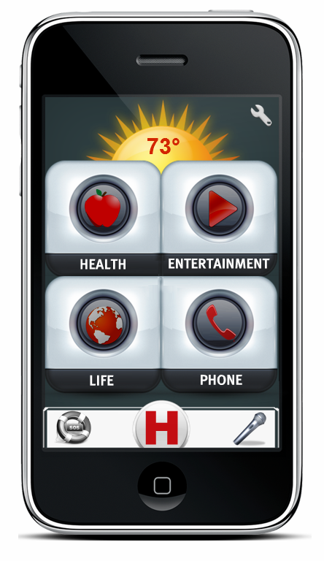
He

Welcome
T-MIP Solutions thanks you for choosing HELPeople platform that will enable your daily life operations in a simple, safe and fast way.

The Best Choice
HELPeople is a project whose mission is to improve the quality of life for those with communication disabilities through assistive technologies embedded in mobile devices. Leveraging existing mobile applications as well as those yet to be invented, our product, HELPeople aims to provide a simplified yet unified interface through which any user, with or without disabilities, can easily accomplish many of their important daily tasks via alternative methods of input and output.
HELPeople is designed and developed by the great interest of our specialized team in order to serve your needs by taking into account all suggestions and comments. We are determined to pursue our mission to deliver to our customers the best and most advanced service.

HELPeople, your SMART friend!
If you need more detailed explanations, information or assistance on HELPeople platform you can contact us at any time at: contact@tmip-helpeople.com. You will always have at your disposal an authorized representative of T-MIP, which is ready to offer a full support about our innovative product.

For more information, visit our website: http://www.tmip-helpeople.com

- Introduction
HELPeople is a NEW Smartphone application specially designed for older and physically-challenged users, with the aim of helping not only this target market, but at the same time by joining the mobile internet revolution.
T-MIP has developed its own, simpler interface, which it calls ‘Pure’, and it recommends apps that it thinks older or physical-challenged users will find particularly useful.
T-MIP's Pure software can also be installed on any Smartphone which meets the basic system requirements. HELPeople provides a ‘fuss-free’ experience with well-spaced, large and clear application icons.
The key function of HELPeople is its ability to accept multiple inputs - voice, text, touch, image, biometrics, and to respond to user input via different means: audio, visual and/or vibration.
This manual will guide you and any of your friends through the application. We have tried to make it very simple, but below there are additional guidance and instructions.

- Key Charts
Find HELPeople icon on your Smartphone application list and execute it to start HELPeople (See section 4)
Touch SETTINGS button (or ask the system to run it) to access and manage your application features (See section 6)
Touch VOICE COMAND button to access and manage your application features (See section 5.6)
Touch TEXT COMAND button to access and manage your application features
Touch SOS button (or ask the system to execute it) to access and manage your application features
Touch HELP button (or ask the system to execute it) to access and manage your application features
Touch HOME button (or ask the system to execute it) to go back to the main menu
Touch DOWN LIST ARROW to see the rest of the list that is present under a certain category
Touch UP LIST ARROW to see the previous part of the list that is present under a certain category
Touch + ADD to add another application to a specific list using Customize App’s in settings menu
Touch ON button (or ask the system to execute it) to turn on a feature of your application
Touch OFF button (or ask the system to execute it) to turn off a feature of your application

- Communication
We started with a different viewpoint when we first started to engineer HELPeople. We think that most other software companies fail from the start. You may know that today hundreds of Smartphone applications exist, created with the good purpose to serve old or physically challenged people. We think that you don’t need genius apps to make this happen. What you really need are applications that can help with your daily tasks and more important, applications that you can easily access. We know that you enjoy seeing new landscapes build in your town, but we go further, and take into consideration your disappointment if you cannot go through it because you are in a wheelchair and you can’t find an entrance accessible by you.

Talk to HELPeople and you will get an audio response. Text this app and it will give you feedback. Touch it and it will change for you. Now T-MIP has designed a unique experience of communication. Chose your profile, change how you want to communicate with your phone. It’s your best smart friend. Go further on this manual to understand most of the features that HELPeople is ready to offer you today.

- Home Screen
The home screen for the primary user consists of 4 categories that will lead the user to the different applications groups, as well as the Quick Access Menu, Settings and a Weather panel. It is the first screen that you will see once the application is started, and serves as the dashboard or landing page of the entire application. The four main categories are easy to remember because they have relation with our product name HELP – Health, Entertainment, Life and Phone.
Each icon is clearly indicated by a symbol associated with the functionality that it leads to, so that you can easily navigate the application. From the home screen, you can access:
- Weather Panel (See section 5.2)
- Phone Settings (See section 6)
- Quick Access (Emergency Calls; Help Center; Commander) (See section 5.1)
- Health Center (See section 8)
- Entertainment Center (See section 9)
- Life Center (See section 10)
- Phone Center (See section 11)
This allows you to access a category of functionality with a single click. The following is a screenshot of Home Screen.
- Main Menus
  - Quick Access Menu
Quick Access Menu is a fixed menu that will be present all the time while you are working through HELPeople app. It is a customized menu, which means:
- You can switch positions of microphone/keyboard commander and SOS button depending by your needs (if you are a left or right hand user).
- Depending on your selected profile, you will be able to use a voice OR a keyboard commander (Below you can see: on the left, the way that this menu looks if voice commander is selected or in the right, the way that this menu looks if the keyboard commander is selected.

If you have selected the H (HELP) icon in the Quick Access Menu, the screen as in section 5.5 HELP will appear. | If you have selected the H (HELP) icon in the Quick Access Menu, the screen as in section 5.5 HELP will appear.

If you have selected the Voice Command icon in the Quick Access Menu, it will change color from grey to green and the screen as in section 5.6 Commander will appear. | If you have selected the Text Command icon in the Quick Access Menu, it will change color from grey to green and the screen as in section 5.6 Commander will appear.

If you have selected the SOS icon in the Quick Access Menu, it will change color from grey to red and the screen as in section 5.4 SOS will appear. | If you have selected the SOS icon in the Quick Access Menu, it will change color from grey to red and the screen as in section 5.4 SOS will appear.

  - Weather Panel
The most used Smartphone application in 2011, the weather, is incorporated with the home screen of HELPeople. This application uses automatic updates so offers real time information for the weather at your current location. It also serves as an icon which leads to a more detailed weather application.

  - Time
You want to check the time, but your Smartphone clock has small digits. Our interface includes an easy readable electronic clock in each interface (excluding the home screen), so you will be always informed on the real time.

  - SOS
The above SOS screen is what you will see when you press the SOS feature from Quick Access Menu. From here, you can very quickly call or text 911, your doctor, or your emergency assistant, by pressing the corresponding icon. You can quickly approve through YES button a call to 911, or chose to call your predefined contact for doctor or assistant.

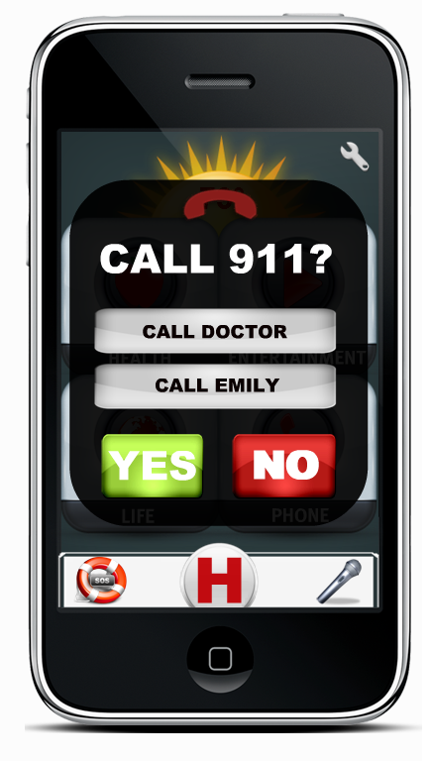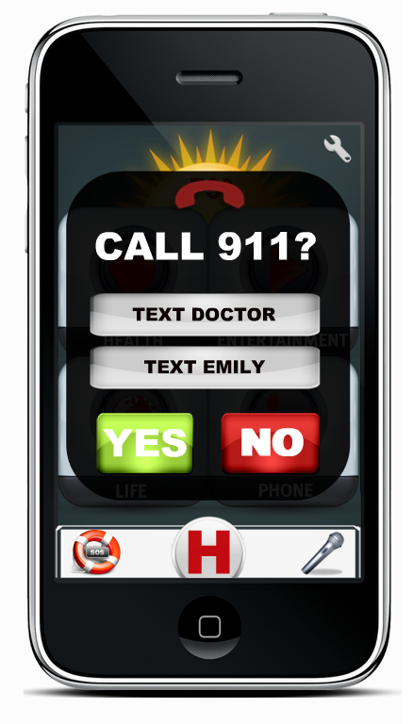

  - HELP
The big H button in the Quick Access Menu is a like a Favorite/Bookmark button of the main applications that a user want to quick access or are really necessary for him/her. As the application is installed, into this category the following applications will appear: Phone; Medical Cabinet; Back Track; Wellness; Recognition; FunBox. The user can customize this category in the same way that is used for the other categories. To better understand the functionalities of the applications mentioned here, please keep reading this user manual.

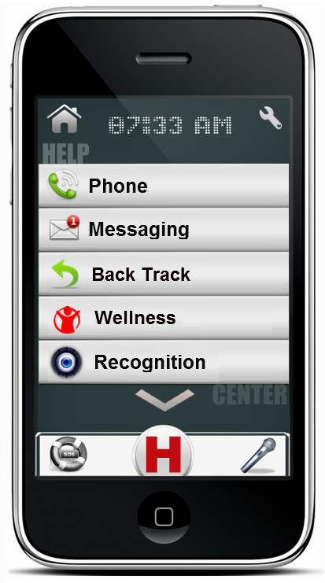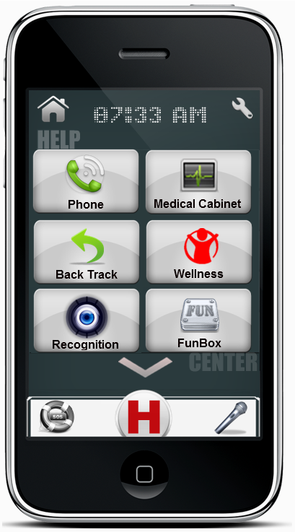
  - Commander
The above Commander screen is what you will see when you press the Voice or Text Commander feature from Quick Access Menu. From here, you can ask your application to run another application, search for a list or in the web, give you information for different questions or many other things that you as user will “command”. For example: If you want to play a song that is stored in your device just speak or text using Commander: “Play Beatles Yesterday”, and HELPeople will do the rest.

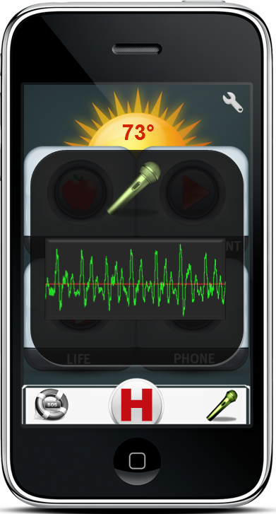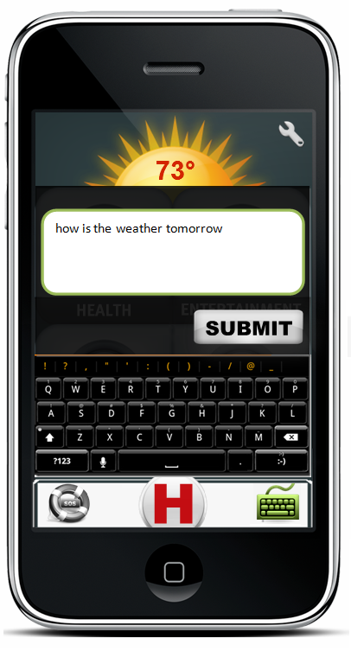

- Settings
Under Settings you can add/remove/change/customize the application in order to better suit your individual needs. Under different categories, you will find a set of tools that are especially related to that category. The general application settings can be accessed by using the settings button (or the following ways to access; see section 6.1) only from the home screen. Built-in apps and different subfolders will have their own settings menu accessible when you will use them (see section 6.2, 6.3)

  - General Settings
Suggested ways to access:
Touch | Run HELPeople > Select Settings
Voice Command | Run HELPeople > Select Voice Command > Speak “Open Settings”
Text Command | Run HELPeople > Select Text Command > Write “Open Settings”

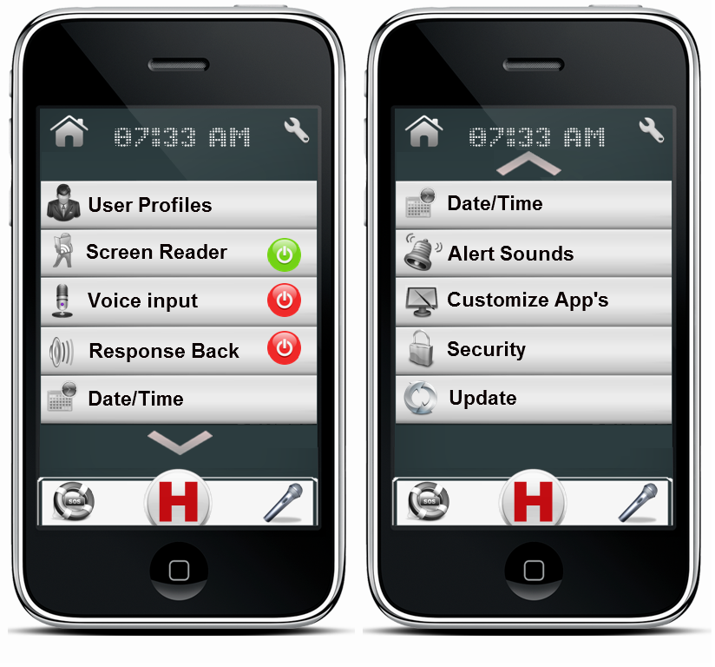
User Profile: Customize your application input/outputs, folders, interface etc through selecting our predefined profiles or by using the one that you will create. (See section 7).
Screen Reader: Directly activate/deactivate your screen reader without going to profile customization.
Voice Input: Activate/deactivate your voice input option to be open/closed all the time. Voice Input could be accessed from the Quick Access Menu (See section 5.1) if this option is deactivated. Optimal for audio profile, but not recommended to be activated.
Response Back: Let your phone notify you when your desired task is accomplished.
Date/Time: HELPeople is designed to update the date/time at your current location. In case that you are in a non-WiFi area but still want to use some of the features of HELPeople, you can manually change the date/time of your new location. Mostly used from people who will travel abroad.
Alert Sounds: Take in control the way you want to be notified for an upcoming call, SMS, MMS, e-mail or notification.
Customize App’s: Choose the app’s you really need. Delete those that you will never use. Change app’s folder destination. Sort in the way you are more comfortable. Everything should be in the place that makes more sense to you.
Security: Manage your security keys and locks.
Update: HELPeople is scheduled to be updated regularly. Anyway, if you want to anticipate an update, you can select this category from the Settings and the app will do the rest.

6.2 Subfolder Settings
Suggested ways to access:
Touch | Run HELPeople > Under Health/Entertainment/Life/Phone or Help Center (and their subdirectories) > Select Settings
Voice Command | Run HELPeople > Under Health/Entertainment/Life/Phone or Help Center (and their subdirectories) > Select Voice Command > Speak “Open Settings”
Text Command | Run HELPeople > Under Health/Entertainment/Life/Phone or Help Center (and their subdirectories) > Select Text Command > Write “Open Settings”

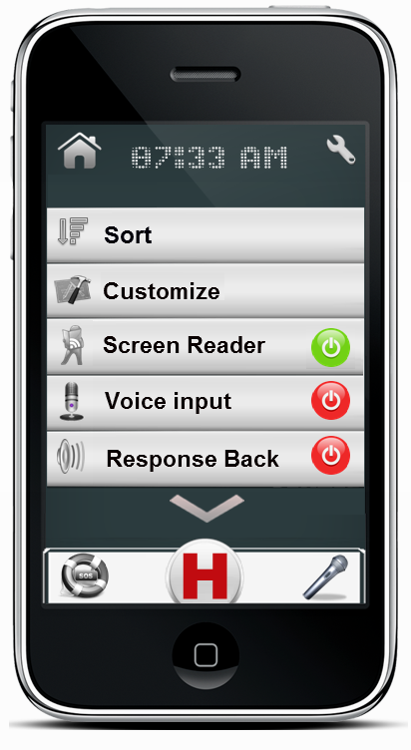
Sort: Sort apps under a certain category in the way you are more comfortable. Everything should be in the place that makes more sense to you.
Customize: Choose the app’s you really need. Delete those that you will never use. Enable previously removed apps. Change app’s folder destination. Switch from list to icon view etc.
Screen Reader: Directly activate/deactivate your screen reader without going to profile customization.
Voice Input: Activate/deactivate your voice input option to be open/closed all the time. Voice Input could be accessed from the Quick Access Menu (See section 5.1) if this option is deactivated. Optimal for audio profile, but not recommended to be activated.
Response Back: Let your phone notify you when your desired task is accomplished.
6.3 Application Settings
A dedicated application settings menu will be available when you will run a specific app (native or integrated with HELPeople) by selecting the Settings button.

- User Profiles

Suggested ways to access:
Touch | Run HELPeople > Select Settings > User Profile
Voice Command | Run HELPeople > Select Voice Command > Speak “Open User Profile”
Text Command | Run HELPeople > Select Text Command > Write “Open User Profile”
The following is a screenshot of User Profiles menu.
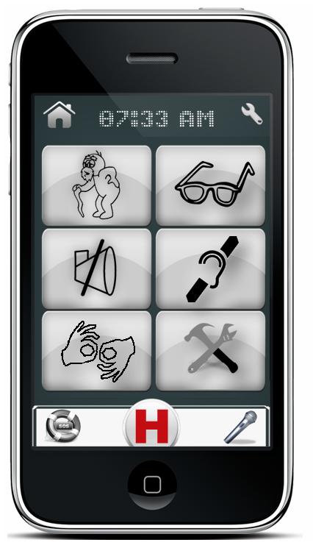
Help Profile: This user profile could be used by everyone, especially is customized specifically for old peoples. Users can access all HELPeople applications using touch-screen or by manually selecting the Voice Commander in the Quick Access Menu. By default ‘Screen Reader’ and ‘Response Back’ are disabled. Using this profile allows the user to have some special applications like FunBox in Entertainment category or a full featured Web Browser.
Audio Profile: This user profile is optimized with features which come in handy to people with visual difficulties. If you are blind or have difficulties identifying objects because of your eye sight, we recommend you use this profile. Users can access all HELPeople applications designed for this profile using audio commands. Since the Voice Commander in the Quick Access Menu is case sensitive, we recommend these users to keep it off and touch it every time they need to give “commands” to their phone. The Voice Commander could be switched left/right in the Quick Access Menu for easy access by left/right hand users. An option to leave the Voice Commander open for some time (or all the time) could be found under settings. This application profile is customized to give audio responses/feedback to the user using its Screen Reader feature. Also users of this profile could access web through a specific software: Web Reader, a Text to Speech based Web Browser (for more information see section 10)
Visual Profile: This user profile is optimized with features which come in handy to people with speaking difficulties. If you are mute or have difficulties with your speech, we recommend you use this profile. Users can access all HELPeople applications using touch-screen or by manually selecting the Text Commander in the Quick Access Menu. By default ‘Screen Reader’ and ‘Response Back’ are disabled. Using this profile allows the user to have some special applications like iTALK (a text-to-speech application/see section 10), FunBox in Entertainment category or a full featured Web Browser.
Touch Profile: This user profile is optimized with features which come in handy to people with hearing difficulties. If you are deaf or have difficulties hearing audio or signals, we recommend you use this profile. Users can access all HELPeople applications using touch-screen or by manually selecting the Voice Commander in the Quick Access Menu. Users have the option to switch from the Voice Commander to Text Commander and still stay under these profile features. Vibration alerts are activated. By default ‘Screen Reader’ and ‘Response Back’ are disabled. An application like iTALK could be used to come in help for audio to text translations.
Only Visual Profile: This user profile is optimized with features which come in handy to people with hearing and speaking difficulties. If you are deaf-mute or have difficulties hearing audio and you have speech impairment, we recommend you use this profile. Users can access all HELPeople applications using touch-screen or by manually selecting the Text Commander in the Quick Access Menu. All audio inputs are disabled for this profile. Audio outputs are used in specific applications such as iTALK. Using this profile allows the user to have some special applications like iTALK (a text-to-speech application/see section 10), FunBox in Entertainment etc. (See the above sections).
Customize Profile: This profile allow the user or its assistant to set a customized profile with audio/visual/text/vibration etc. features that can help better the experience of the user with his/her Smartphone using HELPeople.

- Health Center

Suggested ways to access:
Touch | Run HELPeople > Select Health Button
Voice Command | Run HELPeople > Select Voice Command > Speak “Open Health Center”
Text Command | Run HELPeople > Select Text Command > Write “Open Health Center”
The following is a screenshot of Health Center menu (left list version / right icon version)

In Health Center you are going to find a group of applications that are designed to help your everyday Health Activity, such as: Family History, Medical Cabinet, Calendar/Reminder, and Wellness. You could customize this group in your own way by adding/deleting apps, sorting them or choosing the list/icon view.
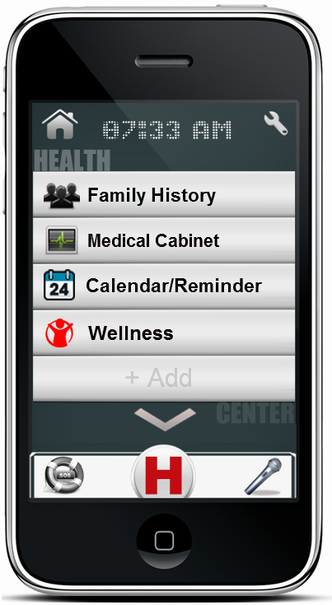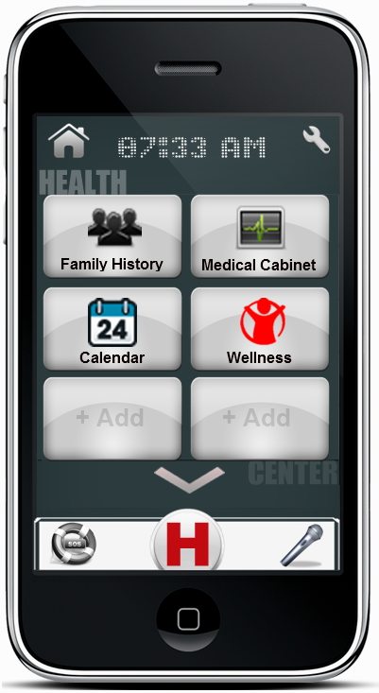
Family History: Build, update and show off your family tree. Whether you are a family history beginner or expert, this user-friendly app makes finding and learning more about your ancestors fun and easy. Add new family members to your pedigree, edit their information, add and edit life events, attach documents and even upload photos.
Medical Cabinet: is a comprehensive record-keeping app for your personal medical information. With this app, any and all information that is important to you is kept together in one place. It stores all data about medical history, allergies, operations, cornice disease etc, so in case of emergencies, doctors can consult with this file to retrieve info.
Calendar/Reminder: now with your voice and in your words, delivered on time, every time. Speak or type! This new app version remembers everything. You will forget nothing anymore with this voice/text ‘to-do’ list. Simply record your personal memo, set the time and date, and you will be reminded in real time.
Wellness: is the essential app to simply find nutritional info for the food you eat and to keep track of your meals, exercise and weight. The Wellness application has all the necessary tools to help you succeed: - A quick food calorie finder and full nutrition information. – A daily food plan to keep track of what you’re eating. – A daily reminder for various tasks like taking pills or eating a meal etc.

- Entertainment Center

Suggested ways to access:
Touch | Run HELPeople > Select Entertainment Button
Voice Command | Run HELPeople > Select Voice Command > Speak “Open Entertainment Center”
Text Command | Run HELPeople > Select Text Command > Write “Open Entertainment Center”
The following is a screenshot of Entertainment Center menu (left list version / right icon version)

In Entertainment Center you are going to find a group of applications that are designed to keep you in shape and in a good mood, such as: Music, Video Recorder, Camera, Multimedia and FunBox. You could customize this group in your own way by adding/deleting apps, sorting them or choosing the list/icon view.

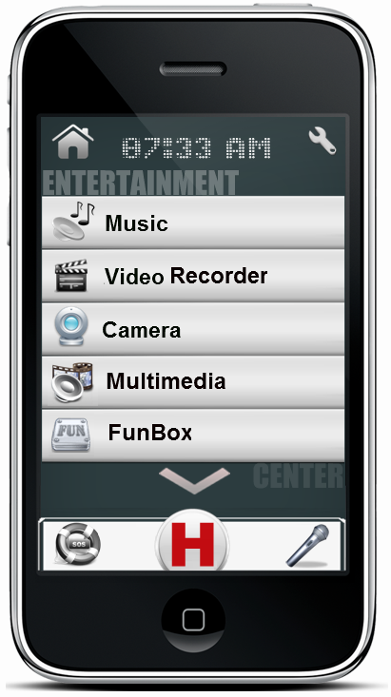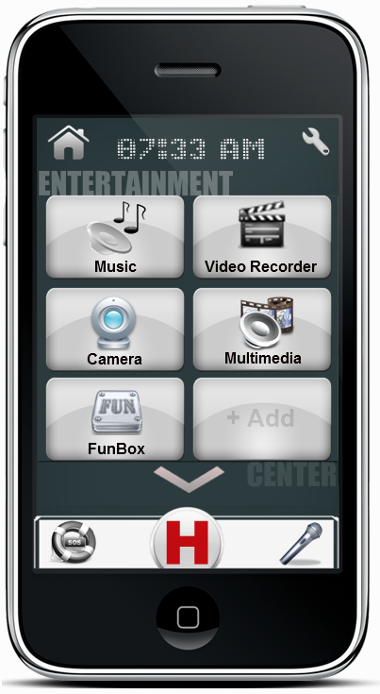
Music: listen to all the music you want on your phone. It’s easy and fast. Upload your preferred music, from your preferred artist, into your phone and listen to them with just a click, anywhere, at any time. No need for internet connection while listening, no need for an antenna. Just upload and enjoy.
Video Recorder: Record video with any Smartphone; share them on Facebook, YouTube and more. Customized with 20 live effects to record videos with. The best way to use your phone's camera to capture unforgettable memories.
Camera: Just have the desire to capture your beautiful life moments. Now you can easily access your phone camera. This app is also a light. Fun and easy camera app that lets you capture, manage, and share with total ease.
Multimedia: Have everything that is stored is your phone, but not only that, show others your music, photos and videos. Add your preferred places, images or favorite videos into this easy manageable folder of art. Find what you want with just a click.
FunBox: Is the package of your entertainment. Find things that relax and give pleasure to you in a single directory. Talk with your friends that are abroad by using Skype Chat, play Sudoku or Cards while you are waiting for someone, or check the last movies in Movie Theater or RedBox. Note: This app bookmark is not offered for all profiles. We will let you know regarding future changes.

- Life Center

Suggested ways to access:
Touch | Run HELPeople > Select Life Button
Voice Command | Run HELPeople > Select Voice Command > Speak “Open Life Center”
Text Command | Run HELPeople > Select Text Command > Write “Open Life Center”
The following is a screenshot of Life Center menu (left list version / right icon version)

In Life Center you are going to find a group of applications that are designed to help you in your daily life tasks, such as: Web Browser (Web Reader), Location, Recognition, Back Track, Places and talk. You could customize this group in your own way by adding/deleting apps, sorting them or choosing the list/icon view.
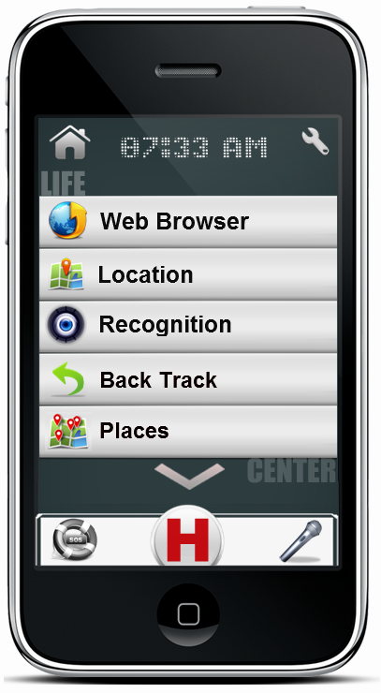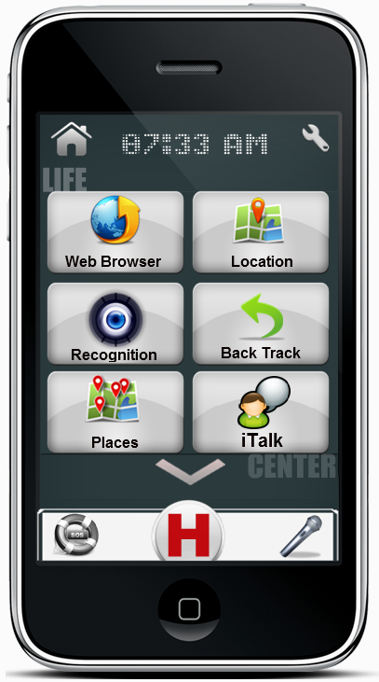
Web Browser: access the World Wide Web. Browse everything you want to accomplish, it may not be in our helping app, but it is for sure on the internet.
Web Reader: If audio profile (or activated in customized profile) is selected, specific web-browser app will be available into this category. Web Reader is a translation service that translates information available on the web, e.g., news, sports and weather bulletins, into messages that are understandable for our target group.
Location: is a voice guided GPS navigation app. It’s packed with Google maps and a robust set of navigation features. Both app and maps are updated for free. Maps are stored on the phone for offline use. Also it has the photo-based GPS feature, a great technology for people who easily forget places or cannot read a map. This technology prevents them from walking/driving the wrong way. By using a photo as a reference, the user only has to select the desired destination using the picture browser and the navigation starts. The only thing the user has to do is follow the instructions on the GPS.
Recognition: capture an image of a person and match against those stored in contacts list or family tree. Or, take the picture of an object and search the Internet for description.
Back Track: remember the starting location (e.g. Where is the car parked?) and lead person back. A direct and easy to use feature of the Location app.
Places: helps you discover nearby places you’ll love. Quickly search for Restaurants, Cafes, Bars and other places, while on the go. Places also makes it easy to quickly rate the places you visit. By rating places you’ll get place recommendations based on the places you like. This is a GPS based system, and uses your current location to show the nearest attractions that are around you.
iTalk: just type and let the phone be your voice. Pre-build with greetings and daily expressions. Add your favorite and most used quotes, the phone will talk for you. It includes a real-time text-to-speech translator for easy conversations between persons with speech difficulties and their friends. Also provides the inverse function. Record voices from the environment and receive as output the text in your screen.

- Personal Communication Center

Suggested ways to access:
Touch | Run HELPeople > Select Phone Button
Voice Command | Run HELPeople > Select Voice Command > Speak “Open Phone Center”
Text Command | Run HELPeople > Select Text Command > Write “Open Phone Center”
The following is a screenshot of Personal Communication (Phone) Center menu (left list version / right icon version)

In Personal Communication (Phone) Center you are going to find a group of applications that are designed to easily connect you with other friends, such as: Phone Call, Messaging, E-mail, Social Networking and Contacts. You could customize this group in your own way by adding/deleting apps, sorting them or choosing the list/icon view.
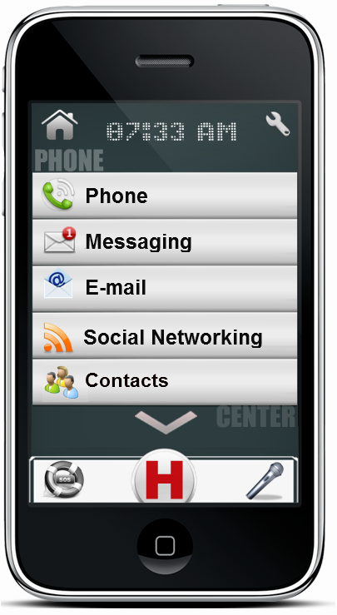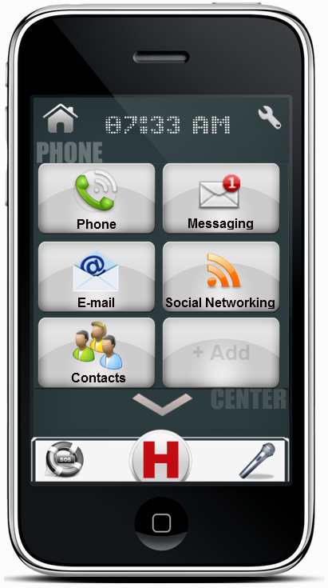
Phone: Make or accept a phone call. Integrated with Help Contacts list creates a better visual feeling when you make or accept a phone call through audio/picture outputs for the contacted person.
Messaging: Send and receive SMS/MMS using your network service provider.
E-mail: Send and receive e-mails from your saved account. It can be an exchange or web account (Yahoo, Gmail, Hotmail, AOL etc).
Social Networking: Share your best experiences using your Facebook or Tweeter account. Stay tuned with your friends and their life’s.
Contacts: Integrated with your phone contact list, this app offers you personalized bigger icons for each contact. Add a picture for each contact, create its profile and you will never forget anything related with him/her.

