Advanced Requirements Engineering
Human Reliability Analysis
Accounting for Human Error on Light Rail Transportation Systems

Michael Murphy
5/19/2012

Abstract
Human Error has been a contributing factor in light rail accidents since the inception of light rail technology in the 1960’s and, as proven in a 2009 Federal Transit Administration study, is still an issue today. As these accidents have continued to be prevalent in multiple industries, several analyses have been made to develop techniques to help predict when human errors might occur, thus preventing future accidents.
Introduction
From 2003 to 2008, the Federal Transit Administration’s (FTA) Office of Safety and Security compiled a report of light rail safety statistics that grouped light rail accident types with light rail accident causes. Accident types and descriptions included:
- Rail Grade Crossing (RGX) Collisions – Include collisions with transit vehicles, people, automobile or other vehicles at rail grade crossings.
- Non-Rail Grade Crossing Collisions – Includes train-to-train, train-to-vehicle, train-to-object and train-to-person collisions. Does not include collisions with transit vehicles, people, automobile or other vehicles at rail grade crossings.
- Derailments – Includes all mainline derailments.
- Fires – Includes fires that cause at least $25,000 in property damage or cause an evacuation of a vehicle or a station for life safety reasons.
- Other – Includes suicide and trespassing-related fatalities; homicides; non-fire related evacuations and other fatality or multiple-injury accidents that are not considered Collisions, Derailments or Fires.
Causes for each type of accident are identified and defined as:
- Equipment failure – Includes the unanticipated failure of a piece of equipment, such as a defective cable, signal or relay.
- Transit workforce behavior – Includes the failure of rail transit personnel to comply with rules, procedures, and policies (i.e., signals, speed restrictions, door opening/closing) or by human factors issues affecting rail transit personnel (inattentiveness, fatigue, etc.). Also includes failures resulting from the poor state of repair of an element of the transit system, such a poor track conditions, poorly trued wheels, poorly maintained switch points, or deteriorating structures for which speed or other restrictions have not been placed or enforced.
- Customer behavior – Includes poor decision-making on the part of a passenger or patron in the station or while boarding/alighting a train (i.e., carelessness, inattention, drunkenness, train surfing, climbing into the right-of-way to retrieve a lost item, leaning into the path of an on-coming train, etc.).
- Public behavior – Includes a variety of unsafe behaviors from those with whom the rail transit interacts, such as trespassers, suicidal individuals, the drivers or automobiles and pedestrians.
Between the years 2003 and 2008, a total of 3,665 accidents were reported to the FTA and recorded into the Safety and Security Office’s database. As evidenced in Tables 1 – 4 of Appendix A, the distribution of Accident Types by Accident Causes is broken out as follows:
- 69% Caused by Public Behavior
- 16% Caused by Workforce Behavior
- 8% Caused by Customer Behavior
- 7 % Caused by Equipment Failure
While Public Behavior was the largest portion of causes of light rail accidents in the years 2003 to 2008, techniques on how to improve the percentage of light rail accidents caused by Workforce Behavior will be the primary focus of this paper. 16% of all light rail accidents being caused by Workforce Behavior can be lowered significantly with the use of established techniques in Human Reliability Analysis.
Case Study
On July 18, 2009, about 2:50 p.m., at West Portal Station, San Francisco, California, San Francisco Municipal Railway Transit System (MUNI) L Line train 1433 struck the rear end of standing MUNI K Line train 1407. The operator of the striking train and 27 of the passengers had serious injuries. The incident was not affected by weather; it occurred as the trains were exiting a tunnel. Estimated damages were $4.5 million.
Before the accident, the automatic train control system (ATCS) had been operating the K Line train through the underground section of the MUNI railway system on the outbound track from downtown San Francisco. When the train automatically stopped at West Portal Station platform, the operator, as she was supposed to, cut out the ATCS and slowly moved the train forward in manual. At the end of the platform she stopped the train and prepared to enter the street and proceed onto the K Line.
The L Line train, also operated by the ATCS, had been following the K Line train through the underground portion of the MUNI system, making numerous station stops. According to the L Line train operator, his train had stopped automatically just inside the West Portal tunnel. He could see that the train ahead (the K Line train) had moved to the far end of the platform leaving enough room at the platform for his train. He later explained, “I went into cutout after my train stopped, which is a normal thing that we usually do.” He then attempted to move the train forward to the platform using the manual mode. He said that he started moving about 5 mph and that was the last thing he could remember until the impact. He said he had “blacked out.” When MUNI officials arrived at the accident, they found that the emergency pushbutton on the control panel was not engaged and that the T-Stick4 was all the way forward in the maximum power application, indicating that the operator had taken no action to stop the train. The MUNI officials also found that the L Line train’s auto mode switch was in the cutout position. See Figure 2 for a diagram of the accident.
Figure 1 – Accident Diagram
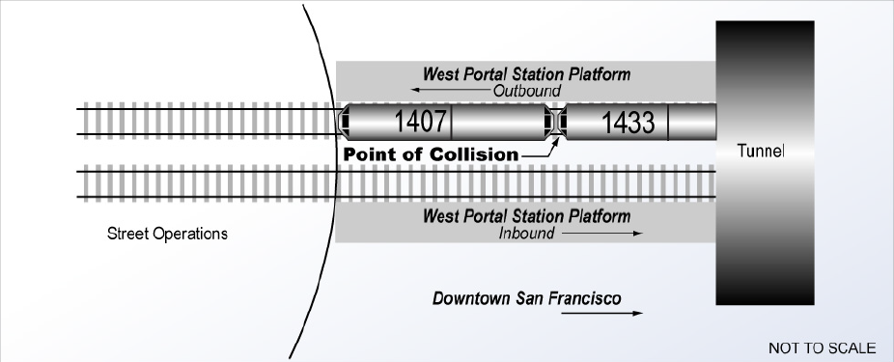
National Transportation Safety Board Investigators found that weather, equipment failure, track defects and drugs/alcohol were not the cause of the accident. It was determined that 2 operating procedures were not followed that could have safe guarded against the system failure when the L train operator “blacked out.” Both the human oversight of not leaving the train in control of the ATCS while on the platform and management’s decision not to enforce the operating procedure were the causes of the accident.
Human Reliability Analysis
Human Reliability Analyses (HRA) have be in existence since the early 1960’s, but more commonly used techniques were not developed until the late 1970’s and early 1980’s to help understand and prevent future failures at Nuclear Power Plants (ie. Three Mile Island). The idea of the HRA techniques is to identify potential human errors and assigning values to project their probability of occurrence. The most commonly used HRA technique is known as the Technique for Human Error Rate Prediction (THERP), which involves the following five steps:
- Define the system or process. This involves describing the system goals and functions and the consequences of not achieving them. It also requires identifying mission, personnel, and hardware/software characteristics.
- Identify and list all the human operations performed and their relationships to the system or process tasks and functions. This requires an analysis of all operator and maintainer tasks.
- Predict error rates for each human operation or group of operations. Errors likely to be made in each task or subtask must be identified. Errors that are not significant in terms of system operation are ignored. This step includes estimating the likelihood of each error occurring and the likelihood of an error not being detected.
- Determine the effect of human errors on the system or process, including the consequences of the error not being detected. This requires the development of event trees. The left limbs of the event trees are success paths; the right limbs are failure paths. Probabilities are assigned to each path. The tree reflects the effects of task dependence. The relative effects of performance-shaping factors, e.g., stress and experience, are estimated.
- Develop and recommend changes that will reduce the system or process failure rate. The recommended changes can be developed using sensitivity analyses, in which factors and values are varied and effects monitored. THERP makes no assumptions about the dependence or independence of personnel behaviors. Data are taken from available sources.
Determining the probability that an error or class of error will result in a system or process failure is a key aspect of THERP. The probability that a class of error will lead to a system failure is determined by:
Q_{i} = 1 – (1 – F_{i}P_{i})^n_{j}
Where 1 - F_{i}P_{i} is the probability that an operation will be performed that does not lead to system failure and n_{j} is the number of independent operations.
There are also several Error Rate Tables available to the public that identify common human error rates.
Once probabilities have been identified for the process events in question, an event tree can be developed to assist in identifying opportunities for human error improvement (See Figure 2).
Figure 2 – Event Tree
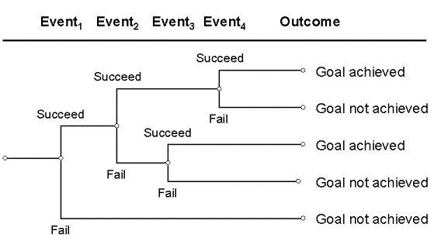
Swiss Cheese Model
In the event that a Human Reliability Analysis Technique cannot predict an adverse event causing error, the Swiss Cheese Model can be used to model where and how the error occurred. The ideal system can be compared to a stack of Swiss cheese, with each piece of cheese representing a different layer of protection from errors. The holes in the cheese represent opportunities and the idea is that when a hazard passes through a hole in a layer of protection it will be stopped by another layer before becoming an adverse event (See Figure 3).
Figure 3 – Layers of defense prevent an adverse event
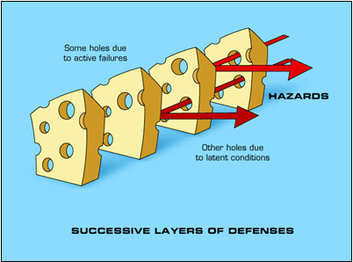
In the case of the San Francisco light rail accident, the holes in the layers of protection lined up in such a way that allowed the adverse event of a collision to occur (See Figure 4). The operating procedure to leave the trains in ATCS and management to monitor when they were taken out of ACTS were the layers of protection. The holes in these layers were the lack of decipline of the train operator and managers to follow them.
Figure 4 – Holes in layer of defense line up to allow accident to happen
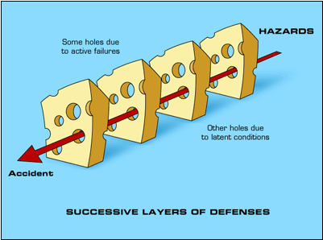
Conclusion
In summary, the use of Human Reliability Analyses has been proven to reduce the probability of human errors occurring in newly developed systems or processes. By defining the system or process, identifying all human operations, predicting error rates, determining the effects of errors and developing and recommending changes to the system, the THERP is recognized as the most affective Human Reliability Analysis technique available. In the event that THERP does not address all Human factors and an adverse event occurs, the Swiss Cheese Model is very effective in identifying and modeling the cause of the failure. In the case of the San Francisco light rail accident, THERP could have been used to identify the possible human errors. Since the errors were made and the accident occurred, the Swiss Cheese Model proves to effectively model where the errors occurred.
Appendix A
Table 1 – Accidents Caused by Equipment Failure
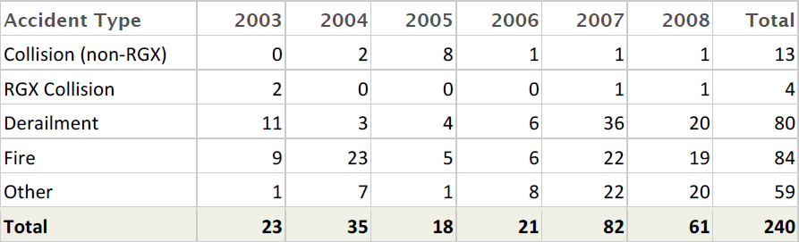
Table 2 – Accidents Caused by Workforce Behavior
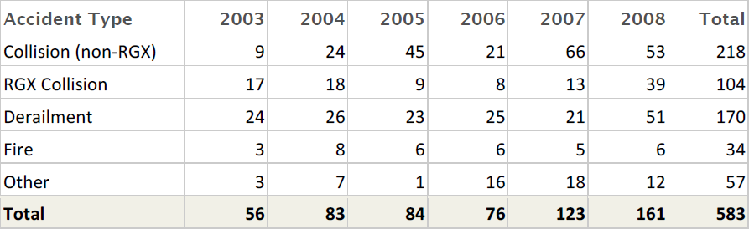
Table 3 – Accidents Caused by Customer Behavior
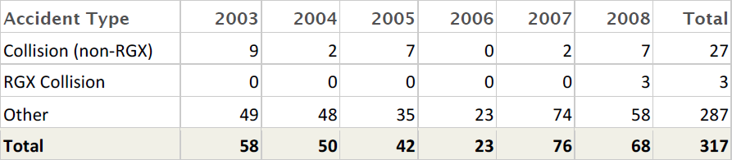
Table 4 – Accidents Caused by Public Behavior
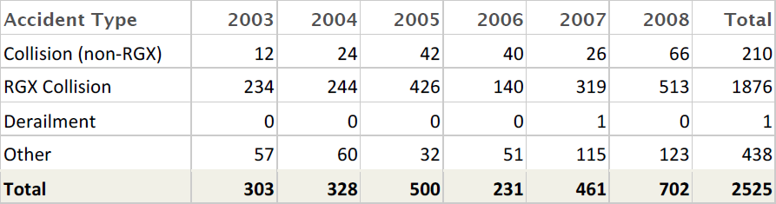

References
- “Collision of Two Municipal Transportation Agency Light Rail Vehicles, 7/18/2009, San Francisco, CA” http://www.ntsb.gov/investigations/reports.html
- “Human Reliability,” http://en.wikipedia.org/wiki/Human_reliability
- E. Hollnagel “Human Reliability Analysis,” 2002, http://www.ida.liu.se/~eriho/WhatIsHRA_M.htm
- “Technique for Human Error Rate Prediction,” http://en.wikipedia.org/wiki/Technique_for_Human_Error_Rate_Prediction
- Barbara Gregory, MPH, Victoria S. Kaprielian, MD “Anatomy of Error – Swiss Cheese Model,” http://patientsafetyed.duhs.duke.edu/module_e/swiss_cheese.html

