PROCESS SPECIFICATION
Schedule360
PURPOSE
This document describes the process specification for the creation of Schedule360 Application. The reason for including this step in the project is to clarify all the steps in the process and to eliminate as much as possible any ambiguity in the process. The process specification will also help in validating the design of the Schedule360 application.

SCOPE
The process specification is used in this document to represent the high level processes involved in the planning, design, testing, and implementation of the Schedule360 system using a top-down approach. The process specification will be used to check for process initiation and completeness but will not be used to check for errors or any redundancies in the process. The process specification in this document will represent both Non-Functional and Functional Requirements for Schedule360.

DEFINITIONS
- Generalization Relationship: A triangular shaped arrow that represents a specialized element (the child).
- Association Relationship: A Structural relationship that describes a set of links connecting different objects
- UML: Unified Modeling Language

REVISION
Name | Date | Revision Number | Revision Reason
Obi Ogbanufe | 04/09/2012 | 1.0 | Process Specification Creation
Obi Ogbanufe | 04/19/2012 | 1.1 | Added StarUML NFR Spec

The objective of process specifications is to provide a means by which systems engineering requirements and processes are documented and communicated to various stakeholders involved in the development of Schedule360 Cloud Based Scheduling Application. The intent is to use UML and SoftGoal to identify, create, organize and specify the process flow each component of Schedule360 application.
The classes in this document will primarily be based on two kinds of relationships – generalization relationship and Association Relationship.
FUNCTIONAL PROCESS SPECIFICATION
The process specification for functional requirements will identify the parts of project. The guidelines for the development of Functional Requirement for Schedule360 application is divided into the following process sections:
- Develop Project Charter
- Identify Stakeholders
- Develop Project Plan
  - Elicit Requirements
  - Define Scope,
  - Develop Requirements
    - NFR/FR
  - Develop Schedule
- Develop Prototype
- Develop User Manual

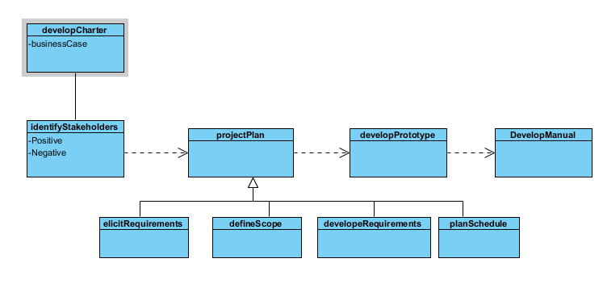

NON FUNCTIONAL PROCESS SPECIFICATION
The guidelines for the development of Non Functional Requirement for Schedule360 application are divided into the following process sections:
- Identify Stakeholders
  - Users
  - Developers
  - Telecommunication Providers
  - Device Manufacturers
- Collect Non Functional Requirements
  - Security
  - Compatibility
  - Usability
- Define Non Functional Requirements
  - Security
    - The software shall allow no more than one user to access a profile at a time.
    - The software shall contain a password security feature.
    - The software security feature shall be modifiable by the user
    - The software security shall allow a user to access his or her unique profile
    - The software security shall blocking access to the profile from unintended users.
  - Compatibility
    - The software shall be compatible with Outlook, Google, Yahoo, and Lotus Notes
    - The file size shall not exceed the maximum limit for iPhone apps
    - The software shall synchronize calendar information from internet connected
  - Usability
    - The software shall be understandable
    - The software functions shall be accessible
    - The GUI application interface shall have an ease of use.
    - The GUI application interface shall have readable text
- Define Scope
  - Team Meetings
  - Scenario Definition
  - Constraints
  - NFR Traceability Matrix
- Create Work Breakdown
  - Team Meetings
  - Brainstorming
  - Task Decomposition

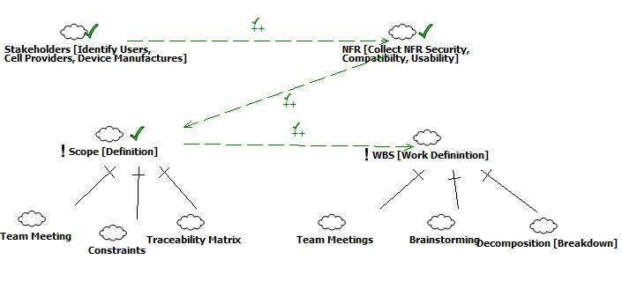

References
http://www.csc.ncsu.edu/faculty/mpsingh/books/SOC/SOC-Chapter13.pdf
http://www.tc.faa.gov/its/worldpac/techrpt/ar02-110.pdf
http://www.cs.le.ac.uk/people/rh122/papers/2005/EFHT05PAIS.pdf
http://www.andrew.cmu.edu/course/90-754/umlucdfaq.html
Supakkul, Sam. The Softgoal UML Profile: An NFRs Modeling Tool. Nov 9, 2010. Retrieved from http://www.utdallas.edu/~supakkul/tools/softgoal-profile/softgoal-profile.html

