|  |
| --- |
| For Schedule360 Version 1.0 | Alpha Group |

|  |  |
| --- | --- |
| Schedule360 | **User Manual** |

**C:\Documents and Settings\1065643\Local Settings\Temporary Internet Files\Content.IE5\VG8A5PQB\MC900198862[1].wmf**

**Schedule360 User Manual**

**Table of Contents**

Registering 2

Home Screen 3

Buttons 4

Viewing your appointments 5

Creating appointments 6

Updating your calendar 6

Deleting Appointments 6

Searching your Schedule360 7

Changing appointments views 8

Synchronize your Schedule360 calendar 9

# Registering

You can register to access Schedule360, through the website- [www.360schedule.com](http://www.360schedule.com) or through your smartphone application.

**Registering Online:**

1. Go to www.360Schedule .com
2. On the upper right hand corner, click on **REGISTER** and then follow the prompts to register
   1. Entering your first name, last name, username and desired password, and email address.
3. After registering, you are prompted
   1. create a new schedule
   2. upload your schedule to the cloud
   3. view the schedule after performing steps 1 and 2 above
4. You are then provided with an access code to use in accessing and synching your cloud calendar

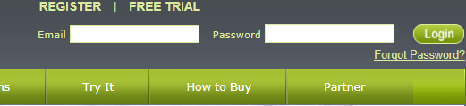

**Registering from your Smartphone**

1. On your Smart Phone, go to the apps store
2. Navigate to the Search box
3. Type in Schedule360
4. The Schedule360 App will display
5. Click on install to download the Schedule360 application
6. After the download is completed
7. Click on the Schedule360 icon on your iPhone
8. A registration screen is displayed for you to create a username and password, and add your email address.
9. After a successful and complete registration is complete, you are prompted to
   1. create a new schedule
   2. upload your schedule to your device
   3. view the schedule after performing steps 1 and 2 above
10. You are then provided with an access code to use in accessing and synching your cloud calendar

# Home Screen

The home screen is the screen that appears on your smartphone when the Schedule360 icon is touched. From here you can see the name that you registered with and a few splash screen buttons

1. Home,
2. Calendar
3. Settings
4. Synchronize Devices



# Buttons

|  |  |  |
| --- | --- | --- |
| C:\Users\obi\AppData\Local\Microsoft\Windows\Temporary Internet Files\Content.IE5\KZMU1RNU\MC900431495[1].png | Home | Organize your calendar and your life with Schedule360 on your iPhone device and keep your life up to date on all of your other mobile devices |
| C:\Users\obi\AppData\Local\Microsoft\Windows\Temporary Internet Files\Content.IE5\EGZXX75B\MC900434804[1].png | Calendar | Access your calendar on Schedule360. Organize your life with due dates and never miss your appointments. |
|  | Settings | Personalize your Schedule360 settings in one convenient place—network, photos, and more. Set up Picture Frame, calendar accounts, synching and backup options and contacts. Manage your cellular data account. Set an auto-lock and a passcode for security. |
|  | Synchronize Devices | Synchronize your calendar with your other computing devices and other scheduling software such as Outlook, Yahoo and Google Calendar. Sync over the Internet with work and home calendars. |

# Viewing your appointments

You can view both your work and family calendars individually or as a combined calendar. This makes it easy to manage your work and family appointments in one place. With Schedule360 you can see your calendars combined in one place and at the same time.

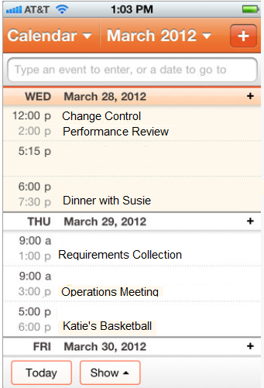

# Creating appointments

1. Tap on the plus **+** sign button to open the new appointment screen
2. Enter event information, then tap done



# Updating your calendar

1. Tap on a calendar event or appointment
2. Tap Edit, and then change event information.

Note: When edits are made to your Schedule360 Internet calendar, the changes will automatically be updated in your mobile Schedule360 Calendar account

# Deleting Appointments

1. Tap on an appointment to display the detail
2. Tap to select the Delete button at the bottom
3. Your appointment will be deleted

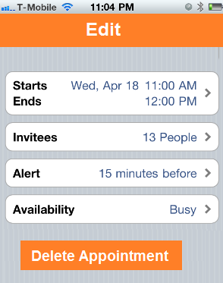

# Searching your Schedule360

You can search the titles, invitees, and locations of the events in your Schedule360 calendar.

1. Calendar searches the calendar you’re currently viewing or all calendars if you’re viewing them all.
2. In list view, enter search information in the search field
3. Search results appear automatically as you type

.

Type search information

# Changing appointments views

You can view individual calendars for your different accounts or a combined calendar for all accounts.

1. From the home screen, Tap Calendars
2. Select a calendar – Work, Home (Google, Outlook etc.), or tap All Calendars to view a combination of all appointments from all calendars.

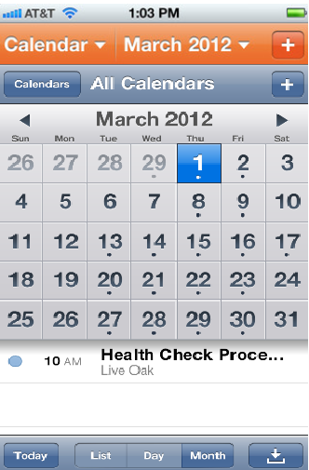

List View

Monthly View

Daily View

1. You can view your calendar events in a list, by day, or by month.
2. To switch from one view to another**,** Tap List, Daily, or Monthly to view your appointments in each of the desired formats
   1. List view will display your appointments in a scrollable list.
   2. Day view will display your appointments in a day (you can tap the back arrow to view the previous or next day’s appointment).
   3. Month view will display your appointments in a month (you can tap the back arrow to view the previous or next month’s appointment)

# Synchronize your Schedule360 calendar

1. On the Home window, tap on the Sync
2. Device choices will be displayed: e.g. Outlook, iPhone, Google
3. Tap to select the device to sync
4. Selected device calendar will sync with Schedule360

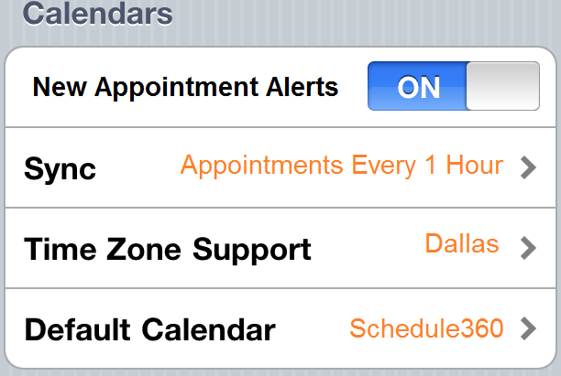

Synchronizing can also be setup on Settings:

1. On the Home window, tap on Settings
2. Turn on Calendars, Outlook, Google, or other calendar accounts to sync with your Scedule360 calendar information over the Internet.
3. You can then choose the frequency of the sync

Reference

1. Cozi [www.cozi.com](http://www.cozi.com)
2. Apple: <http://manuals.info.apple.com/en_US/ipad_user_guide.pdf>
3. Apple: <http://manuals.info.apple.com/en_US/iPhone_iOS3.1_User_Guide.pdf>