Process Specification
Final Phase II

Team T-MIP
www.tmip-helpeople.com

Team Members:
Taraneh Parvaresh
Mairon Toçi
Ian Bùi
Pooria Kamran Rashani
Table of Contents

Revision History 3
1 Introduction 4
1.1 Purpose 4
1.2 Scope 4
1.3 Stakeholders 4
1.4 Definitions and Glossary 4
1.5 References 5
2 Organizational Structure 5
2.1 Vision 5
2.2 Goals 5
2.3 Team Roles 6
2.4 Workflow 8
3 Process Specification 9
3.1 Requirements Engineering Model 9
3.2 Requirements Elicitation 10
3.3 Requirements Analysis and Negotiation 11
3.4 Requirements Specification 12
3.5 Requirements Validation 12
4 Project Organization 13
4.1 Project Phases 13
4.1.1 Interim Phase I – 14
4.1.2 Final Phase I – 16
4.1.3 Interim Phase II – 17
4.1.4 Final Phase II 19
4.2 Traceability 20

Revision History

Date | Version | Description | Author
April 19, 2012 | 0.1 | Initial Version | Ian Bui
April 19, 2012 | 0.2 | Reviewed | T-MIP
April 19 ,2012 | 0.3 | Added Sections 1.4, 1.5; Formatted Diagrams | Mairon Toci
April 20, 2012 | 0.4 | Added Goal Diagram | Ian Bui
April 20, 2012 | 1.0 | First formal version to turn in | Ian Bui
May 15, 2012 | 1.1 | Add Traceability Matrix | Taraneh & Pooria
May 16, 2012 | 1.2 | Update Traceability Matrix phase I | Taraneh
May 16, 2012 | 1.3 | Reviewed | T-MIP
May 17, 2012 | 2.0 | Final version | T-MIP

Introduction

Purpose
The purpose of this document is to describe the process that Team T-MIP used to create the deliverables for Project HELPeople.

Scope
This document describes the process that Team T-MIP used from initial market research to the completion of Phase II deliverables for the Course Requirements.

It explains our vision, goals, organizational structure, process workflow and responsibilities of team members.

Stakeholders
The Process Requirements Specifications described herein are designed to support the following major stakeholders:

- Product Management – Responsible for ensuring that product requirements meet user needs and protect investors’ confidence
- Project Management – Responsible for ensuring that schedules are met and resources are properly allocated
- Engineering – Responsible for developing and testing the Product according to requirements within the time and budget constraints
- Technical Support – Responsible for supporting end-user requirements such as User Guide, Install Guide and Product Maintenance.
- End-Users

Definitions and Glossary
WRS: World Requirements Specification
SPMP: Software Project Management Plan
NFR: Non Functional Requirements
FR: Functional Requirements
T-MIP: Our group name

References
Chung, Dr. Lawrence Advanced Requirements Engineering [UTD website] http://www.utdallas.edu/~chung/SYSM6309/syllabus.htm

Process Specifications: http://www.csc.ncsu.edu/faculty/mpsingh/books/SOC/SOC-Chapter13.pdf

Team Power Dorid Dr. Chung's Requirements Engineering Site. Spring, 2011 http://www.utdallas.edu/~chung/SYSM6309/Presentations11S/

Organizational Structure

Vision
Develop a simple but effective process to produce the required Deliverables as specified in the Course Syllabus without sacrificing accuracy, functionality or quality.

Goals
- Maximize Re-Use
  - Standard Templates
  - Previous Documentations
  - Existing apps on market
- Minimize Cost
  - Teleconferencing when possible
  - Document sharing via Dropbox
  - Manual version control
- Optimize Efforts
  - Assignments match skills
  - Division of labor w/out overlap
  - Utilize familiar tools
- On-time Delivery
  - Scope Management
  - Meeting Management
  - Project Management

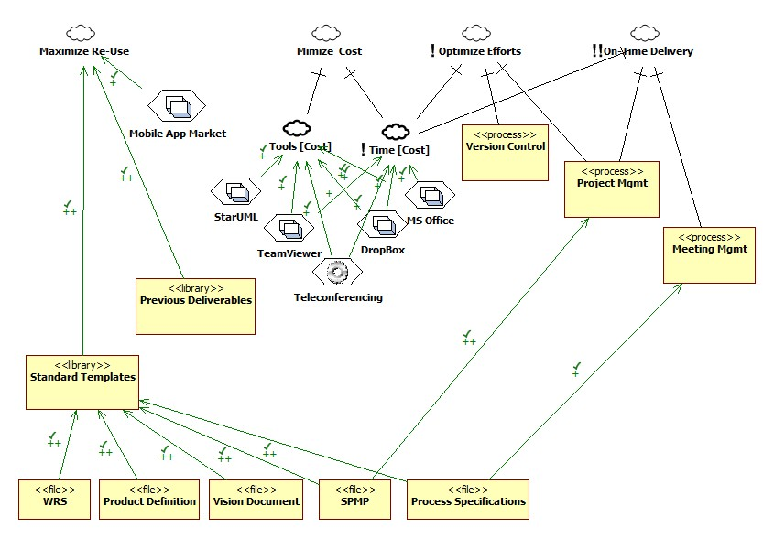

Fig. 1 - Goals Model

Team Roles
Since our team only has four people, we decided to divide up the work along these lines, and one person is mainly responsible for each:

- Overall Product Definition, Vision, Presentation
- Functional Requirements
- Non-Functional Requirements
- Mockup/Prototype/Website/User Manual

Furthermore, all members are involved in the reviewing and refinement of all parts of the Product and Project.

Team Lead/Project Manager
We rotate the Team Lead responsibility among our team members to provide everyone with the opportunity to practice project management and leadership skills.

The team lead’s primary responsibility is the entire project’s progress during his/ her time as team lead. The team lead provides clear communication to the group, helps develop a plan for the project, assigns tasks and duties to those most suited to perform the work, mediates and makes final decisions on difficult issues and calls meetings to order.

Reviewer
Because of our small team size, everyone is involved in reviewing everyone else’s work.

The reviewer’s sole purpose is to provide “new eyes” to a document/deliverable that has been created by another person/group. A reviewer cannot be the same person that created the deliverable and cannot make changes to the deliverable. The reviewer only makes suggestions for the changes of the deliverable to the creator of that deliverable. The reviewer will also ensure that the deliverable under review meets or does not meet requirements.

Requirement Engineer
Every member of T-MIP was also involved in developing requirements for various parts of the Product.

The Requirement Engineer(s) will be responsible for the elicitation, analysis, and specification of all the requirements of the product.

Developer
The developer(s) is responsible for implementation / design of the prototype and website construction.

Workflow
Before each meeting, the Team Lead will create an agenda in cases where there is old business or a number of items to discuss and decide upon. During meetings, decisions will be made upon task allocation and timelines. All assigned tasks are performed by Groups or individual members and posted on a designated folder on Dropbox.

Reviewers will check the documents and make recommendations for changes. Any major issues can be addressed in meetings as old business. Documents are then placed in a central designated digital location. A designated individual will reproduce those documents for physical turn-in.

Process Specification

Requirements Engineering Model
For the HELPeople project, Team T-MIP will use the Spiral Model for the requirements specification. Since there is no Development involved, a Development Process was not used.

We performed 2 Requirements Engineering iterations (1.x & 2.x).

Fig. 1 – Spiral Model

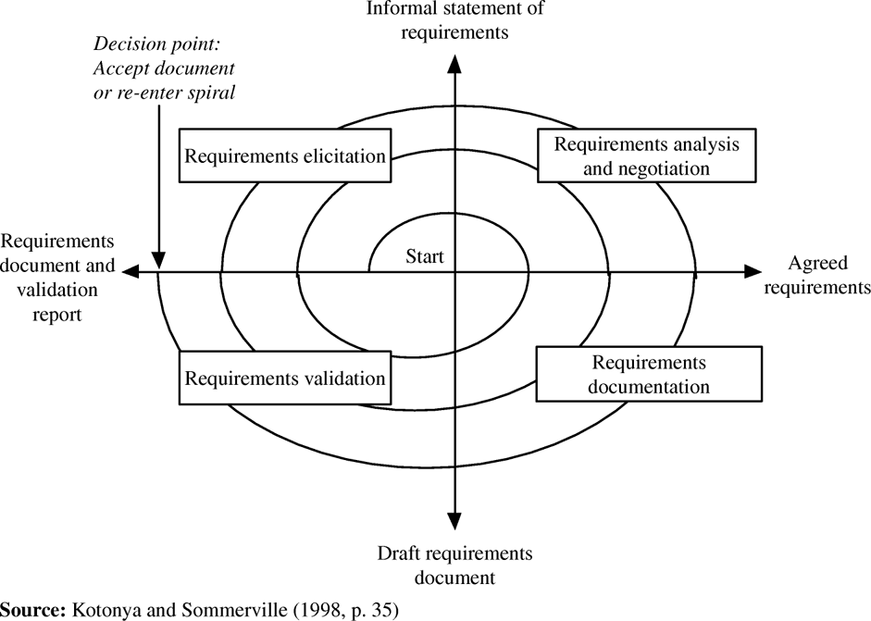

Fig. 2 - Meeting Process Model
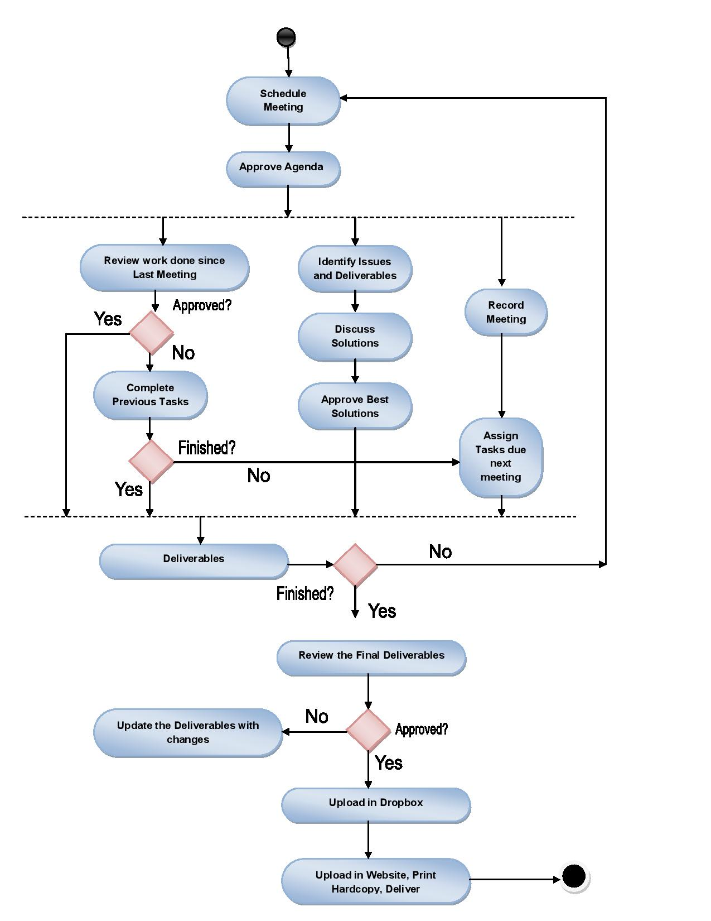

Requirements Elicitation

Phase I
The first phase elicitation began with the preliminary requirements from Dr. Chung, plus some in class discussions. We gathered other requirements by surveying the current mobile app market, researching on the Internet, and talking to people in our main target User Groups (i.e. the elderly)

Phase II
The second phase elicitation consisted of a review of the previous requirements, decisions made by previous teams’ work, and other information discovered as part of Phase I.

Requirements Analysis and Negotiation

Phase I
Once requirements had been elicited, we categorized them as Domain, Functional, or Nonfunctional.

The team then reviewed the requirements and identified the issues (ambiguity, incompleteness, inconsistency, etc...)

For every requirement that had issues, we discussed the nature of the issue, identify the options, and then used the consensus approach, as opposed to voting, to arrive at the final solution.

Phase II
We reviewed other teams’ requirements to get ideas on what might be added or deleted from Phase I requirements.

We ensured that our scope remains manageable and that any new requirements would not affect the scheduled delivery.

Requirements Specification

Phase I
Document created from Analysis and Negotiation to provide a clearer understanding of the requirements of the project.

Phase II
Document revised and reviewed to reflect work in elicitation and in analysis. Modeling techniques were used in order to help with analysis.

Requirements Validation

Phase I
Requirements are validated by creating preliminary mockups which also serves as our prototype.

Phase II
Modified requirements are implemented into the prototype.

Project Organization

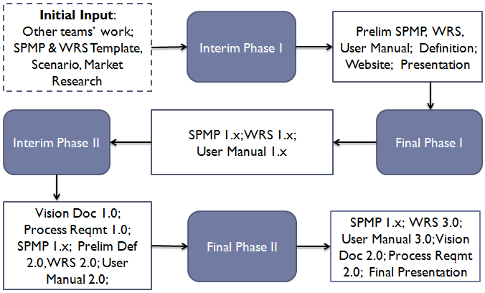
Project Phases

Interim Phase I –
In the interim phase we analyzed the preliminary definition document given by Dr. Chung. The preliminary definition was broken down into domain, functional and nonfunctional requirements.

A website was constructed, a prototype developed, and a PowerPoint slideshow was done to present our initial ideas and direction.

Stakeholders
Users
Dr. Lawrence Chung
Team T-MIP
Goals
Preliminary list of Requirements
Divide and assign requirements to Domain, NFR and FR
Create mockup & prototype
Scenario
Create website
Create presentation for Interim Phase I
Inputs
Initial understanding of the requirements elicitation
Preliminary WRS and SPMP templates
Process
Determine best meeting times
Get to know team members
Get preliminary understanding of deliverables
Agree on tools
Divide work
Prepare minutes after each meeting
Activities
Physical presence team meetings
Create and Revise deliverables
Prepare for the presentation
Outputs
Software Project Management Plan
Preliminary WRS
Mockup & Prototype
Scenarios
Preliminary User Manual
Project Presentation
Roles and Responsibilities
Software Project Management Plan – Ian, Taraneh, Pooria
Preliminary WRS – Taraneh, Pooria, Ian
Mockup & Prototype – Mairon
User Manual – Mairon
Website – Mairon
Scenarios - Mairon
Presentation slides – Ian
Minutes Summary – Taraneh

Final Phase I –
During this phase, Team T-MIP revised our requirements based on input from the class, from issues identified, and from new information we learned from the process.
The WRS and SPMP were updated, as well as the User Manual and Website.

Stakeholders
Users
Dr. Lawrence Chung
Team T-MIP
Goals
Finalize documents for Phase I
Develop Traceability Matrix
Develop clearer requirements
Inputs
Software Project Management Plan (1.0)
Preliminary WRS (1.0)
Preliminary User Manual (1.0)
Preliminary Mockup & Prototype
Preliminary Website
Process
Gather input from Professor and other students
Discuss issues, identify options, select best solutions
Assign tasks for next phase of work
Record all meeting minutes
Submit deliverables
Activities
Conduct team meetings, both in-person and teleconference
Communication via email, phone
Maintain document changes in Dropbox
Outputs
Revised Software Project Management Plan (1.x)
Revised WRS Document (1.x)
Revised Prototype & Mockup
Updated Website
Updated User manual (1.x)
Roles and Responsibilities
Revised Software Project Management Plan – Taraneh
Revised WRS Document – Taraneh, Pooria, Ian
Revised Prototype & Mockup – Mairon
Revised Minutes Summary – Taraneh
User manual – Mairon

Interim Phase II –
This phase began with additional requirements elicited from Dr. Lawrence Chung.

We evaluated the suggestions for new requirements and chose only those that made business sense without adding too much to our scope and thereby threaten our schedule. The WRS was revised to reflect these requirement changes.

We modeled our process and created the Process Specification. A Vision document was created to provide a high-level view of the Project and Product.

Stakeholders
Users
Dr. Lawrence Chung
Team –T-MIP
Goals
Revise requirements
Address new requirements
Modify Prototype
Create Process Specification
Create Vision Document
Inputs
SPMP (1.x)
WRS (1.x)
User Manual (1.x)
Prototype from Phase 1
Changes to the Preliminary Definition
Process
Discuss the new requirements
Address issues about the project
Agree on deliverables for project phase 2
Divide work among team members/groups
Prepare minutes to meetings
Submit deliverables
Activities
Conduct team meetings (in-person and teleconference)
Communication via email
Create Models
Maintain document changes in Dropbox
Revise/Create/Review deliverables
Outputs
Revised Software Project Management Plan (2.0)
Revised WRS Document (2.0)
Revised Prototype & Mockup
Vision Document (1.0)
Process Specification (1.0)
Roles and Responsibilities
Revised Software Project Management Plan – Taraneh
Revised WRS Document – T-MIP
Revised Prototype & Mockup – Mairon
Update Minutes Summary – Taraneh
Process Specification – Ian
Vision Document – T-MIP

Final Phase II
Stakeholders
Users
Dr. Lawrence Chung
Team T-MIP
Goals
Create Product Specification w/modeling
Finalize Vision Document
Finalize WRS
Finalize User Manual
Finalize Website
Create final presentation slide deck
Inputs
Revised SPMP
Process Specification
Revised WRS
Vision document
Phase 1 presentation
Revised Prototype & Mockup
Process
Address issues about the project
Revise schedule for phase 2 deliverables
Divide work among team members/groups
Submit deliverables
Activities
Conduct team meetings (in-person or teleconference)
Communication via emails
Maintain document changes in Dropbox
Revise/Create/Review deliverables
Draw IDEF Traceability Matrix with Edraw Max Tool
Outputs
All Project Final Deliverables in zip file
Roles and Responsibilities
Final Product Specification: T-MIP
Final SPMP – Taraneh
Vision Document – T-MIP
Final Mockups & Prototype– Mairon
Final Minutes Summary – Taraneh
Final Process Specification – Ian & Mairon
Final “Why we are the Best” – Ian

Traceability
Below is IDEF Standard Diagrams to show HELPeople process modeling:

IDEF Level 0

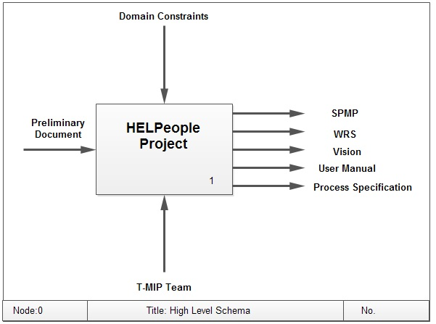

IDEF Level 1

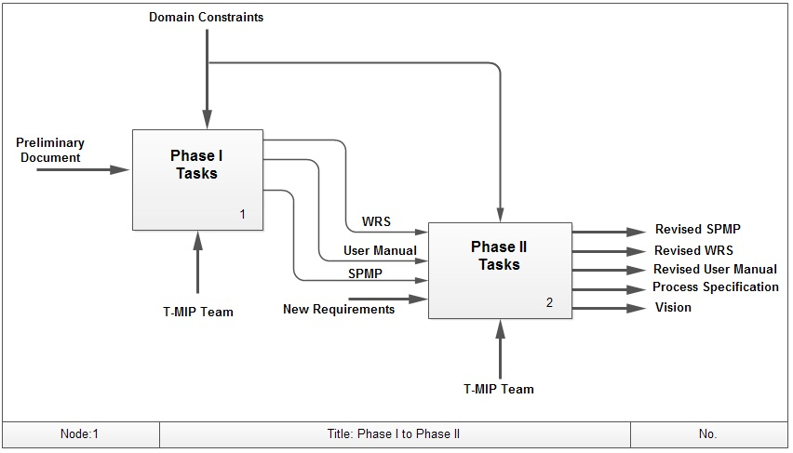

IDEF Level 2 Phase-1

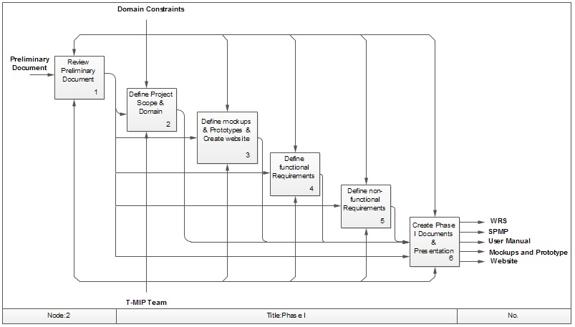

IDEF Level 2 Phase-2

