Vision Document
Final Phase II

Team T-MIP
www.tmip-helpeople.com

Team Members:
Taraneh Parvaresh
Mairon Toçi
Ian Bùi
Pooria Kamran Rashani

Revision History

Date | Version | Description | Author
01 April 2012 | 0.1 | Creation of Product Specification document | Mairon Toci
04 April 2012 | 0.2 | Completed sections 1 through 3 | Ian Bui
10 April 2012 | 0.3 | Completed sections 4 and 6 | Taraneh Parvaresh
10 April 2012 | 0.4 | Completed sections 7 and 9 | Pooria Kamran
11 April 2012 | 0.5 | Completed sections 5, 8 and 10 | Mairon Toci
19 April 2012 | 0.6 | Reviewed | T-MIP
19 April 2012 | 0.7 | Add Appendix A | Taraneh Parvaresh
19 April 2012 | 0.8 | Add Appendix B, C, D | Mairon Toci
20 April 2012 | 1.0 | Added Problem Domain Model, Edited for typos. First formal version to turn in | Ian Bui
16 May 2012 | 1.1 | Reviewed | T-MIP
17 May 2012 | 2.0 | Final Document | T-MIP

Table of Contents
1 Introduction 5
1.1 Purpose 5
1.2 Scope 5
1.3 Definitions, Acronyms, and Abbreviations 5
1.4 References 6
1.5 Overview 6
2 Positioning 7
2.1 Business Opportunity 7
2.2 Problem Statement 7
2.3 Product Position Statement 8
3 Stakeholder and User Descriptions 8
3.1 Market Demographics 8
3.2 Stakeholder Summary 9
3.3 User Summary 10
3.4 User Environment 11
3.5 Stakeholder Profiles 12
3.6 User Profiles 12
3.7 Key Stakeholder or User Needs 12
3.8 Competition and Alternatives 13
4 Product Overview 14
4.1 Product Perspective 14
4.2 Summary of Capabilities 15
4.3 Assumptions and Dependencies 16
4.4 Cost and Pricing 17
4.5 Licensing and Installation 18
5 Product Features 18
5.1 Start application 18
5.2 Execute touch screen input 19
5.3 Execute voice input 19
5.4 Execute text input 19
5.5 Show content 19
5.6 Show current time 19
5.7 Show weather condition 19
5.8 Change frequency of weather updates 19
5.9 Change date/time 20
5.10 Show system updates alert 20
5.11 Accept system updates 20
5.12 Deny system updates 20
5.13 Shows an easy-accessible audio commander button 20
5.14 Shows Favorite applications 20
5.15 Change security 20
5.16 Change alert sounds 21
5.17 Switch from list-to-icon menus and vice versa 21
5.18 Customize folder’s content 21
5.19 Sort by different logic categories contents 21
5.20 Translate Text-to-Speech 21
5.21 Translate Speech-to-Text 21
5.22 Provide visual feedback after getting commands 22
5.23 Turn on Screen Reader 22
5.24 Turn on Voice Input 22
5.25 Turn on Response Back 22
5.26 Connect to a network 22
5.27 Connects to the internet 22
5.28 Communicate with some other phone installed applications 23
5.29 Provide predefined user profiles 23
5.30 Modify a user profile 23
5.31 Create new customized user profiles 23
5.32 Place emergency call to 911 23
5.33 Place emergency call to their doctor 23
5.34 Place emergency call to a selected emergency assistant 23
5.35 Modify doctor and emergency assistant contacts 23
6 Constraints 24
6.1 Responsiveness 24
6.2 User Interface Usability 24
6.3 Security 24
7 Quality Ranges 24
8 Precedence and Priority 25
9 Other Product Requirements 25
9.1 Application Requirements 25
9.2 System Requirements 25
9.3 Performance Requirements 26
10 Documentation Requirements 26
10.1 User Manual 26
10.2 Online Help 26
A. Appendix - Use case Specification 27
Usecase 1: Select User Profile 28
Usecase 2: Add a contact 29
Usecase 3: Make Emergency Call 30
Usecase 4: Select favorite/bookmark applications 31
Usecase 5: Listen to broadcasting in the air 31
Usecase 6: Change the settings 31
Usecase 7: Store pictures and information of family members 31
Usecase 8:Retrieve a picture and information of family members 31
Usecase 9: Access Medical information 31
Usecase 10: Add reminder to Calendar 31
Usecase 11: Find foods nutritional information 31
Usecase 12: Listen to Music 31
Usecase 13: Play Games 31
Usecase 14: Record a video 31
Usecase 15: Surf the web 32
Usecase 16: Find previous Location(s) 32
Usecase 17: Recognize person/object 32
B. SIG Diagram and domain model 32
Diagram 1: Ease of use 32
Diagram 2: User Profiles 33
Diagram 3: SOS 33

Vision

Introduction

Purpose
The purpose of this document is to collect, analyze, and define high-level needs and features of the HELPeople Project. It focuses on the capabilities needed by the stakeholders and the target users, and why these needs exist.

Scope
This document is associated with high-level requirements for the HELPeople project only. The details of how HELPeople fulfills these needs are detailed in the use-case and supplementary specifications.

Supporting documents that will depend on this document for the successful completion of the project include: System Requirements Specifications; System Architecture Specifications; Software Design Specifications; Test Design Specifications; User Manual; Installation Guide.

Definitions, Acronyms, and Abbreviations

The following terms regarding different App Types shall be used within the context of the HELPeople product to mean specific things:

- Resident – any app that physically resides on the device, which can be:
- Native – is built into this product
- Non-Native – is not a part of this product and can be either:
a) Integrated – can communicate with this product via an API
b) Standalone – is not integrated with this product at all
B) Non-Resident
1. Web-based (e.g. Pandora)
2. Network-based (e.g. Teleconferencing)

References

- http://www.emitymeapps.com/2011/09/free-paid-or-freemium-pricing-your-next-app/
- “Mobile Software Licensing” by Ivana Dusparic and Jim Dowling - 3rd July 2003
- Team PowerDroid deliverables
- Online Library System – Vision Document – James C. Helm
- RUP Vision Document for the Home Appliance Control System – Lawrence Chung, Kendra Cooper, Sam Courtney
- Team Steelers Process document

Overview

The rest of this Vision document will be organized into sections that explain and expand on the following subject categories:

- Market Positioning: Which segment should HELPeople be targeting?
- Stakeholders and Users: Who are the key stakeholders in this project and who are its most important users?
- Product Overview: High-level description of HELPeople’s capabilities, assumptions, competition, and so on.
- Product Features: A list of HELPeople’s main features that provide enough information from which Use Case documents can be developed.
- Constraints: Business, Technical, Environmental, Regulatory and so on
- Quality Ranges: Define quantifiable ranges for non-functional requirements such as Performance, Response Time, etc.
- Precedence and Priority: Which features are most important and/or will need to be developed first?
- Other Product Requirements: System, Environmental, Usability, etc.
- Documentation Requirements: What other documents shall be developed and which team are responsible for them?

Positioning

Business Opportunity

The market for smartphone apps has a need for a simple solution that can help the elderly population as well as those with communicative disabilities. The elderly population represents a significant growing market segment as the Baby Boomer generation enters retirement. Most if not all of them will need assisitive devices to maintain quality of life, particularly in the areas of healthcare and social networking.

The segment for those with communicative disabilities, while not insignificant, has been generally neglected and underserved by mobile application developers. The blind, in particular, cannot make use of modern technologies such as mobile web browsers to surf the web. Similarly, the mute and deaf also face tremendous obstacles in using smart devices as they are designed today.

Both of these segments represent tremendous opportunities and growth for a product with the right mix of functionalities and ease of use.

Problem Statement

The problem of | a dearth of mobile apps that help people with memory or communicative disabilities
Affects | the elderly, the blind, mute, deaf, etc.
The impact of which is | that they must depend on whatever PC-based solutions that are available, or be left out of the mobile revolution.
A successful solution would be | A simple, intuitive interface on a smart mobile device (phone, tablet, etc.) that will assist people in important daily tasks and improve their quality of life.

Product Position Statement

For | The elderly and disabled
Who | need assistance in daily activities.
HELPeople | is a mobile app running on smart phones or tablets
That | can integrate other apps and provide a common user interface.
Unlike | existing mobile apps which are built mainly for sighted people,
Our product | makes full use of the multiple input and output capabilities of a mobile device, such as microphone, speaker, keyboard, camera, vibration, and so on

Stakeholder and User Descriptions

Market Demographics

The key market demographics for HELPeople are listed below, in descending order of importance and priority:

- The elderly and those with memory impairments, and their caretakers
- The blind or those with poor eyesight
- The mute or those with speech disabilities
- The deaf or those with poor hearing
- Kids

The market share for smartphones has been steadily increasing and, as of 2012, has overtaken that of traditional mobile phones. Furthermore, the explosion of the tablet market, spearheaded by the Apple iPad, presents a significant growth opportunity for mobile applications targeting the elderly whose physical limitations often require a device larger than a phone that can make things easier to see and manipulate.

At the same time, the heretofore underserved population of people with communicative disabilities presents a greenfield opportunity for mobile application developers. However, the costs of implementing such capabilities into each and every app can be prohibitive and therefore many companies choose not to implement them. HELPeople will help other app developers reach this untapped market by letting them integrate with our product and enhance their market potential while focusing on their core competencies.

The goal of HELPeople is to establish itself as the de facto Mobile User Interface that different types of mobile users will rely on for their daily activities, as well as the most reputable and beneficial partner for other mobile app developers.

Stakeholder Summary

Name | Description | Responsibilities
Investors | Principal shareholders who put up capital for project | Monitor project to make sure it stays within budget and schedule. If additional capital is requested, review the request and take appropriate actions as needed.
Executive Management | CEO, COO, CFO, CTO, etc. | Set long term goal and vision; approve project schedule and funding; monitor progress and make adjustments; report to shareholders and investors on project progress.
Project Management | Program Managers; Project Managers | Manage resource and scheduling; coordinate inter-team activities; assure timely deliverables; report progress and issues to other stakeholders.
Product Management | Requirements Engineering;  Product Roadmap | Elicit, specify and validate technical as well as business requirements; produce and prioritize product requirements; manage requirement changes.
Development | Engineering, Testing | Produce software design specs, architecture specs and test specs based on Requirements. Develop and test software according to specs and schedule.
Product Support | Customer support | Produce User Guide, Online Help. Respond to customer issues. Provide customer feedback to Product Management and Engineering.
Marketing and Sales | Product marketing | Develop marketing strategy and plan; manage marketing process; advertising; manage channel partners; provide input and feedback to PM and Engineering.

User Summary

Name | Description | Responsibilities | Stakeholder
Elderly | The major target user group | Provide input to Product Management for product requirements. Provide feedback to Customer Support regarding issues and enhancements. Beta testers. | Customer Support
Blind | The second major target user group | Provide input to Product Management for product requirements. Provide feedback to Customer Support regarding issues and enhancements. Beta testers. | Customer Support
Mute | Third target user group | Provide input to Product Management for product requirements. Provide feedback to Customer Support regarding issues and enhancements. Beta testers. | Customer Support
Deaf | Fourth target user group | Provide input to Product Management for product requirements. Provide feedback to Customer Support regarding issues and enhancements. Beta testers. | Customer Support
Kids | Ancillary target user group | Beta testers. | Parents
Other App Developers | Creators of other apps that integrate with HELPeople | Provide input to Product Management for product enhancements. Beta testers. | Sales & Marketing; Product Management
Secondary User | Caretaker, Family Member, or Emergency Personnel | Provide input to main user. Beta testers. | Main User

User Environment

Users will be using this product mainly on their mobile devices, such as a smartphone or tablet. Initially, only Apple iOS and Google Android devices will be supported. Furthermore, only those devices that have the necessary input/output hardware required by HELPeople - microphone, speaker, virtual keyboard, camera, etc. will be supported by this product.

Users will be using this product in conjunction with other apps they may already have (or will purchase in the future) which can be integrated with HELPeople. Not all apps can be integrated, and not all apps that can be integrated will be. Users will be given the option to select which “integratable apps” they want to add to, or remove from, HELPeople.

It is assumed that most of the times user devices will be connected to the internet through a data network or a wi-fi connection. In cases where they are not connected to a data network (e.g. outside coverage area) certain features will not usable but other functions that do not require connectivity may still be used; for example: using “text-to-speech” to read a stored document.

Aside from the main user, the product can also be configured to be operated by a secondary user, such as a caretaker or family member. Security measures will be put in place to prevent unauthorized access.

Stakeholder Profiles

N/A

User Profiles

N/A

Key Stakeholder or User Needs

Need | Priority | Concerns | Current Solution |  | Proposed Solutions
Emergency Situation | High | User unable to make a call or notify family members in cases of emergency | User must dial a number. | A one-button press to simultaneously call a number, send a text message and email.
Health Care Assistance | High | User forgets to take medication; or cannot provide medical info to emergency workers; | There are reminder apps; medical cabinet apps; etc. but nothing integrated. | An app to manage family medical history that can be accessed by caretakers, doctors or emergency workers.
Text to Speech | High | People with poor eyesight cannot read screen menus or websites | Some apps offer TTS, but not integrated with other apps | TTS capability that can be integrated with other apps. A Screen Reader to read websites and menus.
Voice Command | High | People with poor eyesight cannot use the touchscreen | Some high-end devices offer limited Voice Command, but not integrated | Built inVoice Command feature that can be used with any integrated app.
Facial Recognition | Low | Old people cannot remember people they know | None | An app that uses stored images of contacts to help identify people
Location | Medium | Cannot remember how to get back | Variety of GPS-based apps, nothing integrated | A solution that integrates GPS with Contacts and other info.
Large Screen | Medium | Older people have a hard time seeing or touching small icons | Tablets | Make tablets even more useful by adding voice control and integrated User Interface
Search | High | Time consuming | Too many apps, each doing a different thing, none talks to each other. | Voice command; integrate with existing search engines/apps

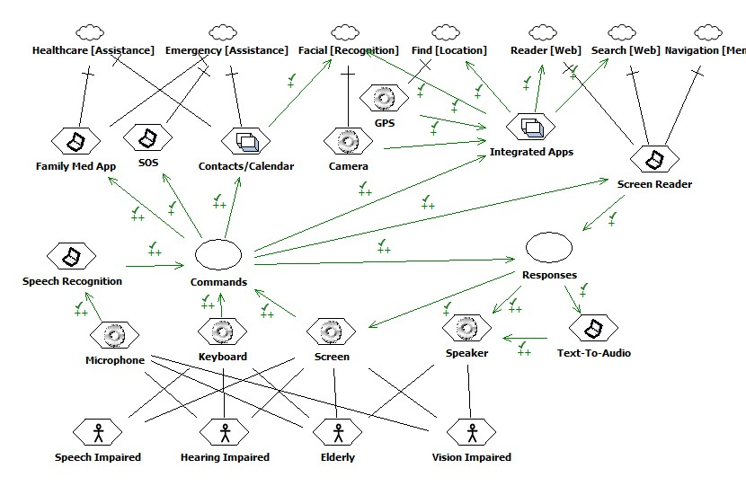

Fig. 1 – Problem Domain Model

Competition and Alternatives

- For voice command: both Apple and Google have some capabilities, although functionalities are restricted to what is built into the product. These products are not capable of integrating with other apps outside of itself, and their availability is limited to certain high-end models only.

- Individual standalone apps for various needs do exist. For examples: Medical Cabinet, Reminder, Calendar, etc. etc. However, none of these apps can integrate with another, thus the user is faced with multiple interfaces and multiple steps to accomplish what HELPeople can provide.

- Some Text to Speech apps today can perform basic reading functionalities but they cannot read web pages like screen readers can on the PC. Thus for those with eye impairments, a mobile solution for web surfing is out of the question, at least until something similar to HELPeople becomes available.

- An alternative solution to building HELPeople from scratch is to partner with a company such as Apple’s Siri division to incorporate these ideas into a well-established platform and take that product to the next level. The downside is that doing so could prevent users on other platforms from buying and using the product.

Product Overview
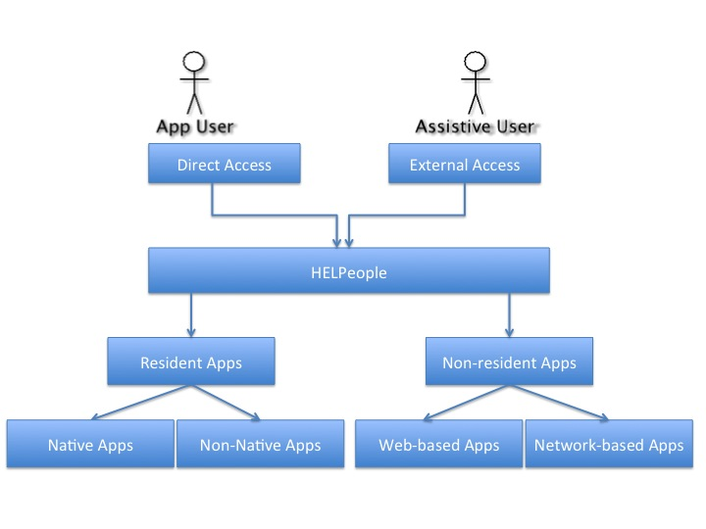
Application User is the person who is using the product via his phone. Assistive User is the person who can help application user in case s/he needs any help. In our application, the idea is to give external access to authorized user(s) so that they can have access to add reminder for a meeting or medication to application user’s calendar so that he will not miss his meetings or any of his medications. Assistive user can set the reminder either by sending a text message or access via web interface to the application.

Product Perspective

HELPeople product intends to give the user various options and to help them manage their daily tasks more conveniently. Apart from some Native applications which have been developed specifically for this product, it will give other options to the user to use other external applications. Certain applications which user already has in his phone can also be integrated with this product, which will give the user easy access to other installed applications from one single HELPeople User Interface. Also there would be a possibility for some other external applications to integrate within HELPeople product if desired, like web-based music application or online TV/Radio applications.

Applications in HELPeople product can be categorized as below:
- Resident Apps: applications which resides in the product
  - Native: Developed for this product
  - Non-Native: Not developed for this product which can either:
    - Integrated – can communicate with this product via an API
    - Standalone – is not integrated with this product at all

- Non-Resident Apps: external apps not resides in the product
  - Web-based: e.g. online TV/Radio applications
  - Network-based: e.g. Teleconferencing

Although the product is totally self-contained, it provides an API to integrate with other apps, whether they are apps already installed on the phone or external apps available in the market.

Summary of Capabilities

User Benefit | Supporting Features
Users who are suffering from any disabilities such as visual impairment, hearing impairment, speech impairment, or who are suffering form memory loss can do daily activities easier. | Different input/output methods such as voice, visual and text would be available to choose from according to their desire.
Easy access to most used applications or favorite ones. | Dedicated “H” Button would visible in all screens of the product all time.
Set the configuration according to their desire. | Additional to product setting, user settings also would be available in configuration section to change them to their favor.
Add desired applications or remove unwanted apps. | Manage applications section will give the power to user to add/remove non-native apps or disable/enable native apps.
Users who suffer from memory loss can store pictures associated to family or friends. | “Family Tree” application will give the user the ability to save pictures of his family member or friends together with contact info, relation.
If the user cannot remember the place he parked or need to go back to any place which he visited before but he can’t remember then he can use this product | “Back Track” application will store the previous locations together with assigned picture to the places so user can use them via GPS to find their way.
User can store medical information for his own or family members to have a complete history | “Medical Cabinet” application can store medical information like medications, user’s operations together in one place.
Reminder for medication, meetings or other activities which user might forget about them. | Reminder in Calendar will give the possibility to user to set them as he desire to remind him about daily activities. User can add the reminder himself or any authorized user can add them on his behalf.
Handle emergency situations more easily via various options. | “Emergency” section will give the user opportunity to easily call 911 and send text or call to 2 predefined numbers.
Visually impaired user can surf the web. | “Web Reader” is available in the product to help users who are suffering from sight impairment to be able to surf the web
Visually impaired user can communicate via speech to the product | “iTalk” application will convert speech to text.
Mute user can communicate via text and product will convert it to voice | “iTalk” application will convert text to speech.
User can recognize faces or objects by taking a picture from them. | “Recognition” application will help the user to take a picture from any object or family/friends so that it can match the faces with already exist photos in his contact list or search the web to find the object.
User can keep track of his meal and nutrition information about the foods he eats | “Wellness” Center will give the information about nutrition facts of each food and keep the records regarding user’s meal

Assumptions and Dependencies

- The default language for HELPeople would be US English. It is assumed that the user is able to communicate in English.

- It’s assumed that the network would be available on users handset so they can use network-based applications such as SMS and call.

- It’s assumed that the user is able to work with basic functionalities of a smart phone; such as: unlock phone, turn on/off the handset, launch the application, send SMS etc.

- It’s assumed that the product shall support Apple iOS and Android initially. Later on it can be extended to support other operation systems if needed.

- It’s assumed that in emergency cases user would be able to use his/her phone to call 911.

- It’s assumed that the handset has adequate facilities used by HELPeople application such as Camera, GPS, Microphone, Speaker, Touchscreen and Virtual keyboard.

Cost and Pricing

There is a free “lite” version and a paid “premium” version of the app. Some people will only use the free version, but others can spend more to buy extra features.

In order to make the product affordable for wider audiences this product would be a “Freemium” application, which means that the initial software would be free but the users can spend their money on in-app purchases. Native applications would be included in the initial free version of the product, with a limited set of functional features. Integration with other non-native applications which are not part of HELPeople will be a premium feature.

Licensing and Installation

HELPeople product would be in the category of “Consumer applications” which would be coded for personal use. Consumer applications for mobile devices are small applications developed by individual customers or small businesses. Licensing for consumer applications is less demanding than licensing for other applications, but still has to be flexible, easy to use and affordable to end users.

Among various licensing models, we chose the “Shrink-wrapped package”. In this model, “License Agreement” is accepted either by unwrapping the product or by digitally checking the “Accept” checkbox. The customer has unlimited lifetime usage of the software under the terms in the license agreement, usually limited to a fixed number of devices the software can be installed on.

For installation phase it should take into consideration that the code should have the ability to split by installing native or non-native applications. If the user selects to install the native languages and paid for non-native applications integration then the product should install both, but if he chose no pay then only native applications should installed in the handset.

Product Features
The followings are general system features

Start application
Users can run the application from a system icon that is placed in their device after HELPeople is installed.
5.1.1- View initial screen
Users can view the initial screen immediately after they have selected to run the application.

Execute touch screen input
Users can execute commands by using the touch screen input option.

Execute voice input
Users can execute commands by using the voice commander input option.

Execute text input
Users can execute commands by using the text commander input option.

Show content
Users can see the content of the screen that they have selected.
5.5.1- Speak content
(If selected) Users can hear the content of the screen that they have selected.

Show current time
Users can check the current time while they are using the application (This feature could be underestimated only for the home screen).

Show weather condition
Users can check in their home screen their local weather conditions.

Change frequency of weather updates
Users can change the frequency that the weather panel gets updates from the internet for their current location.

Change date/time
Users can change date/time in situations where they have no data or internet coverage.

Show system updates alert
Users can get alerts for system updates with the content of changes.

Accept system updates
Users can accept system updates after they have been notified by the system.

Deny system updates
Users can deny system updates after they have been notified by the system.

Shows an easy-accessible audio commander button
Users can have an all time button to access the audio commander.
5.13.1 (If adequate profile is selected) Shows an easy-accessible text commander button
Users can have an all time button to access the text commander.

Shows Favorite applications
Users can fast access the applications that they mostly use

Change security
Users can change the security level of their application.

Change alert sounds
Users can select the proper ringtone to notify them for specific actions.
5.16.1 Change alert volume
Users can select the proper volume of the ringtone that will notify them for a specific action

Switch from list-to-icon menus and vice versa
Users can select how they want to view their folder menus.

Customize folder’s content
Users can arrange the main folder's content in a way that is more appropriate for them by dragging and dropping applications.

Sort by different logic categories contents
Users can sort (by name / most used / last used) the applications that are into a certain folder.

The following relate to communication features

Translate Text-to-Speech
Users can type the text and the system needs to translate it in an audio message.

Translate Speech-to-Text
Users can record an audio message and the system needs to translate it in a text message.

Provide visual feedback after getting commands
Users can check if the command that they have executed is appropriately performed.
5.22.1- Provide audio feedback after getting commands
(If selected) Users can hear if the command that they have asked is appropriately performed.

Turn on Screen Reader
5.23.1- Turn off Screen Reader

Turn on Voice Input
5.24.1- Turn off Voice Input

Turn on Response Back
5.25.1- Turn off Response Back

The following features are related with connection channels

Connect to a network
Users can call/receive phone calls, send/receive SMS, MMS and e-mails.

Connects to the internet
Users can get different network information by using a data plan or Wi-Fi connection.
5.27.1 Get updates from the internet
Users can receive notifications that keep them up to date.

Communicate with some other phone installed applications
Users can use HELPeople features with some other applications that are already in their phone and are integrated with our application system.

The following features relate to the customization of the application features to user needs.

Provide predefined user profiles

Modify a user profile

Create new customized user profiles

The following features relate to placing a emergency call.

Place emergency call to 911

Place emergency call to their doctor
5.33.1 Send an emergency text message to their doctor

Place emergency call to a selected emergency assistant
5.34.1 Send an emergency text message to a selected emergency assistant

Modify doctor and emergency assistant contacts

Constraints

Responsiveness

- Emergency call should be available by no more than 2 clicks
- Any interaction within the product should not take more than 100 ms to respond

User Interface Usability

- Screen icons and pictures should have no more than 7-8 colors
- No more than 6 categories in each screen
- Setting, “H” button, Emergency access, Command and Home button should be available in all screens
- Applications should categorize into groups in meaningful manner so that the user can understand and easily find the group of the application s/he is looking for
- Command button should place in an easy access place so users who are visually impaired can use it

Security

- The HELPeople product incorporates Data Access Control by keeping sensitive data encrypted.
- The HELPeople product incorporates Integrity by assuring accuracy of presented information by updating frequently.
- The HELPeople product incorporates Authentication by requiring a password to log in before displaying medical or personal information.

Quality Ranges

- All output responses should be no more than 1000 ms
- The icons representing categories should be large enough so that elderly users can recognize and understand them easily
- No more than 7-8 colors should used in designing the product user interface
- Emergency situations should be handled by minimum 2 clicks in the product
- Voice outputs should be clear and loud enough so that user can understand them clearly
- Recognition application should be accurate to distinguish the proper faces/objects

Precedence and Priority

The features defined in the vision document will be provided in the first release. Considerations for supporting other Smartphone OS platforms will be taken for a second release. Also, real-time online support for users will be considered in a next phase.

Other Product Requirements

Application Requirements

- Mobile handset must have Apple iOS or Android OS
- Product should occupy no more than 5MB space
- Each application should be represented by a simple icon that resembles its functionality
- Each application should be accompanied by a text name that describe its function

System Requirements

- Mobile should provide a Camera, GPS, Microphone, Speaker and vibration
- Mobile phone should have large screen so that it can show the icons of the product in each screen properly
- Mobile handset should provide enough space for installing the product

Performance Requirements

- The audio output should be without noise interfere and clear enough to understand
- The audio output response should not take more than 1 sec
- Speech to text converter should generate the output no more than 2 seconds after user stopped talking
- Speech to text converter should identify the words spoken by the user at least 90% of the time
- Face or object detection should recognize the object with 99% accuracy most of the time
- The fonts of the application should be customizable between 12 to 30 according to user’s desire
- The system should be able to detect words spoken by the user at 60 dB which is “Moderate hearing loss” threshold
- Camera resolution should not be less than 1 MP
- Screen reader should read within 2 seconds when any icon has pressed
- Emergency calls should establish within 10 seconds

Documentation Requirements

User Manual
A user manual will be provided for this application. The user manual could be found in our company website and each user can download it from any device that supports internet browsing and Adobe Reader. The link to download Adobe Reader is provided in our website. Please see the HELPeople User Manual document for more information.

Online Help
After launching our application in the market, we will provide online help support to assist the users. At first, we will provide e-mail support. By the time that a considerable amount of users are going to use our application, we will consider offering real-time support from our website or directly from our application.

Appendix - Use case Specification

Glossary
User: All Type of users
Help User: elder people with “Help Profile”
A User: Visually impaired user with “Audio Profile”
V User: Mute user with “Visual Profile”
T User: User with hearing difficulties using “Touch Profile”
O User: User with hearing and speak difficulties using “Only Visual User”
Assistive User: Any user than will help the main user of the system

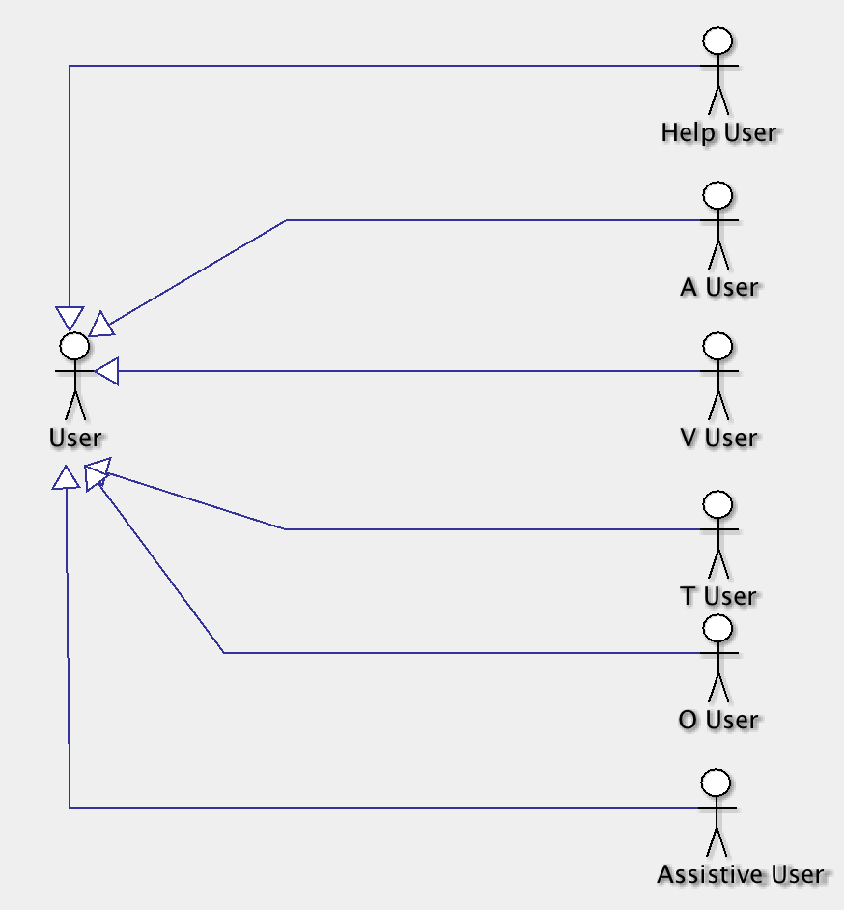

Usecase 1: Select User Profile

Description:
There are 5 categories of predefined user profiles in the product, which users can choose according to their need. And also there is a profile name “Customize Profile” in which the user can customized the settings according to his/her need. Each of them has default settings, which it will define how the user can interact with the system.
The profiles are as below:
- Help Profile
- Audio Profile
- Visual Profile
- Touch Profile
- Only visual Profile
- Customize profile
Actors:
User
Prerequisite:
HELPeople is installed in user’s phone and is running.
Case Flow:
- User select “Setting” from main menu
- User selects one of the profiles, e.g. “Audio Profile”
- Voice commander would be available for this user in all screens of the application and user can interact with the system via voice instead of touch
- Web reader and screen reader would be available for the user

Diagram 1:
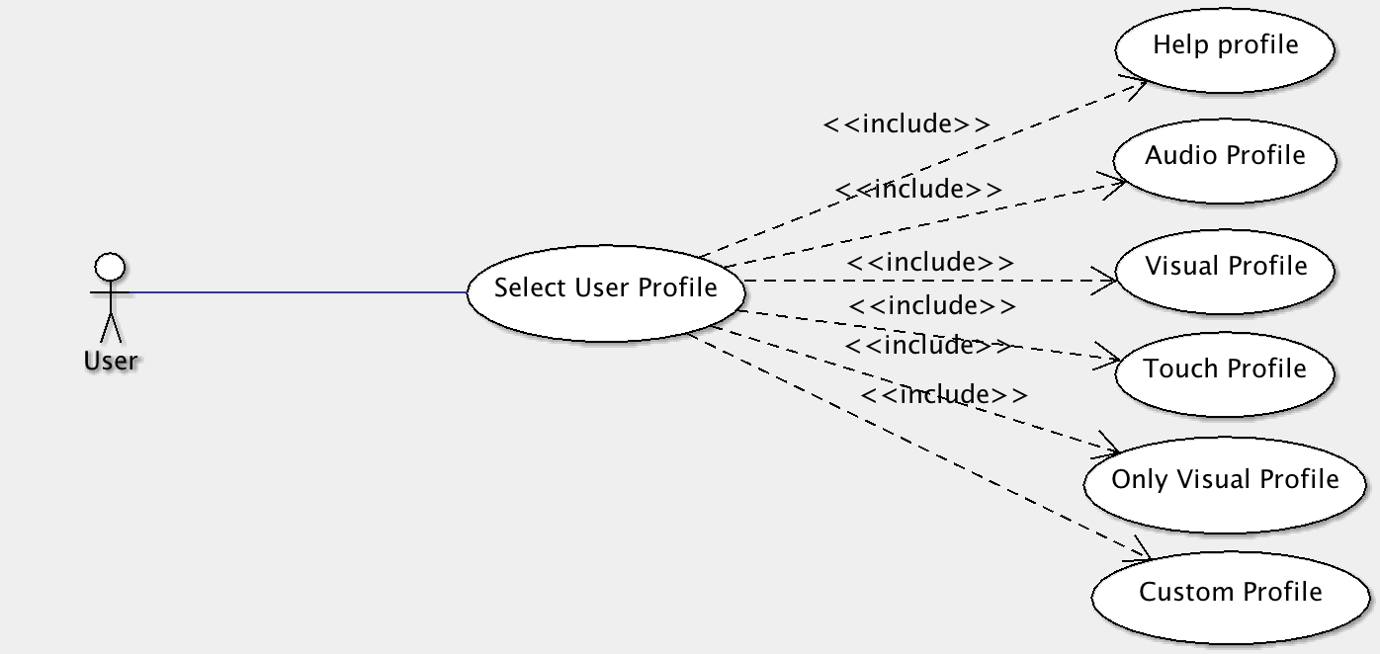

Usecase 2: Add a contact

Description:
This usecase will show how the user whose profile is “Audio Profile” can add a contact to his/her list using voice command. Any other user who chooses voice command input can use voice commands to add contacts to the phone list.

Actors:
A User
Help User

Prerequisite:
- HELPeople is installed in user’s phone and is running
- User’s profile is “Audio Profile” or customize profile activated audio command

Case Flow:
- User click Voice commander icon in any screen of the product
- User says “Add New Contact”
- User will hear a response back “Add new Contact”
- User says “Name: xxx” (the name)
- User says “ Phone: xxx” (the number) or any other additional information
- User says “Save”
- If the contact already exists the system will prompt “Already exists, do you want to overwrite?”
- If user says “YES” the new contact will be added to the contact list and if the user says “No” then it will ignore adding the new contact

Diagram 2:

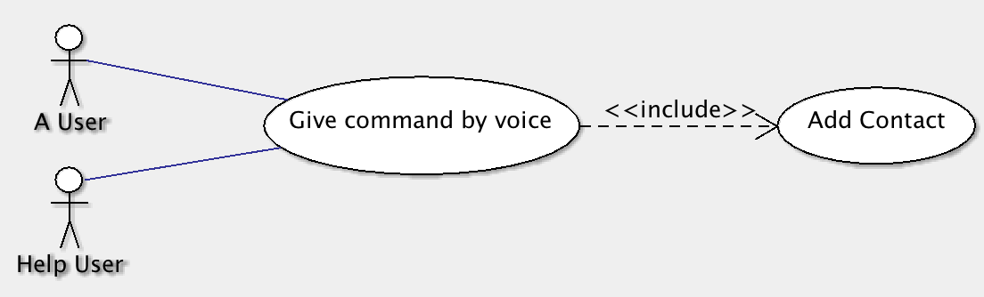

Usecase 3: Make Emergency Call

Description:
In case of emergency situation user can have verity of options to call or text using HELPeople. Users whose profiles are based on audio commands can access the emergency section via voice, other users can access by clicking “Lifebuoy” icon available in all screens of the application.
Actors:
A User, Help User, V User, T User, O User
Prerequisite:
- HELPeople is installed in user’s phone and is running
- User selected the proper user profile according to his/her difficulties
- Define 2 contact numbers for emergency situations

Case Flow:
- “A User” and “Help User” which they can give command need to click on “audio commander” button and say “Emergency”
- The system will respond back by voice telling the options ”Emergency: call 911, call doctor/friend name, Text to family member/friend”
- User can choose either of the options or both calling and sending text.
- The same situation is available for users who can handle the situations by clicking the emergency icon. They have 3 options: confirm calling 911 by clicking YES/No button, or call/text a family member or friend.

Diagram 3:
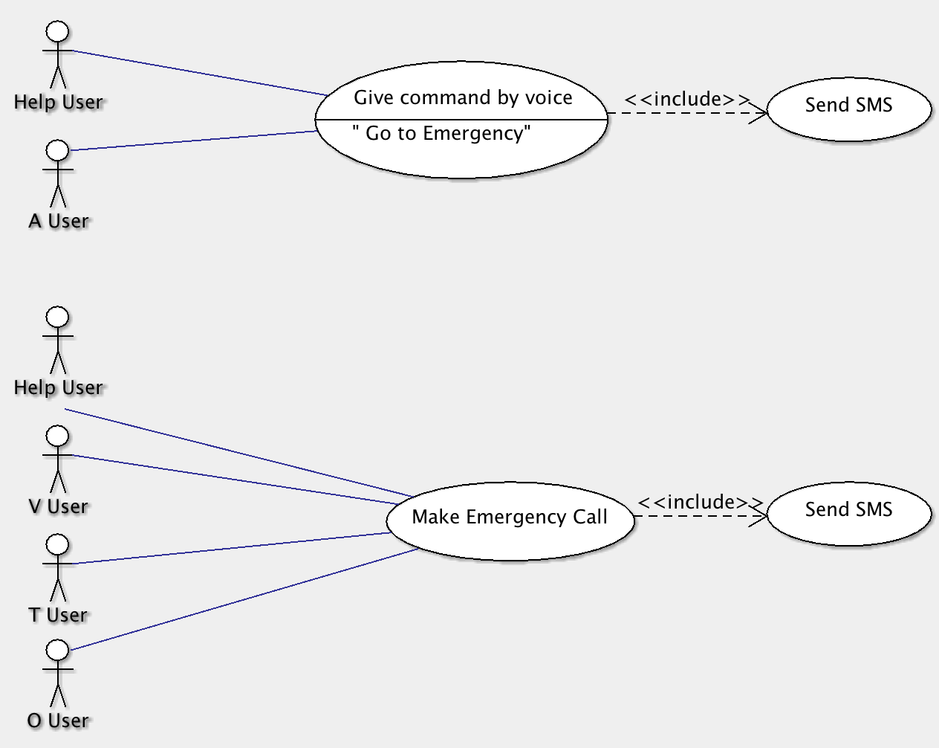

Usecase 4: Select favorite/bookmark applications
- “H” menu

Usecase 5: Listen to broadcasting in the air
- V User

Usecase 6: Change the settings
- Sort
- Screen reader
- Customize
- Voice input
- Response back

Usecase 7: Store pictures and information of family members

Usecase 8:Retrieve a picture and information of family members

Usecase 9: Access Medical information

Usecase 10: Add reminder to Calendar
- Assistive User
- User

Usecase 11: Find foods nutritional information

Usecase 12: Listen to Music
- A User
- V User
- Help User

Usecase 13: Play Games
- Help User
- V User
- T User
- O User

Usecase 14: Record a video

Usecase 15: Surf the web
- A User
- Help User

Usecase 16: Find previous Location(s)

Usecase 17: Recognize person/object

SIG Diagrams and Domain Model

Diagram 1: Ease of Use

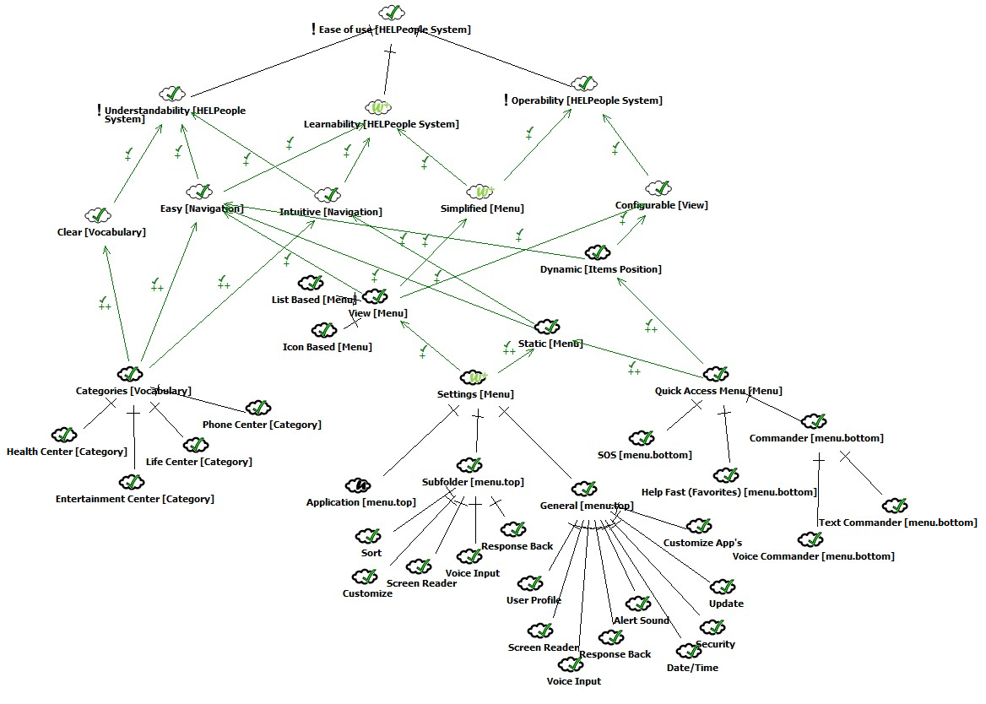

Diagram 2: User Profiles

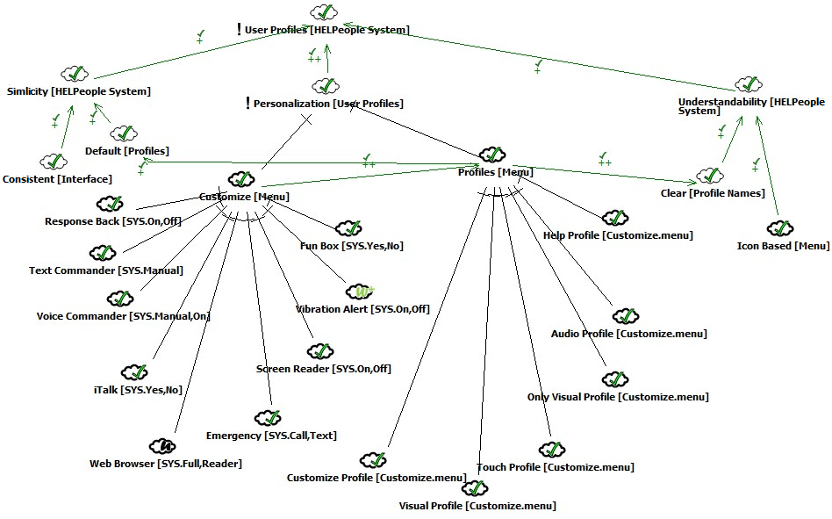

Diagram 3: SOS

