intelliTrac
http://www.wix.com/ayazhayder/intellitrac

Date: 5/19/12
Team Members:
Benji Boban
Aagbara Kpea
Muhammad Ayaz Shaikh
Shilpa Siddavvanahally
Table of Contents

1.0 Introduction 2
2.0 Issues with Preliminary Definition Given 2
2.1 Changes to Preliminary Definitions 3
2.2 Customer Domain Requirement Issues
2.3 Functional Requirements 5
2.4 Non-Functional Requirements 8

3.0 WRS 12
3.1 W 12
3.2 RS 12

4.0 Prototype and User Manual 12
4.1Prototype 12
4.2 Functional Process Model - Requirements Process - State Chart 12
4.3 Functional Process Model - Requirements Process - Use Case Diagram 13
4.4 Non-Functional Process Model - Self Review Process - KAOS Model Diagram 13

5.0 Traceability 14
5.1 Domain “W” Traceability 14
5.2 Functional RS Traceability 14
5.3 Non-Functional RS Traceability 17
6.0 Creep Rate 19
7.0 Why Team Power Droid 19
Reference 19
Appendix 19

1.0 Introduction

Software Overview

Technicians in the Smartphone age are forever wishing to bring the simplification and multitasking capabilities they encounter in their private lives into their hectic, disorganized life of technician house calls. In the industry, there are many ticket management software programs available to assign, queue, annotate, and close the tickets (work items) for the technicians. The problem with many of these programs is the need for access to the main network on which the queue database runs and the cumbersome methods of entering the details of the work done (before, during, or after the visit) into the system.

This program is intended to allow the technician to utilize his/her Smartphone to manage a ticket, including the scheduling, location, annotation, and the emailing abilities. The purpose is to allow the technician a handy application which will provide assistance during the lifecycle of a service ticket.

Version | Work Done
.10 | Creation of Document
.20 | Initial Review of Functional Requirements
.30 | Preliminary Requirements Review
.40 | Preliminary Definition Change
.50 | Updated Process State Chart Diagram and added Justification
.60 | Document updated-section 3

Version History

Issues with Preliminary Definition Given

Changes to Preliminary Definition

Every Menu Item should be 3 clicks away to ensure the technician can quickly navigate

In order to prove the completion of a ticket especially if the customer is not present, some technician would like the ability to record a video and attach to the summary.

Customer Domain Requirement Issues

DR1 Smartphone with Android Platform with data/web capabilities

Android Platform?
Issue: Domain independent of the Android OS revision?
Proposal 1: We should start with Android 2.3 (Gingerbread) and above
Proposal 2: Whichever OS supports GPS interaction.
Resolution: We will start at Android 2.3

Data/Web Capabilities
Issue: Should we define the amount of the data plan required
Proposal 1: All data is stored offline, and once job is complete will be uploaded.
Proposal 2: The data plan amount is not relevant to the functionality of the application.
Proposal 3: Whether the user has a data plan or not is irrelevant. He needs to be able to connect to the internet whether data or wifi connection.
Resolution: Since the data is stored offline, the data plan capability is up to the user, therefore DR1 should be reworded to state access to internet as opposed to data/web capabilities.

DR1 Smartphone with Android Platform with the ability to access the internet.

DR2 Calendar application is an application that has the ability to store events names, dates and/or time of occurrence in the smart phone memory and also has the ability to notify the smartphone user via sound or vibration.

Is the Calendar a necessary part of the domain?
Issue: The application is a calendar, does it need access to the Smartphone (maybe personal) calendar on the phone?
Proposal 1: Yes it should to resolve timing conflicts
Proposal 2: No, for privacy concerns it should not.
Resolution: Strike DR2 from the domain.

DR3 GPS is a program that provides location and time information in all weather, anywhere and helps to determine one’s input destination using the satellite navigation system.
Issues: GPS a program?
Proposal 1: No, it is functionality of the phone.
Proposal 2: We should reword this domain to be GPS application of the phone.
Issue: Reword DR3 from ambiguous definition of capabilities.
Proposal 1: GPS tells our current location and directs us to the destination.
Resolution: DR3: GPS application of the phone tracks our current location and has the ability to guide to the required destination.

DR4 Technician is the owner of the smartphone and is the operator charged with completing the task of the ticket.
Issues: Technician the owner?
Proposal 1: Technician is the user not the owner. It is because the company can be the user of the phone.
Resolution: DR4: Technician is the user of the smartphone and is the operator charged with completing the task of the ticket.

DR5 Ticket is the electronic compilation of a work item for a technician. It contains the following:
    - Problem –initial, service
    - Telephone number - initial
    - Address - initial
    - Date/Time of call - initial
    - Hardware/software required – initial, service
    - Date/Time of service(s) scheduled – initial, service
    - Hardware/software purchased - service
    - Time spent on the service -service
    - Distance calculation –service
    - Notes – initial, service
Issue: No Customer differentiation information field is recorded in the ticket?
Proposal 1: Yes most tickets contain the customer/organization name.
Resolution: include the Customer name in the list in DR5.
Issue: The Cost of service field is not in DR5.
Proposal 1: Include a cost of service filed in the list in DR5.
Resolution: Include a cost of service filed in the list in DR5.

DR6 A Customer is the person/establishment receiving the services of the technician.

DR3 Camera is a hardware device mounted on the phone, providing the capability for camera and video capture and recording.

Functional Requirements

Upon initial phone call, ticket information from DR5 shall be stored.

Issues: Should there be other means of communications?
Proposal 1: The technician should be able to enter ticket information after receiving emails or texts.
Issues: when is the ticket information entered?
Proposal 1: This should be a separate functional requirement.
Proposal 2: Should it be a requirement the phone has a hands free method?
Resolution: Create 1 domain requirement for Proposal 2 and 1 Functional Requirement for Proposal 1.

The application shall interact with the native phone calendar application for time availability

Issues: Native Phone application
Proposal 1: This has been struck from the requirements; see DR2.

There shall be an Application alarm to alert the technician of the coming job.

The application shall interact with the calendar to offer snooze, reset, reschedule, or initiate travel.
Issue: Reference to the calendar
Proposal 1: Remove Reference to the calendar
Proposal 2: Replace calendar with stand alone calendar
Resolution: The application is a calendar, therefore we do not state stand alone calendar.
Issue: Reset and Reschedule are synonymous
Proposal 1: Remove “reset”
Resolution: Remove Reset.

There shall be the ability to interact with the GPS of the phone for directions.

The application shall calculate the mileage driven via the GPS function of the phone or shall give the technician the ability to enter current location.
Issue: The options GPS versus entry are non-functional requirements
Proposal 1: remove reference to the GPS function and the ability to enter current location.
Proposal 2: The application then needs an ability to receive current location once the “start” soft button has been activated.
Resolution: Reword 2.2.6: The application shall calculate the mileage driven.

The application shall provide an option to select destination arrived.

Issue: It should not be an option.
Proposal 1: This is unclear. When the “start” soft button is pressed, the application should have a functionality waiting for “arrived”
Proposal 2: All other functionality of the application with respect to that particular ticket shall be suspended until the “arrive” soft button is clicked.
Resolution: 2.2.7 The Application shall provide a soft button with “arrived” with respect to a particular ticket once the “start” soft button has been pressed.

The application will provide functionality to “start calculating work service time” via a soft button – Choose “yes or no” option

Issue : When does this functionality appear?

Proposal 1: This functionality should appear after the “arrived” soft button has been pressed.

Resolution : This functionality should appear after the “arrived” soft button has been pressed.

The application will allow the user to take notes, record pictures of items purchased, record receipts from hardware/software purchased.

The application will provide functionality to “stop work service time” via a soft button – Choose “yes or no” option

Issue : When does this functionality appear?
Proposal 1: This functionality should appear after the “start work” soft button has been pressed.
Resolution : This functionality should appear after the “start work” soft button has been pressed.

The application shall pop up with completed ticket summary once the stop work service time softbutton is selected
Issue: This does not integrate with the workflow for internet access for calculation

There shall be an ability to receive a signature from a customer once a service has been completed.

There shall be an ability to email the completed ticket.

The Software shall not be required to interact with other software programs, such as ticket management programs and or schedulers.
Issue: Ticket Management programs and or schedulers is a vague statement
Proposal 1: Strike that wording from the Requirement.
Resolution: The wording is now as follows: “The Software shall not be required to interact with other software programs.

The Application shall provide memory allocation for Photo/video storage

The application shall allow the user to record videos in addition to the other medium specified in the requirement 2.3.9

Non-Functional Requirements

Service charges and required hardware/software costs to be purchased will be negotiated with the customer on receipt of ticket.
Issue: Wording on Receipt of ticket
Proposal 1: Re-word to state in the “during the initial creation of the ticket”
Resolution 2.3.2 Service charges and required hardware/software costs to be purchased will be negotiated with the customer during the initial creation of the ticket.

Schedule for service shall be negotiated and entered with the customer on receipt of ticket
Issue: Wording on Reciept of ticket
Proposal 1: Re-word to state in the “during the initial creation of the ticket”
Resolution 2.3.1 Schedule for service shall be negotiated and entered with the customer during the initial creation of the ticket.

It should allow for a calendar view or outline view
Issue: “It” is too vague
Proposal 1: Re-word to state “The Application”
Resolution 2.3.3 The application should allow for a calendar view or outline view

Alarm is set in the calendar of the app

The application alarm has option to snooze, reschedule job, or initiate travel
Issue: What does this mean?
Proposal 1: It means the alarm should present options.
Proposal 2: Should we state soft buttons?
Resolution: We should leave the software engineers to do it however they wish.

The information of the GPS functionality of the phone will be used to direct the technician to the site. This information will also send the mileage data back to the application
Issue1: the information of the GPS functionality, what does it mean?
Issue 2: “This Information” is not clear
Proposal1: Re-state “GPS functionality of the phone will be used to direct”
Proposal 2: app will also provide the mileage data.
Resolution: This functionality should appear after you click “Initiate travel”.

There should be option to calculate from an entered location
Proposal: The application needs an ability to receive current location once the start soft button has been activated.

The Application is a stand alone; it does not interface with other ticket software

Tickets can be created on the phone (i.e. enter information via phone keypad) onto the phone

Tickets can be received via email on the phone – please delete

Issue: chances of missing emails

Proposal 1: This requirement should be deleted from the non-functional requirements document

Resolution 2.311: shall be completely deleted from the non -functional requirements document.

Tickets can be receive text message

Issue: Text messages may not be secured
Proposal 1: This is requirement should be deleted since tickets may contain corporate information
Resolution 2.3.11: The NFR 2.3.11 shall be completely deleted from the non-functional requirements of the app document

Integrated with a calendar scheduler for a later date and time.

Issue: App does not need to access personal calendar schedule?

Proposal 1: Since app will have its stand-alone calendar, the NFR 2.3.12 should be deleted

Resolution: The NFR 2.3.12 shall be completely deleted from the non-functional requirements of the application document

The ability to edit the customer information, e.g. Name, Address, Phone, Email ID etc.
Issue: What? Is it app or technician?
Proposal: Reword it
Resolution 2.3.14: The application shall enable the service technician to edit all of customer information at any time.

The ability to create self tailored alarm with respect to the scheduled time.
Issue: What does “self tailored alarm” mean?
Proposal 1: Remove from requirement. It contradicts with NFR 2.3.4
Resolution: NFR 2.3.15 shall be removed from the non-functional requirement of the application document

Have the ability to postpone the scheduled service ticket via snooze mechanism.

Issue: Is this not the same as NFR 2.3.5?
Proposal: Delete from requirements
Resolution: This item shall be deleted from the non-functional requirements of the application document

Have the ability to postpone the scheduled service ticket via snooze mechanism.
Issue: When to postpone?
Proposal: Postpone when alarm reminds you about the ticket.
Resolution: When alarm reminds you about the coming up ticket, at that time it should also have the ability to postpone the scheduled service ticket.

Will provide note taking capabilities when the customer site destination is reached.

Will have the ability to attach pictures of receipts, or other work related objects.

Issue: where the attach pictures will go?

Proposal: with the summary and in the email

Resolution: Will have the ability to take pictures of receipts or other work related objects then attach it in the summary and in the emails.

The Application will provide the ability to revisit work areas with respect to the service tickets.
Issue: What does revisit means?
Proposal: Revisit can be taken as physically revisiting the customer site. We should use review and getting feedback from customer.
Resolution: When the ticket is completed and marked as closed, then there should be a ability to retrieve the summary of the ticket and enter customer’s feedback.

The Application will provide the option of emailing the completion report to different email ids for e.g. to customer, your manager, yourself, etc.
Issue: If we need to send the ticket to more than default number of peoples?
Proposal: there should be a soft button: “Add email ids”.
Resolution: Will provide the option of emailing the completion report to different email ids for e.g. to customer, your manager, yourself, etc. There will be a soft button “Add another email address” which will help you to enter more email ids.

Every Menu item should be 3 clicks away.
Issue: Is this the main menu items or any option? It is not clear
Proposal: State every Main Menu Item
Resolution: Every Main Menu item should be 3 clicks away.

WRS

W

Problem

The problem of Keeping pace with the complex and cumbersome method of scheduling and entering work to do and work done in the systems affect Technicians house call overall job capability and mobile businesses.
The impact of which is that they are unable to schedule, follow up, maintained an assigned job order without wasting significant time needed to do the job or other assigned duties as appropriate.

Goal

Our goal is to enable mobile service technicians utilize their Smartphone to manage a job order ticket. This includes but not limited to scheduling, locating, annotation, and the emailing capabilities.
We intend to give the technician a handy application which will provide assistance during the lifecycle of a service ticket.

Prototype and User Manual

Prototype – See InteliTrac.ppt

Functional Process Model - Requirements Process - State Chart 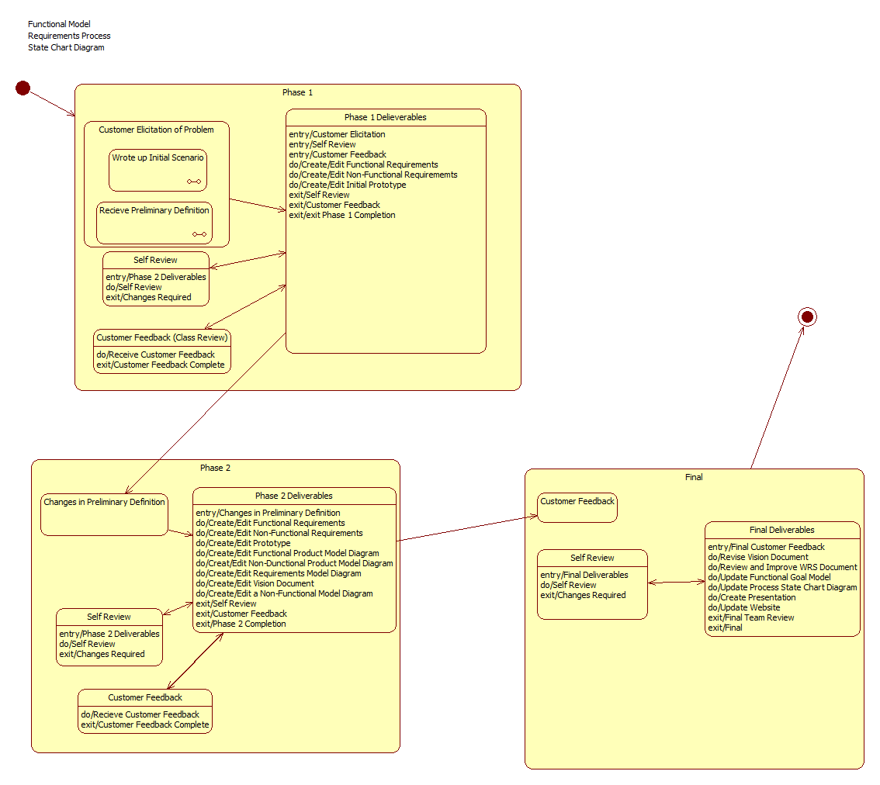

Functional Process Model - Requirements Process – Use Case Diagram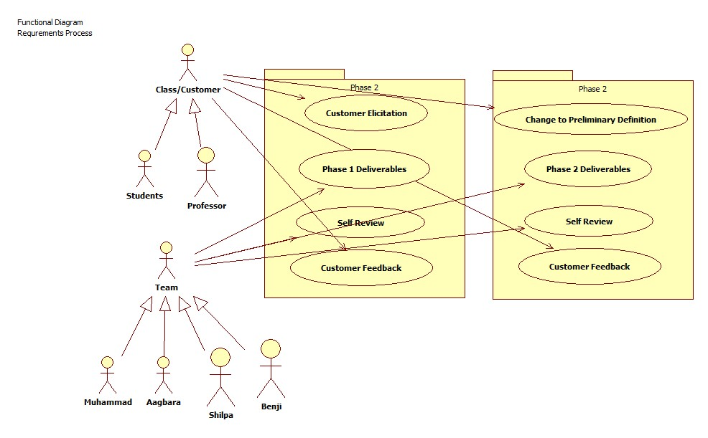

Non-Functional Process Model – Self Review – KAOS Model Diagram

See “InteliTrac.ppt”

Traceability

Domain “W” Traceability
S.NO | Requirements Specification | Forward Traceability
DR1 | Smartphone with Android Platform 2.3 or higher with data/web capabilities | N/A
DR2 | Smartphone with Android Platform with the ability to access the internet | Prototype Page 1, Top of Screen
DR3 | GPS is a program that provides location and time information in all weather, anywhere and helps to determine one’s input destination using the satellite navigation system. | Prototype Page 16
DR4 | Technician is the user of the Smartphone and is the operator charged with completing the task of the ticket. | N/A
DR5 | Ticket is the electronic compilation of a work item for a technician | Prototype Page 4-7
DR6 | A Customer is the person/establishment receiving the services of the technician. | Prototype Page 4

Domain “RS” Traceability

S.NO | Requirements Specification | Forward Traceability
FRS1 | Upon initial phone call, ticket information from DR5 shall be stored. | Prototype Page 6
FRS 2 | The application shall interact with the native phone calendar application for time availability | Struck from FR
FRS 3 | There shall be an Application alarm to alert the technician of the coming job. | Prototype Page 9
FRS 4 | The application shall interact with the calendar to offer snooze, reschedule, or initiate travel | Prototype Page 9
FRS 5 | There shall be the ability to interact with the GPS of the phone for directions. | Prototype Page 17
FRS 6 | The application shall calculate the mileage driven. | Prototype Page 17
FRS 7 | The Application shall provide a soft button with “arrived” with respect to a particular ticket once the “start” soft button has been pressed. | Prototype Page 18
FRS 8 | The application will provide functionality to “start calculating work service time” via a soft button – Choose “yes or no” option, after the “arrived soft button has been pressed. | Prototype Page 18
FRS 9 | The application will allow the user to take notes, record pictures of items purchased, record receipts from hardware/software purchased | Prototype Pages 19,25, and 26
FRS 10 | The application will provide functionality to “stop work service time” via a soft button – Choose “yes or no” option, after the “start” soft button has been pressed. | Prototype Page 19
FRS 11 | The application shall pop up with completed ticket summary once the stop work service time softbutton is selected | Prototype Page 20
FRS 12 | There shall be an ability to receive a signature from a customer once a service has been completed | Prototype Page 22
FRS 13 | There shall be an ability to email the completed ticket | Prototype Page 23
FRS 14 | The Software shall not be required to interact with other software programs. | N/A
FRS 15 | The Application shall provide memory allocation for Photo/video storage | N/A
FRS 16 | The application shall allow the user to record videos in addition to the other medium specified in the requirement 2.3.9 | Prototype Page 19,25,33

Domain “NFRS” Traceability

S.NO | Requirements Specification | Forward Traceability
NFRS 1 | Service charges and required hardware/software costs to be purchased will be negotiated with the customer during the initial creation of the ticket. | Prototype Page 6
NFRS 2 | Schedule for service shall be negotiated and entered with the customer during the initial creation of the ticket | Prototype Page 7
NFRS 3 | The application should allow for a calendar view or outline view | Prototype Page 27-29
NFRS 4 | Alarm is set in the calendar of the app | Prototype Page 7
NFRS 5 | The application alarm has option to snooze, reschedule job, or initiate travel | Prototype Page 11
NFRS 6 | The information of the GPS functionality of the phone will be used to direct the technician to the site. This information will also send the mileage data back to the application | Prototype Page 14,16, and 17
NFRS 7 | There should be option to calculate from an entered location | Prototype Page 15
NFRS 8 | The Application is a stand alone; it does not interface with other ticket software | None
NFRS 9 | Tickets can be created on the phone (i.e. enter information via phone keypad) onto the phone | Prototype Page 5
NFRS 10 | Tickets can be received via email on the phone – please delete | Struck from NFRS
NFRS 11 | Tickets can be receive text messages | Struck from NFRS
NFRS 12 | Integrated with a calendar scheduler for a later date and time | Struck from NFRS
NFRS 13 | The application shall enable the service technician to edit all of customer information at any time | Prototype Page 3
NFRS 14 | The ability to create self tailored alarm with respect to the scheduled time. | Struck from NFRS
NFRS 15 | Have the ability to postpone the scheduled service ticket via snooze mechanism | Struck from NFRS
NFRS 16 | Have the ability to postpone the scheduled service ticket via snooze mechanism when the alarm is initiated about a particular ticket | Prototype Page 9
NFRS 17 | Will provide note taking capabilities when the customer site destination is reached. | Prototype Page 20
NFRS 18 | Will have the ability to take pictures of receipts or other work related objects then attach it in the summary and in the emails | Prototype Page 25, 26,31,32
NFRS 19 | Even after a ticket is completed and marked as closed the Application will provide the ability to revisit work areas with respect to the service tickets. | Prototype Page 3
NFRS 20 | The Application will provide the option of emailing the completion report to different email ids for e.g. to customer, your manager, yourself, etc., There will be a soft button labeled “Add another email address” which will help you to enter more em way of ail ids | Prototype Page 23,30
NFRS 21 | Every Main Menu item should be 3 clicks away. | Prototype Page 3, etc…

Creep Rate

6.1 The Creep Rate shall be less than 25% for both Functional and Nonfunctional Requirements. The Creep Rate shall be less than 50% for the Domain Requirements, as it is not well defined.

Why Team Droid

1. IntelliTrac is exclusively made for individual technicians / client, while others need a lot of different kind of setups and system specifications.
2. IntelliTrac do not need internet connection to fetch the data, it is stand alone application running from your Smartphone and saving the data in your Smartphone.
3. Big icons within the application are designed that way so you can easily tap them and schedule tickets / tasks even when technician / client is busy in a job.
4. IntelliTrac can be used by any individual even if user doing grocery, mall shopping or any other daily routine work.
5. IntelliTrac has an integrated calendar which has different view for user’s ease.
6. IntelliTrac can create a follow-up reminder that will prompt be on a specific date and time to get back to a particular ticket.
7. Easily organize, prioritize and engage with others on support requests to ensure your customers get accurate and timely responses.
8. IntelliTrac guides you till customer’s location via GPS functionality of your own Smartphone.
9. This is made specifically to help your business grow.
10. No any Smartphone application in the market has the feature to take the signatures via your Smartphone’s touch screen and email the ticket summary right away to as many persons you want.
11. It can attach real time videos to your ticket summary as a proof for your future references.
12. Last but the greatest that it’s the best and the cheapest to help you in making you and your business big.

