Kathy Kattamanchi
6309

Term Paper Report – Amazon Fire Phone

Introduction
The Amazon’s Fire Phone (FirePhone) is a 3D-enabled smartphone designed and developed by Amazon.com. It was announced on June 18, 2014, and marks Amazon's first foray into the smartphone market, following the success of the Kindle Fire tablets running the Fire OS operating system. It was available for pre-order on the day it was announced. In the United States, it launched as an AT&T exclusive on July 25, 2014.
The phone is notable for its hallmark feature "Dynamic Perspective": using four front-facing cameras and the gyroscope to track the user's movements, the OS adjusts the UI so that it gives the impression of depth and 3D. Other notable Amazon services on the phone include X-Ray, used for identifying and finding information about media; Mayday, the 24-hour customer service tool; and Firefly, a tool that automatically recognizes text, sounds, and objects, then offering a way to buy recognized items through Amazon's online store
Amazon has not released sales figures for any of its devices, but based in part on its quickly declining prices and the announced $170 million write-down of costs associated with the phone, analysts have judged that it has not been commercially successful.

Features
- 3D enabled smart phone
- 4 front-facing cameras and the gyroscope to track the user's movements
- OS adjusts the UI so that it gives the impression of depth and 3D
  - Issues with the above features: Classifies the product to be more of an advanced camera rather than phone.
- x-ray - used for identifying and finding information
  - Users can touch a word to launch either a dictionary definition or a more in-depth explanation provided by Wikipedia.
  - X-Ray accesses pre-loaded files with relevant information, with no internet
- Mayday - 24-hour customer service tool
- Firefly - tool which lets you point the camera at everyday objects and then view that item in the Amazon online store.
  - Issues: Is this Promoting/Marketing Amazon or driving to develop better phone?

Dev cycle:
- 5 years of Development cycle
- Started on 2010, released in 2014
- Kept Secretive
  - Issues: Long development in this time and age.
  - Many reasons would contribute to this – scope creep, not proper planning.

Features that didn’t make to final product:
- Near-field communication for contactless payments
- Hands-free interactions to allow users to navigate the interface through mid-air gestures
- Force-sensitive grip that could respond in different ways to various degrees of physical pressure
  - Issues: Time spent on features that never made into final product.
  - Plan for successive versions instead.
  - Lacks marketing research and customer feedback

Micro Management of Leadership
- Jeff Bezos – CEO
- Obsessively monitored the product
- Even the smallest decisions needed to go by him
- Employees frustration over Extraneous features Dynamic Perspective
- Kept quite due to the respect they held for Jeff Bezos
  - Issues: Management should be involved at a level where they are being informed but it’s PM & R&D job to deliver.
  - Micro management from leadership sends wrong signals and frustration
Release:
- Introduced in Seattle in Fremont Theatre
- As a limited time promotion, buyers are offered a year of Amazon Prime and 1,000 Amazon coins with the purchase of a Fire Phone.
- Six weeks after the introduction of the phone to the market, its price was cut to $0.99 from $199 with a two-year contract and from $650 to $449 off contract.

Positive Reception
- Firefly and the Dynamic Perspective features to be significant differentiators

Negative Reception
- Lack of Bluetooth LE (low energy)
  - Issues: Lacks minimum features that competition is offering.
- Underdeveloped OS
  - Issues: Not futuristic product, but dates back
- High price
  - Issues: Should be affordable, should be able to take losses until desired market penetration. Not difficult for company like amazon
- Exclusivity of the device to AT&T's network.
  - Issues: Low incentives to switch carriers. Should be versatile like other phones.

Other factors:
- Little incentive to switch carriers or platforms to buy it.
- Its unique features don't provide enough utility, and come at the expense of battery life and performance
  - Issues: Battery life and performance are key factors, can’t have features at the expense of it.
- Lack of frequently used apps available on other platforms.
  - Issues: Did not meet customer’s basic expectations.
- Confusing interface, bland design, Firefly's poor accuracy
  - Buggy features & more like a prototype than a finished product
- Looked more like a prototype than a finished product

Sales
- No more than 35,000 Fire Phones sold in the first 20 days
- $170 million hit due to costs associated with the Fire Phone
- Over $83 million worth of Fire Phones in inventory
- CTO Tom Szkutak indicated that its pricing strategy being initially too high

What could have been done instead?

Define project scope
  - Phone or Camera or simply app for Amazon?
  - Plan for different releases of the product
  - Scope creep is ok as long as project deadline is not slipping

Manage the schedule tightly.
  - Not 5 years but target for 6-8 months
  - Deliver basic customer expected apps/features
  - Durable battery & performance
  - Affordable & Competitive price
  - Differentiators that fit in above schedule

Deliver as expected.
  - Can slip with in tolerance but not drastically

Exec management informed and engaged.
  - Not micro manage

Amazon is no stranger to the mobile device market but unable to materialize of it.

Problem Interdependency Graph
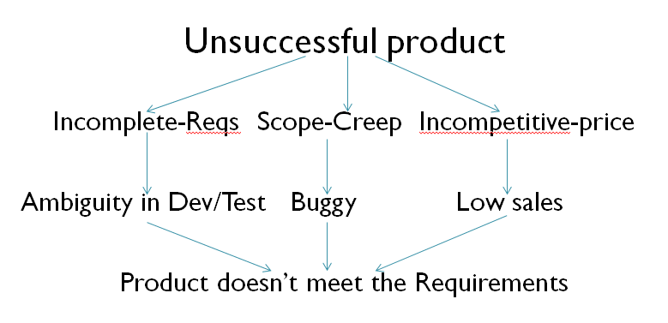

Solution Interdependency Graph
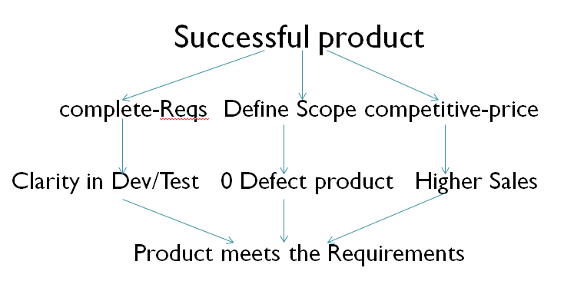

4 World Model
- Subject: Mobile Industry
- System: Hand held Mobile device
- User: Customers needing phones
- Developers: R&D Group
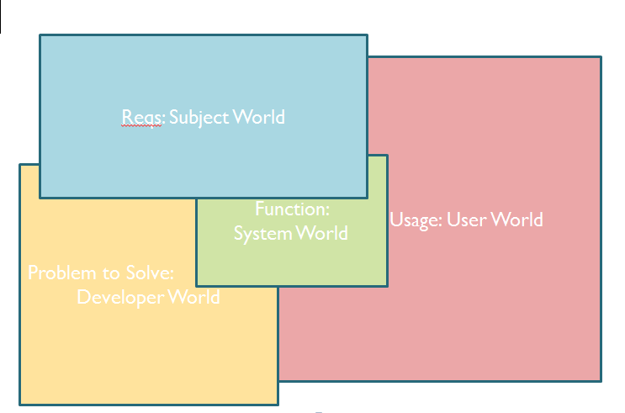

Bibliography
(n.d.). http://en.wikipedia.org/wiki/Fire_Phone.

