fxk

Faizal Khader

Fxk10730@utdallas.edu

**Missing Plane Disaster 2014 - Mitigation through adding - Accountability, Visibility & Responsibility**

**Term paper**

cxv

**The University of Texas at Dallas**

**SYSM 6309 - Spring 2015**

Table of Contents

1. Introduction 2

2. Mitigation Approaches 3

3. Stakeholders 6

4. Requirements model 7

5. Class Diagram 7

6. Worldwide Aviation Systems Domain 9

7. Commercial Aircraft Systems Domain 10

8. Problem Interdependency Graph 11

9. Soft goals Interdependency Graph 12

10. Traceability 13

11. Q & A 13

8. References 14

# Introduction

Planes are a miracle in the sky. It is the best use of physics that humans have invented since the birth of civilization.

* 2014 has seen the lowest number in more than 80 years, says the Geneva-based [Bureau of Aircraft Accidents Archives](http://www.baaa-acro.com/general-statistics/), or BAAA..2014’s number totals at 111.The last time the world had 111 crashes was in 1927. Though low in number of crashes, the number of deaths have been the highest in the last 10 years. There are more aircraft in the sky, so naturally the overall number may appear similar to previous decades and, in some categories of disaster, higher.

|  |  |
| --- | --- |
| http://i2.cdn.turner.com/cnn/dam/assets/141229063939-aviation-crashes-by-year-story-top.jpg | http://i2.cdn.turner.com/cnn/dam/assets/141229064633-aviationdeathsbyyear-story-top.jpg |

Every 10 years or so, we have a year that is less safe than others. Unfortunately 2014 was one of those. Asia has endured a particularly brutal 2014.Odds of any person boarding a flight dying in a plane crash are about 1 in 11 million.

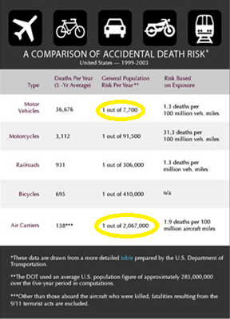

The air market in the region has embraced low-cost carriers, stretching air traffic controllers, and possibly allowing some airlines to expand too rapidly. Carriers, air traffic controllers, and specifically Indonesian airspace in general have become notorious for weak safety regulations. Pilots have been arrested for crystal meth since 2011; crystal meth is a stimulant that can be used to stay awake and alert.

# Mitigation Approaches

Each of major these incidents in 2014 of plane disasters can be helped with some improvements in the processes used, electronic technologies used and improvements in processes. Key points are discussed below.

1. **MH 370** – 8 March: The disappearance of Malaysia Airlines MH370 (a Boeing 777 plane ) during a flight from Kuala Lumpur to Beijing (94 minutes later) leads to the largest and most expensive search in aviation history over the South China Sea, Gulf of Thailand and Indian Ocean. There were 239 passengers on board the flight.
   1. Plane’s location will be transmitted every minute/or-continuous advertising using tamper resistant transmitters through the internet and satellites. This is missing in today’s aircrafts.
   2. Aircraft communications addressing and reporting system (ACARS via Inmarsat) will be mandatory and not be optional. MH 370 had no active subscription to Inmarsat, though it was transmitting its position and the transmission was getting picked up by Inmarsat satellites. These unattended handshakes happened to be the only clues available later.
   3. Technology is available for better communication and detection, but regulatory bodies are slow to implement.
   4. Emphasis has to be to implement low frequency underwater beacons – different from the existing 1960’s technology.
   5. Battery life of these beacons will provide a 90 days charge backup.
   6. Commercial flights will not be allowed to carry any inflammable cargo. (5000 pounds of lithium batteries were stored in MH 370 cargo).
   7. Pilots will not be allowed to make independent decisions without ground control approval/involvement.
   8. Ground control will be handed more responsibility to allow fly by wire auto pilot that will redirect the plan to near-by airport in the flight path, in cases of emergency.
   9. Video recorders will supplement data and voice recorders. These will have auto trigger mechanism, and also manual triggers from ground control.
   10. Cockpit always to be occupied with 2 people. This law is followed in the US aircrafts, but not practiced worldwide.
2. **MH 17** - 17 July: Malaysia Airlines flight MH17 crashes near eastern Ukraine, killing all 298 people on board, including 80 children, and 15 crew members. Pro-Russian rebels are widely accused of shooting the plane down using a surface-to-air missile - they deny responsibility.
   1. There has been evidence found later to this incident that some of the carriers had been avoiding the dangerous route, due to weapons activity in the region. The information though stayed within the siloes of each airlines. Independent decisions also were being made with in each airlines.
   2. Israel’s flag carrier, El Al, which equips its planes with sensors to detect when radars lock on to them as targets.
   3. Virtually anyone these days can check the exact location of a particular plane, including its precise height and speed. "Flight details are transmitted to the ground completely decoded”. Encryption will be enforced on all commercial aircraft related transmissions.
3. **Flight 5017** - 24 July: Air Algerie AH5017 disappears over Mali amid poor weather near the border with Burkina Faso. The McDonnell Douglas MD-83 was operated by Spain's Swiftair, and was heading from Ouagadougou to Algiers.

**ATR**-**72** - 23 July: Taiwanese flight GE222 ATR-72 plane crashes around stormy seas during a short flight. Trans Asia was carrying 54 passengers and four crew to the island of Penghu.

* 1. Microsoft Research illustrated that by combining real-time data from nearby flights, it is possible to predict the wind speed to an accuracy 10 times better than the weather simulations by supercomputers.
  2. The internet of flying things refers to the technology that is ready for adoption by agencies on the ground that want to get a bird’s-eye view of weather conditions. The basic technology is already available for less than $800: Equipping a drone or unmanned airborne vehicle with a GoPro quality camera - can equip airports to survey the neighborhood from the air.
  3. Planes are generally flown by computers – pilots manage them. It is surprising though that the computers give up in critical situations, when it is most needed. For example, auto pilots gets disabled when a plane stalls. Computers should be smart enough to start taking preventive actions, as they are sending out alerts.

1. **Air Asia QZ8501** - 28 December: AirAsia QZ8501 flying from Surabaya in Indonesia to Singapore goes missing over the Java sea with 162 lives on board. The aircraft is a Airbus A320-200 that was built in 2008. AirAsia is one of the world’s largest operators of Airbus A320 series jets.
   1. ‘Vehicle integrated prognostic reasoner’ (funded by NASA) - uses advanced data mining and machine-learning techniques to explore and analyze large amounts of flight data to derive new and useful knowledge. Human experts will then use this knowledge to improve diagnostic monitors and reasoning systems available on aircrafts.
   2. Until the time, pilots can have real assistance from computers in handling critical situations, hand flying experience such as handling the plane in a stalled situation should be part of constant practice exercise. Computer aided flying has led to pilot’s losing hand flying skills. Not everyone is a “Chesley Sullenberger.”
   3. Automatic Dependent Surveillance Broadcast, or ADS-B will be included by manufacturers. The system is designed to broadcast the airplane’s location to air-traffic controllers and to other airplanes nearby.
   4. Pilots try to climb over weather pockets, adding to the risk of an accident due to decreased safety margins and pilot inexperience in upset recovery at high altitudes and high speeds. ATC will need to take responsibility to handle these conditions in the flight path.
   5. No automation can be turned off by pilots. Fire detection and fail safe will need to be constructed into the system. Ground control will be always in control of the automation built into airplanes. Pilots cannot voluntarily perform maneuvers like climbing above or going below flight path limits. In situations of emergency, there will be a recorded flight path that will get activated for nearest point of landing. The decisions for overriding this automation will need to come from ATC.
   6. Boeing has done a research on flying by wire, but found it not practical due to the fact of an unsecure network used for transmitting data, which could be compromised easily. This has to change.
   7. Deployable recorders would assure location of the recorder with flight data and cockpit voice & video recordings within hours of a crash anywhere in the world, including remote ocean locations. Deployable recorders such as these are made by DRS Technologies, have been installed on military airplane
   8. Satellite asset tracking devices, some of which cost less than $100 to purchase and less than $150 per year in tracking service fees per asset/airplane, would allow authorities to track airliners anywhere in the world on Google Maps from a smart phone, laptop, or desktop computer.  These devices, such as the SPOT Trace from Globalstar, can be hidden inside airliners to prevent tampering, operate off battery power for weeks after losing airplane power, and work anywhere in the world

# Stakeholders

* 1. Passengers
     1. Customers
     2. Family
  2. Airlines
  3. Airports
     1. ATC
     2. Cargo Handling
  4. Equipment Manufacturers
     1. Equipment – Electronic and mechanical
     2. Engine
  5. Society
     1. Noise and pollution
     2. Economic growth
     3. Accident victims

# Requirements model

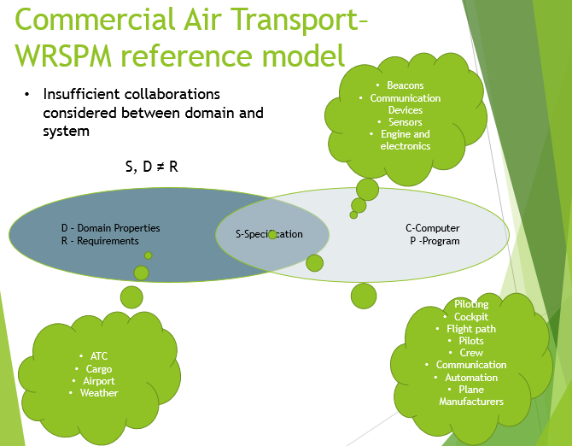

# Class Diagram

Remediation measures are the operations of the sub classes.



# Worldwide Aviation Systems Domain

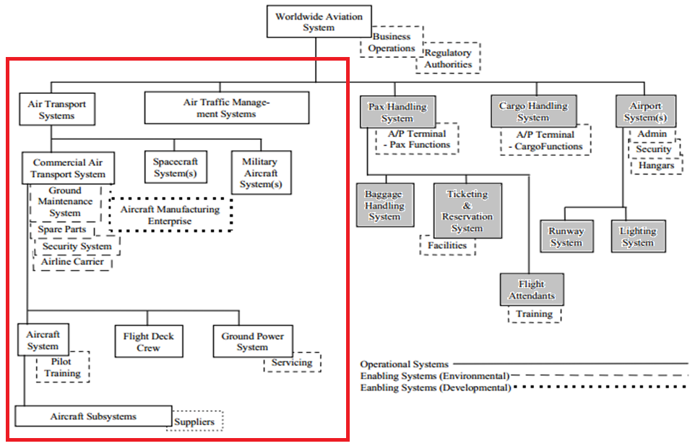

# Commercial Aircraft Systems Domain

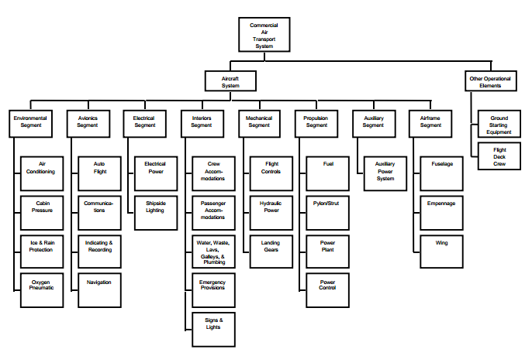

# Problem Interdependency Graph



# Soft goals Interdependency Graph



# Traceability



# Q & A

1. Why is it so difficult in this age to detect the whereabouts of a plane
   1. Technological improvements possible – improved beacons and transmitters
2. Why can't we do a better job at weather predictions for a plane
   1. Improved weather simulations from real-time data and internet of flying things.
3. Why should a plane take off knowing a bad weather prediction in the sky
   1. Internet of flying things will be the solution here.
4. Why can't planes flying over dangerous terrain detect its surroundings better
   1. Sensors to detect radar locks
5. Why are we (ATC) not able to see what is happening inside the plane, and outside the plane
   1. Automated video recorders will get activated
6. Why do we need to rely on a pilot and co-pilot, being responsible for the lives of many
   1. ATC will not be traffic clerks, but instead will need to be treated as mission control
7. Why is piloting a plane not taken seriously anymore
   1. Regular manual flying drills made mandatory

# References

* 1. Aircraft Domain Diagrams: [www.incose.org](http://www.incose.org)
  2. http://www.bbc.com/news/world-asia-26503141
  3. [Malaysia Airlines Flight 370 - Wikipedia, the free encyclopedia](https://www.google.com/url?sa=t&rct=j&q=&esrc=s&source=web&cd=1&cad=rja&uact=8&ved=0CB4QFjAA&url=http%3A%2F%2Fen.wikipedia.org%2Fwiki%2FMalaysia_Airlines_Flight_370&ei=rX8qVajLKYLEggT3uYDwCw&usg=AFQjCNG9h7NbabLpRrPetycclpGqhGmNmQ&bvm=bv.90491159,d.eXY)
  4. <http://www.cnn.com/2015/03/07/asia/mh370-theories/>
  5. [Malaysia Airlines Flight 17 - Wikipedia, the free encyclopedia](http://en.wikipedia.org/wiki/Malaysia_Airlines_Flight_17)
  6. [Air Algérie Flight 5017 - Wikipedia, the free encyclopedia](http://en.wikipedia.org/wiki/Air_Alg%C3%A9rie_Flight_5017)
  7. [Indonesia AirAsia Flight 8501 - Wikipedia, the free ...](http://en.wikipedia.org/wiki/Indonesia_AirAsia_Flight_8501)
  8. [ATR 72 - Wikipedia, the free encyclopedia](http://en.wikipedia.org/wiki/ATR_72)