Identification and Resolution of an Inventory Management Problem

Abstract. This paper covers the process used in a real management consulting project. By contract the scope was limited to problem identification and requirements gathering in support of recommending a proposed solution for their inventory management system. For the purposes of this paper, the discussion will be limited to the process of gathering and managing the requirements related to the resolution of the inventory management problem.

I. Introduction
In the Spring of 2013 the UTD Consulting Club was approached by Invent Technologies to provide some consulting services related to a significant challenge they were facing with the inventory management as stated by Invent, ”Recently, Invent Technologies has been experiencing problems maintaining an accurate inventory management system. Problems have varied from lack of space and overcrowding to inability to track and locate inventory purchases. Due to our complex business model, how we manage our current inventory, as well as purchases, is pivotal to our success as a company. Our company will succeed only to the extent that our inventory management allows “[1].
Invent’s business model is a very unique one which involves supplying obsolete or hard to find replacement parts. Their acquisition strategy model is timed to buy the parts near the end of the products useful life but before it begins to wear out. In many cases they acquire the last of the manufacturer’s stock in anticipation of the future need. This is illustrated using the classic bathtub model of a product’s life-cycle as shown in Fig 1.

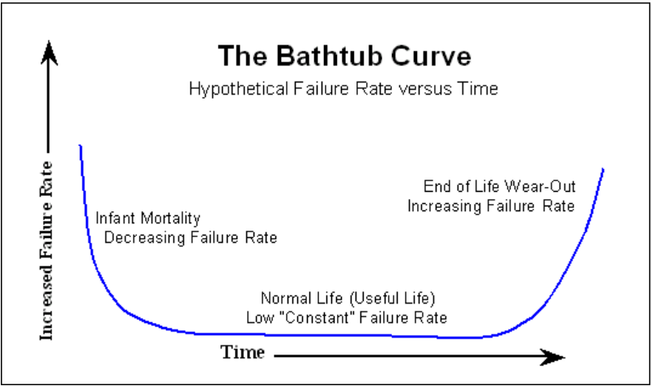
Fig 1 Bathtub Model [2]
The optimum time for acquisition is near the end of the flat portion of the bathtub but before the lifecycle enters its greatest failure rate. This acquisition model creates a unique need for their inventory management system which differs substantially from most enterprises.

II. Problem Identification Process

It is more important to understand the problem than the solution. [Albert Einstein] [3]

The most important part of any problem solving process is to fully comprehend the exact problem that you are trying to solve. This sounds trite and obvious to many but in practice this is where the vast majority of people go awry. In their haste to find a speedy resolution to their problem most people pause only to obtain about an 80% understanding of the problem. For many cases this “good enough” understanding is sufficient to achieve some level of success in problem solving. However it is never optimum to begin solving a problem before it is fully and completely understood, because doing so will most often lead to a solution that is something other than desired or at the very least less than optimum.
- Problem definition
On the Invent project, the team was trying to rush the process to gather requirements before we had a complete understanding of the problems that Invent was facing that resulted in the first and only conflict that the team experienced. It ended when it was laid out in logical terms the case for slowing down long enough to make sure we had the complete picture of the problem including existing processes before we set about trying to change it.
At the very beginning of the project, the company officials introduced us to the logistics manager and took us on a tour of their warehouse so that we could get a scope of the problem they were facing. Both the tour and the interview with the logistics manager were quite enlightening but only gave us one perspective of the problem. In that meeting I made the case that it would be necessary for us to not only talk to logistics but the other functional groups who were key stakeholders in having this problem solved. So in the entailing discussion we were able to identify the key internal stakeholders in the resolution of this problem. These included: Senior Management, Logistics, Production, Procurement, Sales and Software Development. Once these stakeholders were identified the next step in the process was to conduct face-to-face meeting with representatives from each stakeholder group to determine their perspective on the problem. Only then would we have a complete and thorough definition of the problem.
- Stakeholder interviews
The purpose of the stakeholder interviews was twofold. The first objective was to get a complete understanding of their existing business processes with the second objective being to uncover weaknesses, vulnerabilities and pain points within these processes. Both of these objectives are a part of the requirements elicitation process. The interviews were conducted informally over the course of several weeks in regularly scheduled meetings between representatives from the various stakeholder functional groups and the consulting team. In most cases senior management was not present so that the employees felt a greater degree of freedom to speak up about the problems they were facing and they level of frustration they felt. While this was in many instances quite therapeutic for the employees, our challenge was to understand the level of pain they were feeling and determine the business impact that the problems created without allowing emotion to overwhelm the process.

- Existing process definition
One of the tasks facing the consulting team was to provide a mapping of existing business processes based on information collected in the stakeholder interviews. One of the first questions that I personally asked was if they had process diagrams of their existing processes. They indicated that they did not have any but as a result of our prodding they did develop a process that described their receiving process which they provided in fig 2 below.
Figure 2 Current Receiving Process [4]
In addition to the receiving process we determined that the process of fulfilling a sales order was a critical business process that needed to be modeled and is shown in Figure 3 below.

Figure 3 Current Sales Process [4]

- Identify keys weaknesses
After the interviews were completed and processes were well understood it became apparent that there were several issues that were causing pain for everyone in the organization and pointed to some key weaknesses in their business processes. Almost all of the problems could best be summed as poor communication especially intergroup communication. One of the costliest and most pernicious problems was that sales did not have adequate or even reliable information in regards to their current inventory in terms of type of item, quantity, condition (new/refurb) or even if the existing stock had passed or failed incoming inspections. Given that sales is overwhelmed by unsolicited sales calls it is critical to the operation of the enterprise that they have real time, complete, accurate and reliable data on existing inventory.
A second key weakness that was identified was communication between production sales and logistics. Several groups complained about the inaccuracy or incompleteness of the information and pointed fingers at logistics in particular as the reason why information was missing in the database. One informal recommendation that was provided to the software developers was to identify key pieces of information and to make those fields mandatory (requiring that information be populated in those fields) prior to allowing a change to be committed to the database. This could go a long ways toward solving the problem of incomplete or missing information in the database.
A third problem was that there were several groups that were using their own manually created spreadsheets to track inventory data because the current software system either didn’t provide the required functionality or there was insufficient staff training as to the software capabilities and how to leverage it. These disparate processes and separate communications devices again made the task of intergroup communication much more labor intensive and ineffective. One important goal of the new system would be to provide all required functionality that these groups needed thus eliminating the need for separate spreadsheets. Secondarily there needs to be sufficient staff training on both the tool and the business processes to make sure that the tool can achieve maximum benefit to the enterprise.

III. Requirements Development
For the purposes of summarizing the requirements, the Why-What-How model seemed most appropriate, due to the fact that the Why provides a direct linkage to the enterprise and shows a relation between the requirement and a specific need of the enterprise. For this project it seems particularly useful because it is critical to understand the reasons behind the requirements which is the Why part of the model. Specifically the three critical problems identified in the previous section provide the Why. They are:
- Provide accurate inventory information to sales team to allow them to improve efficiency of servicing customers
- Improve interdepartmental communication and cooperation
- Provide single communication tool to support all business groups
The What part of the model deals with the specific functional requirements. There were a total of twenty-one unique functional requirements and design goals. The requirements are denoted by the use of the word “shall”, whereas the design goals contain the word “should”.
- Functional requirements
- Software shall provide the capability to make the state or condition of an item a mandatory field before allowing the data to be updated in the system.
- Software shall have the ability to track all types of requests that are currently being tracked via spreadsheets so that all processes are merged into one system.
- Software shall provide the capability to track the condition of an item (new or refurb)
- Software shall provide the capability to track defects or non conformances.
- Software shall provide the ability to track a vendor's RMA in the system
- Software shall provide the ability to track the items history as it passes through the various states of the process
- Software shall provide the ability to enter vendor contact information for each item obtained.
- Software shall provide the ability to track customer contact information for each item shipped.
- Software shall provide the ability to generate and track service requests to initiate work for production from the order screen.
- Software shall provide the capability to track different revs of the same part number
- Software shall have the ability to track different model numbers of the same part number.
- Sales would like to be able to see the status of an item from the sales screen
- Software shall be able to support all 4 types of requests (RMA, service request, purchase order, and inventory purchase) and be able to differentiate between the type of request an item was placed in the system.
- Software should be capable of generating reports to compare budget against a given Purchase Order.
- Software should support ability to enter information regarding received quality for purposes of tracking supplier quality
- Software shall support entering of photos for each part in database
- Software shall support the generation of a logistics request from the sales screen
- Software generated logistics request shall contain all pertinent part identification data as well as location and priority of the request.
- Software shall support entry of shipping tracking numbers for both purchased and shipped items
- Software should support integration with COTS based customer relationship management software
- Software should have the ability to track subcomponents on a given item and expose these as available parts within the system.

- Non-Functional Requirements
The non-functional requirements are derived from the focus to solve the most vexing problems. The functional requirements specified above are lower level manifestations of the non-functional requirements. While there are many non functional requirements that we could have chosen, there were two that seemed most relevant in addressing the identified problems. These were categorized as Flexibility and usability. The specific non-functional requirements are given below.

- Flexibility
  - The system shall allow for easy evolution to allow for necessary changes to the user interface as the needs of the enterprise changes.
  - The system should allow for integration of disparate business processes and provide screens that are easily customizable to support a given enterprise function.
  - The system should successfully combine all existing inventory tracking, defect tracking, purchase order tracking and sales tracking into one system without sacrificing required functionality that current individual systems support.
- Usability
  - The system shall be designed such that an average high school graduate can use the system to enter the required information into the system with minimal training.
  - The system should provide a rich set of reporting capabilities that provides required reports that is customizable for the needs of individual groups such as sales, customer care and procurement.
  - The system shall make clear distinction between information that is voluntary and the information that is required.
IV. Conclusion
This paper has shown the process of requirements elicitation in the pursuit of solving complex business problem in a consulting role. The Why What How model was employed because of its focus on the requirements from the enterprise level down to the non-functional level all the way down to specific functional requirements. This break-down provided a clear linkage between the low-level functional requirements and how they addressed the needs at the non-functional level and at the enterprise level.
The capture of these requirements marked a delivery point in the consulting contract. They also provide an excellent framework and problem description for the next phase of the project which is evaluation of alternatives. Whether a COTS solution is capable of satisfying the stated requirements or whether a proprietary solution is chosen, these requirements if fully satisfied will make satisfaction of the stakeholders a high probability outcome.
References
[1] Consulting Project Contract Between Invent & UTD Consulting Club
[2] Adopted from Reliability Hotwire Issue 21 November 2002 www.weibull.com
[3] Adapted from Chung, Lawrence Requirements Engineering Journal and a Swing Cartoon
[4 ] Supplied by Invent Senior Management

