Gorgon Stare
Unclear Requirements and
Lack of Traceability

Final Term Paper
Submitter: Dylan Brandt
Professor Lawrence Chung
Course: SYSM 6309
Course Title: Advanced Requirements Engineering
Term: Summer 2013

Abstract
In December of 2010, the 53rd Air Wing Air Combat Command conducted system level testing of Gorgon Stare and provided a DO NOT field recommendation to the Air Force. Gorgon Stare was developed with no formal requirements and because of which, had no traceability to validation testing. In this paper, I will discuss the objectives of the Gorgon Stare program, how it was tested against those objectives, and the importance of formal requirements for traceability to validation testing.
- Problem Statement
Gorgon Stare is an advanced intelligence; surveillance and reconnaissance (ISR) sensor developed by Sierra Nevada Corp as a quick reaction capability for the Air Force to address the urgent operational need for wide area airborne surveillance. The Gorgon Stare sensor was developed with no formal requirements. System level testing was conducted by the 53rd Air Wing Air Combat Command in December of 2010. The Gorgon Stare system was found to be not operationally effective and not operationally suitable for deployment.

- History
In 2008 the Department Of Defense leadership requested funds for the Air Force to acquire a combined, enhanced system, currently called Wide-Area Airborne Surveillance (WAAS), to image a larger area than Constant Hawk or Angel Fire, enable night operations, real-time support to ground forces, provide a forensic capability, and support many simultaneous targeting and surveillance missions. Funding will be allocated in FY09-FY13 for this Air Force Quick Reaction Capability (QRC) program to meet Combatant Commander (COCOM) Wide Area Airborne Surveillance (WAAS) urgent operational need and will be managed through the 645th Aeronautical Systems Group (AESG, a.k.a. BIG SAFARI Program Office), 303rd Reconnaissance Systems Wing, Aeronautical Systems Center, Air Force Material Command.

Sierra Nevada is the prime contractor for the Gorgon Stare ISR system; the electro-optical and infrared (EO/IR) payload for the system is made by ITT Exelis Geospatial Systems. The acquisition strategy for this Air Force QRC includes delivery of capability in two increments, with development of Increment 2 capability expanding the capabilities of Increment 1. The initial deployment, designated Quick Reaction Capability Increment I, consisted of four sets of pods built at a cost of $17.5 million per set, excluding the cost of the ground control station. Total funding allocated for the Gorgon Stare program was 150 million dollars.
- Gorgon Stare Sensor
The sensor is fixed beneath an MQ-9 Reaper unmanned aircraft. Gorgon Stare’s payload is contained in two pods slightly larger than, but about the same total weight as the two 500-lb. GBU-12 laser-guided bombs the Reaper routinely carries. The pods attach to the inboard weapon pylons under the wing.
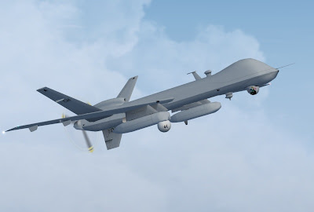
MQ-9 Reaper outfitted with the Gorgon Stare Pods

One pod carries a sensor ball. The ball contains five electro-optical (EO) cameras for daytime and four infrared (IR) cameras for nighttime ISR, positioned at different angles for maximum ground coverage. The pod also houses a computer processor. The cameras shoot motion video at 2 frames/sec., as opposed to full motion video provided by the MTS at 30 frames/sec. The five EO cameras each shoot two 16-megapixel frames/sec., which are stitched together by the computer to create an 80-megapixel image. The four IR cameras combined shoot the equivalent of two 32-megapixel frames/sec. The second Gorgon Stare pod contains a computer to process and store images, data-link modem, two pairs of Common Data Link and Tactical Common Data Link antennas, plus radio frequency equipment.

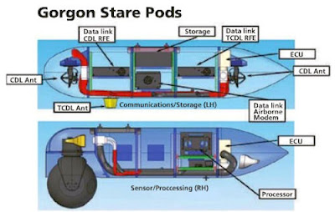
The two pods of the Gorgon Stare system

Gorgon Stare is operated independently but in coordination with the Reaper’s crew by a two-member team working from a dedicated ground station. The result is a system that offers a “many orders of magnitude” leap beyond the “soda straw” view provided by the single MTS EO/IR camera carried by a conventional UAV. The video taken by Gorgon Stare’s cameras can be “chipped out” into 10 individual views and streamed to that many recipients or more via the Tactical Common Data Link (TCDL). Any ground or airborne unit within range of Gorgon Stare’s TCDL and equipped with a Remote Operations Video Enhanced Receiver, One System Remote Video Terminal or a hand-held receiver can view one of the chip-outs.

At the same time, Gorgon Stare will process the images from all its cameras in flight, quilting them into a mosaic for a single wide-area view. That image can be streamed to tactical operations centers or Air Force Distributed Common Ground System intelligence facilities by the Gorgon Stare ground station via line-of-sight data link. The ground station team, which will control the system’s sensors, can also transmit the relatively low-resolution wide-area view to recipient’s in-theater or elsewhere via other wideband communication devices, plus chip-out an additional 50-60 views and forward them as needed.

Gorgon Stare is a generational change, which turns a UAV in a platform capable to look simultaneously over a whole small town, instead of down one single street, which means that the work of a drone fitted with Gorgon Stare could be matched only using several more drones.

- Program Objectives
Gorgon Stare was developed to provide persistent WAAS of a “city-sized” area. The system was designed to deliver operationally effective Electro-optical (EO) and infrared (IR) motion imagery to ground troops within a designated circle of persistence, and simultaneously transmit to a GS ground station, which may be forwarded to a processing, exploitation, and dissemination cell for further analysis in theater. The quality of downloaded imagery (post-mission) should allow for forensically tracking vehicles and dismounts to their point of origin/destination, developing pattern-of-life, providing detailed analysis of IED detonations, and satisfying RFIs.

Program objectives can be summarized into the seven major bullets below:
- Image a larger area than Constant Hawk or Angel Fire (legacy WAAS systems).
- Enable night operations.
- Provide real-time support to ground forces.
- Provide a forensic capability.
- Support many simultaneous targeting and surveillance missions.
- Cue and hand off targets to full-motion video platforms for prosecution.
- Operationally effective / suitable.

- System Level Testing
System level testing was conducted by the 53rd Air Wing Air Combat Command (ACC) in December 2010. Testing consisted of 20 sorties totaling 234 hours of operational flight time. The Gorgon Stare system was evaluated for Operational Effectiveness and Operational Suitability based on the following parameters in Table 1.

Operational Effectiveness | Operational Suitability
Downlinked Imagery | Operations
EO Quality Subview | Maintenance
EO Quality Chip-Out | Availability
EO Quality Downloaded | Reliability
IR Quality Subview | Training
IR Quality Chip-Out | Mobility
IR Quality Downloaded | Security
Table 1: Gorgon Stare Test Evaluation Parameters

With no true requirements defined, operational effectiveness can only be measured against program objectives. A summary of the test results compared to objectives can be seen below in Table 2.

ID | OBJECTIVES | TEST RESULTS
1 | Image a larger area than Constant Hawk or Angel Fire (legacy WAAS systems). | Inferior image stitching resulting in large black triangles. Dropped frames during download.
2 | Enable night operations. | Problematic night vision systems. IR image quality poor.
3 | Provide real-time support to ground forces. | Two second latency to RVT operators. Unpredictable software error - faulty coordinate grid for chipout imagery.
4 | Provide a forensic capability. | EO imagery sufficient for detecting ground activity. IR imagery not sufficient.
5 | Support many simultaneous targeting and surveillance missions. | Unpredictable software error - faulty coordinate grid for chipout imagery. Image quality not sufficient to track dismounts.
6 | Cue and hand off targets to full-motion video platforms for prosecution. | 12 to 18 second latency to GSGS, limits ability to cross-cue the MTS targeting pod or track a dynamic target.
Table 2: Program Objectives Traceability to Validation Testing

Operational suitability is a nonfunctional requirement, further defined by the seven additional nonfunctional requirements outlined in Table 1. Traceability to validation testing can be seen below in Table 3.

Non-Functional Requirement | Test Results
Operations | Formally developed operator TOs and checklists were not delivered for operating the aircraft sensor pods.
Maintenance | Formally developed TOs do not exist for the physical changes made to the GS modified MQ-9 aircraft.
Availability | Pod set availability was problematic during the operational utility evaluation. Parts were not interchangeable between pods. Lack of configuration.
Reliability | Overall availability of the system was 63.8%. MTBF was 119 minutes, with an average of 3.7 failures per sortie.
Training | Training program still in development.
Mobility | Requires semi-permanent collocation of 80 nautical miles.
Security | Contains “SECRET // NOFORN” restrictions.
Table 3: Nonfunctional Requirements Traceability to Validation Testing

The 53rd AWACC provided the United States Air Force with a DO NOT field recommendation. The overall assessment was as follows:

The GS system is not operationally effective and not operationally suitable. The GS system, as tested, has significant limitations that degrade its operational utility including deficient IR performance, numerous remote video terminal (RVT) interoperability problems, unpredictable system reliability/stability, and lack of system documentation.
- 53 WG/CC
- Traceability
With no formal requirements, there can be no traceability for proper validation testing of the system, as clearly depicted in the V-model. Big Safari responded to the do not field recommendation disputing the test results. The program office claimed that the tests were unfair as they probed performance areas that were beyond the specifications for the system.

Specifications that were never clearly defined, and never turned into requirements. Without requirements, a third party cannot objectively test a system against its expected performance. Gorgon Stare failed to abide by the one truth in systems engineering, and in not doing so, failed in the eyes of the customer.

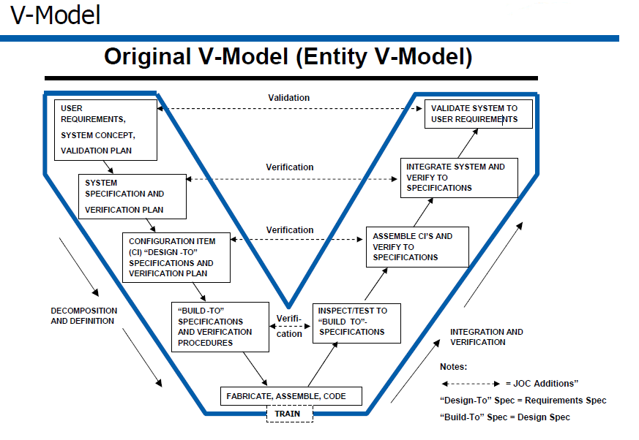
V-Model

- Acronyms
- EO - Electro-optical
- GS - Gorgon Stare
- GSGS - Gorgon Stare Ground Station
- IED - Improvised explosive device
- IR - Infrared
- NRT - Near real time
- OUE - Operational Utility Evaluation
- QRC - Quick Reaction Capability
- RFI - Request for intelligence
- RVT - Remote video terminal
- TO - Technical order

- Bibliography
http://www.globalsecurity.org/intell/systems/gorgon-stare.htm
http://ukarmedforcescommentary.blogspot.com/2012/07/towards-scavenger.html
http://www.defence.pk/forums/pakistan-defence-industry/92072-new-us-drone-spy-cameras-gorgon-stare-fail-air-force-test.html
http://www.strategypage.com/htmw/htecm/articles/20130524.aspx
http://www.darkgovernment.com/news/reaper-sensors-called-gorgon-stare/
http://images.dodbuzz.com/wp-content/uploads/2011/01/53D-Tests-and-Recommendation.pdf

