Case Management Proposal

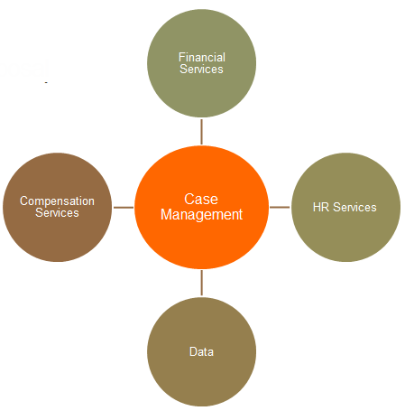

Randi Craig
03 August 2013
Version: 3.0

Contents
Case Management Proposal 1
1. Context and Problem 2
1.1 Stakeholders 3
2. Goals and Objectives 3
3. Proposed Solution 4
3.1 Global Adoption is Critical 5
3.2 Scope 5
3.3 Elicitation/Requirements Step Critical 5
4. Impact 6
4.1 BEFORE: 6
4.2 AFTER: 7
4.3 Business intelligence and Metrics 8
5. Nonfunctional Requirements Highlights 9
5.1 Automated Features 9
5.2 Data Entry 9
5.3 Reporting: 9
6. Revision History 9
7. Works Cited 10

1. Context and Problem
Acme Corp is a large multinational professional services company providing customers with financial, human resources, tax, and business management services. Acme Corp has grown significantly over years acquiring new firms in branching out into new countries and now faces many current challenges, including:
- Speed, turnaround, responsiveness and proactivity is the subject of negative customer feedback
- Customer requirements to have increasing visibility, transparency and vendor performance management
- Providing governance and control to work requests where customer organizations cannot
- Manage global billing, scope management and other factors, efficiently and effectively
Currently, Acme Corp. uses MS Outlook, MS Lync, and Yammer for customer communications. These software applications do not meet Acme Corp.’s current requirements. Outlook captures next days (roughly 24 to 48 hours) communications between the customer and Acme Corp. and the various offices around the globe. It is not a good real time tool. It is possible to capture the history of the communication within a single person’s email box, however, it is not possible to capture this information in a searchable historical fashion for global leadership oversight. It is also difficult capture metrics from the solution. Lync is very useful for real-time communications, that the information is not saved in a searchable fashion, and again it’s not centrally searchable. Yammer is centrally searchable and supports real-time and next day responses, however, communications are fluid moving between topics, and oversight is possible but difficult and time-consuming. Both link and yammer have additional concerns around privacy, and legal risk.

1.1 Stakeholders
There are many different types of stakeholders at ABC Corp., it’s kind customers, and the third-party vendors that support ABC Corp. and customer services. Each type of stakeholder end-user needs to be able to manage their own personal work, as well as different types of responsibility areas. Some resources have management responsibilities based on location or region while others have responsibilities based on service type. Some work would obviously overlap different regions or services. As a result, security and risk associated with it is a high concern for all.
Stakeholder Type | Key Objectives
3rd Party User | - Update & manage information related to personal work
Customer User | - Update & manage information related to personal work
Customer Location Manager | - Update & manage information related to personal work  - Update & manage information across all ABC work in a given location
Customer Service Manager | - Update & manage information related to personal work  - Update & manage information across responsibility area at ABC Corp across service area, regardless of location
Customer Program Manager | - Update & manage information related to personal work  - Update & manage information related to customer organization
ABC Corp User | - Update & manage information related to personal work
ABC Location Manager | - Update & manage information related to personal work  - Update & manage information across all ABC work in a given location
ABC Service Manager | - Update & manage information related to personal work  - Update & manage information across responsibility area at ABC Corp across service area, regardless of location
ABC Corp Program Manager | - Update & manage information related to personal work  - Update & manage information related to specific customer’s organizations  - Update & manage information across responsibility area at ABC Corp

2. Goals and Objectives
- The first goal is to know customer’s global needs, across multiple stakeholders and multiple points of entry with different goals. Acme Corp.’s customers are very diverse and spread out across countries, and services and products themselves. They need a professional services provider that can help them make sense of their organization.
- Next, Acme Corp. must understand who in in the company is actively progressing Customer work. With so many moving pieces, it is nearly impossible to tell who is working on any given piece of work at any given time without research. In a global company, research takes time due to scale, time zones, and language translation. A single system where work status is commonly stored and can be researched quickly is needed.
- The next objective is a shared objective between Acme Corp. and its customers. Both Acme Corp. and customers require more transparent oversight into resource performance, progress, delivery, response time and closure. Both companies want to improve efficiencies, and improve profitability. If customers take too long to provide Acme Corp. with data, this additional time costs the customer money and lost efficiency. If Acme Corp. takes too long to process data and requests, this causes Acme Corp. to lose time and money. All organizations benefit from improved transparency and proactive management options.
- Finally, Acme Corp. would like to get paid promptly for the work that it does. The company needs to manage billing and scope with oversight to both in a more effective manner globally.

3. Proposed Solution
The global technology office at Acme Corp. has studied the issues raised, and is proposing a case management system. In this context, a case management system is a software system is part of a overall strategic customer relationship management strategy. The software system can be used to create cases which will then be used to track and report on key performance indicators, service-level agreements, and other useful metrics. Acme Corp. provides a number of services to customers, so a “case” is essentially anything to be tracked. A case record captures categories, departments, assigned resources, metadata information about the originating system or user. Along with these details, a case collects all related communications, such as emails and documents, and notes by Acme Corp. professionals are stores together in a case number associated index. For Acme Corp., examples of cases include: Acme work product/deliverables, customer questions, missing information and reminders, meetings, third-party data requests, invoice creation, out of scope, and billing.
Case management meets the relationship management requirements that Acme Corp. is struggling with by supporting real-time and next day’s business communications in a centrally searchable, and organized in a logical manner by case number, with important metadata and other categories selected. All case management activity has a date/time stamp. Combining the timestamps in metadata will allow Acme Corp. to report on aggregate activity, as well as drill down into specific issues.

Stakeholder Type | Key Objectives
3rd Party User | - Update & manage information related to personal work
Customer User | - Update & manage information related to personal work
Customer Location Manager | - Update & manage information related to personal work  - Update & manage information across all ABC work in a given location
Customer Service Manager | - Update & manage information related to personal work  - Update & manage information across responsibility area at ABC Corp across service area, regardless of location
Customer Program Manager | - Update & manage information related to personal work  - Update & manage information related to customer organization
ABC Corp User | - Update & manage information related to personal work
ABC Location Manager | - Update & manage information related to personal work  - Update & manage information across all ABC work in a given location
ABC Service Manager | - Update & manage information related to personal work  - Update & manage information across responsibility area at ABC Corp across service area, regardless of location
ABC Corp Program Manager | - Update & manage information related to personal work  - Update & manage information related to specific customer’s organizations  - Update & manage information across responsibility area at ABC Corp

3.1 Global Adoption is Critical
The usefulness of the case management system relies on all data being in one place. If users do not adopt the case management system, data and communications will still be in multiple systems. To address adoption, the system must be extremely easy to use, and must support very simple updates. The easiest update is to reply to an email generated from existing case. A reply email must include metadata identifying the case number. The case management system must read that metadata and directly update the originating case with a new activity stamp from the email receipt date. In this way, existing users of email would not need to change their processes overnight. Over time, users are expected to learn that it is easier to work directly in the case management system, generating emails and responses from the system with history all in one place, rather than jumping back and forth Outlook. This feature is so critical to adoption that it is a requirement constraint. Without this feature further implementation is not warranted.
Case management does not replace users, nor does it set the stage for primarily administration support. Instead, case management shall provide Acme Corp. with the opportunity to transform its support model. Cases will be manually assigned to appropriate level professionals with oversight to a higher level. A support team will be needed to identify any data (such as email replies) that do not automatically associate to an existing case number.

3.2 Scope
The case management system supports web service interface with other tools for automated updates, however, those interfaces are not part of the standard solution. Interfaces and their requirements would need requirements scoping and definition outside of the case management solution. Interface functionality is expected to become more critical as adoption increases an additional users are brought into the case management system. (Salesforce, 2013)

3.3 Elicitation/Requirements Step Critical
As mentioned, software adoption is critical on a global scale. There are also many different stakeholders with different objectives. What is common is that users want the same types of data, just different levels. It will be critical to first implement an off-the-shelf pilot and identify key requirements and gaps and traceability between stakeholder non-functional, and function needs, as well as the related technical requirements. A rigorous formal process to gather non-functional requirements will help Acme Corp understand if it should build a case management system in house or if it should buy one off the shelf.

4. Impact
Acme Corp.’s existing process is built around the use of a helpdesk and a central mailbox, with an administrative team supporting the central mailbox. This process is to provide greater oversight to customers and Acme Corp. management. Without these two groups, there would be very little oversight and no centrally searchable information. For example, if a customer sends an email it goes to the ABC Corp. helpdesk supporting all clients, who routes it to an administration center for that specific customer. The admin center identifies the country in question and the contacts for those services in that country for that customer. Typically, the contact person is junior or a local admin. Finally, the local supporting person sends it to the resource for that customer and that service in that country, and the reply is given. Unfortunately, these administrative steps add 2 to 3 additional layers of administrative support between a question and an answer. At the same time, this is the only way to generate any limited metrics or oversight. At this time, automated metadata analysis can identify unique topic, first sent date, first response date, last response date. The system is not able to evaluate whether the responses were accurate. And, this evaluation is done significantly after the fact, revealing only what went wrong, not how to fix it or address it as is happening.
The current process looks like this:

4.1 BEFORE:
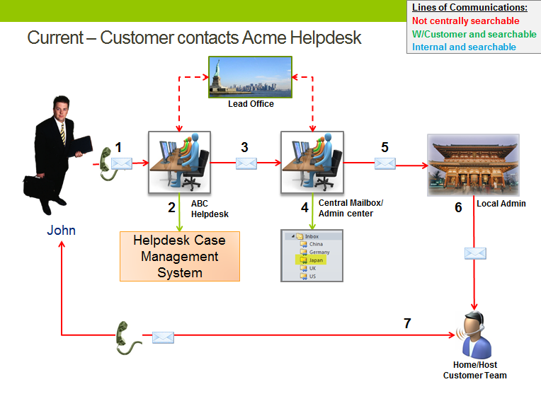

4.2 AFTER:
The case management system will replace administrative steps with more value added right-time right-people functionality. In this example, using security groups, the case management system shall be able to tell that John-customer should be helped by Acme Corp. named X. Moreover, since all information is one place, more junior people may actually be able to answer questions, rather than simply identify contact addresses to forward emails. Acme Corp. employees, management, and customers will have greater transparency into work being done currently, work completed, and work not yet started. The next time John-customer calls with the question, Acme resources will be able to see that he called/emailed previously, and what that previous response was. Acme users will also be able to see that John has other additional requests open at the same time.
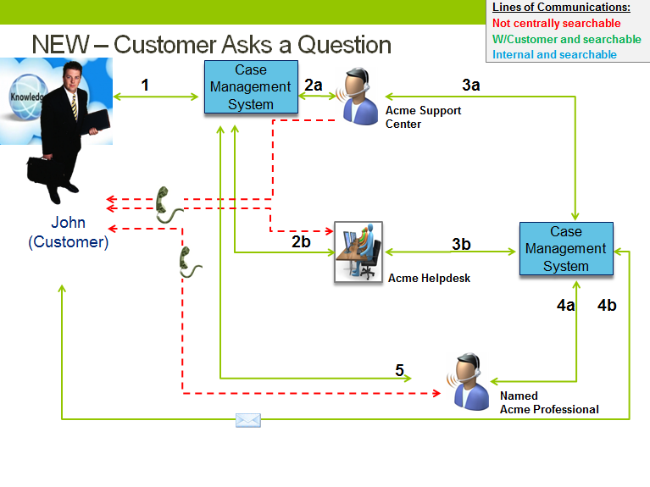 (Salesforce, 2013)

4.3 Business intelligence and Metrics
Case management greatly enhances the transparency within the system for day-to-day users. It also greatly enhances the management options and business intelligence available to regional managers and leadership.
An example of the kind of analytics capable through case management might look like this. – actual data from IT helpdesk demo.
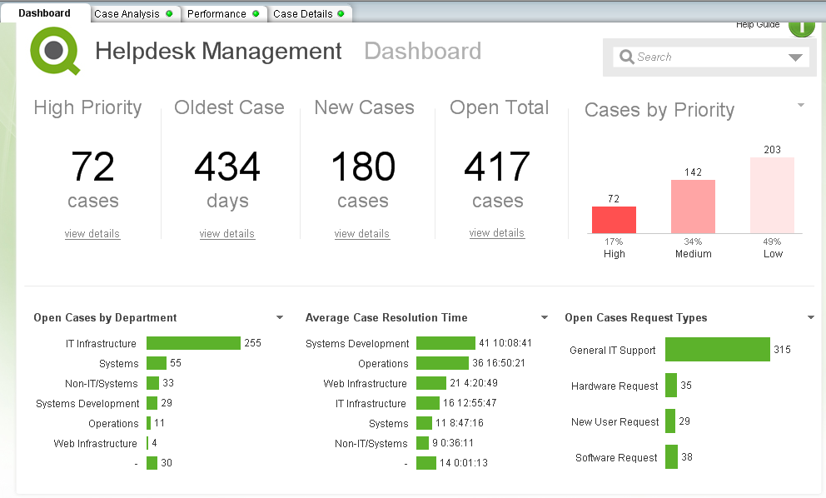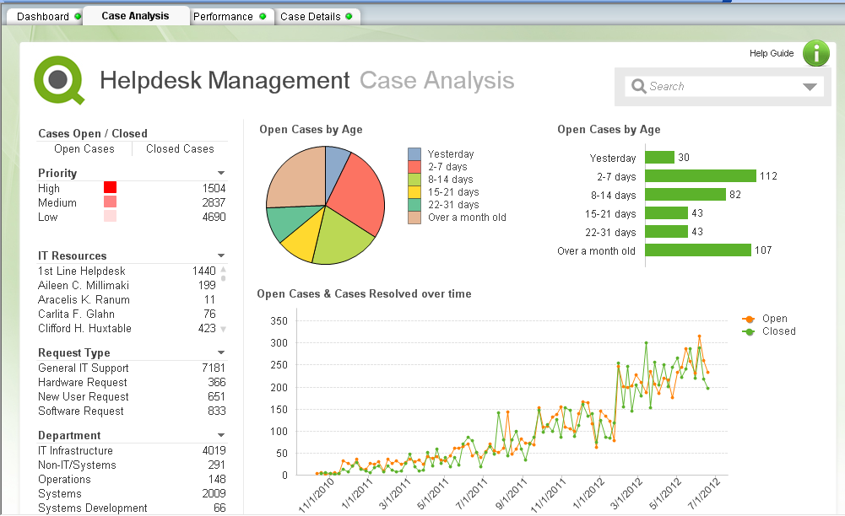
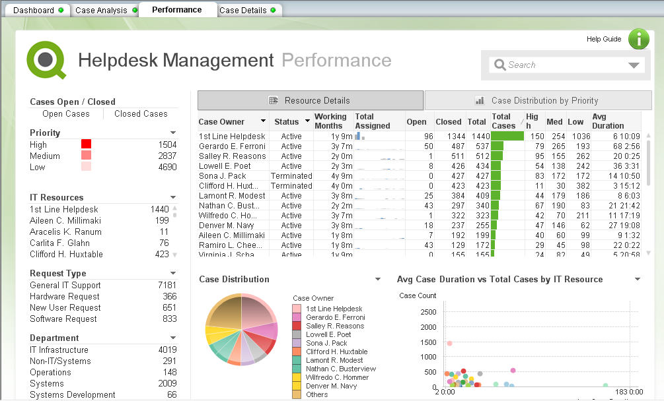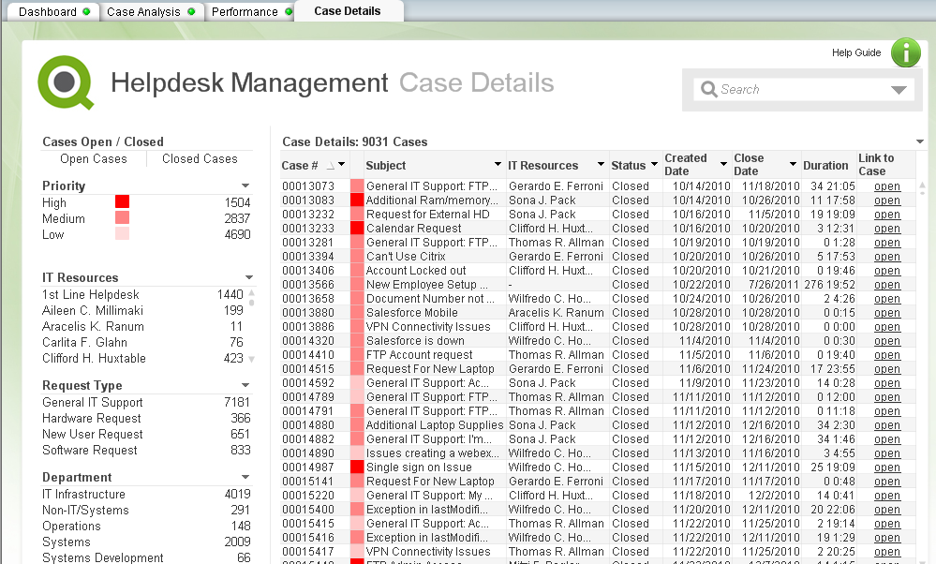
(QlikTech, 2013)

5. Nonfunctional Requirements Highlights
Detailed requirements will be captured in later documents. The non-functional requirements captured here are to give a flavor around requirement needs and system features.

5.1 Automated Features
- System shall include user group security to limit the data each person can access.
- System shall record date/time stamp and activity type category with each data save.
- System shall automatically update existing case notes by user reply email to case generated email.
- For any incoming email not automatically identified with a case, system shall identify these as pending identification.
- System shall schedule and display reminders by user name.
- System shall support formal assigned workflow and escalation across applications, user teams, and organizations.
- For each activity on a case, the system shall capture key metrics (to be defined), examples including customer organization, user name, location, status.
- System shall support web services for updates of key fields defined in functional requirements.
- System shall support user feedback capture after specific activities, such as 1 minute survey.

5.2 Data Entry
- System shall support real-time communications between users, and capture those communications with the originating case.
- System shall support the next day’s communications between users, and capture those communications with the originating case.
- System shall allow users to create a case with specific topic categories and other metadata (to be defined).
- System shall allow users to add additional notes/communications to an existing case.
- System shall not allow regular users to edit previous case notes, but shall allow user to hyperlink to a related correction note.
- System shall include communication templates.
- System shall allow flexible user defined escalation of cases.
- System shall include searchable Frequently Asked Questions, maintainable by Acme Corp.

5.3 Reporting:
- System shall support aggregate reporting using categories identified in metadata.
- System shall support reporting with real-time drill down capacity and active links to cases.

6. Revision History

Version | Date | Name | Description
1.0 | 14-Jul-2013 | Randi Craig | 1st Draft
2.0 | 21-Jul-2013 | Randi Craig | 2nd Draft
3.0 | 3-Aug-2013 | Randi Craig | Final Version

7. Works Cited
QlikTech. (2013, July 31). Demo - Help Desk Management.qvw. Retrieved July 31, 2013, from Qlikview: http://us.demo.qlikview.com/?ga-link=hero
Salesforce. (2013, July 25). Salesforce CRM Demo for Small Business. Retrieved July 25, 2013, from YouTube: http://www.youtube.com/watch?v=mbo8_VHaBWw
Salesforce. (2013, July 29). Service Cloud. Retrieved July 29, 2013, from Salesforce.com: https://www.salesforce.com/service-cloud/overview/

