Chilled Water Optimization in a Thermal Plant

There are three types of HVAC systems that utilize water as a heat transfer medium:
1. The first system, which is used for cooling in dry climates, is called the “Swamp Cooler.” This system employs a fan that blows outdoor air or return air over a revolving drum. The drum is covered with a sponge-like material and the lower portion of the drum is immersed in water. As the air passes over the drum, the air temperature is lowered, and the relative humidity of the air is increased as water on the drum evaporates. This evaporation process will remove 760 BTU per pound of water evaporated. However, as mentioned earlier, the process only works in dry climates where the air has moisture content that is low enough to allow it to accept the additional moisture from the evaporation process.
2. The second water-based system uses a constant source of water at a temperature of 80°F or less to condense the refrigerant vapor in a standard mechanical refrigeration circuit. This water is called condenser water. This type of unit is known as a packaged water-cooled air conditioner. Condenser water is normally provided by a mall or a large building for use by its tenants. The building then maintains a cooling tower that is used to cool the condenser water and pumps that are used to circulate the water. This type of system is used where there is limited access to outdoor areas such as roofs for placement of outdoor equipment. We will deal with water-cooled systems in detail in a future article.
3. The third type of water based air conditioning system is called a chilled water system. Chilled water systems utilize a constant source of water at a temperature of approximately 45°F. This water can be provided by a central building chilled water plant, an off-site utility that sells chilled water, or by the tenant’s own packaged chiller. Most retail stores with less than 40,000 square feet of floor space do not have their own chillers and depend on Landlord furnished chilled water.
For our purposes, let’s assume that the Landlord is providing an uninterruptable source of 45°F chilled water to the building. This water is distributed throughout the building via a piping network. The large horizontal pipes are called mains, the small piping leading to each tenant space are called branches, and the vertical runs are called risers. The chilled water piping is heavily insulated and the insulation is covered with a vapor barrier, which is impervious to moisture. These pipes are carrying a low temperature liquid, and if they were left un-insulated, moisture from the air would condense on the outside of the pipes and drip onto anything below the piping. In addition, heat would be transferred to the piping from the air resulting in wasted energy and a rise in the chilled water temperature. One or more air handlers serve each tenant. An air handler is a sheet metal box that contains a fan and a cooling coil. The cooling coil is made of copper tubing bent into a serpentine shape with aluminum fins bonded to the copper tubing to increase the heat transfer area. The air handler also contains air filters that remove impurities from the air that is being drawn over the coil by the fan. The fan is also called a blower. A motor drives the blower via a drive belt that has a V section. The air handler may also be furnished with a heating coil that adds heat to the air when heat is required. Most chilled water air handlers contain a section called a mixing box. The mixing box is a sheet metal section with two openings in it. There is a duct connected to each opening and a damper located within each opening. One duct is used to bring return air from the conditioned space back to the air handler. The second duct is connected to the outdoors and is used to introduce outdoor air for ventilation purposes. Operation of a system like this is simple. The fan runs continuously, drawing a mix of outdoor air and return air through the air filters. The air is then heated or cooled as it passes over hot coils or cold coils. Chilled water flow to the cooling coil is controlled by a motorized valve. If the space temperature is at or below the set point of the thermostat, the motorized valve closes. If the thermostat is not satisfied, the motorized valve opens causing chilled water to flow through the coil. If the air handler is equipped with a hot water heating coil and a chilled water-cooling coil the system is known as a four-pipe system. In some buildings, the same coil is used for both heating and cooling. During the cooling season, chilled water is circulated through the piping system that serves the air handlers and during the heating season, hot water is circulated through the system. This is known as a two-pipe system. Sometimes heat is provided by an electric resistance coil, a steam heating coil, or a gas fired duct furnace instead of being provided by hot water. Most chilled water air handlers are installed with outdoor air ducts that can deliver the full volume of air the unit is designed to circulate. This oversized outdoor air duct, the mixing box, and the addition of certain controls, forms the components required for an economizer cycle. When outdoor air temperatures are below a threshold value of approximately 55°F, outdoor air may be used for cooling in lieu of using chilled water. This is an energy saving device in four pipe systems and a necessity in two pipe systems. In buildings with two-pipe systems, the building may be circulating hot water in an attempt to provide heat, while some spaces with high internal loads require cooling. Under these circumstances, outdoor air is the only medium available to provide cooling.
The most common problem we find with chilled water systems is insufficient water flow to individual air handlers. In a mall, for example, the piping to each tenant’s air handler forms a parallel path between the supply and return mains. Water will follow the path of least resistance; therefore, the more resistance to flow (friction) in each path, the less water will flow through that path. The total resistance to flow in any path is a function of the length of run, the diameter of the piping, the resistance of the coil, and the resistance of the valves and fittings. Distance from the pump also plays a role, as does the piping layout. Balancing valves are installed on each branch to add resistance to flow in order to guarantee that each branch receives the volume of water it was designed to handle.
The next most prevalent problem is dirty chilled water coils. Air handlers have a usable life span of up to 30 years. Over time, chilled water coils become obstructed with airborne dirt that renders them inefficient. Unlike mechanical refrigeration units, which freeze-up and leak when the indoor coils get plugged, chilled water coils just become less and less efficient until they reach a point where they cannot deliver enough capacity to cool the space.
Normally chilled water is delivered into the piping system at a temperature between 42°F and 46°F. This is the water temperature that should be present at the supply connection on the air handler. Some buildings vary the temperature of chilled water with outdoor temperature change. This is called reset. In an effort to save energy, a building may install a control system that resets the chilled water temperature upward as the outdoor temperature drops. The theory is that as outdoor temperatures decrease there is less of a need for cooling and the cooling requirements can be met with higher temperature water or less water. They may deliver 42°F water at 95° outdoor temperatures and 50° water at 65° outdoor temperatures. Unfortunately, in a retail store the load on a 65°F day may be almost as great as the load on a 95°F day. When the building resets the chilled water temperature, the store receives insufficient cooling.
Optimizing the Plant:
Optimizing the Plant will manage the chiller plant with specialized control algorithms. These algorithms require the conversion of constant speed condenser pumps, chilled water pumps, and cooling tower fans to variable speed through the installation of Variable Frequency Drives (VFDs). The VFDs allow the Demand Flow algorithms to maintain optimal differential system pressure, reduce excessive pumping energy, reduce equipment runtime and increase system deliverable tonnage on systems suffering from a diminished refrigeration effect. The Optimization Controller automatically optimizes all plant functions. Typically, system access to the system will be available through a unique Graphical User Interface (GUI). Siemens Web-Based EMC software enables chiller plant system performance monitoring from anywhere in the world via the Internet. EMC is responsible for data accumulation, reporting energy profiles, and detailing equipment operating parameters. Currently we have 9 chillers in the North Thermal Plant and 5 chillers at the Bass Thermal Plant.
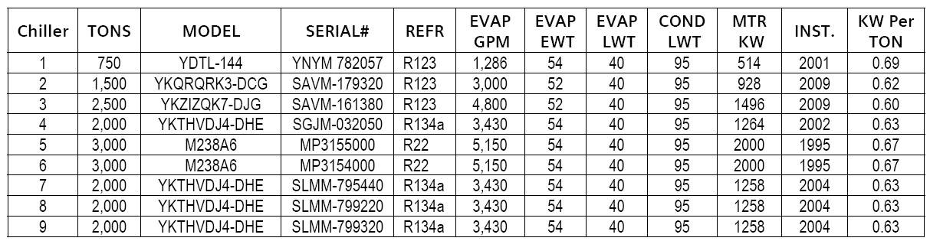
Fig 1 NTEP chiller Data
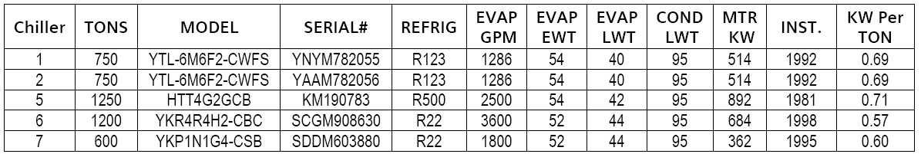
Fig 2 BTEP chiller Data
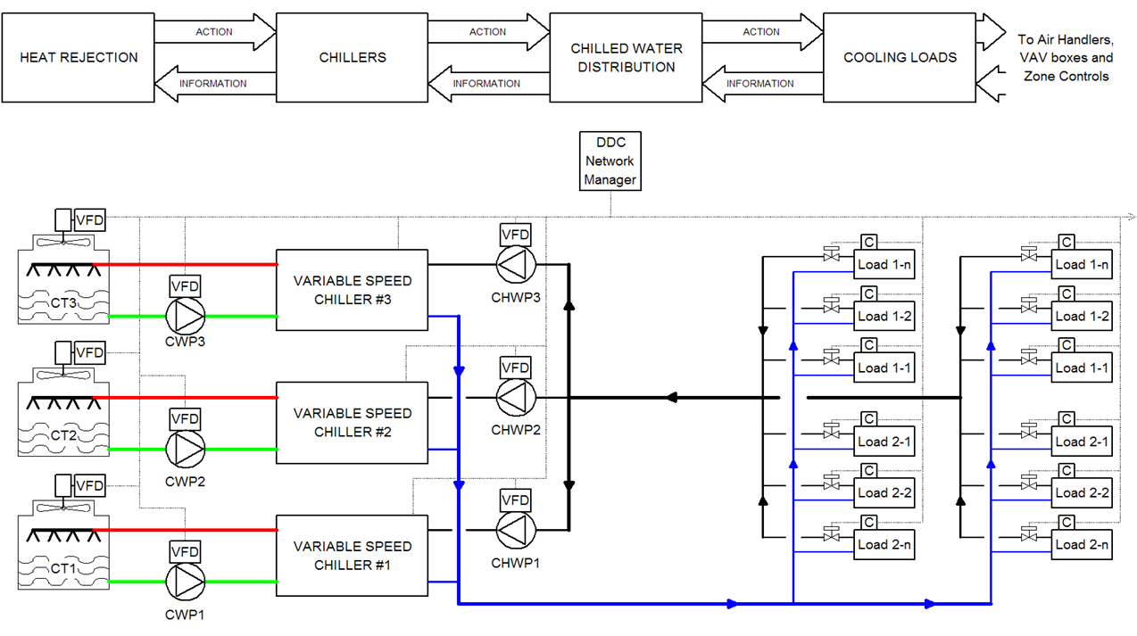
Fig. 3: Configuration of Chilled Water System.
Currently equipment is operated independently with local PID temperature and pressure loops. Chillers and towers are sequenced to keep on-line equipment as fully loaded as possible. Plant optimization, if it is applied at all, requires another level of control that continuously resets the various set points, which can reduce overall system stability. Constant Speed Chiller Efficiency is nearly constant between 60% & 100% loading, the Efficiency of Variable Speed Centrifugal Chillers increases dramatically as load falls in that range. The Efficiency of Variable Speed Centrifugal Chillers is more significantly improved by the reduction in Condensing Water Temperature. Equipment is connected via an integrated network and operation is coordinated to maintain lowest overall energy use at all load conditions using demand based control and natural curve sequencing of equipment. Unless incorporated as design criteria, temperature and pressure set points are not employed except as operating limits.
Valve Control: Multivariable "Intelligent Iterative Control" is used whereby valve adjustment is based on set point error, pump speed, chilled water temperature, and current valve position.
Pump Control:
"Orifice area" pump speed control adjusts speed based on percent of total valve orifice area currently open and further adjusted by the number of valves nearly wide open. Pump Sequencing is based on "natural curve" principle.
In order to control these pumps VFD are essential. This device uses power electronics to vary the frequency of input power to the motor, thereby controlling motor speed. A VFD is the ideal soft starter since it provides the lowest inrush of any starter type as shown in Table B. Unlike all other types of starters, the VFD can use frequency to limit the power and current delivered to the motor. The VFD will start the motor by delivering power at a low frequency. At this low frequency, the motor does not require a high level of current. The VFD incrementally increases the frequency and motor speed until the desired speed is met. Given that the load is always driven by the air handlers in the building there is no need to run the pumps on the rest of the equipment at 100% all time. Therefore VFD allows the modulation of motors to ramp down with demand. This will allow us to save energy, maintenance and longevity of equipment’s.

