**Courier in Real Time**

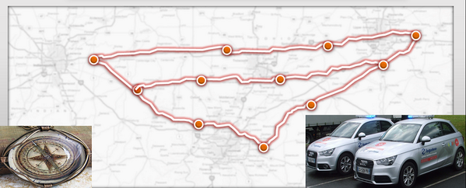

***Preliminary Definition***

***Interim Phase I***

**Team CIRT**

[**http://inet0.net/~cirt**](http://inet0.net/~cirt)

**Summer 2013**

**7/13/2013**

**Team Members:**

Sigit Priyanggoro

Lewis Scaife

Adi Yogo Nugroho

Robiel Ghebrekidan

* Table of Contents

Revision History

Process/Project Responsibilities

I. Introduction 6

I.1 Terminologies 7

II. Preliminary Definition 9

II.1 Stakeholders and Domain Requirements 9

II.2 Functional Requirements 11

II.3 Non-Functional Requirements 12

III. WRS 13

III.1 W 13

III.2 Problem 13

III.3 Goal 13

III.4 Improved understanding of Domain, Stakeholders, Functional and Non-Functional objectives 14

III.4.1 Stakeholders 14

IV. Preliminary Prototype and User Manual 14

V. Traceability 14

VI. Creep Rate 15

VII. Best Solution 15

Reference

Appendix

Index

Revision History

|  |  |  |
| --- | --- | --- |
| **Revision** | **Date** | **Changes** |
| 0.0 | 6/1/13 | Project Discovery |
| 1.0 | 6/8/13 | Development of Project Management Plan  Introduction, Problem, Goal, Stakeholders and Domain Requirements |
| 1.1 | 6/10/13 | Summary and Domain Issues |
| 1.2 | 7/9/13 | Functional Requirements, Revised Domain Issues, Non – Functional Requirements |
| 1.3 | 7/12/13 | Revised Functional Requirements, Traceability Matrix, Issues with Non-Functional Requirements and revised requirements, Reviewed |

Process/Project Responsibilities

|  |  |  |  |  |  |
| --- | --- | --- | --- | --- | --- |
| **Phase 1** | **Deliverables** | **Adi** | **Lewis** | **Robiel** | **Sigit** |
| **Introduction** | X | X | X | X |
| **Preliminary Definition** | X | X | X | X |
| **Functional Requirements** | X | X | X | X |
| **Non-Functional Requirements** | X | X | X | X |
| **Mockups** | X | X | X | X |
| **User Manual** | X | X | X | X |
| **Scenario** | X | X | X | X |
| **Improved Understanding** | X | X | X | X |
| **Presentation** | X | X | X | X |

Meeting Dates

|  |
| --- |
| Meeting Dates |
| 6/4/13 - Online |
| 6/6/13 - Online |
| 6/12/13 - Online |
| 7/9/13 – Face to face |

Project Leader Schedule

|  |  |  |  |  |
| --- | --- | --- | --- | --- |
|  | Work Element | Team Lead | Start Date | End Date |
| 1 | Project Management Plan | Lewis Scaife | 6/1/13 | 6/8/13 |
| 2 | Interim Project I | Adi Yogo Nugroho | 6/8/13 | 6/22/13 |
| 3 | Final Project I | Robiel Ghebrekidan | 6/22/13 | 6/29/13 |
| 4 | Interim Project II | Sigit Priyanggoro | 6/29/13 | 7/13/13 |
| 5 | Final Project II | Lewis Scaife | 7/13/13 | 7/27/13 |

Project Phase I: Requirements Elicitation: Initial Understanding

*Efficient delivery/pick-up routes can lead to a 20%-30% reduction in operating cost, reduce work hours, improve fuel cost, and provide the same coverage with less staff - making a company more profitable.*

# Introduction

Companies want to reduce operational expenditures. The aim of C.I.R.T is to provide medical couriers who deliver blood to diagnostic centers, an optimized path. This will enable courier companies to capitalize on having a more efficient system. With the ubiquitous growth of cellular phones, C.I.R.T will develop an application which can be installed on a courier’s or company smartphone for optimized path solutions. The Medical courier industry is a growing industry that generates up to 7 billion dollars in revenue. Medical courier companies want a way to differentiate themselves from their competitors. C.I.R.T aims to provide a way for companies to reduce their human capital while achieving the same coverage of customer’s locations. C.I.R.T will also provide a mechanism to track employee productivity by mapping the mean delivery times of routes through GPS. The bulk of the data processing will be done on computer systems hosted in a cloud environment. Customers (courier companies) will have access through a web portal to input pick-up locations and C.I.R.T will also have a web portal to upgrade and maintain the application package. The app on the mobile smartphone device will direct the courier to their next destination, until all pick-up locations have been visited. Couriers will be able to deliver feedback from their devices regarding traffic conditions and their status in regards to, their ability to complete required tasks. The company administrator will have the authority to re-route or re-calculate the routes based on courier feedback. C.I.R.T who provide medical courier companies a service which will reduce the cost of operational and human resources, leading them to higher profit margins.

C.I.R.T has gathered some initial requirements which will define the services being provided to the medical courier companies. However, the company is well aware that they haven't yet clearly characterized whether their initial requirements will satisfy the business needs of a particular customer.

Consequently, the requirements definition is only preliminary, sketch, imprecise, incomplete and possibly inconsistent. C.I.R.T is also well aware that getting the right requirements the first time will be the barometer to successfully completing the entire development effort and ultimately to satisfying our customers.

Due to the specific niche market of laboratory and specimen delivery, C.I.R.T is looking to a partner with a local courier company to pilot our application. The data gained from this partnership we hope will deliver a detailed requirements description which captures our client’s needs/wants as precisely, concisely and conceptually as possible.

## I.1 Terminologies

The following terms are used throughout this document.

1. **CIRT** – Courier In Real Time. Smartphone application studied and developed for this project
2. **Courier** – Delivery personnel, part of CIRT customer team. This personnel drives car using CIRT as guide
3. **Customer** – Medical provider using CIRT to optimize their delivery route of medical substance (e.g. blood)
4. **Location Data** – Set of location information provided by customer to CIRTPreliminary Definition

## Stakeholders and Domain Requirements

***Stakeholder 1: Medical Providers***

Companies in which distributes medical substance to be delivered to central lab for further processing. The core business of these companies is to ensure timely deliveries of medical test substance from various health centers to the central lab for further test and processing.

As medical companies, they will need help from their own courier team to help collecting and delivering medical substances. CIRT targets these medical providers to ensure cost effectiveness and service guarantee of the delivery process.

***Stakeholder 2: Product Ecosystem***

Product ecosystem also considered as stakeholder. In this category, following functions are considered: Investors; Application Developers; Sales/Marketing; Management; Engineering; Service Support.

CIRT will be built on top of Android ecosystem and later on iOS ecosystem. Therefore CIRT team will provide comprehensive support for both ecosystem.

***Domain Requirements***

Domain requirements below identified in order to build CIRT system.

|  |  |
| --- | --- |
| **RID** | **Requirements Specification** |
| DR1 | CIRT shall be able to take multiple location data |
| DR2 | CIRT shall provide user friendly output (map with directions) |
| DR3 | CIRT shall provide API to integrate with customer input system |
| DR4 | CIRT shall use of Andoid or iOS’s built-in GPS capabilities |
| DR5 | CIRT shall use device screen to provide turn by turn direction with speech |
| DR6 | CIRT shall compute the most optimize route path |
| DR7 | CIRT shall provide interactive UI and UX |
| DR8 | CIRT shall evolve over time providing more features to the customers |

## 

## II.2 Functional Requirements

CIRT has a function to help medical provider companies to ensure efficiency and reliability of their core business which is to collect and deliver medical substance from various health centers to the central lab for further processing.

Therefore CIRT application has the following requirements

|  |  |
| --- | --- |
| **RID** | **Requirements Specification** |
| FR1 | Provide mobile application to work with any Android and iOS platform |
| FR2 | Take input data location from medical providers to pick up medical substances |
| FR3 | Provide best route path to optimize courier pickup and delivery |
| FR4 | Provide user friendly UI and UX |
| FR5 | Provide turn by turn direction in map format |
| FR6 | Provide turn by turn direction in speech format, uses Android and iOS text to speech API |
| FR7 | Record check list of pick up location completed, also update customer database by scanning the bar code and picture of medical substance |
| FR8 | Interact with courier using: Start, Pickup, Next, Deliver button to ensure courier record their pickup and delivery service |
| FR9 | Provide guaranteed pickup and delivery within the same day to maintain medical substance validity |
| FR10 | As add on sales, CIRT will provide courier backup service in case there’s accident with customer courier |
| FR11 | Provide API interface towards customer information system so that customer can input their location data in flexible way |
| FR12 | Generate end of day report to be sent to CIRT team system and customer system for tracking and archiving function |

## 

## II.3 Non-Functional Requirements

The CIRT system will be used by different courier each day with different vehicle and different smartphone. CIRT will also route the courier through different path depends on the traffic and weather condition.

To make sure CIRT device, courier and vehicle agnostic whilst maintaining its main functionality, following NFR defined.

|  |  |
| --- | --- |
| **RID** | **Requirements Specification** |
| NFR1 | CIRT application should be easily downloadable from Android Play Store and Apple App Store |
| NFR2 | CIRT should use effective battery use |
| NFR3 | CIRT should have size less than 5 MB. Main computing function to be put in CIRT cloud system |
| NFR4 | CIRT follow Android and Apple design guideline for User Interface and User Experience design for user friendliness |
| NFR5 | CIRT should be timely updated to improve and add functionality over time |
| NFR6 | CIRT application provide call interface button for emergency support (e.g. courier backup service) |
| NFR7 | CIRT provides customer separation by using username and password system. This way customer data will be preserved for privacy requirements |
| NFR8 | CIRT interface adjust to environment lighting. During daytime, CIRT provide bright map and turn by turn interface. During nighttime, CIRT provide dim map and turn by turn interface for easier interaction with courier |
| NFR9 | CIRT icon should be designed to be intuitively easy to recognize. This way courier can multitask and back again to the CIRT application fast |

# III. WRS

## III.1 W

## III.2 Problem

The medical courier business has numerous strategies for scheduling pick up of specimens from their clients and delivering it to a final destination. Due to the efficiency of routes and the required resources needed to satisfy company operations, optimal solutions are needed to provide companies with greater profit margins.

While it is true that companies can choose to continue to operate as they have been in reference to pick-up and delivery of blood samples, their operating expenditures will constantly increase.

There needs to be a way for medical couriers (the employees driving the vehicles) to be in constant communication while proceeding with their daily routes. Adjustments need to be made dynamically to ensure that optimal paths are taken. This is an optimization problem.

## III.3 Goal

Our goal is to leverage cloud computing, mobile devices with Global Positioning Satellite technology, and optimization algorithms to solve the problem of optimization and efficiency in regards to pick-up and delivery of medical material (i.e. blood and tissue samples).

## III.4 Improved understanding of Domain, Stakeholders, Functional and Non-Functional objectives

## III.4.1 Stakeholders

Medical courier companies located in widely decentralized cities (i.e. Dallas/Fort Worth) will be our main target. However, we do acknowledge the opportunity to transfer this application into other industries dealing with logistics and optimization of operations.

For the initial launch of this product the stakeholders will be the couriers that drive the vehicles and the companies that employee them.

Another group of stakeholders are the patients that the courier companies are acting on behalf of. The patient’s samples must be delivered to the laboratory so they can receive their results. In the event that delivery does not happen, the patients will have indirect stakeholder status.

The technical stakeholders include the cloud vendor supplying the resources needed to offer service to courier companies. Developers of the application and support staff also need to be taken into account.

Lastly, senior management and investors will play the most critical roles in the success of the company and the service offering.

# IV. Preliminary Prototype and User Manual

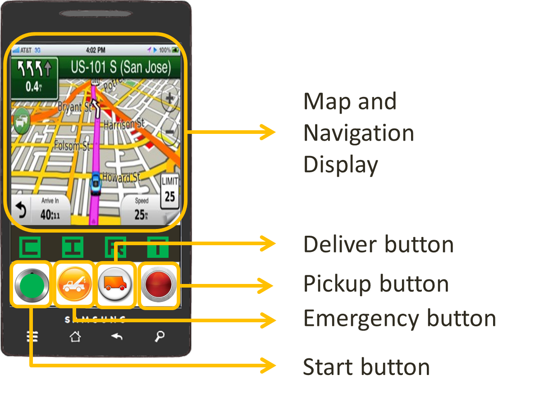

# V. Traceability







# VI. Creep Rate

The Creep Rate shall be less than 30% for Functional, Nonfunctional, and Domain Requirements.

# VII. Best Solution

* Cost effective solution: reduce gas cost, reduce courier man hour cost
* Adaptive to courier condition: CIRT provides emergency courier support
* Ubiquitous: installed as application for smartphone ecosystem
* Cloud based system: interactively adapted to customer requirements by providing API to integrate with customer database system