Virtual hands-on workshop : “Enjoyable Introduction to Programming using Alice”
by Dr. Jeyakesavan Veerasamy, CS faculty,
The University of Texas at Dallas, USA
Email: jeyv@utdallas.edu
Complete workshop materials @ www.utdallas.edu/~jeyv/alice
How did we learn to ride a bicycle? We had to learn 2 things together: Balancing & Pedaling to go forward. That is why we used training wheels to take care of balancing until we mastered pedaling. Learning to program has similar characteristics. When students are introduced to C/C++/Java language directly, they are expected to learn & apply the syntax and logic together. After struggling with syntax for hours, good % of students want to run away & never come back to programming!
Carnegie Mellon University (CMU) and a few other universities have recognized this issue and devised visual programming environments to help the freshers. Idea is to use drag-and-drop programming and avoid the syntax errors all-together. Visual environment also enables the students to test the logic quickly and enjoy the learning experience. With increased confidence & strong logic skills, students can go forward to learn more serious languages like C/C++/Java.
Alice is an innovative 3D programming environment that makes it easy to create an animation for telling a story, playing an interactive game, or a video to share on the web. Alice is a freely available teaching tool designed to be a student's first exposure to programming. It allows students to learn fundamental programming concepts in the context of creating animated movies and simple video games. In Alice, 3-D objects (e.g., people, animals, and vehicles) populate a virtual world and students create a program to animate the objects.

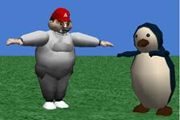  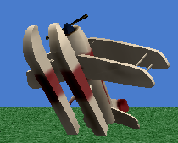 | 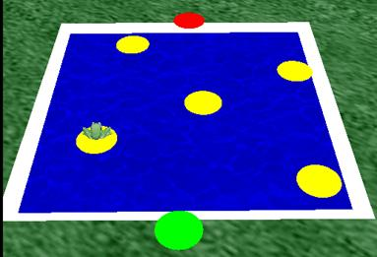
In Alice's interactive interface, students drag and drop graphic tiles to create a program, where the instructions correspond to standard statements in a production oriented programming languages, such as Java, C++, and C#. Alice allows students to immediately see how their animation programs run, enabling them to easily understand the relationship between the programming statements and the behavior of objects in their animation. By manipulating the objects in their virtual world, students. gain experience with all the programming constructs typically taught in an introductory programming course and enables them to try serious programming languages with more confidence.
We will use Alice 2.3 software for this course. You can download the one with "Alice textbook worlds" since it has additional scenes from a textbook. Alice 2.3 is available for Windows and Mac. Download the software and follow the instructions in Alice website to set it up before coming to the class.

